WORKING DRAFT — NOT FOR USE

Rolling Backdrop System
  - Illustrated Construction and Field Operations Manual
Version | Date | Status | One-line description
Release v0 (unreleased) — Development build D1 | 2026-09-01 | WORKING DRAFT — NOT FOR USE | Standardized master manual with 2026 CBA competition rules, 3/4" wing ballast posts, handle sandbag specifications, and instrument tote guidelines

Intro / Overview
This master manual is organized as two independently printable appendices under one controlled revision history. The complete package contains the system overview, field operations procedures, 2026 competition rules compliance, construction instructions, and purchasing index for the Pine Creek High School Marching Band rolling backdrop prop.
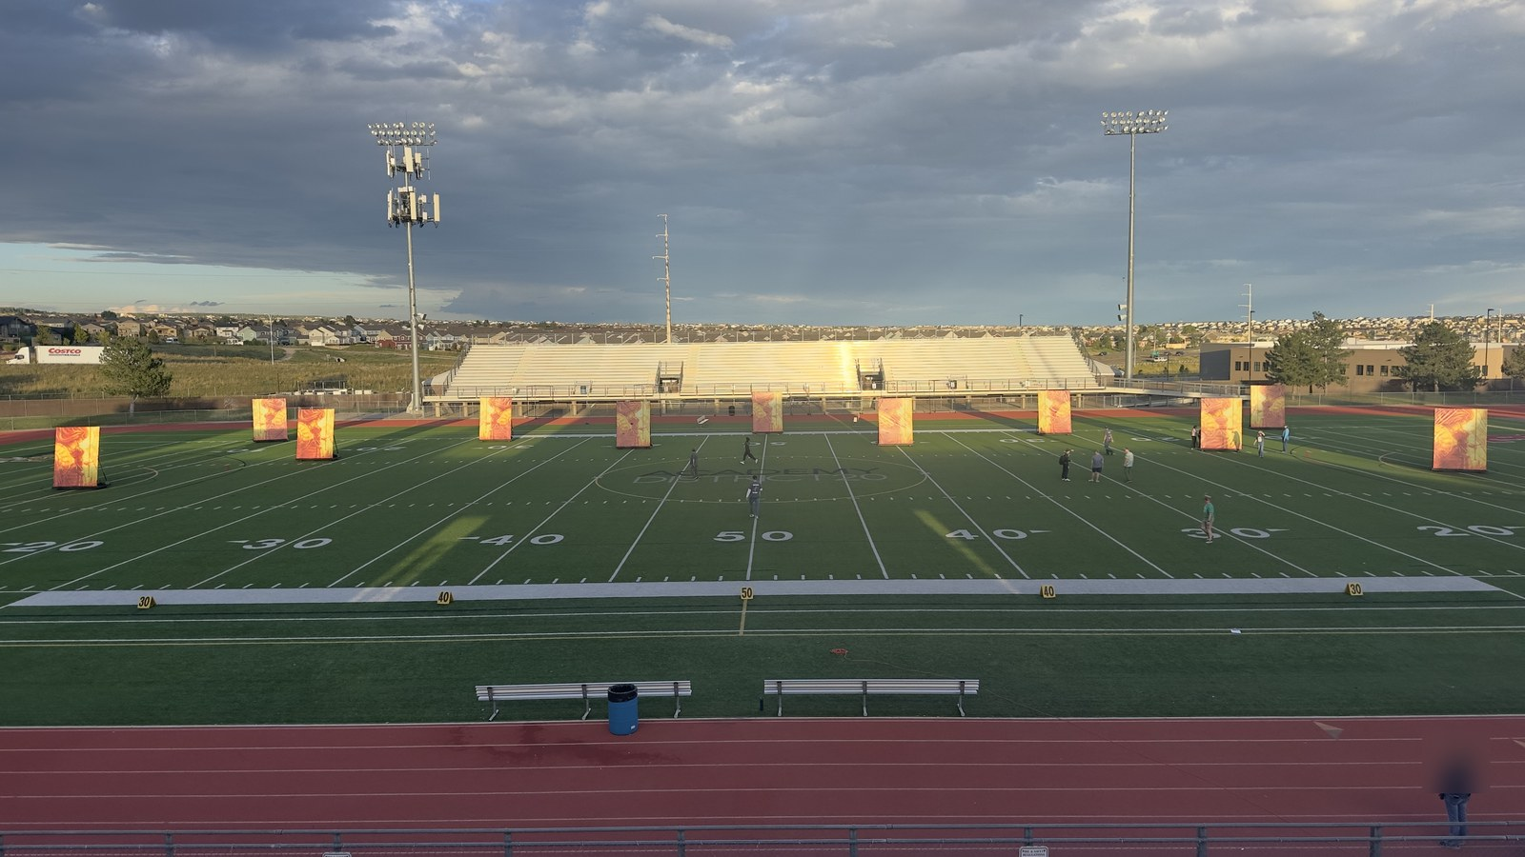
Figure 2. Backdrop units deployed in performance formation on athletic field.

Appendix A: Operations Manual
Covers field transport, entrance and exit procedures, student and parent volunteer training drills, 3/4-inch wing ballast retention posts, double-bagged sandbag requirements, student instrument stowage, 2026 CBA competition prop rules, and post-use teardown/trailer storage. Intended for parent field crew, prop handlers, and student stage crew.

Appendix B: Construction Manual
Covers workshop safety, materials, 2x4 rolling cart base fabrication, decking and 3/4-inch ballast post flange installation, 1-5/8 in. steel pipe upright frame assembly, diagonal support strut pre-drilling and mounting, vinyl banner installation with snap clamps, inspection checklist, and source lookup. Intended for fabrication volunteers and workshop build teams.

Printing and separation
Each appendix begins with an explicit cover page and uses independent page numbering (labeled A- for operations and B- for construction). When printing work packets for rehearsal or fabrication sessions, print the relevant appendix in its entirety, including its cover sheet.

Acknowledgments and Design Credit
Special thanks and credit to the Plainfield North Bands for creating the original rolling cart design and foundational engineering concept. The Pine Creek High School Marching Band adapted and refined this design for our field operations, 3/4" vertical wing ballast retention posts, turf ballasting standards, and custom 3D-printed alignment fixtures.
PART OF THE ROLLING BACKDROP CONSTRUCTION AND FIELD OPERATIONS MANUAL
APPENDIX A
Operations Manual
Field transport, entrance/exit, training, ballasting posts, instrument stowage, 2026 rules, and storage
This appendix is designed as a complete, independently printable work packet which can be distributed separately to parent volunteers, student stage crew, and field handlers.
Audience: Field operators, parent prop crew, and student handlers
Contents: Transport & field entrance; student/volunteer training; wing ballast posts; double-bagging rules; student instrument stowage; 2026 CBA rules; trailer storage
Print or carry: All pages labeled A-
Parent revision: Release v0 (unreleased) | Development build D1 | September 1, 2026
When separated from the master document, keep this cover as the first page of Appendix A.

Field Operations

1.1 Roles and Crew Organization
Field execution of the rolling backdrop props relies on a coordinated division of responsibility between parent volunteers and student performers:
A. Parent Pit & Logistics Crew:
- • Trailer Unloading & Staging: Offload backdrop carts from the equipment trailer and roll them to the stadium entrance tunnel or staging chute (Figure 3).
- • Ballast Loading & Verification: Place 2 to 3 double-bagged 15-lb sandbags over the 3/4" vertical retention posts on each side wing (4–6 bags total, 60–90 lbs) prior to field entrance.
- • Pre-Show Safety Check: Verify all four swivel casters rotate freely, brake levers are disengaged for transit, and strut mounting hardware is secure.
- • Staging Order: Arrange backdrops in numerical show drill order at the field gate.
- • Exit Catch Crew: Position parent volunteers (holding official Field Pass wristbands per Rule 9.07) at the stadium exit gate to receive carts from students, assist with deceleration, remove ballast sandbags, and pack the trailer.
B. Student Prop Handlers / Performers:
- • Field Operators: Students have sole responsibility for pushing and maneuvering the backdrop carts onto the field, executing show transitions, and pushing them off the field at the conclusion of the performance.
- • Crew Pairing: Exactly two student handlers are assigned to each backdrop cart, positioned on opposite outer end perimeter rails (B).
- • Instrument Stowage & Future Cradle Revision: The central opening cradles an HDX 14-gallon tough storage tote (Index [9]) for student handlers to temporarily place their musical instruments while pushing carts onto and off the field. Operational Note: The 14-gallon tote accommodates smaller instruments (flutes, clarinets, trumpets, alto saxophones), but is constrained when handlers play larger instruments (mellophones, trombones, baritones, tenor/bari saxes, or battery percussion). A future design revision is planned to engineer an expanded modular instrument cradle system.
- • On-Field Locking & Egress: Students engage all four caster wheel locks upon reaching field coordinates and release locks immediately upon show exit cue.
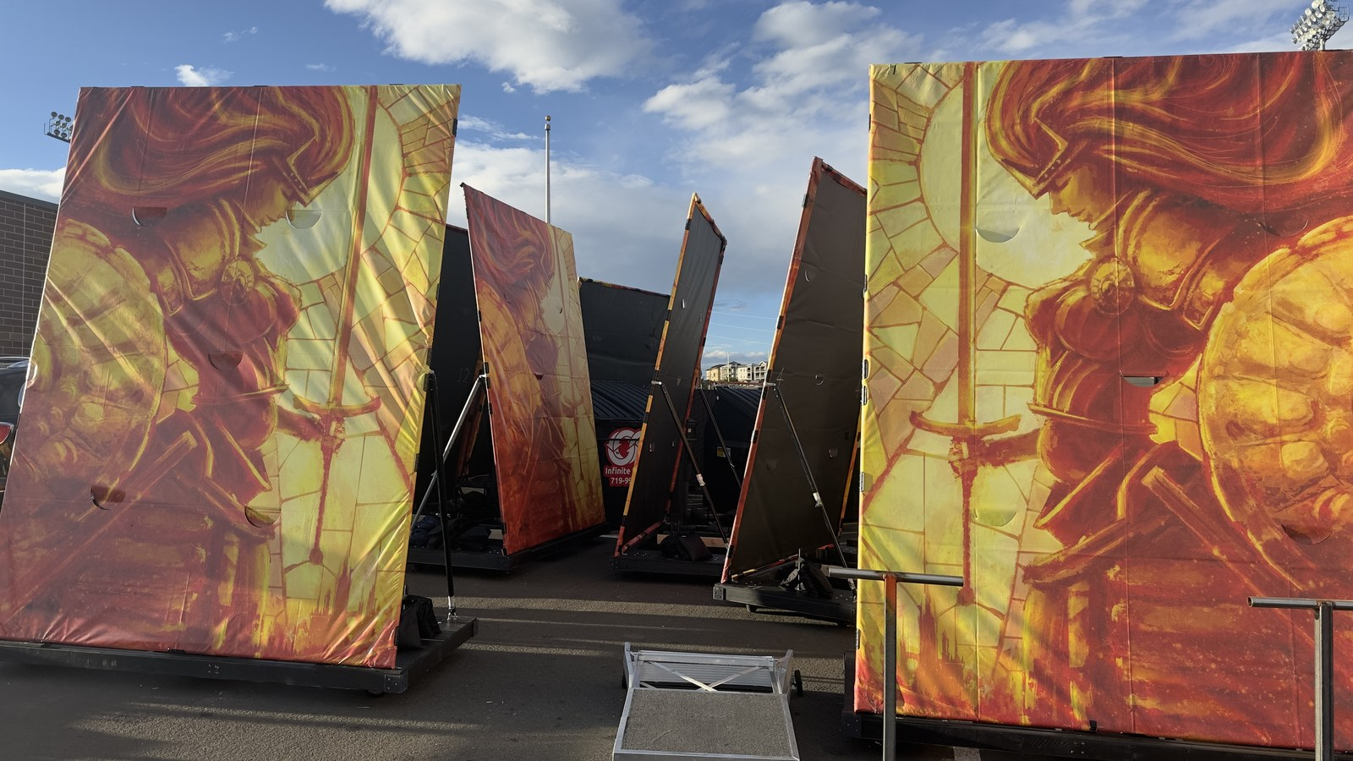
Figure 3. Assembled rolling backdrops staged and ready for field deployment.

1.2 Field Entrance, Positioning, and Egress
Timed performance intervals require strict adherence to navigation protocols:
1. Stadium Gate to Field Transit: Students take control of the staged carts at the field gate, placing their instruments safely inside the central tote bin. Push carts in two-person teams with the upright frame facing perpendicular to travel to maximize forward visibility.
2. Track & Curb Crossovers: Approach all running track crossings, track protector mats, and turf curb transitions square-on at a controlled walking pace. Both front casters MUST cross curbs simultaneously. Never approach curbs at an angle, which can bind casters or induce frame tipping.
3. Drill Coordinate Placement & Wheel Locking: Guide the cart to its exact field drill coordinate. Once in position, both handlers immediately depress the foot-operated wheel brake locks on all four swivel casters to prevent prop drift during wind gusts or choreography, retrieve their instruments from the center tote, and enter field positions.
4. Rapid Field Egress: On the final performance cue, handlers place instruments in the tote and both handlers kick-release all four caster brakes simultaneously. Push the carts in assigned exit order directly toward the exit gate where the parent catch crew is stationed to assist with deceleration and off-field handover. All props must maintain continuous movement until completely off the performance field per Rule 8.05.

1.3 Student and Volunteer Training Protocol
All student handlers and parent volunteers must complete practical training before competition deployment:
1. Proper Hand Placement & Leverage Safety: Handlers must ALWAYS keep hands low, grasping the outer wooden 2x4 perimeter rails (B) or inner reinforcement joists. NEVER push, pull, or apply body weight to the upper 1-5/8 in. steel pipe frame or diagonal struts. Pushing high creates massive overturning leverage that can tip the prop or bend steel mounting brackets.
2. Instrument Transition Drills: Practice smooth, rapid instrument placement and retrieval from the central carrier tote during timed entry, staging, and exit drills.
3. Rehearsal Run-Throughs: Conduct full-speed timed entry, positioning, brake-setting, brake-releasing, and exit drills during dress rehearsals on both synthetic turf and natural grass surfaces.
4. Handshake & Communication Protocol: The student on the outer sideline edge acts as the primary caller ('Clear left', 'Approaching curb', 'Brakes locked', 'Brakes released'). Handlers maintain continuous verbal communication during moves.
5. High Wind Emergency Response: If sustained winds exceed 20 mph or sudden gusts threaten prop stability during a performance, student handlers maintain firm contact on the wooden base with all brakes locked. Parent pit crew members stationed along the sideline with Field Pass wristbands will step onto the field to provide perimeter stabilization as directed by band directors.

1.4 Ballasting System, Wing Retention Posts, and Double-Bagging Protocol
To maintain vertical stability against outdoor wind shear while protecting stadium athletic turf, follow this exact ballasting standard:
1. Vertical Ballast Retention Posts: Each cart is equipped with two vertical 3/4-in. black iron pipe posts (18 inches tall) screwed into floor flanges through-bolted to the center of the left and right 1/2" plywood decking wings (see Appendix B, Stage 2).
2. Primary Ballast Standard (4–6 Bags, 60–90 lbs): Standard ballasting uses 4 to 6 15-lb heavy-duty sandbags with sewn-in handles (Index [13]). Stack 2 to 3 sandbags on the left wing and 2 to 3 sandbags on the right wing, looping the handles securely over the 3/4" vertical iron pipe posts. The vertical posts prevent sandbags from shifting, sliding off, or falling during cart movement or high winds.
3. Mandatory Double-Bagging (Rule 8.05): All 15-lb sandbags MUST utilize heavy-duty inner plastic liner insert bags (Index [14]) sealed securely inside the outer fabric sandbags. This dual-layer containment strictly satisfies the mandatory CBA competition anti-leakage rule.
4. High-Wind Reserve Ballast (70-lb Tube Sand): On severe high-wind days (sustained winds >15–20 mph), crew may add one or two 70-lb Sakrete traction tube sand bags (Index [15]) placed across the lower center frame joists. MANDATORY: Every 70-lb tube sandbag MUST be completely wrapped and sealed inside a thick contractor-grade garbage bag to satisfy the secondary containment rule before entering the stadium.
CRITICAL TURF OPERATION & DOUBLE-BAGGING WARNING: Under no circumstances may unbagged or single-layer sandbags be brought onto any competition turf (see Section 1.5, Rule 8.05). In addition, do not exceed 100–140 lbs total ballast under normal conditions, as excessive weight causes casters to sink into artificial turf rubber infill, multiplying rolling friction and making carts sluggish for student handlers.

1.5 Applicable 2026 Marching Band Competition & Prop Rules
The following governing rules are extracted directly from the official 2026 Colorado Bandmasters Association (CBA) Marching Band Rulebook (Index [17]). All prop builders, parent crew, and student handlers must adhere to these standards:
ANNUAL RULEBOOK NOTICE: This section reflects the governing rules for the 2026 competitive season. Logistics staff and build leads must review this section annually against updated CBA and Bands of America (BOA) rulebooks to verify continuing compliance.

Rule 8.05: Props, Equipment, Surface Protection, and Double-Bagging
- • Gate Ingress: All props and equipment must be designed and of a quantity such that they can be brought onto the Performance Field from the band entrance gate.
- • Continuous Movement: Following the end of the band's Performance, all props and equipment must be in continuous movement until entirely removed from the stadium.
- • Turf Contact Protection: All wooden props must be protected with a heavy-duty sustainable plastic product (PVC, Melamine, etc.) where said prop comes in contact with the field surface. Steel props with smooth edges are acceptable without the need for additional protection.
- • Secondary Containment for Sandbags: Props must not leave holes in the Performance Field surface. Sand bags must be in a secondary container (bucket, double bagged, etc.) that will prevent sand from leaking.

Rule 8.07: Equipment Wheel and Turf Protection Standards
- • Pneumatic-Like Tires: All instruments and equipment wheeled into the stadium from the entrance gate forward must have pneumatic-like tires. Wheels must be able to support the weight of the instrument/prop without creating damage to the field surface.

Rule 8.08: Prop Staging Height Restrictions
- • 12-Foot Rigid Height Limit: Staging (props, backdrops, screens, or similar objects) built and/or used by bands at CBA sanctioned events shall be limited to a maximum total height of twelve (12) feet, including wheels, platforms, and safety railings. Materials such as wood, metal, plastic, or aluminum are not permitted above the twelve-foot limit.

Rule 8.09: Prop Assembly, Timing, and USAFA Falcon Stadium Clearance
- • Staging Ingress: A band may bring props into the stadium after the previous band has entered the field. Props must fit in the end zone curve without blocking entrance/exit gates.
- • Falcon Stadium 9'6" Tunnel Rule: Any prop being used at Falcon Stadium (United States Air Force Academy) must not exceed 9 ft 6 in. to clear the tunnel entrance. Props up to the 12-ft limit may be erected in the tunnel after clearing the initial entrance.
- • Falcon Stadium Venue Update (2025/2026): While the 9'6" tunnel restriction remains in the printed CBA rulebook, it has been rendered obsolete by stadium renovations completed prior to the 2025 season. The lower overhead crossbeam at the bottom of the Falcon Stadium tunnel was permanently removed, and these backdrop props cleared the tunnel entrance at their full upright height (~10.5 ft) without issue throughout the 2025 season.

Rule 9.07: Parent Field Access & Wristband Limits
- • 25 Field Pass Wristbands: Access to the field is restricted to Directors/Staff with CBA passes and parents assisting with props/front ensemble with designated Field Pass wristbands. Each band receives exactly 25 Field Pass wristbands upon check-in. Additional wristbands are not available.

1.6 Post-Use Teardown and Trailer Storage
1. Immediate De-Ballasting: Remove all 15-lb sandbags from the 3/4" vertical wing posts at the exit chute. Never transport carts in trailers with sandbags installed on the posts.
2. Sandbag Trailer Staging: Stack sandbags low over the trailer axles on rubber floor mats to maintain a low trailer center of gravity.
3. Cart Base Loading: Roll empty cart bases into the front trailer nose wall standing upright (Figure 4). The 3D-printed Black ASA corner bumper braces prevent scuffing between adjacent carts.
4. Ratchet Strap Restraint: Secure cart bases using heavy-duty E-track ratchet straps wrapped around the bottom 2x4 lumber rails (Figure 4). NEVER strap across the steel pipe frame or struts.
5. Frame & Banner Rack: Store detached 10' x 8' steel frames with attached vinyl banners upright in protective padded storage racks (Figure 5).
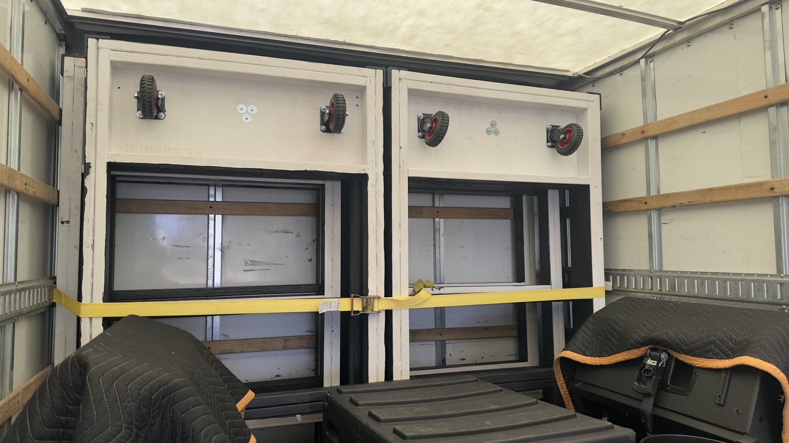
Figure 4. Rolling cart bases strapped to front trailer nose wall for transit.
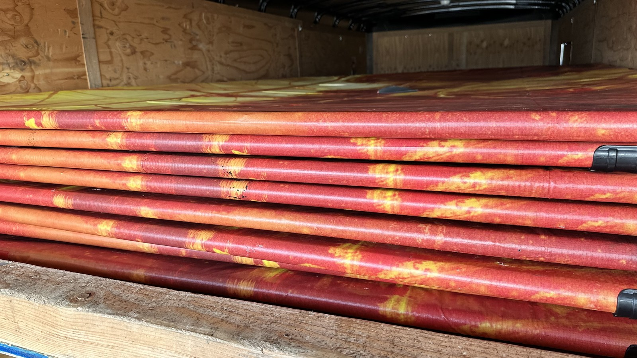
Figure 5. Stacked steel backdrop frames with installed vinyl banners in trailer storage rack.
PART OF THE ROLLING BACKDROP CONSTRUCTION AND FIELD OPERATIONS MANUAL
APPENDIX B
Construction Manual
Materials, cutting, cart assembly, ballast retention posts, instrument tote, steel frame, vinyl, and source lookup
This appendix is designed as a complete, independently printable work packet which can be distributed separately to fabrication volunteers and workshop build teams.
Audience: Fabrication volunteers and workshop build teams
Contents: Components; tools; 3D printed parts; 2x4 cart assembly; 3/4" ballast posts; HDX tote bay; steel frame; struts & pre-drilling; vinyl installation; Appendix B index
Print or carry: All pages labeled B-
Parent revision: Release v0 (unreleased) | Development build D1 | September 1, 2026
When separated from the master document, keep this cover as the first page of Appendix B.

Construction

Safety and work area
1. Personal Protective Equipment (PPE): Always wear ANSI Z87.1 safety glasses and hearing protection when cutting lumber, operating metal saws, or drilling galvanized steel tubing.
2. Workspace Setup: Provide a clean, flat 12 ft x 12 ft assembly floor for squaring the 96" x 44.5" cart base and 10' x 8' steel upright frame.

Materials and components
Component | Specification | Qty / Prop | Source
2x4 SPF / Doug Fir | 2x4x8 ft framing lumber (96" rails, 44.5" joists) | 8 pcs | Lumber yard
1/2" Plywood Decking | 1/2 in. CDX / Sanded Plywood (Left & Right wings) | 1 sheet | Lumber yard
3/4" Floor Flanges | 3/4 in. Black Iron Threaded Floor Flanges | 2 pcs | Index [16] / Home Depot
3/4" x 18" Iron Pipe | 3/4 in. Dia. x 18 in. Threaded Black Iron Pipe (Posts) | 2 pcs | Index [16] / Home Depot
Flange Carriage Bolts | 1/4-20 x 1-1/2 in. Carriage Bolts, Washers, Lock Nuts | 8 sets | Hardware store
HDX 14-Gal. Storage Tote | 14-Gallon Tough Tote (Black/Yellow) - Instrument Carrier | 1 pc | Index [9] / Home Depot
GRK #9 x 2-1/2" Screws | Star-drive R4 multi-purpose screws (Red markers) | ~40 pcs | Index [5] / Home Depot
GRK #10 x 4" Screws | Self-countersinking flat head screws (Blue markers) | 12 pcs | Index [6] / Home Depot
Swivel Casters | Heavy-duty turf-compatible swivel plate casters w/ brakes | 4 | Index [4] / Amazon
Fence Line Posts | 1-5/8" Dia. x 10 ft 16-Ga. Galvanized Steel Posts (Black) | 2 | Index [1] / Home Depot
Fence Top Rails | 1-5/8" Dia. x 8 ft Top Rails (Frame & Struts) | 4 | Home Depot
3-Way Corner Clamps | 1-5/8" 3-Way Clamp Corner Elbow Brackets | 4 | Index [2] / Amazon
Fence Tension Bands | 1-5/8" Galvanized Steel Tension Bands | 4 | Index [3] / Home Depot
Steel End Caps & U-Bolts | 1-5/8" Steel Rail End Caps & Heavy-Duty U-Bolts | 4 caps, 2 U-bolts | Index [7] / Amazon
15-lb Handle Sandbags | Abccanopy 15-lb Heavy-Duty Sandbags w/ Handle | 4–6 pcs | Index [13] / Amazon
Sandbag Inner Liners | Heavy-Duty Plastic Sandbag Liner Bags (Double-Bag) | 4–6 pcs | Index [14] / Amazon
70-lb Tube Sand (Reserve) | Sakrete 70-lb Traction Tube Sand + Contractor Bags | 1–2 pcs | Index [15] / Lowe's
Pipe Snap Clamps | 1-5/8" Pipe Snap Clamps | 16-24 | Index [8] / Amazon
Double-Sided Carpet Tape | Heavy-duty indoor/outdoor tape | 1 roll | Hardware supplier

Tools and equipment
Required workshop tools and fixtures:
- • Miter saw or circular saw with wood framing blade
- • Metal chop saw or reciprocating saw with metal cutting blade
- • Impact driver with Torx T-25 bit
- • Cordless drill with 1/8-in. HSS / Cobalt drill bit rated for steel (pre-drilling 16-ga. tubing)
- • 5/16-in. socket wrench, 7/16-in. wrench for 1/4-20 flange bolts, and open-end wrenches for U-bolt hardware
- • Pipe wrench for threading 3/4-in. black iron pipe into floor flanges
- • 25-ft tape measure, framing square, and speed square
- • Isopropyl alcohol and microfiber rags for surface degreasing

3D-printed parts and fixtures
Print all fixtures in Black ASA or PETG for outdoor UV and heat stability. Do not use PLA.
Part / Tool | Qty | Purpose & Source File
Corner Bumper Braces | 4 | Protects 2x4 outer corners from scuffing; Index [10] (Hardware/Corner Brace.FCStd)
Drill Alignment Jig | 1 | Guides 1/8" pilot holes through 1-5/8" fence pipe; Index [11] (Hardware/Drill Alignment Jig.3mf)
Strut Bracket Marker | 1 | Locates base U-bolt & upper tension band positions; Index [12] (Hardware/Steel Support Strut Bracket Marker.FCStd)

Frame assembly

Stage 1: Assemble the Rolling Cart Base
The rolling cart base is fabricated from 2x4 SPF/Doug Fir lumber according to the component layout and fastener map shown in Figure 1:
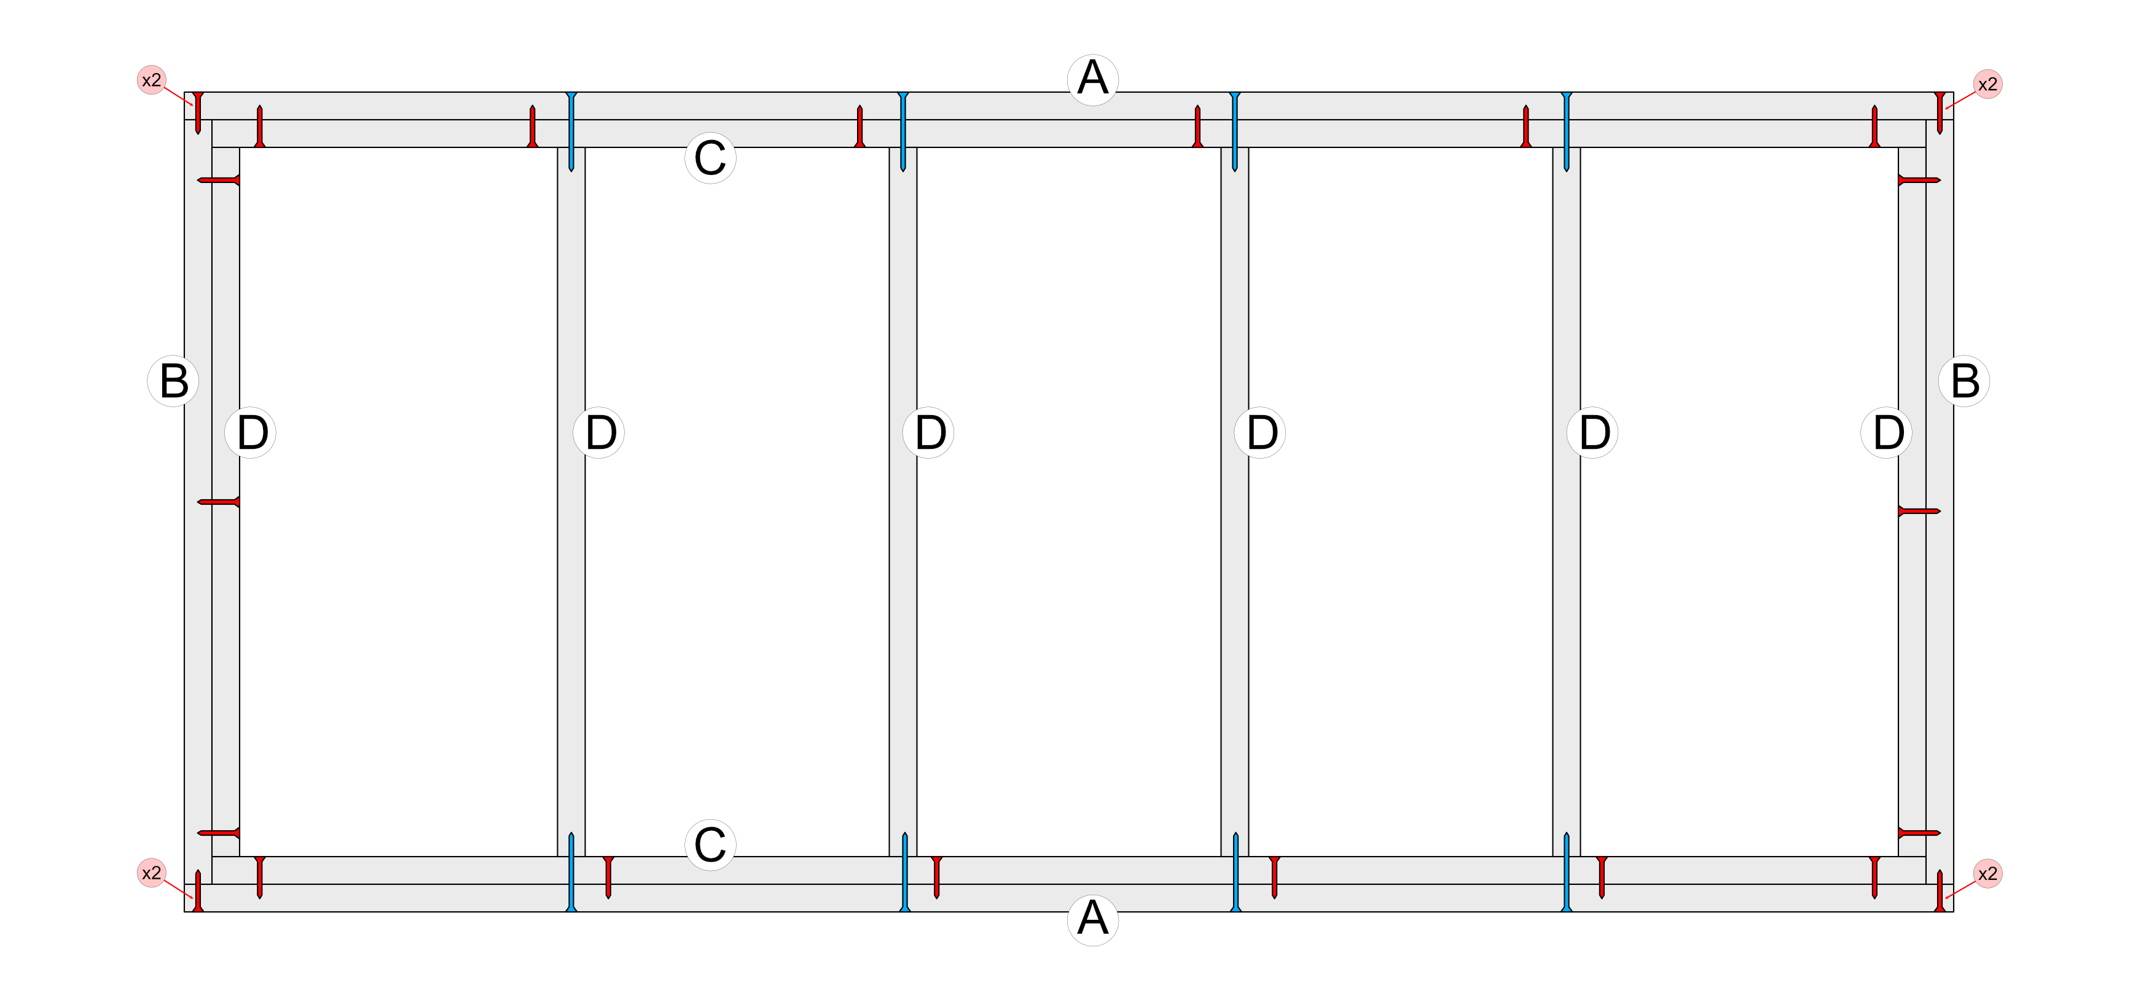
Figure 1. Top-down 2x4 rolling cart frame layout and screw fastening map.
Stage 1 Assembly Procedure:
1. Cut Lumber: Cut outer longitudinal rails (A) to 96.0 inches and end perimeter rails (B) to 44.5 inches.
2. Square Perimeter: Lay the four perimeter members flat on the shop floor. Measure opposite diagonals to confirm exact squareness.
3. Outer Corners: Fasten each outer corner joint with two GRK #9 x 2-1/2 in. wood screws (red markers labeled 'x2').
4. Joist Layout: Place six cross joists (D): two flush against the inner face of end rails (B), and four interior joists spaced to define the left decking wing, open tote bay, and right decking wing.
5. End Joists: Secure each outer end joist (D) to end rail (B) with three GRK #9 x 2-1/2 in. screws.
6. Structural Screws: Drive GRK #10 x 4 in. structural screws (blue markers) from outside rail (A) into the end grain of each cross joist (D) (two structural screws per joist).
7. Lamination: Laminate inner reinforcement rails (C) to the inside faces of rails (A) using GRK #9 x 2-1/2 in. screws as indicated by the interior red markers.

Stage 2: Install Decking, Ballast Posts, Casters, and Instrument Tote
1. Plywood Decking: Fasten two 1/2-in. plywood panels across the left wing (outer rail B to 2nd joist D) and right wing (5th joist D to outer rail B) with 1-1/4 in. screws. Confirm the center bay between the 3rd and 4th joists remains completely clear to receive the HDX 14-gallon tough tote.
2. Ballast Retention Post Flange Installation: Locate the geometric center of each 1/2" plywood wing panel. Position a 3/4-in. black iron floor flange (Index [16]) and mark four bolt holes. Drill 1/4" clearance holes through the plywood. Secure each flange from the underside using 1/4-20 x 1-1/2 in. carriage bolts, flat washers, and nylon lock nuts. Thread a 3/4-in. x 18-in. black iron pipe into each flange and tighten firmly with a pipe wrench.
3. Instrument Carrier Tote Installation: Insert the central HDX 14-gallon tough storage tote (Index [9]) into the open center frame bay between the 3rd and 4th cross joists (D). The tote rim rests on the 2x4 framing to serve as the student instrument carrier during show operations. (Note: A future design revision is planned to accommodate larger instrument geometries).
4. Painting: Paint all cart bases and wood surfaces with exterior-grade semi-gloss black paint before final caster assembly (Figure 7).
5. Swivel Casters: Invert the cart base. Mount four heavy-duty swivel plate casters (Index [4]) directly beneath the corner lumber intersections using 5/16 in. x 1-1/2 in. structural timber screws with flat washers (Figure 9).
6. Corner Bumpers: Fasten four 3D-printed Corner Braces (Index [10]) over each outer corner with #8 pan-head screws to protect the wood cart from transport impacts.
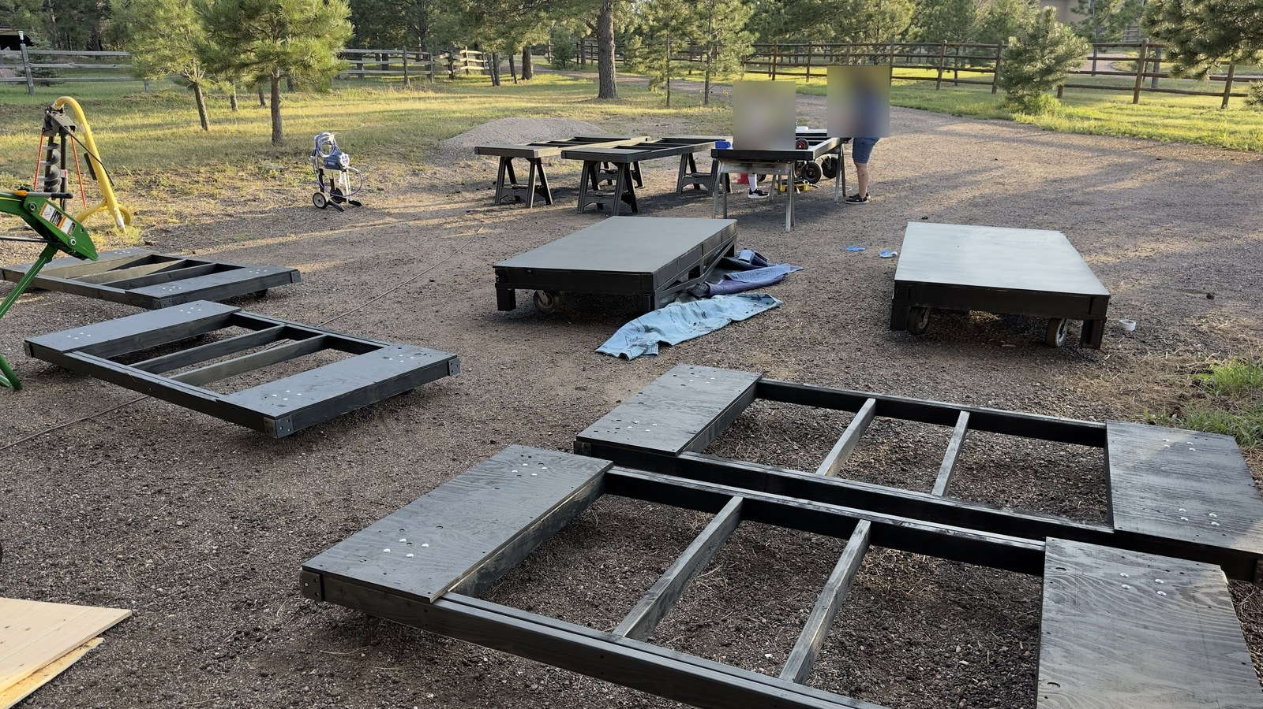
Figure 7. Cart base frames painted black with plywood decking wings installed.
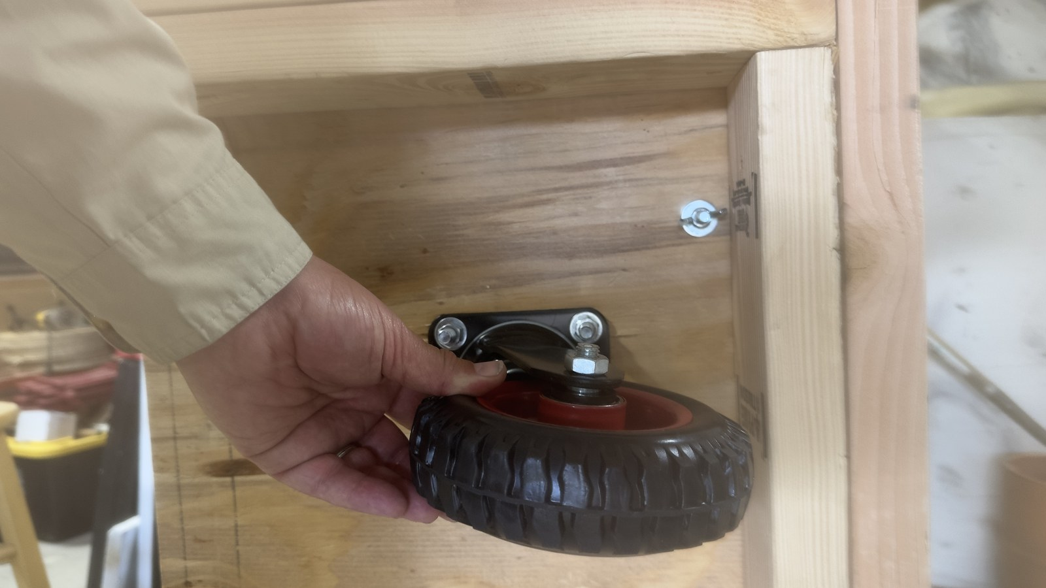
Figure 9. Swivel caster wheel assembly mounted beneath corner framing.
Operational Caster Fastening Standard: While early prototype builds utilized wing nuts as pictured in Figure 9, field operations standardized on standard hex nuts. Using standard hex nuts enables parent crew to rapidly remove and secure casters using an impact driver / cordless drill, significantly outperforming manual wing nut threading during teardowns.

Stage 3: Assemble the Upright Backdrop Frame
1. Upright Rectangle: Join two 10-ft 16-gauge steel fence line posts and two 8-ft top rails using four 1-5/8 in. 3-way clamp corner elbow brackets (Index [2]). Bottom out all tube ends inside the clamp sockets and tighten clamp bolts evenly.
2. Base Attachment: Stand the upright frame against the front rail (A) of the cart base. Anchor the bottom of each vertical post using 1-5/8 in. galvanized steel tension bands (Index [3]) through-bolted to the 2x4 lumber frame.

Stage 4: Fabricate and Install Diagonal Support Struts
Because 16-gauge galvanized steel is exceptionally hard, direct self-tapping screws will skate and dull. Follow this guided drilling protocol:
1. Strut Preparation: Cut two diagonal strut lengths from 1-5/8 in. steel top rail and slide 1-5/8 in. steel end caps over each end.
2. Guided Pre-Drilling: Clamp the 3D-printed Drill Alignment Jig (Index [11]) over the end cap pilot location. Using a 1/8-in. HSS / Cobalt drill bit rated for steel, drill clean pilot holes through the end cap and underlying pipe wall. Drive self-tapping screws into the pre-drilled holes to lock the end caps permanently.
3. Frame Mounting: Mount upper tension bands on the vertical posts using the 3D-printed Strut Bracket Marker template (Index [12]). Bolt the upper strut end caps to the tension bands. Anchor the lower strut end caps to the rear 2x4 cart framing with heavy-duty steel U-bolts (Index [7]) as shown in Figure 8.
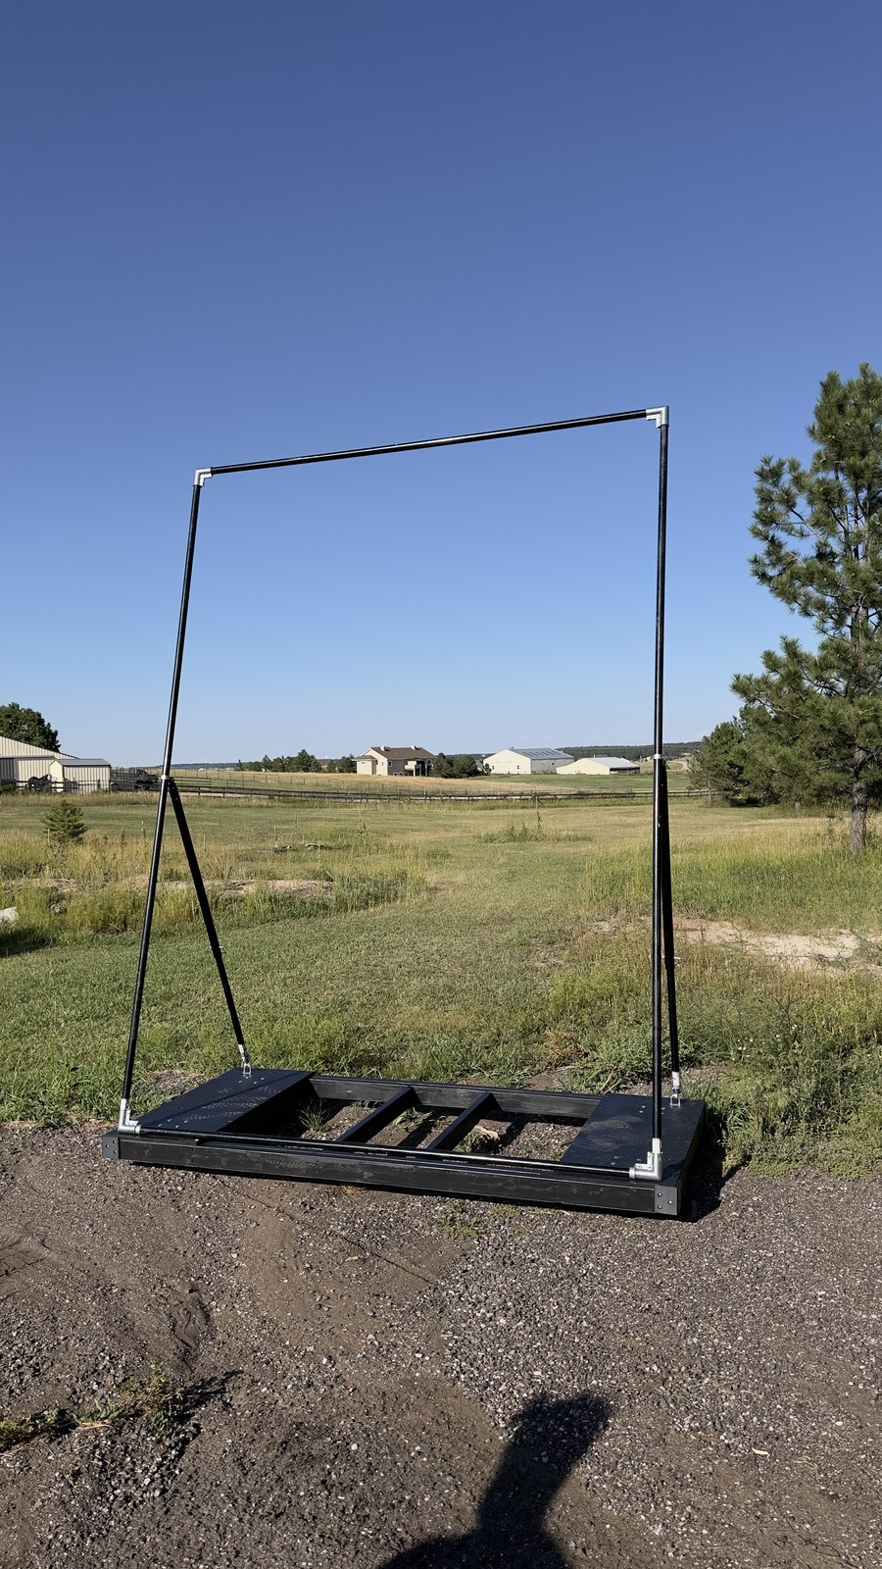
Figure 8. Completed rolling cart base and upright steel frame assembly.

Vinyl Installation
1. Surface Prep: Clean the front face of all perimeter 1-5/8 in. steel pipes with isopropyl alcohol.
2. Carpet Tape: Apply heavy-duty double-sided indoor/outdoor carpet tape along the front contact edges of the top rail, bottom rail, and vertical uprights.
3. Banner Alignment: Stretch the 10 ft x 8 ft vinyl banner across the frame, pressing firmly into the carpet tape from the center outwards to eliminate wrinkles (Figure 6).
4. Mechanical Snap Clamping: Snap 1-5/8 in. pipe snap clamps (Index [8]) directly over the vinyl at every taped contact location (spaced 12–16 inches apart). The snap clamps mechanically lock the banner against dynamic wind shear.
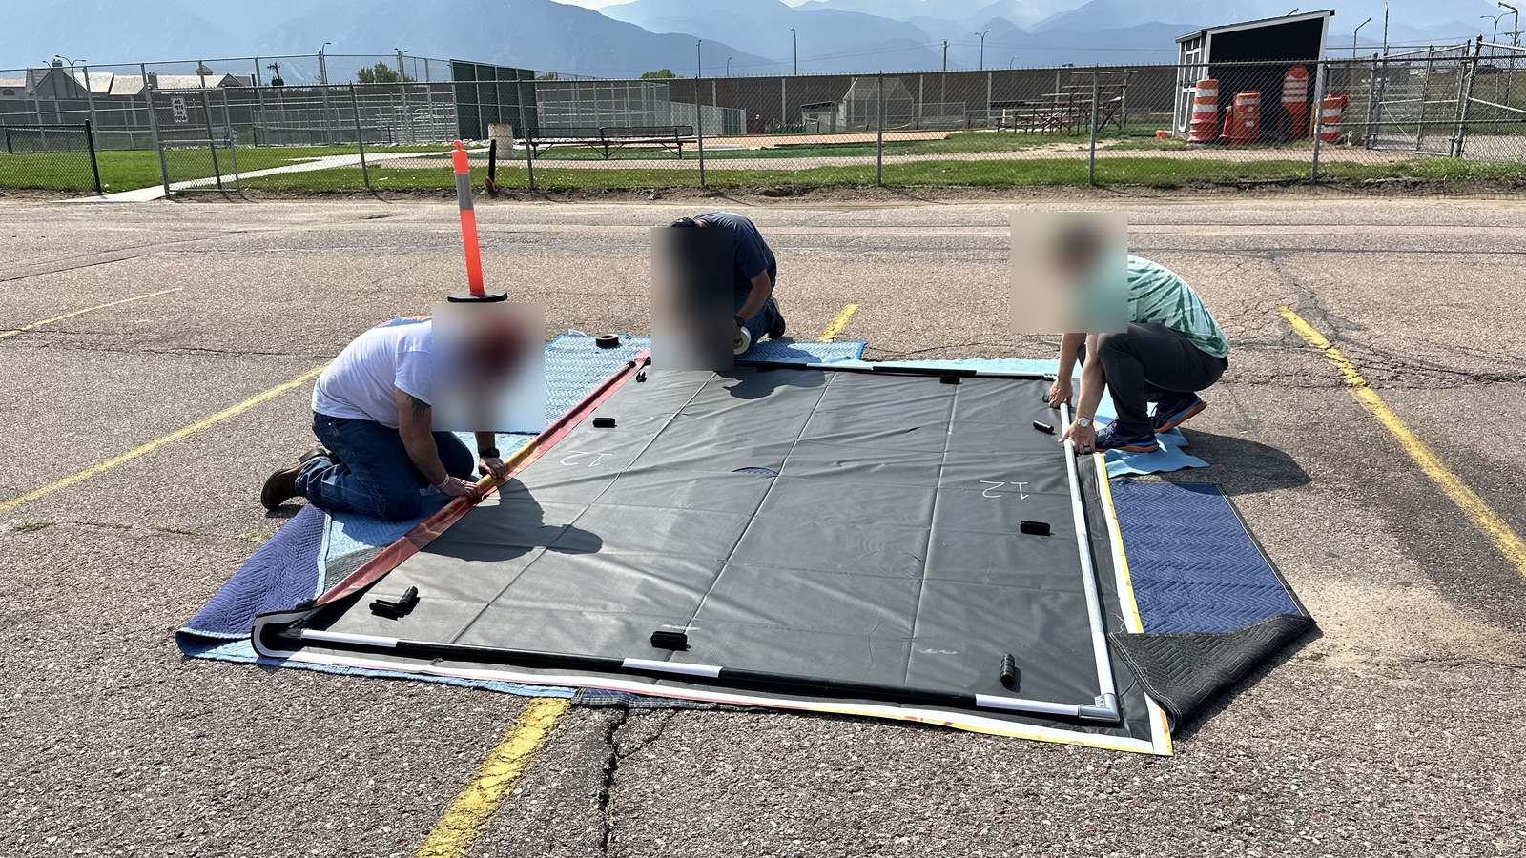
Figure 6. Installation team applying carpet tape and securing vinyl banner with pipe snap clamps.

Final construction inspection
Verify before releasing prop for field use:
□ Cart Base Squareness: Opposite diagonal measurements within 1/8 in.
□ Ballast Posts: 3/4" flanges through-bolted securely to plywood; 18" pipes tight without wobble.
□ Instrument Tote Bay: HDX 14-gallon tote drops smoothly into center frame bay.
□ Fasteners: All GRK red/blue screws fully countersunk without wood splitting.
□ Casters: Smooth 360° swivel action; hex nuts tightened securely; brake levers lock.
□ Upright Frame: All 3-way corner clamp bolts torqued securely.
□ Support Struts: End cap screws and base U-bolts tight with zero play.
□ Vinyl: Banner taut, wrinkle-free, and locked with snap clamps along all four sides.

Appendix B Index

Purchase sources
[1] 1-5/8 in. Dia. x 10 ft Steel Fence Line Posts - Home Depot
https://www.homedepot.com/p/Everbilt-1-5-8-in-Dia-x-8-ft-16-Gauge-Galvanized-Steel-Chain-Link-Fence-Line-Post-328923DPTSEB/312373067
[2] 1-5/8 in. 3-Way Clamp Corner Elbow Brackets - Amazon
https://www.amazon.com/dp/B0CD7QT6L6
[3] 1-5/8 in. Galvanized Steel Tension Bands - Home Depot
https://www.homedepot.com/p/Everbilt-1-5-8-in-Galvanized-Steel-Chain-Link-Fence-Tension-Band-328521EB/312373099
[4] Heavy-Duty Swivel Plate Casters - Amazon
https://www.amazon.com/dp/B0CPXFJCJL
[5] GRK #9 x 2-1/2 in. Star Drive R4 Multi-Purpose Screws - Home Depot
https://www.homedepot.com/p/GRK-Fasteners-9-x-2-1-2-in-Star-Drive-Torx-Bugle-Head-R4-Multi-Purpose-Wood-Screw-300-Pack-100101/203533402
[6] GRK #10 x 4 in. R4 Self-Countersinking Flat-Head Screws - Home Depot
https://www.homedepot.com/p/GRK-Fasteners-10-x-4-in-R4-Self-Countersinking-Flat-Head-Multi-Purpose-Screw-50-per-Pack-103141/203525231
[7] Heavy-Duty Steel U-Bolts - Amazon
https://www.amazon.com/dp/B09L41JFMS
[8] 1-5/8 in. Pipe Snap Clamps - Amazon
https://www.amazon.com/dp/B0CDZP8YVF
[9] HDX 14-Gallon Tough Storage Tote (Black/Yellow) - Home Depot
https://www.homedepot.com/p/HDX-14-Gal-Tough-Storage-Tote-in-Black-with-Yellow-Lid-999-14G-HDX/328027053
[13] Abccanopy 15-lb Heavy-Duty Sandbags with Handle (4-Pack) - Amazon
https://www.amazon.com/dp/B0DFVVZDVK
[14] Heavy-Duty Plastic Sandbag Liner Bags (Double-Bag Compliance) - Amazon
https://www.amazon.com/dp/B0BG3F5XVS
[15] Sakrete 70-lb Traction Tube Sand - Lowe's
https://www.lowes.com/pd/Sakrete-0-07-cu-ft-70-lb-Traction-Sand/5015728687
[16] 3/4 in. Black Iron Floor Flange and 18 in. Threaded Pipe - Home Depot
https://www.homedepot.com/p/The-Plumber-s-Choice-3-4-in-Black-Malleable-Iron-Floor-Flange-5-Pack-FBNF034-5/308967916

Digital part files & governing rules
[10] 3D Printed Corner Bumper Brace - FreeCAD Model
https://github.com/ericrowe/music/blob/main/PCHSMB/_Backdrop/Hardware/Corner%20Brace.FCStd
[11] 3D Printed 1-5/8" Pipe Drill Alignment Jig - Slicer 3MF
https://github.com/ericrowe/music/blob/main/PCHSMB/_Backdrop/Hardware/Drill%20Alignment%20Jig.3mf
[12] 3D Printed Support Strut Bracket Marker - FreeCAD Model
https://github.com/ericrowe/music/blob/main/PCHSMB/_Backdrop/Hardware/Steel%20Support%20Strut%20Bracket%20Marker.FCStd
[17] 2026 Colorado Bandmasters Association (CBA) Marching Band Rulebook (PDF)
https://ebf5c7e8-3869-4325-bd98-ce10f57d7545.filesusr.com/ugd/83f67e_cb5fe6efdbdb4ce98f619580f694bc94.pdf

