WORKING DRAFT — NOT FOR USE

Rolling Backdrop System
  - Illustrated Construction and Field Operations Manual
Version | Date | Status | One-line description
Release v0 (unreleased) — Development build D1 | 2026-09-01 | WORKING DRAFT — NOT FOR USE | Standardized master manual with 2026 CBA competition rules, 3/4" wing ballast posts, handle sandbag specifications, and instrument tote guidelines
Release v0 (unreleased) — Development build D2 | 2026-09-10 | WORKING DRAFT — NOT FOR USE | Add detailed vinyl installation procedure, specifications table, hardware relief slits, and snap clamp fastening
Release v0 (unreleased) — Development build D3 | 2026-09-10 | WORKING DRAFT — NOT FOR USE | Add engineered wind relief slit specifications, tiered 15-lb handle sandbag ballast schedule, rear-rail leverage optimization, and high-wind emergency protocol

Intro / Overview
This master manual is organized as three independently printable appendices under one controlled revision history. The complete package contains the system overview, field operations procedures, 2026 competition rules compliance, construction instructions, and purchasing index for the Pine Creek High School Marching Band rolling backdrop prop.
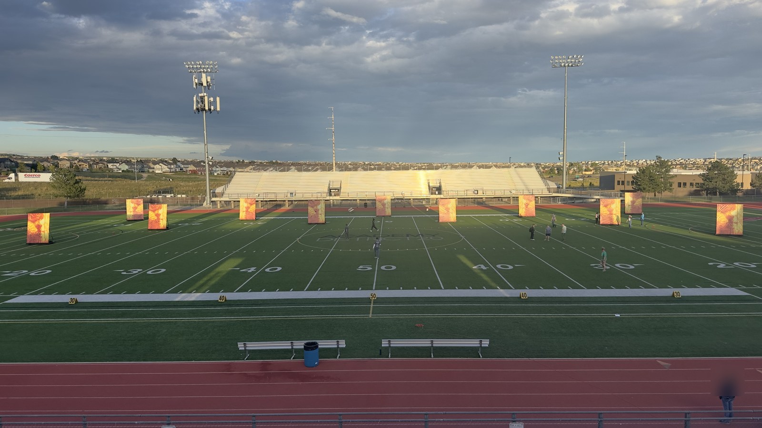
Figure 2. Backdrop units deployed in performance formation on athletic field.

Appendix A: Operations Manual
Covers field transport, entrance and exit procedures, student and parent volunteer training drills, 3/4-inch wing ballast retention posts, double-bagged sandbag requirements, student instrument stowage, 2026 CBA competition prop rules, and post-use teardown/trailer storage. Intended for parent field crew, prop handlers, and student stage crew.

Appendix B: Construction Manual
Covers workshop safety, materials, 2x4 rolling cart base fabrication, decking and 3/4-inch ballast post flange installation, 1-5/8 in. steel pipe upright frame assembly, diagonal support strut pre-drilling and mounting, vinyl banner installation with snap clamps, inspection checklist, and source lookup. Intended for fabrication volunteers and workshop build teams.

Appendix C: Field Operations Placard
A dedicated one-page quick-reference sheet designed to be printed, laminated, and attached directly to each backdrop cart for instant field reference by trained student handlers and parent pit crew. Contains the tiered wind limits and ballast schedule, emergency abort rules, rapid assembly/teardown steps, and a dedicated 4" × 6" space for each prop's show drill coordinate diagram.

Printing and separation
Each appendix begins with an explicit cover page and uses independent page numbering (labeled A- for operations and B- for construction). When printing work packets for rehearsal or fabrication sessions, print the relevant appendix in its entirety, including its cover sheet.

Acknowledgments and Design Credit
Special thanks and credit to the Plainfield North Bands for creating the original rolling cart design and foundational engineering concept. The Pine Creek High School Marching Band adapted and refined this design for our field operations, 3/4" vertical wing ballast retention posts, turf ballasting standards, and custom 3D-printed alignment fixtures.
PART OF THE ROLLING BACKDROP CONSTRUCTION AND FIELD OPERATIONS MANUAL
APPENDIX A
Operations Manual
Field transport, entrance/exit, training, ballasting posts, instrument stowage, 2026 rules, and storage
This appendix is designed as a complete, independently printable work packet which can be distributed separately to parent volunteers, student stage crew, and field handlers.
Audience: Field operators, parent prop crew, and student handlers
Contents: Transport & field entrance; student/volunteer training; wing ballast posts; double-bagging rules; student instrument stowage; 2026 CBA rules; trailer storage
Print or carry: All pages labeled A-
Parent revision: Release v0 (unreleased) | Development build D3 | September 10, 2026
When separated from the master document, keep this cover as the first page of Appendix A.

Field Operations

1.1 Roles and Crew Organization
Field execution of the rolling backdrop props relies on a coordinated division of responsibility between parent volunteers and student performers:
A. Parent Pit & Logistics Crew:
- • Trailer Unloading & Field Staging Protocol: To fit inside equipment trailers, backdrops travel with the 10 ft × 8 ft steel frame detached from the cart base. Logistics crew execute field reassembly in the stadium tunnel or staging chute (Figure 3) as the exact reverse of trailer loading:
1. Cart Base Offloading: Release the heavy-duty E-track ratchet straps securing the cart bases against the front nose wall of the trailer. Carefully lower each cart base from its vertical short-end orientation onto all four swivel casters and roll it down the ramp to the level venue staging area.
2. Vinyl Frame Retrieval & Protective Tennis Ball Removal: With two operators lifting opposite sides, retrieve the 10 ft × 8 ft steel frames with attached vinyl banners from the trailer’s interior cross support beams (Figure 5). Pull off the protective cut tennis balls from the exposed ends of the upper strut arms and stow the tennis balls in the cart’s center HDX tough tote for post-show repacking.
3. Rapid Frame-to-Cart Fastening (Power Driver Recommended): Set the upright steel frame into the base mounting tension bands / clamp brackets along the front 2x4 rail of the cart base. Retrieve the mounting bolts from the tote. Using a cordless power drill/driver with an appropriate socket is strongly recommended to rapidly spin on and torque the hex nuts and lock washers, securing the upright frame to the cart in seconds.
4. Two-Piece Strut Mating & Pinning: Pivot the lower strut section up from the cart base (where it remained attached during transit), align it with the upper strut section attached to the frame upright, slide the sleeved two-piece joint together, and insert and lock the quick-release retaining pin through the aligned pin holes. Confirm both diagonal struts are rigid with zero slop.
5. Pre-Show Staging & Ballasting: Roll assembled backdrops to the field entrance gate in numerical show drill order. Load the required tiered sandbag ballast onto the wing posts (and rear rail if high wind), stage extra double-bagged 15-lb ground sandbag chocks for on-field use, verify 360° caster rotation, and prepare for gate ingress.
• Ballast Loading & Staging: Assess stadium wind conditions and stage double-bagged 15-lb sandbags according to the quick-reference schedule below (see Section 1.4 for full engineering analysis and leverage details):
Wind Condition | Wing Posts (3/4" Pipe) | Rear Rail (2x4 A) | Total Ballast | Field Status
Calm / Zero-Wind (0–8 mph) | 0 bags (unballasted) | None | 0 lbs (153 lb prop) | Safe to 8 mph (10 mph gust max)
Light Breeze (8–12 mph) | 4x 15-lb bags (2 per wing post) | None | 60 lbs (213 lb prop) | Standard Deployment
Advisory (12–18 mph) | 6x 15-lb bags (3 per wing post) | None | 90 lbs (243 lb prop) | Attentive Staging
High-Wind (18–22 mph) | 6x 15-lb bags (3 per wing post) | 3x 15-lb bags laid flat | 135 lbs (288 lb prop) | Max Safe Turf Limit
Abort (>20 mph / gusts >25) | — | — | — | NO-GO / LAY FLAT
• Pre-Show Safety Check: Verify all four swivel casters rotate freely, 360° swivel action is smooth without binding, mounting hex nuts are tightened securely, and strut hardware has zero play.
- • Staging Order: Arrange backdrops in numerical show drill order at the field gate.
- • Exit Catch Crew & Uphill Transit Assistance: Position parent volunteers (holding official Field Pass wristbands per Rule 9.07) at the stadium exit gate to receive carts from student handlers, assist with deceleration, and join students in pushing the fully ballasted carts all the way up the stadium ramp/hill to the trailer staging lot. Props cannot be de-ballasted at the stadium exit chute due to continuous traffic flow regulations.
B. Student Prop Handlers / Performers:
- • Field Operators: Students have sole responsibility for pushing and maneuvering the backdrop carts onto the field, executing show transitions, and pushing them off the field at the conclusion of the performance.
- • Crew Pairing & Incline Safety: No fewer than two student handlers are assigned to each backdrop cart under normal conditions, positioned on opposite outer end perimeter rails (B). During high-wind conditions or when navigating steep grades—such as the steep concrete tunnel entrance ramp at USAFA Falcon Stadium—additional student handlers (three to four students per cart) must be assigned to maintain positive braking, prevent runaway acceleration on downgrades, and provide adequate uphill momentum.
- • Instrument Stowage & Future Cradle Revision: The central opening cradles an HDX 14-gallon tough storage tote (Index [9]) for student handlers to temporarily place their musical instruments while pushing carts onto and off the field. Operational Note: The 14-gallon tote accommodates smaller instruments (flutes, clarinets, trumpets, alto saxophones), but is constrained when handlers play larger instruments (mellophones, trombones, baritones, tenor/bari saxes, or battery percussion). A future design revision is planned to engineer an expanded modular instrument cradle system.
• On-Field Positioning & Ground Chocking: Carts are equipped with non-locking swivel casters to maximize rolling agility during rapid field entrances and exits. When props reach their drill coordinates in windy conditions, handlers or parent pit crew deploy supplemental double-bagged 15-lb sandbags on the ground directly against the wheels to serve as wheel chocks, preventing field drift during the performance.
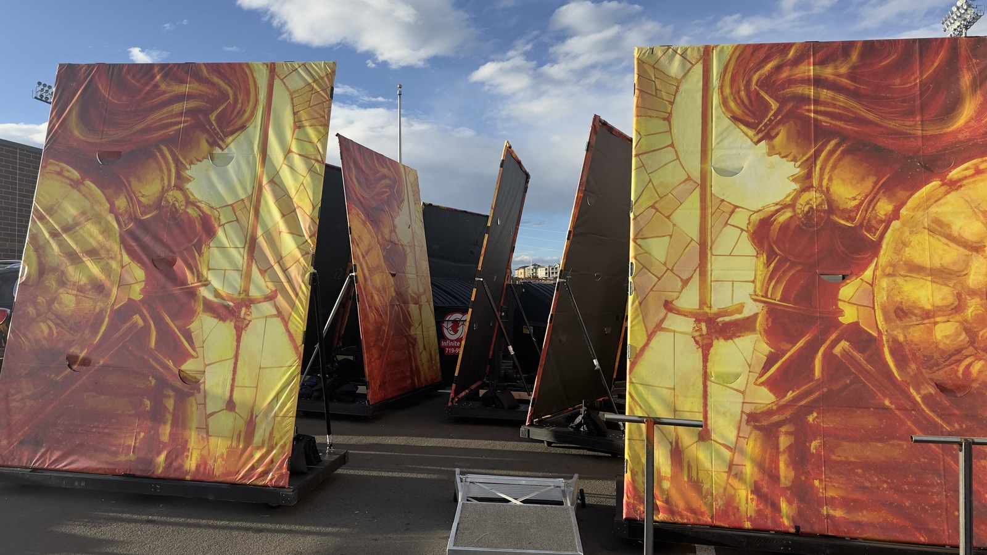
Figure 3. Assembled rolling backdrops staged and ready for field deployment.

1.2 Field Entrance, Positioning, and Egress
Timed performance intervals require strict adherence to navigation protocols:
1. Stadium Gate to Field Transit: Students take control of the staged carts at the field gate, placing their instruments safely inside the central tote bin. Push carts in two-person teams with the upright frame facing perpendicular to travel to maximize forward visibility.
2. Track, Curb & Steep Ramp Transitions: Approach all running track crossings, track protector mats, and turf curb transitions square-on at a controlled walking pace. Both front casters MUST cross curbs simultaneously. Never approach curbs at an angle, which can bind casters or induce frame tipping. When navigating steep slopes, stadium tunnels (such as Falcon Stadium), or windy ramps, deploy supplemental handlers to maintain positive deceleration control and prevent runaway roll.
3. Drill Coordinate Placement & Ground Chocking: Guide the cart to its exact field drill coordinate. Because carts utilize non-locking swivel casters, handlers position the cart square to the front sideline. When needed in breezy conditions, place extra double-bagged 15-lb sandbags on the ground firmly against the caster wheels as temporary wheel chocks to eliminate roll drift, retrieve instruments from the center tote, and take show positions.
4. Rapid Field Egress & Continuous Uphill Transit: On the final performance cue, handlers place instruments into the tote, quickly lift any ground sandbag chocks onto the cart base or hand them to sideline parent crew, and push the carts in assigned exit order directly through the gate. Under CBA Rule 8.05, props must maintain continuous movement off the field and CANNOT be de-ballasted at the stadium exit chute or tunnel. Props remain fully ballasted (213–288 lbs) and are pushed all the way up the hill to the trailer staging lot. On steep inclines (such as USAFA Falcon Stadium), assign 3 to 4 student handlers per cart to maintain uphill momentum.

1.3 Student and Volunteer Training Protocol
All student handlers and parent volunteers must complete practical training before competition deployment:
1. Proper Hand Placement & Leverage Safety: Handlers must ALWAYS keep hands low, grasping the outer wooden 2x4 perimeter rails (B) or inner reinforcement joists. NEVER push, pull, or apply body weight to the upper 1-5/8 in. steel pipe frame or diagonal struts. Pushing high creates massive overturning leverage that can tip the prop or bend steel mounting brackets.
2. Instrument Transition Drills: Practice smooth, rapid instrument placement and retrieval from the central carrier tote during timed entry, staging, and exit drills.
3. Rehearsal Run-Throughs: Conduct full-speed timed entry, positioning, ground sandbag chocking, and egress drills during dress rehearsals on both synthetic turf and natural grass surfaces.
4. Handshake & Communication Protocol: The student on the outer sideline edge acts as the primary caller ('Clear left', 'Approaching curb', 'On coordinate', 'Chocks set', 'Chocks clear'). Handlers maintain continuous verbal communication during moves.
5. High Wind Emergency Response & Abort Protocol: If sustained winds exceed 20 mph or sudden gusts exceed 25 mph, rolling backdrops MUST NOT enter the performance field (strict safety NO-GO threshold). If severe gusts strike while props are already on the field, student handlers position themselves on the upwind side of the cart, place ground sandbag chocks firmly against wheels, and brace the lower 2x4 framing. At no time should students attempt to hold backdrops from the upper steel pipe rails or climb the frame. Designated parent volunteers with Field Pass wristbands (Rule 9.07) will step onto the field to provide perimeter stabilization or assist handlers in immediately tipping the props flat onto the turf if ordered by band directors.

1.4 Ballasting System, Tiered Wind Schedule, and Double-Bagging Protocol
To maintain vertical stability against outdoor wind shear while strictly protecting stadium athletic turf from rutting and sand contamination, all backdrop props must adhere to this engineering ballasting standard and operational loading schedule.

A. Standardized Tiered Ballasting & Wind Speed Schedule
Ballasting requirements are scaled dynamically based on observed stadium wind velocity and peak gust forecasts prior to field gate ingress:
Tier / State | Wind Velocity | Wing Posts (3/4" Pipe) | Rear Rail (2x4 A) | Total Ballast | Max Safe Gust & Protocol
Tier 0: Calm | Calm / light air (0–8 mph, gusts ≤10 mph) | 0 bags (unballasted) | None | 0 lbs (153 lb total) | 10.0 mph max safe gust (14.4 mph tipping limit). FoS ≥ 2.07. Must upgrade to Tier 1 if wind exceeds 8 mph.
Tier 1: Normal | Light breeze (8–12 mph) | 4x 15-lb bags (2 per wing post; 30 lb/side) | None | 60 lbs (213 lb total) | 16.9 mph max gust. Standard operations; zero turf compaction.
Tier 2: Advisory | Moderate breeze (12–18 mph) | 6x 15-lb bags (3 per wing post; 45 lb/side) | None | 90 lbs (243 lb total) | 18.4 mph max gust. Handlers deploy ground sandbag chocks if breezy.
Tier 3: High-Wind | High wind advisory (18–22 mph) | 6x 15-lb bags (3 per wing post; 45 lb/side) | 3x 15-lb bags laid flat along rear rail A | 135 lbs (288 lb total) | 22.5 mph max gust. Symmetrical stability; max safe turf limit.
Tier 4: Safety Abort | Severe gale (>20 mph sustained / >25 mph gusts) | — | — | — | UNSAFE. Field withdrawal / NO-GO. Props kept off field or laid flat.

B. High-Wind Rear-Rail Ballast Leverage Optimization
Because the 10 ft x 8 ft vertical upright steel frame sits on the front perimeter rail (A) of the cart base, the structure possesses an inherent tipping asymmetry:
1. Critical Failure Mode (Forward Tipping): When wind blows from the rear toward the front, the cart pivots about the front caster wheels. Because the 48-lb steel frame and vinyl banner sit directly above the front caster line, their deadweight provides zero restoring leverage. As a result, an unballasted prop tips forward at just 12.4 mph (11.2 mph at sea level).
2. The Rear-Rail Mechanical Advantage: The 3/4-in. wing pipe posts sit at mid-depth (22.25 in. from front), providing a restoring lever arm of 1.71 ft to the front casters. By contrast, placing supplemental sandbags along the rear 2x4 framing rail (A) behind the instrument tote increases the lever arm to 3.46 ft (41.5 in.)—more than double the mechanical leverage! Three 15-lb bags placed across the rear rail produce the overturning resistance of six bags stacked on the center posts, equalizing forward and backward tipping thresholds to 22.5 mph.
3. Turf Compaction Ceiling: Total supplemental ballast must never exceed 140 lbs (293 lbs total prop deadweight). Concentrating more than ~75 lbs per caster wheel causes casters to sink into artificial turf rubber infill, multiplying rolling drag and risking permanent turf depressions or track damage.

C. Mandatory Double-Bagging Protocol (CBA Rule 8.05)
All 15-lb sandbags MUST utilize heavy-duty inner plastic liner insert bags (Index [14]) sealed securely inside the outer fabric cordura bags. Under no circumstances may unbagged or single-layer sandbags be brought onto any competition turf. If an outer fabric bag abrades, splits, or suffers seam failure, the heavy-duty inner liner guarantees zero sand escapes onto the performance field.

D. Emergency Reserve Protocol (70-lb Tube Sand)
In the event that 15-lb handle sandbags are depleted or extreme wind gusts threaten during stationary staging, crew may deploy 1 to 2 70-lb Sakrete traction tube sand bags (Index [15]) positioned flat across the rear lumber framing rail. MANDATORY: Every 70-lb tube sandbag MUST be completely wrapped and sealed inside a thick contractor-grade garbage bag to satisfy the secondary containment rule before entering the stadium.
CRITICAL TURF OPERATION & DOUBLE-BAGGING WARNING: Under no circumstances may unbagged or single-layer sandbags be brought onto any competition turf (see Section 1.5, Rule 8.05). In addition, do not exceed 135–140 lbs total ballast under any operational conditions, as excessive weight causes casters to sink into artificial turf rubber infill, multiplying rolling friction and making carts sluggish for student handlers.

1.5 Applicable 2026 Marching Band Competition & Prop Rules
The following governing rules are extracted directly from the official 2026 Colorado Bandmasters Association (CBA) Marching Band Rulebook (Index [17]). All prop builders, parent crew, and student handlers must adhere to these standards:
ANNUAL RULEBOOK NOTICE: This section reflects the governing rules for the 2026 competitive season. Logistics staff and build leads must review this section annually against updated CBA and Bands of America (BOA) rulebooks to verify continuing compliance.

Rule 8.05: Props, Equipment, Surface Protection, and Double-Bagging
- • Gate Ingress: All props and equipment must be designed and of a quantity such that they can be brought onto the Performance Field from the band entrance gate.
- • Continuous Movement: Following the end of the band's Performance, all props and equipment must be in continuous movement until entirely removed from the stadium.
- • Turf Contact Protection: All wooden props must be protected with a heavy-duty sustainable plastic product (PVC, Melamine, etc.) where said prop comes in contact with the field surface. Steel props with smooth edges are acceptable without the need for additional protection.
- • Secondary Containment for Sandbags: Props must not leave holes in the Performance Field surface. Sand bags must be in a secondary container (bucket, double bagged, etc.) that will prevent sand from leaking.

Rule 8.07: Equipment Wheel and Turf Protection Standards
- • Pneumatic-Like Tires: All instruments and equipment wheeled into the stadium from the entrance gate forward must have pneumatic-like tires. Wheels must be able to support the weight of the instrument/prop without creating damage to the field surface.

Rule 8.08: Prop Staging Height Restrictions
- • 12-Foot Rigid Height Limit: Staging (props, backdrops, screens, or similar objects) built and/or used by bands at CBA sanctioned events shall be limited to a maximum total height of twelve (12) feet, including wheels, platforms, and safety railings. Materials such as wood, metal, plastic, or aluminum are not permitted above the twelve-foot limit.

Rule 8.09: Prop Assembly, Timing, and USAFA Falcon Stadium Clearance
- • Staging Ingress: A band may bring props into the stadium after the previous band has entered the field. Props must fit in the end zone curve without blocking entrance/exit gates.
- • Falcon Stadium 9'6" Tunnel Rule: Any prop being used at Falcon Stadium (United States Air Force Academy) must not exceed 9 ft 6 in. to clear the tunnel entrance. Props up to the 12-ft limit may be erected in the tunnel after clearing the initial entrance.
- • Falcon Stadium Venue Update (2025/2026): While the 9'6" tunnel restriction remains in the printed CBA rulebook, it has been rendered obsolete by stadium renovations completed prior to the 2025 season. The lower overhead crossbeam at the bottom of the Falcon Stadium tunnel was permanently removed, and these backdrop props cleared the tunnel entrance at their full upright height (~10.5 ft) without issue throughout the 2025 season. However, the tunnel concrete ramp is exceptionally steep; crews must assign supplemental handlers (3–4 students per cart) rather than the standard two-student pairing to control cart descent and ascent.

Rule 9.07: Parent Field Access & Wristband Limits
- • 25 Field Pass Wristbands: Access to the field is restricted to Directors/Staff with CBA passes and parents assisting with props/front ensemble with designated Field Pass wristbands. Each band receives exactly 25 Field Pass wristbands upon check-in. Additional wristbands are not available.

1.6 Post-Use Teardown and Trailer Storage
1. Continuous Egress & Uphill Transit to Trailer: Props CANNOT be de-ballasted at the stadium exit chute or concourse. Rule 8.05 requires continuous movement off the field, and stadium chutes must remain clear for following bands. Student handlers and parent crew push fully ballasted carts (213–288 lbs total) all the way up the hill/ramp to the equipment trailer staging lot. On steep inclines (such as Falcon Stadium), 3 to 4 handlers must be assigned per cart to ensure adequate pushing force and prevent rollbacks.
2. "Two-Shot" Competitions (Prelims & Finals Inter-Show Staging): Most marching band competitions feature an afternoon Preliminary contest followed by an evening Finals competition. Between shows, props remain staged in the trailer lot with all sandbag ballast left in place on the carts to minimize volunteer labor and avoid hardware wear. If wind gusts threaten during inter-show lot staging, crew lay the vinyl frames flat directly onto the carts by pulling the quick-release retaining pin from each two-piece diagonal support strut. This eliminates wind sail area while keeping props fully ballasted and ready for rapid re-erection before Finals.
3. Final Teardown De-Ballasting (At Trailer Only): Following the final performance of the day (or when preparing for trailer transport), remove all 15-lb sandbags at the trailer. Stack sandbags low over the trailer axles on rubber floor mats to maintain a low center of gravity and balanced axle load during transit.
4. Two-Piece Strut Disassembly & Pin Stowage: Pull the quick-release wire-lock retaining pin holding the upper and lower strut sections together. Stow the pins immediately in the hardware container inside the center HDX tough tote to prevent loss during travel.
5. Strut Lower Arm Stowing & Upper Arm Vinyl Protection (Tennis Balls): Allow the lower half of each strut to pivot down flat against the cart decking (it remains anchored to the base U-bolt throughout transport). Install a standard tennis ball with a hole cut in it securely over the exposed open end of each upper strut arm (which remains attached to the vertical frame upright). This cushioned ball prevents the metal tube end from puncturing, tearing, or abrading the printed scrim vinyl during transit and handling.
6. Rapid Frame-to-Cart Unbolting (Power Driver Recommended): Remove the bolts securing the vertical upright steel frame to the cart base tension bands / clamp brackets along the front lumber rail. Using a cordless power drill/driver with an appropriate socket is strongly recommended to accelerate nut and bolt removal during tight post-show teardown intervals. Stow all mounting bolts, nuts, and washers in the cart's hardware container.
7. Vinyl Frame Loading onto Trailer Cross Support Beams: With two operators lifting opposite sides, carry the detached 10 ft × 8 ft steel frame with installed vinyl banner (and tennis-ball protected upper strut arms) into the equipment truck/trailer. Slide the frames onto the trailer's interior cross support beams (load bars / shoring beams / attic deck racks) as shown in Figure 5.
8. Cart Base Stowing on Short End & Ratchet Strap Restraint: Roll the detached wooden cart bases into the truck. Stand each cart base vertically on its short end up against the front nose wall of the truck (Figure 4). The 3D-printed ASA corner bumpers prevent scuffing between adjacent carts. Secure the cart bases firmly against the nose wall using heavy-duty E-track ratchet straps wrapped around the 2x4 lumber framing rails. NEVER strap across the steel pipe posts or the lower strut arms.
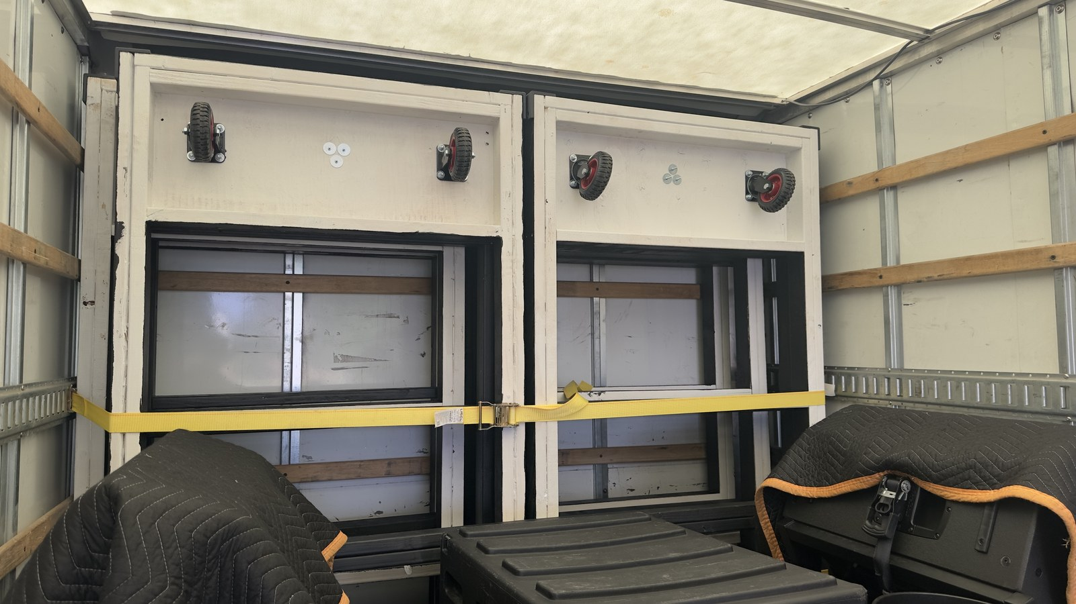
Figure 4. Rolling cart bases strapped to front trailer nose wall for transit.
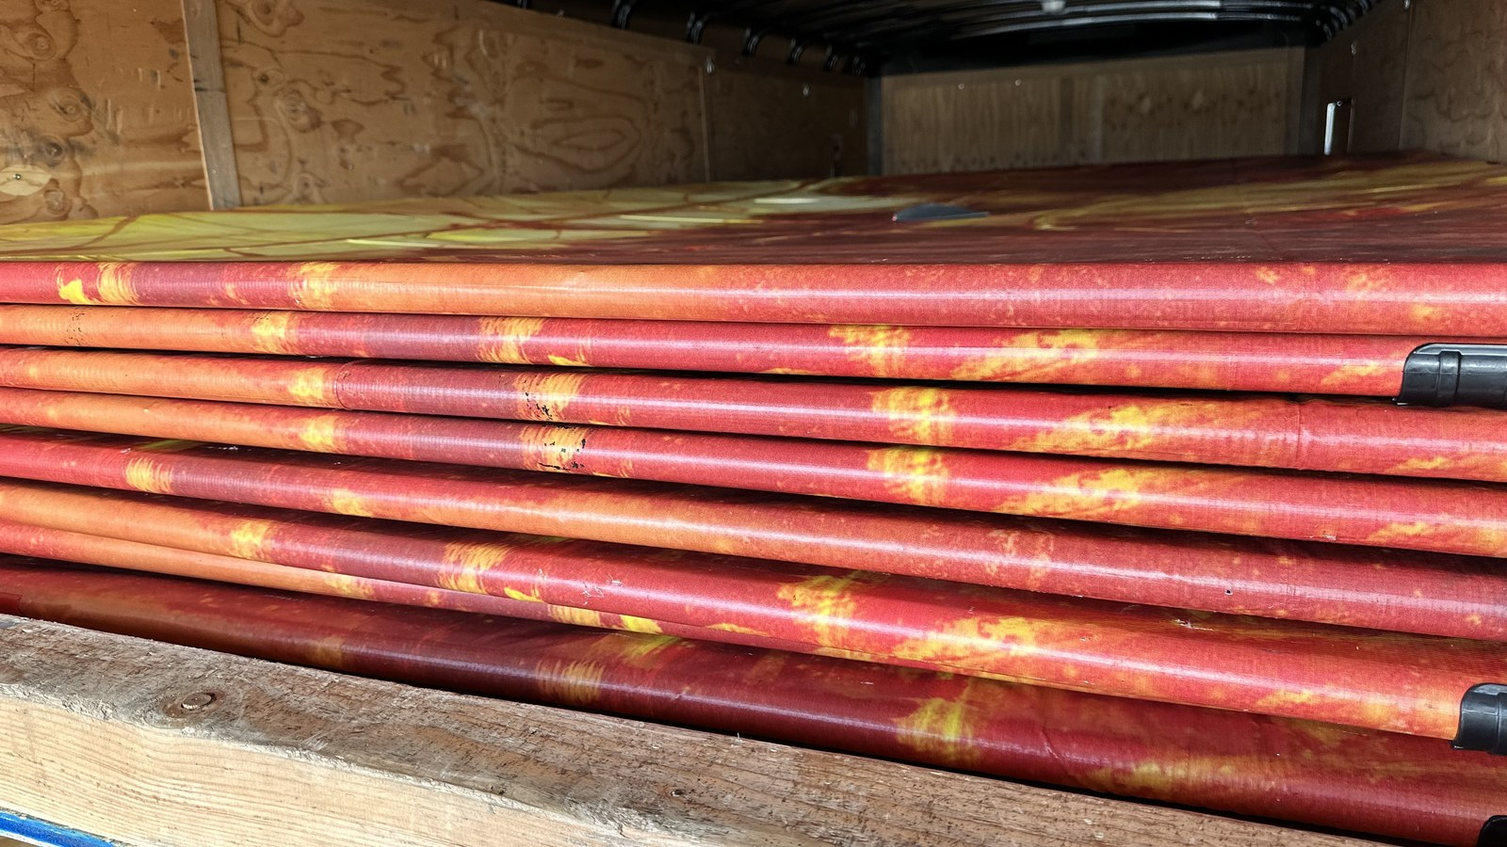
Figure 5. Stacked steel backdrop frames with installed vinyl banners in trailer storage rack.
PART OF THE ROLLING BACKDROP CONSTRUCTION AND FIELD OPERATIONS MANUAL
APPENDIX B
Construction Manual
Materials, cutting, cart assembly, ballast retention posts, instrument tote, steel frame, vinyl, and source lookup
This appendix is designed as a complete, independently printable work packet which can be distributed separately to fabrication volunteers and workshop build teams.
Audience: Fabrication volunteers and workshop build teams
Contents: Components; tools; 3D printed parts; 2x4 cart assembly; 3/4" ballast posts; HDX tote bay; steel frame; struts & pre-drilling; vinyl installation; Appendix B index
Print or carry: All pages labeled B-
Parent revision: Release v0 (unreleased) | Development build D3 | September 10, 2026
When separated from the master document, keep this cover as the first page of Appendix B.

Construction

Safety and work area
1. Personal Protective Equipment (PPE): Always wear ANSI Z87.1 safety glasses and hearing protection when cutting lumber, operating metal saws, or drilling galvanized steel tubing.
2. Workspace Setup: Provide a clean, flat 12 ft x 12 ft assembly floor for squaring the 96" x 44.5" cart base and 10' x 8' steel upright frame.

Materials and components
Component | Specification | Qty / Prop | Source
2x4 SPF / Doug Fir | 2x4x8 ft framing lumber (96" rails, 44.5" joists) | 8 pcs | Lumber yard
1/2" Plywood Decking | 1/2 in. CDX / Sanded Plywood (Left & Right wings) | 1 sheet | Lumber yard
3/4" Floor Flanges | 3/4 in. Black Iron Threaded Floor Flanges | 2 pcs | Index [16] / Home Depot
3/4" x 18" Iron Pipe | 3/4 in. Dia. x 18 in. Threaded Black Iron Pipe (Posts) | 2 pcs | Index [16] / Home Depot
Flange Carriage Bolts | 1/4-20 x 1-1/2 in. Carriage Bolts, Washers, Lock Nuts | 8 sets | Hardware store
HDX 14-Gal. Storage Tote | 14-Gallon Tough Tote (Black/Yellow) - Instrument Carrier | 1 pc | Index [9] / Home Depot
GRK #9 x 2-1/2" Screws | Star-drive R4 multi-purpose screws (Red markers) | ~40 pcs | Index [5] / Home Depot
GRK #10 x 4" Screws | Self-countersinking flat head screws (Blue markers) | 12 pcs | Index [6] / Home Depot
Swivel Casters | Heavy-duty turf-compatible non-locking swivel plate casters | 4 | Index [4] / Amazon
Fence Line Posts | 1-5/8" Dia. x 10 ft 16-Ga. Galvanized Steel Posts (Black) | 2 | Index [1] / Home Depot
Fence Top Rails | 1-5/8" Dia. x 8 ft Top Rails (Frame & Struts) | 4 | Home Depot
3-Way Corner Clamps | 1-5/8" 3-Way Clamp Corner Elbow Brackets | 4 | Index [2] / Amazon
Fence Tension Bands | 1-5/8" Galvanized Steel Tension Bands | 4 | Index [3] / Home Depot
Steel End Caps & U-Bolts | 1-5/8" Steel Rail End Caps & Heavy-Duty U-Bolts | 4 caps, 2 U-bolts | Index [7] / Amazon
15-lb Handle Sandbags | Abccanopy 15-lb Heavy-Duty Sandbags w/ Handle | 4–9 pcs (4–6 wing, 3 rear rail) | Index [13] / Amazon
Sandbag Inner Liners | Heavy-Duty Plastic Sandbag Liner Bags (Double-Bag) | 4–9 pcs (Double-Bag Compliance) | Index [14] / Amazon
70-lb Tube Sand (Reserve) | Sakrete 70-lb Traction Tube Sand + Contractor Bags (emergency reserve only) | 1–2 pcs | Index [15] / Lowe's
Custom Vinyl Banner | Heavyweight outdoor scrim vinyl (dimensions TBD; flush straight cut, no hems/grommets) | 1 | Custom printed
Greenhouse Snap Clamps | 1-1/4" Greenhouse Snap Clamps (sized for 1-5/8" fence pipe w/ vinyl) | 14 pcs | Index [8] / Amazon
Double-Sided Tape | 1-in. heavy-duty mounting tape (14x ~4-in. strips: 4 per long side, 3 per short side; TBD) | 1 roll | Hardware supplier
Moving Blankets | Clean protective floor pads for scratch-free vinyl staging | 3-4 | Shop stock
Relief Hole Punch Tool | 3/8-in. (10 mm) Rotary Leather Punch / Gasket Hole Punch | 1 pc | Workshop stock
Strut Retaining Pins | 1/4" or 5/16" Wire lock hitch pins for 2-piece strut joint | 2 pcs | Hardware stock; stowed in cart tote
Protective Tennis Balls | Standard tennis balls with cut hole (protective caps for upper strut ends) | 2 pcs | Pit crew equipment; protects vinyl banner

Tools and equipment
Required workshop tools and fixtures:
- • Miter saw or circular saw with wood framing blade
- • Metal chop saw or reciprocating saw with metal cutting blade
- • Impact driver with Torx T-25 bit
- • Cordless drill with 1/8-in. HSS / Cobalt drill bit rated for steel (pre-drilling 16-ga. tubing)
- • 5/16-in. socket wrench, 7/16-in. wrench for 1/4-20 flange bolts, and open-end wrenches for U-bolt hardware
- • Pipe wrench for threading 3/4-in. black iron pipe into floor flanges
- • 25-ft tape measure, framing square, and speed square
- • Isopropyl alcohol and microfiber rags for surface degreasing

3D-printed parts and fixtures
Print all fixtures in Black ASA or PETG for outdoor UV and heat stability. Do not use PLA.
Part / Tool | Qty | Purpose & Source File
Corner Bumper Braces | 4 | Protects 2x4 outer corners from scuffing; Index [10] (Hardware/Corner Brace.FCStd)
Drill Alignment Jig | 1 | Guides 1/8" pilot holes through 1-5/8" fence pipe; Index [11] (Hardware/Drill Alignment Jig.3mf)
Strut Bracket Marker | 1 | Locates base U-bolt & upper tension band positions; Index [12] (Hardware/Steel Support Strut Bracket Marker.FCStd)

Estimated fabrication cost breakdown
The following table itemizes estimated material costs per backdrop prop based on standard retail pricing (excluding custom printed vinyl):
Subsystem / Category | Items Included | Est. Cost
Cart Base Framing | 8x 2x4 SPF lumber, 1/2 sheet 1/2" plywood, GRK screws, paint | $98.00
Casters & Bumpers | 4x Heavy-duty non-locking swivel casters, 4x ASA corner bumpers | $51.00
Ballast Posts & Tote | 2x 3/4" flanges & 18" pipes, carriage bolts, 1x HDX 14-gal tote | $46.00
Upright Steel Frame | 2x 10-ft 16-ga fence posts, 2x 8-ft top rails, 4x 3-way brackets, bands | $121.00
Diagonal Struts & Mounts | 1x 10-ft top rail (2 struts), 4x end caps, tension bands, 2x U-bolts | $49.50
Vinyl Attachment Hardware | 1-1/4" greenhouse snap clamps pack (14 pcs), 1" heavy-duty tape, pilot hardware | $25.00
TOTAL PER PROP (EXCL. VINYL) | Hardware & lumber complete chassis | ~$390.00
Optional Rule 8.05 Ballast Pack: 4–9 Abccanopy 15-lb handle sandbags + inner double-bag liners + traction sand adds approximately +$37.00 to $55.00 per cart (scaled to the Tiered Ballasting Schedule in Section 1.4).

Frame assembly

Stage 1: Assemble the Rolling Cart Base
The rolling cart base is fabricated from 2x4 SPF/Doug Fir lumber according to the component layout and fastener map shown in Figure 1:
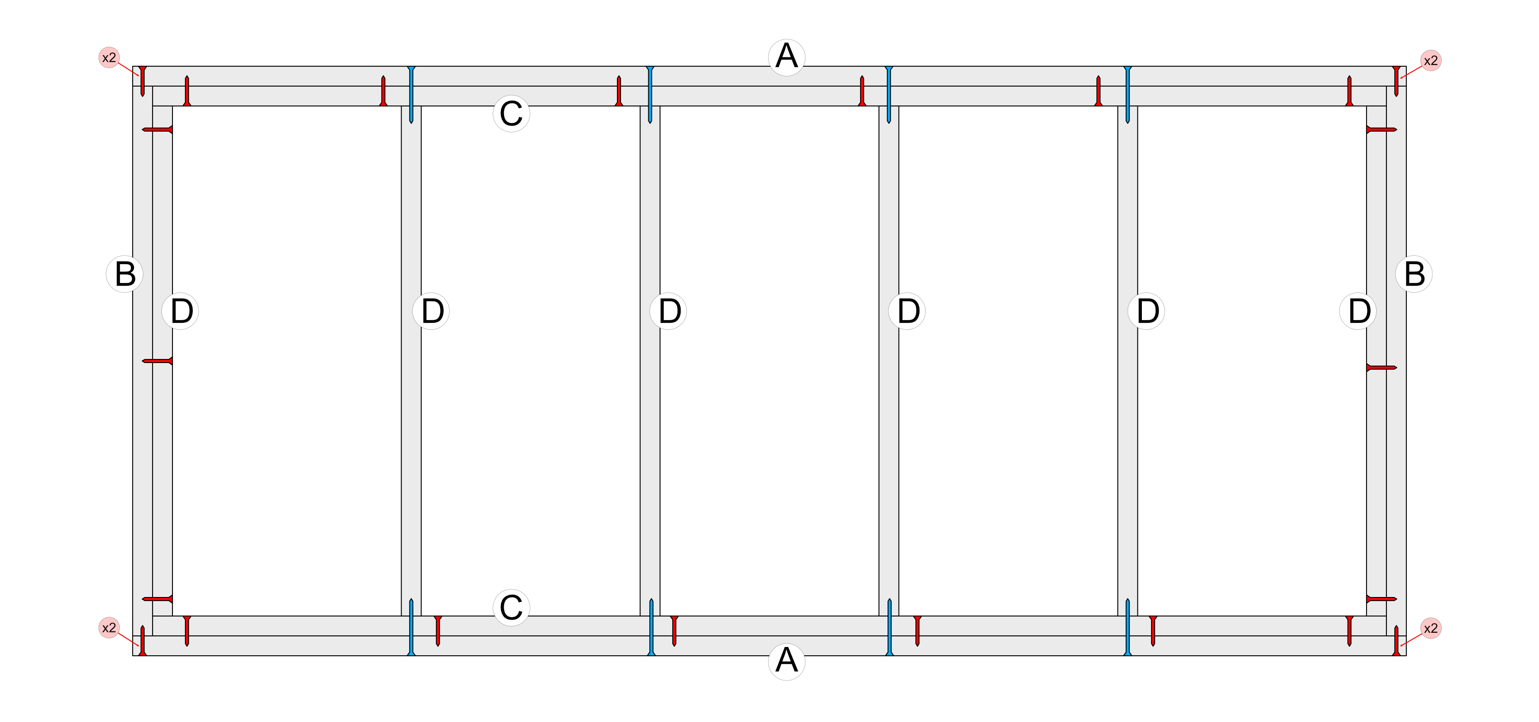
Figure 1. Top-down 2x4 rolling cart frame layout and screw fastening map.
Stage 1 Assembly Procedure:
1. Cut Lumber: Cut outer longitudinal rails (A) to 96.0 inches and end perimeter rails (B) to 44.5 inches.
2. Square Perimeter: Lay the four perimeter members flat on the shop floor. Measure opposite diagonals to confirm exact squareness.
3. Outer Corners: Fasten each outer corner joint with two GRK #9 x 2-1/2 in. wood screws (red markers labeled 'x2').
4. Joist Layout: Place six cross joists (D): two flush against the inner face of end rails (B), and four interior joists spaced to define the left decking wing, open tote bay, and right decking wing.
5. End Joists: Secure each outer end joist (D) to end rail (B) with three GRK #9 x 2-1/2 in. screws.
6. Structural Screws: Drive GRK #10 x 4 in. structural screws (blue markers) from outside rail (A) into the end grain of each cross joist (D) (two structural screws per joist).
7. Lamination: Laminate inner reinforcement rails (C) to the inside faces of rails (A) using GRK #9 x 2-1/2 in. screws as indicated by the interior red markers.

Stage 2: Install Decking, Ballast Posts, Casters, and Instrument Tote
1. Plywood Decking: Fasten two 1/2-in. plywood panels across the left wing (outer rail B to 2nd joist D) and right wing (5th joist D to outer rail B) with 1-1/4 in. screws. Confirm the center bay between the 3rd and 4th joists remains completely clear to receive the HDX 14-gallon tough tote.
2. Ballast Retention Post Flange Installation: Locate the geometric center of each 1/2" plywood wing panel. Position a 3/4-in. black iron floor flange (Index [16]) and mark four bolt holes. Drill 1/4" clearance holes through the plywood. Secure each flange from the underside using 1/4-20 x 1-1/2 in. carriage bolts, flat washers, and nylon lock nuts. Thread a 3/4-in. x 18-in. black iron pipe into each flange and tighten firmly with a pipe wrench.
3. Instrument Carrier Tote Installation: Insert the central HDX 14-gallon tough storage tote (Index [9]) into the open center frame bay between the 3rd and 4th cross joists (D). The tote rim rests on the 2x4 framing to serve as the student instrument carrier during show operations. (Note: A future design revision is planned to accommodate larger instrument geometries).
4. Painting: Paint all cart bases and wood surfaces with exterior-grade semi-gloss black paint before final caster assembly (Figure 7).
5. Swivel Casters: Invert the cart base. Mount four heavy-duty swivel plate casters (Index [4]) directly beneath the corner lumber intersections using 5/16 in. x 1-1/2 in. structural timber screws with flat washers (Figure 9).
6. Corner Bumpers: Fasten four 3D-printed Corner Braces (Index [10]) over each outer corner with #8 pan-head screws to protect the wood cart from transport impacts.
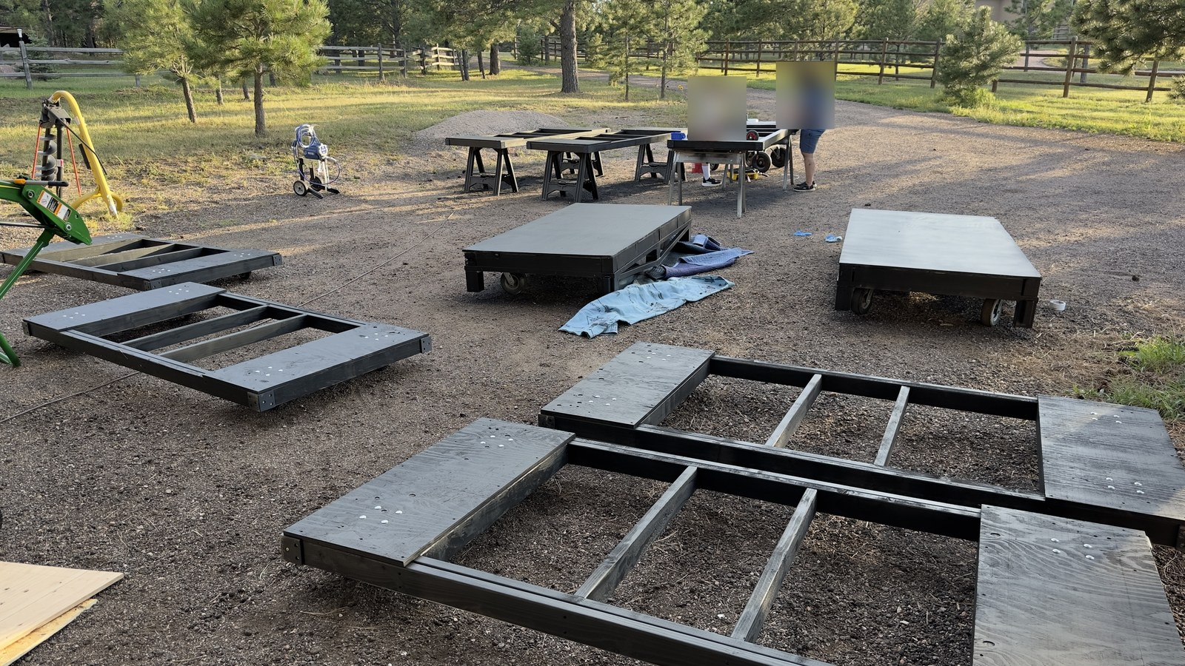
Figure 7. Cart base frames painted black with plywood decking wings installed.
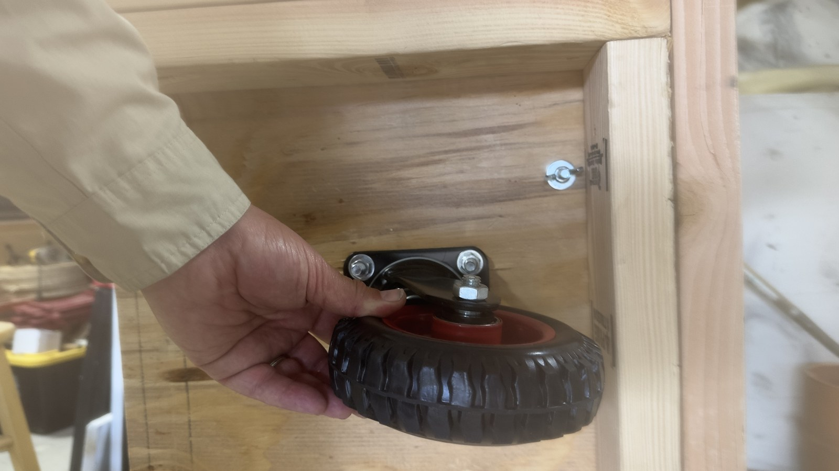
Figure 9. Swivel caster wheel assembly mounted beneath corner framing.
Operational Caster Fastening Standard: While early prototype builds utilized wing nuts as pictured in Figure 9, field operations standardized on standard hex nuts. Using standard hex nuts enables parent crew to rapidly remove and secure casters using an impact driver / cordless drill, significantly outperforming manual wing nut threading during teardowns.

Stage 3: Assemble the Upright Backdrop Frame
1. Upright Rectangle: Join two 10-ft 16-gauge steel fence line posts and two 8-ft top rails using four 1-5/8 in. 3-way clamp corner elbow brackets (Index [2]). Bottom out all tube ends inside the clamp sockets and tighten clamp bolts evenly.
2. Base Attachment: Stand the upright frame against the front rail (A) of the cart base. Anchor the bottom of each vertical post using 1-5/8 in. galvanized steel tension bands (Index [3]) through-bolted to the 2x4 lumber frame.

Stage 4: Fabricate and Install Diagonal Support Struts
Because 16-gauge galvanized steel is exceptionally hard, direct self-tapping screws will skate and dull. Follow this guided drilling protocol:
1. Strut Preparation: Cut two diagonal strut lengths from 1-5/8 in. steel top rail and slide 1-5/8 in. steel end caps over each end.
2. Guided Pre-Drilling: Clamp the 3D-printed Drill Alignment Jig (Index [11]) over the end cap pilot location. Using a 1/8-in. HSS / Cobalt drill bit rated for steel, drill clean pilot holes through the end cap and underlying pipe wall. Drive self-tapping screws into the pre-drilled holes to lock the end caps permanently.
3. Frame Mounting: Mount upper tension bands on the vertical posts using the 3D-printed Strut Bracket Marker template (Index [12]). Bolt the upper strut end caps to the tension bands. Anchor the lower strut end caps to the rear 2x4 cart framing with heavy-duty steel U-bolts (Index [7]) as shown in Figure 8. In production, each diagonal strut is fabricated as a two-piece modular assembly with a mid-span sleeved joint and drilled retaining pin hole (secured with a quick-release wire-lock pin). This enables rapid separation during trailer loading, allowing the lower arm to fold flat onto the cart while the upper arm remains on the frame with a protective tennis ball cap.
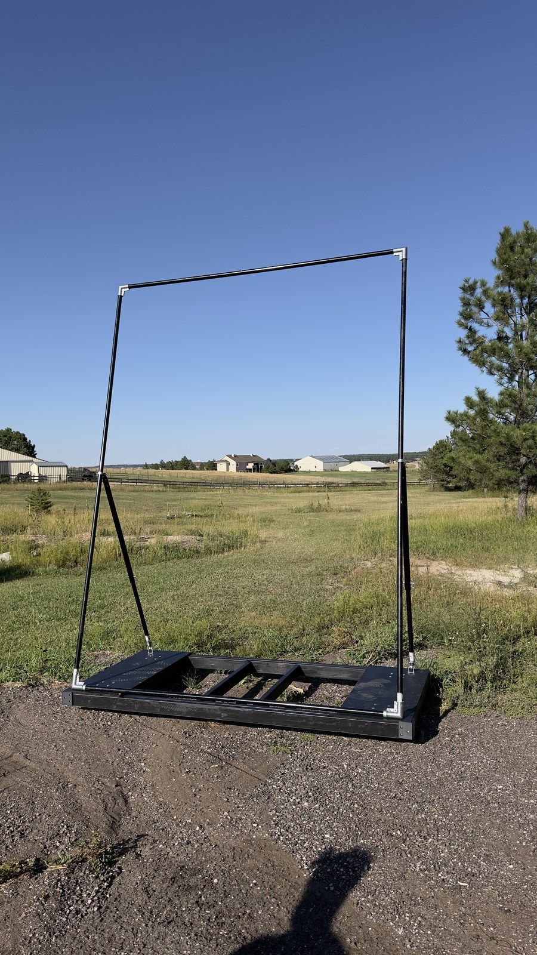
Figure 8. Completed rolling cart base and upright steel frame assembly.

Vinyl Installation
WORKING DRAFT — VINYL INSTALLATION PROCEDURE INCLUDED: Working draft procedure for vinyl installation using perimeter double-sided tape, hardware relief slits, and mechanical greenhouse snap clamps. Recommended vinyl dimensions (image size, bleed size, overall cut size) and tape strip quantities are provisional and subject to shop fit-up confirmation.
This section governs the preparation, alignment, dual-axis tensioning, relief slit cutting, and mechanical fastening of the custom printed vinyl coverings to completed backdrop upright frames. Installing vinyl on the 10 ft x 8 ft steel frame requires a clean staging area, careful bleed centering, razor relief cuts for protruding frame hardware, double-sided tape adhesion, and mechanical clamping with greenhouse snap clamps to prevent loosening under high stadium wind loads.

Recommended Vinyl Dimensions & Ordering Specifications
Custom printed backdrop banners must be ordered to exact dimensions to provide clean full-bleed framing around the outer perimeter of the steel pipe structure. The specifications below define the required production allowances:
Specification / Parameter | Engineering Requirement / Dimension
Nominal Upright Frame Size | 8 ft Width × 10 ft Height (96.0 in. × 120.0 in. outer pipe perimeter)
Visible Graphic / Live Face | [TBD] in. Width × [TBD] in. Height (Front visible image area)
Perimeter Bleed Wrap Allowance | [TBD] in. per border (top, bottom, left, and right outer pipe wrap)
Overall Flat Cut Size | [TBD] in. Width × [TBD] in. Height (Including bleed allowance)
Substrate Material | 13 oz or 18 oz heavy-duty outdoor matte scrim vinyl (UV and tear resistant)
Edge Perimeter Finish | Square raw-cut perimeter; DO NOT order hemmed borders or brass grommets, as raw edges wrap smoothly under snap clamps.

Required Materials & Fastening Hardware
• Moving blankets: Three to four clean, heavy-duty moving blankets or carpet runners spread across the shop floor to cushion the printed vinyl face against dust, grit, and concrete abrasion.
• Custom vinyl banner: One custom printed outdoor banner per backdrop (nominal 8 ft x 10 ft), rolled with print side facing inward. Unroll and inspect for print flaws and correct orientation prior to assembly.
• Utility knife / razor: Fresh, sharp razor knife for cutting precision relief slits around mounting brackets and tension bands.
• Double-sided tape: 1-in. wide heavy-duty outdoor mounting tape (Appendix B Table 1). Cut into fourteen (14) strips of approximately 4-in. length (~56 linear inches per frame). Application schedule: 4 strips on each vertical upright rail (8 total) and 3 strips on each cross rail (6 total). Tape quantities are provisional (TBD) and will be validated during build testing.
• Greenhouse snap clamps: Fourteen (14) 1-1/4 in. greenhouse clamp clips (Appendix B Index [8]). Snapped directly over the wrapped vinyl at every tape location (4 along each long vertical rail, 3 along each short cross rail). Note: While the frame uses 1-5/8 in. outer diameter fence post tubing, 1-1/4 in. greenhouse clamp clips provide the proper snug snap fit over the tubing, vinyl, and tape.
• Surface preparation (Optional): Isopropyl alcohol (IPA) and clean microfiber cloth. Degreasing the steel pipe is completely optional—the heavy-duty tape combined with mechanical greenhouse snap clamps provides more than enough holding power. A weaker initial adhesive bond to the bare steel pipe is actually preferable, as it significantly simplifies tape removal and cleanup later.
• Personnel requirement: Minimum two operators required; three to four recommended for synchronized dual-operator transverse tensioning and safe frame lifting.

Step-by-Step Vinyl Installation Procedure

Step 1: Staging and Surface Protection
Clear an unobstructed shop workspace measuring at least 12 ft x 14 ft. Thoroughly sweep and vacuum the area to remove metal chips, drill burrs, or grit that could puncture or scratch the printed vinyl face.
Lay clean moving blankets flat across the floor, overlapping edges to create a continuous, cushioned staging area larger than the overall banner flat cut size.
Carefully unroll the custom vinyl banner and lay it completely face down directly onto the moving blankets. Smooth the banner flat by hand and inspect the back side to confirm it is clean and free of trapped debris.

Step 2: Frame Placement and Bleed Alignment
With two operators lifting opposite ends, carry the assembled 10 ft x 8 ft steel upright frame onto the staging area and place it face down centered over the back side of the vinyl banner.
Measure the bleed wrap margin extending beyond the outer edge of the steel tubing along all four perimeter borders. Shift the frame incrementally until an equal reveal of bleed extends evenly on all four sides (top, bottom, left, and right outer rails).
Verify frame squareness by measuring crossed diagonals prior to applying tape or making relief cuts.

Step 3: Hardware Relief Slits
Before adhering tape or wrapping vinyl, use a fresh, sharp utility razor knife to make small, neat relief slits in the vinyl bleed wrap allowance to accommodate protruding frame hardware:
• Long edges (Vertical Uprights): Cut small slits directly aligned with the diagonal support strut attachment brackets (tension bands) on the left and right upright rails. These slits allow the strut brackets to protrude through the bleed wrap cleanly, preventing unsightly puckering, tenting, or bunching of the visible banner face.
• Bottom edge (Cart-Mounting Interface): Cut two small relief slits along the bottom rail bleed wrap corresponding to the base tension bands and mounting brackets that secure the upright frame to the wood cart base.

Step 3.1: Cutting Engineered Wind Relief Slits
To prevent violent wind flutter, reduce peak dynamic overturning impulses during stadium gusts, and protect greenhouse snap clamps from popping off under high wind loads, cut six (6) engineered inverted-U crescent wind relief flaps into the custom vinyl banner while it remains face-down on the cushioned moving blankets:
• Mandatory Tear-Arrest Relief Holes: CRITICAL FABRICATION RULE: NEVER cut wind relief slits purely with a utility razor knife leaving sharp 90° corners. Sharp razor corners create extreme stress concentration factors (Kt ≥ 3.0) that will rapidly propagate into catastrophic tears across the entire banner during the first stadium wind gust. Before making any razor cuts, use a 3/8-in. (10 mm) rotary leather punch or clean gasket punch against a wooden backup block to punch two smooth, circular holes at the upper hinge corners of each planned flap.
• Inverted "U" Crescent Flap Geometry: Each flap measures 8.0 in. wide with a 5.0 to 6.0 in. downward curved drop. The top 8.0-in. span between the two punched relief holes remains uncut to serve as a flexible vinyl hinge. Using a fresh utility razor knife, cut a smooth downward curve starting from the bottom of one hole, curving down 5 to 6 inches, and terminating cleanly into the bottom of the second hole.
• Aerodynamic Function & Audience Appearance: Under calm conditions, gravity pulls the flap flush against the banner face. From audience stands 50 to 150 feet away, the narrow slit line is virtually invisible, preserving complete graphic visual continuity. Under forward or rear wind pressure, the flap swings open freely, venting dynamic pressure spikes and damping vortex-shedding flutter oscillations.
• Upper-Venting Zone Layout (Row 1 & Row 2): Because overturning moment increases directly with height above the turf (M = F · y), venting pressure near the top of the prop is 2.5 times more effective at preventing tipping than venting near the bottom. Slits must be concentrated in the upper 40%–60% of the banner:
- Row 1 (Upper Tier): Located 8.0 ft (96 in.) above the bottom rail (2.0 ft below top rail). Center three flaps across the width at X = 2.0 ft (24 in.), X = 4.0 ft (48 in. centerline), and X = 6.0 ft (72 in.) from the left outer edge.
- Row 2 (Mid-Upper Tier): Located 5.5 ft (66 in.) above the bottom rail. Center three flaps across the width at X = 2.0 ft (24 in.), X = 4.0 ft (48 in. centerline), and X = 6.0 ft (72 in.) from the left outer edge.
• Artwork & Graphic Clearance Rules: Before punching or cutting, inspect the front face of the custom printed artwork. Adjust flap centerlines horizontally by ±6 to 12 inches to place slits in solid background fields, skies, or low-contrast negative space. NEVER cut across student performer faces, school crests, band logos, or sharp typographic lettering.

Step 4: Perimeter Double-Sided Tape Application
Cut fourteen (14) strips of 1-in. heavy-duty double-sided tape, each approximately 4 inches in length.
Apply the tape strips to the rear-facing surface of the perimeter steel fence post tubing according to the following layout:
• Long rails (Left and Right 10-ft Vertical Uprights): Apply 4 strips along each upright (8 total). Crucially, position two of the strips immediately above and below the support strut bracket to anchor the vinyl around the bracket interface, and place two additional strips spaced along the remaining length of each upright.
• Short end rails (Top and Bottom 8-ft Cross Rails): Apply 3 strips evenly spaced along each rail (one centered and two approximately 6 inches inward from the corner brackets; 6 strips total).
Burnish each tape strip firmly onto the steel pipe surface, then peel and discard the protective release liners from all 14 strips.

Step 5: Long-Side Tensioning and Initial Wrap
Start along one designated long side (left vertical upright). Beginning at the support strut bracket, ease the bracket through its pre-cut relief slit, fold the vinyl bleed margin tightly around the steel pipe, and press it firmly into the 4 double-sided tape strips on the rear of the tube.
Move to the opposing long side (right vertical upright). Pull the vinyl firmly across the frame face to eliminate all slack and wrinkles. Ease the second support strut bracket through its relief slit, fold the vinyl edge tightly around the steel pipe, and press it securely into the 4 opposing tape strips.
Sight down the front face: confirm that longitudinal tension is smooth, uniform, and drum-tight, with no diagonal wrinkling or wave patterns.

Step 6: Short-Side Dual-Operator Tensioning and Wrap
Station operators at opposite short ends (top cross rail and bottom cross rail).
Working simultaneously, both operators firmly grasp the vinyl bleed margin on opposite ends and pull outward in opposing directions away from the center. This synchronized outward pull establishes balanced transverse tension across the entire frame without racking the structure out of square.
While maintaining continuous outward tension, wrap the top vinyl edge over the top cross rail and press into the 3 tape strips. At the bottom rail, guide the cart-mounting base brackets through their two pre-cut relief slits, wrap the vinyl edge tightly around the bottom pipe, and press into the 3 bottom tape strips.
Neatly fold excess vinyl corner tabs around the 3-way corner elbow brackets, flattening the material to maintain clean, square corners without bulky bunches.

Step 7: Greenhouse Snap Clamp Installation
Install the 1-1/4 in. greenhouse snap clamps directly over the wrapped vinyl at every tape location, pressing each clamp firmly over the pipe until it snaps into full mechanical lock:
• Long rails (Vertical Uprights): Install 4 snap clamps on each upright (8 clamps total). Crucially, position two of the snap clamps immediately above and below each support strut bracket to firmly sandwich and hold the bracket in place, preventing bracket slip, flutter, or vinyl detachment under wind loads.
• Short end rails (Top and Bottom Cross Rails): Install 3 snap clamps on the top rail and 3 snap clamps on the bottom rail (6 clamps total).
The 1-1/4 in. greenhouse snap clamps compress the vinyl tightly against the tape and 1-5/8 in. steel fence post tubing, providing heavy-duty mechanical clamping that prevents edge detachment under stadium wind gusts or rough transport handling.
Confirm that no snap clamp interferes with the cart-mounting base brackets or corner elbow clamp bolts.

Step 8: Final Tension Inspection and Frame Re-Mounting
With three to four operators, carefully lift the completed backdrop frame upright off the moving blankets.
Inspect the front vinyl face in bright lighting: verify that the graphic is drum-tight, square, free of wrinkles or sagging, and cleanly fitted around all protruding bracket slits.
Verify that all 14 greenhouse snap clamps are fully seated and firmly gripping the tubing over each tape strip.
Re-secure the vertical upright posts into the cart base tension bands and re-connect the diagonal support struts. Confirm that the wrapped vinyl and snap clamps do not bind or impede strut attachment.
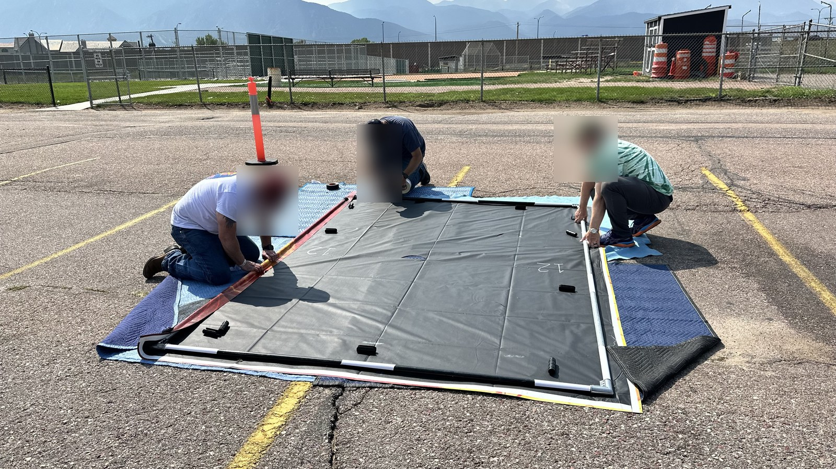
Figure 6. Installation team applying carpet tape and securing vinyl banner with pipe snap clamps.

Vinyl Removal & End-of-Season Teardown Protocol
CAUTION — Temperature Requirement for Vinyl Removal: Do not attempt removal of the vinyl or adhesive tape unless the ambient temperature is above 80°F (27°C). Attempting to peel the vinyl at lower temperatures will cause the material to tear and permanently damage the custom banner face. In cooler weather, warm the shop or gently heat the taped perimeter with a heat gun on low before peeling.
When taking down backdrops or preparing frames for graphic replacement:
• Recommended timing (Defer to Band Camp): It is usually much easier to leave the vinyl on the frames over the winter and wait until summer band camp of the following season before attempting removal. Cold late-fall temperatures following competition season make adhesive stiff and brittle, drastically increasing tear risk.
• Solar heating advantage: The warmer it is outside, the better. Staging the backdrops outdoors in direct sunlight for just a few minutes prior to peeling warms the steel tubing and softens the tape adhesive, allowing the vinyl and tape to release cleanly and effortlessly with minimal pull resistance.
• Remove greenhouse snap clamps: Carefully pry off all 14 greenhouse snap clamps from the perimeter tubing.
• Peel slowly at shallow angle: Starting at one corner, slowly peel the vinyl wrap back at a shallow angle. Warm adhesive releases cleanly from the bare steel pipe without pulling the scrim or ink layer.
• Tape stripping & cleanup: Peel remaining tape strips from the steel pipe. Because the pipe was not aggressively degreased during initial assembly, tape strips will pull off cleanly with minimal adhesive residue.

Final construction inspection
Verify before releasing prop for field use:
□ Cart Base Squareness: Opposite diagonal measurements within 1/8 in.
□ Ballast Posts: 3/4" flanges through-bolted securely to plywood; 18" pipes tight without wobble.
□ Instrument Tote Bay: HDX 14-gallon tote drops smoothly into center frame bay.
□ Fasteners: All GRK red/blue screws fully countersunk without wood splitting.
□ Casters: Smooth 360° swivel action; hex nuts tightened securely; wheels roll freely without wobble (non-locking agility design).
□ Upright Frame: All 3-way corner clamp bolts torqued securely.
□ Support Struts: End cap screws and base U-bolts tight with zero play.
□ Vinyl: Banner taut, wrinkle-free, and locked with snap clamps along all four sides.

Appendix B Index

Purchase sources
[1] 1-5/8 in. Dia. x 10 ft Steel Fence Line Posts - Home Depot
https://www.homedepot.com/p/Everbilt-1-5-8-in-Dia-x-8-ft-16-Gauge-Galvanized-Steel-Chain-Link-Fence-Line-Post-328923DPTSEB/312373067
[2] 1-5/8 in. 3-Way Clamp Corner Elbow Brackets - Amazon
https://www.amazon.com/dp/B0CD7QT6L6
[3] 1-5/8 in. Galvanized Steel Tension Bands - Home Depot
https://www.homedepot.com/p/Everbilt-1-5-8-in-Galvanized-Steel-Chain-Link-Fence-Tension-Band-328521EB/312373099
[4] Heavy-Duty Swivel Plate Casters - Amazon
https://www.amazon.com/dp/B0CPXFJCJL
[5] GRK #9 x 2-1/2 in. Star Drive R4 Multi-Purpose Screws - Home Depot
https://www.homedepot.com/p/GRK-Fasteners-9-x-2-1-2-in-Star-Drive-Torx-Bugle-Head-R4-Multi-Purpose-Wood-Screw-300-Pack-100101/203533402
[6] GRK #10 x 4 in. R4 Self-Countersinking Flat-Head Screws - Home Depot
https://www.homedepot.com/p/GRK-Fasteners-10-x-4-in-R4-Self-Countersinking-Flat-Head-Multi-Purpose-Screw-50-per-Pack-103141/203525231
[7] Heavy-Duty Steel U-Bolts - Amazon
https://www.amazon.com/dp/B09L41JFMS
[8] Greenhouse snap clamps (1-1/4 in.) - Amazon
https://www.amazon.com/dp/B0CDZP8YVF
[9] HDX 14-Gallon Tough Storage Tote (Black/Yellow) - Home Depot
https://www.homedepot.com/p/HDX-14-Gal-Tough-Storage-Tote-in-Black-with-Yellow-Lid-999-14G-HDX/328027053
[13] Abccanopy 15-lb Heavy-Duty Sandbags with Handle (4-Pack) - Amazon
https://www.amazon.com/dp/B0DFVVZDVK
[14] Heavy-Duty Plastic Sandbag Liner Bags (Double-Bag Compliance) - Amazon
https://www.amazon.com/dp/B0BG3F5XVS
[15] Sakrete 70-lb Traction Tube Sand - Lowe's
https://www.lowes.com/pd/Sakrete-0-07-cu-ft-70-lb-Traction-Sand/5015728687
[16] 3/4 in. Black Iron Floor Flange and 18 in. Threaded Pipe - Home Depot
https://www.homedepot.com/p/The-Plumber-s-Choice-3-4-in-Black-Malleable-Iron-Floor-Flange-5-Pack-FBNF034-5/308967916

Digital part files & governing rules
[10] 3D Printed Corner Bumper Brace - FreeCAD Model
https://github.com/ericrowe/music/blob/main/PCHSMB/_Backdrop/Hardware/Corner%20Brace.FCStd
[11] 3D Printed 1-5/8" Pipe Drill Alignment Jig - Slicer 3MF
https://github.com/ericrowe/music/blob/main/PCHSMB/_Backdrop/Hardware/Drill%20Alignment%20Jig.3mf
[12] 3D Printed Support Strut Bracket Marker - FreeCAD Model
https://github.com/ericrowe/music/blob/main/PCHSMB/_Backdrop/Hardware/Steel%20Support%20Strut%20Bracket%20Marker.FCStd
[17] 2026 Colorado Bandmasters Association (CBA) Marching Band Rulebook (PDF)
https://ebf5c7e8-3869-4325-bd98-ce10f57d7545.filesusr.com/ugd/83f67e_cb5fe6efdbdb4ce98f619580f694bc94.pdf

APPENDIX C: FIELD OPERATIONS PLACARD
One-Page Laminated Field Reference for Trained Student Handlers & Parent Pit Crew
ATTACH 4" × 6" FIELD PLACEMENT / DRILL CARD HERE
(Exact 6.0" wide × 4.0" high mounting area for season-printed laminated drill card from Appendix C.1)
Prop #: _________ | Show Segment: _________________ | Side: [ ] Side 1 [ ] Side 2
Field Drill Coordinate: _______________________________________________________________
Assigned Handlers (Min. 2; 3–4 on ramps/wind): 1) _______________ 2) _______________ 3) _______________

1. Wind Velocity Limits & Standardized Ballasting Schedule
Tier / State | Wind Velocity | Ballast Deployment (15-lb Bags) | Total Wt | Operational Limits & Action
Tier 0: Calm | 0–8 mph (gusts ≤10) | 0 bags (unballasted) | 153 lbs | Safe to 8 mph (10 gust max). Must upgrade to Tier 1 if wind >8 mph.
Tier 1: Normal | 8–12 mph | 4x bags (2 per wing post; 60 lb) | 213 lbs | Standard staging. 16.9 mph max gust. Zero turf compaction.
Tier 2: Advisory | 12–18 mph | 6x bags (3 per wing post; 90 lb) | 243 lbs | Attentive staging. 18.4 mph max gust. Deploy ground wheel chocks.
Tier 3: High-Wind | 18–22 mph | 6 on wings + 3 across rear rail (135 lb) | 288 lbs | 22.5 mph max gust. Rear rail doubles leverage. Max safe turf load.
Tier 4: ABORT | >20 sust. / >25 gust | — | — | STRICT SAFETY NO-GO. Withdraw props or immediately lay flat.

2. Critical On-Field Safety & Turf Protection Rules
• Non-Locking Casters & Ground Chocking: Carts use non-locking swivel casters for rapid agility. When positioned at drill coordinates in breezy conditions, place extra double-bagged 15-lb sandbags on the turf firmly against wheels as wheel chocks to prevent roll drift.
• Hand Placement & Crew Pairing: Always push from lower 2x4 cart framing; NEVER push or climb on upright pipes or struts. No fewer than 2 handlers per cart under normal conditions; assign 3 to 4 handlers on steep grades (such as the Falcon Stadium tunnel ramp) or in high winds.
• Mandatory Double-Bagging (Rule 8.05): All 15-lb sandbags must have intact heavy-duty plastic inner liners. Never bring single-layer bags onto athletic turf. Carts must not exceed 300 lbs total (~75 lb/wheel) to prevent rubber infill rutting.
• CBA Field Entrance & Exit Routing (Rule 8.05 & Timing Rules): Props and handlers must enter and exit strictly via designated back sideline or rear end zone gates (above goal posts). NEVER cross or stage props in the front sideline end zone area below the goal posts (marked with a red 'X' on drill cards)—strictly prohibited under CBA boundary rules to protect front ensemble staging, judge sightlines, and timing intervals.
• High-Wind Emergency Abort: If severe gusts strike on-field, handlers brace on the upwind 2x4 base. Authorized parent crew (with Rule 9.07 wristbands) will assist to lay props flat on turf if ordered by directors.

3. Rapid Field Assembly, Egress & Two-Shot Staging Checklist
• Unloading & Venue Staging: 1) Unstrap carts & lower from short ends; 2) Retrieve 10'×8' frames from trailer cross beams; 3) Pull off protective tennis balls (stow in tote); 4) Rapidly bolt frame to cart using cordless power driver; 5) Mate 2-piece struts and lock quick-release retaining pins; 6) Stage required ballast & wheel chocks.
• Egress, "Two-Shot" Staging & Teardown: 1) Continuous egress through designated rear end zone exit up hill to trailer lot (NEVER de-ballast at stadium chute; avoid front end zone restricted area); 2) Between Prelims & Finals ("Two-Shot"), leave ballast on carts in trailer lot; if gusts pick up, pull strut pins to lay vinyl frames flat on carts; 3) Final teardown: remove sandbags over axles; 4) Pull strut pins (stow in tote); 5) Install tennis balls over upper strut ends; 6) Unbolt frame using power driver; 7) Frames onto cross beams; 8) Carts vertical on short ends strapped against front nose wall.

APPENDIX C.1: 4" × 6" FIELD PLACEMENT CARD TEMPLATE
Printable & Fillable Coordinate Card for Appendix C On-Prop Placard (Cut along dashed line)
PCHS MARCHING BAND — BACKDROP FIELD DRILL CARD
Prop #: ________ | Segment/Song: ___________________ | Side: [ ] Side 1 (Left) [ ] Side 2 (Right)
Drill Coordinate: _________________________________________________________________________________
Handlers (Min. 2; 3–4 for ramps/wind): 1) ____________________ 2) ____________________ 3) ____________________
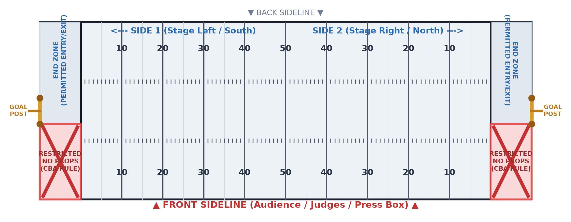
✂ Cut along dashed blue border (exact 6.0" × 4.0" card). Mark prop routes with dry/wet-erase marker, laminate, and attach to placard.

Field Coordinator & Drill Writer Instructions
1. Season Preparation & Card Fabrication: Coordinate cards are prepared and printed ONCE PER SEASON with all static information at the top filled in (Prop #, Show Segment, Field Coordinate, Show Side, and assigned student handlers). Cut out along the 6" × 4" dashed border, laminate in standard 4x6 heat-seal pouches, and affix into the Appendix C placard placeholder box using outdoor hook-and-loop (Velcro) coins or corner photo tabs.
2. Competition Day Route Marking: On the day of each competition, the ONLY update made to the card is drawing the specific field entrance route, coordinate placement, prop facing orientation, and exit trajectory arrows directly onto the laminated card using a wet-erase or dry-erase marker. Students are pre-trained on facing symbols.
3. CBA Field Entrance & Exit Routing Rules: Follow all CBA boundary and timing regulations. Enter and exit strictly through designated back sideline or rear end zone gates (above goal posts). NEVER cross, stage, or transit props in the front sideline end zone area below the goal posts (marked with a red 'X'). Maintain continuous egress uphill to the trailer staging lot without de-ballasting at the stadium chute.
4. Two-Shot Staging Protocol: During two-shot competitions (Prelims & Finals), leave sandbag ballast intact on the carts in the trailer lot between shows. If winds increase during the afternoon break, simply remove the quick-release pin from each diagonal strut to lay the vinyl frames flat on the carts, eliminating sail area while maintaining readiness.

