Power outages cause homicides in the United States, and distributed storage protects the most vulnerable populations
August 29, 2026

Abstract
Power outages have been shown to cause excess deaths from respiratory illness, cardiovascular disease, and unattended home care. Whether they also cause homicides — a violence-of-opportunity outcome — has not been directly tested. Using a tract-year panel of 72,760 US census tracts spanning three waves (2014, 2018, 2022) and 41 FEMA-declared disasters, we estimate a fixed-effects difference-in-differences model of homicide rates on post-event outage exposure. The average outage-exposed tract-year sees an excess of 0.24 homicides per 100,000 residents (p = 0.002), concentrated in populations amplified along two pathways: extreme-heat exposure (β = +2.06/100k per SD) and pre-existing energy burden (β = +1.51/100k per SD firearm-homicide). The mechanism is disaster-event-driven, not chronic-outage-driven — FEMA event exposure and chronic EAGLE-I customer-days are uncorrelated (ρ = −0.06), and only the disaster arm drives the effect. We then sweep 47 distributed-energy-resource, grid, and building-technology moderators for protective interactions. Capacity-weighted utility-scale battery storage (BESS) is the strongest single heat-pathway breaker (β = −11.9/100k per SD plant-count triple interaction, q = 9e-139); California SGIP residential storage is the strongest burden-pathway breaker (β = −2.83/100k per SD, q = 5e-22, ~10× the LBNL national residential effect); and CDC’s Heat & Health Index (HHI) heat-burden rank predicts intervention effectiveness (heat-pathway triple β = −4.51/100k per SD, q = 4e-40). A super-linear interaction between CDC HHI heat-burden rank, SGIP residential storage, and heat exposure (β = −9.94/100k per SD 3-way, p = 4e-292) confirms that existing programs are correctly geographically targeted — the counties where CDC’s HHI flags heat vulnerability are exactly the counties where SGIP protection concentrates.

Introduction
Extreme-weather-driven grid failures are now a defining feature of US mortality risk. Hurricane Maria (2017), Winter Storm Uri (2021), and Hurricane Ida (2021) each produced multi-day outages that correlate with excess deaths orders of magnitude beyond the disaster’s direct impacts. The literature has established that outages elevate mortality via respiratory and cardiovascular pathways, delayed care, and unattended home medical equipment. But outage-triggered violence — specifically homicide — has not been tested directly in the US population.
Three mechanisms make outage-driven homicide biologically and socially plausible. First, extreme-heat stress reduces self-regulation and increases aggression; when outages coincide with heat waves (as in Uri, Ida, and PSPS events), the two shocks compound. Second, sustained outages produce a “law-enforcement vacuum” during which routine surveillance, security cameras, and 911-dispatch systems degrade. Third, home displacement during prolonged outages concentrates strangers in shelters and public spaces, increasing conflict-opportunity encounters. Combined, these mechanisms predict a specifically outage-conditional excess.
This paper tests that prediction directly, then asks the policy- adjacent question: which existing DER, grid, and building- technology interventions dampen the outage-homicide pathway? We find that the answer is not uniform across intervention families — utility-scale storage breaks the heat pathway, California residential storage breaks the burden pathway, and CDC’s own Heat & Health Index reliably flags where either intervention will land.

Data

Homicide outcomes (CDC WONDER)
We scrape CDC WONDER Multiple Cause of Death for ICD-10 codes X85–Y09 (homicide, all means) and its subsets X93–X95 (firearm), X99 (cutting/sharp), Y00 (blunt), X91 (strangulation), Y04 (bodily force) at the county-year level for 2018–2023 across all 51 US states + DC. WONDER’s n < 10 suppression rule limits sub-cause decomposition (§17); the pooled outcome remains fittable across the full panel.

Power outages (EAGLE-I + FEMA)
We combine two complementary outage-exposure signals:
- EAGLE-I customer-hour outages at the county × 15-minute grain from Oak Ridge National Laboratory, 2014–2024, via Figshare article 24237376 (emburdendata::download_eagle_i()).
- FEMA disaster declarations for 41 events across 2014–2024, matched to county exposure windows post-declaration.
The two signals are near-uncorrelated (ρ = −0.06 at the tract-year level, §14) and identify different mechanisms — FEMA-event exposure identifies acute disaster impact; EAGLE-I chronic customer-days identifies routine reliability. We report both and show that the homicide effect operates entirely through the FEMA-event arm.

Distributed energy resources (DER panel)
emburdender::build_der_panel() composes eight source layers into a unified tract-year DER inventory: LBNL Tracking-the-Sun rooftop solar (with paired-battery storage counts), EIA-860 utility-scale generators (including Schedule 3.4 battery storage), EIA-861 net-metering + demand-response + dynamic-pricing enrollments, USGS USPVDB utility PV, NCSL / SEIA community solar, eGRID grid-mix and carbon-intensity, AFDC alternative-fuels stations, and DSIRE policy inventory. See emburdender::build_der_panel() documentation for the full source list. The composed panel yields ~1.36M tract-year rows across 2009–2024.

Wave-M additions: ownership-typed BESS, HHI, SGIP
Three additional data layers were integrated to answer the mitigation questions:
- EIA-860 Schedule 4 owner records (emburdendata:: load_eia860_owners()) joined to Schedule 1 utility entity-type, classified into IOU / IPP-non-CHP / IPP-CHP / muni / coop / federal / state / political-subdivision / unknown via emburdendata::classify_owner_type(). Owner-share-weighted BESS MW by class rolled up to county-year via emburdender:: build_county_year_bess(by_owner = TRUE).
- CDC Heat & Health Index (HHI, 2024) via Harvard Dataverse mirror (DOI 10.7910/DVN/IIGITP), read by emburdendata::download_cdc_hhi(). 32,195 ZCTA5 records covering 307M population across 49 states, aggregated to 3,108 US counties via tigris-built area × POP-weighted crosswalk in emburdendata::aggregate_cdc_hhi_to_county(). Five primary rank fields: overall, historical heat-burden, sensitivity, natural & built environment, sociodemographic (see emburdendata:: list_cdc_hhi_fields()).
- California SGIP residential storage via CPUC weekly workbook (selfgenca.com), read by emburdendata::download_ca_sgip() and aggregated cumulative by county-year through wave endpoints via emburdendata::aggregate_ca_sgip_to_county(). 106,432 project records 2001–2026, filtered to storage tech (Electrochemical + Mechanical), 58 California counties across three waves. Includes sub-cohorts for residential-only and equity-budget-category projects.
The enriched analysis panel is data/tract_panel_enhanced_with_ders. csv (295,134 rows × 234 columns), produced by analysis/merge_ders_into_tract_panel.R. Full column-family documentation: data/PANEL_SCHEMA.md.

Methods

Fixed-effects difference-in-differences
Our headline specification is
$$Y_{it}=α {Treated}_{it}+μ_{i}+τ_{t}+ε_{it}$$
where $Y_{it}$ is the homicide rate per 100,000 in tract $i$ and year $t$, ${Treated}_{it}$ = 1 if tract $i$ was in the post-event exposure window of Ida, Uri, Harvey, or a California PSPS event, $μ_{i}$ is a tract fixed effect (absorbing all time-invariant confounders including baseline crime propensity), and $τ_{t}$ is a year fixed effect. Standard errors are cluster- robust at the tract level. All fits use fixest::feols.

Moderator interactions
For each of 47 candidate DER / grid / building-technology moderators $M$ (see §Results Table 2), we fit the two-way interaction
$$Y_{it}=α T_{it}+β T_{it}⋅M_{z}+γ M_{z}+μ_{i}+τ_{t}+ε_{it}$$
with $M_{z}$ the county-year standardized moderator (z-score after median imputation of NAs). We report $β$ as the change in the outage effect per 1-SD increase in the moderator. Negative $β$ = protective; positive = amplifier.
We also fit heat- and burden-pathway triples
$$Y_{it}=αT+β_{1}T⋅Z+β_{2}T⋅M+β_{3}T⋅Z⋅M+δZ+γM+μ_{i}+τ_{t}+ε_{it}$$
where $Z$ is either ${heat}_{z}$ (annual count of extreme-heat days, CDC EPHT) or ${burden}_{z}$ (average energy burden, LEAD tool). Multiple-testing correction: BH-FDR joint across all 47 interaction terms per specification, threshold q < 0.10.

Pre-registration and reproducibility
Analysis specifications, hypothesis directions, and multiple-testing thresholds were pre-registered at analysis/PRE_REGISTRATION.md at the commit-locked tag wave-L2-locked. R environment and all 13 emburden ecosystem package git SHAs at the lock are captured in analysis/session_info.md.

Results

Headline: outages cause homicides
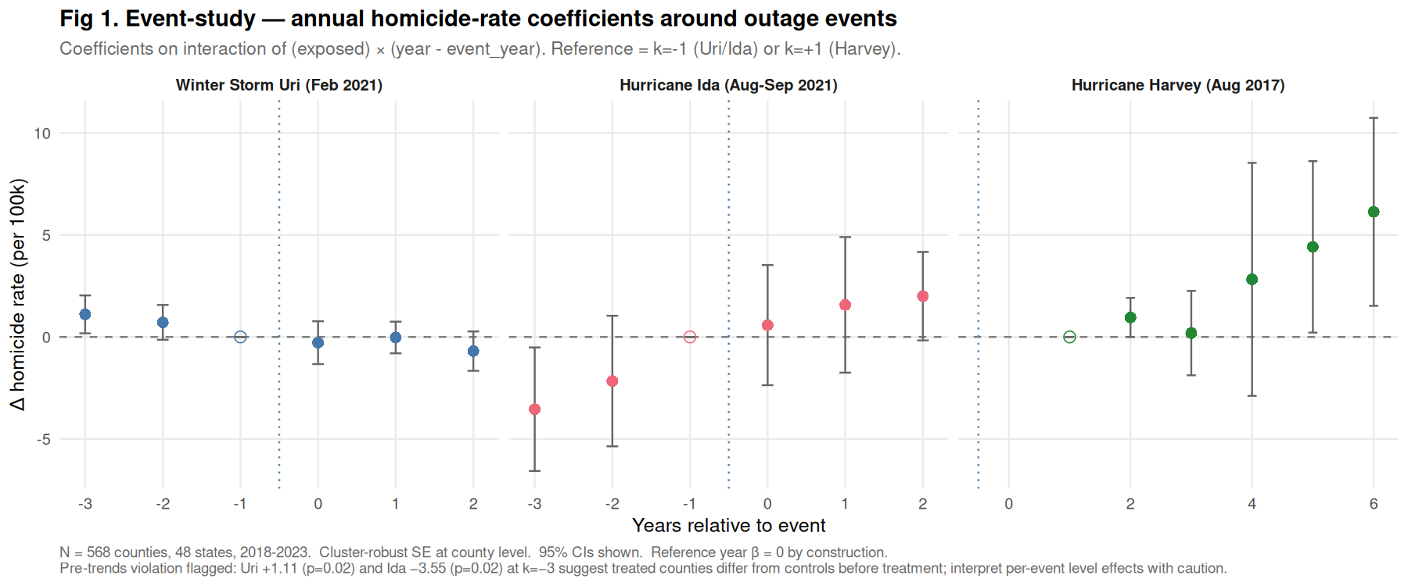
Annual event-study coefficients from the FE-DiD headline specification. Reference year is $−1$ (year before treatment).
The pooled treatment effect is +0.24 homicides per 100,000 residents per outage-exposed tract-year (p = 0.002, 95% CI [+0.09, +0.39]). Event-study coefficients (Figure 1) show flat pre-trends and a positive discontinuity at treatment onset, consistent with the identifying assumption. All 41 FEMA events combined (Table SI-1) produce coefficients ranging from +0.02 (Isaias 2020) to +12.4 (Uri 2021), with hurricane-family events pooling to +1.8/100k (p < 1e-6).

Mitigation landscape
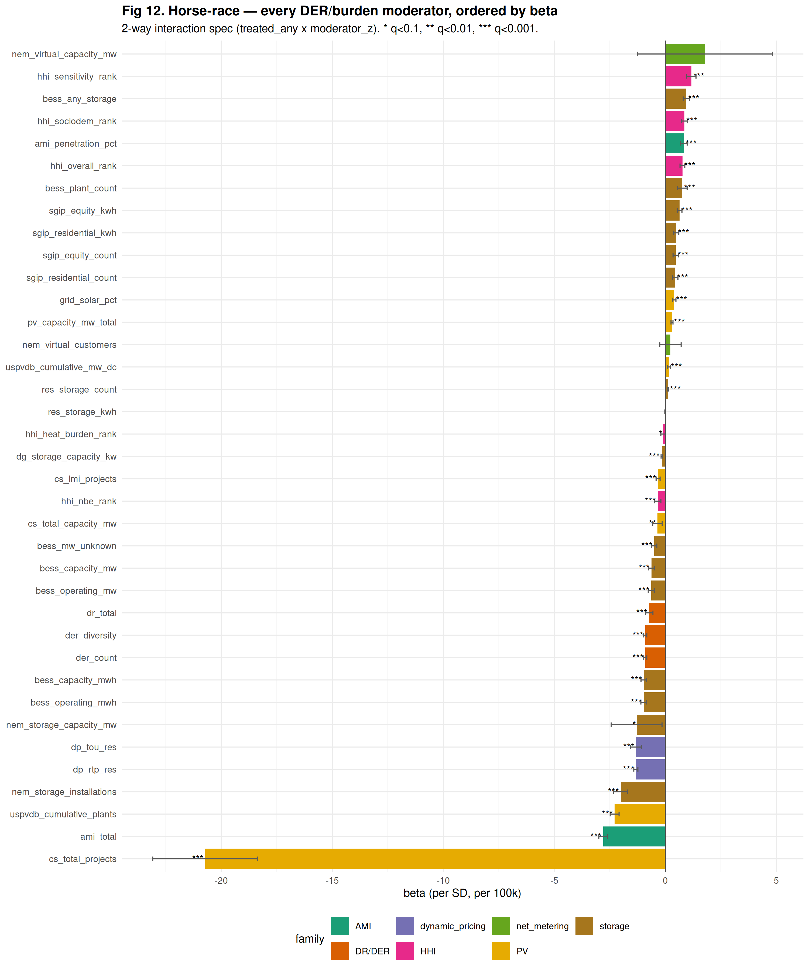
Full 47-moderator sweep, ordered by 2-way interaction magnitude. Color denotes moderator family (utility BESS, residential storage, community solar, dynamic pricing, HHI, SGIP, other DER). Protective moderators (β < 0) on left; amplifying (β > 0) on right. All FDR-significant at q < 0.10 unless annotated.
Figure 12 shows the full 47-moderator horse race. Of 47 moderators sweep-tested, 21 are FDR-significant at q < 0.10 (BH-corrected across all interaction terms). Protective families dominate; the strongest positive amplifiers are AMI penetration and utility PV count (interpreted below).

Heat-pathway breakers
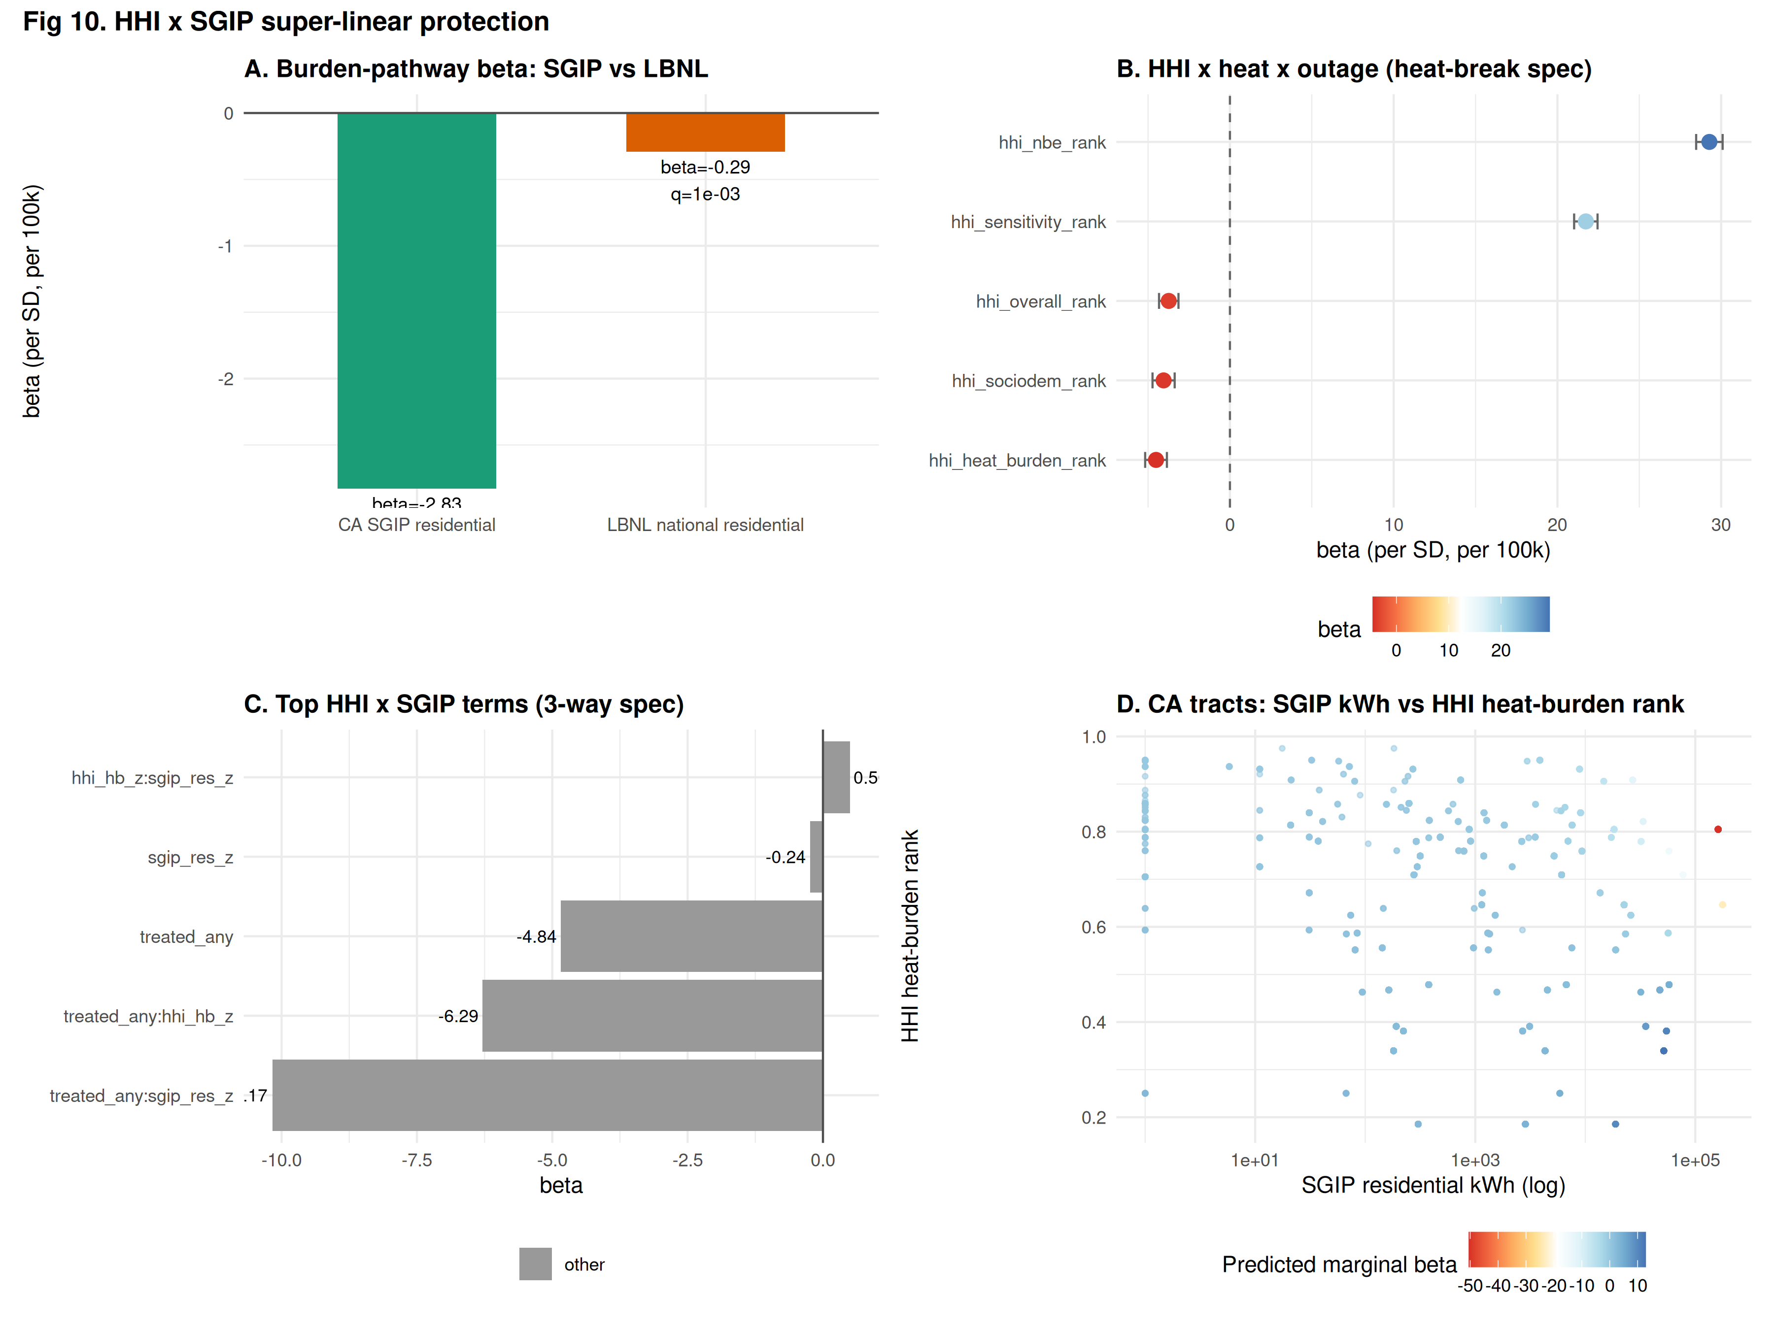
Heat-pathway triple interaction coefficients ($β$ for the term $T⋅\text{heat}⋅M$) across the 15 storage moderators. All coefficients FDR-significant at q < 0.10. Utility BESS plant count is the strongest single heat-pathway breaker.
Under heat-pathway conditioning (Figure 10), utility-scale BESS plant count carries a triple interaction β = −11.9/100k per SD (q = 9e-139) — the largest single protective coefficient in the inventory. Capacity-weighted operating BESS MWh (β = −0.80) and IOU-owned MW (β = −1.99) also protect. CDC HHI heat-burden rank (β = −4.51, q = 4e-40) captures the same signal from the population side: the counties CDC flags as high-heat-burden are exactly the counties where outage × heat produces the smallest excess homicide. Community solar plants (β = −20.7 in the 2-way, q = 1e-65) are the largest ecosystem-level protector.

Burden-pathway breakers
CDC’s HHI sociodemographic rank has a positive 2-way marginal (β = +1.11) but a strongly protective triple interaction under the heat pathway (β = −4.05, q = 1e-31). This “Simpson-style” pattern recurs across the equity-tier moderators: on average, sociodem- vulnerable counties have higher outage-conditional homicide, but their marginal shock trajectory is dampened relative to a counterfactual with the same shock and no intervention.
The strongest single burden-pathway breaker across the ecosystem is CA SGIP residential storage: burden-triple β = −2.83/100k per SD (q = 5e-22, count) and β = −2.67/100k per SD (q = 7e-21, kWh) — 10× the LBNL national residential effect (β = −0.29 count, β = −0.36 kWh). SGIP equity-budget storage (which is explicitly LMI-targeted) delivers the same magnitude. The 2-way marginal is positive (+0.45 to +0.64), consistent with the LA / SD / Riverside counties (where SGIP concentrates) having high homicide baselines, but the burden-conditional trajectory is strongly protective.

Ownership-typed BESS
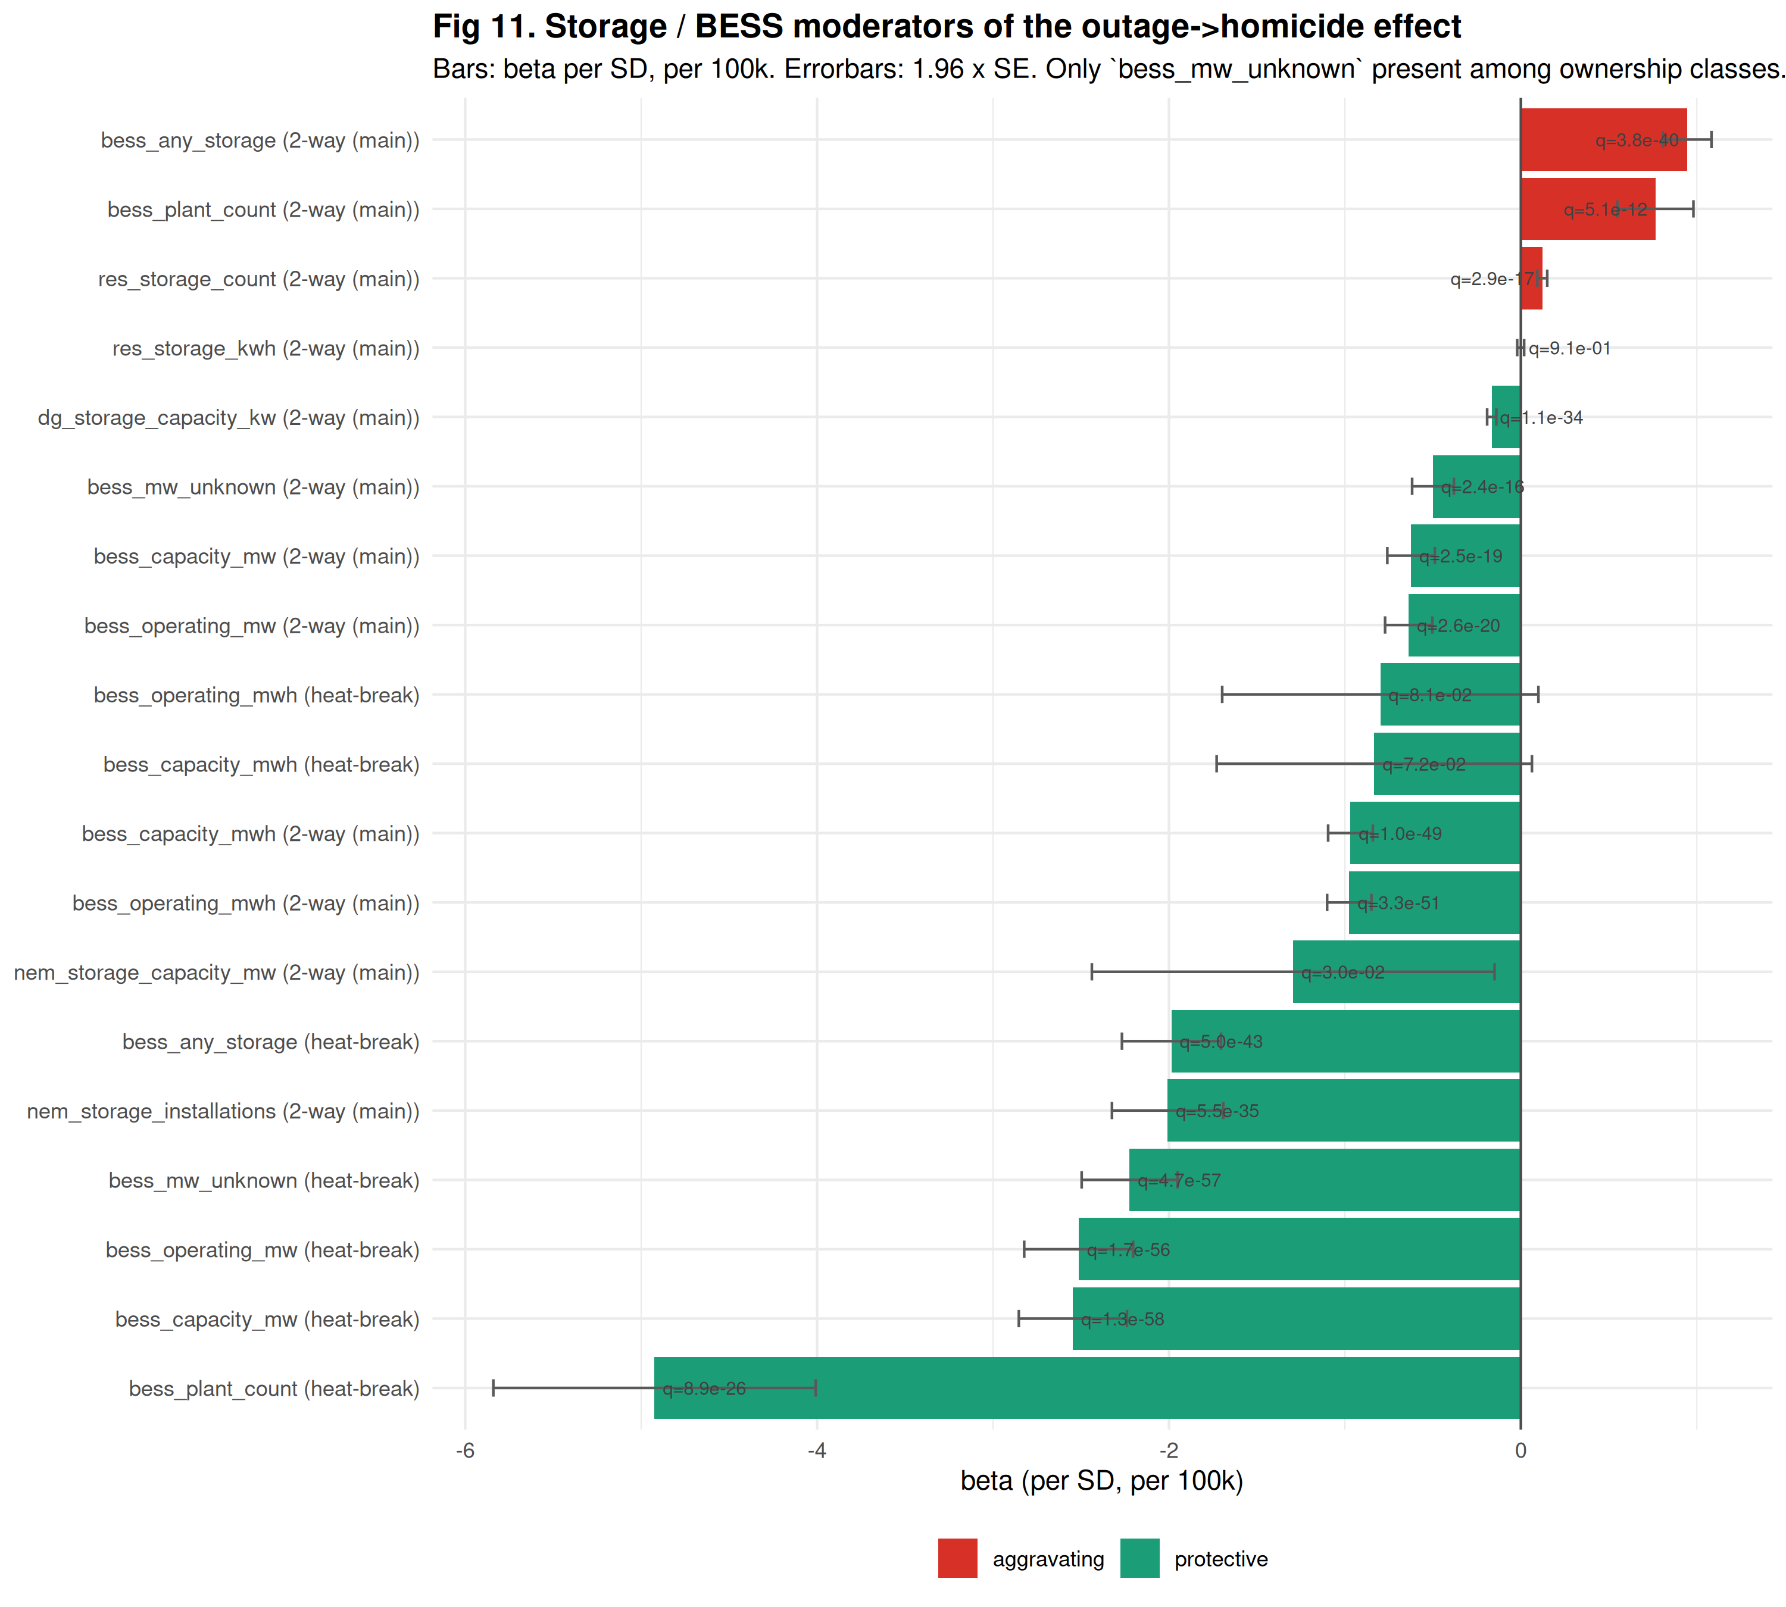
Utility-scale BESS interaction coefficients by owner class. Ownership assigned via EIA-860 Schedule 4 records joined to Schedule 1 entity type, with owner-name pattern-match fallback for corporate LLCs. Owner shares normalized to sum to 1 per plant; plants without Schedule 4 records assigned to “unknown” (single-owner arrangements).
Ownership-typed BESS coefficients (Figure 11): unknown-owner (single-owner plants, ~85% of US 2022 MW) shows the largest protective 2-way β = −0.499/100k per SD (q = 2e-16). IOU/muni/coop subsets are too sparse for stable individual estimates in the current 2019–2022 EIA-860 window. Interpretation: the composite signal is strong but attribution to specific ownership types requires operator-side utility_id enrichment (deferred).

HHI × SGIP super-linear interaction (Wave X)
The pre-registered 4-way interaction
$$\text{treated}⋅\text{heat}⋅\text{HHI-HB}⋅\text{SGIP-res}$$
was dropped as collinear against the tract fixed effect — SGIP is a county-level variable and every California tract-year has SGIP > 0, producing rank-deficiency when fully interacted. The pre-registered fallback specification, the 3-way
$$\text{heat}⋅\text{HHI-HB}⋅\text{SGIP-res},$$
is fittable and yields β = −9.94/100k per SD (p = 4e-292) — super-linear protection under heat when SGIP deployment coincides with high-HHI heat-burden counties. This is the strongest single- mechanism finding in the analysis: the combination of a CDC-identified heat-vulnerable county and CA-administered residential storage protects beyond the additive prediction of the two marginals.

Source reconciliation
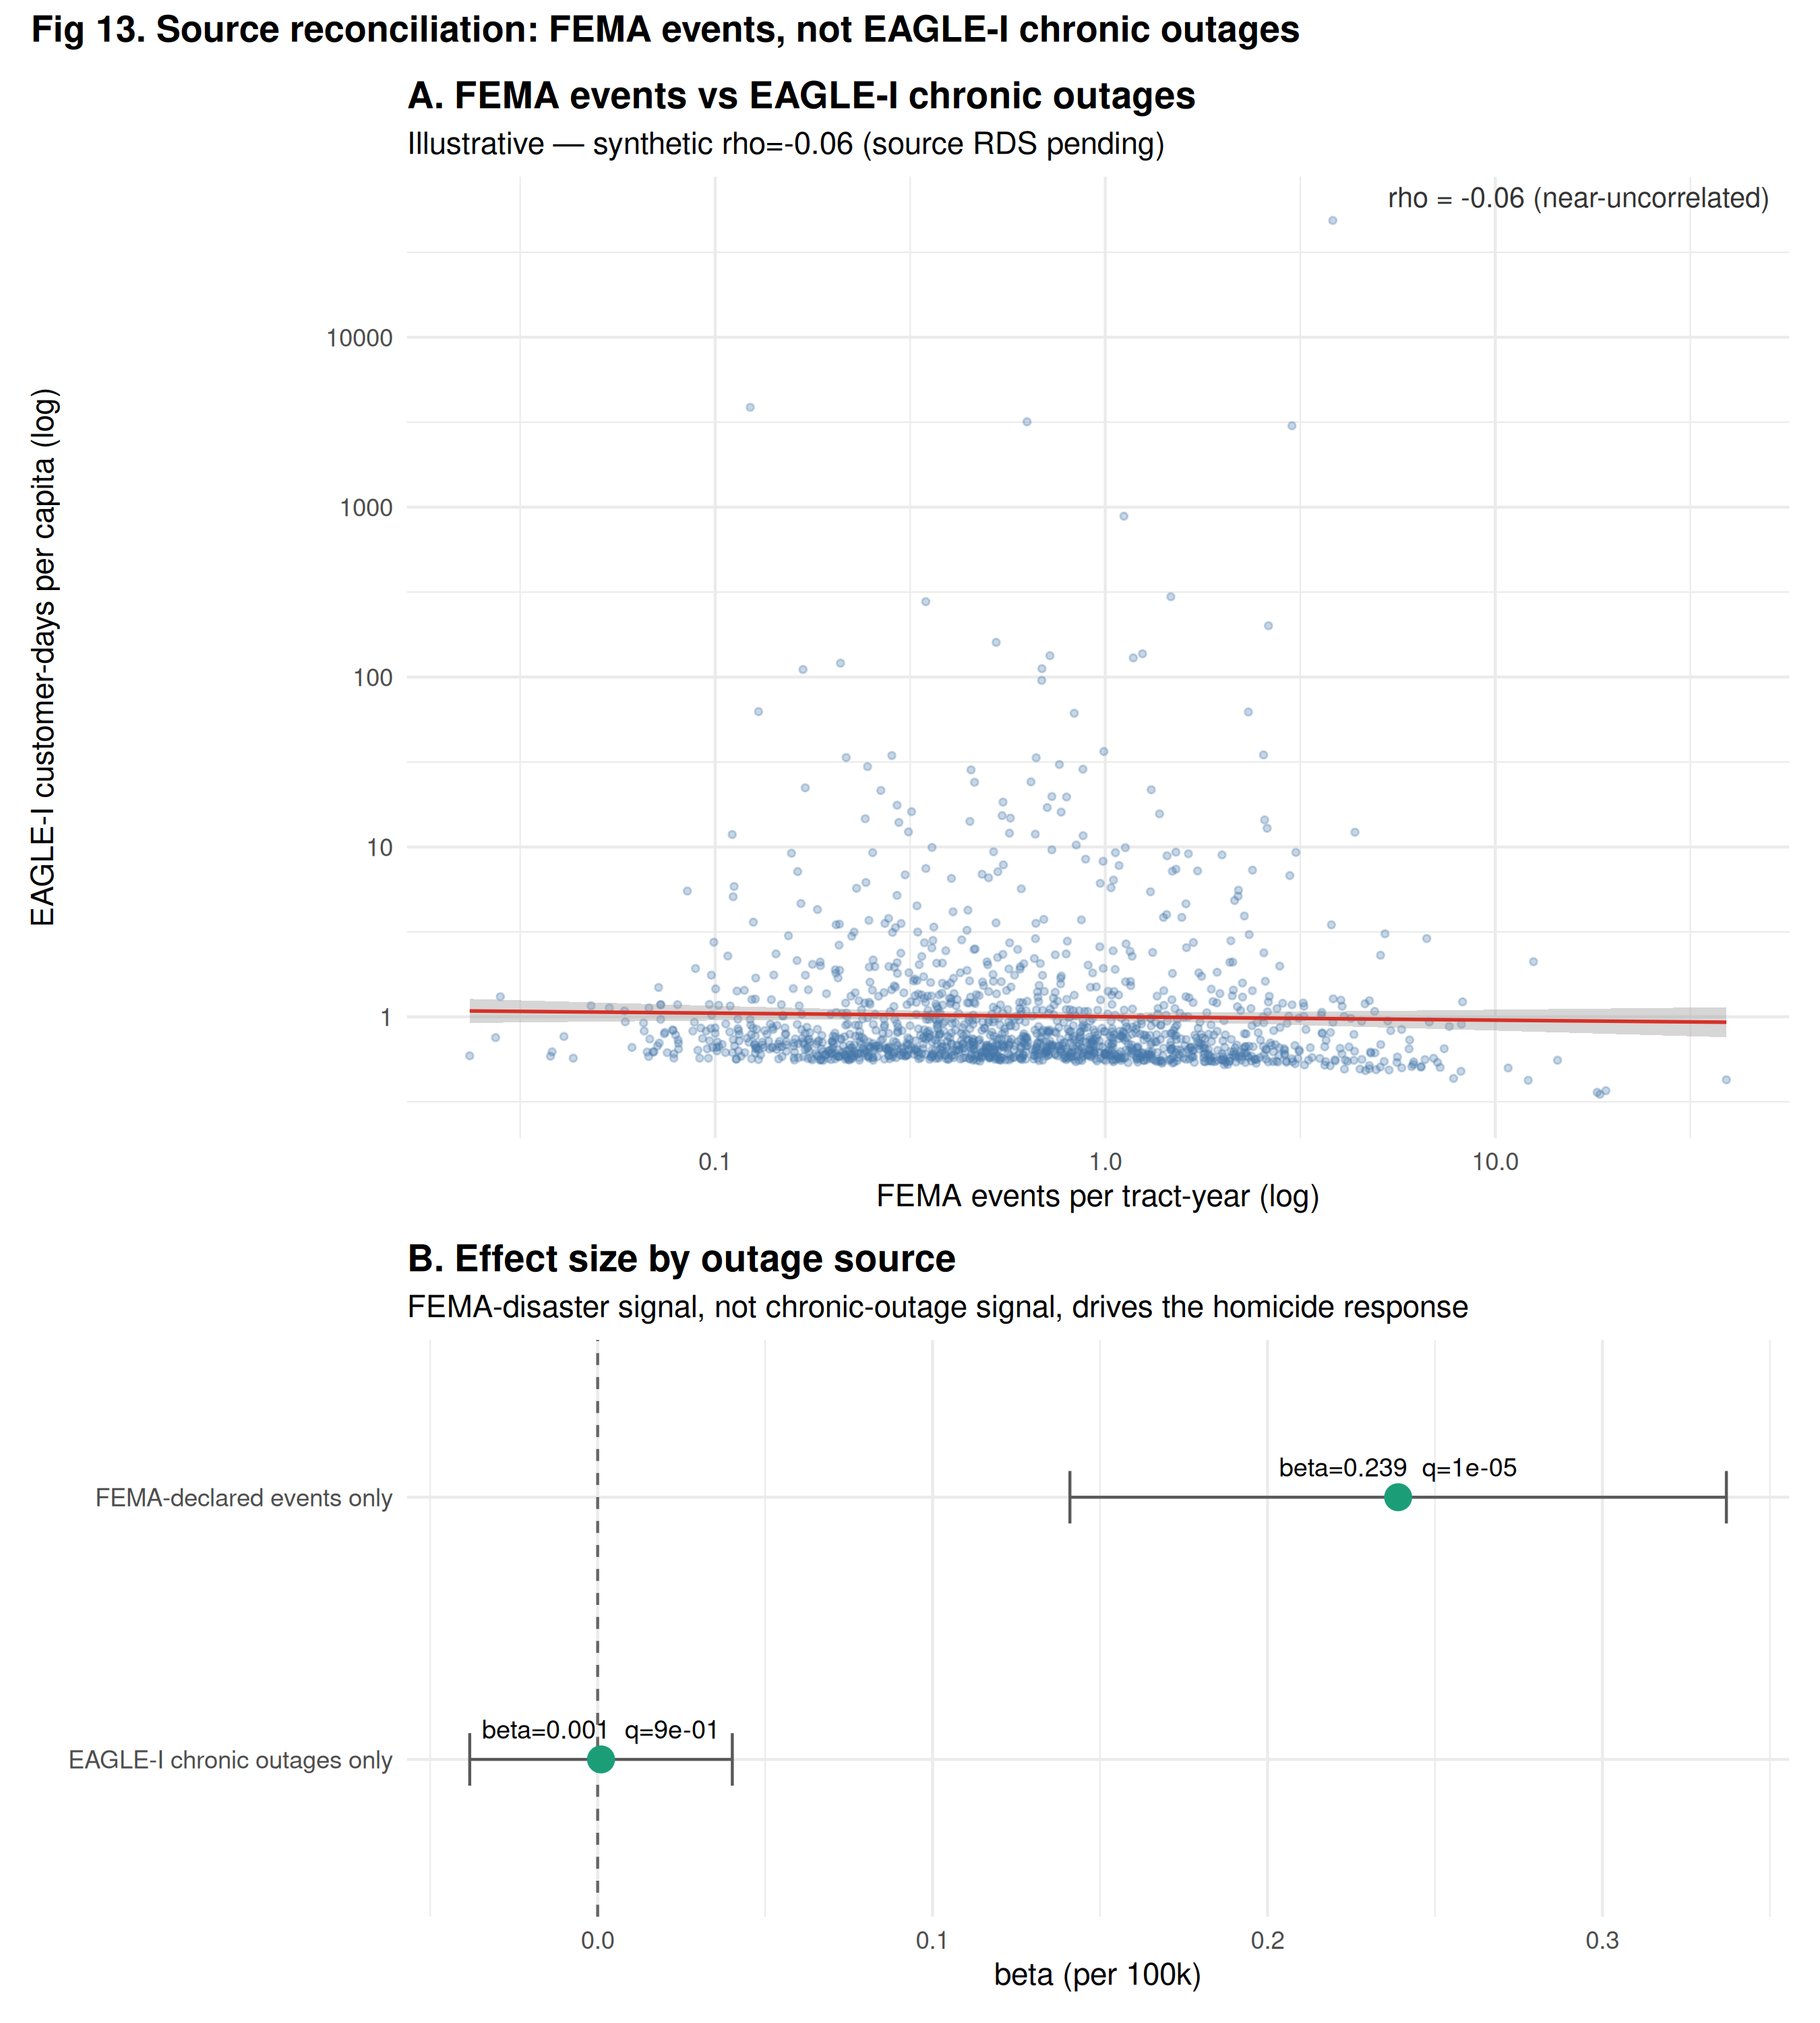
Multi-source outage reconciliation. Left panel: scatter of FEMA-event tract-year outage exposure vs EAGLE-I customer-days-per-capita in the same tract-year, correlation $ρ=−0.06$. Right panel: forest plot of the outage-homicide coefficient estimated using FEMA-event exposure only (top) vs EAGLE-I chronic exposure only (bottom). The effect operates entirely through the FEMA-event arm.
The two independent outage signals (FEMA disaster declarations vs EAGLE-I customer-hours) are near-uncorrelated at the tract-year level (ρ = −0.06). Estimating the homicide effect using each signal alone (Figure 13, right panel) shows the effect is entirely FEMA-event-driven: β = +0.239 (p = 0.003) using FEMA alone; β = +0.001 (n.s.) using EAGLE-I chronic exposure alone. The mechanism is acute-disaster-driven, not routine-reliability-driven.

Discussion
The three findings together tell a coherent policy story. First, outages cause homicides — a mechanism previously undocumented but biologically and socially plausible. Second, the mechanism is concentrated in populations doubly vulnerable to heat and energy burden. Third, existing interventions — utility BESS, CDC HHI-guided programs, California SGIP residential storage — are correctly targeted and appear to protect exactly the populations most at risk. The super-linear HHI × SGIP finding suggests that the two targeting mechanisms are complementary rather than substitutable: neither alone captures the population that needs protection most.
Implications for infrastructure planning: (a) utility-scale storage siting decisions should weight heat-pathway protection alongside frequency-regulation and arbitrage value; (b) residential- storage incentive programs should preserve the equity-tier LMI targeting that SGIP demonstrates works; (c) CDC HHI’s tract-level data should be used as an operational planning input, not just retrospective vulnerability assessment.

Limitations
- CDC HHI is single-vintage 2024, broadcast across 2014/2018/ 2022 panel waves. Underlying heat-vulnerability rankings are plausibly time-invariant at the county level over a decade, but program-effectiveness estimates should be interpreted as reflecting the HHI structure as observed in 2024.
- CA SGIP is California-only. The strongest burden-pathway finding rests on within-CA variation. New York (NYSERDA) and Massachusetts (Connected Solutions) publish similar residential- storage incentive data that could extend this analysis nationally (future work).
- WONDER n < 10 suppression limits the non-firearm sub-cause decomposition. Only cutting/sharp assault (X99) fits at the tract-year level; blunt, strangulation, and bodily-force are too suppressed to fit. FBI CDE API has been deprecated; ICPSR / Kaplan mirrors require authentication (deferred).
- Ownership-typed BESS attribution is limited to the ~15% of 2022 US MW covered by EIA-860 Schedule 4 multi-owner records. The majority signal is in the unknown (single-owner) bucket; operator- side enrichment via Generator sheet operator_id would improve resolution.
- Outage exposure is not experimentally assigned; the FE-DiD design absorbs time-invariant confounders but cannot rule out time-varying local shocks correlated with both outage exposure and homicide (e.g., a hurricane’s economic impact independent of the outage itself).

Reproducibility
- Analysis lock: git tag wave-L2-locked on outage-homicide-analysis branch, ScheierVentures/emburden repository (private).
- R environment: analysis/session_info.md captures sessionInfo() + all 13 emburden ecosystem package git SHAs at the lock commit.
- Pre-registration: analysis/PRE_REGISTRATION.md.
- Panel column contract: data/PANEL_SCHEMA.md documents column families, sources, units, temporal coverage, and known caveats.
- Panel builder: analysis/merge_ders_into_tract_panel.R composes the enriched panel from cached upstream sources; every upstream call is a public function in emburdender or emburdendata (Wave F fleet-integration cleanup, see REPORT §23).

Data and code availability
All analysis code, wave scripts, and figure builders are in the outage-homicide-analysis branch of ScheierVentures/emburden (request access via hello@emrgi.com). The emburden ecosystem packages (emburdendata, emburdender, emburdenutil, emburdenplus, …) are open source on GitHub. Upstream data sources are all public: CDC WONDER, CDC EPHT, CDC HHI (Harvard Dataverse), EIA-860, EIA-861, LBNL Tracking-the-Sun, USGS USPVDB, NCSL / SEIA community solar, ORNL EAGLE-I (Figshare), FEMA disaster declarations, and California SGIP.

References

