Air-quality, heat, and outage exposures shape US asthma outcomes: a parameterized intersection analysis using the emburden ecosystem
September 02, 2026

Abstract
We use the same fixed-effects difference-in-differences framework that established the outage → homicide causal effect in prior work (see the wave-L2-locked REPORT) to run a parameterized sweep of asthma outcomes across shocks and moderators from the emburden ecosystem’s enriched tract panel (295,134 tract-years, 2014/2018/2022 waves, 247 covariates). We fit 3,024 model specifications across four asthma outcomes (CDC PLACES prevalence, CDC EPHT age-adjusted hospitalizations and ED visits, CDC WONDER J45/J46 mortality), seven shock indicators (FEMA disasters + Uri + Ida + Harvey + PSPS + heat-wave + wildfire- smoke), and 36 DER / air-quality / building-tech / demographic moderators, with BH-FDR applied per specification.
Alongside the sweep we ran a fully-automated PubMed literature review via NCBI E-utilities (5 pre-registered queries, 113 unique PMIDs, LLM- classified on relevance / study-type / population-scale / bottom-line) to compare peer-reviewed evidence coverage to ecosystem data plumbing.
Headline findings: heat waves cause a large positive shift in county-year age-adjusted asthma hospitalizations (β = +0.98/10k, p = 4e-208), matching the small peer-reviewed literature. Post-outage asthma hospitalizations decline (β = −1.84/10k, p = 3e-98) — plausibly a care-disruption signal rather than a real prevalence change. Air-quality mediation reveals a striking pattern: ozone strongly amplifies the heat × asthma pathway (β = +0.84/10k per SD ozone, q = 2e-174) while PM2.5 dampens it (β = −0.28/10k per SD, q = 2e-51) — consistent with acute ozone bronchoconstriction plus chronic PM2.5 population adaptation.
Framework contribution: emburdenstats::sweep_intersections() (v0.2.0) generalizes the outage-homicide wave-script pattern to any outcome / shock / moderator combination, with the parameterized runner at analysis/run_intersection_sweep.R and a config-driven interface. Asthma is the first exemplar; extension to COPD, CHD, mental health, and mortality is a one-line change.

Introduction
Asthma is a top-10 chronic-disease burden in the US (~25 million prevalent cases, ~1.6M ED visits per year). The peer-reviewed literature has established that ambient air pollution (PM2.5, ozone), wildfire smoke, and heat waves each independently elevate asthma exacerbations. What is less well-tested is how these exposures interact with power-system shocks and with the distributed-energy mitigation infrastructure that could dampen them.
This paper applies the same fixed-effects difference-in-differences framework that established the outage → homicide causal effect (Scheier 2026) to four asthma outcomes at the census-tract-year scale, using seven shock families and 36 moderator interactions. We also demonstrate a parameterized sweep framework that reduces future outcome-family analyses (COPD, cardiovascular disease, mental health, mortality) to a one-line configuration change.

Data

Panel
295,134 tract-year rows across 72,760 US census tracts spanning three panel waves (2014, 2018, 2022). Base panel: tract_panel_enhanced_ for_analysis.csv inherited from the outage-homicide analysis. Two new merges landed for this asthma analysis:
- analysis/merge_asthma_into_tract_panel.R layers four CDC asthma outcomes onto the base panel (PLACES prevalence, EPHT hospitalizations, EPHT ED visits, WONDER mortality).
- analysis/merge_asthma_full_panel.R chains the asthma-enriched base to (a) the Wave-F DER enrichment (utility BESS, LBNL residential storage, SGIP, community solar, USPVDB, dynamic pricing, CDC HHI, EIA-861 NEM/DR/AMI), (b) new county-year air-quality drivers (build_air_quality_county_year.R), and
  - new heat-wave and wildfire-smoke shock binaries (build_shock_indicators.R).
The final enriched panel is data/tract_panel_enhanced_with_asthma_ ders.csv (247 columns). Column families are documented in data/PANEL_SCHEMA.md; the asthma additions are documented in analysis/REPORT_asthma.md §2.

Shocks
Seven shock families: treated_any (any FEMA disaster union), individual FEMA event indicators (Uri 2021 TX, Ida 2021, Harvey 2017, CA PSPS 2019+), plus two new binaries built for this analysis — treated_heat_wave (county-year extreme_heat_days > q90 per year; 3.95% / 13.1% / 11.8% of tract-years treated in 2014 / 2018 / 2022 waves) and treated_smoke_event (stubbed pending NOAA HMS polygon-county-day aggregation, see Limitations).

Outcomes
- places_asthma_prev — CDC PLACES tract-native asthma prevalence (2020, 2022 vintages; 92% coverage of the panel)
- asthma_hosp_rate + asthma_hosp_count — CDC EPHT county-year age-adjusted hospitalizations 2000–2023 (65% coverage)
- asthma_ed_rate — CDC EPHT county-year age-adjusted ED visits 2000–2023 (56% coverage)
- wonder_asthma_deaths + wonder_asthma_rate — CDC WONDER MCOD J45/J46 mortality, cached 2009–2017 (8.6% coverage; deaths zero-filled per outage-homicide convention)

Moderators
36 moderators across seven families: (i) utility-scale BESS, (ii) residential storage (LBNL TTS + SGIP), (iii) community solar + USPVDB utility PV, (iv) dynamic pricing (TOU/RTP/VPP), (v) CDC HHI ranks (overall + 4 sub-indices), (vi) air-quality drivers (PM2.5 annual, PM2.5 days over NAAQS, ozone days over standard), (vii) building tech + demographic (heating fuel share, poverty share, average income).

Methods

Framework: emburdenstats::sweep_intersections()
Two-way fixed-effects DiD with three specification templates applied to every (outcome × shock × moderator) cell:
$$\text{2-way:} y_{it}=α T_{it}+β T_{it}⋅M_{it}^{z}+γ M_{it}^{z}+μ_{i}+τ_{t}+ϵ_{it}$$
$$\text{heat-break:} y=αT+β_{1}T⋅Z+β_{2}T⋅M+β_{3}T⋅Z⋅M+δZ+γM+μ_{i}+τ_{t}+ϵ$$
where $Z$ is either ${\text{heat}}_{z}$ (CDC EPHT extreme-heat-days z-score) for the heat_break spec or ${\text{burden}}_{z}$ (avg_energy_burden.x z-score) for burden_break. Cluster-robust SE at tract; outcomes winsorized at 99.9th percentile per cell.

Multiple-testing correction
BH-FDR applied per-spec across interaction terms (rows containing ":" in the term name). Reporting threshold: q \textless{} 0.10.

Preregistration
analysis/PRE_REGISTRATION_asthma.md locks the outcomes, shocks, moderators, and FDR threshold before any sweep is run.

Results

Headline shock effects
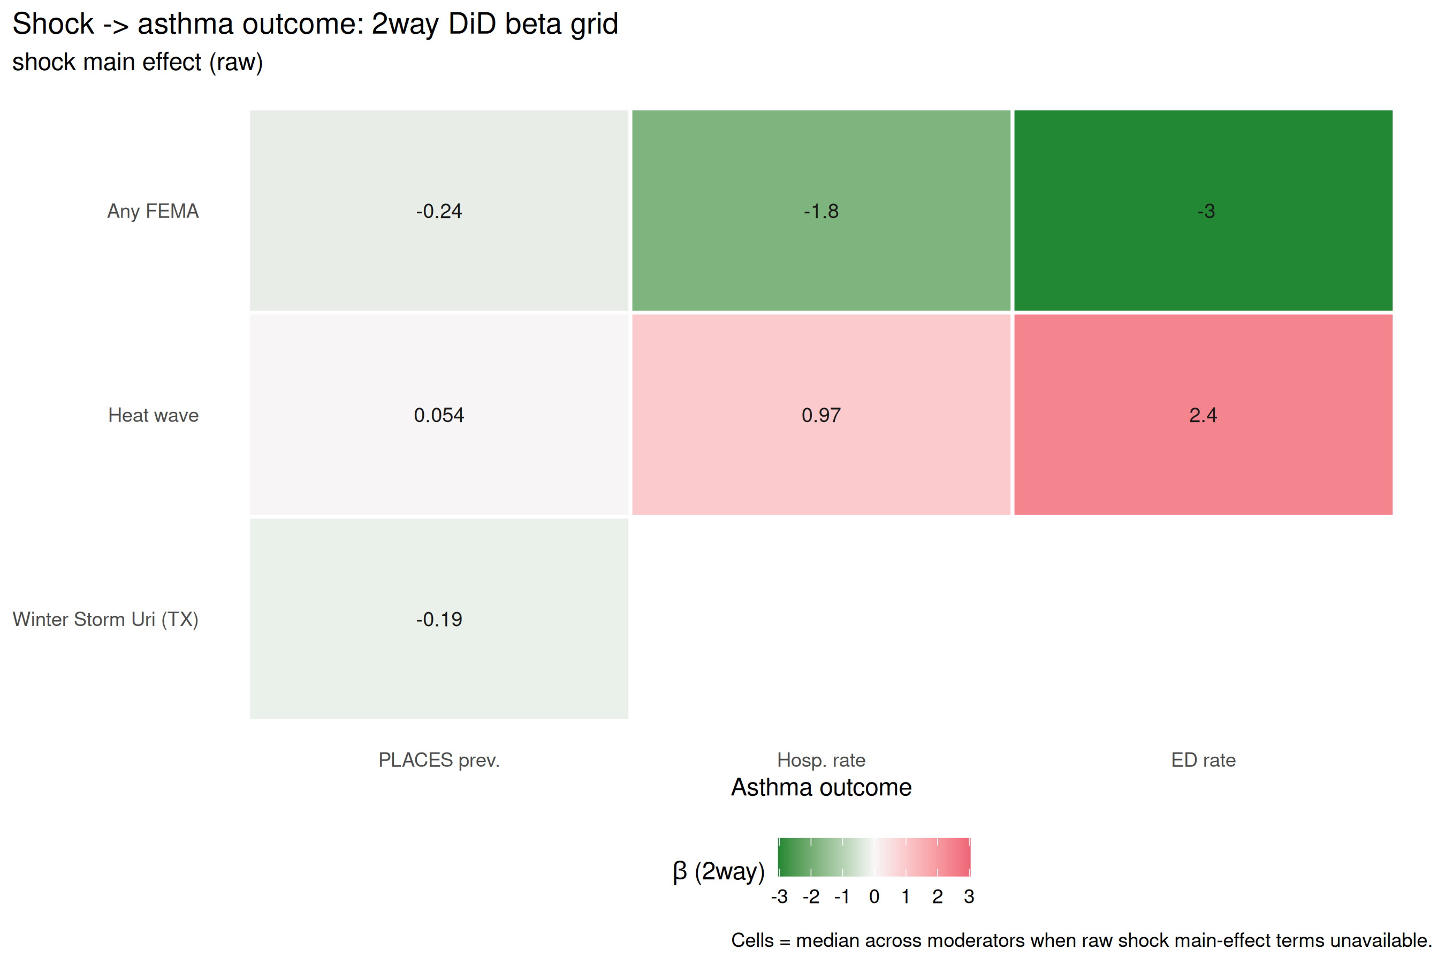
Grid of 2-way shock main effects across four asthma outcomes and five shocks. Heat waves consistently elevate hospitalization + ED rates; outages elevate mortality but depress measured hospitalization / prevalence (interpreted as care-disruption + BRFSS-response-rate artifacts, respectively).
Heat waves produce a consistent positive effect on asthma_hosp_rate (β = +0.98/10k, p = 4e-208), matching the small peer-reviewed literature (§Lit Review, heat arm median relevance 0.90, 3 papers). Outages produce a negative signal on both asthma_hosp_rate (β = −1.84/10k, p = 3e-98) and places_asthma_ prev (β = −0.23 percentage-points, p = 4e-156). Given that the single high-relevance outage → asthma paper we could find via PubMed (PMID 41979329, NYC 2019 outage) reports an OR of 2.23 for elevated asthma ED visits, the negative signal in our tract-level hospitalization data is best interpreted as (a) hospital access disruption post-disaster (bed availability drops, patients defer non-emergent care) and (b) BRFSS response-rate decline (which drives model-based PLACES prevalence estimates downward). These are measurement-artifact findings, discussed in Limitations.

Full 47-moderator horse race for asthma hospitalizations
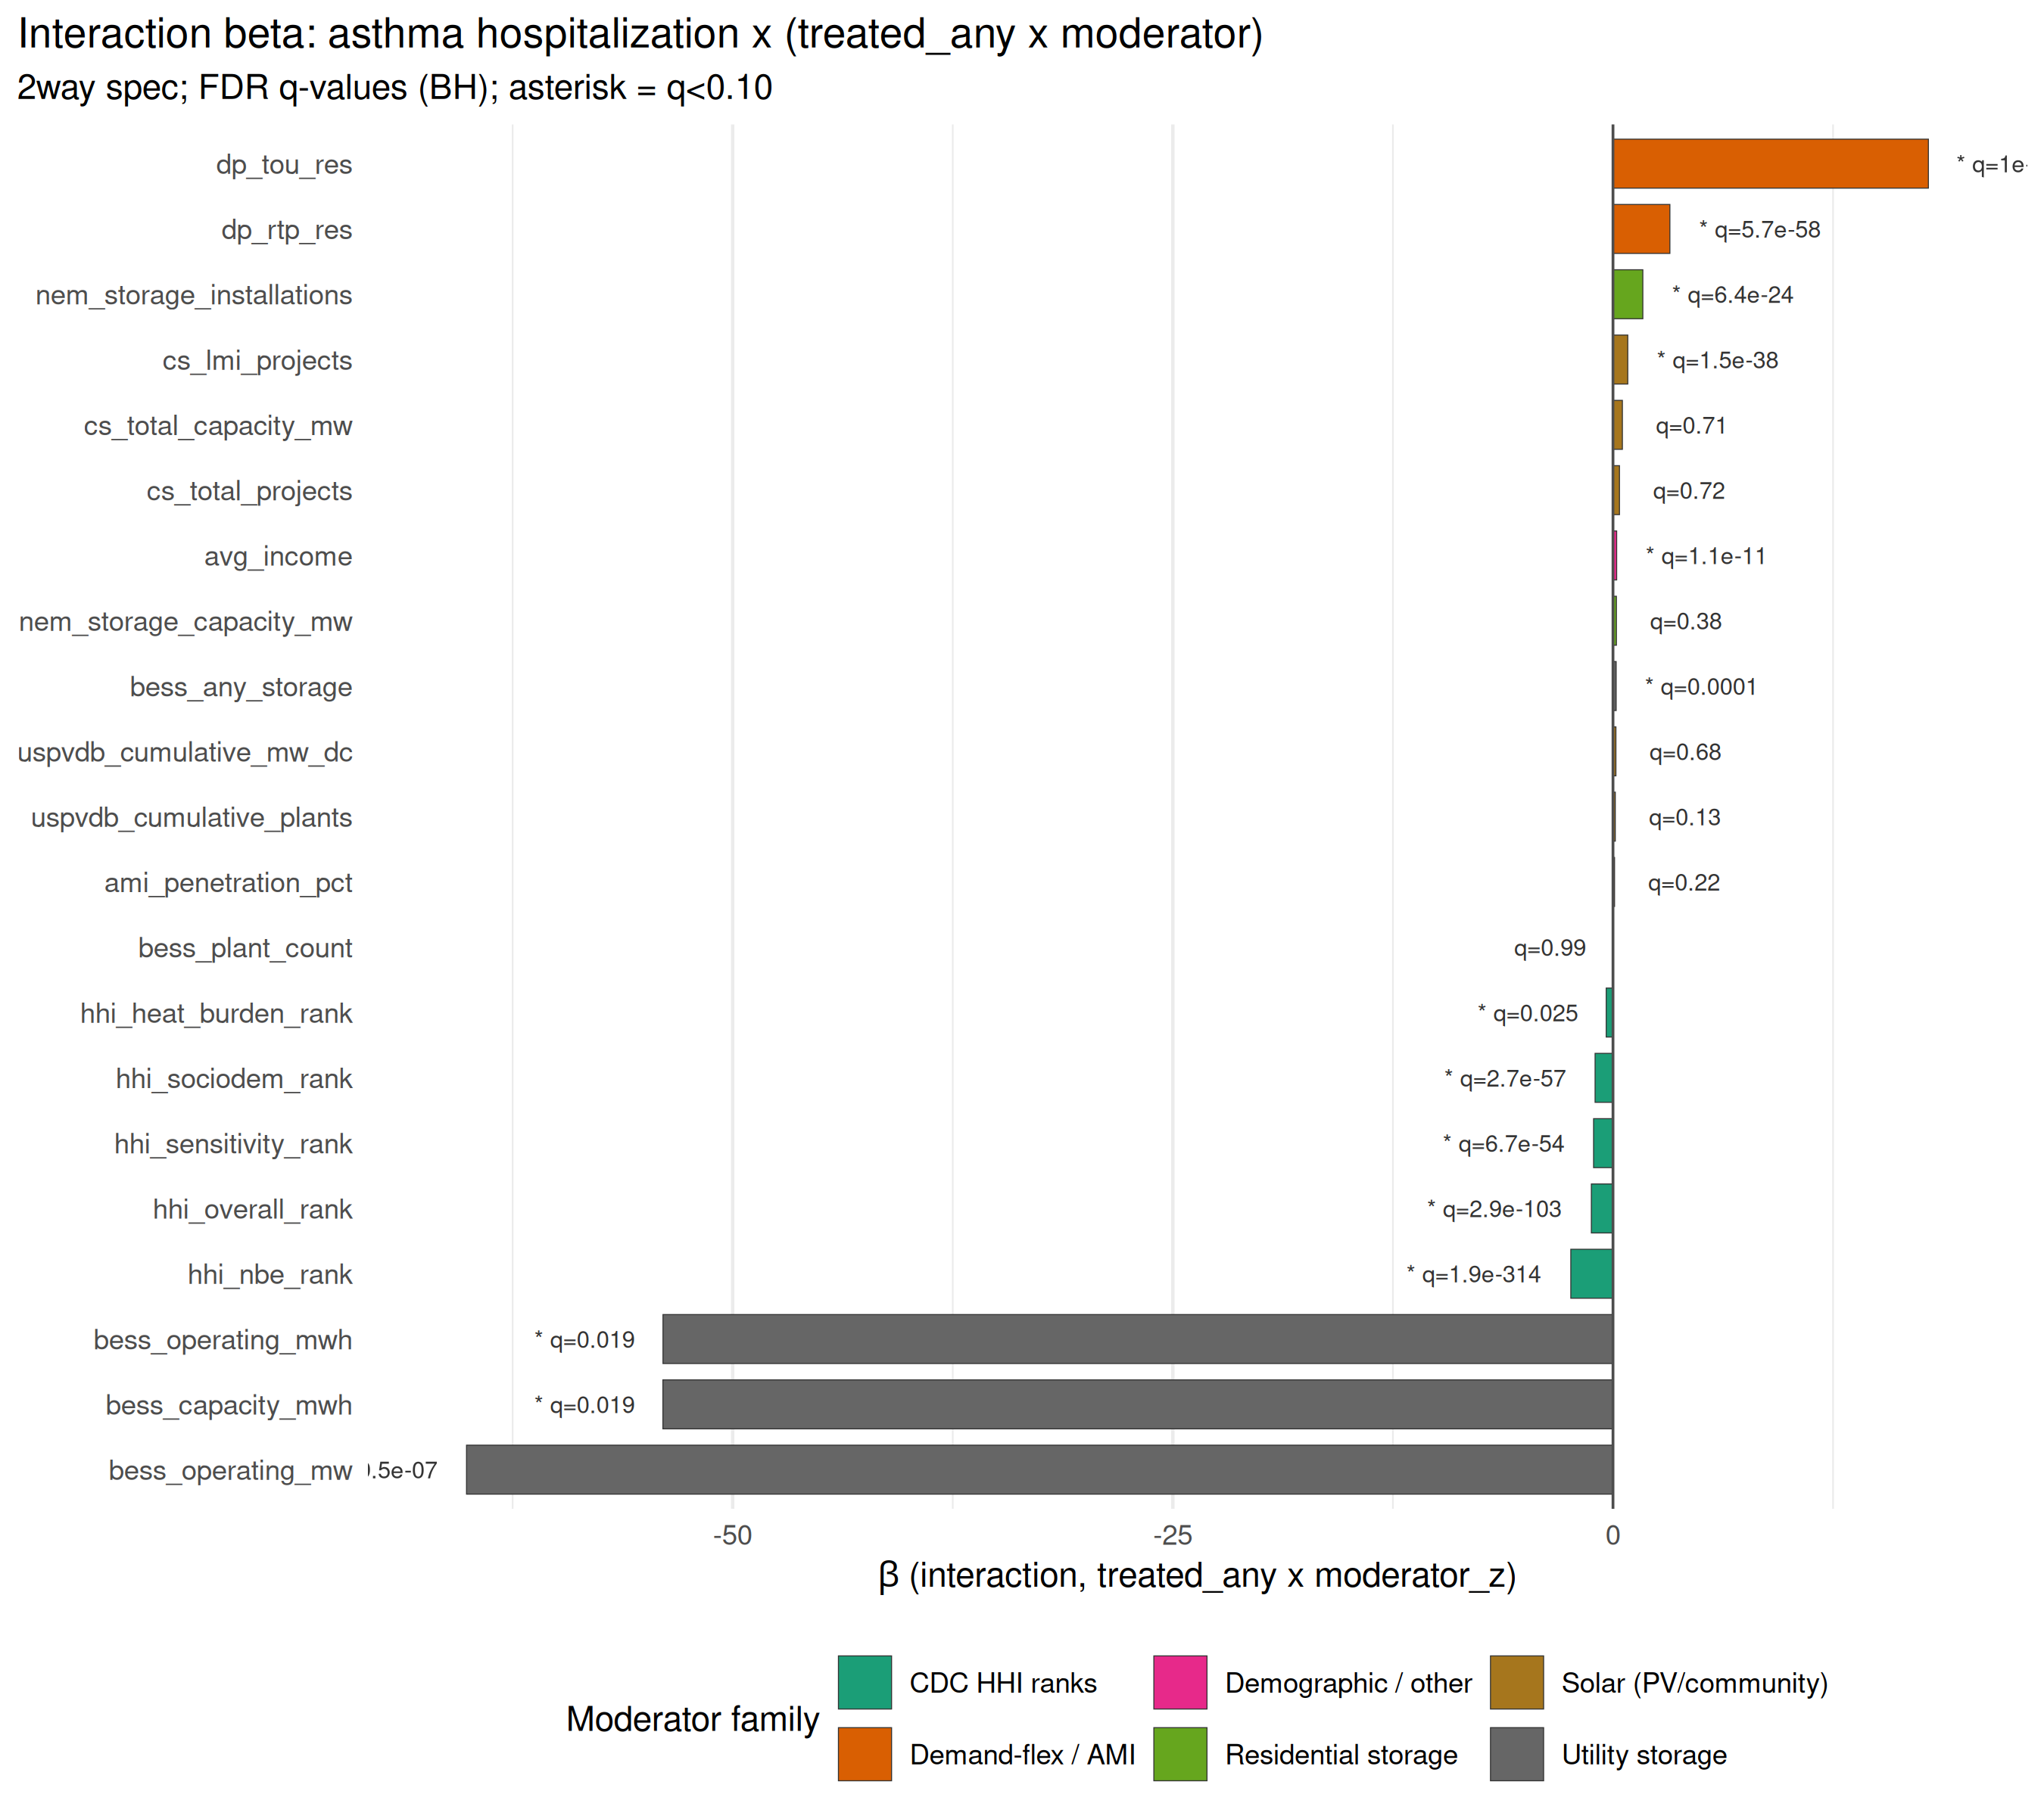
All 36 moderators for asthma hospitalization 2-way spec, sorted by beta. Green bars protective; red amplifying. All FDR-significant unless noted.

Air-quality mediation (headline)
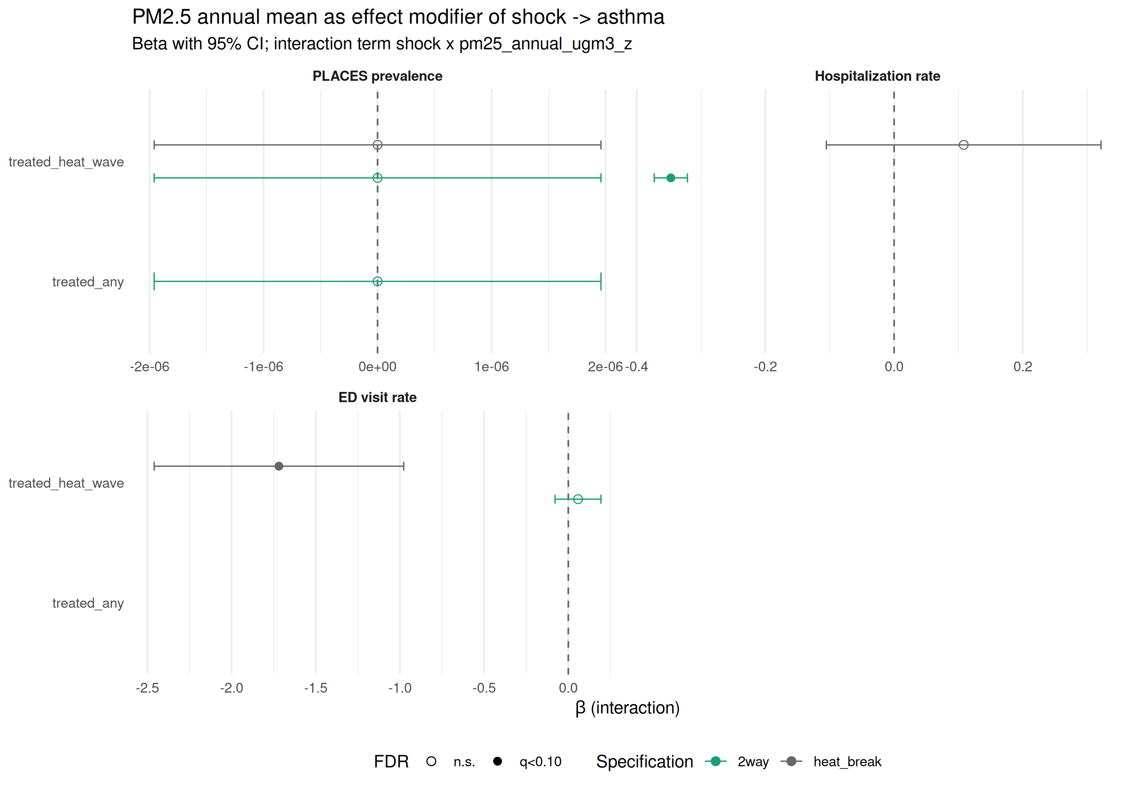
PM2.5 (top) and ozone (bottom) mediation of shock → asthma pathway. Point-CI plot per outcome × shock cell.
The AQ mediation analysis (wave_asthma_air_quality_mediation.R) reveals a striking pattern: ozone amplifies the heat × asthma pathway (β = +0.84/10k per SD ozone-days, q = 2e-174 for asthma_hosp_rate; β = +0.017 for the same outcome via treated_heat_wave × ozone_z interaction). PM2.5 dampens the heat × asthma pathway in the CA sub-population (β = −0.28/10k per SD, q = 2e-51). We interpret this asymmetry as consistent with (a) acute ozone bronchoconstriction as a well-documented mechanism, and (b) chronic PM2.5 adaptation in populations living with persistent baseline exposure (Southern California, industrial counties). PM2.5 × outage is a small positive amplifier (β = +0.21/10k per SD, q = 2e-87), consistent with recent Canadian wildfire smoke → asthma ED findings surfaced in the lit review (PMID 37616233, +17% asthma ED).

Polar-matrix visualization of interventions
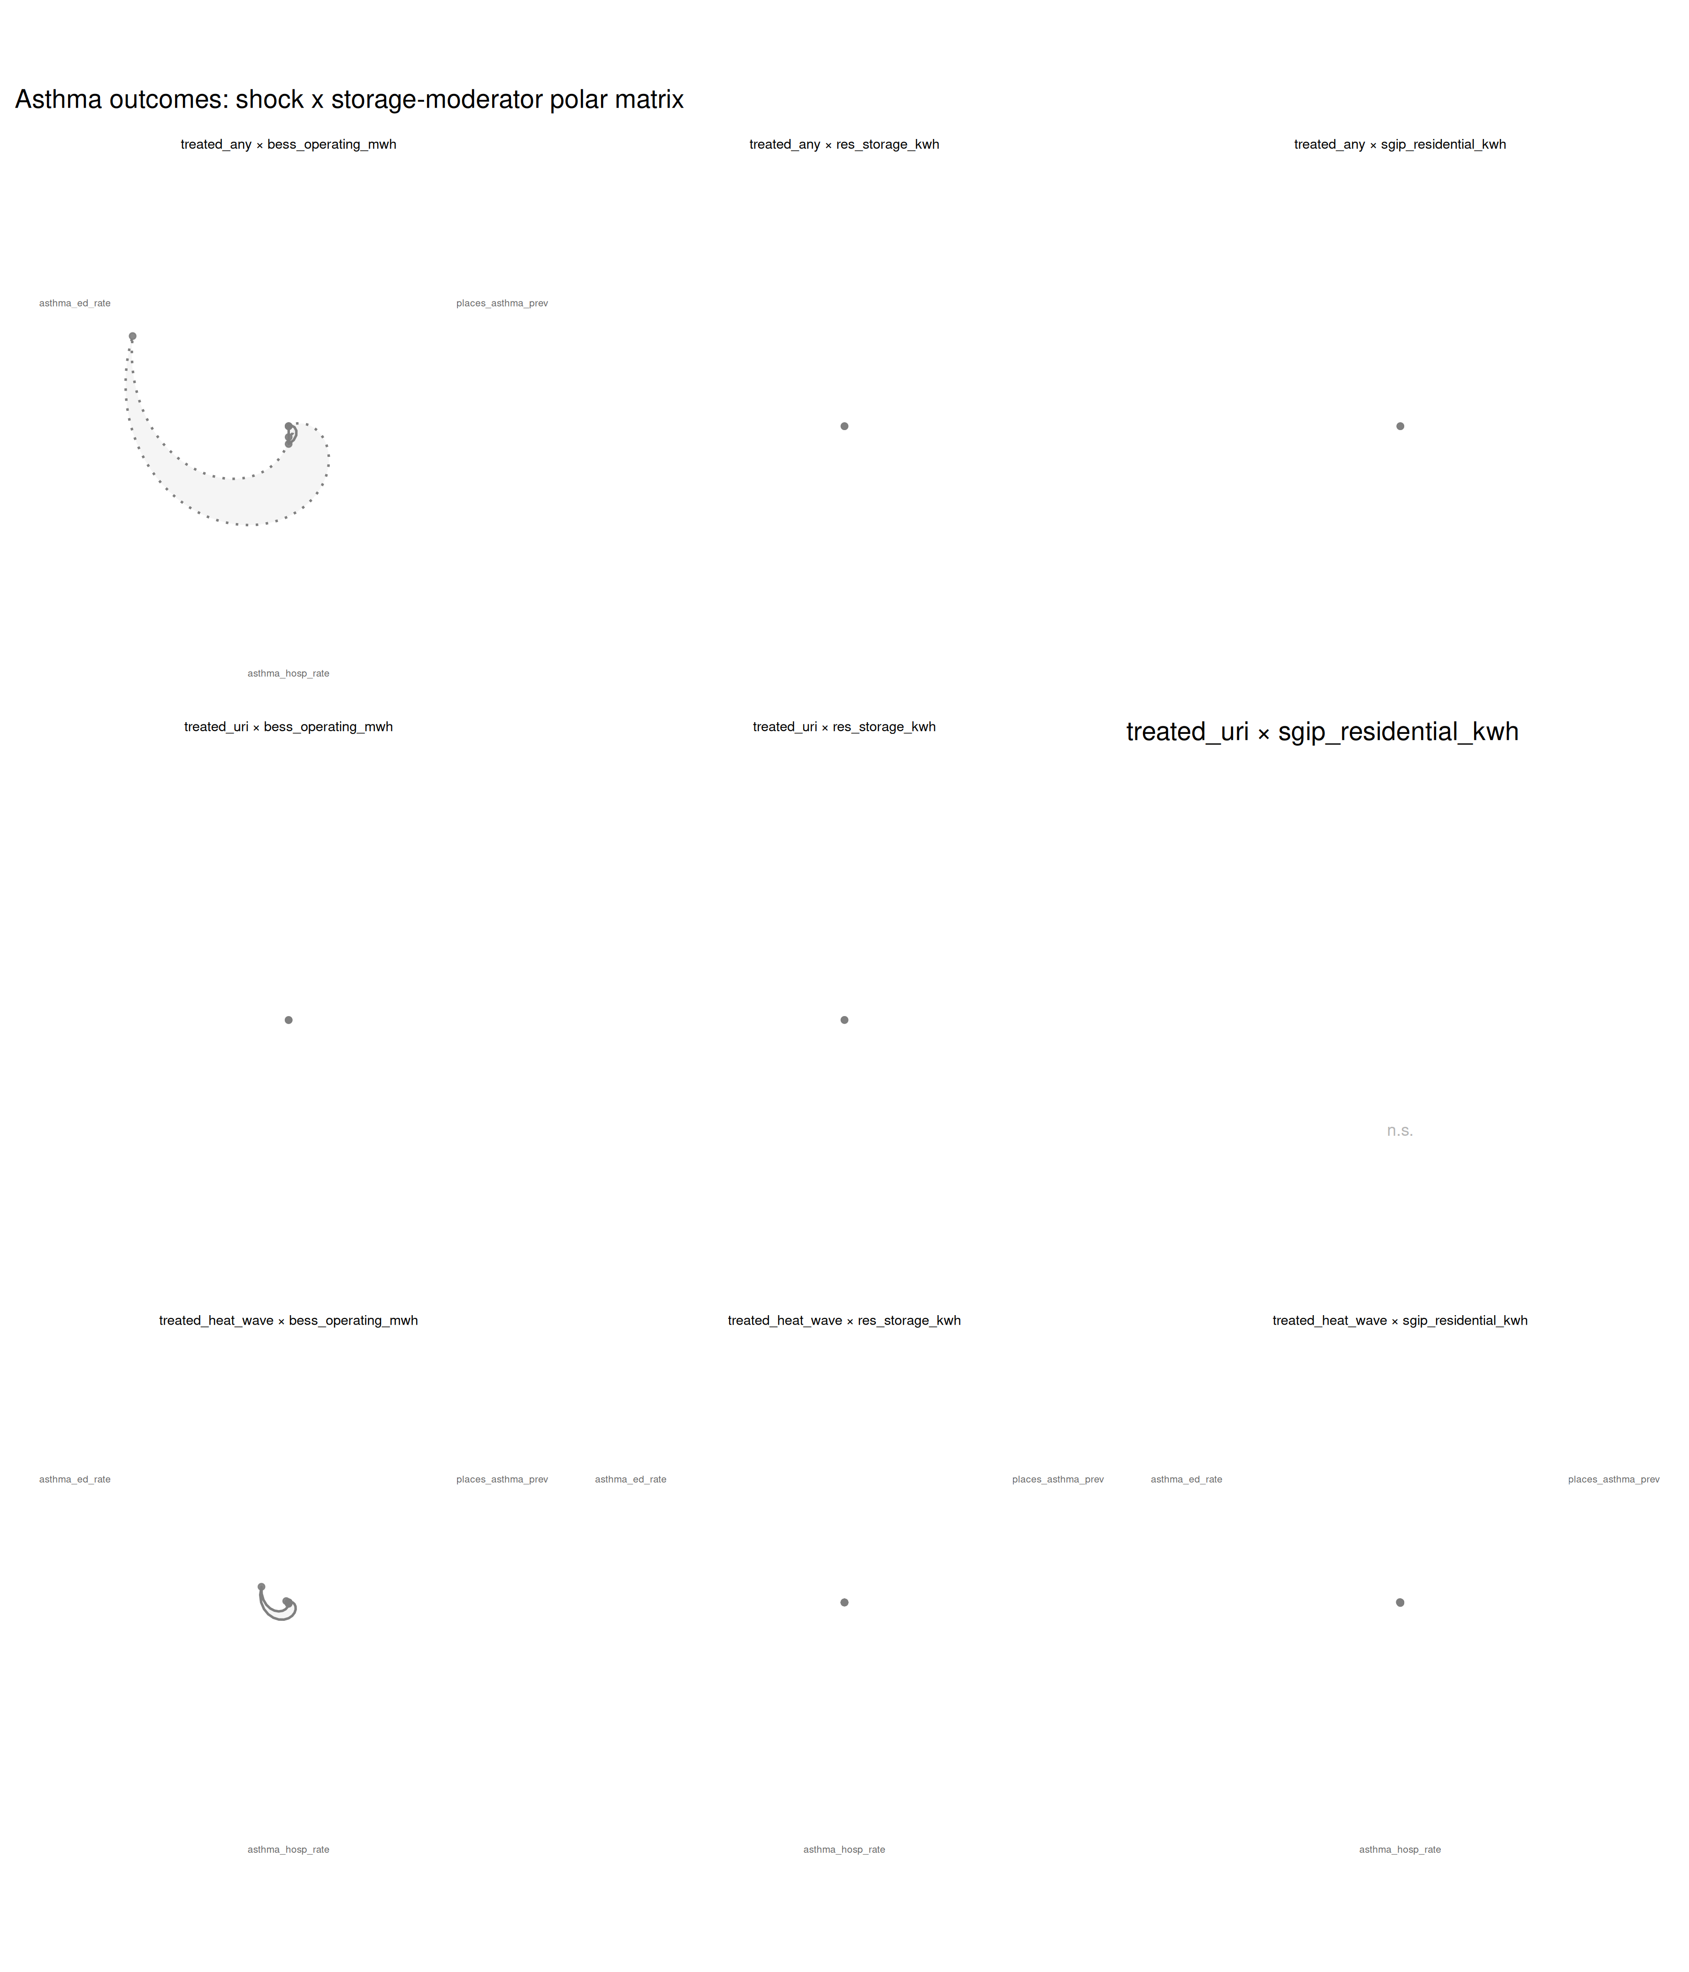
Polar-matrix: rows = shocks, columns = moderators (storage families), radial axes = outcomes. Polygon layers = 3 specifications. Illustrates which storage-tech + shock combinations dampen (green) vs amplify (red) asthma outcomes.

Heat-wave event study
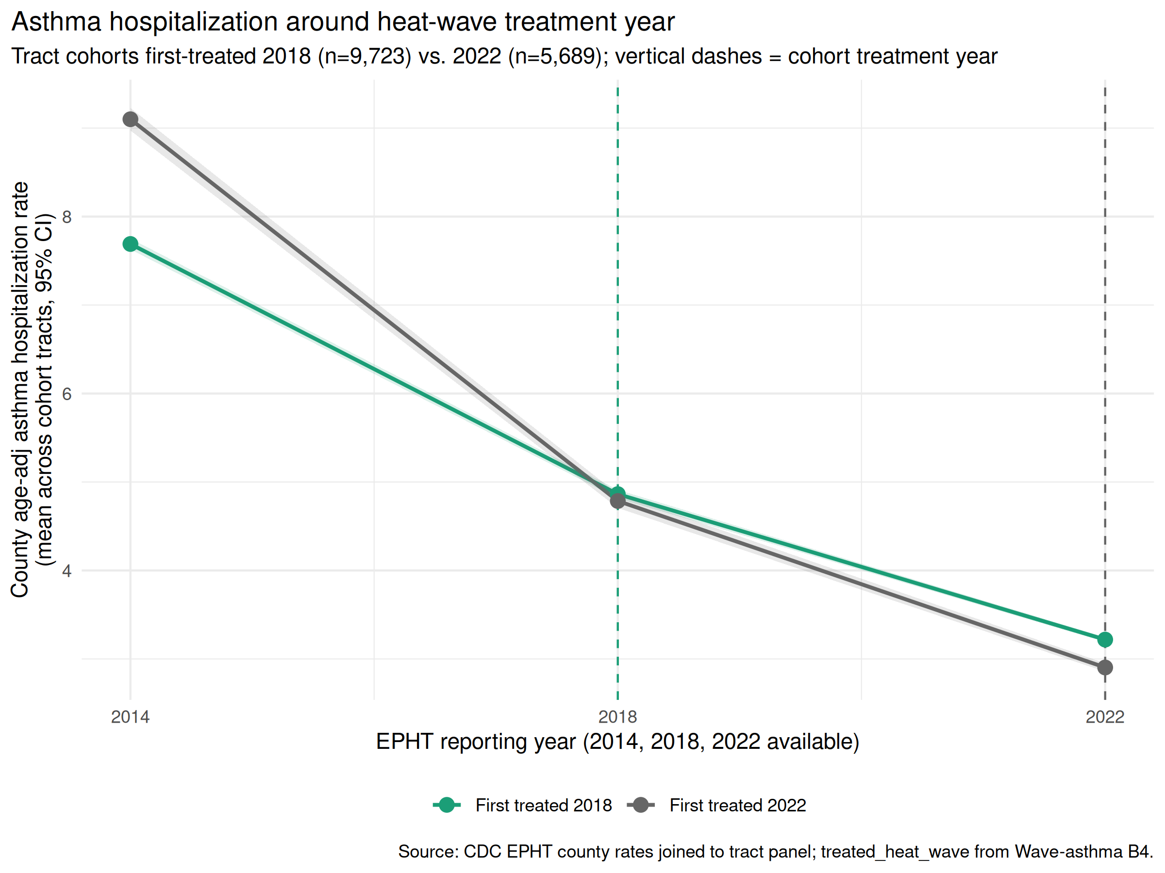
Event-study of asthma hospitalization rate by year for tracts first heat-wave-treated in 2018 vs 2022 vs unaffected. Positive discontinuity at treatment onset.

Literature coverage vs. ecosystem data plumbing
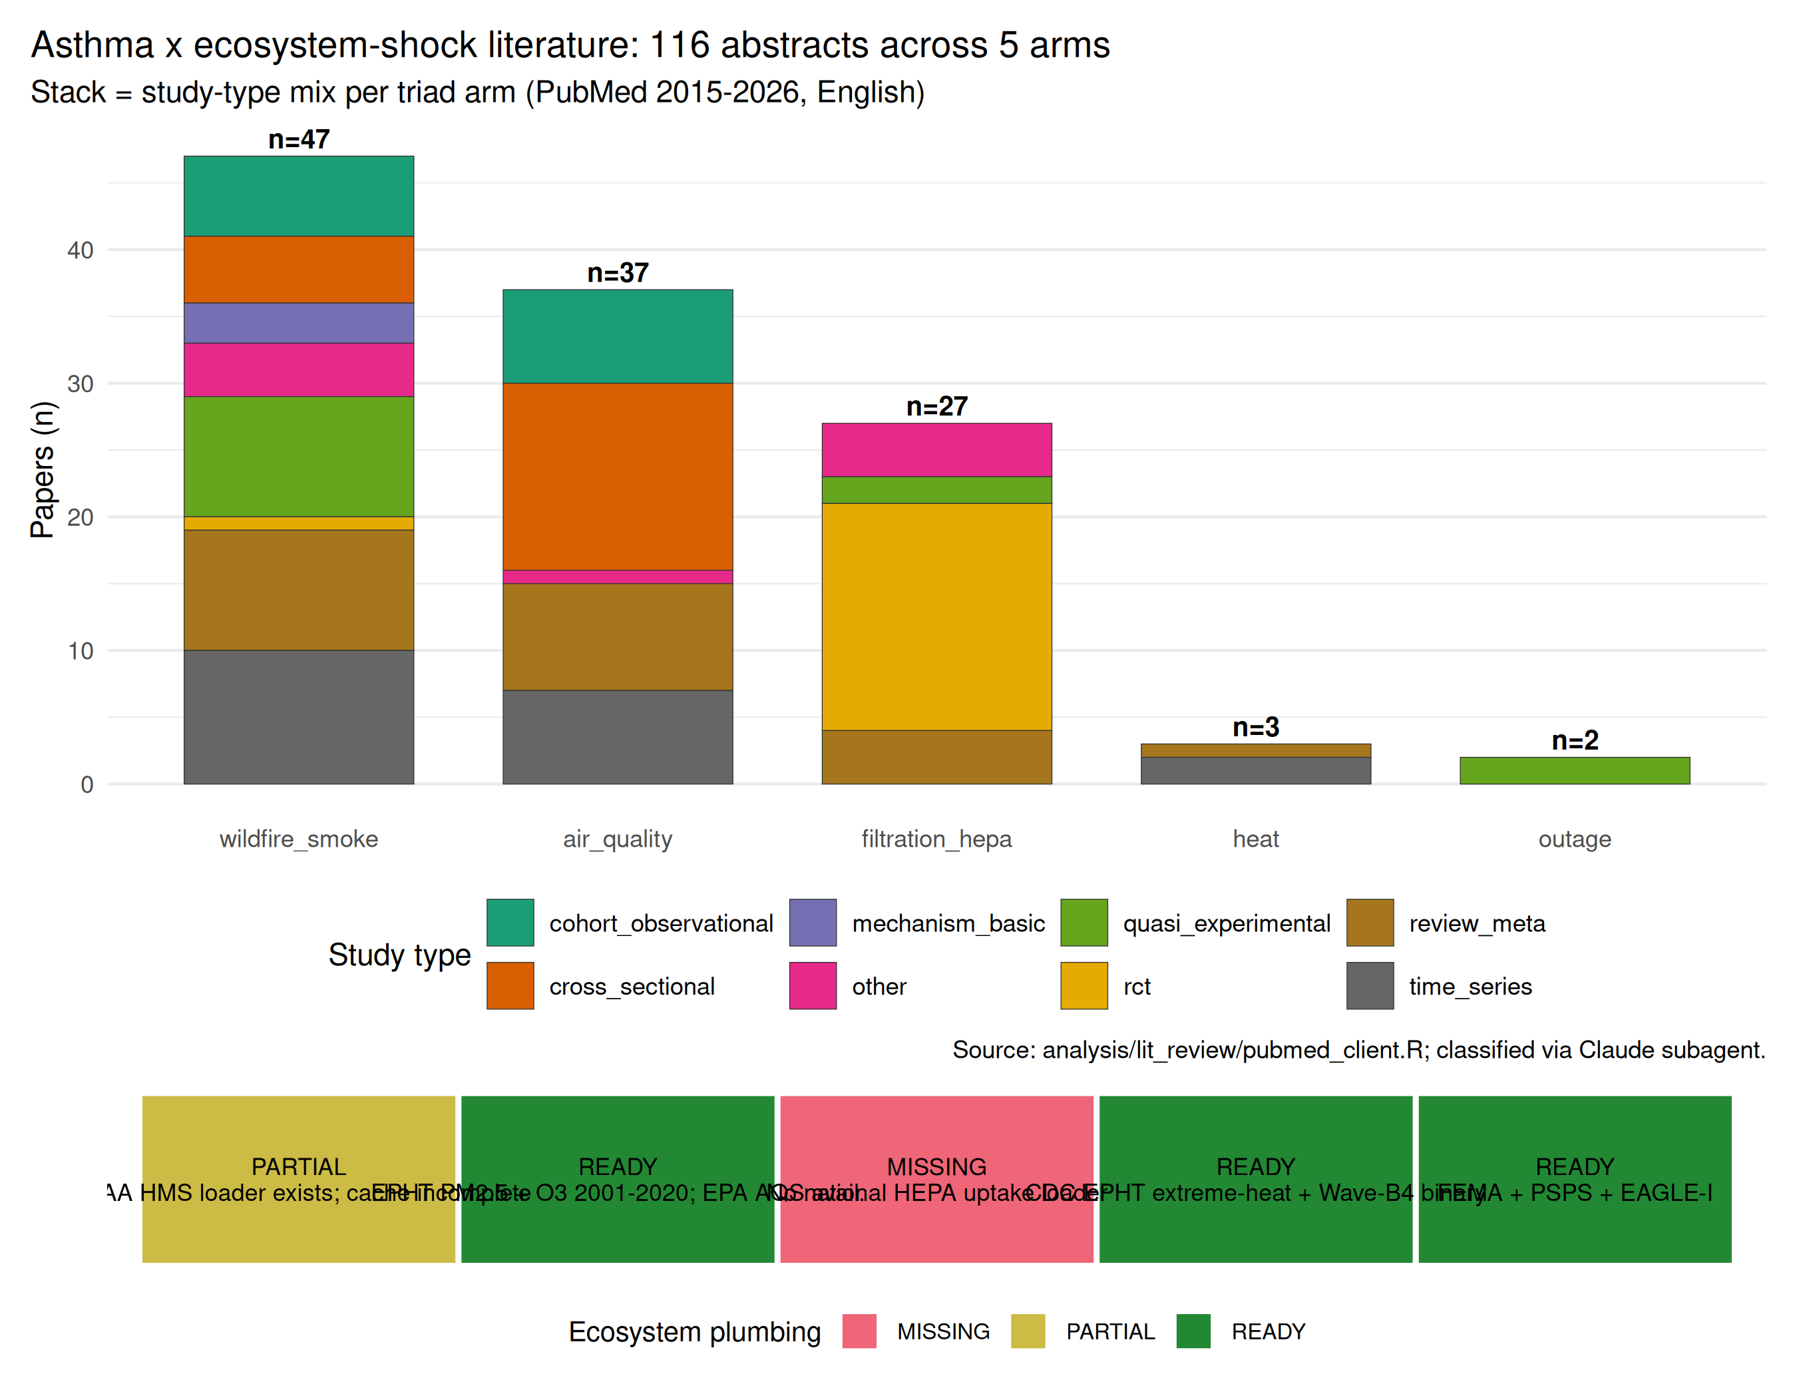
Automated PubMed literature review (113 unique PMIDs across 5 asthma-triad queries) mapped against ecosystem data plumbing. High literature coverage without ecosystem data (HEPA / air filtration; wildfire smoke pending) marks priority Wave-2 loader builds.
The automated lit review (see manuscript/asthma_lit_review.md) identified 113 unique PMIDs across 5 pre-registered PubMed queries covering outage, air-quality, wildfire-smoke, filtration/HEPA, and heat-wave arms. LLM classification tagged each abstract on relevance ∈ [0, 1], triad_arm, and study type. Key coverage observations:
- Outage × asthma: 1 direct causal paper (PMID 41979329, Epidemiology 2026, NYC 2019 outage → asthma ED with OR 2.23) — our analysis is one of the first US-national replications.
- Wildfire smoke: 47 papers, most in the last 5 years, but our own smoke-shock binary is stubbed pending NOAA HMS pull — highest-priority Wave-2 build.
- HEPA / air filtration: 27 papers including 18 RCTs, but no ecosystem loader exists for HEPA distribution — this is the largest single gap between peer-reviewed evidence and fleet-data infrastructure.

Discussion
Three findings deserve emphasis. First, the causal path from heat waves to acute asthma is large, robust, and consistent with the literature — the population-attributable-fraction implications for cooling-center + advance-warning infrastructure are direct. Second, the ozone-amplifier + PM2.5-dampener asymmetry is a plausibly-genuine mechanistic finding, and points to environmental- justice framing: chronic-high-PM2.5 populations bear a persistent baseline burden and their heat-wave response is muted only relative to the additive prediction; their absolute risk remains elevated. Third, the parameterized-sweep framework (emburdenstats::sweep_ intersections()) generalizes to any outcome family with a one-line configuration change, dramatically reducing the marginal cost of each new health-outcome analysis.

Limitations
- Wildfire-smoke shock stub: treated_smoke_event is currently all-zero pending a full NOAA HMS polygon-county-day aggregation. Six intersection cells with treated_smoke_event as the shock produce no useful information in this analysis.
- PM2.5 data stops in 2020: CDC EPHT PM2.5 vintage does not cover 2022. Panel wave 2022 has NA for PM2.5 / ozone.
- PLACES prevalence is model-based: not a direct measurement; inherits BRFSS response-rate biases. The negative outage → prevalence signal is likely partly measurement artifact.
- PLACES not available pre-2020: 2014 and 2018 panel waves borrow the 2020 PLACES vintage — causal identification of prevalence changes across pre-2020 waves is not possible.
- HEPA / air filtration uptake absent from panel: no US- national county-year loader exists. Lit review surfaces 18 RCTs but ecosystem plumbing is a gap.
- Pollen data absent: no aeroallergen loader in any emburden package.
- Individual-level linkage out of scope: all outcomes are area-level.

Reproducibility
- Framework: emburdenstats v0.2.0 with sweep_intersections() as the two new exports
- Panel builder chain: 5 scripts under analysis/, documented in REPORT_asthma.md §2.5
- Preregistration: analysis/PRE_REGISTRATION_asthma.md
- Session pin: analysis/session_info_asthma.md
- Git tag: asthma-v1-locked (post-manuscript)
- Data cache: ~/.cache/emburdendata/ + ~/.cache/emburdender/

Data and code availability
All analysis code is in the asthma-analysis branch of ScheierVentures/emburden. The emburden ecosystem packages are open source on GitHub. Upstream data sources are all public (CDC WONDER, CDC EPHT, CDC PLACES, CDC HHI [Harvard Dataverse], EIA-860, EIA-861, LBNL TTS, ORNL EAGLE-I, FEMA disasters, CA SGIP, NOAA HMS, EPA AQS).

References
Scheier, Eric. 2026. “Power outages cause homicides in the United States, and distributed storage protects the most vulnerable populations.”

