Depth information of Detecting Faces’ to determine spatial relationships from single Image

Contents
Contents 2
Abstract: 4
Chapter 1: Introduction 5
1.1 Face Detection 5
1.1.1 Knowledge-based Face Detection Methods 6
1.1.2 Feature Invariant Face Detection Methods 7
1.1.3 Template Matching Face Detection Methods 8
1.1.4 Appearance-based Face Detection Methods 8
1.2 Spatial Relationships 9
1.2.1 2-Dimentional spatial relationships 9
1.2.2 3-Dimentional spatial relationships 10
1.3 MATLAB Introduction 10
1.3.1 Image Processing Basics 11
1.3.2 Image Type Converting 11
1.3.3 Image Enhancement 11
1.3.4 Computer Vision Toolbox 12
Chapter 2: Implements and Analysis 12
2.1 Our Work 13
2.2 Face Detection and 2D Coordinates 14
2.2.1 Problem Description 14
2.2.2 Viola-Jones Algorithm 15
2.2.3 Haar-like feature selection 15
2.2.4 Creating an integral image 17
2.2.5 Adaboost training 19
2.2.6 Cascading classifiers 20
2.2.7 Get 2D coordinates 21
2.3 Depth information and 3D coordinates 22
2.3.1 Problem Statement 23
2.3.2 Elder and Zucker algorithm 23
2.3.3 Hu and Haan algorithm 27
2.3.4 Combination of two algorithm 29
Chapter 3: Experiments 31
3.1 Configuration 31
3.2 Experiment Results 31
3.2.1 Face Detection 32
3.2.2 Get Coordinates 33
3.3 Evaluations 38
Chapter 4: Conclusion 40
Chapter 5: Future Work 41
References 43

Abstract:
With the rapid development of graphics field, more and more people are engaging in the vision field. In the vision field, face recognition is one of the most popular direction which now is being researching. Face recognition system actually contains constructing a series of related technologies, including facial image acquisition, face detection, face recognition pretreatment, identification and identify searching and so on. We can see that face detection is the basis of the face recognition technology. Face detection is a computer technology that determines the locations and sizes of human faces in arbitrary images. It detects facial features and ignores anything else, such as buildings, trees and bodies. In the field of computer vision and biometrics, face detection is a hot spot. Face detection is widely used in practice in the real world. Sometimes, we not only need to mark faces, but also need to judge the relative positions of the faces marked. The relative positions of the faces also called spatial relationships between faces. In this relationship, the most difficult is how to get a 3D relationship using a 2D image. This means, not only the plane relations are considered, but also the depth relations will be concerned. Then, the hardest will be how to calculate the depth information of all faces that detected.
Based on the above problems, this paper consists of two parts: face detection with Viola-Jones algorithm; spatial relationships of faces that detected with Elder-Zucker and Hu-Haan algorithm. In our method, it is worth to say that we just use a single monocular 2D image to detect faces and get the depth information of all detected faces. We divide spatial relationships into two situations: 2D relationships of faces in image and 3D relative spatial relationships between detected faces.

Chapter 1: Introduction
With the rise of artificial intelligence techniques and advances in study of computer vision and computer graphics, more and more people are engaging in the research work of face recognition. Face detection is the basis of the face recognition which is widely used in various places such as monitoring, identity recognition. We can see that face detection is an important research direction in graphics. Coincidentally, spatial relationship is another important research direction. Because, people not only want to know whether an image has faces, but also the spatial relationships between them. It is widely used in identifying human positions. Spatial relationship represents the location relationships between objects detected in images which includes 2D relationships and 3D relationships. In this area, the common research works put emphasis on the depth information of images which can reflect the 3D relative positions between objects in images. The depth information of image can be used in a lot of aspects, such as binocular stereo vision, motion sensing game and so on. Below, we will introduce face detection with Viola-Jones algorithm and spatial relationships combined with Elder-Zucker and Hu-Haan algorithms to get depth information in brief respectively.

1.1 Face Detection
With the development of the society, all aspects on fast effective of automatically identity validation of requirements are increasingly urgent. Because biological features are the inner properties of human and are strong self-stability and individual differences. That means we can use these inner properties to distinguish one from others. As a result, biological features are the most ideal basis of identity validation [1]. And in the biological features, human face features for identity validation is most natural directly of means. In common sense, two people are scarcely possible of looks exactly the same. Compared with other human biological features, it is directly, friendly, convenient, and easy to be accepted by users [2]. Face detection problem was first raised as an automatic face recognition positioning system. In recent years, due to its value of vision inspection, security access control and other areas, it started as a stand-alone issue received wide attention from researchers. Face Detection means to determine if it exists human faces in the given images, if exists, then give the position of all the faces, size and poses of the faces.

Face detection has important academic value. Face is a kind of natural structure of the target with a rather complex details of changes, the detection problems of these targets lies below [3]:
- Since the difference of appearance, facial expression, angles of faces and skin color between humans, detection pattern has variability;
- Human’s face in a generic sense, may be with glasses, beard and other appendages as well as scars;
- As a person’s face is an 3D object, it inevitably affects by the shadow of the lights and angle of camera while taking photos.
Thus, it is hard to get a big improvement in the area of face detection and so far, there is no face detection algorithms achieves the 100 percent accuracy of all images.
Human face detection is the most outstanding one of visual capacity of humans. It involves pattern recognition, image processing, physiology, psychology, cognitive science, and other biometric-based identification methods and closely tied to the field of computer-human-perception interaction [4]. Face detection includes a wide range of issues, there are many classifications from different angles, such as gray image, color image, single people image, multi people image and so on. Through there are many classifications, the face detection methods are mainly the following four types:
- Knowledge-based Face Detection Methods: It forms a rule base with typically human faces and encodes human faces. In general, the method locates human face through the relations between face features.
- Feature Invariant Face Detection Methods: This objective of this method is to find the existence structure in the condition of changing pose, angle of view and lighting. Then use the structure to detect human faces.
- Template Matching Face Detection Methods: Preserve several patterns of faces which used to describe total face and facial feature; then calculate relationships between input images and preserved patterns to detect faces.
- Appearance-based Face Detection Methods: This method trains models from a set of images and use the model to detect faces.
Below we explain these methods respectively.

1.1.1 Knowledge-based Face Detection Methods
Knowledge-based face detection methods are also called Rule-based face detection methods. These rules come from priori knowledges. It is easy to propose several simple rules about face features and their relations intuitively. For example, if an image has a human face, commonly it has symmetrical eyes, nose and a mouse. So we use the relative distances and positions to describe relations between them. In a word, we first extract face features and determine the face candidate regions based on encoding.
However, the existing problems of this type of methods is that it is hard to convert human knowledges to clearly defined rules. For example, if the rules are detailed, it can be failed because it can’t use all rules to detect faces; else if the rules are simple, it will get a low percent of accuracy. Besides, it is difficult to expand this method to the images that people has different poses, because it impossible to list all the situations of human poses.
Yang and Huang use the layered knowledge-based face detection method [5]. Their method uses three layers of rules:
- Find all the faces candidate regions through scanning the window of input images.
- Describe what human face looks like.
- Use more facial details to detect faces.
There are also some other knowledge-based methods. Kotropoulos and Pitas proposed a new method to locate faces [6]. In a word, knowledge-based methods mean that we use priori model to detect the input images.

1.1.2 Feature Invariant Face Detection Methods
Feature Invariant methods detect human faces not only from facial features, but also from geometrical relationship of facial features. Different from knowledge-based methods, feature invariant methods find the invariant facial features. As common sense says, from the front view, human always have features of two eyes, one nose and one mouse. Human faces have abundant pattern features. It is a key study point to determine which feature is useful and how to use the features to detect faces. The following Fig.1 shows the common features of human faces.
Face features
Color feature
(skin, hair)
Contour feature
(cartouche)
Heuristic feature
(hair, mandible)
Template feature
(mean, distance)
Transform feature
(eigenface, wavelet)
Structure feature
(symmetry, projection)
Mosaic map feature
(mosaic)
Histogram feature
(distribution, distance)

Fig.1 Face detection features
The facial features are mainly extracted by edge detection method. According to the extracted features, we build the statistical model to describe the relationship between features and determine the presence of human faces.
However, due to lighting, noise and shadow in the images, the features will be seriously damaged. For example, shadows may cause strong edges, and these edges may be difficult to apply edge detection algorithms. There are many edge algorithms, such as Robust real-time face detection [7], Face detection in color images [8] and so on.

1.1.3 Template Matching Face Detection Methods
In the process of machine identifying things, we always require different sensors or the same sensor at different times in the condition of different imaging to find the human face patterns. In the early time, first, we establish a standard face template which consists of local facial features sub-templates. Then, we search all areas of input images according to different size of windows. In each window, we compare them with the facial template to determine whether this window contains human faces.
There are many template matching face detection methods, such as Face recognition: Features versus templates [8], View-based and modular eigenspaces for face recognition [9] and so on. In template matching methods, they also combine with skin features.

1.1.4 Appearance-based Face Detection Methods
As we known, template is pre-defined by experts who are proficient in it in template matching methods, but appearance-based methods produce template from learning image samples. Generally, human face features are found by statistical analysis and machine learning technology. Many appearance-based methods need to reduce dimensionality and can be considered as probabilistic model. So the appearance-based methods also called Probabilistic-based methods.
In the appearance-based face detection methods, we should train a template of human face (eigenface) first, then use the eigenface to judge faces in images.

In a word, we can detect faces whatever methods we use. Each type of methods has its own advantages and disadvantages. We should choose the best method aimed at different situations.

1.2 Spatial Relationships
Space plays an important role in human’s cognition, which is the most basic part of people's life. People can use spatial relationships to describe objects and identify objects. If people has a wrong estimation of spaces, it will cause a lot of troubles, such as cannot reach things with hands, unable to walk and so on. It is very important. In spatial reasoning, relationships between spatial entities play a major role [10]. A spatial relation shows how some objects is located in space in relation to the given reference objects. In face detection, the found (reference) objects are often represented by bounding boxes which around faces.

In reality, we just see the 2D pictures taking from camera, there are no extra spatial relationships show. Although we can realize the location relations between objects in images with our eyes through common sense, but the computer does not know them, it has no eyes, so it needs definite data to represent spatial relationships between the objects and reference objects which is called Space Relationships in images. So when researching the images, it not only need to consider locations of the objects, but also need to consider their space relationships between objects (faces). Actually, spatial relationship is wide, spatial relationship may be characterized by a set of spatial objects (including space object of space location and shape).

This paper studies the spatial relationship of human faces in a single monocular image. We simply show the coordinates of the human faces refer to the original image. There are two phases of spatial relationships of human faces showing below.

1.2.1 2-Dimentional spatial relationships
In a single monocular image, as common sense, computer can’t get 3-dimensional spatial relationships between detected faces directly (computer has no eyes). For example, we can’t distinguish the relative locations of faces about front and back. But we can get the 2-dimensional spatial relationships directly from the image. In the 2D space, we can easy get the relative locations of detected faces. Because the locations of people in the image is mirror to the locations of people in real word. For example, in image, one people is left than the reference people, then in the real word this people will be right of the reference people. So we just need to tell the relative positions of faces in image, we use the 2D coordinates refer to the image axis.

As above, we only need to distinguish relative spatial relationships of human faces in images, then we will know the actual spatial relationships. In this paper, we get the 2-dimensional coordinates in simplest way. We define the left-top point of the image as coordinate (0,0), the right-bottom coordinate is the width and height of the image. So we judge the locations of faces by x axis and y axis in the coordinates. We can also get the distances between these faces.

1.2.2 3-Dimentional spatial relationships
As above, we can get the 2-dimentional coordinates, but at some times, we want to get the relative positions of faces about front and back. Because we just have a single monocular image, it is difficult to get the 3-dimentional positions of faces. Based on this, the depth information is introduced. So it means we need to get the depth information from a single monocular image.

In 3D computer graphics a depth map is an image or image channel that contains information relating to the distance of the surfaces of scene objects from a viewpoint. For example, the depth is the distance between the scene of image and the camera. There are two types of methods to estimate depth information: monocular and binocular.
- Binocular vision uses two cameras to take pictures. There are many sophisticated algorithms to handle binocular images. Because two cameras have distances, the same scenery through two cameras will reflect into two images. There is a parallax between two images, we can use the parallax to estimate the depth of the objects in the normal way.
- Monocular vision is harder than binocular vision, because it has less information than binocular image. In this paper, we use blur estimation to simulate depth estimation.
In a word, we mainly use the face detection bounding box to determine the 2D coordinates and use depth estimation to estimate 3D positions of faces.

1.3 MATLAB Introduction
MATLAB is a multi-paradigm numerical computing environment and fourth-generation programming language. MATLAB is good at scientific calculation and graphic processing. The syntax restrictions of MATLAB language which is developed by Math Work are not strict. As a result, the MATLAB program designing has a great freedom, and it has good portability. MATLAB also launched a powerful toolbox which is used in image analysis and processing [11]. So our program uses MATLAB as the development tools. Usually, image processing toolbox, wavelet analysis toolbox and digital signal processing toolbox are utilized. By using these toolboxes, we can make close study of the characteristics of the image. MATLAB image processing toolbox supports indexed images, RGB images, grayscale image, and binary image. And it can operate files of multiple image format such as .bmp, .jpg files and so on. Below we will introduce some aspects of image knowledge and vision toolbox.

1.3.1 Image Processing Basics
In MATLAB, it reads and displays the image with imread() and imshow() functions. The output of image function, imwrite(), can be easily used to output the image to the hard disk. In addition, MATLAB can also use imcrop(), imrisize(), and imrotate() functions to implement cropping, resizing, and rotating functions on image. As we can see, there are many operations on images.

1.3.2 Image Type Converting
MATLAB supports a variety of image types. But in some image manipulation, image type is limited. So it comes to convert image type. MATLAB image processing Toolbox provides us with a large number of functions which are used to convert different image types, such as the mat2gray() function which converts matrix to grayscale images, and rgb2gray() functions which converts RGB images or color map to grayscale images. In type conversions, we often encounter that the data types do not match. In view of this situation, MATLAB Toolbox also provides us with a variety of data-type conversion functions, such as double() function which converts data to a double type data.

1.3.3 Image Enhancement
Image enhancement is designed to improve the visual effect, improving the clarity of the image and the process of adaptation, so that human and computer analysis and process in order to meet the requirements of copying or reproduction of the image. Image enhancement methods are spatial domain method and frequency-domain method. Space law is mainly to operate each pixel in the image. A transform of frequency domain method is the domain operations on the entire image, and modify the transform coefficients, such as Fourier transform coefficients of the DCT transform. Then the inverse transform can then be processed images. Spatial concentration of enhanced method described below.
- gray-scale transformation enhancement
There are a variety of ways to realize the image grayscale transformation. One of the most commonly used histogram transformation method, namely the histogram equalization. This method is approximately uniform distribution of the output image histogram algorithm [12]. MATLAB image processing Toolbox provides the image histogram equalization function of histeq(), we can use the function imhist() to calculate and display the histogram of the image.
- spatial filtering enhanced
Spatial filtering according to the spatial filter function can be divided into smooth filter and sharpening filters. Can be implemented with low-pass filter smoothing filter. It aims to blur the image, or remove noise. Sharpen filter is implemented with high pass filter. It aims to stress the detail of image [12]. It can use the fspecial () function to create a predefined filter, you can then use the IMFilter() or filter2() function to create a good filter to filter the image.

1.3.4 Computer Vision Toolbox
Computer Vision System Toolbox provides algorithms, functions, and apps for designing and simulating computer vision and video processing systems. The toolbox can perform feature extraction, detection and matching; object detection and tracking; motion estimation; and video processing. For 3D computer vision, the system toolbox supports camera calibration, stereo vision, 3D reconstruction and 3D point cloud processing. With machine learning based frameworks, you can train object detection, object recognition and image retrieval systems.
Face detection belongs to object detection. Object detection is used to locate, identify and categorize objects in images and video. Computer Vision System Toolbox provides a comprehensive suite of algorithms and tools for object detection. In this paper, we mainly use this vision toolbox to detect faces.

Chapter 2: Implements and Analysis
In this section, we analyze problems and detail the implementation of our work. We divide our work into two phases. First phase is face detection and show 2D coordinates. Another phase is getting the depth information of faces and show 3D coordinates. In each phase, we use a relative effective algorithm to get the output texts to show coordinates. Below we introduce these two phases respectively. The flow chart of our work is shown in Fig.2.
No
Yes
Start
Face detection

Bounding box

Get 2D
coordinates
Input images

Get depth
information
Get 3D
coordinates
More images
End

Fig.2 Flow chart of our program
Refer to the above figure, we explain what our work is in the next section.

2.1 Our Work
In this paper, our work aims at face detection and depth spatial relationships, we use three algorithms to achieve the goal: Viola-Jones algorithm and Elder-Zucker, Hu-Haan algorithm. Viola-Jones algorithm applies to face detection which we just know the theory and use the MATLAB vision toolbox to implement it. While, the other two algorithms show the depth information of faces, we implement the two algorithms with MATLAB codes. Based on these two algorithms, we get two depth information, then, we combine two depth information to get the final depth.
In a word, our work consists of following points:
- Use MATLAB computer toolbox to implement the face detection and use red line to paint the bounding boxes of all detected faces.
- Implement codes of Elder-Zucker algorithm and use blur estimation to produce the depth information.
- Implement codes of Hu-Haan algorithm and get the depth information through blur estimation.
- Combine two depth information to estimate the depth of points in bounding boxes.
- Output 2D coordinates and 3D coordinates to files. We can use these files to further analyze the spatial relationships between people.
In later sections, we detail the implementation of our work.

2.2 Face Detection and 2D Coordinates
In this phase, we use MATLAB vision toolbox to detect faces. In MATLAB vision toolbox, it uses Viola-Jones algorithm to detect human faces. The Viola-Jones object detection framework is the first object detection framework to provide competitive object detection rates in real-time proposed in 2001 by Paul Viola [13,14]. Although it can be trained to detect a variety of object classes, it was motivated primarily by the problem of face detection. In the later sections, we will introduce this algorithm in details.

2.2.1 Problem Description
The one of the biggest difficult problems is how to detect human faces in an image. A human can detect faces in an image easily, but a computer needs precise instructions to guide it how to detect human faces. To make this feasible, Viola-Jones algorithm requires images with full view of frontal upright faces. The half-faces will make this algorithm work bad. So we need to get full view of frontal faces in images. Another thing to notice is the entire faces in an image should point towards the camera and should not be tilted to either side (this also can be seemed as half-faces). This is the disadvantages of this algorithm. We will do some improvement in the future work. In spite of these constraints seem to diminish the algorithm’s utility, because the detection steps are often followed by recognition steps, these constraints on pose are quite acceptable in practice. Below is the detail introduction of Viola-Jones algorithm.

2.2.2 Viola-Jones Algorithm
A face detector has to distinguish whether an image of arbitrary size contains human faces, if it contains, then use bounding box to show them. The Viola-Jones algorithm is very popular and it is the basis of other face detection algorithms. It describes a machine learning approach for visual object detection which is capable of processing images extremely rapidly and achieving high detection rates [15]. This algorithm has several characteristics and advantages:
- Robust: very high true-positive rate and very low false-positive rate.
- Real time: according to the practice situation, at least 2 frames per second must be processed.
- Face detection: the goal is to detect human faces, not other non-faces.
The reasons to achieve the advantages of Viola-Jones algorithm is that it has three contributions. Firstly, it proposed an integral image to show a new image representation that allows for fast feature evaluation, the integral image can be computed from an image using a few operations per pixel. Secondly, it uses a method for constructing a classifier by selecting a small number of important features using AdaBoost which provides an effective machine learning algorithm and strong bounds on generalization performance. Lastly, this algorithm combines successively more complex classifiers in a cascade structure which greatly increases the speed of detector by paying attention to candidate regions of the image. Below we introduce this algorithm in details with four stages:
- Haar-like feature selection.
- Creating an integral image.
- Adaboost training.
- Cascading classifiers.
These stages will be introduced in the following sections.

2.2.3 Haar-like feature selection
The face detection procedure classifier images based on the value of simple features. There are many motivations of using features rather than the pixels. The most common reason is that features can act to encode ad-hoc domain knowledge that is difficult to learn using a finite quantity of training data [13].
The earliest Haar feature (Haar-like feature for short) is raised by Papageorgiou C. in [18]. Then Paul Viola and Michal Jones proposed a method that use integral image approach to rapid calculation [13]. Haar-like features are digital image features used in object recognition. Because it is very similar with Haar wavelet, it named Haar-like feature. It is the first operator in real-time face detection.
The principle in Haar-like feature is easy to understand. It uses adjacent rectangular regions which detection window specified to calculate each pixel in each rectangular and take the difference between them, then we use these differences to classify the sub-region of the image. For example, current image has a set of human faces. We can find from the picture that eye color is deeper than cheek. Thus, Haar-like feature used in face detection are two adjacent rectangular regions placed above eyes and cheek. The positions of the adjacent rectangular regions are defined relative to a detection window that acts like a bounding box to the target faces.
A rectangular region Haar-like feature can be defined as difference between several sum of pixels of areas inside the rectangle. This characteristic also called 2-rectangle feature. For example, a 2-rectangle feature indicates a border between bright area and dark area. Viola and Jones also defined 3-rectangle and 4-rectangle feature.
There are three types of Haar-like features: edge feature, linear feature, center and diagonal feature. These features combine as a feature template. In feature template, there are white rectangular region and black rectangular region. So the eigenvalue of this feature template which reflects changes of grayscale image defines as the pixels in white rectangular region minus pixels in black rectangular. The following Fig.3 shows the samples of rectangular regions.
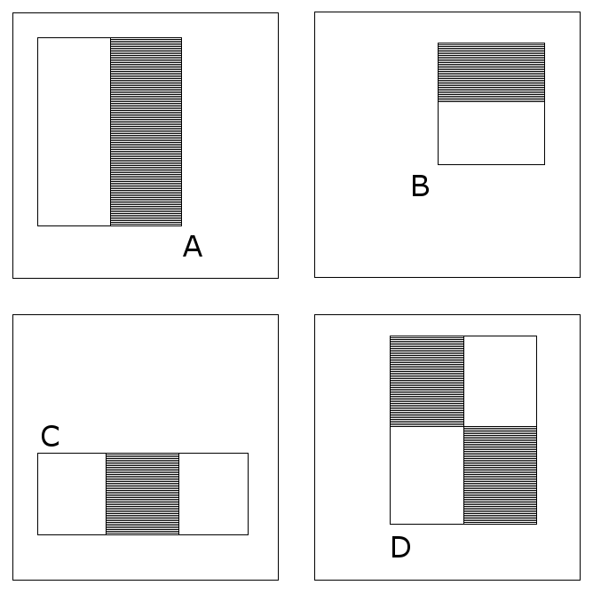
Fig.3 Different type of feature rectangular region
In A, B, D, the number of white rectangular regions equals to the number of black rectangular regions, so the eigenvalue can be calculated in the following formula:
𝜈=sum_{white}-sum_{black} (1)
While, in C, the formula will be 𝜈=sum_{white}-2*sum_{black} , this makes the number of pixels in black rectangular regions equals to the sum of number pixels in white rectangular regions.
Through altering the size and position of the feature template, we can list a lot of features in sub-region of image. The base resolution of the detector is 24x24, so the total set of rectangle features is quite large. That means the set of rectangle features is overcomplete. In a word, we select the Haar-like features from images. In this phase, we can also add a rotation feature to the existing features to handle rotated faces.

2.2.4 Creating an integral image
The one of the important contributions of Viola Jones algorithm is integral image. It can compute rectangle features very rapidly. Integral image is a 2-rectangle lookup table, it has the same size of the original image. Each element of the integral image contains the sum of all pixels located on the up-left region of the original image (in relation to the element's position). For example, we compute the sum of rectangular regions in the image using only four lookups, shown in the following Fig.4:
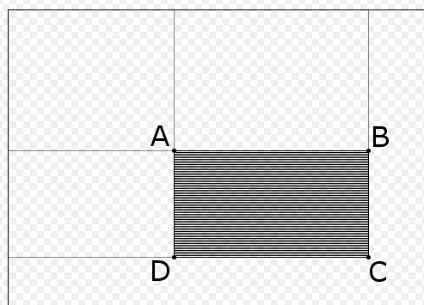
Fig.4 Integral image compution
𝑠um=I(C)+I(A)-I(B)-I(D) （2）
The points A, B, C, D belong to the integral image I, as shown in the figure. Each type of features needs different number of lookups. Viola and Jones’s 2-rectangle feature needs six lookups, 3-rectangle feature needs eight lookups, and 4-rectangle feature needs nine lookups.
In a word, integral image aims to calculate sum of all pixels in image through scan image once. This practice greatly improves the efficiency of computing eigenvalue of images. In this phase, the calculated elements will be preserved in memory, then compute the other elements using the saved value in memory. Now, we see how to compute the integral image. Integral image is a way to describe the global information matrix representation. The function shown as below:
f(k,𝜆), （3）
The steps of integral image algorithm:
- s(i, j) represents the cumulative of row direction, initialize s(i, -1)=0;
- ii(i, j) represents an integral image, initialize ii(-1, i)=0;
- scan image by row, compute each s(i, j) and ii(i, j) at each pixel (i, j) recursively:
s(i, j)=s(i, j-1)+f(i, j) (4)
ii(i, j)=ii(i-1, j)+s(i, j) (5)
f(i,j) represents the value at position (i,j) of original image.
- when scan reach to the bottom of the image, integral image construction finished.
As the above functions show, in an integral image, every pixel is the summation of the pixels above and to the left of it. Now, we use an example to show the calculation of integral image. Let’s see the following figure.
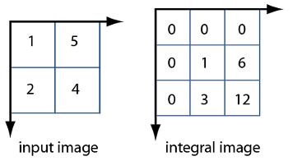
Fig.5 input image and integral image
In the figure, the pixel value at (2,1) in the original image becomes the pixel value (3,2) in the integral image after adding the pixel value above it (2+1) and to the left (3+0). The other pixel value is determined in the same manner. Then we will get the integral image.
In a word, using the integral image, every rectangular region sum can be calculated in four arrays. The integral image algorithm seems like a dynamic programming algorithm.

2.2.5 Adaboost training
AdaBoost, short for ‘Adaptive Boosting’, is a machine learning meta-algorithm formulated by Yoav Freund and Robert Schapire. In the Viola-Jones algorithm, adaboost selects a small number of critical visual features from a larger set and yields extremely efficient classifiers [13]. Now, we introduce the Adaboost machine learning algorithm.
Adaboost is adaptive in the sense that subsequent weak learners are tweaked in favor of those instances misclassified by previous classifiers. It is an iterative algorithm, aims to train different weak classifiers according to the same training data, then combine all the weak classifiers to construct a strong classifier. Adaboost changes the data distribution to achieve itself, it determines the weighted value of every sample according to the correction of each sample in each training set as well as the accuracy of the overall classification. The overview of the adaboost algorithm shown in below:
- train N training samples and get the first weak classifier;
- the misclassification data with other new data form a new N training samples and train the second weak classifier;
- cycle the step (2) and get the third, forth, …Tth classifiers;
- determine the weighted values of each weak classifier and get the final strong classifier.
As above section says, there are a lot of features to be computed, but experiments show that only a very small number of these features can be combined to form an effective classifier. The goal is to find these features. For each feature, the weak learner determines threshold to classify samples. The function shows below:
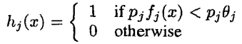 (6)
Here x is the 24x24 pixel sub-window of an image. h_{j}(X) is a weak learner, f_{j} is a feature and a polarity p_{j} indicates the direction of the inequality sign. The final strong classifier is combined with weak classifiers.

2.2.6 Cascading classifiers
As we known, traditional adaboost algorithm is time-consuming. According to this situation, the Viola-Jones algorithm proposed a cascade adaboost algorithm to save time. It achieves increased detection performance while radically reducing time. For example, each level of adaboost classifier gets a very high precision (99%), but it also has a high false positive rate (50%), then we cascade 20 small adaboost classifiers, we get a false positive rate as (50%)²⁰=9.5x10⁻⁷, while the accurary is (99%)²⁰=98%. We can see it is a good classifier.
Then, Viola-Jones algorithm proposed a simple and valid method to train cascade of classifiers:
- user determine the maximum acceptable rate of FPR (false positive rate) and minimum acceptable detection rate in each level;
- user determine the total FPR_{target};
- initialize FPR=1, D=1, D means detection rate;
- cycle: if FPR > FPR_{target} , add another adaboost classifier;
- when train current level classifier, if the current level features up to the f_{i}, then add new feature;
- in each level of classifier, the negative sample called false positive, this makes classifier cares more about the false positive samples;
Finally, we get multi overlapped face positions, then combine them as the final face position. The figure of the cascade process shown in Fig.7. Above are the brief introduction of the cascade classifiers, the details of the classifier refer to [13].
F
T
T
T
All Sub-windows
1
2
3
4
Future
processing

p
Reject Sub-window
T
F
F
F

Fig.7 sub-window of cascade processing
Above sections show the detail steps of Viola-Jones algorithm, we can use any language to implement it. In MATLAB, it provides a computer vision toolbox which have already integrated this algorithm. So, for convenience, we directly use this toolbox, the code shown as:
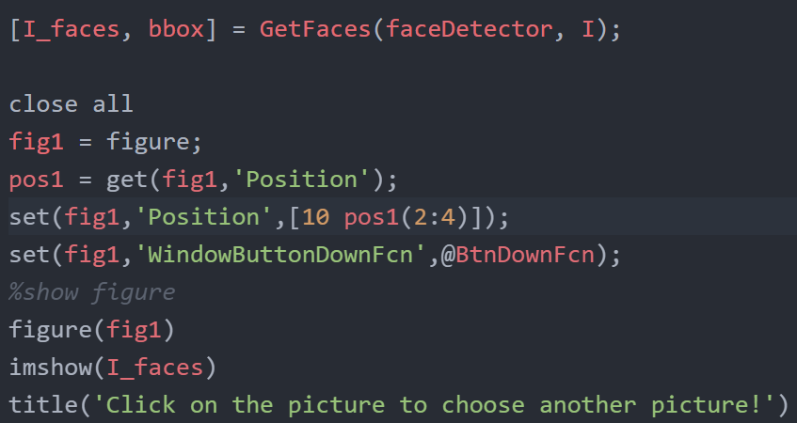

The codes use ‘vision.CascadeObjectDetector’ object to preserve the face detection class. This class encapsulates some methods to detect faces, we just need to call them. In the above code, we see the most important codes is the function called ‘GetFaces’. In this function, we use the ‘step’ method to get detected faces and a set of coordinates of bounding boxes shown in ‘bbox’. Then we use the ‘bbox’ to paint the bounding boxes on this figure and get the 2D coordinates.

2.2.7 Get 2D coordinates
In the above algorithm, we finish the face detection operation. In the MATLAB program, we use the bounding boxes to locate the faces, then these locations produce the 2D coordinates based on image coordinates system. In our program, we supposed the left-top point of the image as the 2D coordinate (0, 0). Then the left-top point of bounding box is the coordinates of the face which bounding box circled. Through all the coordinates, we can get the relative left-right 2D spatial relationships of detected faces. The MATLAB codes show as below:
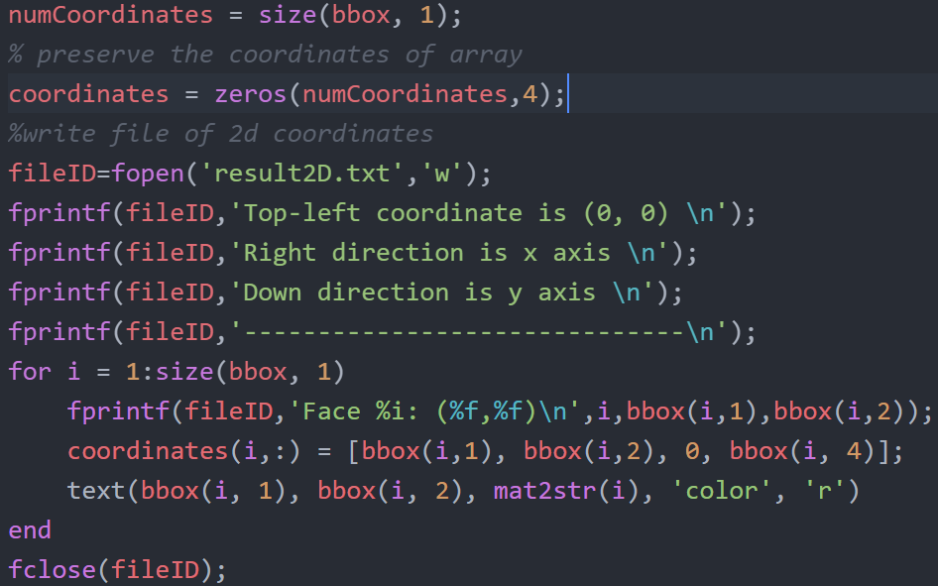
The above codes preserve the 2D coordinates of bounding boxes to files. As we can see, the output file named as ‘result2d.txt’. The 2D coordinates come from bounding boxes, we use the coordinates of bounding boxes to represent the position of faces. In this code，we not only output 2D coordinates in files, but also show the bounding boxes in the picture.

2.3 Depth information and 3D coordinates
In this phase, we get the depth information of a still image, and then show the 3D coordinates of the faces. As we known, computer can’t calculate the depth of faces itself because it just a 2D image. So we need to tell the computer what to do. So far, there are many methods to get the depth information, but a large percent of them use multi images, such as binocular images. We can compare all the images and compute the depth of objects according to the angles of shooting. The other methods most use a lot of images taken from different angles, then use these images to estimate the depth information.
However, in our requirements, we just have only one monocular still image which come from camera. There are also several methods to handle this situation. Most of these methods use prior knowledges: water is in the ground, sky and clouds above, texture information and gray information. But our methods choose to uses the ‘blur’ information to estimate depth information, such as Elder-Zucker and Hu-Haan algorithms.
As we known, each image taking by camera has a focal point (we assume that faces are in focus), then the background image looks blurry. Based on this common sense, we can estimate the blur information as the depth information. If we are able to measure the size of this blur, we can also produce a three dimensional depth map of the same image [17]. In this paper, we use two algorithms to estimate depth: Elder, Zucker algorithm and Hu, Haan algorithm. Then we standardize two depth information and combine them together. Below, we introduce these two algorithms respectively.

2.3.1 Problem Statement
In the paper, we use a still monocular image to detect human faces. When the image is captured in a small depth of field, the object which away from the focal plane is out of focus and is considered to be ambiguous. The image includes objects with image focusing and defocusing and then object may therefore be segmented in depth. So if we are able to measure the size of this vague, we can also produce the same three-dimensional depth map of the image. Below, we use two algorithms to estimate depth information: Elder-Zucker algorithm and Hu-Haan algorithm.

2.3.2 Elder and Zucker algorithm
The Elder and Zucker algorithm is a popular algorithm used for graphics. It mainly includes two parts: Edge Detection and Blur Estimation.
- Edge Detection:
Edge detection is the name for a set of mathematical methods which aim at detecting points in a digital image at which the brightness of images changes sharply or, more formally, has discontinuities. Edges in the images have many properties, we use these properties to accomplish edge detection algorithm. The edges extracted from 2D images can be divided into viewpoint dependent and viewpoint independent. A viewpoint independent edge which means hardly changed, typically reflects inherent properties of the three-dimensional objects, such as surface markings, surface shape and surface texture. While, a viewpoint dependent edge may change as the viewpoint changes, and typically reflects the geometry of the scene, such as objects occluding one another, lighting of the objects and surface color of objects.
Image edges are usually found where there is a sudden change in image intensity. This will result in local minima or maxima of the first derivative of the intensity. Unfortunately, real images are corrupted with noise, which can change faster than the image data. An effective edge detector must be able to differentiate between real intensity transitions and sudden noise transitions. Edge detectors are typically designed to recover step discontinuities in an image, however the boundaries of physical structures in the world generally do not project to the image as step discontinuities [16]. The principle of edge detection shown in the following Fig.9.
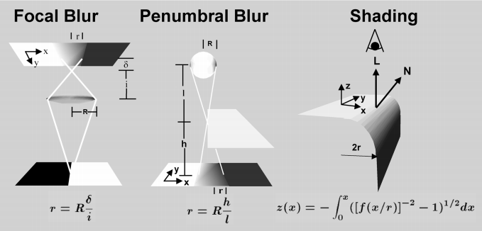
Fig.9 Edge detection
In the above image, the left of the figure shows a straight, sharp reflectance edge, away from the object plane, so that the physical edge projects to the image as a blurred luminance transition; the center of the figure represents the transition of the shadow of a straight-edged object onto a flat ground surface by a spherical light source; the right of the figure shows a slightly rounded object edge produce a blurred edge by the above illumination and view. In a word, we can get edges according to the situations above.
Traditional edge detectors filter noises by using an isotropic Gaussian filter. The standard devitation of this filter determines how many neighboring points are considered significant by the filter kernal. The larger it is, the more points will be contained in the result. However, Elder proposed a multi-scale or multi-resolution approach where different scales of sigma are employed. For example, sharp image with little noise require a narrow filter while blur noise images require a broad filter. For each point in the gradient map, Elder-Zucker determines the "minimum reliable scale" (the smallest filter that can be used reliably) and uses that scale locally. After computing the "minimum reliable gradient," it uses that information for a second "minimum reliable Laplacian" steered in the gradient direction (direction of the edge-normal). In this way, it only tries to compute a 1D Laplacian locally across edges. Zero-crossings in the "minimum reliable Laplacian" will indicate edge locations.
In a word, Elder and Zucker algorithm performs a edge detection using local scale control, and use reliable scales to detect valid edges which suited for blur estimation. We conclude the edge detection as three stages:
(1) Use local scale control to estimate the gradient at each image point.
(2) Use local scale control to estimate the second derivative of intensity function of the gradient direction at each point of image.
(3) Use zero-crossing of the second derivative in the gradient direction to locate edges.
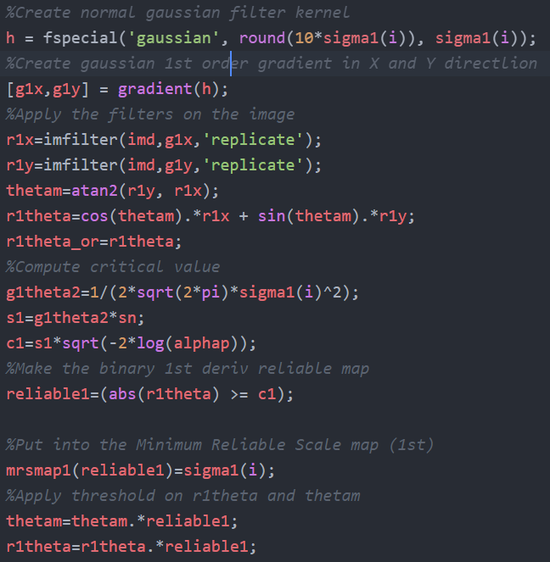
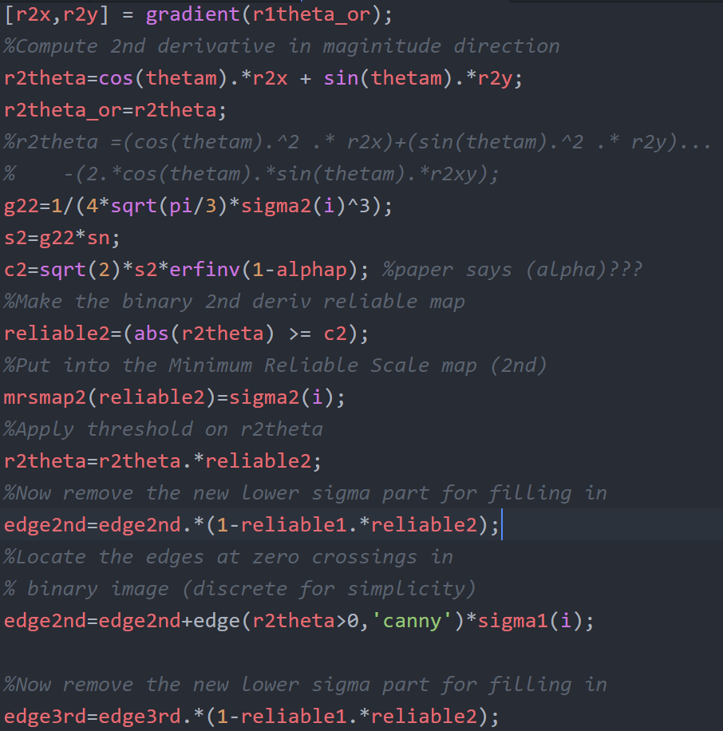
As the above codes show, we use the gradient method to determine the edges. We use the canny operator to get the edges. In this codes, we can see the three stages: ‘reliable1’ and ‘reliablee2’ coorespond to the first two stages, while ‘edge2nd’ represents the last stage. At last, we use canny operator to find edges. The canny operator is not discussed in detail here.
- Blur Estimation:
In the above phase, we use the edge detection to reliable edges transferred to blur estimation. As we known, small estimation filters will lead to large errors in blur estimation due to noise, while large estimation filters also increase errors due to interference between distinct structures. So Elder proposed the following to estimate the blur at a particular edge:
d=distance in pixels between extrema in 2nd derivative map
s=minimum reliable scale for second derivative operation
blur=sqrt((d/2)²-s²) (7)
The theory behind this is very straightforward. d is an estimate of the sharpness of the edge. However, we cannot estimate this better than the minimum reliable scale, so we correct for that in the estimate. Due to the uncertainty afforded by the minimum reliable scale, we err on the side of less blurring, blurring only those pixels that we are sure need blur. According to the blur function, the blur due to defocus can be estimated from the measured thickness of the contours, after compensation for the blur induced by the estimation itself. We use several scales to estimate depth information, the result shown in the following figure, it represents the depth information of each pixel.
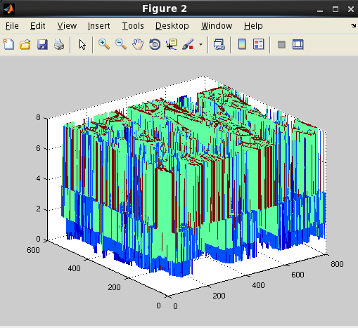
Fig.10 depth of each pixel
In a word, despite the noise in the algorithm for blur estimation, it may still be employed usefully to segment image structure into distinct depth planes. It produces blur estimation with different scales of maps. The Elder-Zucker algorithm shows a good performance.

2.3.3 Hu and Haan algorithm
Nowadays, focal blur estimation is an important topic in many other applications, such as restoring blurred background, 3D reconstruction and so on. The Hu-Haan algorithm is a novel local blur estimation method. It uses focal blur which is usually modeled as Gaussian blurring. It means that the focal blur process is usually modeled as a Gaussian low-pass filtering and then the problem of blur estimation is to identify the Gaussian blur kernel [19].
The Hu-Haan algorithm proposed blur estimation based on two aspects: an ideal edge and a blur kernel. The edge function shows below:
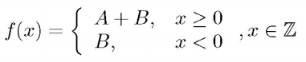 (8)
f(x) is a step function, x is the position, A is the amplitude and B is the offset. While the focal blur kernel function shows as:
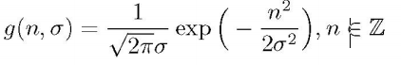 (9)
𝜎 is the unknown blur radius to be estimated. The algorithm mainly uses these two function to estimation depth.
In the Hu and Haan proposed method, the blurred input image is first re-blurred by Gaussian blur kernels with different blur radii. Then the difference ratios between the multiple re-blurred images and the input images are used to determine the unknown blur radius. That means Hu and Haan proposed a straightforward method for blur estimation. The blur radius can be easily calculated from the difference ratio, and it is independent from the edge amplitude. In their approach, they reblur the signal to be determined twice with Gaussian kernels ,𝜎-_{a} and 𝜎-_{b} to determine the local blur 𝜎- of the signal. The method applies a robust local blur estimation to obtain a blur map of the image. The estimation uses the maximum of difference ratio between the original image and its two digitally re-blurred versions to estimate the local blur radius [17]. The steps of blur estimation show below:
- One dimensional signal (seems as 1D image):
𝑔(n, 𝜎..)=C(𝜎)exp(-n²/(2𝜎²)), n∈Z (10)
Where 𝜎 is the unknown blur radius to be estimated and C(𝜎) is the normalization factor. The constraints are:
𝛴_{n∈Z} g(n,𝜎)= 𝛴_{n∈Z} C(𝜎)exp(-n²/(2𝜎²))=1 (11)
- Two dimensional signal (2D image):
We use two parameter 𝜎₁, 𝜎₂ to represents two Gaussian functions:
g(n, 𝜎₁)*g(n, 𝜎₂)=g(n, sqrt(𝜎₁²+ 𝜎₂²,-,)) (12)

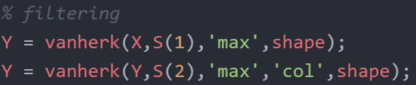
Above codes, we use two Gaussian kernel to handle images. Then use the vanherk function to do the filtering process. The total codes shown in the MATLAB files.
For the blur estimation in images (2D signals), we use a 2D isotropic Gaussian blur kernel for the re-blurring. The following flow chart shows the architecture of the blur estimation. The main codes show in below:
Input image
Blur (𝜎₁)
Blur (𝜎₂)
Different ratio pixel-wise
Difference ratio block-wise
Difference ratio block-wise
Blur map

Fig.11 Flow chart of blur estimation

In the above codes, the ‘ blurmap’ preserve the blur estimation of the image. We can see from the codes, the ‘blurmap’ is an array which preserves the blur information.
In a word, this algorithm using the 2D signal rather than Elder-Zucker algorithm. The principle of the Hu and Haan algorithm is easy to understand as a whole. We proposed an example to explain the principle. For example, you have an image, in the image, there are focal region and non-focal region. Because an object out of focus will produce a blur because it is too far away from the focal plane. The non-focal region seems like blur. As we known, most of the blurring are using Gaussian filter to implement. So we reblur our image using Gaussian filter with two ratios parameters. Then we use these two reblurring images to estimate the blur ratio of the original picture. So we can get the depth information from the blur map. Actually, it already hints to distance or depth. Based on this, we can get the estimated depth information of all faces. The details of this algorithm refer to the paper [17,19].

2.3.4 Combination of two algorithm
In our program, we use MATLAB to implement these two algorithms. Each algorithm produces a 3D coordinates. For example, if the image contains two faces, then Elder-Zucker algorithm and Hu-Haan algorithm each produces a 3D coordinates, their first two coordinates are the same. Each algorithm has its own depth information. So we first normalize each depth information in each algorithm. Then we get the average value of the two depth information in two algorithms. The calculated depth information will be the final depth of faces. As we see, the final depth of 3D coordinates ranged in (0,1). The higher the depth is the closest the face to the camera. The codes in MATLAB shown as:
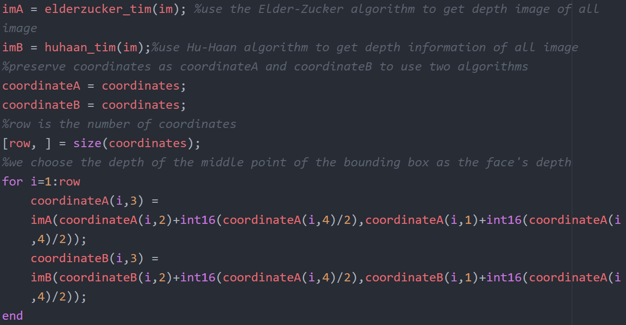
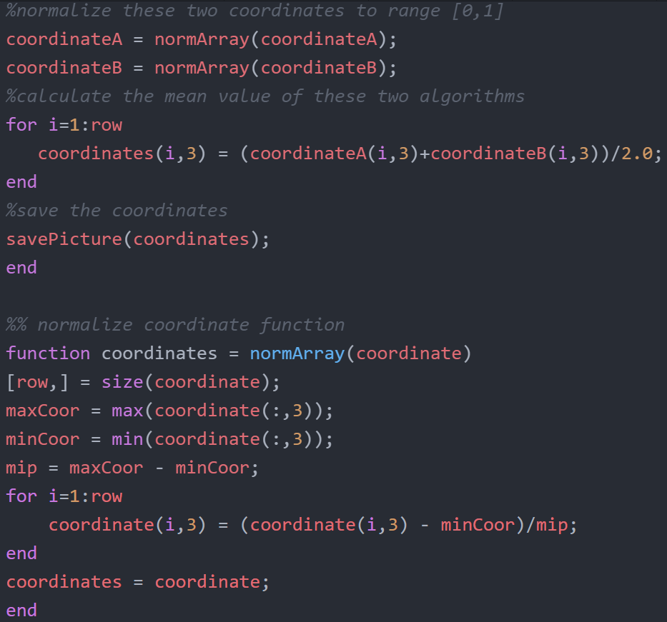
We use the center point of the bounding box as the depth point of the detected face. That means we use this point to estimate depth, because the left-top point of bounding box may not be the face. In the above codes, ‘coordinates’ represents the coordinates of all bounding boxes, ‘coordinateA’ and ‘coordinateB’ are the coordinates of blur estimation of algorithms, ‘normArray’ function used to normalize the coordinates which can be seen in the codes. At last, we combine two coordinates together to get the final 3D coordinates.

Chapter 3: Experiments

3.1 Configuration
We use MATLAB2014 to code our program in Linux environment. We use Redhat as our Linux system. The version of Redhat is 6.0. The architecture of our program shown in the following figure:
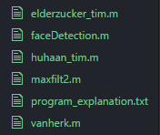
Fig.12 Architecture of program
In above figure, each blur estimation algorithm is a MATLAB file: “elderzucker_tim.m” and “huhaan_tim.m”. The entry point of this program is the “main” function in “faceDetection.m” file. This file also implements the face detection. Another two files: “maxfilt2.m” and “vanherk.m” are the functions that will be called by Hu-Haan algorithm. So the execution flow shown as follows:
faceDetection.m
start
end
elderzucker_tim.m
hu_haan.m
maxfilt2.m
vanherk.m

Fig.13 Flowchart of program

3.2 Experiment Results
Based on the above description, we see that our work mainly focuses on two parts: face detection and getting coordinates. So, in our experiments, we divided it into two parts: Face detection and get Coordinates. Below, we introduce these two parts respectively.

3.2.1 Face Detection
In this part, we use MATLAB computer vision toolbox to implement the face detection. Actually, it is the implementation of Viola-Jones algorithm. Firstly, it converts a RGB image to grey image and do the edge detection operation, then use the features to detect faces, lastly draw up the faces with bounding boxes. Here we choose several images to test this, the results show below:
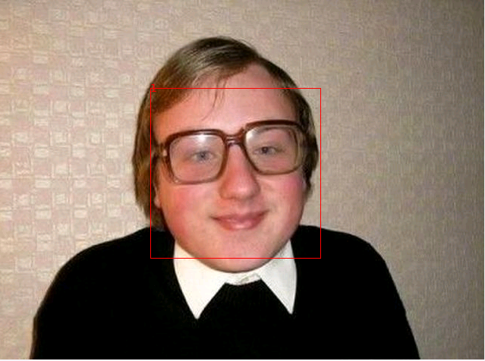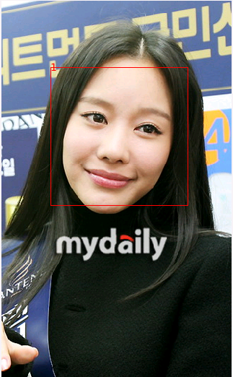
Fig. 14 Face detecion
We can see from the pictures, the bounding boxes are used to locate the faces. But in the above two images, we only have a single face in the image. When we have many faces in the image, we may get a false positive rate. The result shows in the following picture.
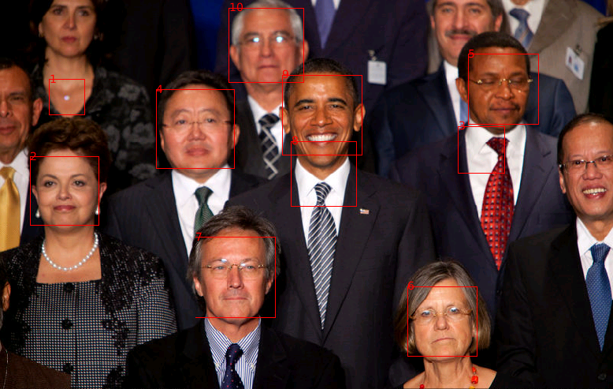
Fig.15 Multi-faces detecion
From the picture, we see that there are some non-faces are marked. This is because the face detection algorithm is not very precise, the non-face rectangular region seems like a face. In other words, non-faces regions has the same features as this algorithm trained. Another point is there are some faces has not been identified. As above says, the Viola-Jones algorithm mainly useful for positive full faces photos. So in the picture some half-faces do not detected. The left-top woman has full face, but she is also not detected, because it is fuzzy which we can not extract features as faces have. In future, we will do the improvement with Viola-Jones algorithm to get a better performance with half-faces.
It is worth mentioning that in the picture the bounding boxes are numbered. The numbers are not only on behalf of the recognition sequence, but also provide convenience to the later coordinates.

3.2.2 Get Coordinates
In our program, we not only get the 2D coordinates, but also get the 3D coordinates with a focus image. So in this section, we introduce the coordinates about 2-dimensional and 3-dimensional coordinates respectively. In the image, we use Left-Hand coordinate system. We define the right direction as x axis, down direction as y axis and the direction pointing to you as z axis. We use four situations combined with human face amounts to introduce the performance:
- 2-dimensional coordinates and single face in image:
As we talked above, the 2D coordinates are the positions relative to the top-left coordinate (0, 0) of the image.
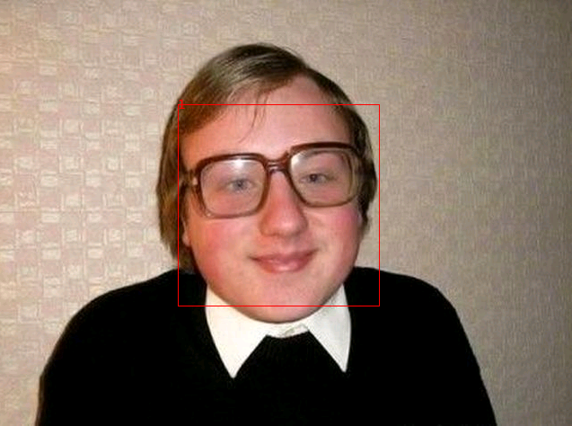
Fig.16 Single-face
In the above picture, we use the bounding box which is numbered with 1 to represent the face, the 2D coordinates of the face can be replaced by the coordinates of the left-top point of the bounding box, then the output of the 2D coordinates shown in the following:
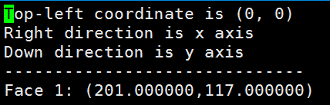
Fig.17 2D coordinates of single face
The picture shows the 2D coordinates of the face 1. The number 201 represents the horizontal pixel distances to the left of the image, 117 represents the vertical pixel distances to the top of the image. Because there are just one face in the image, so we only get one 2D coordinates, let’s see multi-faces situation.
- 2-dimensional coordinates and multi faces in image:
In this situation, we have multi faces in the image, so we get multi coordinates of faces. The result shows below:
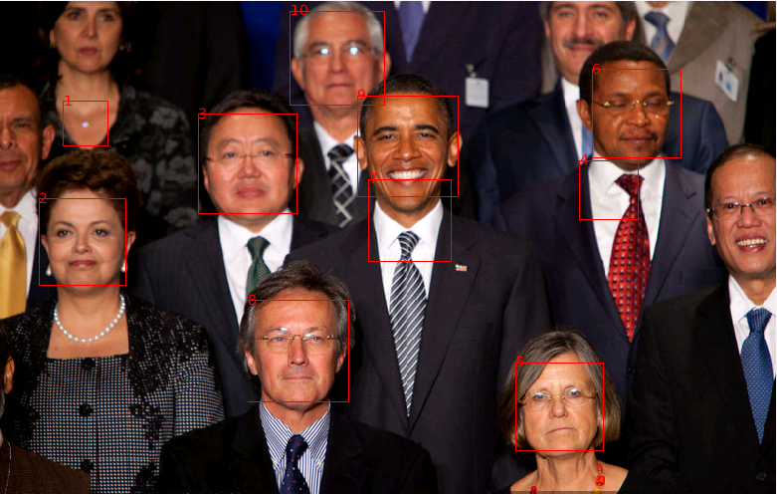
Fig.18 Multi-faces
There are 10 detected faces in the image. We can see them from the sequence number. However, there are some mistakes in the detection. The reasons about the mistakes are shown above. In this phase, we do not remove the mistake faces. That means we calaculate coordinates of all the 10 faces. The coordinates of bounding boxes show as below:
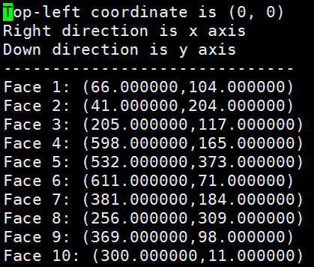
Fig.19 2D coordinates of Multi-faces
The 2D coordinates are the same meaning as the above. Through these coordinates we can judge the left and right relationships of all the faces using the vector direction between faces, such as face 5 is right of face 8 from the point of our eyes. This relations is mirror to the relations in image.
- 3-dimensional coordinates and single face in image:
In this section, we need to calculate depth information. If the image has a single face, it has no spatial relationship with other faces, the depth information has no meaning. So we do not take it into consideration.
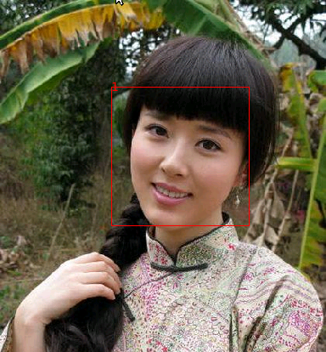
Fig.20 Single face
The 2D coordinates are the same, we see the 3D coordinates.
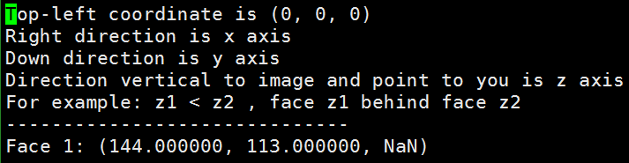
Fig.21 3D coordinates of single face
In the figure, we see the 3D coordinates, but the third coordinate are NaN. The reason is that through Elder-Zucker and Hu-Haan algorithms, we get two depth information, then we normalize the depth respectively, the codes shows as below:
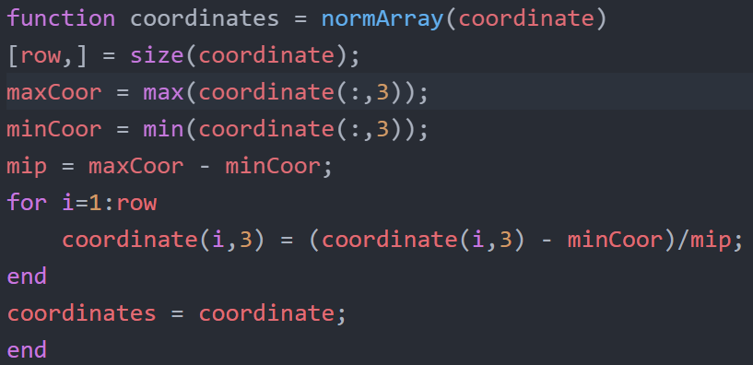
Fig.22 normalize array
In this code, we see if we just have one coordinate, the return value will be zero. Then the divide 0 mistake gets “NaN”. However, one face has no relations with others, so its value has no meaning. Then the “NaN” is okay.
- 3-dimensional coordinates and multi faces in image:
In this section, we will see the 3D coordinates. We show all the coordinates of the bounding boxes in the images, in spite of non-faces or faces.
Fig.23 Multi-faces
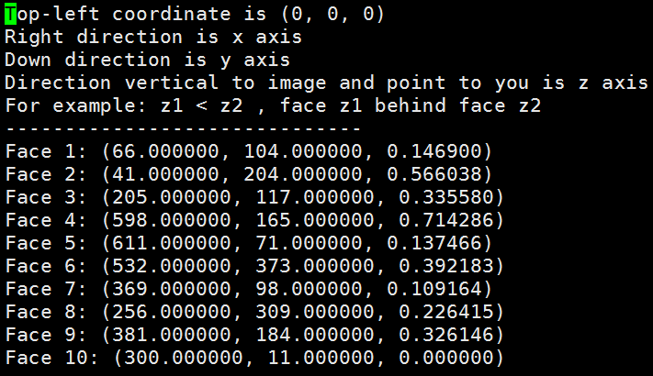
Fig.24 3D coordinates of multi-faces
We can see from the picture, face 10 has the smallest depth, so it is the farrest from us. However, it has some mistakes, for example, face 4 has the largest number, it means closest to us, but it is wrong from the picture. Another problem is that if two faces have the same depth, the coordinates of depth will not be the same. In this case, we may combine the x, y values and z value to judge the relations. For example, if two people have a small displacement, it may has a front-behind relations. Otherwise, if they have a large displacement, we use the depth information, set a threshold depth value to judge relations. If the distance of depth exceeds the threshold value, then they have front-behind relations, otherwise they stand in the same plane.
In brief, we use three algorithms to detect faces and calculate depth information of faces. The bounding boxes and depth information consist of 3D coordinates. We can use 3D coordiantes to calculate the spatial relationship between faces. In the next section, we evaluate these algorithms using serveral experiments. These experiments come from the articles which introduce these algorithms.

3.3 Evaluations
In this section, we evaluate these three algorithms: Viola-Jones algorithm, Elder-Zucker algorithm and Hu-Haan algorithm respectively. Below, we simply do some experiments to evaluate them.
- Viola-Jones algorithm: The advantage of this algorithm is to use cascade of classifiers. So in order to explore the feasibility of the cascade approach two simple detectors were trained: a monolithic 200-feature classifier and a cascade of ten 20-feature classifiers. The first stage classifier in the cascade was trained using 5000 faces and 10000 nonface sub-windows randomly chosen from non-face images. The second stage classifier was trained on the same 5000 faces plus 5000 false positives of the first classifier. This process continued so that subsequent stages were trained using the false positives of the previous stage.
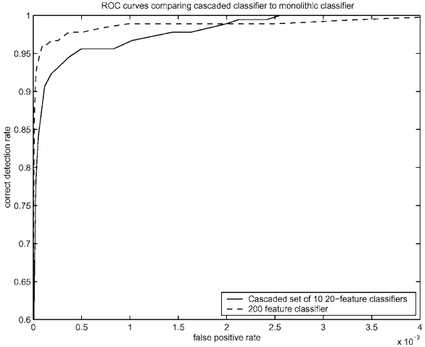
Fig.25 ROC curves comparing a 200-feature classifier with a cascade classifier containing ten 20-feature classifiers.
In the above figure, it gives the ROC curves comparing the performance of the two classifiers. It shows that there is little difference between the two in terms of accuracy. However, there is a big difference in terms of speed. The cascaded classifier is nearly 10 times faster since its first stage throws out most non-faces so that they are never evaluated by subsequent stages.
- Elder-Zucker algorithm:
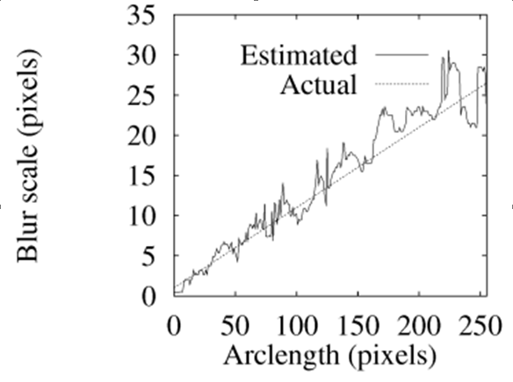
Fig.26 Estimated vs. actual blur scale along edge
In the above figure, we can see the blur accuracy of Elder-Zucker algorithm. In this situation, if we get a blur image, we can get a well performance about getting depth information. In this experiment, we see that our blur estimation is very similar to actual blur scale with edges. The Abscissa represents the different length of rectangular region for detection. We use different images with different actual blur scales, then we use edge detector to estimate blur scales. The experiment shows the good performance.
- Hu-Haan algorithm:
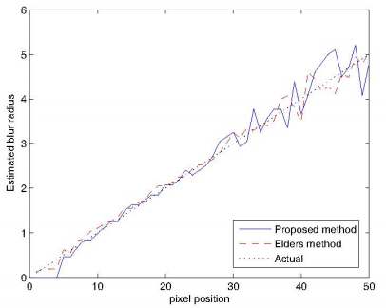
Fig.27 Estimated blur radius on the image
This experiment is similar to the above. The Abscissa has the same meaning, and the vertical coordinate shows the precision of blur estimation, named blur radius. In this figure, we can see the Hu-Haan algorithm get a little better performance than Elder’s method. We combine these two methods together to get the relatively better accuracy than them. Then we get the 3D coordinates of detected faces. Using these coordinated, we can deduce the relationships between faces.

Chapter 4: Conclusion
In this section, we conclude our work. Our work divides into two parts. In face detection, we use the Viola-Jones algorithm to detect faces. Viola-Jones algorithm is a basis computer vision algorithm for object detection, mainly for face detection. It gets a relatively good performance in spite of some false positive rate. The main points of Viola-Jones algorithm are Haar-like feature extraction and Adaboost cascade classifiers. The explanation of these points show in the above. We can also refer to the paper by Viola and Jones [13]. The side effect of the algorithm is showing the bounding boxes. Each bounding box corresponds to a face. Based on this, we can get the 2D coordinates about the top-left of the bounding box which represents the coordinate of the face. Then the contribution of the Viola-Jones algorithm is not only the face detection, but also the 2D coordinates of the faces.
Another part is extracting depth information of faces. We use Elder-Zucker and Hu-Haan algorithms to get depth together. Elder-Zucker algorithm use two core components: Edge Detection and Blur estimation. In edge detection, we can get the blur boundary which will be used in blur estimation. In blur estimation, we use the blur information to get the focal and non-focal depth. In Elder-Zucker algorithm, we get the 3D coordinates. While in Hu-Haan algorithm, the core component is blur estimation. The difference between Elder-Zucker and Hu-Haan algorithms is that in the later algorithm we use two Gaussian function to produce blur map. In Hu-Haan algorithm, we also get the 3D coordinates. Then we get two 3D coordinates in our main function. In this function, we normalize these two 3D coordinates to range (0,1) and combines them. So the z-axis of the final 3D coordinates will be ranged to (0, 1).
As we get all the 3D coordinates of the faces, we can calculate the relative spatial relationships of faces. The final step of this program is to output the coordinate files and show pictures with bounding boxes.

Chapter 5: Future Work
As we can see from the image with multi faces, we can see two mistakes. This is the improvement we need to do in the future:
- From the image, the bounding box 1,4,7 are not faces:
According to this mistake, we use some prior knowledge to judge whether it is a face. For example, the bounding box 1 is not a face, when we bounding it in the image, we do an additional verifying operation to judge all the bounding boxes, such as detect eyes, noise or mouse. Another improvement of this phase is that we can extract more features to detect faces. But this method is very hard, because we can hardly find the common feature of all faces.
- In the image, there are some faces not detected:
In this phase, we can see that the faces with non-focal and the faces without showing all. In this situation, the reasons are the Viola-Jones algorithm does not work very well. So we can train a face library with thousands of face images (including non-focal faces and half faces), then use this library to detect faces. If the face library trains very well, we will get the better precision. Another trick is adding some prior knowledges, such as human is in the center of the image as common sense.
However, the above improvements are aimed at the Viola-Jones algorithm, then the improvements aimed at Elder-Zucker and Hu-Haan algorithms are in edge detection and blur estimation.
- Edge detection:
In this phase, we can use a new edge detection algorithm to get a better performance, such as improved Canny algorithm. The functions of this algorithm can also be altered to detect edges more precisely.
- Blur estimation:
The blur estimation of Hu-Haan algorithm is better than Elder-Zucker algorithm, because it uses two Gaussian functions to do the blur estimation. In this section, we can also use the new blur estimation algorithm or adjust the weights of two algorithms to produce the final 3D coordinates.
Another improvement is that we can use multi images to get depth information, such as we can use Kinect equipment to take images which already contain depth information.
In summary, we get the face detection with bounding boxes and depth information for 3D coordinates.

References
[1] I.Maglogiannis, D.Vouyioukas, and C.Aggelopoulos (2009), “Face detection and recognition of natural human emotion using markov random ﬁelds”, Personal and Ubiquitous Computing, pp:95–101.
[2] J.D.Woodward (1997), “Proceedings of IEEE”, pp:1480～1492.
[3] Sung K. and Poggio T. Example-based learning for view based human face detection. IEEE Trans. on Pattern Analysis and Machine Intelligence, 1998, 20(1): 39-51
[4] P.Kuchi, P.Gabbur, P.Subanna Bhat, et al (2002), “Human face detectionand trackingusing skin color modeling and connected component operators”, IETE journal of research, pp:289–293.
[5] S Huang, G Z Yang. Human Face Detection in a Complex Background[J] . Pattern Recognition, 1994 , 27( 1) : 53- 63.
[6] Kotropoulos, I Pitas. Rule- based Face Detection in Frontal Views Proc[ C] . Int’l Conf. Acoustics, Speech and Signal Processing, 1997. 2537- 2540
[7] Viola P, Jones M J. Robust real-time face detection[J]. International journal of computer vision, 2004, 57(2): 137-154.
[8] Brunelli R, Poggio T. Face recognition: Features versus templates[J]. IEEE Transactions on Pattern Analysis & Machine Intelligence, 1993 (10): 1042-1052.
[9] Pentland A, Moghaddam B, Starner T. View-based and modular eigenspaces for face recognition[C]//Computer Vision and Pattern Recognition, 1994. Proceedings CVPR'94., 1994 IEEE Computer Society Conference on. IEEE, 1994: 84-91.
[10] Bloch I. Fuzzy spatial relationships for image processing and interpretation: a review[J]. Image and Vision Computing, 2005, 23(2): 89-110.
[11] M.Oge (2011), “Practical Image and Video Processing Using MATLAB”.
[12] G.C.Rafael (C2010 2nd en.), “Digital image processing using MATLAB”, McGraw Hill Education India.
[13] Viola P, Jones M. Rapid object detection using a boosted cascade of simple features[C]//Computer Vision and Pattern Recognition, 2001. CVPR 2001. Proceedings of the 2001 IEEE Computer Society Conference on. IEEE, 2001, 1: I-511-I-518 vol. 1.
[14] Viola P, Jones M. Robust real-time object detection[J]. International Journal of Computer Vision, 2001, 4: 51-52.
[15] Zaman T. Depth Estimation from Blur Estimation[J].
[16] Elder J H, Zucker S W. Local scale control for edge detection and blur estimation[J]. Pattern Analysis and Machine Intelligence, IEEE Transactions on, 1998, 20(7): 699-716.
[17] Hu H, De Haan G. Adaptive image restoration based on local robust blur estimation[C]//Advanced Concepts for Intelligent Vision Systems. Springer Berlin/Heidelberg, 2007: 461-472.
[18] Papageorgiou C P, Oren M, Poggio T. A general framework for object detection[C]//Computer vision, 1998. sixth international conference on. IEEE, 1998: 555-562.
[19] Hu H, De Hann G. Low cost robust blur estimator[C]//Image Processing, 2006 IEEE International Conference on. IEEE, 2006: 617-620.

