Spatial Relationships of Detecting Faces in single Image

Contents
Contents 2
Abstract: 4
Chapter 1: Introduction 5
1.1 Face Detection 5
1.1.1 Knowledge-based Face Detection Methods 6
1.1.2 Feature Invariant Face Detection Methods 7
1.1.3 Template Matching Face Detection Methods 8
1.1.4 Appearance-based Face Detection Methods 8
1.2 Spatial Relationships 9
1.2.1 2-Dimentional spatial relationships 9
1.2.2 3-Dimentional spatial relationships 10
1.3 MATLAB Introduction 10
1.3.1 Image Processing Basics 11
1.3.2 Image Type Converting 11
1.3.3 Image Enhancement 11
1.3.4 Computer Vision Toolbox 12
Chapter 2: Implements and Analysis 13
2.1 Face Detection and 2D Coordinates 13
2.1.1 Problem Description 14
2.1.2 Viola-Jones Algorithm 14
2.1.3 Haar-like feature selection 15
2.1.4 Creating an integral image 16
2.1.5 Adaboost training 17
2.1.6 Cascading classifiers 18
2.1.7 Get 2D coordinates 18
2.2 Depth information and 3D coordinates 19
2.2.1 Problem Statement 19
2.2.2 Elder and Zucker algorithm 19
2.2.3 Hu and Haan algorithm 21
2.2.4 Combination of two algorithm 23
Chapter 3: Experiments 24
3.1 Configuration 24
3.2 Experiment Results 24
3.2.1 Face Detection 24
3.2.2 Get Coordinates 25
Chapter 7: Conclusion 29
Chapter 8: Future Work 30
References 32

Abstract:
With the rapid development of graphics field, more and more people are engaging in the vision field. In the vision field, face recognition is one of the most popular direction which now is being researching. Face recognition system actually contains constructing a series of related technologies, including facial image acquisition, face detection, face recognition pretreatment, identification and identify searching and so on. We can see that face detection is the basis of the face recognition technology. Face detection is a computer technology that determines the locations and sizes of human faces in arbitrary images. It detects facial features and ignores anything else, such as buildings, trees and bodies. In the field of computer vision and biometrics, face detection is a hot spot. Face detection is widely used in practice in the real world. Sometimes, we not only need to mark faces, but also need to judge the relative positions of the faces marked. The relative positions of the faces also called spatial relationships between faces. In this relationship, the most difficult is how to get a 3D relationship using a 2D image. This means, not only the plane relations are considered, but also the depth relations will be concerned. Then, the hardest will be how to calculate the depth information of all faces that detected.
Based on the above problems, this paper consists of two parts: face detection with Viola-Jones algorithm; spatial relationships of faces that detected with Elder-Zucker and Hu-Haan algorithm. In our method, it is worth to say that we just use a single monocular 2D image to detect faces and get the depth information of all detected faces. We divide spatial relationships into two situations: 2D relationships of faces in image and 3D relative spatial relationships between detected faces.

Chapter 1: Introduction
With the rise of artificial intelligence techniques and advances in study of computer vision and computer graphics, more and more people are engaging in the research work of face recognition. Face detection is the basis of the face recognition which is widely used in various places such as monitoring, identity recognition. We can see that face detection is an important research direction in graphics. Coincidentally, spatial relationship is another important research direction. Because, people not only want to know whether an image has faces, but also the spatial relationships between them. It is widely used in identifying human positions. Spatial relationship represents the location relationships between objects detected in images which includes 2D relationships and 3D relationships. In this area, the common research works put emphasis on the depth information of images which can reflect the 3D relative positions between objects in images. The depth information of image can be used in a lot of aspects, such as binocular stereo vision, motion sensing game and so on. Below, we will introduce face detection with Viola-Jones algorithm and spatial relationships combined with Elder-Zucker and Hu-Haan algorithms to get depth information in brief respectively.

1.1 Face Detection
With the development of the society, all aspects on fast effective of automatically identity validation of requirements are increasingly urgent. Because biological features are the inner properties of human and are strong self-stability and individual differences. That means we can use these inner properties to distinguish one from others. As a result, biological features are the most ideal basis of identity validation [12]. And in the biological features, human face features for identity validation is most natural directly of means. In common sense, two people are scarcely possible of looks exactly the same. Compared with other human biological features, it is directly, friendly, convenient, and easy to be accepted by users [1]. Face detection problem was first raised as an automatic face recognition positioning system. In recent years, due to its value of vision inspection, security access control and other areas, it started as a stand-alone issue received wide attention from researchers. Face Detection means to determine if it exists human faces in the given images, if exists, then give the position of all the faces, size and poses of the faces.

Face detection has important academic value. Face is a kind of natural structure of the target with a rather complex details of changes, the detection problems of these targets lies below [27]:
- Since the difference of appearance, facial expression, angles of faces and skin color between humans, detection pattern has variability;
- Human’s face in a generic sense, may be with glasses, beard and other appendages;
- As a person’s face is 3D object, it inevitably affects by the shadow of the lights while taking photos.
Thus, it is hard to get a big improvement in the area of face detection and so far, no one face detection algorithm achieves the 100 percent accuracy of all images.

Human face detection is the most outstanding one of visual capacity of humans. It involves pattern recognition, image processing, Physiology, psychology, cognitive science, and other biometric-based identification methods and closely tied to the field of computer-human-perception interaction [22]. Face detection includes a wide range of issues, there are many classifications from different angles, such as gray image, color image, single people image, multi people image and so on. Through there are many classifications, the face detection methods are mainly the following four types:
- Knowledge-based Face Detection Methods: It forms a rule base with typically human faces and encodes human faces. In general, the method locates human face through the relations between face features.
- Feature Invariant Face Detection Methods: This objective of this method is to find the existence structure in the condition of changing pose, angle of view and lighting. Then use the structure to detect human faces.
- Template Matching Face Detection Methods: Preserve several patterns of faces which used to describe total face and facial feature; then calculate relationships between input images and preserved patterns to detect faces.
- Appearance-based Face Detection Methods: This method trains models from a set of images and use the model to detect faces.
Below we explain these methods respectively.

1.1.1 Knowledge-based Face Detection Methods
Knowledge-based face detection methods are also called Rule-based face detection methods. These rules come from priori knowledges. It is easy to propose several simple rules about face features and their relations intuitively. For example, if an image has a human face, commonly it has symmetrical eyes, nose and a mouse. So we use the relative distances and positions to describe relations between them. In a word, we first extract face features and determine the face candidate regions based on encoding.

However, the existing problems of this type of methods is that it is hard to convert human knowledges to clearly defined rules. For example, if the rules are detailed, it can be failed because it can’t use all rules to detect faces; else if the rules are simple, it will get a low percent of accuracy. Besides, it is difficult to expand this method to the images that people has different poses, because it impossible to list all the situations of human poses.

Yang and Huang use the layered knowledge-based face detection method [28]. Their method uses three layers of rules:
- Find all the faces candidate regions through scanning the window of input images.
- Describe what human face looks like.
- Use more facial details to detect faces.
There are also some other knowledge-based methods. Kotropoulos and Pitas proposed a new method to locate faces [29]. In a word, knowledge-based methods mean that we use priori model to detect the input images.

1.1.2 Feature Invariant Face Detection Methods
Feature Invariant methods detect human faces not only from facial features, but also from geometrical relationship of facial features. Different from knowledge-based methods, feature invariant methods find the invariant facial features. As common sense says, from the front view, human always have features of two eyes, one nose and one mouse. Human faces have abundant pattern features. It is a key study point to determine which feature is useful and how to use the features to detect faces. The following figure shows the common features of human faces.
Face features
Color feature
(skin, hair)
Contour feature
(cartouche)
Heuristic feature
(hair, mandible)
Template feature
(mean, distance)
Transform feature
(eigen face, wavelet)
Structure feature
(symmetry, projection)
Mosaic map feature
(mosaic)
Histogram feature
(distribution, distance)

Fig.1 Face detection features
The facial features are mainly extracted by edge detection method. According to the extracted features, we build the statistical model to describe the relationship between features and determine the presence of human faces.

However, due to lighting, noise and shadow in the images, the features will be seriously damaged. For example, shadows may cause strong edges, and these edges may be difficult to apply edge detection algorithms. There are many edge algorithms, such as Robust real-time face detection [30], Face detection in color images [31] and so on.

1.1.3 Template Matching Face Detection Methods
In the process of machine identifying things, we always require different sensors or the same sensor at different times in the condition of different imaging to find the human face patterns. In the early time, first, we establish a standard face template which consists of local facial features sub-templates. Then, we search all areas of input images according to different size of windows. In each window, we compare them with the facial template to determine whether this window contains human faces.

There are many template matching face detection methods, such as Face recognition: Features versus templates [31], View-based and modular eigenspaces for face recognition [32] and so on. In template matching methods, they also combine with skin features.

1.1.4 Appearance-based Face Detection Methods
As we known, template is pre-defined by experts who are proficient in it in template matching methods, but appearance-based methods produce template from learning image samples. Generally, human face features are found by statistical analysis and machine learning technology. Many appearance-based methods need to reduce dimensionality and can be considered as probabilistic model. So the appearance-based methods also called Probabilistic-based methods.

In the appearance-based face detection methods, we should train a template of human face (eigenface) first, then use the eigenface to judge faces in images.

In a word, we can detect faces whatever methods we use. Each type of methods has its own advantages and disadvantages. We should choose the best method aimed at different situations.

1.2 Spatial Relationships
Space plays an important role in human’s cognition, which is the most basic part of people's life. People can use spatial relationships to describe objects and identify objects. In spatial reasoning, relationships between spatial entities play a major role [33]. A spatial relation shows how some objects is located in space in relation to the given reference objects. The found objects are often represented by bounding boxes.

In images, we just see the 2D pictures, there are no spatial relationships shows. Although we can realize the location relations between objects in images through common sense, but the computer does not know them, it needs definite relations between the objects and reference objects which called Space Relationships in images. So when researching the images, it not only need to consider locations of the objects, but also need to consider their space relationships between objects. Actually, spatial relationship is wide, spatial relationship may be characterized by a set of spatial objects (including space object of space location and shape).

This paper studies the spatial relationship of human faces in a single image. We simply show the coordinates of the human faces. There are two phases of spatial relationships of human faces.

1.2.1 2-Dimentional spatial relationships
In a single monocular image, as common sense, computer can’t get 3-dimensional spatial relationships between faces directly. For example, we can’t distinguish the relative locations of faces about front and back. But we can get the 2-dimensional spatial relationships directly from the image. In the 2D space, we can easy get the relative locations of detected faces. Because the locations of people in the image is mirror to the locations of people in real word. For example, in image, one people is left than the reference people, then in the real word this people will be right of the reference people.

As above, we only need to distinguish relative spatial relationships of human faces in images, then we will know the actual spatial relationships. In this paper, we get the 2-dimensional coordinates in simplest way. We define the left-top point of the image as coordinate (0,0), the right-bottom coordinate is the width and height of the image. So we judge the locations of faces by x axis and y axis in the coordinates. We can also get the distances between these faces.

1.2.2 3-Dimentional spatial relationships
As above, we can get the 2-dimentional coordinates, but at some times, we want to get the relative positions of faces about front and back. Because we just have a single monocular image, it is difficult to get the 3-dimentional positions of faces. Based on this, the depth information is introduced. So it means we need to get the depth information from a single monocular image.

In 3D computer graphics a depth map is an image or image channel that contains information relating to the distance of the surfaces of scene objects from a viewpoint. For example, the depth is the distance between the scene of image and the camera. There are two types of methods to estimate depth information: monocular and binocular.
- Binocular vision uses two cameras to take pictures. There are many sophisticated algorithms to handle binocular images. Because two cameras have distances, the same scenery through two cameras will reflect into two images. There is a parallax between two images, we can use the parallax to estimate the depth of the objects in the normal way.
- Monocular vision is harder than binocular vision, because it has less information than binocular image. In this paper, we use blur estimation to simulate depth estimation.
In a word, we mainly use the face detection bounding box to determine the 2D coordinates and use depth estimation to estimate 3D positions of faces.

1.3 MATLAB Introduction
MATLAB is a multi-paradigm numerical computing environment and fourth-generation programming language. MATLAB is good at scientific calculation and graphic processing. The syntax restrictions of MATLAB language which is developed by Math Work are not strict. As a result, the MATLAB program designing has a great freedom, and it has good portability. MATLAB also launched a powerful toolbox which is used in image analysis and processing [25]. So our program uses MATLAB as the development tools. Usually, image processing toolbox, wavelet analysis toolbox and digital signal processing toolbox are utilized. By using these toolboxes, we can make close study of the characteristics of the image. MATLAB image processing toolbox supports indexed images, RGB images, grayscale image, and binary image. And it can operate files of multiple image format such as .bmp, .jpg files and so on. Below we will introduce some aspects of image knowledge and vision toolbox.

1.3.1 Image Processing Basics
In MATLAB, it reads and displays the image with imread() and imshow() functions. The output of image function, imwrite(), can be easily used to output the image to the hard disk. In addition, MATLAB can also use imcrop(), imrisize(), and imrotate() functions to implement cropping, resizing, and rotating functions on image. As we can see, there are many operations on images.

1.3.2 Image Type Converting
MATLAB supports a variety of image types. But in some image manipulation, image type is limited. So it comes to convert image type. MATLAB image processing Toolbox provides us with a large number of functions which are used to convert different image types, such as the mat2gray() function which converts matrix to grayscale images, and rgb2gray() functions which converts RGB images or color map to grayscale images. In type conversions, we often encounter that the data types do not match. In view of this situation, MATLAB Toolbox also provides us with a variety of data-type conversion functions, such as double() function which converts data to a double type data.

1.3.3 Image Enhancement
Image enhancement is designed to improve the visual effect, improving the clarity of the image and the process of adaptation, so that human and computer analysis and process in order to meet the requirements of copying or reproduction of the image. Image enhancement methods are spatial domain method and frequency-domain method. Space law is mainly to operate each pixel in the image. A transform of frequency domain method is the domain operations on the entire image, and modify the transform coefficients, such as Fourier transform coefficients of the DCT transform. Then the inverse transform can then be processed images. Spatial concentration of enhanced method described below.
- gray-scale transformation enhancement
There are a variety of ways to realize the image grayscale transformation. One of the most commonly used histogram transformation method, namely the histogram equalization. This method is approximately uniform distribution of the output image histogram algorithm [26]. MATLAB image processing Toolbox provides the image histogram equalization function of histeq(), we can use the function imhist() to calculate and display the histogram of the image.
- spatial filtering enhanced
Spatial filtering according to the spatial filter function can be divided into smooth filter and sharpening filters. Can be implemented with low-pass filter smoothing filter. It aims to blur the image, or remove noise. Sharpen filter is implemented with high pass filter. It aims to stress the detail of image [26]. It can use the fspecial () function to create a predefined filter, you can then use the IMFilter() or filter2() function to create a good filter to filter the image.

1.3.4 Computer Vision Toolbox
Computer Vision System Toolbox provides algorithms, functions, and apps for designing and simulating computer vision and video processing systems. The toolbox can perform feature extraction, detection and matching; object detection and tracking; motion estimation; and video processing. For 3D computer vision, the system toolbox supports camera calibration, stereo vision, 3D reconstruction and 3D point cloud processing. With machine learning based frameworks, you can train object detection, object recognition and image retrieval systems.
Face detection belongs to object detection. Object detection is used to locate, identify and categorize objects in images and video. Computer Vision System Toolbox provides a comprehensive suite of algorithms and tools for object detection. In this paper, we mainly use this vision toolbox to detect faces.

Chapter 2: Implements and Analysis
In this chapter, we divide our work into two phases. First phase is face detection and show 2D coordinates. Another phase is get the depth information and show 3D coordinates. In each phase, we use a relative simple algorithm to get the output texts to show coordinates. Below we introduce these two phases respectively. The flow chart algorithm shown in Fig.1.
No
Yes
Start
Face detection

Bounding box

Get 2D
coordinates
Input images

Get depth
information
Get 3D
coordinates
More images
End

2.1 Face Detection and 2D Coordinates
In this phase, we use MATLAB vision toolbox to detect faces. In MATLAB vision toolbox, it uses Viola-Jones algorithm to detect human faces. The Viola-Jones object detection framework is the first object detection framework to provide competitive object detection rates in real-time proposed in 2001 by Paul Viola [34,35]. Although it can be trained to detect a variety of object classes, it was motivated primarily by the problem of face detection. In this section, we will introduce this algorithm in details.

2.1.1 Problem Description
Our problem is how to detect human faces in an image. A human can detect faces in an image easily, but a computer needs precise instructions to guide it how to detect human faces. To make this feasible, Viola-Jones algorithm requires images with full view of frontal upright faces. Another thing to notice is the entire faces in an image should point towards the camera and should not be tilted to either side. This is the advantages of this algorithm. We will do some improvement in the future work. In spite of these constraints seems to diminish the algorithm’s utility, because the detection steps are often followed by recognition steps, these constraints on pose are quite acceptable in practice. Below is the detail introduction of Viola-Jones algorithm.

2.1.2 Viola-Jones Algorithm
A face detector has to distinguish whether an image of arbitrary size contains human faces, if it contains, then use bounding box to show them. The Viola-Jones algorithm is very popular and it is the basis of other face detection algorithms. This algorithm has several characteristics and advantages:
- Robust: very high true-positive rate and very low false-positive rate.
- Real time: according to the practice situation, at least 2 frames per second must be processed.
- Face detection: the goal is to detect human faces, not other non-faces.
The Viola-Jones algorithm mainly has four stages:
- Haar-like feature selection
- Creating an integral image
- Adaboost training
- Cascading classifiers
These stages will be introduced in the following sections.

2.1.3 Haar-like feature selection
The earliest Haar feature (Haar-like feature for short) is raised by Papageorgiou C. in [36]. Then Paul Viola and Michal Jones proposed a method that use integral image approach to rapid calculation [34]. Haar-like features are digital image features used in object recognition. Because it is very similar with Haar wavelet, it named Haar-like feature. It is the first operator in real-time face detection.
The principle in Haar-like feature is easy to understand. It uses adjacent rectangular regions which detection window specified to calculate each pixel in each rectangular and take the difference between them, then we use these differences to classify the sub-region of the image. For example, current image has a set of human faces. We can find from the picture that eye color is deeper than cheek. Thus, Haar-like feature used in face detection are two adjacent rectangular areas placed above eyes and cheek. The positions of the adjacent rectangular regions are defined relative to a detection window that acts like a bounding box to the target faces.
A rectangular region Haar-like feature can be defined as difference between several sum of pixels of areas inside the rectangle. This characteristic also called 2-rectangle feature. For example, a 2-rectangle feature indicates a border between bright area and dark area. Viola and Jones also defined 3-rectangle and 4-rectangle feature.
There are three types of Haar-like features: edge feature, linear feature, center and diagonal feature. These features combine as a feature template. In feature template, there are white rectangular region and black rectangular region. So the eigenvalue of this feature template which reflects changes of grayscale image defines as the pixels in white rectangular region minus pixels in black rectangular. The following figure shows the samples of rectangular regions.
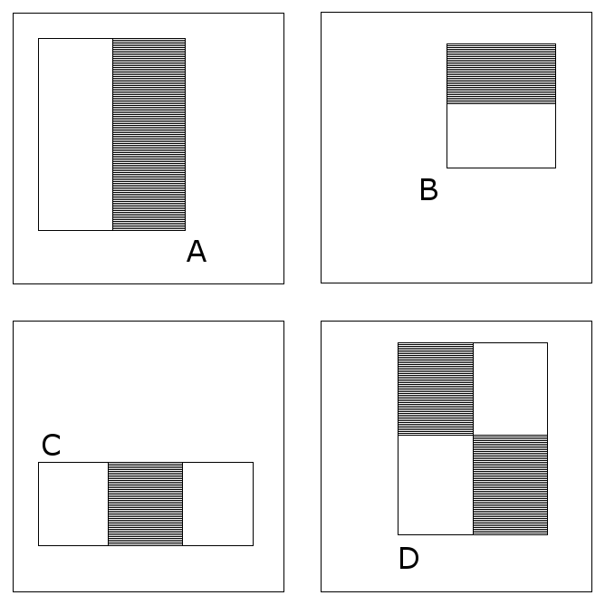
In A, B, D, the number of white rectangular region equals to the number of black rectangular region, so the eigenvalue can be calculated in the following formula:
𝜈=sum_{white}-sum_{black}
While, in C, the formula will be 𝜈=sum_{white}-2*sum_{black} , this makes the number of pixels in black rectangular region equals to the sum of number pixels in white rectangular regions.
Through altering the size and position of the feature template, we can list a lot of features in sub-region of image. In a word, we select the Haar-like features from images. In this phase, we also add a rotation feature to the existing features.

2.1.4 Creating an integral image
The one of the important contributions of Viola Jones algorithm is integral image. Integral image is a 2-rectangle lookup table, it has the same size of the original image. Each element of the integral image contains the sum of all pixels located on the up-left region of the original image (in relation to the element's position). For example, we compute the sum of rectangular areas in the image using only four lookups, shown in the following figure:
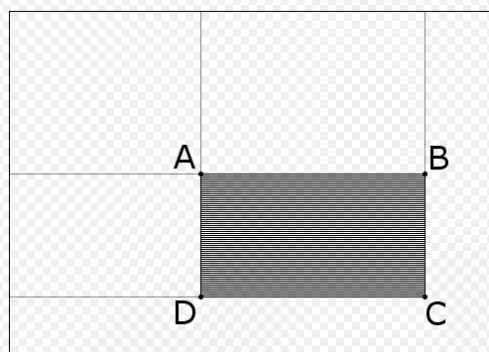
𝑠um=I(C)+I(A)-I(B)-I(D)
The points A, B, C, D belong to the integral image I, as shown in the figure. Each type of feature needs different number of lookups. Viola and Jones’s 2-rectangle feature needs six lookups, 3-rectangle feature needs eight lookups, and 4-rectangle feature needs nine lookups.
In a word, integral image aims to calculate sum of all pixels in image through scan image once. This practice greatly improves the efficiency of computing eigenvalue of images. In this phase, the calculated elements will be preserved in memory, then compute the other elements using the saved value in memory. Now, we see how to compute the integral image. Integral image is a way to describe the global information matrix representation. The function shown as below:
f(k,𝜆),
The steps of integral image algorithm:
- s(i, j) represents the sum of row direction, initialize s(i, -1)=0;
- ii(i, j) represents an integral image, initialize ii(-1, i)=0;
- scan image by row, compute each s(i, j) and ii(i, j) at each pixel (i, j) recursively:
s(i, j)=s(i, j-1)+f(i, j)
ii(i, j)=ii(i-1, j)+s(i, j)
- when scan reach to the bottom of the image, integral image construction finished.
In a word, the integral image algorithm seems like a dynamic programming algorithm.

2.1.5 Adaboost training
AdaBoost, short for ‘Adaptive Boosting’, is a machine learning meta-algorithm formulated by Yoav Freund and Robert Schapire. In the Viola-Jones algorithm, adaboost selects a small number of critical visual features from a larger set and yields extremely efficient classifiers [34]. Now, we introduce the Adaboost machine learning algorithm.
Adaboost is adaptive in the sense that subsequent weak learners are tweaked in favor of those instances misclassified by previous classifiers. It is an iterative algorithm, aims to train different weak classifiers according to the same training data, then combine all the weak classifiers to construct a strong classifier. Adaboost changes the data distribution to achieve itself, it determines the weighted value of every sample according to the correction of each sample in each training set as well as the accuracy of the overall classification. The overview of the adaboost algorithm shown in below:
- train N training samples and get the first weak classifier;
- the misclassification data with other new data form a new N training samples and train the second weak classifier;
- cycle the step (2) and get the third, forth, …Tth classifiers;
- determine the weighted values of each weak classifier and get the final strong classifier.

2.1.6 Cascading classifiers
As we known, traditional adaboost algorithm is time-consuming. According to this situation, the Viola-Jones algorithm proposed a cascade adaboost algorithm to save time. For example, each level of adaboost classifier gets a very high precision (99%), but it also has a high false positive rate (50%), then we cascade 20 small adaboost classifiers, we get a false positive rate as (50%)²⁰=9.5x10⁻⁷, while the accurary is (99%)²⁰=98%. We can see it is a good classifier.
Then, Viola-Jones algorithm proposed a simple and valid method to train cascade of classifiers:
- user determine the maximum acceptable rate of FPR (false positive rate) and minimum acceptable detection rate in each level;
- user determine the total FPR_{target};
- initialize FPR=1, D=1, D means detection rate;
- cycle: if FPR > FPR_{target} , add another adaboost classifier;
- when train current level classifier, if the current level features up to the f_{i}, then add new feature;
- in each level of classifier, the negative sample called false positive, this makes classifier cares more about the false positive samples;
Finally, we get multi overlapped face positions, then combine them as the final face position. Above are the brief introduction of the cascade classifiers, the details of the classifier refer to [34].

2.1.7 Get 2D coordinates
In the above algorithm, we finish the face detection operation. In the MATLAB program, we use the bounding box to locate the faces, then these locations produce the 2D coordinates. In our program, we supposed the left-top point of the image as the 2D coordinate (0, 0). Then the left-top point of bounding box is the coordinates of the face which bounding box circled. Through all the coordinates, we can get the relative 2D spatial relationships of detected faces.

2.2 Depth information and 3D coordinates
In this phase, we get the depth information of a still image, and then show the 3D coordinates of the faces. As we known, computer can’t calculate the depth of faces itself. So we need to tell the computer what to do. So far, there are many methods to get the depth information, but a large percent of them use multi images, such as binocular images. We can compare all the images and compute the depth of objects according to the angles of shooting. The other methods most use a lot of images to train a face library, then use the library to detect faces.
However, in our requirements, we just have only one monocular image which come from camera. There are also several methods to handle this situation. Most of these methods use prior knowledges: water is in the ground, sky and clouds above, texture information and gray information. But our method uses the ‘blur’ information to estimate depth information.
As we known, each image taking by camera has a focal point (we assume that faces are in focus), then the background image looks blurry. Based on this common sense, we can estimation the blur information as the depth information. If we are able to measure the size of this blur, we can also produce a three dimensional depth map of the same image [37]. In this paper, we use two algorithms to estimate depth: Elder, Zucker algorithm and Hu, Haan algorithm. Then we standardize two depth information and combine them together. Below, we introduce these two algorithms respectively.

2.2.1 Problem Statement
In the paper, we use a still monocular image to detect faces. When the image is captured in a small depth of field, the object which away from the focal plane is out of focus and is considered to be ambiguous. The image includes objects with image focusing and defocusing and then object may therefore be segmented in depth. So if we are able to measure the size of this vague, we can also produce the same three-dimensional depth map of the image.

2.2.2 Elder and Zucker algorithm
The Elder and Zucker algorithm is a popular algorithm used for graphics. It mainly includes two parts: Edge Detection and Blur Estimation.
- Edge Detection:
Edge detection is the name for a set of mathematical methods which aim at detecting points in a digital image at which the brightness of images changes sharply or, more formally, has discontinuities. Edges in the images have many properties, we use these properties to accomplish edge detection algorithm. The edges extracted from 2D images can be divided into viewpoint dependent and viewpoint independent. A viewpoint independent edge which means hardly changed, typically reflects inherent properties of the three-dimensional objects, such as surface markings, surface shape and surface texture. While, a viewpoint dependent edge may change as the viewpoint changes, and typically reflects the geometry of the scene, such as objects occluding one another, lighting of the objects and surface color of objects.
Image edges are usually found where there is a sudden change in image intensity. This will result in local minima or maxima of the first derivative of the intensity. Unfortunately, real images are corrupted with noise, which can change faster than the image data. An effective edge detector must be able to differentiate between real intensity transitions and sudden noise transitions. Edge detectors are typically designed to recover step discontinuities in an image, however the boundaries of physical structures in the world generally do not project to the image as step discontinuities [38]. The principle of edge detection shown in the following figure.
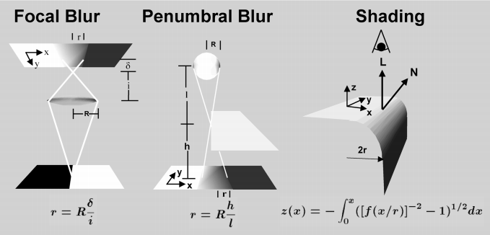
Traditional edge detectors filter noise by using an isotropic Gaussian filter. The standard devitation of this filter determines how many neighboring points are considered significant by the filter kernal. The larger it is, the more points will be contained in the result. However, Elder proposed a multi-scale or multi-resolution approach where different scales of sigma are employed. For example, sharp image with little noise require a narrow filter while blur noise images require a broad filter. For each point in the gradient map, Elder-Zucker determines the "minimum reliable scale" (the smallest filter that can be used reliably) and uses that scale locally. After computing the "minimum reliable gradient," it uses that information for a second "minimum reliable Laplacian" steered in the gradient direction (direction of the edge-normal). In this way, it only tries to compute a 1D Laplacian locally across edges. Zero-crossings in the "minimum reliable Laplacian" will indicate edge locations.
In a word, Elder and Zucker algorithm performs a edge detection using local scale control, and use reliable scales to detect valid edges which suited for blur estimation.
- Blur Estimation:
In the above phase, we use the edge detection to reliable edges transferred to blur estimation. Elder proposed the following to estimate the blur at a particular edge:
d=distance in pixels between extrema in 2nd derivative map
s=minimum reliable scale for second derivative operation
blur=sqrt((d/2)²-s²)
The theory behind this is very straightforward. d is an estimate of the sharpness of the edge. However, we cannot estimate this better than the minimum reliable scale, so we correct for that in the estimate. Due to the uncertainty afforded by the minimum reliable scale, we err on the side of less blurring, blurring only those pixels that we are sure need blur. According to the blur function, the blur due to defocus can be estimated from the measured thickness of the contours, after compensation for the blur induced by the estimation itself [38].

2.2.3 Hu and Haan algorithm
The focal blur process is usually modeled as a Gaussian low-pass filtering and then the problem of blur estimation is to identify the Gaussian blur kernel. In the Hu and Haan proposed method, the blurred input image is first re-blurred by Gaussian blur kernels with different blur radii. Then the difference ratios between the multiple re-blurred images and the input images are used to determine the unknown blur radius. That means Hu and Haan proposed a straightforward method for blur estimation. In their approach, they reblur the signal to be determined twice with Gaussian kernels ,𝜎-_{a} and 𝜎-_{b} to determine the local blur 𝜎- of the signal. The method applies a robust local blur estimation to obtain a blur map of the image. The estimation uses the maximum of difference ratio between the original image and its two digitally re-blurred versions to estimate the local blur radius [39]. The steps of blur estimation show below:
- One dimensional signal (seems as 1D image):
𝑔(n, 𝜎..)=C(𝜎)exp(-n²/(2𝜎²)), n∈Z
Where 𝜎 is the unknown blur radius to be estimated and C(𝜎) is the normalization factor. The constraints are:
𝛴_{n∈Z} g(n,𝜎)= 𝛴_{n∈Z} C(𝜎)exp(-n²/(2𝜎²))=1
- Two dimensional signal (2D image):
We use two parameter 𝜎₁, 𝜎₂ to represents two Gaussian functions:
g(n, 𝜎₁)*g(n, 𝜎₂)=g(n, sqrt(𝜎₁²+ 𝜎₂²,-,))
For the blur estimation in images (2D signals), we use a 2D isotropic Gaussian blur kernel for the re-blurring. The following flow chart shows the architecture of the blur estimation:
Input image
Blur (𝜎₁)
Blur (𝜎₂)
Different ratio pixel-wise
Difference ratio block-wise
Difference ratio block-wise
Blur map

In a word, this algorithm using the 2D signal rather than Elder-Zucker algorithm. The principle of the Hu and Haan algorithm is easy to understand as a whole. We proposed an example to explain the principle. For example, you have an image, in the image, there are focal region and non-focal region. Because an object out of focus will produce a blur because it is too far away from the focal plane. The non-focal region seems like blur. As we known, most of the blurring are using Gaussian filter to implement. So we reblur our image using Gaussian filter with two ratios parameters. Then we use these two reblurring images to estimate the blur ratio of the original picture. So we can get the depth information from the blur map. Actually, it already hints to distance or depth. Based on this, we can get the estimated depth information of all faces. The details of this algorithm refer to the paper [39].

2.2.4 Combination of two algorithm
In our program, we use MATLAB to implement these two algorithms. Each algorithm produces a 3D coordinates. For example, if the image contains two faces, then Elder-Zucker algorithm and Hu-Haan algorithm each produces a 3D coordinates, their first two coordinates are the same. Each algorithm has its own depth information. So we first normalize each depth information in each algorithm. Then we get the average value of the two depth information in two algorithms. The calculated depth information will be the final depth of faces. As we see, the final depth of 3D coordinates ranged in (0,1). The higher the depth is the closest the face to the camera.

Chapter 3: Experiments

3.1 Configuration
We use MATLAB2014 to code our program in Linux environment. Each blur estimation algorithm is a MATLAB file. We also use the computer vision toolbox.

3.2 Experiment Results
In our experiments, we depart this into two parts: Face detection and get Coordinates. We introduce these two parts respectively.

3.2.1 Face Detection
In this part, we use MATLAB computer vision toolbox to implement the face detection. We choose several images to test this, the results show below:
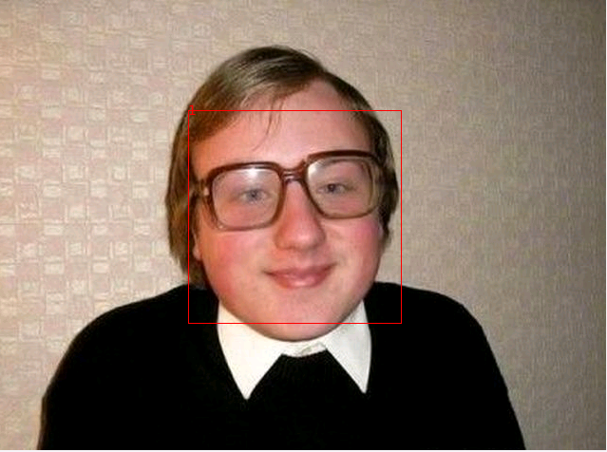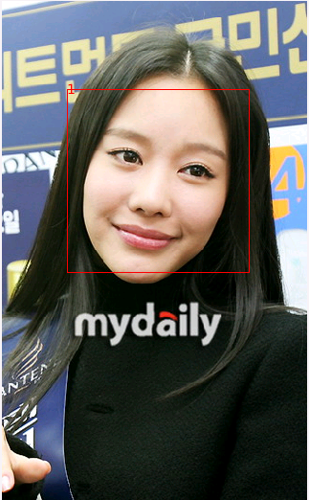
We can see from the pictures, the bounding boxes are used to locate the faces. But in the above two images, we only have a single face in the image. When we have many faces in the image, we may get a false positive rate. The result shows in the following picture.
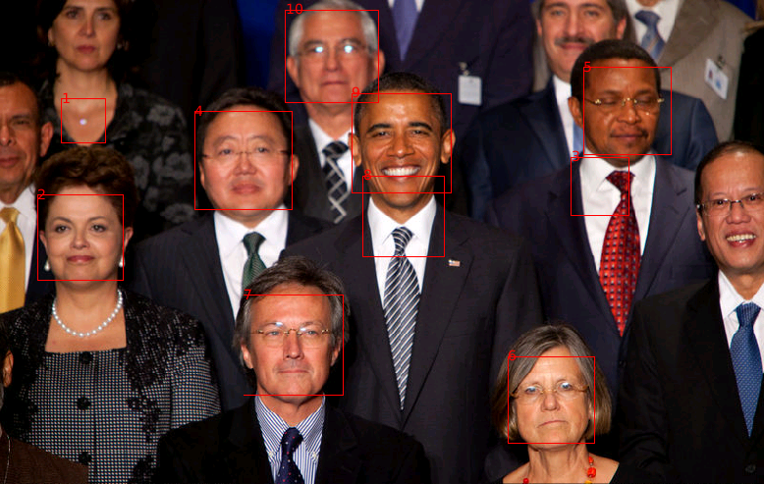
From the picture, we see that there are some non-faces are marked. This is because the face detection algorithm is not very precise, the non-face rectangular region seems like a face. Another point is there are some faces has not been identified. The improvement of the face detection algorithm will be implemented in the future.
It is worth mentioning that in the picture the bounding boxes are numbered. The numbers are not only on behalf of the recognition sequence, but also provide convenience to the later coordinates.

3.2.2 Get Coordinates
In this section, the coordinates divide into 2-dimensional and 3-dimensional coordinates. Then it will be four situations:
- 2-dimensional coordinates and single face in image:
As we talked above, the 2D coordinates are the positions relative to the top-left coordinate (0, 0) of the image.
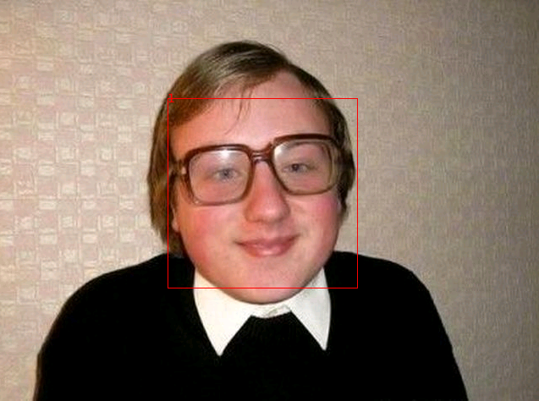
The single face in the image is numbered with 1, then the output of the 2D coordinates shown in the following:
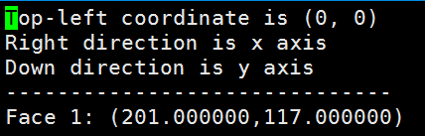
The picture shows the 2D coordinates of the face 1. 201 represents the horizontal distance to the left of the image. 117 represents the vertical distance to the top of the image.
- 2-dimensional coordinates and multi faces in image:
In this situation, we have multi faces in the image, so we get multi coordinates of faces.
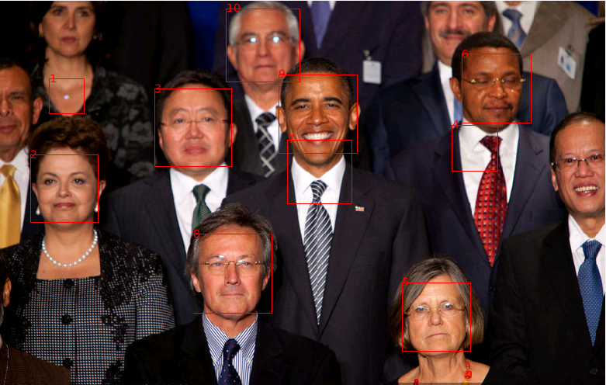
There are 10 detected faces in the image. Althrough there are some mistakes in the detection. Then the coordinates of faces show below:
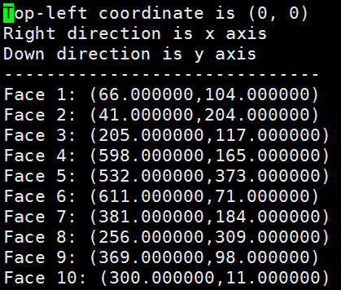
The 2D coordinates are the same meaning as the above. Through these coordinates we can judge the left and right relationships of all the faces.
- 3-dimensional coordinates and single face in image:
In this section, we need to calculate depth information. If the image has a single face, it has no spatial relationship with other faces. So the depth information has no meaning.
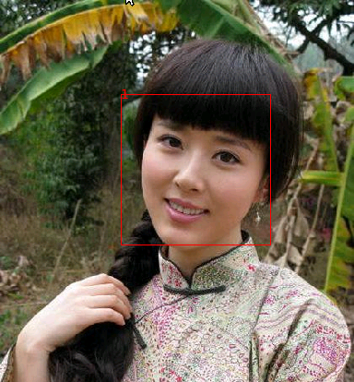
The 2D coordinates are the same, we see the 3D coordinates.
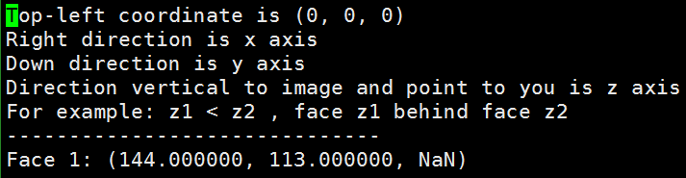
We can see the third coordinate are NaN, because the image just has one face, there are no spatial relationships in the image.
- 3-dimensional coordinates and multi faces in image:
In this section, we will see the 3D coordinates. We show all the coordinates of the bounding boxes in the images, in spite of non-faces or faces.
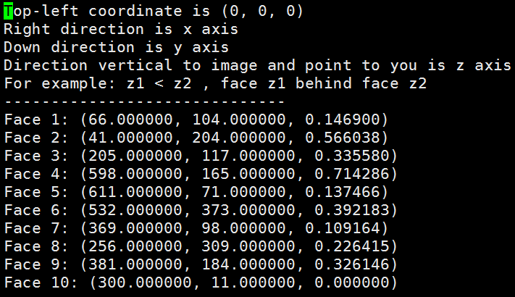
We can see in the picture, face 10 has the smallest depth, so it is the most far from us. However, it has some mistakes, for example, face 4 has the largest number, it means closest to us, but it is wrong from the picture.
In brief, we use several algorithms to detect faces and calculate depth information of faces. The bounding boxes and depth information consist of 3D coordinates. The 3D coordiantes show the spatial relationship between faces.

Chapter 7: Conclusion
In this section, we conclude our work. Our work divides into two parts. In face detection, we use the Viola-Jones algorithm to detect faces. Viola-Jones algorithm is a basis computer vision algorithm for object detection, mainly for face detection. It gets a relatively good performance in spite of some false positive rate. The main points of Viola-Jones algorithm are Haar-like feature extraction and Adaboost cascade classifiers. The explanation of these points show in the above. We can also refer to the paper by Viola and Jones [34]. The side effect of the algorithm is showing the bounding boxes. Each bounding box corresponds to a face. Based on this, we can get the 2D coordinates about the top-left of the bounding box which represents the coordinate of the face. Then the contribution of the Viola-Jones algorithm is not only the face detection, but also the 2D coordinates of the faces.
Another part is extracting depth information of faces. We use Elder-Zucker and Hu-Haan algorithms to get depth together. Elder-Zucker algorithm use two core components: Edge Detection and Blur estimation. In edge detection, we can get the blur boundary which will be used in blur estimation. In blur estimation, we use the blur information to get the focal and non-focal depth. In Elder-Zucker algorithm, we get the 3D coordinates. While in Hu-Haan algorithm, the core component is blur estimation. The difference between Elder-Zucker and Hu-Haan algorithms is that in the later algorithm we use two Gaussian function to produce blur map. In Hu-Haan algorithm, we also get the 3D coordinates. Then we get two 3D coordinates in our main function. In this function, we normalize these two 3D coordinates to range (0,1) and combines them. So the z-axis of the final 3D coordinates will be ranged to (0, 1).
As we get all the 3D coordinates of the faces, we can calculate the relative spatial relationships of faces. The final step of this program is to output the coordinate files and show pictures with bounding boxes.

Chapter 8: Future Work
As we can see from the image with multi faces, we can see two mistakes. This is the improvement we need to do in the future:
- From the image, the bounding box 1,4,7 are not faces:
According to this mistake, we use some prior knowledge to judge whether it is a face. For example, the bounding box 1 is not a face, when we bounding it in the image, we do an additional verifying operation to judge all the bounding boxes, such as detect eyes, noise or mouse. Another improvement of this phase is that we can extract more features to detect faces. But this method is very hard, because we can hardly find the common feature of all faces.
- In the image, there are some faces not detected:
In this phase, we can see that the faces with non-focal and the faces without showing all. In this situation, the reasons are the Viola-Jones algorithm does not work very well. So we can train a face library with thousands of face images (including non-focal faces and half faces), then use this library to detect faces. If the face library trains very well, we will get the better precision. Another trick is adding some prior knowledges, such as human is in the center of the image as common sense.
However, the above improvements are aimed at the Viola-Jones algorithm, then the improvements aimed at Elder-Zucker and Hu-Haan algorithms are in edge detection and blur estimation.
- Edge detection:
In this phase, we can use a new edge detection algorithm to get a better performance, such as improved Canny algorithm. The functions of this algorithm can also be altered to detect edges more precisely.
- Blur estimation:
The blur estimation of Hu-Haan algorithm is better than Elder-Zucker algorithm, because it use two Gaussian functions to do the blur estimation. In this section, we can also use the new blur estimation algorithm or adjust the weights of two algorithms to produce the final 3D coordinates.
Another improvement is that we can use multi images to get depth information, such as we can use Kinect equipment to take images which already contain depth information.
In summary, we get the face detection with bounding boxes and depth information for 3D coordinates.

References
[1] I.Maglogiannis, D.Vouyioukas, and C.Aggelopoulos (2009), “Face detection and recognition of natural human emotion using markov random ﬁelds”, Personal and Ubiquitous Computing, pp:95–101.
[2] J.D.Woodward (1997), “Proceedings of IEEE”, pp:1480～1492.
[3] Sung K. and Poggio T. Example-based learning for view based human face detection. IEEE Trans. on Pattern Analysis and Machine Intelligence, 1998, 20(1): 39-51
[4] P.Kuchi, P.Gabbur, P.Subanna Bhat, et al (2002), “Human face detectionand trackingusing skin color modeling and connected component operators”, IETE journal of research, pp:289–293.
[5] S Huang, G Z Yang. Human Face Detection in a Complex Background[J] . Pattern Recognition, 1994 , 27( 1) : 53- 63.
[6] Kotropoulos, I Pitas. Rule- based Face Detection in Frontal Views Proc[ C] . Int’l Conf. Acoustics, Speech and Signal Processing, 1997. 2537- 2540
[7] Viola P, Jones M J. Robust real-time face detection[J]. International journal of computer vision, 2004, 57(2): 137-154.
[8] Brunelli R, Poggio T. Face recognition: Features versus templates[J]. IEEE Transactions on Pattern Analysis & Machine Intelligence, 1993 (10): 1042-1052.
[9] Pentland A, Moghaddam B, Starner T. View-based and modular eigenspaces for face recognition[C]//Computer Vision and Pattern Recognition, 1994. Proceedings CVPR'94., 1994 IEEE Computer Society Conference on. IEEE, 1994: 84-91.
[10] Bloch I. Fuzzy spatial relationships for image processing and interpretation: a review[J]. Image and Vision Computing, 2005, 23(2): 89-110.
[11] M.Oge (2011), “Practical Image and Video Processing Using MATLAB”.
[12] G.C.Rafael (C2010 2nd en.), “Digital image processing using MATLAB”, McGraw Hill Education India.
[13] Viola P, Jones M. Rapid object detection using a boosted cascade of simple features[C]//Computer Vision and Pattern Recognition, 2001. CVPR 2001. Proceedings of the 2001 IEEE Computer Society Conference on. IEEE, 2001, 1: I-511-I-518 vol. 1.
[14] Viola P, Jones M. Robust real-time object detection[J]. International Journal of Computer Vision, 2001, 4: 51-52.
[15] Zaman T. Depth Estimation from Blur Estimation[J].
[16] Elder J H, Zucker S W. Local scale control for edge detection and blur estimation[J]. Pattern Analysis and Machine Intelligence, IEEE Transactions on, 1998, 20(7): 699-716.
[17] Hu H, De Haan G. Adaptive image restoration based on local robust blur estimation[C]//Advanced Concepts for Intelligent Vision Systems. Springer Berlin/Heidelberg, 2007: 461-472.

