**Sterols biomarkers settling material and sediments from contrasting areas of the Rio de la Plata basin**

Speranza, E.D.12, AUTHORS, Colombo, J.C.13

1: Laboratorio de Química Ambiental y Biogeoquímica, Facultad de Ciencias Naturales y Museo, Universidad Nacional de La Plata, Av. Calchaquí 6200, Florencio Varela, 1888, Buenos Aires, Argentina.

2: Consejo Nacional de Investigaciones Científicas y Técnicas, Godoy Cruz 2290 C1425FQB, C.A.B.A., Argentina

3: Comisión de Investigaciones Científicas de la Provincia de Buenos Aires, calle 10 y 526, La Plata 1900, Argentina

**Abstract:**

To complete

Keywords: Sterols, Sewage markers, Settling material, Rio de la Plata.

**Introduction**

To complete.

**Materials and methods**

The sampling strategy comprised two sites with contrasting anthropogenic impact: the heavily polluted Buenos Aires metropolitan area of the Rio de la Plata estuary near the main sewer outfall (BA, 34°43.329'S - 58°10.301'O) and a more pristine site ︡~200 km upstream on the Uruguay River, the Ñandubaysal bay (N, 33°05.270'S - 58°21.374'W; Fig.1). Sampling campaigns were carried out seasonally from 2007 to 2014. Settling material was collected in pre-weighed polypropylene conical Falcon tubes coupled to a fixed 10 cm diameter cylindrical sediment trap deployed at 1.5m during 1-3 days (BA) or 30-60 days (N). Superficial sediments were collected using a stainless steel Hydro-Bios Van-Veen grab sampler. Samples were immediately refrigerated and transported to the laboratory. Tubes containing the settling material were centrifuged and weighed after discarding supernatant water. Water content was determined gravimetrically after drying in an oven at 40°C. Total particle flux was computed as:

$$\text{Flux (mg.cm}\text{-2}\text{.day}\text{-1}\text{)}=\frac{\text{s}\text{e}\text{ttling matter mass }\left(\text{mg}\right)}{\text{trap surface (78.5 cm}\text{2}\text{) . deployment time (days)}}$$

Sedimentation rate was calculated as:

$$\text{SR(cm.year}\text{-1}\text{)=}\frac{\text{Flux.365}}{\text{1000.density (g.cm}\text{-3}\text{)}}$$

The average settling material density (2.65 g.cm-3) was taken from previous work in the same sampling sites.

The discharge of the Uruguay River was calculated as the turbinated plus compensation flow discharged daily by the Salto Grande Dam, located 240 km upstream N station and averaged for each sediment trap deployment period (wholesale electricity market administration company: [www.cammesa.com](http://www.cammesa.com)). The discharge of the Rio de la Plata estuary was assumed as the sum of the corresponding monthly discharges of the Uruguay River, measured 90 km upstream N station, and of the Parana River, measured near the mouth of its main channels (Paraná Guazú and Paraná de las Palmas; Base de Datos Hidrológica Integrada, [bdhi.hidricosargentina.gov.ar](http://www.bdhi.hidricosargentina.gov.ar); Menendez, 2002).

Lipids were extracted ultrasonically with acetone:dichloromethane:petroleum ether (1:2:2). The extract was dried over anhydrous sodium sulfate and lipid content was determined gravimetrically. Deuterated sterols (deuterocholesterol and deuterositosterol, Steraloids, Inc., Newport, RI, steraloids.com) were added as internal standards. In order to avoid the interference of fatty acids, lipids were saponified with 1M KOH in methanol and non-saponifiable compounds were extracted with petroleum ether – diethyl ether (4:1 v/v, Christie, 1989). The extracts were concentrated under a nitrogen stream and derivatized with N,O-Bis(trimethylsilyl)trifluoroacetamide and trimethylchlorosilane (BSTFA:TMCS, 10:1v/v; AppliChem GmbH, Darmstadt, Germany, [www.applichem.com](http://www.applichem.com); Sigma-Aldrich, St. Louis, MO, USA, [www.sigmaaldrich.com](http://www.sigmaaldrich.com)) for 3 hours at 60ºC. The resulting trimethylsilyl derivatives were concentrated to dryness under nitrogen and resuspended in toluene prior analysis.



**Fig. 1.** Sampling stations of settling material and sediments in the metropolitan coastal area of the Rio de la Plata estuary, near Buenos Aires main sewer (BA) and at a northern site in the Uruguay River (N).

Samples were analyzed using a Perkin Elmer Clarus 500 GC-MS (Perkin Elmer, Waltham, MA, USA; [www.perkinelmer.com](http://www.perkinelmer.com)) fitted with a Quadrex 007-5MS capillary column (60 m, 0.32 mm i.d., 0.25 μm; Quadrex Corp., Bethany, CT, USA., [quadrexcorp.com](http://www.quadrexcorp.com)). Helium was used as a carrier gas with a flow rate of 1.2 mL/min and the temperature of injector was set at 250ºC (split-splitless mode). The oven temperature program was started at 100 ºC with a ramp to 225 ºC at 15 ºC /min and to 300 ºC at 3 ºC /min with a final holding time of 10 min. The transfer line temperature was set at 200 ºC and the analytes were ionized by 70eV electron impact at 180 ºC. The mass spectrometer was simultaneously operated in scan mode (from 60 to 600 amu) and selective ion monitoring. Data were acquired and processed with TurboMass 5.1 software (Perkin Elmer).

Steroids with their trivial and IUPAC names, molecular weight, retention times and mass-to-charge ratios (m/z) used for quantification and confirmation are presented in Table 1. Compounds were identified by comparison with authentic standards of 14 steroids (Steraloids, Sigma-Aldrich), literature data and interpretation of mass spectrometric fragmentation patterns. Quantification was performed using a 4-points calibration curve (0,2-50 μg ml-1) with authentic standards (Table 1). Peak areas were corrected according internal standard recoveries. Commercially standards were not available for some compounds (cholestenol, campestanol, 24-Ethylcoprostanol and γ-Sitosterol) which were quantified based on response factors of structurally related sterols.

**Table 1.** Names, formula, molecular weight (MW), retention time (Rt) and mass of ions used for quantification (target ion) and identification (confirmatory ions) of sterols and steroids (coprostane and coprostanone) analysed in this work.

|  |  |  |  |  |  |  |  |
| --- | --- | --- | --- | --- | --- | --- | --- |
| **Trivial name** | **IUPAC Name** | **Formula** | **MW** | **Rt** | **Target ion** | **Confirmatory ions** | |
| Coprostane | 5β -Cholestane | C27H48 | 372.67 | 30.80 | 217 | 357 | 372 |
| Coprostanol | (3β,5β)-Cholestan-3-ol | C27H48O | 388.67 | 35.57 | 370 | 355 | 215 |
| Epicoprostanol | (3α,5β)-Cholestan-3-ol | C27H48O | 388.67 | 36.08 | 370 | 215 | 355 |
| Cholestanol | (3β,5α)-Cholestan-3-ol | C27H48O | 388.67 | 36.16 | 215 | 355 | 370 |
| Coprostanone | (5α)-Cholestan-3-one | C27H46O | 386.65 | 37.13 | 386 | 231 | 370 |
| Deuterocholesterol | (3β)-Cholest-5-en-3-ol-25,26,26,26,27,27,27-D7 | C27H46O | 393.70 | 37.31 | 129 | 336 | 375 |
| Cholesterol | (3β)-Cholest-5-en-3-ol | C27H46O | 386.65 | 37.48 | 329 | 129 | 368 |
| Dehydrocholesterol | (3β)-Cholesta-5,7-dien-3-ol | C27H44O | 384.64 | 37.73 | 215 | 445 | 355 |
| Brassicasterol | (3β,22E)-Ergosta-5,22-dien-3-ol | C28H46O | 398.66 | 38.19 | 456 | 129 | 366 |
| Desmosterol | (3β)-Cholesta-5,24-dien-3-ol | C27H44O | 384.64 | 38.36 | 129 | 343 | 253 |
| Ergosterol | (3β)-Ergosta-5,7,22-trien-3-ol | C28H44O | 396.65 | 39.17 | 343 | 337 | 468 |
| Campestanol | (3β,5α,24R)-Ergostan-3-ol | C28H50O | 402.70 | 39.75 | 343 | 129 | 384 |
| Campesterol | (3β,24R)-Ergost-5-en-3-ol | C28H48O | 400.68 | 39.92 | 343 | 129 | 382 |
| 24-Ethylcoprostanol | (3β,5β,24S)-Stigmastan-3-ol | C29H52O | 416.72 | 40.19 | 398 | 215 | 383 |
| Stigmasterol | (3β,22E)-Stigmasta-5,22-dien-3-ol | C29H48O | 412.69 | 40.55 | 129 | 255 | 484 |
| γ-Sitosterol | (3β,24S)-Stigmast-5-en-3-ol | C29H50O | 414.71 | 41.82 | 129 | 473 | 488 |
| Deutero-β-Sitosterol | (3β)-Stigmast-5-en-3-ol-25,26,26,26,27,27,27 -D7 | C29H50O | 421.75 | 42.00 | 129 | 364 | 403 |
| β-Sitosterol | (3β)-Stigmast-5-en-3-ol | C29H50O | 414.71 | 42.20 | 129 | 488 | 473 |
| Stigmastanol | (3β)-Stigmastan-3-ol | C29H52O | 416.72 | 42.59 | 215 | 473 | 488 |

The limit of detection (LOD) of each steroid was estimated by calculating the signal to-noise ratio (S/N) of triplicate standard solutions in the range of 0,2-50 μg ml-1 . LODs values averaged……., ranging from () to (). Reproducibility was assessed by the relative standard deviation (RSD) of triplicate analysis of the same samples in different batches, and averaged 11±3.8 The method was highly linear in the range of concentrations of calibration curves (R2>0.99 for all steroids with available authentic standards). Recoveries of deuterated internal standards averaged 96±1.7 Individual recoveries, evaluated by analysis of spiked samples ranged from 82±15% (Ergosterol) to 110±19% (Desmosterol). Detailed information on method performance is provided in S1.

Statistical analysis was carried on with Python scripting language, using SciPy, NumPy, MatPlotlib and pandas libraries. Multivariate analyses was executed in *R* language, using ggplot2 and ggbiplot packages. Data were expressed as mean ± SD. Relative standard deviation (RSD: [data – mean].100.SD-1) was used to assess parameter variability. To avoid division by zero errors, the ratios between two sterols, A and B were calculated as: A.(A+B)-1. The accumulation efficiency of sterols from settling material to sediments was estimated as the relationship between the annual vertical flux of the sterol and its corresponding one-year inventory in sediments (sterol concentration in sediment * annual mineral flux). Student’s t test was used to perform comparisons between two means as well as to evaluate the significance of correlation coefficients. Multivariate analysis was performed by principal component analysis of standardized data (x−Xy−1, where X = mean and y = S.D.). Forward stepwise multiple regression (*P-to-enter*<0·05) was used to identify the variables that best accounted for the observed temporal variation in sterol vertical flux.

**Results and discussion**

Particle vertical flux:

The intense discharge of one of the largest sewer outfall worldwide at BA contributes to the natural particle load of the Rio de la Plata, resulting in an extraordinarily high total particle flux (34±24 mg.cm2.day-1) and sedimentation rate (4.7±3.3 cm.year-1), in agreement with previous measurements at this area (5.5 ± 2.1 cm.year-1, Colombo et al., 2007). This value is much higher than sedimentation rates reported for nearby areas of this turbid estuary (0.3 -1.3 cm.year-1; Di Gregorio et al., 2007; Bonachea et al., 2010), suggesting than most particles captured by sediment traps at BA are highly organic detritus derived from urban-industrial discharges. This is supported by the high lipid content previously measured in BA settling material (11±7.4 mg.g-1), which was 27-times higher than at the Parana river (0.41±0.28 mg.g-1), which contributes the most to the solid load of the Rio de la Plata estuary (Speranza et al., 2013). At N, the total particle flux was 7-times lower (4.6±3.6 mg.cm2.day-1) and the resulting sedimentation rate (0.64±0.49 cm.year-1) was comparable to values reported by Colombo et al. 2015, which also showed a high variability (1.0±0.88 cm.year-1, range: 0.27-2.7 cm.year-1). In contrast to BA settling material composed of anthropogenic detritus over the background particle load derived from Parana River, the settling material at N represent the smaller solid discharge of the Uruguay River (Moreira et al. 2013 from Jaime and Menendez 2002). The settling material flux was largely dependent on river discharge, which was 6-46 times higher at BA (19465-46088m3.s-1) relative to N (420-8410 m3.s-1), fitting an exponential curve (R2 = 0.78, *p*<0.0001; Fig. 2). This correlation had been previously observed at the Uruguay River and reflects the enhanced transport of eroded material as river flow increases (Colombo et al. 2015).

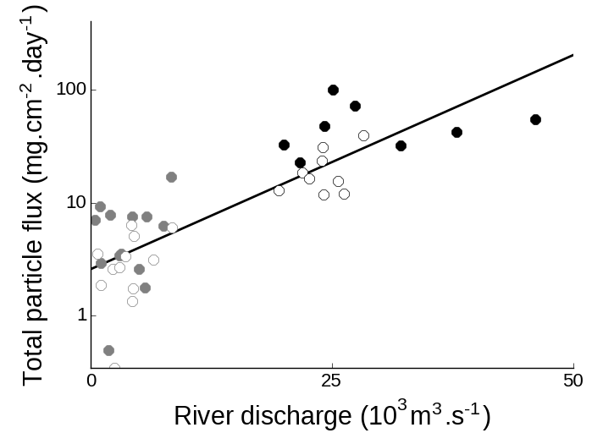

**Fig. 2.** Relationship between river discharge and total particle flux at Buenos Aires (black circles) and North (grey circles) sites during warm (September to March, solid circles) and cold months (April to August, empty circles). Note the logarithmic scale on the y-axis.

Total sterols concentrations:

The total sterol concentration in settling material was highly variable (RSD: 113-114%) and exhibited a marked geographical difference. At BA, the tendency of sterols to associate with particulate matter due to their high hydrophobicity is enhanced by the high organic content of settling particles (total organic carbon: 7.7±5.5%; Colombo et al. 2007), resulting in very high sterol concentrations at this site 7140±7905 μg.g-1 dry weight). Previous studies dealing with sterols in settling particles were mostly based in ocean waters, relatively deep and clear, which had average concentrations 1-4 orders of magnitude lower compared to this shallow and turbid freshwater environment (Colombo et al. 1996; Parrish et al., 2000; Takada et al., 1994; Burns et al., 2008). Studies dealing with sterols in settling material from riverine environments were more limited and reported concentrations much lower than those from BA (1-184 μg.g-1; Saliot et al., 2001; Li et al 1995; Jeng and Kao 2002). In fact, total sterol concentrations in BA settling material are comparable to values reported for sewage sludge from wastewater treatment plants (2-9 mg.g-1; Venkatesan and Kaplan 1990; Kelly 1995; Nguyen et al., 1995). At N, total sterol concentrations in settling material were 2-3 orders of magnitude lower (41±47 μg.g-1) and comparable to aforementioned values in particulate matter from riverine environments. Total sterols in sediments were 10-20 times lower than in settling material and were less variable (RSD: 10-61%) but also presented a 2-3 orders of magnitude difference between BA and N (708±454 vs. 1.9±0.18 μg.g-1). The reduction in sterol concentration from settling material to sediments reflects the tendency of sterol to degrade at the water-sediment interfase, especially under oxic conditions (Sun and Wakeham 1998).

Sterol composition:

The sterol composition in settling material showed contrasting differences between BA and N (Fig. 3). At BA, the settling material composition was dominated by fecal sterols (75±5.4% of total sterols), mostly coprostanol (52±11%), followed by cholesterol (12±2.9%) and phytosterols (8.3±3.6%). This fecal signature, resembled the composition of human feces (fecal sterols: 85%, phytosterols: 8.8%, cholesterol: 5.2%, others: 1.2%; Leeming et al. 1996), reflecting the massive discharges of crude sewage at this site. Moreover, the coprostanol proportion of BA settling material felt in the 50-80% range found in sewage sludge and effluents (Venkatesan and Kaplan 1990). Nevertheless, the presence of smaller proportions of epicoprostanol (9.3±9.6%), originated from microbial degradation of coprostanol evidence an incipient degradation of the fecal material. Considering the large residence time of fecal material in the large Buenos Aires sewer network (9900 km, main sewers: >100km, AySA 2017; Roberts and Villegas, 2016), a preliminary degradation is likely to occur in sewer pipeline rather than in the very shallow (3-4 m) water column. The presence of a relatively important proportion of ethylcoprostanol (8.5±4.4%) is usually associated with non-human (herbivore) fecal pollution since it is the product of microbial hydrogenation of β–sitosterol, the main sterol in terrestrial vegetation. However, human feces can include significant amounts of ethylcoprostanol (Leeming et al. 1996) so the mere presence of this sterol cannot be unambiguously attributed to herbivore fecal contribution. The significance of coprostanone (5.4±3.3%) is difficult to ascertain since it originates in mammalian gut as an intermediary in coprostanol microbial synthesis, but it can also be produced in sediments as a result of interconversions between this ketone and coprostanol and epicoprostanol (McCalley et al. 1981; Bull et al., 2002). The relatively low proportions phytosterols, mainly represented by β–sitosterol (4.4±1.9%), reflected the minor contribution of vegetal inputs at this site. Despite the relative abundance of cholesterol, its utility as biomarker is rather limited since it is present in sewage material but also in multiple organic matter sources, such as algae, zooplankton and benthic fauna (Mudge et al. 1999; Creuzberg and von Elert 2009).The change in percentage composition with total sterol concentration also showed geographical differences. At BA, as total sterol concentration increased, coprostanol proportion raised (r = 0.55; *p*<0.005) while stigmasterol and campesterol (r = -0.56 and 0.64; *p*<0.005) decreased and the remaining sterol proportions were not correlated, confirming that the increase in particulate sterol is due to anthropogenic discharge.

At N, the sterol compositon in settling particles presented a predominant vegetal signature (phytosterols: 57±13%, cholesterol: 26±12, fecal sterols: 7.5±7.0%). Despite being found in some algae species, the three major phytosterols at N, β-sitosterol (19±5.4%), stigmasterol (15±7.9%) and campesterol (13±11%), are strongly associated with land plants (Huang and Meinschein 1979, Volkman 2005), to such an extent that they have used as biomarkers of paper mill pollution (Lahdelma and Oikari 2006). The fecal sterols signal at N, dominated by ethylcoprostanol (3.9±4.7%) followed by coprostanol (1.3±1.3%), differs both quantitatively and qualitatively from the typical sewage signature observed at BA. The presence of ethylcoprostanol as the main fecal sterol at N probably reflects the contribution of cattle fecal matter from the neighboring livestock establishments. There was a strong significant correlation of total sterols with cholesterol proportion (r = 68; *p*<0.0001) and an inverse relationship with ethylcoprostanol and stigmasterol (r = -0.39 and -0.43 respectively; *p*<0.05).

The sediment sterol profile was similar to that of settling material, with some minor differences related to the sterol degradation at sediment surface. At BA, this degradation is manifest in the proportional increase of degradation products such as epicoprostanol, stigmastanol and cholestanol proportions from settling particles to sediment (16±4.5, 2.6±1.5 and 2.8±1.1%, respectively, *p*<0.05), due to the microbial reduction of stenols to stanols and the coprostanol epimerization that takes places at the oxic-anoxic boundary (Wakeham 1989). Despite this degradation, sediments at BA still had remarkably high sterol concentrations, especially of coprostanol whose concetration is among the highest reported for surficial sediments severely impacted by sewage discharges (Table 2). Most of the highest coprostanol levels were measured in freshwater locations or in relatively enclosed seawater environments where ocean dilution is reduced. In sediments from the Uruguayan coast of the Rio de la Plata near Montevideo, Venturini et al. (2015) reported 17-400 times lower concentrations of coprostanol (0.05-21 μg.g-1,) and cholesterol (0.48-5.1 μg.g-1), evidencing that the background levels of these sterols are quite low and that they derive mainly from the local urban discharges at BA. Interestingly, the concentrations of phytosterols reported by Venturini et al. were only slightly lower to those of BA for stigmasterol and campesterol (0.30-3.14 and 0.13-2.13 μg.g-1, respectively) but not for β–sitosterol, which was 6-70 times lower (0.43-5.3 μg.g-1). This suggests that while sewage discharge contributes significantly to β–sitosterol levels at BA sediments, the terrestrial runoff is the main source of stigmasterol and campesterol. These is in agreement with previous report of high concentrations of β–sitosterol in sewage effluents of domestic origin (e.g. flush of kitchen vegetable oils; Furtula et al., 2011).

At N, the sediment sterol profile was dominated by land phytosterols and cholesterol, as observed in settling material but with higher proportions of epicoprostanol, β-sitosterol and stigmastanol (2.7±1.2, 25±3.0 and 12±1.9%, respectively, *p*<0.05). The marginal impact of sewage pollution at N sediments was evidenced by the low coprostanol concentrations, which are well below the threshold values reported as indicative of sewage pollution (0.1-0.7 μg.g-1; Grimalt et al. 1990; Leeming et al. 1997; Rada et al. 2015) and are comparable to values reported for riverine sites with low to moderate sewage pollution (Table 2).

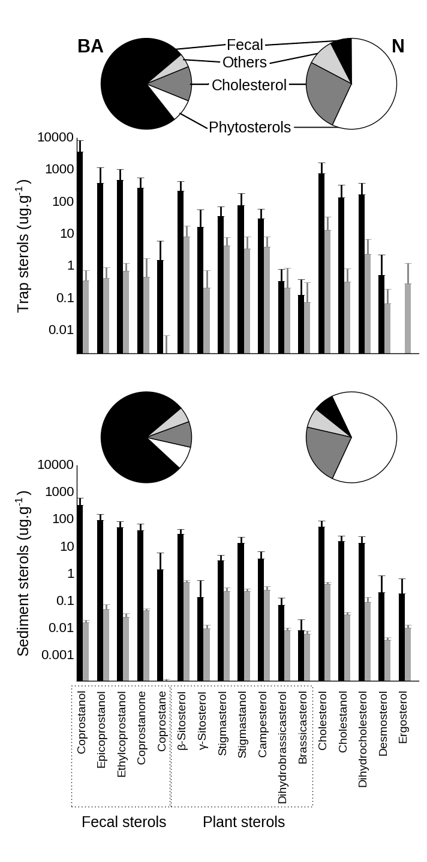

**Fig. 3.** Sterol composition of settling material (top panel) and sediments (bottom panel) at Buenos Aires (BA, black bars, left pie chart) and North (N, grey bars, right pie chart). Pie charts show proportions of cholesterol, fecal sterols, phytosterols and other sterols. Bar graphs show individual sterols concentrations, in a dry weight basis (note the logarithmic scale).

**Table 3.** Coprostanol concentration (μg.g-1) from surficial sediments throughout the world.

|  |  |  |  |
| --- | --- | --- | --- |
| Sampling site | Environment | Concentration | Reference |
| *Highly polluted sediments* |  |  |  |
| Yucatan Cenotes, Mexico | Underground river | <1-1690* | Arcega-Cabrera et al. 2014 |
| Northeastern Hamilton Harbour, Canada | Lake | <1-1600 | Coakley et al. 2002 |
| **Rio de la Plata, Argentina** | **River** | **59-708** | **This study** |
| Barcelona, Spain | Sea | <1-390 | Grimalt and Albaiges, 1990 |
| Iguaçu and Barigui Rivers, Brazil | River | <1-375 | Puerari et al. 2012 |
| Bilbao Estuary, Spain | Estuary | 2.2-293 | Gonzalez-Oreja and Saiz-Salinas 1998 |
| Barigui River, Brazil | River | <1-196 | Froehner et al. 2009 |
| Firth of Clyde, Scotland, United Kingdom | Sea | <1-176 | Kelly and Campbell 1995 |
| Tan-Shui Estuary Taiwan | Estuary | <1-163 | Jeng and Han 1994 |
| Northeastern Hamilton Harbour, Canada | Lake | <1-147 | Bachtiar et al. 1996 |
| Guanabara Bay, Brazil | Sea | 1.4-105 | Lima da Costa and Carreira 2005 |
| Kaoping River, Taiwan | River | <1-58 | Jeng et al. 1996 |
| Lake of Neuchatel, Switzerland | Lake | 6.1-55 | Pittet et al. 1990 |
| Ria Formosa, Portugal | Sea lagoon | <1-42 | Mudge and Bebbiano 1997 |
| Venice Lagoon, Italy | Sea lagoon | <1-41 | Sherwin et al. 1993 |
| Narrangansett Bay, USA | Sea | <1-39 | Le Blanc et al. 1992 |
| *Reference low-moderately polluted river sediments* | |  |  |
| Siak River, Indonesia | River | 0.050-11 | Liebezeit and Wöstmann 2010 |
| Mississippi River, USA | River | 0.10-7.5 | Hawkins Writer et al. 1995 |
| Capibaribe River, Brazil | River | 0.52-7.3 | Fernandes et al. 1999 |
| **Uruguay River, Argentina** | **River** | **nd -1.7** | **This study** |
| Santa Ana River, USA | RIver | nd-0.49 | Noblet et al. 2004 |
| Langat River, Malaysia | River | 0.0028-0.42 | Adnan et al. 2012 |

*: Sum of fecal sterols.

Sterol vertical fluxes and accumulation efficiency:

Vertical flux of total sterol was highly variable and averaged 116±168 mg.cm-2.year-1 at BA, with coprostanol accounting up to 60% of it (Fig. 2). At N, sterol flux was four orders of magnitude lower, 0.070±0.13 mg.cm-2.year-1 and cholesterol and β–sitosterol were the sterols with the highest fluxes. The accumulation efficiencies, obtained from the difference between sterol deposition (trap fluxes) and sediment concentrations allow an evaluation of the early diagenesis of these compounds. The accumulation efficiencies were 2-7 times higher at BA compared with N but the general pattern of accumulation efficiency of individual sterols was rather similar for both sampling sites. The higher accumulation efficiencies at BA compared with N reflect the differences in the oxic-anoxic transition of the sediments and the greater preservation of organic matter at sites with faster burial (Hedges and Keil, 1995). At BA, the high sedimentation rate rapidly moves the sterols to anoxic black-colored sediment, less diagenetically active, in which the sterols are well preserved. On the contrary, at N the oxic layer is thicker resulting in a greater aerobic degradation of sterols. Epicoprostanol was the better-preserved sterol, especially at BA (BA: 40%, N: 5.9%) probably due to *in-situ* microbial epimerization of coprostanol rather than to an enhanced preservation during deposition. Coprostanone accumulated more efficiently than coprostanol (BA: 10 vs. 6.5%, N: 3.7 vs 2.2%). Since coprostanone and coprostanol belong to the same metabolic pathway and can readily interconvert (Grimalt et al., 1990; Bull et al., 2002), the preferential coprostanone preservation in sediments might be related to its higher resistance to biodegradation (Wakeham 1989; Chaler et al., 2001). The plant sterols were in general well preserved (BA: 9.8-14%, N: 2.9-3.4%), as previously observed by Colombo et al. (1997) and it was attributable to the enhanced resistance of terrestrial sterols, associated with waxy higher plant material that hinder bacterial degradation (Volkman et al. 1987). Galeron et al. (2015) found that β–sitosterol have a low susceptibility to biodegradation and most of its decomposition proceeds via autoxidation and photodegradation, a process that is especially intense on land where chlorophyll acts as a sensitizer. Cholesterol was the least preserved sterol (BA: 4.6%, N: 1.6%) reflecting the intense breakdown of this sterol, mostly through biodegradation (Galeron et al., 2015). This explain the high accumulation efficiency of cholestenol (BA:10%, N: 6.1%), which results from *in situ* microbial reduction of cholesterol rather than from preservation of settling cholestanol.

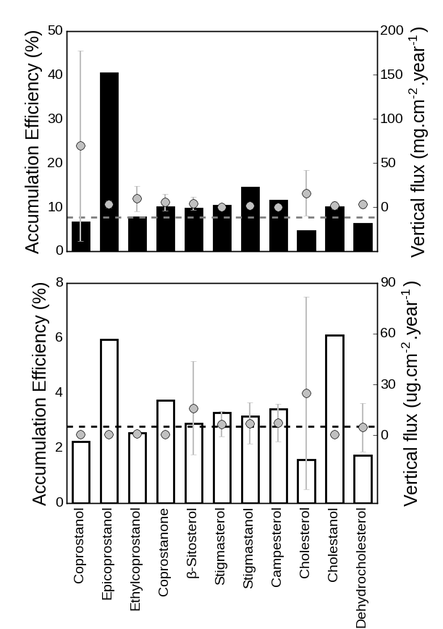

**Fig. 4.** Accumulation efficiencies of sterols from settling material in superficial sediments (%, bars, left axis) and vertical fluxes (points with standard error bars, left axis) for BA (upper panel) and N (bottom panel). Horizontal dotted lines indicate accumulation efficiency of total sterols. Minor sterols (<1% of total sterols) were excluded from calculations.

Sterol ratios:

Many sterol ratios have been routinely used to assess the contribution of different sources of organic as well as degradation processes (Venkatesan and Kaplan, 1990; Grimault et al., 1990; Jeng and Han, 1994; Quemeneur and Marty, 1994; Takada et al., 1994; Chalaux et al., 1995; Fattore et al., 1996). Since many of them provide redundant information, only five have evaluated in this work (Fig. 4). All the ratios presented highly significant differences between BA and N (*t*-test; *p*<0.0001), both for settling material and sediments. BA and N represented the endmembers of the fecal/phytosterol ratio in this basin (settling material: 0.90±0.044 vs 0.12±0.10; sediments: 0.90±0.032 vs 0.10±0.019) showing the ample variation of the contribution of sewage-derived material over the background inputs of terrestrial land plant runoff. The high coprostanol/epicoprostanol ratio at BA settling material (0.85±0.15) reflects the fresh degraded sewage inputs discharged, in contrast to the weak and extensively degraded fecal signature of N, with a low ratio (0.48±0.15), typical of aged fecal material (Mudge and Duce, 2005). Coprostanol degradation continues after particle deposition, resulting in lower coprostanol/epicoprostanol ratios in sediments relative to settling material (BA: 0.75±0.064, N: 0.26±0.058). As previously noted, the fecal sterol profile differs qualitatively between both contrasting sites as demonstrate the coprostanol/24-ethylcoprostanol ratio, which is useful to distinguish between different fecal sources of sterols (Leeming et al., 1996). This ratio was high at BA (settling material: 0.86±0.064; sediments: 0.84±0.076), due to the abundance of coprostanol in human feces, and 2 times lower at N (settling material: 0.35±0.19; sediments: 0.38±0.058), evidencing the input of herbivore mammal feces, rich in ethylcoprostanol. In fact, these values fall in the extremes of this relationship according to Leeming et al. (1997), with BA ratio surpassing the 0.73 threshold for exclusively human fecal pollution and N ratio below the 0.38 threshold for solely herbivore fecal pollution. However, the overwhelming abundance of coprostanol at BA may lead to erroneously neglect the non-human fecal pollution at this site. At BA, the β–sitosterol/24-ethylcoprostanol index, used to assess herbivore fecal pollution (Nash et al., 2005), was 0.36±0.15 (settling material) – 0.38 ± 0.060 (sediments), below the threshold of 1.0 (equivalent to 0.5 for the equation used in this work) proposed as typical of cow feces runoff (Nash et al. 2005). Is important to note that beside cattle, the fecal contribution of other animals with high ethylcoprostanol proportions in their feces, such as pigs and poultry also affect this ratio (Leeming et al. 1996). This reveals a small non-human contribution to the overall fecal pollution at BA, mostly determined by human inputs. At N, this ratio was 0.84±0.17 (settling material) – 0.95±0.018 (sediments), above the limit of 4 (equivalent to 0.8 for the equation used in this work) suggested by Nash et al. (2005) as indicative of non-fecal polluted plant decay inputs, denoting the minimum impact of fecal contamination at this site. The cholesterol/cholestanol ratio is useful to assess the microbial reduction of stenols to 5α-stanols that typically takes places in anoxic conditions (Reeves 2005; Nishimura and Koyama, 1977). At BA, the relatively low values of this ratio (0.85±0.043) indicate prevailing reductive conditions in the sewage effluent, which favors sterol preservation. On the contrary, oxidative conditions at N favors the sterol degradation over their hydrogenation (Nishimura and Koyama, 1977), resulting in proportionally low amounts of cholestanol (ratio: 0.95±0.043). This microbial degradation of cholesterol intensifies at the sediment surface further, resulting in lower values for this ratio in sediments (BA: 0.75±0.11, N: 0.93±0.025).

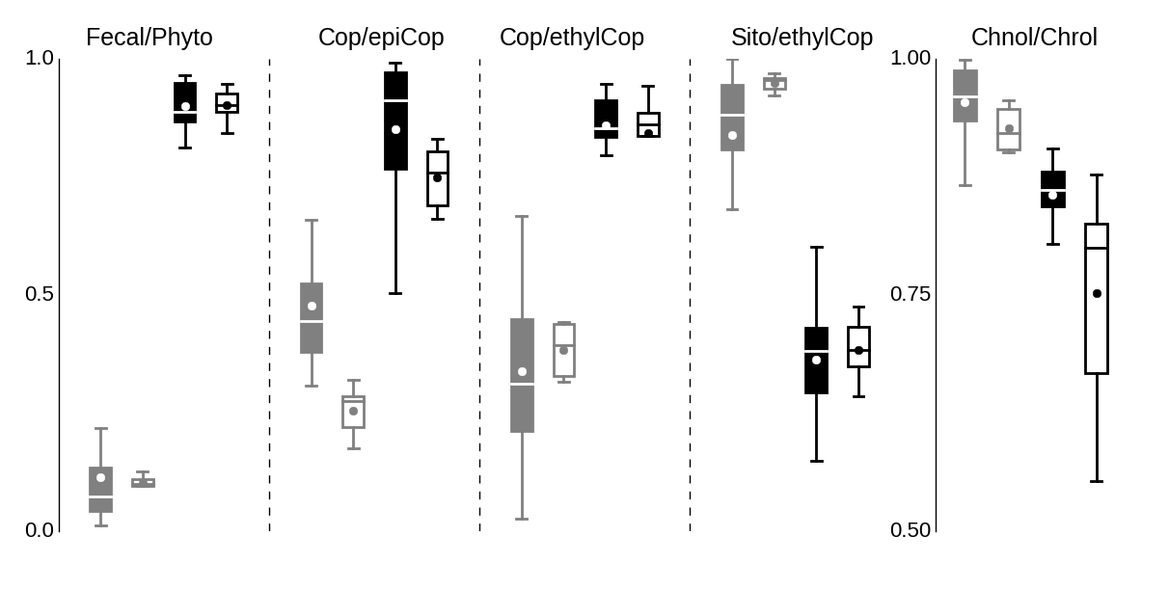

**Fig. 5.** Box plots of different sterol ratios from Buenos Aires (black) and North (grey) in settling material (hollow boxes) and sediment (filled boxes). Fecal/Phyto: Fecal sterols/phytosterols, Copr/epiCop: Coprostanol/Epicoprostanol, Cop/ethylCop: Coprostanol/24-Ethylcoprostanol, Sito/ethylCop: β-sitosterol/24-Ethylcoprostanol, Chnol/Chrol: Cholesterol/Cholestanol All ratios were significantly different between Buenos Aires and North (p<0.0001).

Temporal variation in settling material:

The large data variability observed both at BA and N resulted from the clear temporal variations (warm vs. cold months) in particle flux and sterol concentrations. There was a significant temporal pattern at BA of higher particle fluxes during warm months (September to March, 50±25 mg.cm2.day-1) relative to cold ones (April to August, 20±9.4 mg.cm2.day-1, *p*<0.005; Fig. 6). A similar seasonal variation (6.2±4.0 vs. 3.2±1.9 mg.cm2.day-1 at warm and cold months, *p*<0.05) was observed at N. Total sterol concentration at BA were significantly correlated with total particle flux (r = 0.64, *p*<0.05) and follows its temporal variation, raising during warm months (11163±9599 μg.g-1) and decreasing significantly during cold ones (3564±3711 μg.g-1; *p*<0.05, Fig. 6). This results in increased sterol vertical fluxes during warm periods compared to cold ones (220±202 vs. 23±19 mg. cm2.year-1, respectively). Since the warm periods correspond to the rainy season, this variation may be related to the enhanced terrestrial/urban runoff during this period, in agreement with previous observations at this site (Colombo et al., 2007). At N, sterols were also significantly correlated with particle flux (r = 0.60, *p*<0.05), but there was no difference between warm and cold months (45±61 vs. 36±28 μg.g-1 respectively). The sterol composition, on a percentage basis, showed little temporal variation except for the inverse trend of coprostanol and epicoprostanol at BA. While coprostanol proportion was higher at warm months than at cold ones (59±9.5 vs 45±8.7; *p*<0.01) and was correlated with total particle flux (*r*: 0.38; *p*<0.05), its epimer showed an opposite trend, increasing at cold months (2.6±2.0 vs 15± 9.2; *p*<0.005) and inversely correlating to total particle flux (*r*: -0.70; *p*<0.005). This reflect the enhanced level of sewage degradation in the cold and relatively dry period, as observed by Puerari et al, 2012.

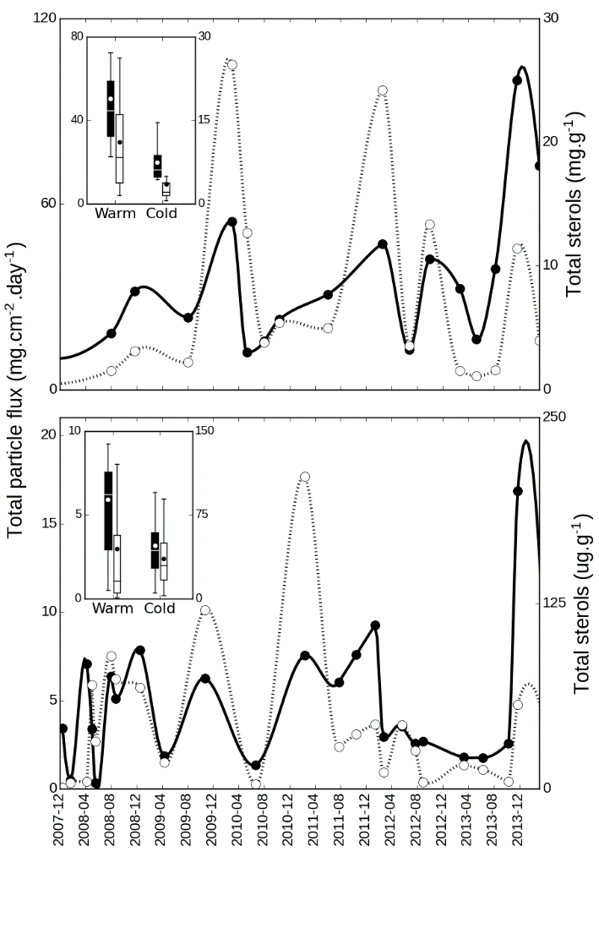

**Fig. 6.** Temporal variation of total particles flux (solid line, left axis) and total sterol concentration in settling material (dotted line, right axis) at Buenos Aires (top panel) and North (bottom panel). The boxplot inserts shows the averages for warm months (September to March) and cold months (April to August) for total particle flux (black boxes) and total sterols (white boxes).

Multivariate analysis/Conclusion

To simultaneously evaluate the contribution of the different sterol to overall variability in settling material and sediments, multiple regression and multivariate analysis (PCA) was performed (sterols with average concentrations lower than 0.5% were excluded from analysis, Fig.). This model explain 59% of total variability, mainly through principal component 1 (47%), which is loaded in the negative side with coprostanol and epicoprostanol and in the positive side with cholesterol and plant sterols.

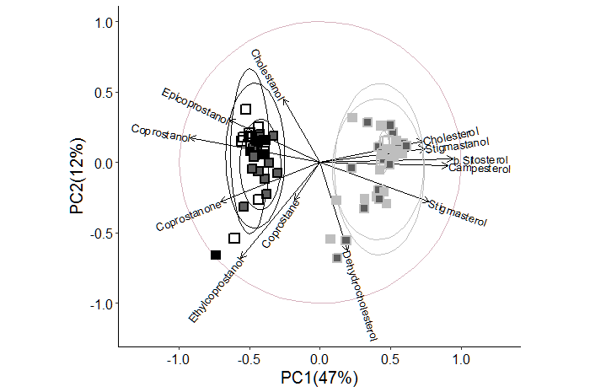

**Fig. 6.** Principal component analysis of sterol composition of settling particles (solid squares) and sediments (empty squares) from Buenos Aires (black edgecolor) and North (grey edgecolor). Markers with dark filling correspond to warm periods settling material while light filling correspond to cold periods. Confidence ellipses were set to 90% of normal probability.

**References**

Gas Chromatography and Lipids by William W. Christie and published in 1989 by P.J. Barnes & Associates (The Oily Press Ltd)

Menéndez, A. N. (2002). “Description and modeling of the hydrosedimentologic mechanisms in the Río de la Plata River.” Instituto Nacional del Agua INA, Buenos Aires, Argentina.

Chalaux, N., Takada, H., Bayona, J.M. 1995. Molecular Markers in Tokyo Bay Sediments: Sources and Distribution. Marine Environmental Research, Vol. 40, No. 1, pp. 11-92,

Nash, D., Leeming, R., Clemow, L., Hannah, M., Halliwell, D., & Allen, D. (2005). Quantitative determination of sterols and other alcohols in overland flow from grazing land and possible source materials. Water, 39, 2964–2978. <http://doi.org/10.1016/j.watres.2005.04.063>

Jeng, W., Wang, J., & Hanb, B. (1996). COPROSTANOL DISTRIBUTION IN MARINE SEDIMENTS SOUTHWESTERN TAIWAN OFF. Science, 94(I), 47–52.

Sherwin, M. R., Vleet, E. S. V. A. N., Fossatot, V. U., & Dolcit, F. (1993). Lagoonal Sediments and Mussels of Venice , Italy, 2(September), 501–507.