**Sterols biomarkers settling material and sediments from contrasting areas of the Rio de la Plata basin**

Speranza, E.D.12, AUTHORS, Colombo, J.C.13

1: Laboratorio de Química Ambiental y Biogeoquímica, Facultad de Ciencias Naturales y Museo, Universidad Nacional de La Plata, Av. Calchaquí 6200, Florencio Varela, 1888, Buenos Aires, Argentina.

2: Consejo Nacional de Investigaciones Científicas y Técnicas, Godoy Cruz 2290 C1425FQB, C.A.B.A., Argentina

3: Comisión de Investigaciones Científicas de la Provincia de Buenos Aires, calle 10 y 526, La Plata 1900, Argentina

**Abstract:**

To complete

Keywords: Sterols, Sewage markers, Settling material, Rio de la Plata.

**Introduction**

The runoff of solid and dissolved material from land into large river basins are a major source of sediments and organic matter to the ocean. Among the major river system worldwide, the Rio de la Plata basin ranks 5th in terms of drainage area (2.83x106 km2), covering nearly 20% of South America surface area (Milliman and Meade 1983). The main rivers of this basin, the Parana and Uruguay rivers (4900 and 1800 km, respectively) discharge about 22,000 m3.s-1 of water to the Atlantic Ocean through the Rio de la Plata estuary. The discharge, as well as other hydrological parameters, have a marked seasonal and interannual variability, especially in the Uruguay river which is highly sensitive to ENSO-induced variability (Colombo et al. 2015). With only 5-15m water depth and a width of 230 km at its mouth, the Rio de la Plata is a large funnel shaped estuary that receives 80x106 tons.year-1 of particulate load, mostly silt (Gilberto et al 2004), making it one of the most turbid estuaries in the world, with extreme concentrations more than 400gm3 (Framiñan and Brown,1996). The high amounts of nutrients and organic matter carried on by these sediments support an abundant fauna, including important fisheries (Acha et al., 2008).

At the metropolitan area of Buenos Aires city, which concentrates about 15x106 people, the Rio de la Plata estuary is strongly impacted by anthropogenic activities. The discharge of a large number of urban-industrial effluents and highly polluted streams results in high concentrations hydrocarbons, organochlorine pesticides (OCPs), and polychlorinated biphenyls (PCBs) and metals (Colombo et al. 2005, 2006, 2007). Owing to its magnitude, the main Buenos Aires sewer outfall stand out among these effluents. It discharge at 2.5 km offshore the domestic wastes of more than 5.6x106 inhabitants as well as industrial and municipal wastes, making a total of 2x106 m3.day-1 of effluents (AySA 2017, FREPLATA 2005). This massive sewage load had been discharged untreated to the Rio de la Plata River until 2015 when a primary wastewater treatment plant began to operate. Another important effluent, the Riachuelo channel also discharge large amounts of sewage material and industrial wastes 20 km upstream the main sewer. The combined discharge of both effluents make up to 3.8 m3.day-1 of effluents, which is comparable to the flow of the world’s largest sewage outfall in Boston (Roberts and Villegas, 2016).

In this context of high turbidity and organic matter load, the analysis of settling material is particularly relevant. Due to its hydrophobicity most of the organic matter reaching to the rivers readily associates with the particles and settled down in superficial sediments, where is intensely degraded by microbial action. The settling material represent thus the fresh inputs of organic matter to aquatic environments and is highly useful to assess the different contributions to the organic matter pool as well as the temporal variability of its composition. The sediments integrate this temporal variability over a wide temporal range, with a composition biased towards the compounds more resistant to degradation. The comparison between settling material and the underlying sediments allows understanding the early diagenesis of organic compounds in aquatic systems, which depends on multiple factors such as the sedimentation rate, the temperature and the oxidation reduction potential (Colombo et al., 1996)

.The molecular composition of the lipids of settling material and sediments provides particularly useful information about the sources and diagenetic alterations of organic matter (Meyers and Ishiwatari, 1993). Among the lipids, the sterols are especially useful as biomarker compounds due to their widespread environmental occurrence, stability and diversity of their structures. They are present in all eukariotes, as components of cell membranes, and they have been recently found in some prokaryote microalgae (Volkman 2005). The structural diversity of sterols, in terms of insaturation, stereochemistry, methylation of polycyclic framework and Meyers and Ishiwatari, 1993 sidechain configuration, allows inferring sources and diagenetic pathways of organic matter in sediments (Meyers and Ishiwatari, 1993). Their source specificity range from some rather unspecific sterols (e.g. cholesterol) to several sterol associated with particular organisms, such as diatoms, land plants and fungi (Volkman et al., 1986; Puglisi et al., 2003). A group of sterols, collectively referred as fecal sterols, have been widely used as sewage tracers. Coprostanol, formed during the biohydrogenation of the Δ5 double bond of cholesterol by bacteria present in the gut of humans or animals, is the primary fecal sterol detected in the domestic wastes (<60% total sterols, Leeming et al., 1984; Bull et al., 2002). In contrast with cholesterol, coprostanol is barely absorbed by the human intestinal epithelium and is massively excreted with feces (Veiga et al. 2005). Although it is degraded under oxic conditions, it can resist relatively unaltered for many years in anoxic bed sediments (Nishimura & Koyama, 1977). Trace concentrations of coprostanol cannot be unambiguously attributed to sewage pollution since small relative amounts of coprostanol can be formed by in situ hydrogenation of cholesterol in sediments not contaminated by fecal pollution (Nishimura and Koyama, 1977). The sterol composition of feces is largely dependent on diet, intestinal flora and sterol synthesis. Feces of mammalian herbivores (e.g. cows, horses, sheep) are dominated by 24-ethylcoprostanol, derived from intestinal bihydrogenation of the main land plant sterol, β–sitosterol (Bull et al., 2002).

In this paper, the sterol composition of settling material and superficial sediments was analyzed in two contrasting sites of the Rio de la Plata basin: the highly impacted metropolitan area of the Rio de la Plata estuary and the relatively non-polluted Nandubaysal bay, at the Uruguay River. Differences in terms of sterol concentration and composition, vertical fluxes, differential preservation in sediments and temporal variation are discussed.

**Materials and methods**

The sampling strategy comprised two sites with contrasting anthropogenic impact: the heavily polluted Buenos Aires metropolitan area of the Rio de la Plata estuary near the main sewer outfall (BA, 34°43.329'S - 58°10.301'O) and a more pristine site ︡~200 km upstream on the Uruguay River, the Ñandubaysal bay (N, 33°05.270'S - 58°21.374'W; Fig.1). Sampling campaigns were carried out seasonally from 2007 to 2014. Settling material was collected in pre-weighed polypropylene conical Falcon tubes coupled to a fixed 10 cm diameter cylindrical sediment trap deployed at 1.5m during 1-3 days (BA) or 30-60 days (N). Superficial sediments were collected using a stainless steel Hydro-Bios Van-Veen grab sampler. Samples were immediately refrigerated and transported to the laboratory. Tubes containing the settling material were centrifuged and weighed after discarding supernatant water. Water content was determined gravimetrically after drying in an oven at 40°C. Total particle flux was computed as:

$$\text{Flux (mg.cm}\text{-2}\text{.day}\text{-1}\text{)}=\frac{\text{s}\text{e}\text{ttling matter mass }\left(\text{mg}\right)}{\text{trap surface (78.5 cm}\text{2}\text{) . deployment time (days)}}$$

Sedimentation rate was calculated as:

$$\text{SR(cm.year}\text{-1}\text{)=}\frac{\text{Flux.365}}{\text{1000.density (g.cm}\text{-3}\text{)}}$$

The average settling material density (2.65 g.cm-3) was taken from previous work in the same sampling sites.

The discharge of the Uruguay River was calculated as the turbinated plus compensation flow discharged daily by the Salto Grande Dam, located 240 km upstream N station and averaged for each sediment trap deployment period (wholesale electricity market administration company: [www.cammesa.com](http://www.cammesa.com)). The discharge of the Rio de la Plata estuary was assumed as the sum of the corresponding monthly discharges of the Uruguay River, measured 90 km upstream N station, and of the Parana River, measured near the mouth of its main channels (Paraná Guazú and Paraná de las Palmas; Base de Datos Hidrológica Integrada, [bdhi.hidricosargentina.gov.ar](http://www.bdhi.hidricosargentina.gov.ar); Menendez, 2002).

Lipids were extracted ultrasonically with acetone:dichloromethane:petroleum ether (1:2:2). The extract was dried over anhydrous sodium sulfate and lipid content was determined gravimetrically. Deuterated sterols (deuterocholesterol and deuterositosterol, Steraloids, Inc., Newport, RI, steraloids.com) were added as internal standards. In order to avoid the interference of fatty acids, lipids were saponified with 1M KOH in methanol and non-saponifiable compounds were extracted with petroleum ether – diethyl ether (4:1 v/v, Christie, 1989). The extracts were concentrated under a nitrogen stream and derivatized with N,O-Bis(trimethylsilyl)trifluoroacetamide and trimethylchlorosilane (BSTFA:TMCS, 10:1v/v; AppliChem GmbH, Darmstadt, Germany, [www.applichem.com](http://www.applichem.com); Sigma-Aldrich, St. Louis, MO, USA, [www.sigmaaldrich.com](http://www.sigmaaldrich.com)) for 3 hours at 60ºC. The resulting trimethylsilyl derivatives were concentrated to dryness under nitrogen and resuspended in toluene prior analysis.



**Fig. 1.** Sampling stations of settling material and sediments in the metropolitan coastal area of the Rio de la Plata estuary, near Buenos Aires main sewer (BA) and at a northern site in the Uruguay River (N).

Samples were analyzed using a Perkin Elmer Clarus 500 GC-MS (Perkin Elmer, Waltham, MA, USA; [www.perkinelmer.com](http://www.perkinelmer.com)) fitted with a Quadrex 007-5MS capillary column (60 m, 0.32 mm i.d., 0.25 μm; Quadrex Corp., Bethany, CT, USA., [quadrexcorp.com](http://www.quadrexcorp.com)). Helium was used as a carrier gas with a flow rate of 1.2 mL/min and the temperature of injector was set at 250ºC (split-splitless mode). The oven temperature program was started at 100 ºC with a ramp to 225 ºC at 15 ºC /min and to 300 ºC at 3 ºC /min with a final holding time of 10 min. The transfer line temperature was set at 200 ºC and the analytes were ionized by 70eV electron impact at 180 ºC. The mass spectrometer was simultaneously operated in scan mode (from 60 to 600 amu) and selective ion monitoring. Data were acquired and processed with TurboMass 5.1 software (Perkin Elmer).

Steroids with their trivial and IUPAC names, molecular weight, retention times and mass-to-charge ratios (m/z) used for quantification and confirmation are presented in Table 1. Compounds were identified by comparison with authentic standards of 14 steroids (Steraloids, Sigma-Aldrich), literature data and interpretation of mass spectrometric fragmentation patterns. Quantification was performed using a 4-points calibration curve (0,2-50 μg ml-1) with authentic standards (Table 1). Peak areas were corrected according internal standard recoveries. Commercially standards were not available for some compounds (cholestenol, campestanol, 24-Ethylcoprostanol and γ-Sitosterol) which were quantified based on response factors of structurally related sterols.

**Table 1.** Names, formula, molecular weight (MW), retention time (Rt) and mass of ions used for quantification (target ion) and identification (confirmatory ions) of sterols and steroids (coprostane and coprostanone) analysed in this work.

|  |  |  |  |  |  |  |  |
| --- | --- | --- | --- | --- | --- | --- | --- |
| **Trivial name** | **Systematic name\*** | **Formula** | **MW** | **Rt** | **Target ion** | **Confirmatory ions** | |
| Coprostane | 5β-cholestane | C27H48 | 372.37 | 30.80 | 217 | 357 | 372 |
| Coprostanol | 5β-cholestan-3β-ol | C27H48O | 388.37 | 35.57 | 370 | 355 | 215 |
| Epicoprostanol | 5β-cholestan-3α-ol | C27H48O | 388.37 | 36.08 | 370 | 215 | 355 |
| Cholestanol | 5α-cholestan-3α-ol | C27H48O | 388.37 | 36.16 | 215 | 355 | 370 |
| Coprostanone | 5β-cholestan-3-one | C27H46O | 386.35 | 37.13 | 386 | 231 | 370 |
| Deuterocholesterol | cholest-5-en-3β-ol-25,26,26,26,27,27,27-D7 | C27H46O | 393.70 | 37.31 | 129 | 336 | 375 |
| Cholesterol | cholest-5-en-3β-ol | C27H46O | 386.35 | 37.48 | 329 | 129 | 368 |
| Dehydrocholesterol | cholesta-5,22E-dien-3β-ol | C27H44O | 384.34 | 37.73 | 215 | 445 | 355 |
| Brassicasterol | ergosta-5,22E-dien-3β-ol | C28H46O | 398.35 | 38.19 | 456 | 129 | 366 |
| Desmosterol | cholest-5,24-dien-3β-ol | C27H44O | 384.34 | 38.36 | 129 | 343 | 253 |
| Ergosterol | ergosta-5,7,22E-trien-3β-ol | C28H44O | 396.65 | 39.17 | 343 | 337 | 468 |
| Dihydrobrassicasterol | ergost-5-en-3β-ol | C28H48O | 400.37 | 39.75 | 343 | 129 | 384 |
| Campesterol | campest-5-en-3β-ol | C28H48O | 400.37 | 39.92 | 343 | 129 | 382 |
| Ethylcoprostanol | 24S-5β-stigmastan-3β-ol | C29H52O | 416.40 | 40.19 | 398 | 215 | 383 |
| Stigmasterol | stigmasta-5,22E-dien-3β-ol | C29H48O | 412.37 | 40.55 | 129 | 255 | 484 |
| γ-Sitosterol | 24S-stigmast-5-en-3-ol | C29H50O | 414.71 | 41.82 | 129 | 473 | 488 |
| Deutero-β-Sitosterol | stigmast-5-en-3β-ol-25,26,26,26,27,27,27 -D7 | C29H50O | 421.75 | 42.00 | 129 | 364 | 403 |
| β-Sitosterol | stigmast-5-en-3β-ol | C29H50O | 414.39 | 42.20 | 129 | 488 | 473 |
| Stigmastanol | stigmastan-3β -ol | C29H52O | 416.40 | 42.59 | 215 | 473 | 488 |

*: according LIPID MAPS classification system (http://www.lipidmaps.org/data/classification).

The limit of detection (LOD) of each steroid was estimated by calculating the signal to-noise ratio (S/N) of triplicate standard solutions in the range of 0,2-50 μg.ml-1 . LODs values averaged 6.5±11 ng.g-1, ranging from (0.31 ng.g-1, coprostanol) to (43 ng.g-1, ergosterol). Reproducibility was assessed by the relative standard deviation (RSD) of triplicate analysis of the same samples in different batches, and averaged 11±3.8 The method was highly linear in the range of concentrations of calibration curves (R2>0.99 for all steroids with available authentic standards). Recoveries of deuterated internal standards averaged 96±1.7 Individual recoveries, evaluated by analysis of spiked samples ranged from 82±15% (Ergosterol) to 110±19% (Desmosterol). Detailed information on method performance is provided in S1.

Statistical analysis was carried on with Python scripting language, using SciPy, NumPy, MatPlotlib and pandas libraries. Multivariate analyses was executed in *R* language, using ggplot2 and ggbiplot packages. Data were expressed as mean ± SD. Relative standard deviation (RSD: [data – mean].100.SD-1) was used to assess parameter variability. To avoid division by zero errors, the ratios between two sterols, A and B were calculated as: A.(A+B)-1. The accumulation efficiency of sterols from settling material to sediments was estimated as the relationship between the annual vertical flux of the sterol and its corresponding one-year inventory in sediments (sterol concentration in sediment * annual mineral flux). Student’s t test was used to perform comparisons between two means as well as to evaluate the significance of correlation coefficients. Multivariate analysis was performed by principal component analysis of standardized data (x−Xy−1, where X = mean and y = S.D.). Forward stepwise multiple regression (*P-to-enter*<0·05) was used to identify the variables that best accounted for the observed temporal variation in sterol vertical flux.

**Results and discussion**

Total particle flux:

The intense discharge of one of the largest sewer outfall worldwide at BA contributes to the natural particle load of the Rio de la Plata, resulting in an extraordinarily high vertical particle flux (34±24 mg.cm2.day-1) and sedimentation rate (4.7±3.3 cm.year-1), in agreement with previous measurements in this area (5.5 ± 2.1 cm.year-1, Colombo et al., 2007). This value is much higher than sedimentation rates reported for nearby areas of this turbid estuary (0.3 -1.3 cm.year-1; Di Gregorio et al., 2007; Bonachea et al., 2010), suggesting than most particles captured by sediment traps at BA are highly organic detritus derived from urban-industrial discharges. This is supported by the high lipid content previously measured in BA settling material (11±7.4 mg.g-1), which was 27-times higher than at the Parana river (0.41±0.28 mg.g-1), which contributes most of the solid load of the Rio de la Plata estuary (Speranza et al., 2013). At N, the total particle flux was 7-times lower (4.6±3.6 mg.cm2.day-1) and the resulting sedimentation rate (0.64±0.49 cm.year-1) was comparable to values reported previously for the Uruguay River (Colombo et al. 2015), which also showed a high variability (1.0±0.88 cm.year-1, range: 0.27-2.7 cm.year-1). In contrast to BA settling material composed of anthropogenic detritus over the background particle load derived from Parana River, the settling material at N reflects the smaller solid discharge of the Uruguay River (Moreira et al. 2013 from Jaime and Menendez 2002). The total particle flux was largely dependent on river discharge, which was 6-46 times higher at BA (19465-46088m3.s-1) relative to N (420-8410 m3.s-1), fitting an exponential curve (R2 = 0.78, *p*<0.0001; Fig. 2). This correlation had been previously observed at the Uruguay River and reflects the enhanced transport of eroded material as river flow increases (Colombo et al. 2015).

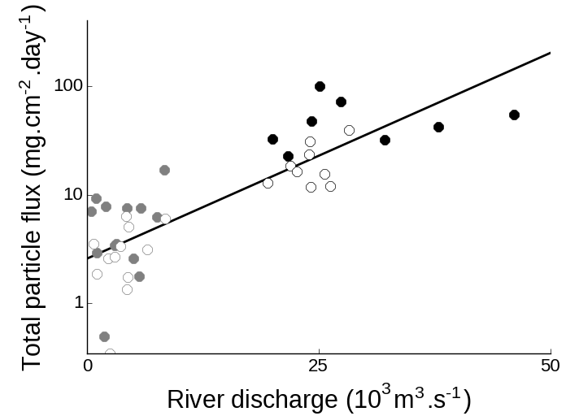

**Fig. 2.** Relationship between river discharge and total particle flux at Buenos Aires (black circles) and North (grey circles) sites during warm (September to March, solid circles) and cold months (April to August, empty circles). Note the logarithmic scale on the y-axis.

Total sterols concentrations:

The total sterol concentration in settling material was highly variable (RSD: 113-114%) and exhibited a marked geographical difference. At BA, the tendency of hydrophobic sterols to associate to particulate matter is enhanced by the high organic content of settling particles (total organic carbon: 7.7±5.5%; Colombo et al. 2007), resulting in very high sterol concentrations at this site 7140±7905 μg.g-1 dry weight). Previous studies dealing with sterols in settling particles were mostly based in ocean waters, relatively deep and clear, which had average concentrations 1-4 orders of magnitude lower compared to this shallow, turbid and polluted freshwater environment (Colombo et al. 1996; Parrish et al., 2000; Takada et al., 1994; Burns et al., 2008). Reports of sterols in settling material from riverine environments are more limited but the concentrations are still much lower than those from BA (1-184 μg.g-1; Saliot et al., 2001; Li et al 1995; Jeng and Kao 2002). In fact, total sterol concentrations in BA settling material are comparable to values reported for sewage sludge from wastewater treatment plants (2-9 mg.g-1; Venkatesan and Kaplan 1990; Kelly 1995; Nguyen et al., 1995). At N, total sterol concentrations in settling material are 2-3 orders of magnitude lower (41±47 μg.g-1) and comparable to aforementioned values in particulate matter from riverine environments. Total sterols in sediments were 10-20 times lower than in settling material and were less variable (RSD: 10-61%) but also presented a 2-3 orders of magnitude difference between BA and N (708±454 vs. 1.9±0.18 μg.g-1). The reduction in sterol concentration from settling material to sediments reflects the tendency of sterol to degrade at the water-sediment interfase, especially under oxic conditions (Sun and Wakeham 1998).

Temporal variation of particle flux and sterol concentrations in settling material:

The large data variability observed for both BA and N settling material resulted from significant temporal variations between warm and cold months. Effectively, a temporal pattern of higher particle fluxes during warm months (September to March) relative to cold ones (April to August) was observed both a BA (50±25 vs. 20±9.4 mg.cm2.day-1, *p*<0.005; Fig. 6) and N (6.2±4.0 vs. 3.2±1.9 mg.cm2.day-1, respectively, *p*<0.05). Total sterol concentration at BA was significantly correlated with total particle flux (r = 0.64, *p*<0.05) and followed its temporal variation, raising during warm months (11163±9599 μg.g-1) and decreasing significantly during cold ones (3564±3711 μg.g-1; *p*<0.05, Fig. 6). This increased sterol flux during the rainy period is related to the wash-out of organic matter to the stream and effluents that discharge in this area of the Rio de la Plata, as observed by Colombo et al 2007. The reinforcement of both patterns results in an order of magnitude higher sterol vertical fluxes during warm periods (220±202 vs. 23±19 mg. cm2.year-1 in cold months). Since warm periods correspond to the rainy season, this variation may be related to the enhanced terrestrial/urban runoff, in agreement with previous observations at this site (Colombo et al., 2007). At N, sterols were also significantly correlated with particle flux (r = 0.60, *p*<0.05), but there was no significant difference between warm and cold months (45±61 vs. 36±28 μg.g-1 respectively) thus sterol fluxes reflect basically the total particle flux pattern of higher values during the warm period (87±165 vs. 52±63 μg.cm2.year-1 in cold months).

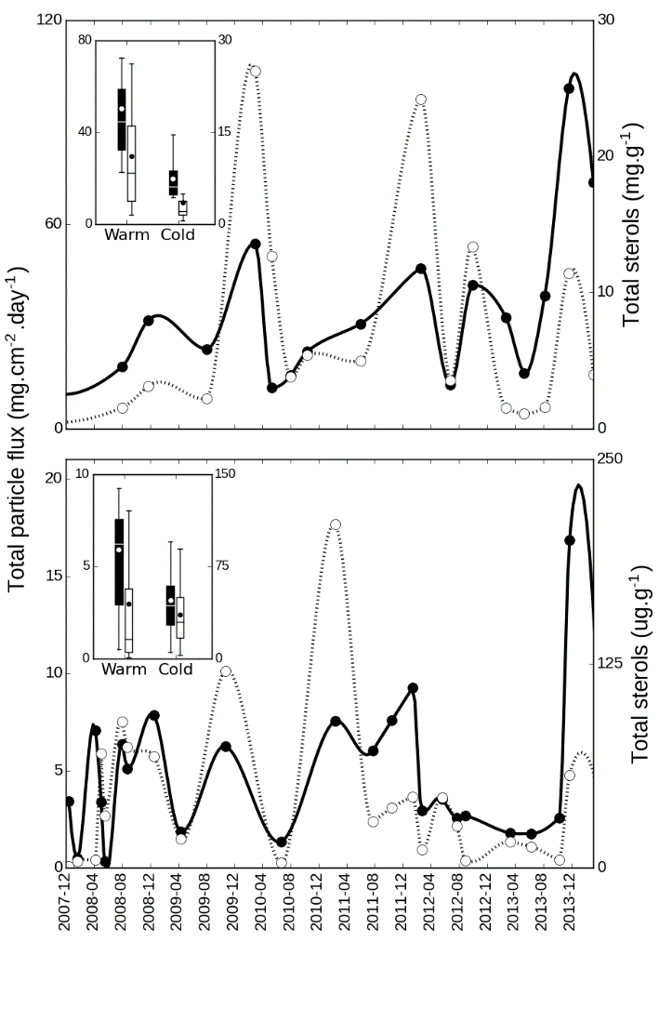

**Fig. 6.** Temporal variation of total particle flux (solid line, left axis) and total sterol concentration in settling material (dotted line, right axis) at Buenos Aires (top panel) and North (bottom panel). The boxplot inserts shows the averages for warm months (September to March) and cold months (April to August) for total particle flux (black boxes) and total sterols (white boxes).

Sterol composition:

The sterol composition of settling material showed contrasting differences between BA and N (Fig. 3). At BA, the composition was dominated by fecal sterols (75±5.4% of total sterols), mostly coprostanol (52±11%), followed by cholesterol (12±2.9%) and phytosterols (8.3±3.6%). This fecal signature, resembled the composition of human feces (fecal sterols: 85%, phytosterols: 8.8%, cholesterol: 5.2%, others: 1.2%; Leeming et al. 1996), reflecting the massive discharges of crude sewage at this site. Moreover, the coprostanol proportion of BA settling material (52±11%) felt in the 50-80% range found in sewage sludge and effluents (Venkatesan and Kaplan 1990). Nevertheless, the presence of smaller proportions of epicoprostanol (9.3±9.6%), originated from microbial degradation of coprostanol evidence an incipient degradation. Considering the long residence time of fecal material in the large Buenos Aires sewer network (9900 km, main sewers: >100km, AySA 2017; Roberts and Villegas, 2016), a preliminary degradation is likely to occur in sewer pipeline rather than in the very shallow (3-4 m) water column. The presence of a relatively important proportion of ethylcoprostanol (8.5±4.4%) is usually associated with non-human (herbivore) fecal pollution since it is the product of microbial hydrogenation of β–sitosterol, the main sterol in terrestrial vegetation. However, human feces can include significant amounts of ethylcoprostanol (Leeming et al. 1996) so the mere presence of this sterol cannot be unambiguously attributed to herbivore fecal contribution. The significance of coprostanone (5.4±3.3%) is difficult to ascertain since it originates in mammalian gut as an intermediary in coprostanol microbial synthesis, but it can also be produced in sediments as a result of interconversions between this ketone and coprostanol and epicoprostanol (McCalley et al. 1981; Bull et al., 2002). The relatively low proportions phytosterols, mainly represented by β–sitosterol (4.4±1.9%), reflect the minor contribution of vegetal inputs at this site. Despite the relative abundance of cholesterol, its utility as biomarker is rather limited since it is present in sewage material but also in multiple organic matter sources, such as algae, zooplankton and benthic fauna (Mudge et al. 1999; Creuzberg and von Elert 2009).The change in percentage composition with total sterol concentration also showed geographical differences. At BA, as total sterol concentration increased, coprostanol proportion raised (r = 0.55; *p*<0.005) while stigmasterol and campesterol (r = -0.56 and 0.64; *p*<0.005) decreased and the remaining sterol proportions were not correlated, confirming that the increase in particulate sterol responds basically to anthropogenic discharges. The sterol composition, on a percentage basis, showed little temporal variation except for the inverse trend of coprostanol and epicoprostanol. While coprostanol proportion tends to be higher during warm months (59±9.5 vs 45±8.7 in cold months; *p*<0.01) and correlates with total particle flux (*r*: 0.38; *p*<0.05), its epimer increases during the cold period (2.6±2.0 to 15± 9.2; *p*<0.005) and correlates inversely to total particle flux (*r*: -0.70; *p*<0.005). This is in agreement with previous work in this area of Rio de la Plata estuary where the terrestrial runoff results in an enhanced discharge of organic compounds with a fresh signature during the warm and rainy period, in contrast with the less intense and more degraded signal observed during the cold and dry months (Colombo et al., 2007). Similarly, Puerari et al (2012) observed an enhanced level of sewage degradation in the cold and relatively dry period in Brazilian rivers.

At N, the sterol composition of settling particles presented a predominant vegetal signature (phytosterols: 57±13%, cholesterol: 26±12, fecal sterols: 7.5±7.0%). Despite being found in some algae species, the three major phytosterols at N, β-sitosterol (19±5.4%), stigmasterol (15±7.9%) and campesterol (13±11%), are strongly associated with land plants (Huang and Meinschein 1979, Volkman 2005), to such an extent that they have used as biomarkers of paper mill pollution (Lahdelma and Oikari 2006). The fecal sterols signal at N, dominated by ethylcoprostanol (3.9±4.7%) followed by coprostanol (1.3±1.3%), differs both quantitatively and qualitatively from the typical sewage signature observed at BA. The presence of ethylcoprostanol as the main fecal sterol at N probably reflects the contribution of cattle fecal matter from the neighboring livestock establishments. There was a strong significant correlation of total sterols with cholesterol proportion (r = 68; *p*<0.0001) and an inverse relationship with ethylcoprostanol and stigmasterol (r = -0.39 and -0.43 respectively; *p*<0.05). No clear temporal variation was observed in sterol composition of N settling material.

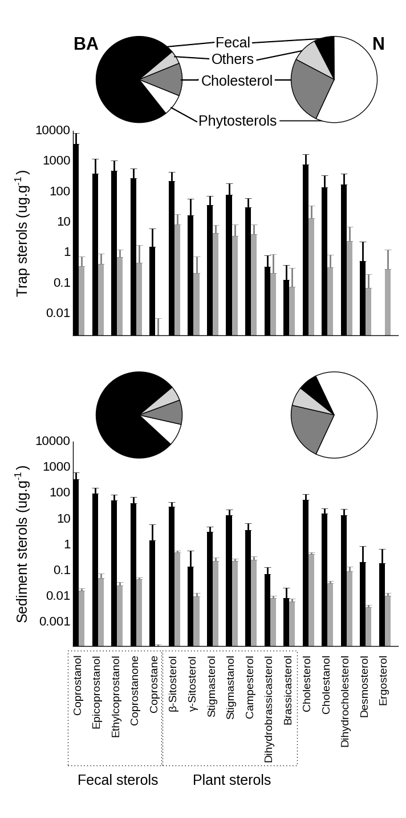

**Fig. 3.** Sterol composition of settling material (top panel) and sediments (bottom panel) at Buenos Aires (BA, black bars, left pie chart) and North (N, grey bars, right pie chart). Pie charts show proportions of cholesterol, fecal sterols, phytosterols and other sterols. Bar graphs show individual sterols concentrations, in a dry weight basis (note the logarithmic scale).

The sediment sterol profile was similar to that of settling material, with some minor differences related to the sterol degradation at sediment surface. At BA, this degradation is apparent in the relative increase of degradation products such as epicoprostanol, stigmastanol and cholestanol from settling particles to sediments (16±4.5, 2.6±1.5 and 2.8±1.1% vs. 9.3±9.6, 1.6±0.88 and 1.7±1.2% in settling material respectively, *p*<0.05), reflecting the microbial reduction of stenols to stanols and coprostanol epimerization at the oxic-anoxic boundary (Wakeham 1989). Despite this degradation, sediments at BA still had remarkably high sterol concentrations, especially of coprostanol whose concentration is among the highest reported for surficial sediments severely impacted by sewage discharges (Table 2). Coprostanol highest values were chiefly measured in freshwater locations or in relatively enclosed seawater environments where ocean dilution is reduced. In sediments from the Uruguayan coast of the Rio de la Plata near Montevideo, Venturini et al. (2015) reported 17-400 times lower concentrations of coprostanol (0.05-21 μg.g-1,) and cholesterol (0.48-5.1 μg.g-1), evidencing that the background levels of these sterols are quite low and that they derive mainly from local urban discharges at BA. Interestingly, the concentrations of phytosterols were only slightly lower to those of BA for stigmasterol and campesterol (0.30-3.14 and 0.13-2.13 μg.g-1, respectively; Venturini et al., 20015) but not for β–sitosterol, which was 6-70 times lower (0.43-5.3 μg.g-1). This suggests that while sewage discharge contributes significantly β–sitosterol at BA sediments, the terrestrial runoff is the main source of stigmasterol and campesterol. This is in agreement with previous reports of high concentrations of β–sitosterol in sewage effluents of domestic origin (e.g. flush of kitchen vegetable oils; Furtula et al., 2011).

**Table 3.** Coprostanol concentration (μg.g-1) from surficial sediments throughout the world.

|  |  |  |  |
| --- | --- | --- | --- |
| Sampling site | Environment | Concentration | Reference |
| *Highly polluted sediments* |  |  |  |
| Yucatan Cenotes, Mexico | Underground river | <1-1690* | Arcega-Cabrera et al. 2014 |
| Northeastern Hamilton Harbour, Canada | Lake | <1-1600 | Coakley et al. 2002 |
| **Rio de la Plata, Argentina** | **River** | **59-708** | **This study** |
| Barcelona, Spain | Sea | <1-390 | Grimalt and Albaiges, 1990 |
| Iguaçu and Barigui Rivers, Brazil | River | <1-375 | Puerari et al. 2012 |
| Bilbao Estuary, Spain | Estuary | 2.2-293 | Gonzalez-Oreja and Saiz-Salinas 1998 |
| Barigui River, Brazil | River | <1-196 | Froehner et al. 2009 |
| Firth of Clyde, Scotland, United Kingdom | Sea | <1-176 | Kelly and Campbell 1995 |
| Tan-Shui Estuary Taiwan | Estuary | <1-163 | Jeng and Han 1994 |
| Northeastern Hamilton Harbour, Canada | Lake | <1-147 | Bachtiar et al. 1996 |
| Guanabara Bay, Brazil | Sea | 1.4-105 | Lima da Costa and Carreira 2005 |
| Kaoping River, Taiwan | River | <1-58 | Jeng et al. 1996 |
| Lake of Neuchatel, Switzerland | Lake | 6.1-55 | Pittet et al. 1990 |
| Ria Formosa, Portugal | Sea lagoon | <1-42 | Mudge and Bebbiano 1997 |
| Venice Lagoon, Italy | Sea lagoon | <1-41 | Sherwin et al. 1993 |
| Narrangansett Bay, USA | Sea | <1-39 | Le Blanc et al. 1992 |
| *Reference low-moderately polluted river sediments* | |  |  |
| Siak River, Indonesia | River | 0.050-11 | Liebezeit and Wöstmann 2010 |
| Mississippi River, USA | River | 0.10-7.5 | Hawkins Writer et al. 1995 |
| Capibaribe River, Brazil | River | 0.52-7.3 | Fernandes et al. 1999 |
| **Uruguay River, Argentina** | **River** | **nd -1.7** | **This study** |
| Santa Ana River, USA | River | nd-0.49 | Noblet et al. 2004 |
| Langat River, Malaysia | River | 0.0028-0.42 | Adnan et al. 2012 |

*: Sum of fecal sterols.

At N, the sediment sterol profile was dominated by terrestrial plant phytosterols and cholesterol, as observed in settling material but with higher proportions of epicoprostanol, β-sitosterol and stigmastanol (2.7±1.2, 25±3.0 and 12±1.9%, respectively, *p*<0.05). The marginal impact of sewage pollution at N sediments was evidenced by the low coprostanol concentrations, which are well below the threshold values reported as indicative of sewage pollution (0.1-0.7 μg.g-1; Grimalt et al. 1990; Leeming et al. 1997; Rada et al. 2015) and are comparable to values reported for riverine sites with low to moderate sewage pollution (Table 2).

To simultaneously evaluate the contribution of the different sterols to overall variability in settling material and sediments, multiple regression and multivariate analysis (PCA) were performed for major sterols (compounds with < 0.5% abundance were excluded, Fig. ) average proportions lower than 0.5% were excluded from analysis, Fig.). This model explain 59% of total variability, mainly through principal component 1 (47%), which is loaded in the negative side with fecal coprostanol and epicoprostanol and in the positive side with cholesterol and plant sterols.

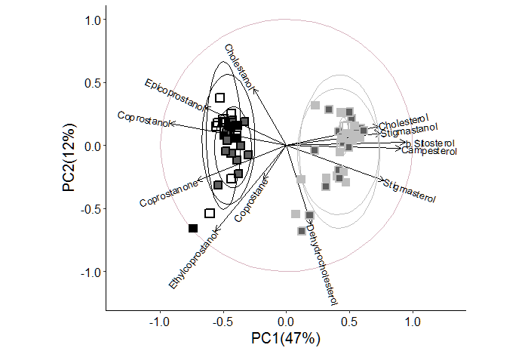

**Fig. 7.** Principal component analysis of sterol composition of settling particles (solid squares) and sediments (empty squares) from Buenos Aires (black edgecolor) and North (grey edgecolor). Markers with dark filling correspond to warm periods settling material while light filling correspond to cold periods. Confidence ellipses were set to 90% of normal probability.

Sterol vertical fluxes and accumulation efficiency:

Vertical flux of total sterols was highly variable and averaged 116±168 mg.cm-2.year-1 at BA, with coprostanol accounting up to 60% (70±108 mg.cm-2.year-1, Fig. 2). At N, sterol flux was four orders of magnitude lower, 0.070±0.13 mg.cm-2.year-1 and cholesterol and β–sitosterol were the sterols with the highest fluxes. The accumulation efficiencies, obtained from the difference between the expected sterol deposition based on trap fluxes and the observed sediment concentrations allow an evaluation of the early diagenetic behavior of these compounds. The accumulation efficiencies were 2-7 times higher at BA compared with N but the general pattern of accumulation efficiency of individual sterols was rather similar at both sampling sites. The higher accumulation efficiencies at BA reflect the differences in the oxic-anoxic transition of the sediments and the greater preservation of organic matter at sites with faster burial (Hedges and Keil, 1995). At BA, the high sedimentation rate rapidly removes sterols to anoxic black-colored sediment, less diagenetically active, favoring their preservation. In contrast, at N the oxic layer is thicker resulting in a greater aerobic degradation of sterols. Epicoprostanol presented the highest accumulation efficiency, especially at BA (BA: 40%, N: 5.9%) probably due to *in-situ* microbial epimerization of coprostanol rather than to an enhanced preservation during deposition. Coprostanone accumulated more efficiently than coprostanol (BA: 10 vs. 6.5%, N: 3.7 vs 2.2%). Since coprostanone and coprostanol belong to the same metabolic pathway and can readily interconvert (Grimalt et al., 1990; Bull et al., 2002), the preferential coprostanone preservation in sediments might be related to its higher resistance to biodegradation (Wakeham 1989; Chaler et al., 2001). Plant sterols were in general well preserved (BA: 9.8-14%, N: 2.9-3.4%), as previously observed in the Saint Lawrence estuary (Colombo et al., 1997) and it was attributable to the enhanced resistance of terrestrial sterols, associated with waxy higher plant material that hinder bacterial degradation (Volkman et al. 1987). Galeron et al. (2015) found that β–sitosterol have a low susceptibility to biodegradation and most of its decomposition proceeds via autoxidation and photodegradation, a process that is especially intense on land where chlorophyll acts as a sensitizer. Cholesterol was the least preserved sterol (BA: 4.6%, N: 1.6%) reflecting the intense breakdown of this sterol, mostly through biodegradation (Galeron et al., 2015). This explain the high accumulation efficiency of cholestenol (BA:10%, N: 6.1%), which results from *in situ* microbial reduction of cholesterol rather than from preservation of settling cholestanol.

The massive vertical flux of coprostanol at BA (69±108 mg.cm-2.year-1) results in its rapid buildup in surficial sediment (735±1143 g.m-2 for the top 5-cm layer). Based on coprostanol concentrations in sediments, this top 5-cm layer inventory results 16-times lower, 46±37 g.m-2, reflecting the sterol degradation at sediment surface. Considering that the sewer network serves 5.6 x 106 people (AySA 2007), with a per capita feces production of 300 g.day-1 (cite) and an average coprostanol concentration of 13 mg.g-1 (Glatz et al., 1985, Westrate et al., 1999, Leeming et al. 1996), the total coprostanol discharge can be roughly estimated to be 8000 tons.year-1. Considering an outfall plume area of 50 km2 (5 km broad, 10 km long; Roberts and Villegas 2016) in which most of the sewage material would settle down, the expected coprostanol inventory for the top 5 cm layer would be 170 g.m-2, which is intermediate between the values calculated in this work from sediment concentration and settling material flux.

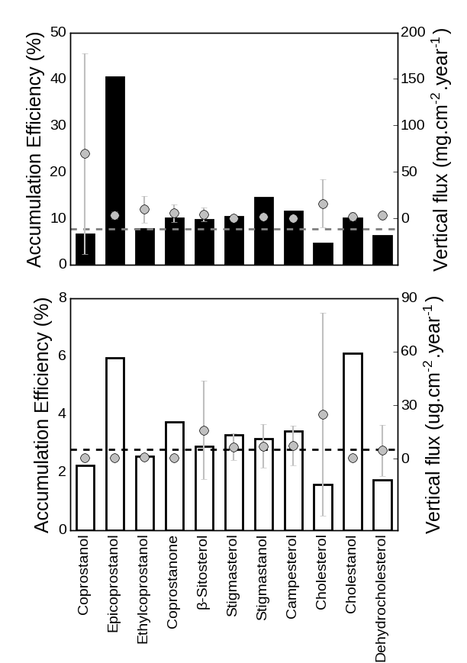

**Fig. 4.** Accumulation efficiencies of sterols from settling material in superficial sediments (%, bars, left axis) and vertical fluxes (points with standard error bars, right axis) for BA (upper panel) and N (bottom panel). Horizontal dotted lines indicate accumulation efficiency of total sterols. Minor sterols (<1% of total sterols) were excluded from calculations.

Sterol ratios:

Many sterol ratios have been routinely used to assess the contribution of different sources of organic matter as well as degradation processes (Venkatesan and Kaplan, 1990; Grimault et al., 1990; Jeng and Han, 1994; Quemeneur and Marty, 1994; Takada et al., 1994; Chalaux et al., 1995; Fattore et al., 1996). Since many of them provide redundant information, only five have evaluated in this work (Fig. 4). All the ratios presented highly significant differences between BA and N (*t*-test; *p*<0.0001), both for settling material and sediments. BA and N represented the endmembers of the fecal/phytosterol ratio in this basin (settling material: 0.90±0.044 vs 0.12±0.10; sediments: 0.90±0.032 vs 0.10±0.019) showing the ample variation of the contribution of sewage-derived material over the background inputs of terrestrial land plant runoff. The high coprostanol/epicoprostanol ratio at BA settling material (0.85±0.15) reflects the relatively fresh sewage inputs discharged, in contrast to the weak and extensively degraded fecal signature at N, with a low ratio (0.48±0.15), typical of aged fecal material (Mudge and Duce, 2005). Coprostanol degradation continues after particle deposition, resulting in lower coprostanol/epicoprostanol ratios in sediments relative to settling material (BA: 0.75±0.064, N: 0.26±0.058). As previously noted, the fecal sterol profile differs qualitatively between both contrasting sites as demonstrate the coprostanol/24-ethylcoprostanol ratio, which is useful to distinguish between different fecal sources of sterols (Leeming et al., 1996). This ratio was high at BA (settling material: 0.86±0.064; sediments: 0.84±0.076), due to the abundance of coprostanol in human feces, and 2 times lower at N (settling material: 0.35±0.19; sediments: 0.38±0.058), evidencing the input of herbivore mammal feces, rich in ethylcoprostanol. In fact, these values fall in the extremes of this relationship according to Leeming et al. (1997), with BA ratio surpassing the 0.73 threshold for exclusively human fecal pollution and N ratio below the 0.38 threshold for solely herbivore fecal pollution. However, the overwhelming abundance of coprostanol at BA may lead to erroneously neglect the non-human fecal pollution at this site. At BA, the β–sitosterol/24-ethylcoprostanol index, used to assess herbivore fecal pollution (Nash et al., 2005), was 0.36±0.15 (settling material) – 0.38 ± 0.060 (sediments), below the threshold of 1.0 (equivalent to 0.5 for the equation used in this work) proposed as typical for cow feces runoff (Nash et al. 2005). Is important to note that beside cattle, the fecal contribution of other animals with high ethylcoprostanol proportions in their feces, such as pigs and poultry also affect this ratio (Leeming et al. 1996). This reveals a small non-human contribution to the overall fecal pollution at BA. At N, this ratio was 0.84±0.17 (settling material) – 0.95±0.018 (sediments), above the limit of 4 (equivalent to 0.8 for the equation used in this work) suggested by Nash et al. (2005) as indicative of non-fecal polluted plant decay inputs, denoting the minimum impact of fecal contamination at this site. The cholesterol/cholestanol ratio is useful to assess the microbial reduction of stenols to 5α-stanols that typically takes places in anoxic conditions (Reeves 2005; Nishimura and Koyama, 1977). At BA, the relatively low values of this ratio (0.85±0.043) indicate prevailing reductive conditions in the sewage effluent, which favors sterol preservation. On the contrary, oxidative conditions at N favors the sterol degradation over their hydrogenation (Nishimura and Koyama, 1977), resulting in proportionally low amounts of cholestanol (ratio: 0.95±0.043). This microbial degradation of cholesterol intensifies at the sediment surface further, resulting in lower values for this ratio in sediments (BA: 0.75±0.11, N: 0.93±0.025).

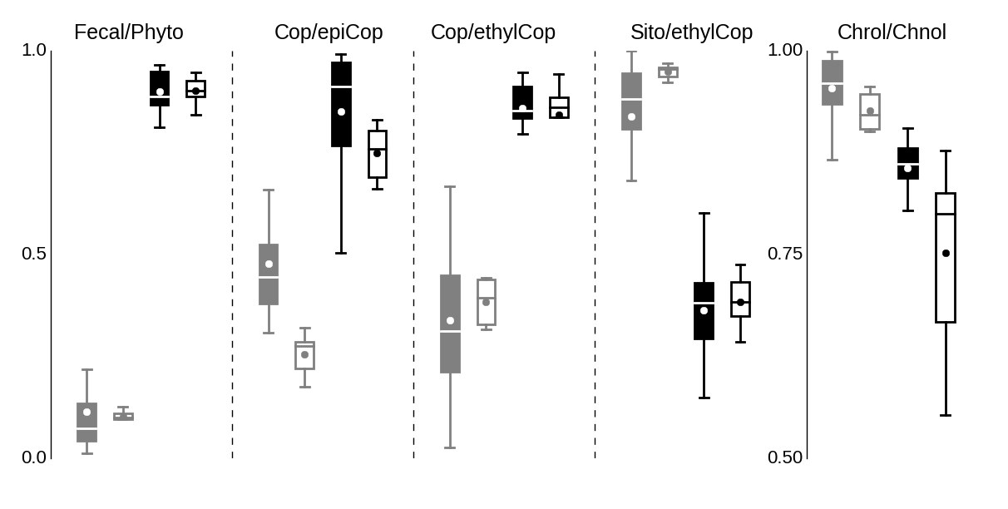

**Fig. 5.** Box plots of different sterol ratios from Buenos Aires (black) and North (grey) in settling material (hollow boxes) and sediment (filled boxes). Fecal/Phyto: fecal sterols/(fecal sterols + phytosterols), Copr/epiCop: coprostanol/(coprostanol + epicoprostanol), Cop/ethylCop: coprostanol/(coprostanol + ethylcoprostanol), Sito/ethylCop: β-sitosterol/(β-sitosterol + ethylcoprostanol, Chnol/Chrol: cholesterol/(cholesterol + cholestenol) All ratios were significantly different between Buenos Aires and North (p<0.0001).

Conclusions:

**References**

Gas Chromatography and Lipids by William W. Christie and published in 1989 by P.J. Barnes & Associates (The Oily Press Ltd)

Menéndez, A. N. (2002). “Description and modeling of the hydrosedimentologic mechanisms in the Río de la Plata River.” Instituto Nacional del Agua INA, Buenos Aires, Argentina.

Chalaux, N., Takada, H., Bayona, J.M. 1995. Molecular Markers in Tokyo Bay Sediments: Sources and Distribution. Marine Environmental Research, Vol. 40, No. 1, pp. 11-92,

Nash, D., Leeming, R., Clemow, L., Hannah, M., Halliwell, D., & Allen, D. (2005). Quantitative determination of sterols and other alcohols in overland flow from grazing land and possible source materials. Water, 39, 2964–2978. <http://doi.org/10.1016/j.watres.2005.04.063>

Jeng, W., Wang, J., & Hanb, B. (1996). COPROSTANOL DISTRIBUTION IN MARINE SEDIMENTS SOUTHWESTERN TAIWAN OFF. Science, 94(I), 47–52.

Sherwin, M. R., Vleet, E. S. V. A. N., Fossatot, V. U., & Dolcit, F. (1993). Lagoonal Sediments and Mussels of Venice , Italy, 2(September), 501–507.