**Sterols biomarkers in settling material and sediments from contrasting areas of the Rio de la Plata basin**

Eric Demian Speranzaab*, Manuel Colomboac[1], Juan Carlos Colomboac

a: Laboratorio de Química Ambiental y Biogeoquímica, Facultad de Ciencias Naturales y Museo, Universidad Nacional de La Plata, Av. Calchaquí 6200, Florencio Varela, 1888, Buenos Aires, Argentina.

b: Consejo Nacional de Investigaciones Científicas y Técnicas, Godoy Cruz 2290 C1425FQB, C.A.B.A., Argentina

c: Comisión de Investigaciones Científicas de la Provincia de Buenos Aires, calle 10 y 526, La Plata 1900, Argentina

* Corresponding author. Tel.: +54 4275 8266. E mail address: [esperanza@fcnym.unlp.edu.ar](mailto:esperanza@fcnym.unlp.edu.ar) (E.D. Speranza)

**Abstract:**

Sources and diagenetic alterations of sterol markers were studied in settling material and sediments near Buenos Aires main sewer (BA), and at a relatively non-polluted upstream site at the Uruguay River (N). The vertical particle flux was 7-times higher at BA relative to N (34±24 vs. 4.6±3.6 mg.cm2.day-1) and increased during rainy months. The total sterol contents was also higher at BA, both in settling material (7140±7905 vs. 41±47 μg.g-1 at N), and in more degraded sediments (708±454 vs. 1.9±0.18 μg.g-1). The difference was further amplified in the sterol vertical flux (116±168 vs. 0.070±0.13 mg.cm-2.year-1). At BA, the sterol composition of settling material and sediments was dominated by fecal sterols (75-77%), with very high coprostanol concentrations (3.6±4.8 and 0.35±0.28 mg.g-1, respectively) similar to sewage sludges, while at N plant sterols dominated (57-64%), mainly β-sitosterol, stigmasterol and campesterol. The accumulation efficiencies calculated as the difference between trap fluxes ad sediment inventories were 2-7 times higher at BA reflecting the higher vertical fluxes and enhanced preservation in anoxic conditions. Epicoprostanol, cholestanol and plant sterols were the best-preserved sterols, while cholesterol was the most labile. At BA the discharge of fresh sewage was evidenced by the high fecal sterols/phytosterols and coprostanol/epicoprostanol ratios. At N, the overwhelming dominance of plant sterols over fecal sterol, mostly derived from herbivores feces was reflected by the high β–sitosterol/24-ethylcoprostanol ratio and the low coprostanol/24-ethylcoprostanol ratio. The coprostanol/epicoprostanol cholesterol/cholestanol ratios were lower in sediments than in settling material, reflecting the sterol degradation at sediment surface.

Keywords: Sterols, Sewage markers, Settling material, Rio de la Plata.

1. **Introduction**

Discharge of municipal wastewater to rivers is a source of continuing environmental concern. These effluents are a major source of organic matter and nutrients that may cause eutrophication, oxygen depletion, turbidity increase, acidification, trophic structure alteration changes and other processes leading to habitat deterioration (Takada et al., 1997; Blanch et al., 2004; deBruyn et al., 2003). Moreover, since most sewer systems in Latin America also receive industries and storm drainage inputs besides domestic discharges, sewage contains many hazardous materials such as organic and inorganic pollutants and pathogens that jeopardize the use of water for human consumption, fishing activities or recreation (Helmer and Hespanhol, 1997). The discharge of urban-industrial effluents on the estuarine area of major river systems is particularly relevant since they are an important source of anthropogenic material to marine environments.

Among these major river system worldwide, the Rio de la Plata basin ranks 5th in terms of drainage area (2.83x106 km2), covering nearly 20% of South America surface area (Milliman and Meade, 1983). The main rivers of this basin, the Parana and Uruguay rivers (4900 and 1800 km, respectively) discharge average 22,000 m3.s-1 of water to the Atlantic Ocean through the Rio de la Plata estuary, a large funnel and shallow shaped estuary that receives 80x106 tons.year-1 of particulate load making it one of the most turbid estuaries in the world (Framiñan and Brown,1996). At the metropolitan area of Buenos Aires city, which concentrates about 15x106 people, the Rio de la Plata estuary is strongly impacted by anthropogenic activities. The discharge of a large number of urban-industrial effluents and highly polluted streams results in high concentrations of hydrocarbons, organochlorine pesticides (OCPs), and polychlorinated biphenyls (PCBs) and metals in sediments (Colombo et al., 1989, 2005; Tatone et al., 2009), settling material (Colombo et al. 2007; Tatone et al., 2012) and biota (Colombo et al., 1997, 2007a, 2007b, 2011). Owing to its magnitude, the main Buenos Aires sewer outfall stand out among these effluents. It discharges 2.2x106 m3.day-1 of domestic wastes from 6x106 inhabitants as well as industrial and municipal wastes at 2.5 km offshore ([www.aysa.com.ar](http://www.aysa.com.ar); FREPLATA, 2005). This massive sewage load had been discharged untreated to the Rio de la Plata River until 2015 when a primary wastewater treatment plant began to operate. Another important effluent, the Riachuelo River also discharges large amounts of sewage material and industrial wastes 20 km upstream the main sewer. The combined discharges of both effluents make up to 3.8 m3.day-1, which is comparable to the flow of the world’s largest sewage outfall in Boston (Roberts and Villegas, 2016).

In this context of high turbidity and organic matter load, the analysis of settling material is particularly relevant. Most of the organic matter reaching the rivers readily associates with the particles and settle down to superficial sediments, where is intensely degraded by microbial action. Settling material represents the fresh inputs of organic matter to aquatic environments and is thus useful to assess the sources as well as the temporal variability of its composition. Sediments integrate this temporal variability over a wide temporal range, with a composition biased towards more resistant compounds. The comparison between settling material and underlying sediments permits a detailed evaluation of the early diagenetic behavior of organic compounds which is basically controlled by factors such as sedimentation rate, temperature and redox conditions (Colombo et al., 1996)

The molecular composition of lipids from settling material and sediments provides particularly useful information on the sources and diagenetic alterations of organic matter (Meyers and Ishiwatari, 1993). Among lipids, sterols are especially suited as biomarker compounds due to their widespread environmental occurrence, stability and structure diversity. They are present in all eukariotes as components of cell membranes, and they have been also found in some prokaryote microalgae (Volkman, 2005). The structural diversity of sterols, in terms of insaturation, stereochemistry, methylation of polycyclic framework and sidechain configuration, allows inferring sources and diagenetic pathways of organic matter in sediments (Meyers and Ishiwatari, 1993). Their source specificity range from some rather unspecific sterols (e.g. cholesterol) to several marker sterols associated to particular organisms, such as diatoms, dinoflagellates, plants and fungi (Volkman et al., 1986; Puglisi et al., 2003). A group of sterols, collectively referred as fecal sterols, have been widely used as sewage tracers. Coprostanol, formed during the biohydrogenation of the Δ5 double bond of cholesterol by bacteria present in the gut of humans or animals, is the primary fecal sterol detected in domestic wastes (<60% total sterols, Bull et al., 2002). In contrast with cholesterol, coprostanol is barely absorbed by the human intestinal epithelium and is massively excreted with feces (Veiga et al., 2005). Although it is degraded under oxic conditions, it can resist relatively unaltered for many years in anoxic sediments (Nishimura and Koyama, 1977). Trace concentrations of coprostanol cannot be unambiguously attributed to sewage pollution since small relative amounts of coprostanol can be formed by in situ hydrogenation of cholesterol in sediments not contaminated by fecal pollution (Nishimura and Koyama, 1977). The sterol composition of feces is largely dependent on diet, intestinal flora and sterol synthesis. Feces of mammalian herbivores (e.g. cows, horses, sheep) are dominated by 24-ethylcoprostanol, derived from intestinal biohydrogenation of the main land plant sterol, β–sitosterol (Bull et al., 2002).

In this paper, we evaluate the sources, vertical fluxes and diagenetic alterations of sterol markers during burial in two contrasting sites of the Rio de la Plata basin: the highly impacted metropolitan area of the Rio de la Plata estuary and a relatively non-polluted north site at the Uruguay River. Differences in terms of sterol concentration and composition, vertical fluxes, differential preservation in sediments and temporal variation are discussed.

1. **Materials and methods**

The sampling strategy comprised two sites with contrasting anthropogenic impact: the heavily polluted Buenos Aires metropolitan area of the Rio de la Plata estuary near the main sewer outfall (BA, 34°43.329'S - 58°10.301'O) and a more pristine site ~200 km upstream on the Uruguay River, the Ñandubaysal bay (N, 33°05.270'S - 58°21.374'W; Fig.1). Sampling campaigns were carried out seasonally from 2007 to 2014. Settling material was collected in pre-weighed polypropylene conical Falcon tubes coupled to a fixed 10 cm diameter cylindrical sediment trap deployed at 1.5m during 1-3 days (BA) or 30-60 days (N). Superficial sediments were collected using a stainless steel Hydro-Bios Van-Veen grab sampler. Samples were immediately refrigerated and transported to the laboratory. Tubes containing the settling material were centrifuged and weighed after discarding supernatant water. Water content was determined gravimetrically after drying in an oven at 40°C. Total particle flux was computed as:

$$\text{Flux (mg.cm}\text{-2}\text{.day}\text{-1}\text{)}=\frac{\text{s}\text{e}\text{ttling matter mass }\left(\text{mg}\right)}{\text{trap surface (78.5 cm}\text{2}\text{) . deployment time (days)}}$$

Sedimentation rate was calculated as:

$$\text{SR(cm.year}\text{-1}\text{)=}\frac{\text{Flux.365}}{\text{1000.density (g.cm}\text{-3}\text{)}}$$

The discharge of the Uruguay River was calculated as the turbinated plus compensation flow discharged daily by the Salto Grande Dam, located 240 km upstream N station and averaged for each sediment trap deployment period (wholesale electricity market administration company: [www.cammesa.com](http://www.cammesa.com)). The discharge of the Rio de la Plata estuary was assumed as the sum of the corresponding monthly discharges of the Uruguay River, measured 90 km upstream N station, and of the Parana River, measured near the mouth of its main channels (Paraná Guazú and Paraná de las Palmas; Base de Datos Hidrológica Integrada, [bdhi.hidricosargentina.gov.ar](http://www.bdhi.hidricosargentina.gov.ar); Jaime and Menendez, 2002).

Lipids were extracted ultrasonically with acetone:dichloromethane:petroleum ether (1:2:2). The extract was dried over anhydrous sodium sulfate and lipid content was determined gravimetrically. Deuterated sterols (deuterocholesterol and deuterositosterol, Steraloids, Inc., Newport, RI, steraloids.com) were added as internal standards. In order to avoid the interference of fatty acids, lipids were saponified with 1M KOH in methanol and non-saponifiable compounds were extracted with petroleum ether – diethyl ether (4:1 v/v, Christie, 1989). The extracts were concentrated under a nitrogen stream and derivatized with N,O-Bis(trimethylsilyl)trifluoroacetamide and trimethylchlorosilane (BSTFA:TMCS, 10:1v/v; AppliChem GmbH, Darmstadt, Germany; Sigma-Aldrich, St. Louis, MO, USA) for 3 hours at 60ºC. The resulting trimethylsilyl derivatives were concentrated to dryness under nitrogen and resuspended in toluene prior analysis.



**Fig. 1.** Sampling stations of settling material and sediments in the metropolitan coastal area of the Rio de la Plata estuary, near Buenos Aires main sewer (BA) and at a northern site in the Uruguay River (N).

Samples were analyzed using a Perkin Elmer Clarus 500 GC-MS (Perkin Elmer, Waltham, MA, USA) fitted with a Quadrex 007-5MS capillary column (60 m, 0.32 mm i.d., 0.25 μm; Quadrex Corp., Bethany, CT, USA). Helium was used as a carrier gas with a flow rate of 1.2 mL/min and the temperature of injector was set at 250ºC (split-splitless mode). The oven temperature program was started at 100 ºC with a ramp to 225 ºC at 15 ºC /min and to 300 ºC at 3 ºC /min with a final holding time of 10 min. The transfer line temperature was set at 200 ºC and the analytes were ionized by 70eV electron impact at 180 ºC. The mass spectrometer was simultaneously operated in scan mode (from 60 to 600 amu) and selective ion monitoring. Data were acquired and processed with TurboMass 5.1 software (Perkin Elmer).

Steroids with their trivial and IUPAC names, molecular weight, retention times and mass-to-charge ratios (m/z) used for quantification and confirmation are presented in Table 1. Compounds were identified by comparison with authentic standards of 14 steroids (Steraloids, Sigma-Aldrich), literature data and interpretation of mass spectrometric fragmentation patterns. Quantification was performed using a 4-points calibration curve (0.20-50 μg.ml-1) with authentic standards (Table 1). Peak areas were corrected according internal standard recoveries. Commercially standards were not available for some compounds (cholestenol, Dehydrobrassicasterol, 24-Ethylcoprostanol and γ-Sitosterol) which were quantified based on response factors of structurally related sterols.

**Table 1.** Names, formula, molecular weight (MW), retention time (Rt) and mass of ions used for quantification (target ion) and identification (confirmatory ions) of sterols and steroids (coprostane and coprostanone) analysed in this work.

|  |  |  |  |  |  |  |  |
| --- | --- | --- | --- | --- | --- | --- | --- |
| **Trivial name** | **Systematic name\*** | **Formula** | **MW** | **Rt** | **Target ion** | **Confirmatory ions** | |
| Coprostane | 5β-cholestane | C27H48 | 372.37 | 30.80 | 217 | 357 | 372 |
| Coprostanol | 5β-cholestan-3β-ol | C27H48O | 388.37 | 35.57 | 370 | 355 | 215 |
| Epicoprostanol | 5β-cholestan-3α-ol | C27H48O | 388.37 | 36.08 | 370 | 215 | 355 |
| Cholestanol | 5α-cholestan-3α-ol | C27H48O | 388.37 | 36.16 | 215 | 355 | 370 |
| Coprostanone | 5β-cholestan-3-one | C27H46O | 386.35 | 37.13 | 386 | 231 | 370 |
| Deuterocholesterol | cholest-5-en-3β-ol-25,26,26,26,27,27,27-D7 | C27H46O | 393.70 | 37.31 | 129 | 336 | 375 |
| Cholesterol | cholest-5-en-3β-ol | C27H46O | 386.35 | 37.48 | 329 | 129 | 368 |
| Dehydrocholesterol | cholesta-5,22E-dien-3β-ol | C27H44O | 384.34 | 37.73 | 215 | 445 | 355 |
| Brassicasterol | ergosta-5,22E-dien-3β-ol | C28H46O | 398.35 | 38.19 | 456 | 129 | 366 |
| Desmosterol | cholest-5,24-dien-3β-ol | C27H44O | 384.34 | 38.36 | 129 | 343 | 253 |
| Ergosterol | ergosta-5,7,22E-trien-3β-ol | C28H44O | 396.65 | 39.17 | 343 | 337 | 468 |
| Dihydrobrassicasterol | ergost-5-en-3β-ol | C28H48O | 400.37 | 39.75 | 343 | 129 | 384 |
| Campesterol | campest-5-en-3β-ol | C28H48O | 400.37 | 39.92 | 343 | 129 | 382 |
| Ethylcoprostanol | 24S-5β-stigmastan-3β-ol | C29H52O | 416.40 | 40.19 | 398 | 215 | 383 |
| Stigmasterol | stigmasta-5,22E-dien-3β-ol | C29H48O | 412.37 | 40.55 | 129 | 255 | 484 |
| γ-Sitosterol | 24S-stigmast-5-en-3-ol | C29H50O | 414.71 | 41.82 | 129 | 473 | 488 |
| Deutero-β-Sitosterol | stigmast-5-en-3β-ol-25,26,26,26,27,27,27 -D7 | C29H50O | 421.75 | 42.00 | 129 | 364 | 403 |
| β-Sitosterol | stigmast-5-en-3β-ol | C29H50O | 414.39 | 42.20 | 129 | 488 | 473 |
| Stigmastanol | stigmastan-3β -ol | C29H52O | 416.40 | 42.59 | 215 | 473 | 488 |

*: according LIPID MAPS classification system (http://www.lipidmaps.org/data/classification).

The limit of detection (LOD) of each steroid was estimated by calculating the signal to-noise ratio (S/N) of triplicate standard solutions in the range of 0,20-50 μg.ml-1 . LODs values averaged 6.5±11 ng.g-1, ranging from (0.31 ng.g-1, coprostanol) to (43 ng.g-1, ergosterol). Reproducibility was assessed by the relative standard deviation (RSD) of triplicate analysis of the same samples in different batches, and averaged 11±3.8 The method was highly linear in the range of concentrations of calibration curves (R2>0.99 for all steroids with available authentic standards). Recoveries of deuterated internal standards averaged 96±1.7 Individual recoveries, evaluated by analysis of spiked samples ranged from 82±15% (Ergosterol) to 110±19% (Desmosterol).

Statistical analysis was carried on with Python scripting language, using SciPy, NumPy, MatPlotlib and pandas libraries. Multivariate analyses was executed in *R* language, using ggplot2 and ggbiplot packages. Data were expressed as mean ± SD. Relative standard deviation (RSD: [data – mean].100.SD-1) was used to assess parameter variability. To avoid division by zero errors, the ratios between two sterols, A and B were calculated as: A.(A+B)-1. The accumulation efficiency of sterols from settling material to sediments was estimated as the relationship between the annual vertical flux of the sterol and its corresponding one-year inventory in sediments (sterol concentration in sediment * annual mineral flux). Student’s t test was used to perform comparisons between two means as well as to evaluate the significance of correlation coefficients. Multivariate analysis was performed by principal component analysis of standardized data (x−Xy−1, where X = mean and y = S.D.).

1. **Results and discussion** 
   1. Total particle flux

The intense discharge of one of the largest sewer outfall worldwide at BA contributes to the natural particle load of the Rio de la Plata, resulting in an extraordinarily high vertical particle flux (34±24 mg.cm2.day-1) and sedimentation rate (4.7±3.3 cm.year-1), in agreement with previous measurements in this area (5.5 ± 2.1 cm.year-1, Colombo et al., 2007). This value is much higher than sedimentation rates reported for nearby areas of this turbid estuary (0.3 -1.3 cm.year-1; Di Gregorio et al., 2007; Bonachea et al., 2010), suggesting than most particles captured by sediment traps at BA are highly organic detritus derived from urban-industrial discharges. This is supported by the high lipid content previously measured in BA settling material (11±7.4 mg.g-1), which was 27-times higher than at the Parana river (0.41±0.28 mg.g-1), which contributes most of the solid load of the Rio de la Plata estuary (Speranza et al., 2013). At N, the total particle flux was 7-times lower (4.6±3.6 mg.cm2.day-1) and the resulting sedimentation rate (0.64±0.49 cm.year-1) was comparable to values reported previously for the Uruguay River (Colombo et al., 2015), which also showed a high variability (1.0±0.88 cm.year-1, range: 0.27-2.7 cm.year-1). In contrast to BA settling material composed of anthropogenic detritus over the background particle load derived from Parana River, the settling material at N reflects the smaller solid discharge of the Uruguay River (Moreira et al., 2013 from Jaime and Menendez, 2002). The total particle flux was largely dependent on river discharge, which was 6-46 times higher at BA (19465-46088m3.s-1) relative to N (420-8410 m3.s-1), fitting an exponential curve (R2 = 0.78, *p*<0.0001; Fig. 2). This correlation had been previously observed at the Uruguay River and reflects the enhanced transport of eroded material as river flow increases (Colombo et al., 2015).

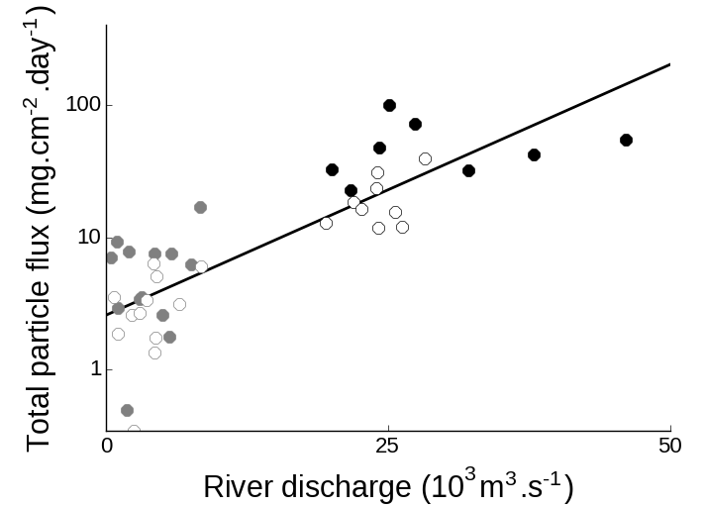

**Fig. 2.** Relationship between river discharge and total particle flux at Buenos Aires (black circles) and North (grey circles) sites during warm (September to March, solid circles) and cold months (April to August, empty circles). Note the logarithmic scale on the y-axis.

* 1. Total sterol concentrations

The total sterol concentration in settling material was highly variable (RSD: 113-114%) and exhibited a marked geographical difference. At BA, the tendency of hydrophobic sterols to associate to particulate matter is enhanced by the high organic content of settling particles (total organic carbon: 7.7±5.5%; Colombo et al., 2007), resulting in very high sterol concentrations at this site 7140±7905 μg.g-1 dry weight). Previous studies dealing with sterols in settling particles were mostly based in ocean waters, relatively deep and clear, which had average concentrations 1-4 orders of magnitude lower compared to this shallow, turbid and polluted freshwater environment (Takada et al., 1994; Colombo et al., 1996; Parrish et al., 2000; Burns et al., 2008). Reports of sterols in settling material from riverine environments are more limited but the concentrations are still much lower than those from BA (1-184 μg.g-1; Saliot et al., 2001; Li et al., 1995; Jeng and Kao, 2002). In fact, total sterol concentrations in BA settling material are comparable to values reported for sewage sludge from wastewater treatment plants (2-9 mg.g-1; Venkatesan and Kaplan, 1990; Kelly, 1995; Nguyen et al., 1995). At N, total sterol concentrations in settling material are 2-3 orders of magnitude lower (41±47 μg.g-1) and comparable to aforementioned values in particulate matter from riverine environments. Total sterols in sediments were 10-20 times lower than in settling material and were less variable (RSD: 10-61%) but also presented a 2-3 orders of magnitude difference between BA and N (708±454 vs. 1.9±0.18 μg.g-1). The reduction in sterol concentration from settling material to sediments reflects the tendency of sterol to degrade at the water-sediment interfase, especially under oxic conditions (Sun and Wakeham, 1998).

* 1. Temporal variation of particle flux and sterol concentrations in settling material

The large data variability observed for both BA and N settling material resulted from significant temporal variations between warm and cold periods. Effectively, a temporal pattern of higher particle fluxes during warm and rainy months (September to March, 22±2.6°C, 127±18 mm) relative to cold and dry ones (April to August, 13±2.5ºC, 74±23 mm) was observed both at BA (50±25 vs. 20±9.4 mg.cm2.day-1, *p*<0.005; Fig. 6) and N (6.2±4.0 vs. 3.2±1.9 mg.cm2.day-1, respectively, *p*<0.05). Total sterol concentration at BA was significantly correlated with total particle flux (r = 0.64, *p*<0.05) and followed its temporal variation, raising during warm months (11163±9599 μg.g-1) and decreasing significantly during cold ones (3564±3711 μg.g-1; *p*<0.05, Fig. 6). This increased sterol flux during the rainy period is related to the wash-out of streams and effluents that discharge in this area of the Rio de la Plata, as also observed previously for other organic tracers (Colombo et al., 2007). The reinforcement of total flux and concentration patterns results in an order of magnitude higher sterol vertical fluxes during warm periods (220±202 vs. 23±19 mg. cm2.year-1 in cold months). At N, sterols were also significantly correlated with particle flux (r = 0.60, *p*<0.05), but there was no significant difference between warm and cold months (45±61 vs. 36±28 μg.g-1 respectively) thus sterol fluxes reflect basically the total particle flux pattern of higher values during the warm period (87±165 vs. 52±63 μg.cm2.year-1 in cold months).

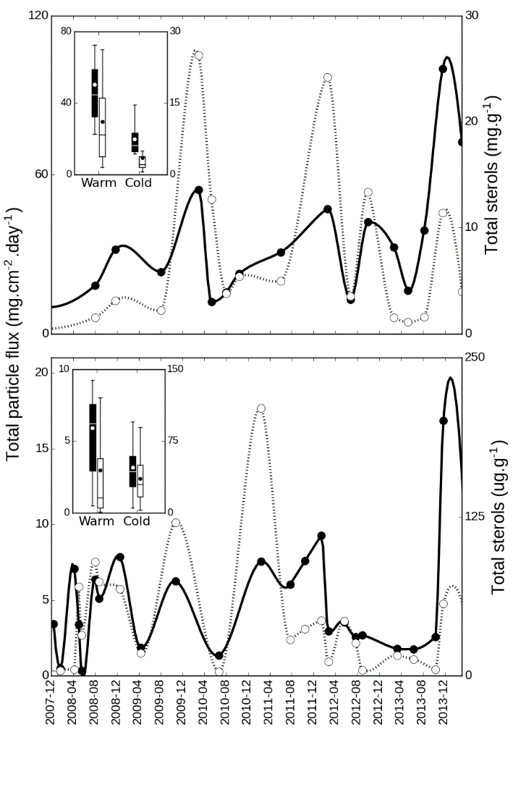

**Fig. 6.** Temporal variation of total particle flux (solid line, left axis) and total sterol concentration in settling material (dotted line, right axis) at Buenos Aires (top panel) and North (bottom panel). The boxplot inserts shows the averages for warm months (September to March) and cold months (April to August) for total particle flux (black boxes) and total sterols (white boxes).

* 1. Sterol composition

The sterol composition of settling material showed contrasting differences between BA and N (Fig. 3). At BA, the composition was dominated by fecal sterols (75±5.4% of total sterols), mostly coprostanol (52±11%), followed by cholesterol (12±2.9%) and phytosterols (8.3±3.6%). This fecal signature, resembled the composition of human feces (fecal sterols: 85%, phytosterols: 8.8%, cholesterol: 5.2%, others: 1.2%; Leeming et al., 1996), reflecting the massive discharges of crude sewage at this site. Moreover, both the concentration (3.6±4.8 mg.g-1) and the proportion of coprostanol in BA settling material felt in the range found in sewage sludge and effluents (1-4 mg.g-1, 50-80%; Venkatesan and Kaplan, 1990, Nguyen et al., 1995). Nevertheless, the presence of smaller proportions of epicoprostanol (9.3±9.6%), originated from microbial degradation of coprostanol evidence an incipient degradation. Considering the long residence time of fecal material in the large Buenos Aires sewer network (9900 km total with main sewers >100km, [www.aysa.com.ar](http://www.aysa.com.ar)), a preliminary degradation is likely to occur in sewer pipeline rather than in the very shallow (3-4 m) water column. The presence of a relatively important proportion of ethylcoprostanol (8.5±4.4%) is usually associated with non-human (herbivore) fecal pollution since it is the product of microbial hydrogenation of β–sitosterol, the main sterol in terrestrial vegetation. However, human feces can include significant amounts of ethylcoprostanol (Leeming et al., 1996) so the mere presence of this sterol cannot be unambiguously attributed to herbivore fecal contribution. The significance of coprostanone (5.4±3.3%) is difficult to ascertain since it originates in mammalian gut as an intermediary in coprostanol microbial synthesis, but it can also be produced in sediments as a result of interconversions between this ketone and coprostanol and epicoprostanol (McCalley et al., 1981; Bull et al., 2002). The relatively low proportions phytosterols, mainly represented by β–sitosterol (4.4±1.9%), reflect the minor contribution of vegetal inputs, including kitchen oil and foodstuff products, at this site. Despite the relative abundance of cholesterol, its utility as biomarker is rather limited since it is present in sewage material but also in multiple organic matter sources, such as algae, zooplankton and benthic fauna (Mudge et al., 1999; Creuzberg and von Elert, 2009).The change in percentage composition with total sterol concentration also showed geographical differences. At BA, as total sterol concentration increased, coprostanol proportion raised (r = 0.55; *p*<0.005) while stigmasterol and campesterol (r = -0.56 and 0.64; *p*<0.005) decreased and the remaining sterol proportions were not correlated, confirming that the increase in particulate sterol responds basically to anthropogenic discharges. The sterol composition, on a percentage basis, showed little temporal variation except for the inverse trend of coprostanol and epicoprostanol. While coprostanol proportion tends to be higher during warm months (59±9.5 vs 45±8.7 in cold months; *p*<0.01) and correlates with total particle flux (*r*: 0.38; *p*<0.05), its epimer increases during the cold period (2.6±2.0 to 15± 9.2; *p*<0.005) and correlates inversely to total particle flux (*r*: -0.70; *p*<0.005). This is in agreement with previous work in this area of Rio de la Plata estuary where the terrestrial runoff results in an enhanced discharge of organic compounds with a fresher signature during the warm and rainy period, in contrast with the less intense and more degraded signal observed during cold and dry months (Colombo et al., 2007). Similarly, Puerari et al. (2012) observed an enhanced level of sewage degradation in the dry winter period in Brazilian rivers, associated with a lower terrestrial runoff.

At N, the sterol composition of settling particles presented a predominant vegetal signature (phytosterols: 57±13%, cholesterol: 26±12, fecal sterols: 7.5±7.0%). Despite being found in some algae species, the three major phytosterols at N, β-sitosterol (19±5.4%), stigmasterol (15±7.9%) and campesterol (13±11%), are strongly associated with land plants (Huang and Meinschein, 1979, Volkman, 2005), to such an extent that they have used as biomarkers of paper mill pollution (Lahdelma and Oikari, 2006). The fecal sterols signal at N, dominated by ethylcoprostanol (3.9±4.7%) followed by coprostanol (1.3±1.3%), differs both quantitatively and qualitatively from the typical sewage signature observed at BA. The presence of ethylcoprostanol as the main fecal sterol at N probably reflects the contribution of cattle fecal matter from the neighboring livestock establishments. There was a strong significant correlation of total sterols with cholesterol proportion (r = 68; *p*<0.0001) and an inverse relationship with ethylcoprostanol and stigmasterol (r = -0.39 and -0.43 respectively; *p*<0.05). No clear temporal variation was observed in sterol composition of N settling material.

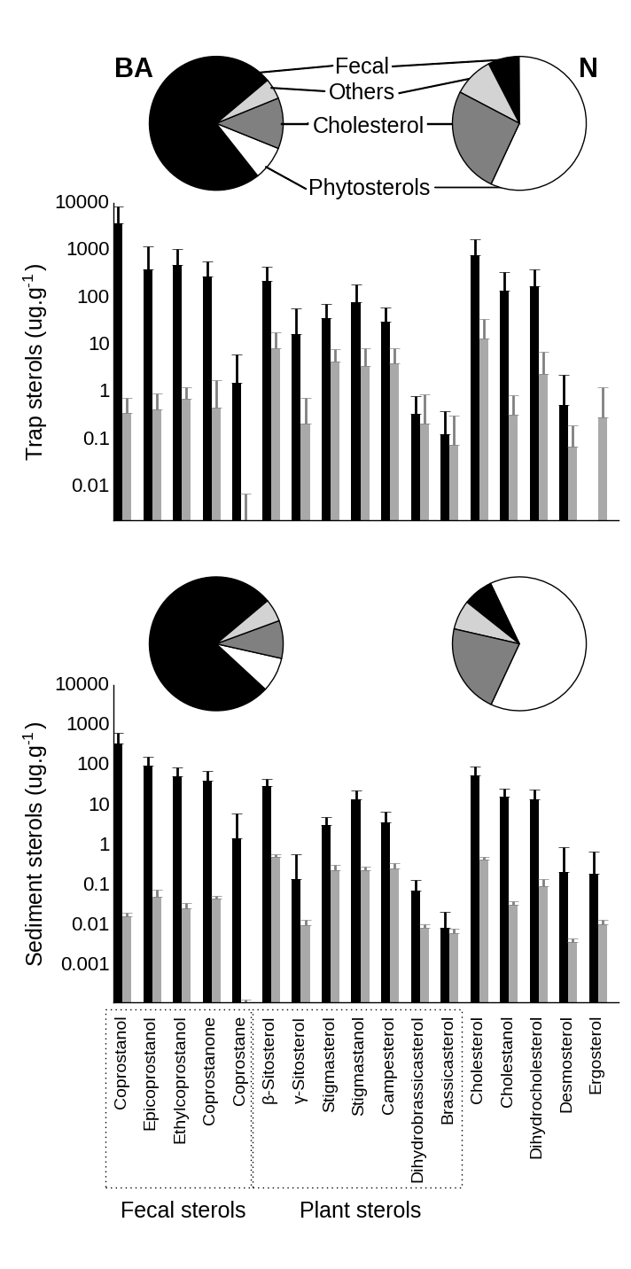

**Fig. 3.** Sterol composition of settling material (top panel) and sediments (bottom panel) at Buenos Aires (BA, black bars, left pie chart) and North (N, grey bars, right pie chart). Pie charts show proportions of cholesterol, fecal sterols, phytosterols and other sterols. Bar graphs show individual sterols concentrations, in a dry weight basis (note the logarithmic scale).

The sediment sterol profile was similar to that of settling material, with some minor differences related to the sterol degradation at sediment surface. At BA, this degradation is apparent in the relative increase of degradation products such as epicoprostanol, stigmastanol and cholestanol from settling particles (9.3±9.6, 1.6±0.88 and 1.7±1.2%) to underlying sediments (16±4.5, 2.6±1.5 and 2.8±1.1%, respectively, *p*<0.05), reflecting the microbial reduction of stenols to stanols and coprostanol epimerization at the oxic-anoxic boundary (Wakeham, 1989). Despite this degradation, sediments at BA still have remarkably high sterol concentrations, especially of coprostanol whose concentration (349±282 μg.g-1) is among the highest reported for surficial sediments severely impacted by sewage discharges (Table 2). Coprostanol highest values were chiefly measured in freshwater locations or in relatively enclosed seawater environments where ocean dilution is reduced. In sediments from the Uruguayan coast of the Rio de la Plata near Montevideo, Venturini et al., (2015) reported 17-400 times lower concentrations of coprostanol (0.05-21 μg.g-1,) and cholesterol (0.48-5.1 μg.g-1), evidencing that the background levels of these sterols are quite low and that they derive mainly from local urban discharges at BA. Interestingly, the concentrations of phytosterols were only slightly lower to those of BA for stigmasterol and campesterol (0.30-3.14 and 0.13-2.13 μg.g-1, respectively; Venturini et al., 2015) but not for β–sitosterol, which was 6-70 times lower (0.43-5.3 μg.g-1). This suggests that while sewage discharge contributes significantly β–sitosterol at BA sediments, the terrestrial runoff is the main source of stigmasterol and campesterol. This is in agreement with previous reports of high concentrations of β–sitosterol in sewage effluents of domestic origin (e.g. flush of kitchen vegetable oils; Furtula et al., 2011).

**Table 3.** Coprostanol concentration (μg.g-1) from surficial sediments throughout the world.

|  |  |  |  |
| --- | --- | --- | --- |
| Sampling site | Environment | Concentration | Reference |
| *Highly polluted sediments* |  |  |  |
| Yucatan Cenotes, Mexico | Underground river | <1-1690* | Arcega-Cabrera et al., 2014 |
| Northeastern Hamilton Harbour, Canada | Lake | <1-1600 | Coakley et al., 2002 |
| **Rio de la Plata, Argentina** | **River** | **59-708** | **This study** |
| Barcelona, Spain | Sea | <1-390 | Grimalt and Albaiges, 1990 |
| Iguaçu and Barigui Rivers, Brazil | River | <1-375 | Puerari et al., 2012 |
| Bilbao Estuary, Spain | Estuary | 2.2-293 | Gonzalez-Oreja and Saiz-Salinas, 1998 |
| Barigui River, Brazil | River | <1-196 | Froehner et al., 2009 |
| Firth of Clyde, Scotland, United Kingdom | Sea | <1-176 | Kelly and Campbell, 1996 |
| Tan-Shui Estuary Taiwan | Estuary | <1-163 | Jeng and Han, 1994 |
| Northeastern Hamilton Harbour, Canada | Lake | <1-147 | Bachtiar et al., 1996 |
| Guanabara Bay, Brazil | Sea | 1.4-105 | Lima da Costa and Carreira, 2005 |
| Kaoping River, Taiwan | River | <1-58 | Jeng et al., 1996 |
| Lake of Neuchatel, Switzerland | Lake | 6.1-55 | Pittet et al., 1990 |
| Ria Formosa, Portugal | Sea lagoon | <1-42 | Mudge and Bebbiano, 1997 |
| Venice Lagoon, Italy | Sea lagoon | <1-41 | Sherwin et al., 1993 |
| Narrangansett Bay, USA | Sea | <1-39 | Le Blanc et al., 1992 |
| Rio de la Plata, Uruguay | River | <1-21 | Venturini et al., 2014 |
| *Reference low-moderately polluted river sediments* | |  |  |
| Siak River, Indonesia | River | 0.050-11 | Liebezeit and Wöstmann, 2010 |
| Mississippi River, USA | River | 0.10-7.5 | Writer et al., 1995 |
| Capibaribe River, Brazil | River | 0.52-7.3 | Fernandes et al., 1999 |
| **Uruguay River, Argentina** | **River** | **nd -1.7** | **This study** |
| Santa Ana River, USA | River | nd-0.49 | Noblet et al., 2004 |
| Langat River, Malaysia | River | 0.0028-0.42 | Adnan et al., 2012 |

*: Sum of fecal sterols.

At N, the sediment sterol profile was dominated by terrestrial plant phytosterols and cholesterol, as observed in settling material but with higher proportions of epicoprostanol, β-sitosterol and stigmastanol (2.7±1.2, 25±3.0 and 12±1.9%, respectively, *p*<0.05). The marginal impact of sewage pollution at N sediments was evidenced by the low coprostanol concentrations, which are well below the threshold values reported as indicative of sewage pollution (0.1-0.7 μg.g-1; Grimalt et al., 1990; Leeming et al., 1997; Rada et al., 2016) and are comparable to values reported for riverine sites with low to moderate sewage pollution (Table 2).

To simultaneously evaluate the contribution of the different sterols to overall variability in settling material and sediments, multiple regression and multivariate analysis (PCA) were performed for major sterols (compounds with < 0.5% abundance were excluded, Fig. ) average proportions lower than 0.5% were excluded from analysis, Fig.). This model explain 59% of total variability, mainly through principal component 1 (47%), which is loaded in the negative side with fecal coprostanol and epicoprostanol and in the positive side with cholesterol and plant sterols.

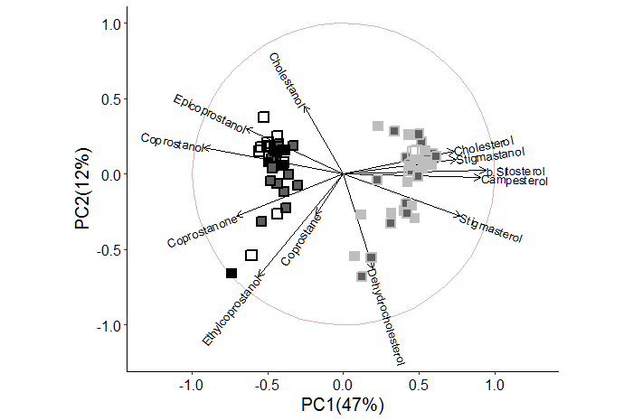

**Fig. 7.** Principal component analysis of sterol composition of settling particles (solid squares) and sediments (empty squares) from Buenos Aires (black edgecolor) and North (grey edgecolor). Markers with dark filling correspond to warm periods settling material while light filling correspond to cold periods. Confidence ellipses were set to 90% of normal probability.

* 1. Sterol vertical fluxes and accumulation efficiency

Vertical flux of total sterols was highly variable and averaged 116±168 mg.cm-2.year-1 at BA, with coprostanol accounting up to 60% (70±108 mg.cm-2.year-1, Fig. 2). At N, sterol flux was four orders of magnitude lower, 0.070±0.13 mg.cm-2.year-1 and cholesterol and β–sitosterol were the sterols with the highest fluxes. The accumulation efficiencies, obtained from the difference between the expected sterol deposition based on trap fluxes and the observed sediment concentrations allow an evaluation of the early diagenetic behavior of these compounds. The accumulation efficiencies were 2-7 times higher at BA compared with N but the general pattern of accumulation efficiency of individual sterols was rather similar at both sampling sites. The higher accumulation efficiencies at BA reflect the differences in the oxic-anoxic transition of the sediments and the greater preservation of organic matter at sites with faster burial (Hedges and Keil, 1995). At BA, the high sedimentation rate rapidly removes sterols to anoxic black-colored sediment, less diagenetically active, favoring their preservation. In contrast, at N the oxic layer is thicker resulting in a greater aerobic degradation of sterols. Epicoprostanol presented the highest accumulation efficiency, especially at BA (BA: 40%, N: 5.9%) probably due to *in-situ* microbial epimerization of coprostanol rather than to an enhanced preservation during deposition. Coprostanone accumulated more efficiently than coprostanol (BA: 10 vs. 6.5%, N: 3.7 vs 2.2%). Since coprostanone and coprostanol belong to the same metabolic pathway and can readily interconvert (Grimalt et al., 1990; Bull et al., 2002), the preferential coprostanone preservation in sediments might be related to its higher resistance to biodegradation (Wakeham, 1989; Chaler et al., 2001). Plant sterols were in general well preserved (BA: 9.8-14%, N: 2.9-3.4%), as previously observed in the Saint Lawrence estuary (Colombo et al., 1997) and it was attributable to the enhanced resistance of terrestrial sterols, associated with waxy higher plant material that hinder bacterial degradation (Volkman et al., 1987). Galeron et al., (2015) found that β–sitosterol have a low susceptibility to biodegradation and most of its decomposition proceeds via autoxidation and photodegradation, a process that is especially intense on land where chlorophyll acts as a sensitizer. Cholesterol was the least preserved sterol (BA: 4.6%, N: 1.6%) reflecting the intense breakdown of this sterol, mostly through biodegradation (Galeron et al., 2015). This explain the high accumulation efficiency of cholestenol (BA: 10%, N: 6.1%), which results from *in situ* microbial reduction of cholesterol rather than from preservation of settling cholestanol.

Despite the large spatial and temporal variability of hydrological parameters and sewage emission, an attempt was made to compare the sediment burden of coprostanol with the expected discharge from BA outfall. The massive vertical flux of coprostanol results in its rapid buildup in superficial sediments, which contain 24±19 g.m-2 of this sterol in the top 5-cm layer. Human coprostanol excretion depends on multiple factors such as diet, water intake, lifestyle and genetic differences, resulting in daily emission varying from <0.2 to >2 g.day-1 per capita (Walker et al., 1982; Keller and Jahreis, 2004; Daughton et al., 2012). Considering an average coprostanol excretion of 1 g.day-1 per capita and taking into account that the sewer network serves 6 x 106 people ([www.aysa.com.ar](http://www.aysa.com.ar)), the expected sewer discharge of coprostanol can be roughly estimated to be 2190 tons.year-1. As previously discussed, coprostanol undergoes an extensive degradation at the water-sediment interface, so based its accumulation efficiency estimated in this work (6.5%) from 2190 tons.year-1 only 142 tons.year-1 would be effectively preserved in sediments. Considering an average outfall plume area of 25 km2 (Roberts and Villegas, 2016) in which most of the sewage material would settle down and a sedimentation rate of 4.7 cm.year-1, the expected coprostanol inventory for the top 5 cm layer (averaged for the whole plume area) would be 6.0 g.m-2. This value is in the lower range of the estimated BA inventory (24±19 g.m-2) which considers sediments sampled close to the sewer outfall (0.5 km) neglecting the rapid coprostanol decrease usually observed with distance from sources (Venkatesan and Kaplan, 1990; LeBlanc et al., 1992; Bachtiar et al, 1996) .

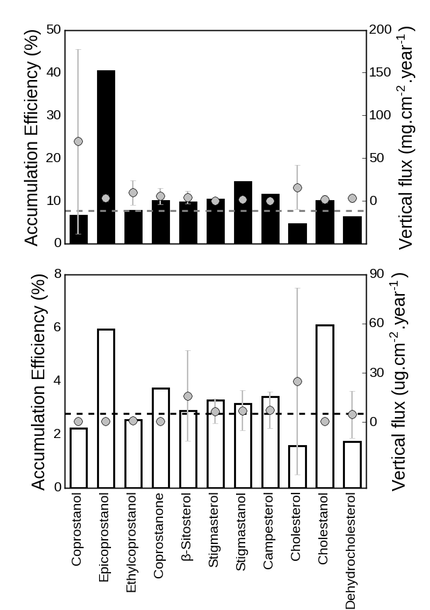

**Fig. 4.** Accumulation efficiencies of sterols from settling material in superficial sediments (%, bars, left axis) and vertical fluxes (points with standard error bars, right axis) for BA (upper panel) and N (bottom panel). Horizontal dotted lines indicate accumulation efficiency of total sterols. Minor sterols (<1% of total sterols) were excluded from calculations.

* 1. Sterol ratios

Many sterol ratios have been routinely used to assess the contribution of different sources of organic matter as well as degradation processes (Jeng and Han, 1994; Takada et al., 1994; Chalaux et al., 1995; Fattore et al., 1996). Since many of them provide redundant information, only five have evaluated in this work (Fig. 4). All the ratios presented highly significant differences between BA and N (*t*-test; *p*<0.0001), both for settling material and sediments. BA and N represented the endmembers of the fecal/phytosterol ratio in this basin (settling material: 0.90±0.044 vs 0.12±0.10; sediments: 0.90±0.032 vs 0.10±0.019) showing the ample variation of the contribution of sewage-derived material over the background inputs of terrestrial land plant runoff. The high coprostanol/epicoprostanol ratio at BA settling material (0.85±0.15) reflects the relatively fresh sewage inputs discharged, in contrast to the weak and extensively degraded fecal signature at N, with a low ratio (0.48±0.15), typical of aged fecal material (Mudge and Duce, 2005). Coprostanol degradation continues after particle deposition, resulting in lower coprostanol/epicoprostanol ratios in sediments relative to settling material (BA: 0.75±0.064, N: 0.26±0.058). As previously noted, the fecal sterol profile differs qualitatively between both contrasting sites as demonstrate the coprostanol/24-ethylcoprostanol ratio, which is useful to distinguish between different fecal sources of sterols (Leeming et al., 1996). This ratio was high at BA (settling material: 0.86±0.064; sediments: 0.84±0.076), due to the abundance of coprostanol in human feces, and 2 times lower at N (settling material: 0.35±0.19; sediments: 0.38±0.058), evidencing the small amounts of fecal sterols at N are mainly derived from herbivore mammal feces, rich in ethylcoprostanol. In fact, these values fall in the extremes of this relationship according to Leeming et al. (1997), with BA ratio surpassing the 0.73 threshold for exclusively human fecal pollution and N ratio below the 0.38 threshold for solely herbivore fecal pollution. However, the overwhelming abundance of coprostanol at BA may lead to erroneously neglect the non-human fecal pollution at this site. At BA, the β–sitosterol/24-ethylcoprostanol index, used to assess herbivore fecal pollution, was 0.36±0.15 (settling material) – 0.38 ± 0.060 (sediments), below the threshold of 1.0 (equivalent to 0.5 for the equation used in this work) proposed as typical for cow feces runoff (Nash et al., 2005). Is important to note that beside cattle, the fecal contribution of other animals with high ethylcoprostanol proportions in their feces, such as pigs and poultry also affect this ratio (Leeming et al., 1996). This reveals a small non-human contribution to the overall fecal pollution at BA. At N, this ratio was 0.84±0.17 (settling material) – 0.95±0.018 (sediments), above the limit of 4 (equivalent to 0.8 for the equation used in this work) suggested by Nash et al., (2005) as indicative of non-fecal polluted plant decay inputs, denoting the minimum impact of fecal contamination at this site. The cholesterol/cholestanol ratio is useful to assess the microbial reduction of stenols to 5α-stanols that typically takes places in anoxic conditions (Reeves, 2005). At BA, the relatively low values of this ratio (0.85±0.043) indicate prevailing reductive conditions in the sewage effluent, which favors sterol preservation. On the contrary, oxidative conditions at N favors the sterol degradation over their hydrogenation (Nishimura and Koyama, 1977), resulting in proportionally low amounts of cholestanol (ratio: 0.95±0.043). This microbial degradation of cholesterol intensifies at the sediment surface further, resulting in lower values for this ratio in sediments (BA: 0.75±0.11, N: 0.93±0.025).

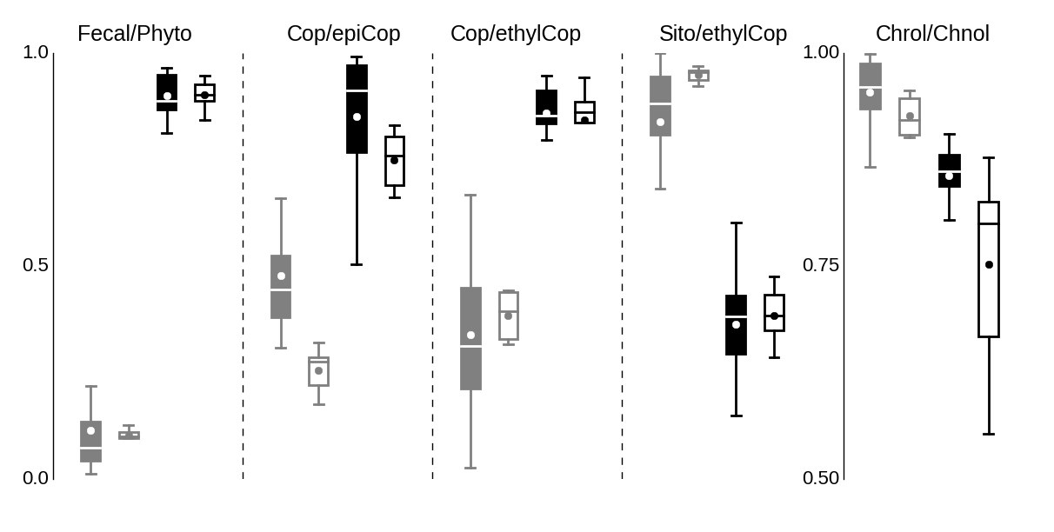

**Fig. 5.** Box plots of different sterol ratios from Buenos Aires (black) and North (grey) in settling material (hollow boxes) and sediment (filled boxes). Fecal/Phyto: fecal sterols/(fecal sterols + phytosterols), Copr/epiCop: coprostanol/(coprostanol + epicoprostanol), Cop/ethylCop: coprostanol/(coprostanol + ethylcoprostanol), Sito/ethylCop: β-sitosterol/(β-sitosterol + ethylcoprostanol, Chnol/Chrol: cholesterol/(cholesterol + cholestanol) All ratios were significantly different between Buenos Aires and North (p<0.0001).

1. **Conclusions**

The massive discharge of crude sewage at Buenos Aires (BA) resulted in huge vertical fluxes of highly organic particles enriched in fecal sterols, which were further intensified during the warm and rainy period due to enhanced terrestrial runoff. The settling material presented a clear predominance of coprostanol, and a high coprostanol/epicoprostanol ratio, comparable to sewage sludge, reflecting high inputs of fresh sewage material. Despite the sterol degradation that takes places at the water/sediment interface, coprostanol readily accumulates in surficial sediments, reaching concentrations that are among the highest reported in literature. In contrast, at the relatively pristine northern site (N), vertical particle fluxes were 7-times lower and both settling material and sediments had sterol concentrations that were 2-3 orders of magnitude lower, dominated by plant sterols such as β–sitosterol, stigmasterol and campesterol. The higher vertical fluxes and prevailing anoxic conditions near the sewer favored sterol preservation, as indicated by the relatively high accumulation efficiencies compared with N. Nevertheless, at both sites the epicoprostanol, cholestanol and plant sterols had the highest accumulation efficiency, reflecting both *in situ* production and the differential resistance to degradation. The massive amounts of coprostanol

**Acknowledgements**

This work was supported by research grants to J.C. Colombo from the Argentinean Agency for Scientific Research Promotion (ANPCyT) and from the National University of La Plata (UNLP). E.D. Speranza is member of the Scientific Research Career of the Argentinean National Scientific and Technical Research Council (CONICET). J.C. Colombo is member of the Scientific Research Career of the Buenos Aires Scientific Research Commission (CIC).

**References**

Adnan, N.H., Zakaria, M.P., Juahir, H., Ali, M.M., 2012. Faecal sterols as sewage markers in the Langat River, Malaysia: Integration of biomarker and multivariate statistical approaches. Journal of Environmental Sciences 24, 1600–1608.

Arcega-Cabrera, F., Velázquez-Tavera, N., Fargher, L., Derrien, M., Noreña-Barroso, E., 2014. Fecal sterols, seasonal variability, and probable sources along the ring of cenotes, Yucatan, Mexico. Journal of Contaminant Hydrology 168, 41–9.

Bachtiar, T., Coakley, J. P., Risk, M. J., 1996. Tracing sewage-contaminated sediments in Hamilton Harbour using selected geochemical indicators. Science of The Total Environment 179, 3–16.

Blanch, A.R, Belanche-Muñoz, L., Bonjoch, X., Ebdon, J., Gantzer, C., Lucena, F., Ottoson, J., Kourtis, C., Iversen, A., Kühn, I., Moce, L., Muniesa, M., Schwartzbrod, J., Skraber, S., Papageorgiou, G., Taylor, H.D., Wallis, J., Jofre, J., 2004. Tracking the origin of faecal pollution in surface water: an ongoing project within the European Union research programme. Journal of Water and Health 2, 249–260.

Bonachea, J., Bruschi, V.M., Hurtado, M.A., Forte, L.M., da Silva, M., Etcheverry, R., Cavallotto, J.F., Dantas, M.F., Pejon, O.J., Zuquette, L.V., Bezerra, M.O., Remondo, J., Rivas, V., Gómez-Arozamena, J., Fernández, G., 2010. Natural and human forcing in recent geomorphic change; case studies in the Rio de la Plata basin. Science of The Total Environment 408, 2674-2695.

Bull, I.D., Lockheart, M.J., Elhmmali, M.M., Roberts, D.J., Evershed, R.P., 2002. The origin of faeces by means of biomarker detection. Environment International 27, 647–654.

Burns, K.A., Hernes, P.J., Brinkman, D., Poulsen, A., Benner, R., 2008. Organic Geochemistry Dispersion and cycling of organic matter from the Sepik River outflow to the Papua New Guinea coast as determined from biomarkers. Organic Geochemistry 39, 1747–1764.

Chalaux, N., Takada, H., Bayona, J.M., 1995. Molecular Markers in Tokyo Bay Sediments: Sources and Distribution. Marine Environmental Research 40, 77-92.

Chaler, R., Simoneit, B.R., Grimalt, J.O., 2001. Bile acids and sterols in urban sewage treatment plants. Journal of Chromatography A 927, 155–60.

Christie, W.W., 1989. Gas Chromatography and Lipids: a Practical Guide. The Oily Press, Ayr.

Coakley, J.P., Skafel, M.G., Marvin, C.H., Bachtiar, T., 2002. Transport of Sewage-Contaminated Sediment in Northeastern Hamilton Harbour. Journal of Great Lakes Research 28, 77–90.

Colombo, J.C., Pelletier, E., Brochu, C., Khalil, M., 1989. Determination of Hydrocarbon Sources Using n -Alkane and Potyaromatic Hydrocarbon Distribution Indexes. Case Study: Rio de La Plata Estuary, Argentina. Environmental Science and Technology 23, 888-894.

Colombo, J.C., Capelletti, N., Lasci, J., Migoya, M.C., Speranza, E., Skorupka, C.N., 2005. Sources, vertical fluxes and accumulation of aliphatic hydrocarbons in coastal sediments of the Rio de la Plata Estuary, Argentina. Environmental Science and Technology 39, 8227-8234.

Colombo, J.C., Cappelletti, N., Migoya, M.C. Speranza, E., 2007a. Bioaccumulation of anthropogenic contaminants by detritivorous fish in the Río de la Plata Estuary: 1-Aliphatic hydrocarbons. Chemosphere 68, 2128-2135.

Colombo, J.C., Cappelletti, N., Migoya, M.C., Speranza, E., 2007b. Bioaccumulation of anthropogenic contaminants by detritivorous fish in the Río de la Plata Estuary: 2-Polychlorinated biphenyls. Chemosphere 69, 1253-1260.

Colombo, J.C., Cappelletti, N., Williamson, M., Migoya, M.C., Speranza, E., Sericano, J. Muir, D.C.G., 2011. Risk ranking of multiple-POPs in detritivorous fish from the Río de la Plata. Chemosphere 83, 882-889.

Colombo, J.C., Silverberg, N., Gearing, J. N., 1997. Lipid biogeochemistry in the Laurentian Trough—II. Changes in composition of fatty acids, sterols and aliphatic hydrocarbons during early diagenesis. Organic Geochemistry 26, 257–274.

Colombo, J.C., Silverberg, N., Gearing, J.N. 1996. Lipid biogeochemistry in the Laurentian Trough: I—fatty acids, sterols and aliphatic hydrocarbons in rapidly settling particles. Organic Geochemistry 25, 211-225.

Colombo, J.C., Skorupka, C.N., Bilos, C., Tatone, L., Cappelletti, N., Migoya, M.C., Astoviza, M., Speranza, E., 2015. Seasonal and inter-annual variability of water quality in the Uruguay River, Argentina. Hydrological Sciences Journal 60, 1155-1163.

Daughton, C.G., 2012. Real-time estimation of small-area populations with human biomarkers in sewage. The Science of the Total Environment 414, 6–21.

deBruyn, A.M.H., Marcogliese, D.J., Rasmussen, J.B. 2003. The role of sewage in a large river food web. Canadian Journal of Fisheries and Aquatic Sciences 60, 1332–1344.

Di Gregorio, D.E., Fernández Niello, J. O., Huck, H., Somacal, H., Curutchet, G., 2007. 210Pb dating of sediments in a heavily contaminated drainage channel to the La Plata estuary in Buenos Aires, Argentina. Applied Radiation and Isotopes 65, 126–130.

Fattore, E., Benfenati, E., Marelli, R., Cools, E., Fanelli, R., 1996. Sterols in sediment samples from Venice Lagoon, Italy. Chemosphere 33, 2383-2393.

Fernandes, M.B., Sicre, M.-A, Cardoso, J.N., Macêdo, S.J., 1999. Sedimentary 4-desmethyl sterols and n-alkanols in an eutrophic urban estuary, Capibaribe River, Brazil. The Science of the Total Environment 231, 1–16.

Framiñan, M.B., Brown, O.B., 1996. Study of the Río de La Plata turbidity front. Part I: Spatial and temporal distribution. Continental Shelf Research 16, 1259–1282.

FREPLATA, 2005. Análisis Diagnóstico Transfronterizo del Río de la Plata y su Frente Marítimo. Documento Técnico. Proyecto PNUD/GEF/RLA/99/G31.

Froehner, S., Fernandes, R., 2009. Assessment of fecal sterols in Barigui River sediments in Curitiba , Brazil. Environmental Monitoring and Assessment 157, 591–600.

Furtula, V., Liu, J., Chambers, P., Osachoff, H., Kennedy, C., Harkness, J., 2011. Sewage Treatment Plants Efficiencies in Removal of Sterols and Sterol Ratios as Indicators of Fecal Contamination Sources. Water, Air, and Soil Pollution 223, 1017–1031.

Galeron, M., Amiraux, R., Charriere, B., Radakovitch, O., Raimbault, P., Lagadec, V., … Raimbault, P. (2015). Seasonal survey of the composition and degradation state of particulate organic matter in the Rhˆ one River using lipid tracers.

Gonzalez-oreja, J.A., Saiz-salinas, J.I., 1998. Short-term Spatio-temporal Changes in Urban Pollution by Means of Faecal Sterols Analysis. Marine Pollution Bulletin 36, 868–875.

Grimalt, J., Ferninder, P., Bayona, J.M., Albaigis, J., 1990. Assessment of Fecal Sterols and Ketones as Indicators of Urban Sewage Inputs to Coastal Waters. Environmental Science and Technology 1, 357–363.

Hedges, J.I., Keil, R.G., 1995. Sedimentary organic matter preservation: an assessment and speculative synthesis. Marine Chemistry 49, 81–115.

Helmer, R., Hespanhol, I., 1997. Water Pollution Control - A Guide to the Use of Water Quality Management Principles. F & FN Spon, London.

Huang, W.Y., Meinschein, W.G., 1979. Sterols as ecological indicators. Geochimica et Cosmochimica Acta 43, 739-745

Jaime, P., Menéndez, A.N., 2002, Análisis del Régimen Hidrológico de los Ríos Paraná y Uruguay, Report INA-LHA 05-216-02, FREPLATA, Buenos Aires.

Jeng, W., Han, B., 1994. Sedimentary Coprostanoi in Kaohsiung Harbour and the Tan-Shui Estuary. Marine Pollution Bulletin 28, 494–499.

Jeng, W., Han, B., 1996. Coprostanol in a Sediment Core from the Anoxic Tan-Shui Estuary , Taiwan. Estuarine, Coastal and Shelf Science 42, 727–735.

Jeng, W., Kao, S., 2002. Lipids in suspended matter from the human-disturbed Lanyang River , northeastern Taiwan. Environmental Geology 43, 138–144.

Keller, S., Jahreis, G., 2004. Determination of underivatised sterols and bile acid trimethyl silyl ether methyl esters by gas chromatography–mass spectrometry–single ion monitoring in faeces. Journal of Chromatography B 813, 199–207.

Kelly, A.G., 1995. Accumulation and persistence of pesticides and faecal sterols at the Garroch Head sewage sludge disposal site, Firth of Clyde. Environmental Pollution 88, 207–217.

Kelly. A.G., Campbell, L.A., 1996. Persistent organochlorine contaminants in the Firth of Clyde in relation to sewage sludge input. Marine Environmental Research 41, 99-132.

Lahdelma, I., Oikari, A., 2006. Stratigraphy of wood-derived sterols in sediments historically contaminated by pulp and paper mill effluents. Journal of Paleolimnology 35, 323–334.

Le Blanc, L.A., Latimer, J.S., Ellis, J.T., Quinn, J.G., 1992. The Geochemistry of Coprostanol in Waters and Surface Sediments from Narragansett Bay. Estuarine, Coastal and Shelf Science 34, 439-458.

Leeming, R., Ball, A., Ashbolt, N., Nichols, P., 1996. Using faecal sterols from humans and animals to distinguish faecal pollution in receiving waters. Water Research 30, 2893-2900.

Leeming, R., Latham, V., Rayner, M., Nichols, P., 1997. Detecting and Distinguishing Sources of Sewage Pollution in Australian Inland and Coastal Waters and Sediments, In: Eganhouse, R.P. (Ed.), Molecular Markers in Environmental Geochemistry, American Chemical Society, pp. 306–319.

Li, W., Dagaut, J., Saliot, A., 1995. The application of sterol biomarkers to the study of the sources of particulate organic matter in the Solo River system and and Serayu River, Java, Indonesia. Biogeochemistry 31, 139–154.

Liebezeit, G., Wöstmann, R., 2010. Coprostanol in Siak River Sediments, E Sumatra, Indonesia. Bulletin of Environmental Contamination and Toxicology 85, 585–588.

Lima da Costa, R., Carreira, R.S., 2005. A comparison between faecal sterols and coliform counts in the investigation of sewage contamination in sediments. Brazilian Journal of Oceanography 53, 157-167.

Martin-Creuzburg, D., Von Elert, E., 2009. Ecological significance of sterols in aquatic food webs, In: Arts, M.T., Brett, M., Kainz, M. (Eds.), Lipids in Aquatic Ecosystems. Springer, New York, pp. 43-64.

McCalley, D.V, Cooke, M., Nickless, G., 1981. Effect of sewage treatment on facial sterols. Water Research 15, 1019-1025.

Meyers, P.A., Ishiwatari, R., 1993. Lacustrine organic geochemistry-an overview of indicators of organic matter sources and diagenesis in lake sediments. Organic Geochemistry 20, 867-900.

Milliman, J.D., Meade, R.H., 1983. World-wide delivery of river sediments to the oceans. The Journal of Geology 91, 1-21.

Moreira, D., Simionato, C.G., Gohin, F., Cayocca, F., Luz Clara Tejedor, M., 2013. Suspended matter mean distribution and seasonal cycle in the Río de La Plata estuary and the adjacent shelf from ocean color satellite (MODIS) and in-situ observations. Continental Shelf Research 68, 51–66.

Mudge, S.M., Bebbiano, M.J., 1997. Sewage Contamination Following an Accidental Spillage in the Ria Formosa, Portugal. Marine Pollution Bulletin 34, 163–170.

Mudge, S.M., Duce, C.E., 2005. Identifying the source, transport path and sinks of sewage derived organic matter. Environmental Pollution 136, 209-220.

Mudge, S.M., Lintern, D.G., 1999. Comparison of Sterol Biomarkers for Sewage with other Measures in Victoria Harbour, B. C., Canada. Estuarine, Coastal and Shelf Science 48, 27–38.

Nash, D., Leeming, R., Clemow, L., Hannah, M., Halliwell, D., Allen, D., 2005. Quantitative determination of sterols and other alcohols in overland flow from grazing land and possible source materials. Water Research 39, 2964–2978.

Nguyen, D.K., Bruchet, A., Arpino, P., 1995. Determination of Sterols in Sewage Sludge by Combined *In Situ* Trimethylsylation/Supercritical Fluid Extraction and GC/MS. Environmental Science and Technology 29, 1686-1690.

Nishimura, M., Koyama, T., 1977. The occurrence of stanols in various living organisms and the behavior of sterols in contemporary sediments. Geochimica et Cosmochimica Acta 41, 379-385.

Noblet, J.A., Young, D.L., Zeng, E.Y., Ensari, S., 2004. Use of fecal steroids to infer the sources of fecal indicator bacteria in the lower Santa Ana River Watershed, California: Sewage is unlikely a significant source. Environmental Science and Technology 38, 6002–6008.

Parrish, C.C., Abrajano, T.A., Budge, S.M., Helleur, R.J., Hudson, E.D., 2000) Lipid and phenolic biomarkers in marine ecosystems : Analysis and applications, In: Wangersky, P. (Ed.), The Handbook of Environmental Chemistry, Vol. 5, Part D Marine Chemistry. Springer-Verlag, Berlin, pp. 193–223.

Pittet, A., Stettler, R., Kuebler, B., 1990. Use of coprostanol as a specific allochthonous fecal indicator in surface sediment of the Lake of Neuchâtel. Aquatic Sciences 52, 130-143.

Puerari, L., Carreira, R.S., Neto, A.C.B., Albarello, L.C., Gallotta, F.D.C., 2012. Regional assessment of sewage contamination in sediments of the Iguaçu and the Barigui Rivers (Curitiba city, Paraná, southern Brazil) using fecal steroids. Journal of the Brazilian Chemical Society 23, 2027-2034.

Puglisi, E., Nicelli, M., Capri, E., Trevisan, M., Del Re, A.A.M., 2003. Cholesterol, β-Sitosterol, Ergosterol, and Coprostanol in Agricultural Soils. Journal of Environmental Quality 32, 466-471.

Rada, J.P.A., Duarte, A.C., Pato, P., Cachada, A., Carreira, R.S., 2016. Sewage contamination of sediments from two Portuguese Atlantic coastal systems, revealed by fecal sterols. Marine Pollution Bulletin 103, 319-324.

Reeves, A.D., Patton, D., 2005. Faecal sterols as indicators of sewage contamination in estuarine sediments of the Tay Estuary, Scotland: an extended baseline survey. Hydrology and Earth System Sciences 9, 81–94.

Roberts, P.J.W., Villegas, B., 2016. Modeling and Design of the Buenos Aires Outfalls. Journal of Hydraulic Engineering 143, 1–17.

Saliot, A., Mejanelle, L., Scribe, P., Fillaux, J., Pepe, C., 2001. Particulate organic carbon, sterols, fatty acids and pigments in the Amazon River system. Biogeochemistry 53, 79–103.

Sherwin, M.R., Van Vleet, E.S., Fossato, V.U., Dolcit, F., 1993. Lagoonal Sediments and Mussels of Venice, Italy. Marine Pollution Bulletin 26, 501–507.

Speranza, E.D., Tatone, M.L., Cappelletti, N., Colombo, J.C., 2013. Cost-benefit of feeding on anthropogenic organic matter: lipid changes in a detritivorous fish (*Prochilodus lineatus*). Ichthyological Research 60, 334–342.

Sun, M., Wakeham, S.G., 1998. A study of oxic/anoxic effects on degradation of sterols at the simulated sediment-water interface of coastal sediments. Organic Geochemistry 28, 773-784.

Takada, H., Farrlngton, J.W., Bothner, M.H., Johnson, C.G., Tripp, B. W., 1994. Transport of Sludge-Derived Organic Pollutants to Deep-sea Sediments at Deep Water Dump Site 106. Environmental Science and Technology 28, 1062–1072.

Takada, H., Satoh, F., Bothner, M.H., Tripp, B.W., Johnson, C.G., Farrington, J.W., 1997. Anthropogenic Molecular Markers: Tools to Identify the Sources and Transport Pathways of Pollutants, In: Eganhouse, R. (Ed.), Molecular Markers in Environmental Geochemistry. ACS Symposium Series, American Chemical Society, Washington, pp. 178-195.

Tatone, L.M., Bilos, C., Skorupka, C.N., Colombo, J.C., 2009 Vertical Fluxes and Accumulation of Trace Metals in Superficial Sediments of the Río de la Plata Estuary, Argentina. Bulletin of Environmental Contamination and Toxicology 83, 913-919.

Tatone, L.M., Bilos, C., Skorupka, C.N., Colombo, J.C., 2012. Trace Metals in Settling Particles from the Sewage Impacted Buenos Aires Coastal Area in the Río de la Plata Estuary, Argentina. Bulletin of Environmental Contamination and Toxicology 90, 318-322.

Veiga, P., Juste, C., Lepercq, P., Saunier, K., Ge, P., 2005. Correlation between faecal microbial community structure and cholesterol-to-coprostanol conversion in the human gut. FEMS Microbiology Letters 242, 81–86.

Venkatesan, M.I., Kaplan, I.R., 1990. Sedimentary Coprostanol as an Index of Sewage Addition in Santa Monica Basin, Southern California. Environmental Science and Technology 24, 208-214.

Venturini, N., Bícego, M.C., Taniguchi, S., Sasaki, S.T., García-rodríguez, F., Brugnoli, E., Muniz, P., 2014. A multi-molecular marker assessment of organic pollution in shore sediments from the Río de la Plata Estuary, SW Atlantic. Marine Pollution Bulletin 91, 461-475.

Volkman, J.K., 1986. A review of sterol markers for marine and terrigenous organic matter. Organic Geochemistry 9, 83-99.

Volkman, J.K., 2005. Sterols and other triterpenoids: source specificity and evolution of biosynthetic pathways. Organic Geochemistry 36, 139–159.

Volkman, J.K., Farrington, J.W., Gagosian, R.B., 1987. Marine and terrigenous lipids in coastal sediments from the Peru upwelling region at 15°S: Sterols and triterpene alcohols. Organic Geochemistry 11, 463-477.

Wakeham, S.G., 1989. Reduction of stenols to stanols in particulate matter at oxic–anoxic boundaries in sea water. Nature 342, 787–790.

Walker, R.W., Wun, C.K., Litsky, W., Dutka, B.J., 1982. Coprostanol as an indicator of fecal pollution. CRC Critical Reviews in Environmental Control 12, 91-112.

Writer, J.H., Leenheer, J.A., Barber, L.B., Amy, G.L., Chapra, S.C., 1995. Sewage contamination in the upper Mississippi River as measured by the fecal sterol, coprostanol. Water Research 29, 1427–1436.

1. Present address: University of British Columbia, Earth and Ocean Sciences Department, 6339 Stores Rd, Vancouver, British Columbia, Canada, V6T 1Z4.