**Settling particles**

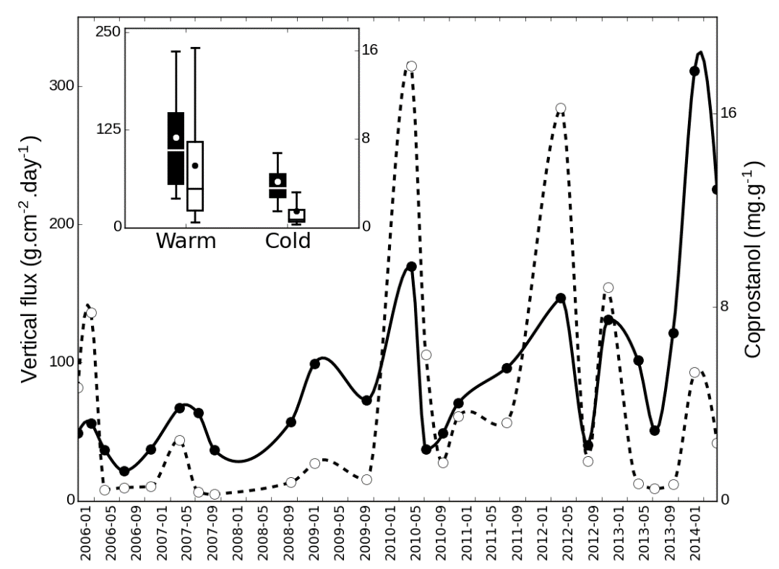

Fig. 1. Temporal variation of vertical flux (left axis, solid line) and coprostanol (right axis, dotted line) in settling particles collected at Buenos Aires. Boxplot depicts variation of vertical flux (left axis, black boxes) and coprostanol (right axis, white boxes) between warm (April-August) and cold (September-March) periods. Difference between these periods was significant for both parameters (t-test, p<0.05)

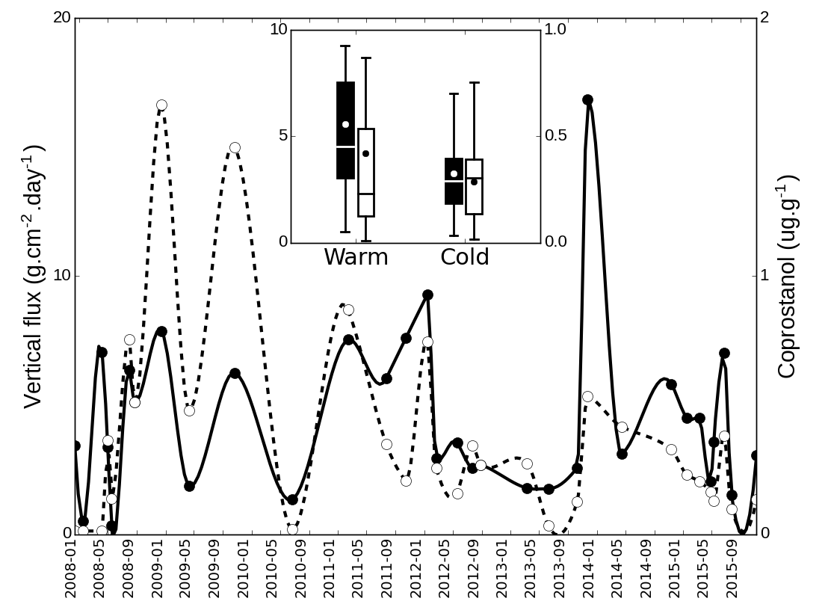

Fig. 2 Temporal variation of vertical flux (left axis, solid line) and coprostanol (right axis, dotted line) in settling particles collected at Nandubaysal (Uruguay River). Boxplot depicts variation of vertical flux (left axis, black boxes) and coprostanol (right axis, white boxes) between warm (April-August) and cold (September-March) periods. Difference between these periods was significant for vertical flux (t-test, p<0.05)

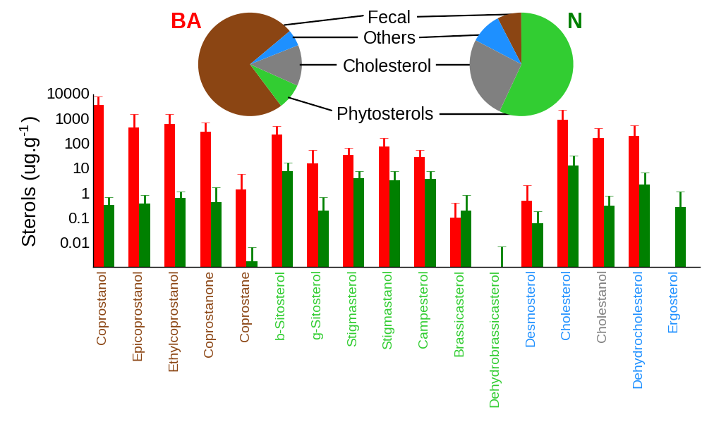

Fig. 3. Individual sterol concentrations of settling particles at Buenos Aires (BA, red bars) and Nandubaysal (N, green bars). Pie charts display the proportions of the main sterol categories (colors of histogram bottom labels correspond to these categories). Note the logarithmic scale at vertical axis.

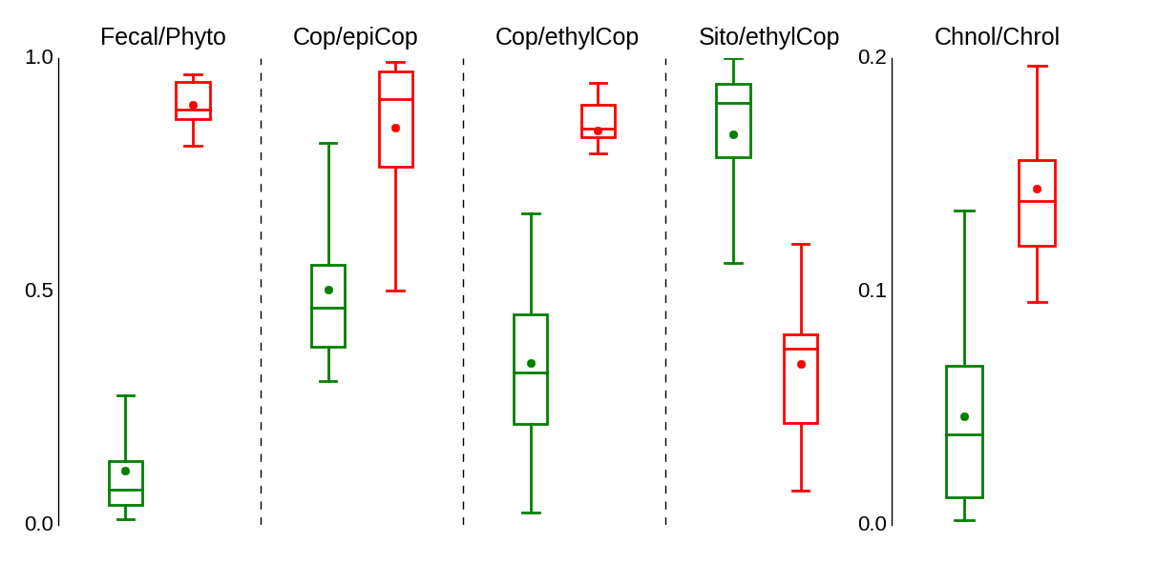

Fig. 4. Differences between Nandubaysal (green boxes) and Buenos Aires (red boxes) for several sterol ratios. Fecal/Phyto: fecal sterols to phytosterols, Cop/epiCop: coprostanol to epicoprostanol, Cop/ethylCop: coprostanol to 24-ethylcoprostanol, Sito/ethylCop: sitosterol to 24-ethylcoprostanol, Chnol/Chrol: cholestenol to cholesterol. All differences were highly significant (t-test, p<0.0001)