

User Manual
GUI module
Version: %VERSION%


Table of contents
1 Introduction 3
2 Features list 3
3 GUI startup 4
4 Main window 4
4.1 "File" menu item 6
4.1.1 “Open” menu items 6
4.1.2 “Reload” menu item 6
4.1.3 “Close” menu item 6
4.1.4 “Generate Test Plan” menu item 6
4.1.5 “Edit” menu item 6
4.1.6 “Quit” menu item 7
4.2 "Test" menu item 8
4.2.1 “Run: sequential” menu item 8
4.2.2 “Run: parallel” menu items 8
4.2.3 “Stop” menu items 8
4.2.4 “Select/Unselect” menu items 8
4.2.5 “Edit parameters” menu item 9
4.2.6 “Edit Configuration” menu item 9
4.2.7 “Edit Run Profile” menu item 11
4.3 "Log" menu item 12
4.3.1 “Application” menu item 12
4.3.2 Log storage option 12
4.3.3 Log level option 12
4.3.4 Save menu item 12
4.3.5 Open menu item 13
4.3.6 Clear menu item 13
4.4 "Stats" menu item 13
4.4.1 “Generate report” menu item 14
4.4.2 “Show report” menu item 14
4.4.3 “Show counters” menu item 14
4.4.4 “Show real-time” menu item 15
4.4.5 Quick configure stats menu item 17
4.4.6 “Reset all” menu item 17
4.5 "Help" menu item 17
4.5.1 “About” menu item 17
4.5.2 “Documentation” menu item 18
4.5.3 “Website” menu item 18
5 Testcase table 18
6 Logs windows 19

Introduction
This module consists of the graphical user interface in order to open display run and to tune a test file.

You can use this application during the script writing and tuning and the test campaign too. You can perform all kinds of testing with it:
- functional testing
- load and stress testing
- server-side simulation

Features list
The functionalities of the GUI user interface are the following:
Component |  | Features
Main  windows | "File"  menu item | - Open a test file with the dialog box  - Open a recent test file  - Close the current test file  - Reload the current test file  - Edit the current test file  - Quit the IMSloader application
Main  windows | "Test"  menu item | - Run the selected testcases in sequential mode  - Run the selected testcases in load mode  - Stop the current run  - Stop all the testcase run  - Select all the testcases  - Unselect all the testcases  - Configure the test parameters  - Edit the configuration  - Configure the run profile
Main  windows | "Log"  menu item | - Show the main log of the application  - Select the log storage (file, memory, none)  - Choose the log level ( Debug, Info, Warn, Error)
Main  windows | "Stats"  menu item | - Generate the statistic report  - Show the statistic report  - Show the statistic real-time window  - Change statistic configuration  - Reset the statistic
Testcase  table | Line | - Select / unselect a testcase  - Show the testcase name and description  - Run a testcase  - Edit the iteration number for a testcase  - Show the testcase running progress information  - Show the testcase running status  - Edit the testcase scenarios
Logs  windows |  | - Show all scenario log information in call flow mode  - Show log information for a scenario  - Choose the iteration running number  - Make a filtering from the level column  - Make a filtering from the topic column  - Clear the log windows  - Close The log windows

GUI startup
To run a test with IMSloader, then you can perform the following actions:

Windows platform:

{root_dir}/bin/startGui.bat <test file>

Linux platform:

{root_dir}/bin/startGui.xxx <test file>

where <testFile>
Test file to run (XML file with a <test> root tag). if not set, then the last test file is automatically opened at the beginning (optional)

NOTE: in some conditions with the Linux platform (for example if you want to listen on port lower than 1023), you should run IMSloader software as root privileges. If you are using a remote access via X windows, then you have to configure the .Xauthority file in the root home directory.

Main window
Here is the look and feel of our GUI interface:
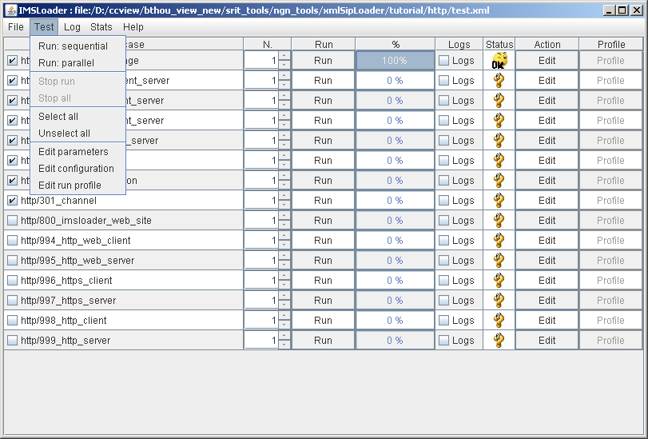

After opening a XML test script with IMSloader, the list of testcases appears in the windows main panel; there is one line for each testcase. With the "Run" or "Stop" button, the user can run and stop manually a single testcase. Then to have an overview on the running, you have on the same line a gauge displays the testcase progression and an icon will; inform you about the status of the testcase. Then you can edit with your favorite editor the scenario files.
Through the "file" menu item, IMSLoader permits to manage the XML test files. Also it allows user to run automatically the selected testcases with 2 different modes (sequential or parallel). Before the test starting, the user can modified graphically the configuration and the main parameters (called editable) of its script. IMSLoader enables to manage the logging and the statistics features with the corresponding menu items.

"File" menu item
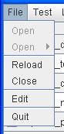
This menu will allow the user to select test, reload and close them. Some items will be disabled sometimes. For example, if there is no opened test, “close” and “reload” will be disabled.

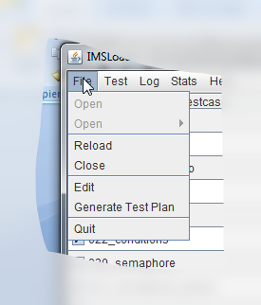

“Open” menu items
The 2 first items will allow the user to open a test.xml file (which will call several testcase). The first one allows looking for the test on the computer file system whereas the second will show a history of the last opened tests (the user can clear this history by clicking in this option, located just under the older test).

“Reload” menu item
This option will reload the current opened test from the file.
Important: If you have made some changes in the test file, then you should use this action to take the new modification into account.
In the same way, if you change the configuration directly by editing the file, then you should use this action too.
Moreover, this action will perform a reset of all stack protocol i.e. that all opened channels and listenpoints are removed on the same time.
Finally the statistic counters are reset by the action.

“Close” menu item
This option allows the user to close the current test in order to open a new one.

“Generate Test Plan” menu item
This option allows generating a test plan from the test file. A csv file will be generated in “logs” (folder) and contains all the test cases, their description and their status.

“Edit” menu item
It will edit the test file in order to change it using your favorite editor; this is configured at the installation or in the tester.properties configuration file (tester.properties/ gui.EDITOR_PATH)
Important: after doing some changes, then you have to use the "Reload" command to take them into account.

“Quit” menu item
This will quit the IMSloader application.

"Test" menu item
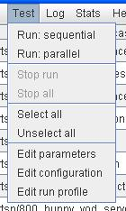

This menu will allow the user to run/stop testcases. He will also be able to edit the internal parameters of IMSLoader, the configuration of the test and the run profile.

“Run: sequential” menu item
The “Run sequential” button will execute all the selected testcases and run them one after one.
This is useful for functional testing.

“Run: parallel” menu items
The “Run: parallel” button will execute all the selected testcases and run them in the same time using a given run profile (containing a duration at a speed for testcase starting in period or frequency).
Please look at the at the 4.2.7 chapter dealing with the RunProfile object.
This is useful for load testing or server-side simulation.

“Stop” menu items
The “Stop run” button will stop the testcases which have been started usgin the options “Run: sequential” or “Run: parallel”.
The “Stop all” button will stop all the running testcases (including the manually started testcases).
Please note that the “finally” parts of a scenario will always be executed. The “Stop” actions will have no effects.

“Select/Unselect” menu items
The “Select all” button will check all the testcases so the user can run them sequentially or in parallel.
The “Unselect all” is the opposite.

“Edit parameters” menu item
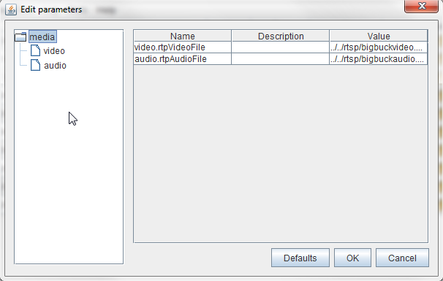

This button will allow the user to change internal parameters which are defined as “editable” in the test.

The parameters can be organized in a tree; each level is separated by a dot in the definition of the parameter in the test. Each row represents a parameter with his name, his description and his value. This last element can be edit.

User can change theses parameters only if the test is not currently running.

With “defaults” button, user can undo his modifications and come back to values specified in test xml file.

“Edit Configuration” menu item
Through this window, the user will not be able to change the configuration of IMSLoader. If he needs to change some properties, it will be done in the directory of the current test. A new property file will be created (if it is not yet) and only the values that have changed will be copy in it.
The user does not need any more to change the property file in his text editor, he should only do it through this window.

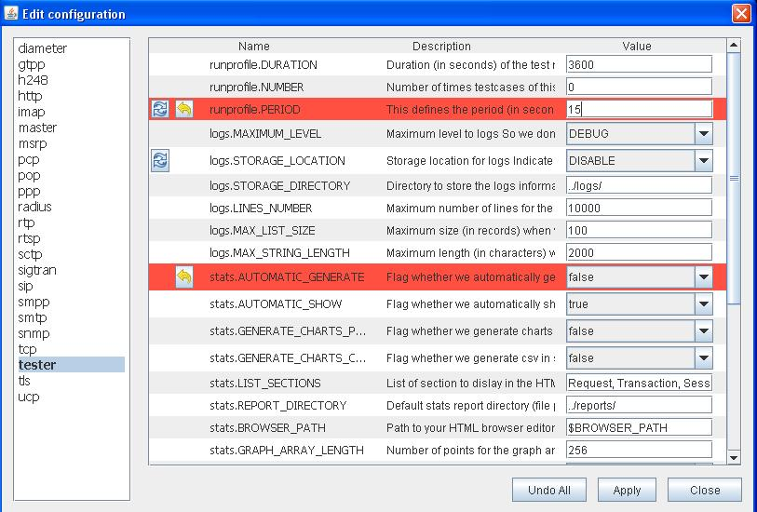
State 1
State 4
State 3
State 2

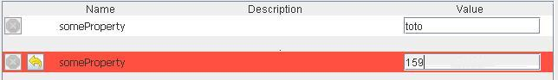
State 5
State 6

This window constitutes of:
- A list of “name.properties” files.
- All the properties of the selected file with their value and description (they can be empty).
- 2 buttons: the red cross could be called “Default” and yellow arrow could be called “Undo”.
- 3 buttons at the bottom right of the window: “Undo All”, “Apply” and “Close”.

After choosing a property file in the list, all the properties will be displayed.

There are 2 specific little buttons:
- “Default”: it allows the user, when he is enable and visible, to go back to the default value of IMSLoader configuration.
- “Undo”: it allows the user, when he is visible, to erase the last changes and go back to the last saved value.

There are 6 states:
- State 1: the value is the first one (it come from the test if it exists, else, it comes from the IMSLoader configuration).
- State 2: the value is under modification for the first time since the opening of the window. The line will be highlighted in red. The button “Default” will be accessible, same as “Undo” one and they will have same effect.
- State 3: after changing a value and saved it, the user is able to go back to the default value by clicking the “Default” button (and go to state 4).
- State 4: the current value is saved, but different than the first one. The button “Undo” will be accessible so the user can erase the current value which is not saved yet.
- State 5: if a property is only present in the test directory (and not in the IMSLoader configuration), the Default” button will be visible but disable.
- State 6: if a property (still only present in the test directory) is under changes, the “Undo” button will be visible.

There are 3 generals’ buttons:
- “Close”: always enable. The user will be able to close this window and come back to IMSLoader. Note that if something is not saved yet, a popup message will ask the user if he wants to save or cancel.
- “Apply”: enable only during changes. All the values that have changed will be copy in the property file (still in the directory of the test). If all the values are the ones from IMSLoader, the property file in the test will be deleted.
- “Undo All”: enable only during changes. All the values will be reloaded from the last backup, it is same as clicking on all “Undo” buttons.

NOTE: if a value has to be a number (or other specific things), the user will not be able to enter a non-number character in the field to avoid mistakes. By default, a value field will allow all the characters except if it is written in the property file.
Some very specific parameters need a restart after a change. That is why, after changing them, a popup message will ask the user to restart IMSLoader if he wants the new value to be effective.

“Edit Run Profile” menu item
1
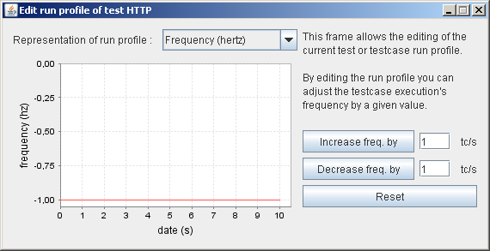
2
3

With this window, user can edit behavior of run test of the current test.
User can define run profile by frequency or by delay (1).
User can increase or decrease frequency of testcase by second (2).
It’s possible to return to values defined in the test file by clicking on “Reset” button (3).

More information about run profile is available in IMSLoader_user_manual_core.doc.

"Log" menu item
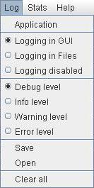

This menu allows the user to change how the logs are stored and their level, he can also display the main logs, save, open and clear all logs.

“Application” menu item
By clicking here, a window will be displayed, showing the logs.
There are more details about this window later.

Log storage option
The user can have 2 different ways to get log or disable them. The first option will display them in a window, accessible through the “main log” button or by checking log option in a testcase. The second option will write all the logs in a file. This file will be in this directory: ..\IMSLoader\logs\name_of_the_test_case. The last option will disable the logs.

Log level option
This option will allow the user to choose between 4 kinds of levels of logs. “Debug” one is the most complete with all the logs whereas “Error” one will only show the minimum. By default, “Debug” is always selected.

Save menu item
By clicking here, all the different “scenario log” (not only opened windows logs) and “main log” viewable in GUI will be save under a directory.
This directory will be selected through a dedicated window. To select the desired directory clicked on "open" on this window. This directory will contain the application log file and the scenario log files will be in subdirectory with the name of the testcase and the number of iteration.

Open menu item
By clicking here, all the different “scenario log” (not only opened windows logs) and “main log” in log files will be open in GUI.
To open logs, the opened test file must be the same as the one used when logs were saved in file.
The directory where logs files are stored will be selected through a dedicated window. To select the desired directory clicked on "open" on this window. The selected directory must contain application log file or/and scenario log files in subdirectory.
Logs are viewable in the log window corresponding to testcase as if they were just been executed.

Clear menu item
By clicking here, all the different “scenario log” (not only opened windows logs) and “main log” will be erase. The user will not be able to get them back.

"Stats" menu item
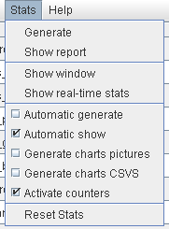
With this menu, user can generate a statistic report, view statistics in real time, configure quickly statistic behavior and reset all stats.

“Generate report” menu item

With the generate function in the “stats” menu, user can generate an HTML document with all statistics.

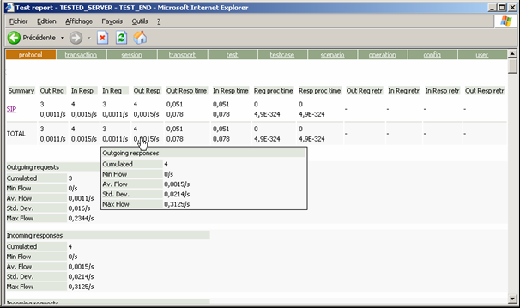
1

2

3

4

5

On the HTML document, there is a menu (1) with all sections. User can click on it to jump on the good sections in the document.

In each section, there is a table (2) that presents a summary of all statistics information. If user wants to have more information about a statistic he can put his mouse on it and a complete tooltip will appear (3).

User can have more information about a sub section (e.g.: SIP on screenshot) by clicking on a head row (5).

User can click on a statistic, in the summary for jump to the detailed part (4). This detailed part can contain numeric’s information, graphics representations (with a CSV files).

“Show report” menu item
This item will display in your browser the last report generate.

“Show counters” menu item
With the generate function in the “stats” menu, you can generate an HTML document with all statistics.

“Show real-time” menu item
1

2

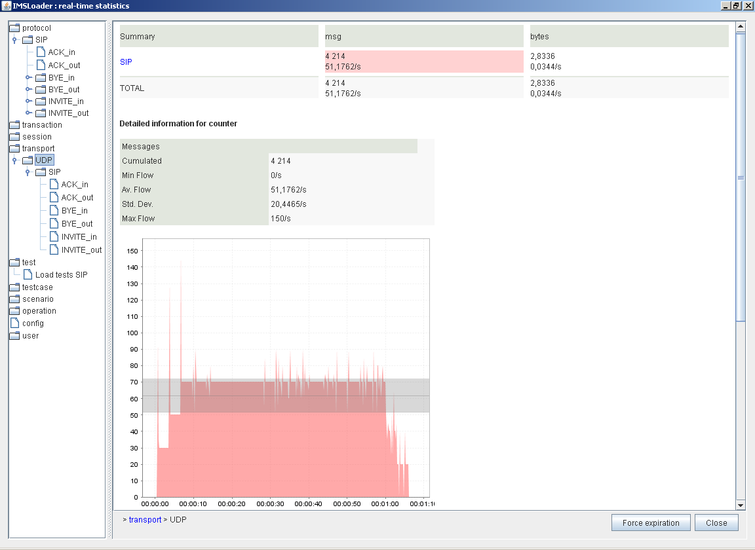

Real-time stats window is composed of two parts:
- On the left (1) there is a tree of all statistics.
- On the right (2) there are details of section selected in the tree.

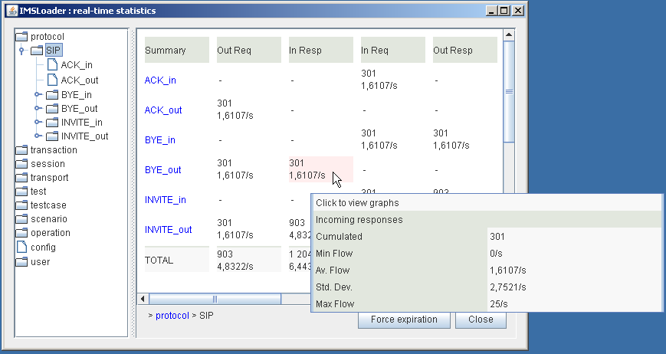
6

3

4

5

The table on (3) displays a summary of all information available for the section selected in the tree.

If user wants more information about a statistic, he can put his mouse on it. A tooltip (4) will show you quickly all information.

A description of each counter is available in IMSLoader_user_manual_core.doc

More information of a sub section is allowed by clicking on a head row (5).

With the railway (6) user can know where we are on the arborescence. He can click on this railway to come back to parents statistical categories.

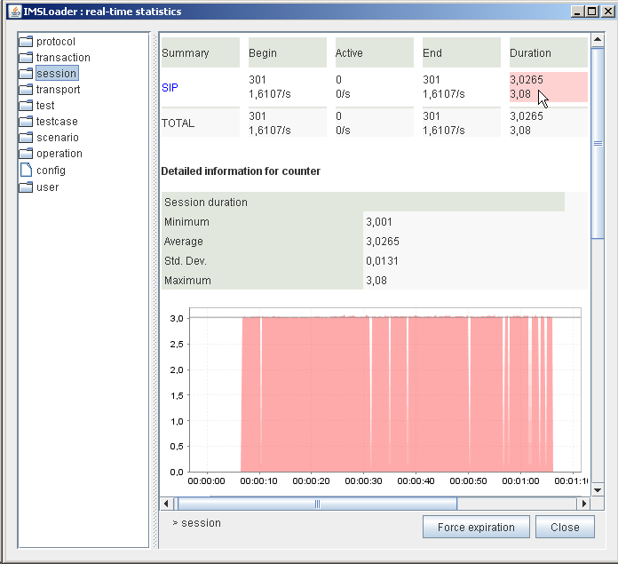
7

8

9

12

11

10

User can display all information about a statistic by double-clicking on it (7).
All numeric’s information (8) and a graphic representation (9) will appear under the summary table.

It’s possible to navigate into the tree by clicking on the path (10).

User can force expiration of some stats (like transaction and session stats) by clicking on “Force expiration” button (12).

User can close window by clicking on “Close” button (12).

Quick configure stats menu item

User can choose to
- Automatic generate report, if he wants to generate regularly an HTML report
- Automatic show report when generate item is clicking in “Stats” menu
- Generate charts pictures in the report
- Generate a CSV file for each charts

“Reset all” menu item
User can choose this item for reset all statistics.

"Help" menu item

“About” menu item
This menu item opens a new window. In this window you can know the current version of your IMSLoader.
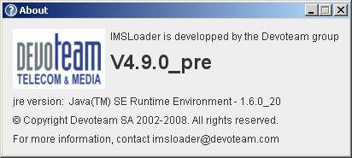

There are also information about JRE (Java Runtime Environment) actually used by IMSLoader.

User has a mail address if you want to have support.

“Documentation” menu item
This menu item opens in your browser all the documentation about IMSLoader.

“Website” menu item
This menu item opens in your browser IMSLoader official website (multiprotocoltestsuite).

Testcase table
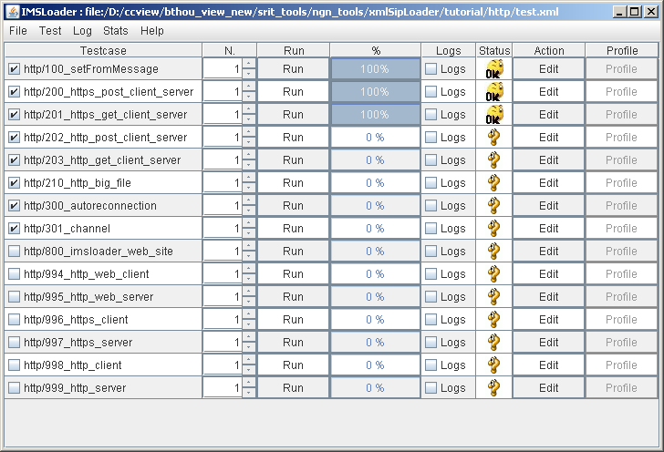
1

2

3

4

5

6

7

8

9

This window displays all testcases of the opened test.
- : name of the testcase
- : status of the testcase (if this is checked, the testcase will be running if user choose to launch a sequential test or a run test.
- : number of iteration for this testcase
- : button to launch quickly the testcase
- : bar to see progressions of the testcase
- : button to display logs window about this tescase
- : icon status to view the current testcase state

icon | status
 | Testcase not already run
 | Testcase actually running
 | Testcase ending success
 | Testcase ending not success (view logs for more information)
 | Testcase waiting (view logs for more information)

- : button for open file of this testcase in user’s xml editor
- : button for open run profile of this testcase

Logs windows
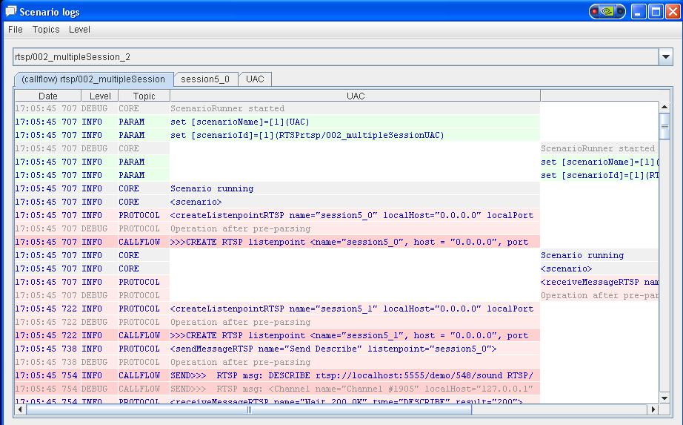

Into logs window IMSLoader print information, warnings, errors messages in the screen with specific colors and save it in log files. For each event, the test tool notifies date, level (info, debug and error) and a message that permits to track progression of the scenario. The user can click in a particular line to expand it and see all the details of the operation.
In the “File” menu, the user can search a text, clear all messages or close the window.
The Search function can also be executed by pressing Ctrl + F in the log window.
A search window is displayed:
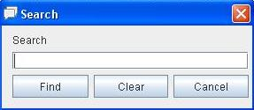
The text searched ignores the case.
By pressing Find, the message that contains the first occurrence is displayed in yellow. The other messages that contain occurrence are in orange. The user can switch between messages with the Next button (the Next button replaces the Find button). When the last message is displayed, a press on the Next button comes back to the first message.
By pressing Clear, the current search is cleared, so the colors of messages back to the normal.
By pressing Cancel, the search is cleared and the Search window is closed.
By pressing Close (the white cross in the red square), the search is conserved and the Search window is closed.

In the “Topics” menu, the user can choose which topic he wants to display (CallFlow, Protocol, Parameter, Core and User).
In the “Level” menu, the user can choose the log level to display.

