

User Manual
PSTN protocol
Version: %VERSION%


Table of contents
1 Generalities 3
1.1 Reference documents 3
1.2 Short summary 3
1.3 Important notes 3
1.3.1 Limitation with dialogic Diva Analog Board 3
1.4 Install Operating System 4
1.5 Install Asterisk 5
1.6 Install Digium Boards 6
1.7 Install Dialogics Boards 6
1.8 Install Sangoma Board (tested with A108) 7
1.9 Configure Asterisk 7
1.10 Configure Digium Boards 8
1.11 Configure Dialogic Boards 8
1.11.1 Board configuration 8
1.11.2 CHAN_CAPI configuration 9
1.12 Configure Sangoma Boards (A108 PRI) 9
2 Protocol elements 10
3 Protocol operations 10
4 Message analyze 10
5 Configuration file 10
6 Tutorial location 11

Generalities

Reference documents
There are protocols to access the PSTN network and the different PSTN protocols are standardized by the ITU consortium. For the moment, we only supports accesses with analog and ISDN lines.

Short summary
IMSLoader does not support directly PSTN protocols; we rely on Asterisk product as a gateway between PSTN and IP network. IMSloader is using the SIP protocol to stimulate the SUT in the PSTN network.

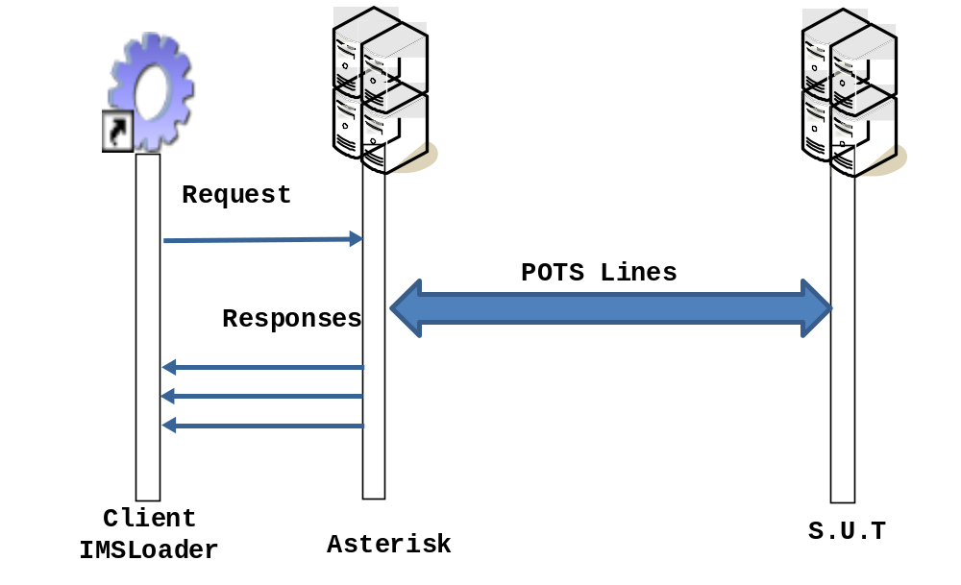

Important notes

Limitation with dialogic Diva Analog Board
In order to be certified with PSTN norms, the Board Dialogic Diva Analog-4 has the following limitations when use with the following country settings:
- Europe (TBR21)
- Australia
- Japan

The limitation is that the driver will refuse to dial a number more than 15 times within 15 minutes. The driver will send an error saying the line is not available. This might show as a congestion error in asterisk.

Install Operating System
We chose CentOS 5.5 as the operating system. We will not cover the installation of a linux OS in this document it is already covered by a great number of tutorials and documentations on internet. Here is an example: http://www.howtoforge.com/perfect-server-centos-5.5-x86_64-ispconfig-2

Please make sure that your Linux installation is not booting on a PAE kernel, that is known to cause problems with the boards drivers.

Install Asterisk
The best way is to install asterisk directly from repositories. First, add the asterisk repositories to your CentOS installation:

- Create and edit the file /etc/yum.repos.d/centos-asterisk.repo

nano -w /etc/yum.repos.d/centos-asterisk.repo

- Copy the following content

[asterisk-tested]
name=CentOS-$releasever - Asterisk – Tested
baseurl=http://packages.asterisk.org/centos/$releasever/tested/$basearch/
enabled=0
gpgcheck=0
#gpgkey=http://packages.asterisk.org/RPM-GPG-KEY-Digium

[asterisk-current]
name=CentOS-$releasever - Asterisk – Current
baseurl=http://packages.asterisk.org/centos/$releasever/current/$basearch/
enabled=1
gpgcheck=0
#gpgkey=http://packages.asterisk.org/RPM-GPG-KEY-Digium

- Create and edit the file /etc/yum.repos.d/centos-digium.repo

nano -w /etc/yum.repos.d/centos-digium.repo

- Copy the following content

[digium-tested]
name=CentOS-$releasever - Digium - Tested
baseurl=http://packages.digium.com/centos/$releasever/tested/$basearch/
enabled=0
gpgcheck=0
#gpgkey=http://packages.digium.com/RPM-GPG-KEY-Digium

[digium-current]
name=CentOS-$releasever - Digium - Current
baseurl=http://packages.digium.com/centos/$releasever/current/$basearch/
enabled=1
gpgcheck=0
#gpgkey=http://packages.digium.com/RPM-GPG-KEY-Digium

- Update yum and install asterisk

yum update
yum install asterisk16 asterisk16-configs

- Start asterisk and go into the CLI

service asterisk start
asterisk -vvvvr

Asterisk is now installed.

Install Digium Boards
First, be sure the card is correctly plugged in the computer then start the computer.

- Install additional software

yum install asterisk16-dahdi dahdi-tools

- Start DAHDI services

service dahdi start

- List the detected DAHDI hardware

dahdi_hardware
> pci:0000:05:08.0 wctdm24xxp+ d161:8003 Wildcard AEX2400

- Overwrite /etc/dahdi/genconf_parameters with the version in IMSLoader/conf/pstn

- Overwrite /etc/asterisk/chan_dahdi.conf with the version in IMSLoader/conf/pstn

- Generate asterisk dahdi configuration, it should generate the file /etc/asterisk/dahdi-channels.conf, included by /etc/asterisk/chan_dahdi.conf

dahdi_genconf

- Apply the configurations chances and restart all impacted services

dahdi_cfg
service asterisk stop
service dahdi restart
service asterisk start

The Digium board should be ready for use. You might have to customize some parameters in /etc/asterisk/chan_dahdi.conf depending on your country or PSTN provider.

Install Dialogics Boards

- CHAN-CAPI must be installed from sources, so we have to install some development tools

yum install gcc-c++ kernel-devel asterisk16-devel
yum install ncurses-devel
yum install zlib-devel xinetd gd-devel jpeg-devel

For Dialogic cards first thing to do is to verify if the CHAN_CAPI module is installed. If the module is not installed you can download it from http://www.melware.org/chancapi and install it by using these following command lines.

However we package the file IMSLoader/conf/pstn/chan_capi-1.1.5-flash.tar.gz. This version of chan-capi contains some modifications in order to have the flash-hook enabled with chan-capi. If you need to use Flash with diva board, please use our customized chan-capi sources.

- tar -xvf chan_capi-1.1.5.tar.gz
- make clean & make & make install
Now we will download drivers for Dialogic boards via the manufacturer's website. On January the 3, 2010 Dialogic driver version is: Diva4Linux_installer_9.5-110-91.bin to install it you can use the following commands on a terminal:

- sh Diva4Linux_installer_9.5-110-91.bin
- cd /usr/lib/opendiva/divas/src/
- ./Build
During the installation you may need to add this link to make installation work well.

- ln -s /lib/modules/2.6.18-194.32.1.el5/source /usr/src/linux
Then you can use GUI interface to configure Dialogic board (HTTP on the asterisk computer, on port 10005). The url for a local access is http://localhost:10005

Install Sangoma Board (tested with A108)
First of all, install missing dependencies:
- yum groupinstall "Development Tools"
- yum install ncurses-devel libtermcap-devel
- yum install dahdi-linux-devel

Download the driver from Sangoma’s website (wanpipe-3.5.20.tgz):
http://wiki.sangoma.com/wanpipe-linux-drivers

Deflate the file on your CentOS host (tar xvzf wanpipe*.tgz) then go into the directory then execute the following command in order to check dependancies:
- ./Setup install

If the first steps are complete then it means that the required dependencies have been found. Cancel the install then execute:
- ./Setup dahdi

Use the default values for everything but the dahdi sources location. When ask, chose to manually input the location (choice [m]), then input: /usr/include.

The necessary software for your Sangoma card is now installed. You can list the detected cards with the command “wanrouter list”.

You should then continue with the configuration.

Configure Asterisk
Asterisk will need a special configuration in order to have the behaviour IMSLoader expects.

- From IMSLoader/conf/pstn, copy the files extensions.conf, sip.conf, and the directory numplan into /etc/asterisk (overwrite files when needed)

- Edit the file /etc/asterisk/numplan/plan.csv to match your configuration. This file is used to link SIP users and asterisk PSTN/ISDN channels. The syntax of the channel is specific depending on the technology. The column number 2 (line numbers) is not used by Asterisk.

- Execute the script /etc/asterisk/numplan/plan.sh, it should generate some files and the file numsip_accounts.conf, included by /etc/asterisk/sip.conf. You must execute plan.sh each time the file plan.csv changes.

cd /etc/asterisk/numplan
chmod +x plan.sh
./plan.sh
sip.conf contains the definition of SIP accounts (at the end of the file). For convenience, this file includes another file, generated by the script plan.sh.

extensions.conf contains the dialpan (rules) that asterisk will apply to forward the calls (at the end of the file). The two sets of rules are:

- [default] (SIP initiated calls): the dialplan will analyse the SIP user and use the CSV file in order to find the matching channel (CAPI, DAHDI, SIP ...) and use this channel to forward the call. It will try to dial the number INVITED by SIP.

- [isdn-in] (CAPI initiated calls): the dialplan will analyse the channel the call was received by and will use the CSV file to find the correct SIP user to forward the call to.

- [from-pstn] (DAHDI initiated calls): the dialplan will analyse the channel the call was received by and will use the CSV file to find the correct SIP user to forward the call to.

Configure Digium Boards
IMSLoader is shipped with a default configuration for Digium boards. The most sensitive points in this configuration are:

- indications.conf
  - country: default localisation parameter
- chan_dahdi.conf
  - callprogress: this feature is experimental and not very reliable.
    - enabled, asterisk will try to detect the ring back tone in order to send the SIP 200OK only when it detects that the other leg of the call picked up the call.
    - disabled, asterisk will send the SIP 200OK as soon as it finished to dial the number.
  - progzone: parameter used for callprogress (only 3 country are available...)
  - language: parameter used for tone detections

Configure Dialogic Boards
There are two sections while configuring the board: configuring the boards themselves and configuring the CAPI configuration (interface with asterisk).
You will find attached reference screen captures for each section of the configuration and we will just go through the main points in this document.


Board configuration
As mentioned in 1.5, we have to configure the board and lines. The lines inherit the configuration of the board.

The main points of the board general configuration are:
- To select the right “D-Channel Protocol” (depending on your country).
- To enable the “Use Caller-ID”
- To configure the “Hook-Flash Length (ms)” (300ms for france/orange)

The main points of each line’s configuration are:
- Assign a unique “Phone Number” to each port of each board.

Then “Save”.

CHAN_CAPI configuration
CHAN_CAPI is the interface with asterisk. For each board, we have to:
- Set “CHAN_CAPI” to “Used by CHAN_CAPI as [ISDNX]”
- Set “Context” to “isdn-in”

Then “Create capi.conf”.

Configure Sangoma Boards (A108 PRI)
The main step of configuration consists in the command:
- wancfg_dahdi

For a french ISDN PRI line, the answers would be (for the ports you want to configure):

Would you like to generate /etc/asterisk/chan_dahdi.conf
1. YES
[1-2]:1

Select media type for AFT-A108 on port 1 [slot:4 bus:36 span:1]
2. E1
3. Unused
[1-4]:2 (or 3 if nothing is plugged to the port)

Configuring port 1 on 108 as E1, line coding:HDB3, framing:CRC4
2. NO - Configure line coding and framing
[1-2, ENTER='YES']:2

Select line coding for port 1 on 108
1. HDB3
[1-2, ENTER='HDB3']:1

Select framing for port 1 on 108
2. NCRC4
[1-3, ENTER='CRC4']:2

Select clock for AFT-A108 on port 1 [slot:4 bus:36 span:1]
1. NORMAL
[1-2]:1

Select signalling type for AFT-A108 on port 1 [slot:4 bus:36 span:1]
1. Zaptel/Dahdi - PRI CPE
[1-12]:1

Select switchtype for AFT-A108 on port 1
5. EuroISDN
[1-7]:5

Would you like to enable hardware DTMF detection?
1. YES
[1-2, ENTER='YES']:1

Would you like to enable hardware fax detection?
1. YES
[1-2, ENTER='NO']:1

Configuring port 1 on AFT-A108 as a full E1
1. YES - Use all channels
2. NO - Configure for fractional
[1-2, ENTER='YES']: answer depending on your configuration

Select dialplan context for AFT-A108 on port 1
2. from-internal
[1-3]:2 (this is the context used in our customized extensions.conf)

Then do the same thing for the other ports (if there are other ports).

After this, generate the dahdi files, save them.

To restart the services in the right order:
- service asterisk stop
- wanrouter stop
- service dahdi stop
- wanrouter start (will also start dahdi)
- service asterisk start

If everything seems good, using the command “wanrouter status” you should the the port as “connected”.

Special note: French’s E1’s pin layout might be different from T1’s standard layout. It might be necessary to build a customized RJ45 cable in order to make the pin layout match. The command “wanpipemon -i wXgX -c Ta” will help diagnosing if there is a short circuit or open circuit alarm.

Protocol elements
As mentioned above, we are using SIP protocol to stimulate the PSTN network.
Please refer to SIP user manual.

Protocol operations
As mentioned above, we are using SIP protocol to stimulate the PSTN network.
Please refer to SIP user manual.

Message analyze
As mentioned above, we are using SIP protocol to stimulate the PSTN network.
Please refer to SIP user manual.

Configuration file
There are no IMSloader configuration files for PSTN protocol.
We provide a standard asterisk configuration files which is located at following path:
<InstallDirectory>/conf/pstn/

Tutorial location
If you want to learn how to use IMSloader for the PSTN protocol, you are have a look to the tutorial provided by the tool. Of course, you could use these scripts as a starting point too, if you have to write a some new testcases.

Examples of scripts are located in the <InstallDir>/tutorial/pstn

