
Tests of IP applications : Offer and know-how | 2013
© DEVOTEAM 2007
Do not copy this document without written agreement

- context and stakes
Great carriers are looking for a multimedia communication platform that allows to:
MTS: MULTIPROTOCOL TEST SUITE
- Preserve, and even extend the operator’s value chain;
- Keep control of service incomes;
- Reduce Capex and Opex;
- Perpetuate investments;
- Migrate from classic telephony service to Voice over IP;
- Converge services of legacy and mobile telephony.

This platform may today take several forms according to the operator’s needs:
- NGN based architecture for legacy carriers;
- IMS based architecture for mobile operators;
- TISPAN Architecture for mixed operators.

All these architectures are founded on the separation of media and control layers and the inter-layer communication based on normalized interfaces and protocols.

Furthermore, all these architectures have in common the use of normalized protocols for the control of services.

Before deploying a new service on such a network, it is primordial to be able to verify its well working. In fact, IMS infrastructure is not less reliable than the classic PSTN network. The MTS product allows detecting and suppressing any robustness problem of the infrastructure. Most of risks are introduced with errors in the implementation of the network component. The earlier these errors are detected, the less important the impact on the service is, guaranteeing a better acceptance of new services by the general public.

Who needs MTS ?
- Telecom manufacturers  - Service providers  - Integrators  - Test Labs | - Network administrators  - Anyone involved in development or use of SIP network
- MTS
It is a critical automatic test tool of software. The high technology Devoteam in service of tests of applications guarantees the robustness, the reliability, and the security of deployed services in the carriers’ network.

It allows you to:
- Simulate several protocols such as SIP, Diameter, RTP, HTTP/SOAP;
- Perform a list of tests sheets – for example, simulate Push-to-Talk (1-1, 1-N) sessions, each test sheet is described in XML files;
- Simulate flows of RTP or RTCP VoIP messages.
It also has a GUI to manage and tune test cases.
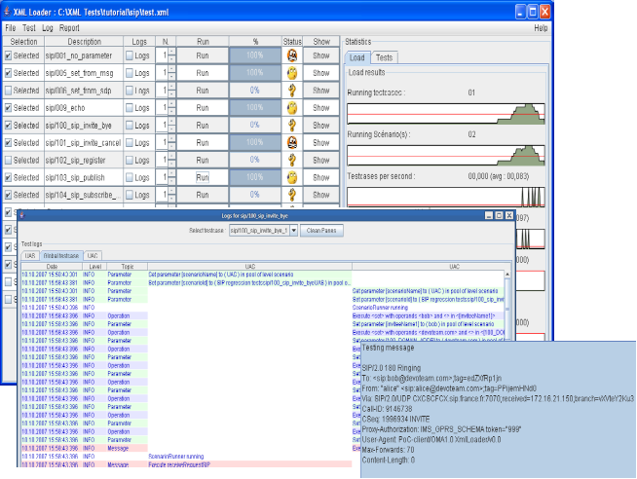

Software architecture
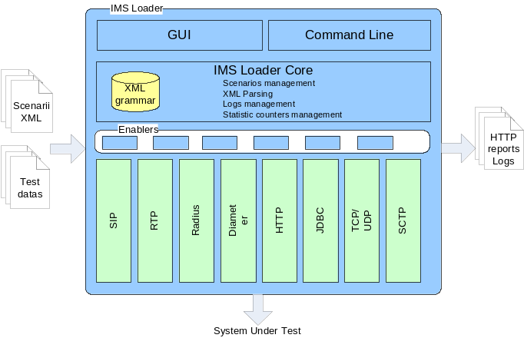
It provides:
MTS : MULTIPROTOCOL TEST SUITE
- A test tool
- An installation procedure
- A user manual

Minimal required configuration:
- Processor : 1 GHz
- RAM 512 MB
- Hard disk : 1 GByte
- Solaris / Windows XP/NT/2000
- Ethernet Card
- CD Reader
- Positioning of Devoteam
Devoteam can support its clients though all the value chain (Study, Realization and Maintenance) and on each element of the IMS network (CSCF, HSS, Application Server) and especially on the IMS service layer. In fact, through its proven experience in the development of SIP applications and SIP applications servers in accordance with IMS and 3GPP (see references), Devoteam can provide its whole expertise in study, development, test and integration of IMS applications. Furthermore, through its expertise in the domain of charging and billing of services, Devoteam can help its carrier’s clients to define models of billing which may be exploited in IMS Core.
- Our competitive advantages
- An experience of 8 years in VoIP protocols and SIP protocol stacks,
- A unique experience in development of SIP middleware and especially a 3GPP SIP Servlet Engine,
- A unique experience in development of IMS applications : Development of a PTT application,
- A partnership with several constructors and editors, leaders in the IMS and SIP services domain (Siemens, Ubiquity, …)

- Our References
- Development for Siemens of a Push-To-Talk application in accordance with 3GPP IMS and OMA,
- Development for Siemens of a SIP Application Server in accordance with 3GPP IMS and with JSR 116 (SIP Servlet API)
- Prototype of IMS services for France Telecom R&D,
- Study and IMS network engineering for France Telecom R&D

Contact: mts@devoteam.com

MTS is able to replace any IMS core block

