

User Manual
MASTER Module
Version: %VERSION%

Table of contents
1 Introduction 3
2 Requirements 4
3 Installation 5
3.1 Linux 5
3.2 Configuration 5
4 Architecture 6
4.1 Description 6
4.2 XML Files 7
4.2.1 Master tag 7
4.2.2 Test tag 7
4.2.3 Parameters 8
4.3 Statistics 8
4.4 Files 8
4.5 Slaves 8
5 Graphical User Interface 10

Introduction
MTS MASTER module allows load testing with a master synching multiple slaves that are running MTS.
The master ensures the deployment of the test (all the files are on the master), the scheduling of the tests, and the compilation of statistics.

Requirements
There is no specific requirement for the MASTER module.

Installation

Linux
On Linux systems it is often necessary to edit the file
/etc/hosts
And to put the right IP address (the one that will be used by MTS for the communication between master and slaves) in front of the computer hostname.

Configuration
The MASTER configuration file is a java properties file.
MTS/conf/master.properties
The properties file itself contains self-explicatory comments for each parameter.
Complete the configuration with the specific parameters of each supported protocols (see protocols user manuals).

Architecture

Description
MTS MASTER module introduces the notion of slave and master. It allows reaching load performances that we could not get using only one computer by using an unlimited number of slaves. Those slaves are all being scheduled by the master.
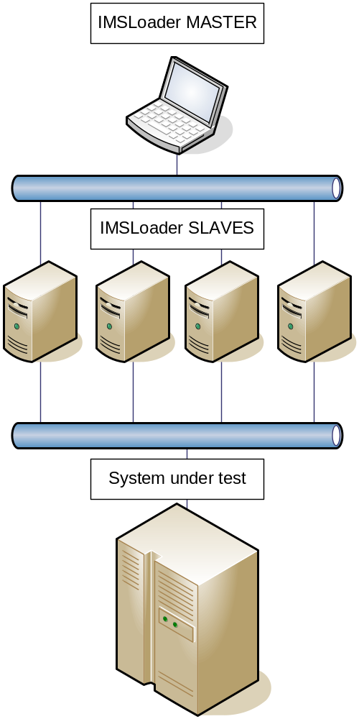

XML Files
The MASTER module introduces a new XML file format. This file contains a list of tests as well as the name or address of the slaves that will be running them.
This file has the following format:
Example : master.xml:
<?xml version="1.0" encoding="UTF-8"?>

<master name=”example” description=”example description”>
<parameter name=”[target_host]” operation=”set” value=”192.168.0.1” />
<parameter name=”[target_port]” operation=”set” value=”8080” />

<test name=”test_1” slave=”192.168.0.10:2099” home=”../config_test_1” path=”../test/test.xml” description=”my first test” runner=”load”>
<parameter name=”[specific_param]” operation=”set” value=value1”/>
</test>

<test name=”test_2” slave=”192.168.0.11:2099” home=”../config_test_2” path=”../test/test.xml” description=”my second test” runner=”load”>
<parameter name=”[specific_param]” operation=”set” value=value2”/>
</test>
</master>

Master tag
This tag contains the following parameters.
name
Name of this master test; used in the GUI and in the report directory.
description (optional)
Description of this master test; used in the GUI.

Test tag
This tag contains the following parameters.
name
Name of this test; used in the GUI; overrides the attribute of the test.xml file.
description
Description of this test; used in the GUI.
runner
Type of the runner the slave will used; can be changed in the GUI;
Values: sequential, load.
slave
Name or address of the slave that will be running this test; used at the deployment.
Value: logical name, “host:port”.
home
Changes the home of the test; overrides the home attribute of the test.xml file. The home of a test defines the directory where the properties and csv files will be read.
path
Path to the XML file describing the test.

Parameters
The master file can contain parameter tags. Those parameters are transmitted to the test and can only override the value of the parameters flagged with “editable=true”.
This is one of the two ways to customize a test on a slave, from the master. The other way is to change the directory where the properties and CSV files will be read, via the home attribute of the test tag.

Statistics
Reports can be generated by clicking on the dedicated button in the GUI.
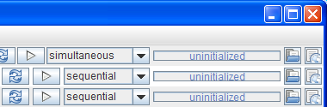

It is possible to generate either the report of a particular test or the merged report of all tests.

Files
Master and test files can be opened by clicking on the dedicated button in the GUI.

Slaves
Slaves are computers running MTS. These computers have to be reachable by the master. There is two ways to refer to a slave. It is possible to refer to it via a name or via its address.
The master keeps a list of connected slaves:
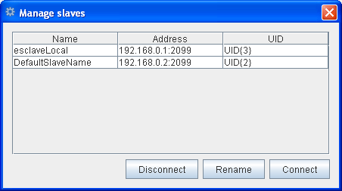
This list allows seeing the currently connected slave, their names and addresses. It is also possible to change the name of a slave or connect to it manually.
When a master test refers to an unknown slave via it’s address, it will first search it among the currently connected slave then will try to initiate a new connection to it.
Naming slaves allows to write master tests using “slave_1”, “slave_2”, “slave_3”, and then run them without having to mind the address of the slave.

Graphical User Interface
The MASTER module GUI contains the different menus necessary to open, close, reload the master tests.
Each line represents either the master or the tests it contains and allows the user to start tests or change some parameters
Expand or collapse the tree to see testcases
Start, deploy or stop all tests (if running)
Change the order the tests are started.
Progression, status of the master.
Open master or test XML file.
ster or test
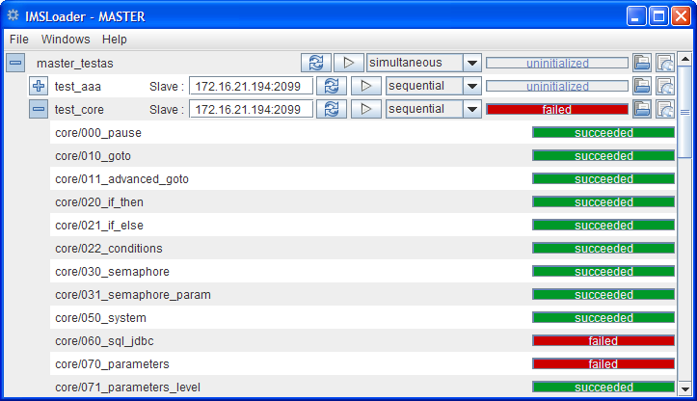
Start, deploy or stop the test (if running)
Change the runner type of the test.
Progression, status of each test.
Generate report of master or test

Expand or collapse the tree to see tests
Edit the name or address of the slave
Progression, status of each testcase.

