

User Manual
ImportSipp
Version: %VERSION%

Table of contents
1 Generalities 3
2 How to use 3
2.1 Syntax 3
2.2 Example 3
3 Parameters configuration 3
4 Restrictions 3

Generalities
This module can generate MTS scripts from a SIPP XML scripts.
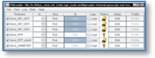
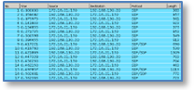
IMPORT
SIPP
Capture file
MTS scripts generated

MTS
SIPP script

How to use

Syntax
This tool can be used by command line with the followed syntax:

importsipp.bat –sippfile <SIPP script> -testcase <testcase name>

<SIPP script> | Name of the SIPP script file to convert to MTS scripts
<testcase name> | Name of the testcase to add in the test file
The result file is called test.xml in the current file.

Example

importsipp.bat -sippfile ..\tutorial\importsipp\uas.xml -testcase test_ua

Parameters configuration

Restrictions

