

User Manual
SIGTRAN protocol
Version: %VERSION%

Table of contents
1 Generalities 3
1.1 Protocol stack 3
1.2 Reference documents 3
1.2.1 Transport protocol (layer #4) 3
1.2.2 User Adaptation layers (UA) 3
1.2.3 SS7 like layers (also called FVO = Fixed-Variable-Optional) 5
1.2.4 ISDN like protocols (also called IE= Element Information) 6
1.2.5 Application Part layers (also called ASN.1) 7
1.3 Short summary 7
1.4 Stack implementations 8
2 Protocol elements 9
2.1 Message element 9
2.2 Channel element 10
2.3 Listenpoint element 10
3 Protocol operations 11
3.1 <sendMessageSIGTRAN> operation 11
3.1.1 <ISDN> XML tag 12
3.1.2 <SS7> element 13
3.1.3 <UA> XML tag 14
3.2 <receiveMessageSIGTRAN> operation 16
3.3 <createListenpointSIGTRAN> operation 16
3.4 <removeListenpointSIGTRAN> operation 16
4 Message analyze 16
5 Configuration file 18
6 Tutorial location 18

Generalities
SIGTRAN is a suite of protocol coming from the telephony world and is transported over Internet Protocol (IP) and usually transported over SCTP layer.

Protocol stack

Here is a short summary of the layers that is currently supported amongst the SIGTRAN protocols: (coloured in orange in the picture)

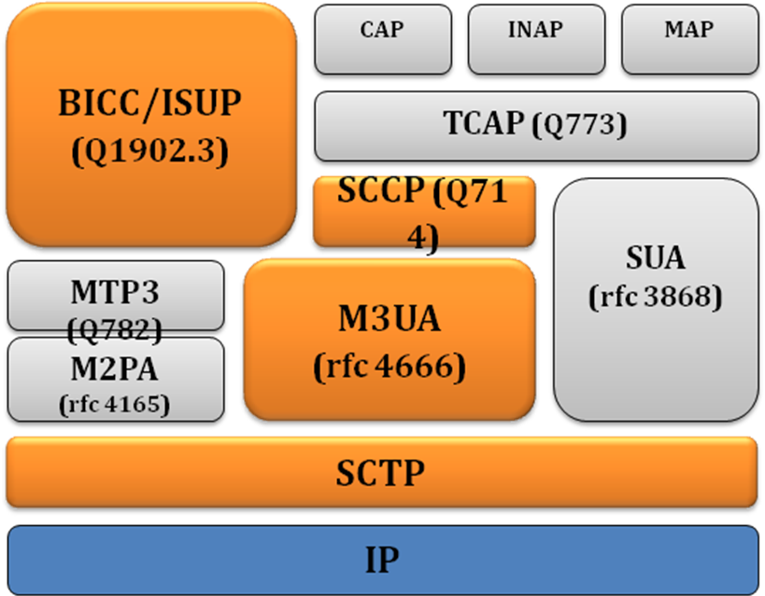

Reference documents

Transport protocol (layer #4)
The transport protocol which is specified by IETF is:
- SCTP : Stream Control Transmission Protocol
It provides the transport protocol for SIGTRAN user adaptation layer messages across an IP network. It is described in RFC 3873, RFC 4166 and RFC 4960.

User Adaptation layers (UA)
This layer is in charge of the adaptation between IP world and SS7 application protocols. For the moment, we only support the following one. It is specified by IETF. All of these kinds of layers are coded based on the TLV format. To have more information about UA layers, please look at the following link: http://www.protocols.com/pbook/sigtran.htm

- M3UA : Message Transfer Part 3 User Adaptation
It provides an SCTP adaptation layer for the seamless backhaul or peering of MTP Level 3 user messages and service interface across an IP network. It is specified in RFC 4666.
RFC summary:
This memo defines a protocol for supporting the transport of any SS7 MTP3-User signalling (e.g., ISUP and SCCP messages) over IP using the services of the Stream Control Transmission Protocol. Also, provision is made for protocol elements that enable a seamless operation of the MTP3-User peers in the SS7 and IP domains. This protocol would be used between a Signalling Gateway (SG) and a Media Gateway Controller (MGC) or IP-resident Database, or between two IP-based applications. It is assumed that the SG receives SS7 signalling over a standard SS7 interface using the SS7 Message Transfer Part (MTP) to provide transport. This document obsoletes RFC 3332.
- IUA : ISDN User Adaptation
It provides an SCTP adaptation layer for the seamless backhaul of Q.921 user messages and service interface across an IP network. Some users that it supports are Q.931 and QSIG.^{[3]} It is specified in RFC 4233.
RFC summary:
This document defines a protocol for backhauling of Integrated Services Digital Network (ISDN) Q.921 User messages over IP using the Stream Control Transmission Protocol (SCTP). This protocol would be used between a Signaling Gateway (SG) and Media Gateway Controller (MGC). It is assumed that the SG receives ISDN signaling over a standard ISDN interface.
- V5UA : V5 User Adaptation
It provides an SCTP adaptation layer for the seamless backhaul of V5.2 user messages and service interface across an IP network. It is a variation of IUA and is specified in RFC 3807.
RFC summary:
This document defines a mechanism for the backhauling of V5.2 messages over IP using the Stream Control Transmission Protocol (SCTP). This protocol may be used between a Signaling Gateway (SG) and a Media Gateway controller (MGC). It is assumed that the SG receives V5.2 signaling over a standard V5.2 interface. This document builds on the ISDN User Adaptation Layer Protocol (RFC 3057). It defines all necessary extensions to the IUA Protocol needed for the V5UA protocol implementation.
- M2UA : Message Transfer Part 2 User Adaptation
It provides an SCTP adaptation layer for the seamless backhaul of MTP Level 2 user messages and service interface across an IP network. It is specified in RFC 3331.
RFC summary:
This document defines a protocol for the backhauling of Signaling System 7 Message Transfer Part 2 (SS7 MTP2) User signalling messages over IP using the Stream Control Transmission Protocol (SCTP). This protocol would be used between a Signalling Gateway (SG) and Media Gateway Controller (MGC). It is assumed that the SG receives SS7 signalling over a standard SS7 interface using the SS7 Message Transfer Part (MTP) to provide transport. The Signalling Gateway would act as a Signalling Link Terminal.
TODO : XML scripts not implemented
- M2PA : Peer-to-Peer Adaptation RFC 4165
It provides an SCTP adaptation layer for providing an SS7 MTP signaling link over an IP network. It is specified in RFC 4165.
RFC summary:
This document defines a protocol supporting the transport of Signaling System Number 7 (SS7) Message Transfer Part (MTP) Level 3 signaling messages over Internet Protocol (IP) using the services of the Stream Control Transmission Protocol (SCTP). This protocol would be used between SS7 Signaling Points using the MTP Level 3 protocol. The SS7 Signaling Points may also use standard SS7 links using the SS7 MTP Level 2 to provide transport of MTP Level 3 signaling messages. The protocol operates in a manner similar to MTP Level 2 so as to provide peer-to-peer communication between SS7 endpoints.
TODO : XML scripts not implemented
- SUA : Signalling Connection Control Part
It provides an SCTP adaptation layer for the seamless backhaul or peering of Signaling Connection Control Part user messages and service interface across an IP network. It is specified in RFC 3868.
RFC summary:
This document defines a protocol for the transport of any Signalling Connection Control Part-User signalling over IP using the Stream Control Transmission Protocol. The protocol is designed to be modular and symmetric, to allow it to work in diverse architectures, such as a Signalling Gateway to IP Signalling Endpoint architecture as well as a peer-to-peer IP Signalling Endpoint architecture.
TODO : XML scripts not implemented

SS7 like layers (also called FVO = Fixed-Variable-Optional)
This is the SS7 application protocol the user wants to transmit inside the network. It is specified by ITU organisation. All of these kinds of layers are coded based on the FVO format. To have more information about SS7 layers, please look at the following link: http://www.protocols.com/pbook/ss7.htm

- BICC : Bearer Independent Call Control
The Bearer Independent Call Control (BICC) is a signaling protocol based on N-ISUP that is used for supporting narrowband ISDN service over a broadband backbone network. BICC is designed to interwork with existing transport technologies. BICC is specified in ITU-T recommendation Q.1901.
- ISUP : ISDN User Part
It is defined into the Q.761, Q.762, Q.763, Q.764 et Q.766 specification. It provides the signaling features for ISDN calls in a SS7 network. It has access to the SCCP interface to allow a end-end signaling.
TODO : XML scripts not implemented
- SCCP : Signaling Connection and Control Part
It is defined into the Q.711, Q.712, Q.713, Q.714, Q.715 et Q.716 specification. It is the transport protocol for SS77 network. It looks like the TCP for Internet. SCCP provides a transport service for the messages from a SCCP address through the network equipments to the remote destination.
TODO : XML scripts not implemented
- MTP3 : Message Transfer part 3
The Message Transfer Part (MTP) is part of the Signaling System 7 (SS7) used for communication in Public Switched Telephone Networks. MTP is responsible for reliable, unduplicated and in-sequence transport of SS7 messages between communication partners. MTP is formally defined primarily in ITU-T recommendations Q.701, Q.702, Q.703, Q.704 and Q.705. Tests for the MTP are specified in the ITU-T recommendations Q.781 for MTP2 and in Q.782 for MTP3. These tests are used to validate the correct implementation of the MTP protocol.
TODO : XML scripts not implemented

ISDN like protocols (also called IE= Element Information)
This is the ISDN application protocol the user wants to transmit inside the network. It is specified by ITU organization. All of these kinds of layers are coded based on the IE format.
- ISDN : Integrated Services Digital Network
ITU-T Recommendation Q.931 is ISDN's connection control protocol, roughly (not at the same layer) comparable to TCP in the Internet Protocol stack. Q.931 doesn't provide flow control or perform retransmission, since the underlying layers are assumed to be reliable and the circuit-oriented nature of ISDN allocates bandwidth in fixed increments of 64 kbit/s.
To have more information about ISDN layers, please look at the following link: http://www.protocols.com/pbook/isdn.htm
- V5.X: Sub-system for the ISDN
V5.1 (ETS 300 324-1) in which there is a 1 to 1 correspondence between subscriber lines and bearer channels in the aggregate link to the exchange. A V5.1 interface relates to a single aggregate E1 (2 Mbit/s) link between a multiplexer and an exchange.
V5.2 (ETS 300 347-1) which provides for concentration where there are not enough bearer channels in the aggregate link(s) to accommodate all subscribers at the same time. A single V5.2 interface can control up to 16 E1 links at once and can include protection of the signalling channels.
To have more information about SIGTRAN layers, please look at the following link: http://www.protocols.com/pbook/v5.htm

Application Part layers (also called ASN.1)
This is the AP application protocol the user wants to transmit inside the network. It is specified by ITU organisation.
- TCAP : Transaction Capability User Part
Transaction Capabilities Application Part, from ITU-T recommendations Q.771-Q.775 or ANSI T1.114 is a protocol for Signalling System 7 networks. Its primary purpose is to facilitate multiple concurrent dialogs between the same sub-systems on the same machines, using Transaction IDs to differentiate these, similar to the way TCP ports facilitate multiplexing connections between the same IP addresses on the Internet.
TODO : java code not implemented
- CAP : CAMEL User Part
The CAMEL Application Part (CAP) is a signalling protocol used in the Intelligent Network (IN) architecture. CAP is a Remote Operations Service Element (ROSE) user protocol, and as such is layered on top of the Transaction Capabilities Application Part (TCAP) of the SS#7 protocol suite. CAP is based on a subset of the ETSI Core and allows for the implementation of carrier-grade, value added services such as unified messaging, prepaid, fraud control and Freephone in both the GSM voice and GPRS data networks.
TODO : java code not implemented
- MAP : Mobile User Part
The Mobile Application Part (MAP) is an SS7 protocol which provides an application layer for the various nodes in GSM and UMTS mobile core networks and GPRS core networks to communicate with each other in order to provide services to mobile phone users. The Mobile Application Part is the application-layer protocol used to access the Home Location Register, Visitor Location Register, Mobile Switching Center, Equipment Identity Register, Authentication Centre, Short message service center and Serving GPRS Support Node (SGSN).
TODO : java code not implemented

Short summary
Here are some examples of the MTS use case inside a NGN architecture.
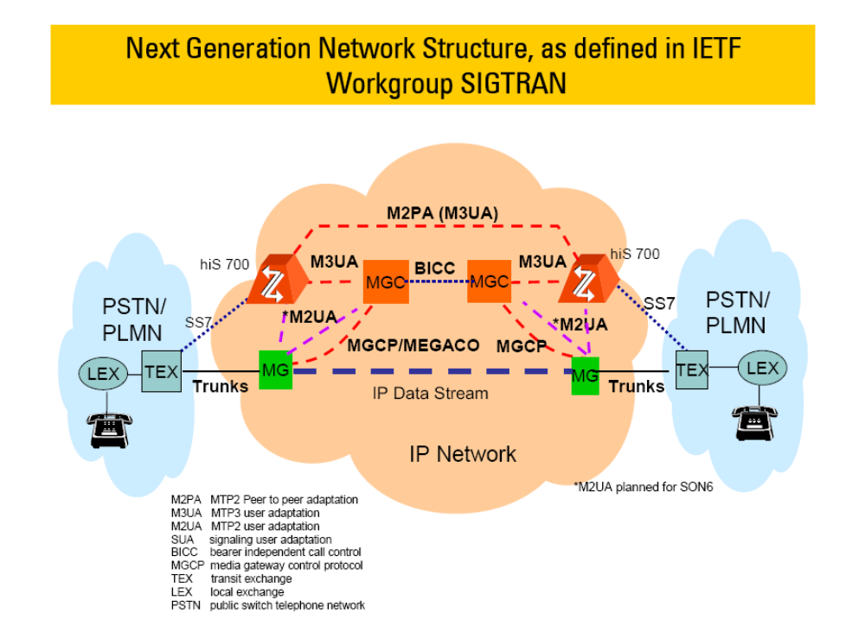

Stack implementations
Around the SIGTRAN layers described above, we only implement and provide dictionary and XML scripts for the following layers:

- UA layers coded in TLV format (m3ua, iua, v5ua)
- ISDN layers coding in IE format (q931, v5.x)
- SS7 layers coding in FVO format (bicc, sccp)
- AP layer coding in ASN.1 (tcap, cap, map, inap) NOT IMPLEMENTED

Here is a table to summarize that whether we can support a given SIGTRAN protocol stack:

 | Feature | XML scripts and dictionary
IUA | OK | All
IUA/ISDN | OK | All
V5UA | OK | All
V5UA/V5X | OK | Most important  TODO Scripts + dico
M3UA | OK | All
M3UA/BICC | OK | Most important  TODO Scripts + dico
M3UA/ISUP | OK | TODO Scripts + dico
M3UA/SCCP | OK | Only one  TODO Scripts + dico
M3UA/SCCP/TCAP | TODO
M3UA/SCCP/TCAP/MAP | TODO
M3UA/SCCP/TCAP/INAP | TODO
M3UA/SCCP/TCAP/CAP | TODO
M2PA | OK | TODO Scripts + dico
M2PA/MTP3 | OK | TODO Scripts + dico
M2PA/MTP3/SCCP | OK | TODO Scripts + dico
M2PA/MTP3/  SCCP/TCAP | TODO
M2PA/ MTP3/  SCCP/TCAP/MAP | TODO
M2PA/MTP3/  SCCP/TCAP/INAP | TODO
M2PA/MTP3/  SCCP/TCAP/CAP | TODO
M2UA | OK | TODO Scripts + dico
M2UA/BICC | OK | TODO Scripts + dico
M2PA/ISUP | OK | TODO Scripts + dico

Protocol elements

Message element
Here is the signification of the message attribute for the (PPP) protocol:

Message attribute | Description
protocol | Always returns “SIGTRAN” for this protocol.
request | Always returns “true” for this protocol (transactions are not handled yet).
type | Returns the contained message’s type coming from the upper layer.  TODO not implemented
result | Not supported, returns nothing  TODO not implemented
transactionId | Depends on the configuration file.  TODO not implemented
messageId | Depends on the configuration file.  TODO not implemented
scenarioName | Depends on the configuration file.  TODO not implemented
retransmissionId | Depends on the configuration file.  TODO not implemented

Channel element
Channel element is not supported for SIGTRAN protocol.

Listenpoint element
The standard features of this operation are described in the core operation documentation. There are no parameters specific to SIGTRAN.

Protocol operations
For the (PPP) protocol we defined the 6 following generic operations.

Generic operations | Features
<sendMessageSIGTRAN> | To send a message for the SIGTRAN protocol using a listenpoint or a channel
<receiveMessageSIGTRAN> | To wait until a message of the SIGTRAN protocol is received.  The scenario failed if no message is received.  The user can specify some filtering criteria to accept the incoming message
<createListenpoint SIGTRAN> | To start listening for the SIGTRAN protocol.
<removeListenpointSIGTRAN> | To stop listening for the SIGTRAN protocol.

<sendMessageSIGTRAN> operation
The standard features of this operation are described in the core operation documentation.
Operation content
The content of this operation describes a SIGTRAN message. A SIGTRAN message contains one or more stacked protocols. The direct children of the <sendMessageSIGTRAN> tag describe those stacked protocols from the higher to the lower level.
Example : Send a (SIGTRAN) message
<?xml version="1.0" encoding="UTF-8"?>

<scenario>
<sendMessage(PPP) name="comment" listenpoint="alice_terminal"
remoteHost="172.16.21.32" remotePort="1234">

<AP>
<!-- optional, format defined in next chapters -->
(...)
</AP>
<AP>
<!-- optional, format defined in next chapters -->
(...)
</AP>

<SS7>
<!-- optional, format defined in next chapters -->
(...)
</SS7>
<SS7>
<!-- optional, format defined in next chapters -->
(...)
</SS7>

OR

<ISDN>
<!-- optional, format defined in next chapters -->
(...)
</ISDN>

<UA>
<!-- mandatory, format defined in next chapters -->
(...)
</UA>

</sendMessage(PPP)>
</scenario>

XML syntax
Content | format | Description
<AP> | fixed [0..N] | Describe AP (Application Part) layer coding in ASN.1 (Abstract Syntax Notation one) format.  Tutorial :  Others: tcap, cap, map, inap …
<SS7> | fixed [0..N] | Describe SS7 (Signaling System 7) layer coding in FVO (Fixed Variable Optional) format.  Tutorial : bicc, isup, sccp  Others: mtp3 …
<ISDN> | fixed [0..1] | Describe ISDN (Integrated Services Data Network) layer coding in IE (Element Information) format.  Tutorial : isdn, v5.2  Others: …
<UA> | fixed [1] | Describe UA (User Adaptation) layer (m3ua, iua, v5ua) coding in FVO (Fixed Variable Optional) format  Tutorial : m3ua, iua, v5ua  Others: m2ua, m2pa, sua…

<ISDN> XML tag
As previously stated, it describes data for ISDN (Q931), V5.x layers widely used in ISDN protocols. Those protocols are encoded the same way based on information elements; however the signification of message types and elements are different. Those elements are defined in a dictionary file that must be specified into the <ISDN> tag.

ISDN data contains a header then a list of elements. Each element contains a variable number of fields.

This XML tag contains an informative name and the dictionary file’s name. The dictionaries are located in <MTS>/conf/sigtran. When sending messages, this dictionary will only be used map the parameter names to numerical ids.

  - <element> tag

It describes an element information. The name is mainly informative. The length of a element is the sum of the lengths of the fields.

    - <field> tag

The field element finally describes the data. Each field has its own length (length bytes and lengthBit bits). Each field can have a type (please refer to the dictionary). The default type (when not specified) is integer.
Example : ISDN layer (EI)
<ISDN name="Q931" syntax="../conf/sigran/q931.xml">

<!-- SETUP = b00000101 = h5 = d5-->
<header discriminator="Recommendation Q.931/I.451" callReference="h0065" type="SETUP"/>

<!-- Channel identification = b0011000 = h18 = d24-->
<element identifier="Channel identification">
<field name="ext1" lengthBit="1" type="boolean" value="1"/>
<field name="Interface identifier present" lengthBit="1" type="enumeration" value="1"/>
<field name="Interface type" lengthBit="1" type="enumeration" value="Basic interface"/>
<field name="Spare" lengthBit="1" type="integer" value="0"/>
<field name="Preferred/Exclusive" lengthBit="1" type="enumeration" value="preferred"/>
<field name="D-channel indicator" lengthBit="1" type="enumeration" value="not D-channel"/>
<field name="Information channel selection" lengthBit="2" type="enumeration" value="No channel"/>
<field name="ext2" lengthBit="1" type="boolean" value="1"/>
<field name="Interface identifier" lengthBit="7" type="integer" value="65"/>
<field name="ext3" lengthBit="1" type="boolean" value="1"/>
<field name="Coding standard" lengthBit="2" type="enumeration" value="ITU-T standardized coding"/>
<field name="Number/map" lengthBit="1" type="enumeration" value="0"/>
<field name="Channel type/map element type" lengthBit="4" type="enumeration" value="B-channel units"/>
<field name="ext4" lengthBit="1" type="boolean" value="1"/>
<field name="Channel number" lengthBit="7" type="integer" value="70"/>
</element>

<!-- Calling party number = b01101100 = h6C = d108-->
<element identifier="Calling party number">
<field name="ext1" lengthBit="1" type="boolean" value="0"/>
<field name="Type of number" lengthBit="3" type="enumeration" value="National number"/>
<field name="Numbering plan identification" lengthBit="4" type="enumeration" value="ISDN/telephony numbering plan"/>
<field name="ext2" lengthBit="1" type="boolean" value="1"/>
<field name="Presentation indicator" lengthBit="2" type="enumeration" value="Presentation allowed"/>
<field name="ext3" lengthBit="3" type="integer" value="0"/>
<field name="Screening indicator" lengthBit="2" type="enumeration" value="User-provided, not screened"/>
<field name="Number digits" type="string" value="1000000101"/>
</element>

</SS7>

<SS7> element
As previously stated, the <SS7> tag describes data for BICC, SCCP layers widely used in SS7 protocols. Those protocols are encoded the same way; however the signification of message types and parameters are different. Those elements are defined in a dictionary file that must be specified into the <SS7> tag.

SS7 data contains a header then a list of parameters. Each parameter contains a variable number of fields.

This XML tag contains an informative name and the dictionary file’s name. The dictionaries are located in <MTS>/conf/sigtran. When sending messages, this dictionary will only be used map the parameter names to numerical ids.

  - <parameter>

The parameter element describes a “mandatory fixed”, “mandatory variable”, or “optional” parameter. The name is mainly informative. The length of a parameter is the sum of the lengths of the fields.

    - <field>

The field element finally describes the data. Each field has its own length (length bytes and lengthBit bits). Each field can have a type (please refer to the dictionary). The default type (when not specified) is integer.
Example : SS7 layer (FVO)
<SS7 name="bicc" file="bicc.xml">
<header>
<field name="CIC" length="4" value="13"/>
<field name="Message_Type" length="1" value="6"/>
</header>
<parameter name="Backward_call_indicators" type="F">
<field name="End-to-end_method_indicator" lengthBit="2" value="0"/>
<field name="Called_party's_category_indicator" lengthBit="2"
value="1"/>
<field name="Called_party's_status_indicator" lengthBit="2" value="1"/>
<field name="Charge_indicator" lengthBit="2" value="2"/>
<field name="SCCP_method_indicator" lengthBit="2" value="0"/>
<field name="Echo_control_device_indicator" lengthBit="1" value="0"/>
<field name="ISDN_access_indicator" lengthBit="1" value="1"/>
<field name="Holding_indicator" lengthBit="1" value="0"/>
<field name="ISDN_user_part/BICC_indicator" lengthBit="1" value="1"/>
<field name="End-to-end_information_indicator" lengthBit="1" value="0"/>
<field name="Interworking_indicator" lengthBit="1" value="0"/>
</parameter>
<parameter name="Optional_backward_call_indicators" id="41" type="O">
<field name="Reserved_for_national_use" lengthBit="4" value="0"/>
<field name="MLPP_user_indicator" lengthBit="1" value="0"/>
<field name="Simple_segmentation_indicator" lengthBit="1" value="0"/>
<field name="Call_diversion_may_occur_indicator" lengthBit="1"
value="0"/>
<field name="In-band_information_indicator" lengthBit="1" value="1"/>
</parameter>
</SS7>

<UA> XML tag
As previously stated, the <UA> tag describes data encoded in m3ua, iua, v5ua, sccp layers used at the top of SCTP to transport the other layers. Those protocols are encoded the same way (TLV encoding); however the signification of message types and parameters are different. Those elements are defined in a dictionary file that must be specified into the <UA> tag.

UA data contains a header then a list of parameters. Each parameter contains a variable number of fields.

This XML tag contains an informative name and the dictionary file’s name. The dictionaries are located in <MTS>/conf/sigtran. When sending messages, this dictionary will only be used map the parameter names to numerical ids.

  - <parameter>

The parameter element describes a TLV, the tag can be either an integer or a name. If it is a name, the dictionary will be used in order to find the matching integer value. The length of a parameter is the sum of the lengths of the fields.

    - <field>

The field element finally describes the data. Each field has its own length (length bytes and lengthBit bits). Each field can have a format (please refer to the dictionary). The default type (when not specified) is integer. If neither length nor lengthBit is specified, then the length is read from the dictionary.

There is a special format that is “fvo”. That format means that the field will contain the data described in the FVO element of this operation.
Example : UA layer (TLV)
<UA name="m3ua" file="m3ua.xml">
<header version="1" reserved="0" messageClass="1" messageType="1"/>
<parameter tag="Network_Appearence">
<field name="Network_Appearence" value="8"/>
</parameter>
<parameter tag="Protocol_Data">
<field name="Originating_Point_Code" value="3454"/>
<field name="Destination_Point_Code" value="3450"/>
<field name="SI" value="BICC"/>
<field name="NI" value="2"/>
<field name="MP” value="0"/>
<field name="SLS” value="10"/>
<field name="DATA" format="fvo"/>
</parameter>
</UA>

<receiveMessageSIGTRAN> operation
The standard features of this operation are described in the core module documentation.
Example : Receive a (PPP) message
<?xml version="1.0" encoding="UTF-8"?>

<scenario>

<receiveMessage(PPP) name="comment" request=”false” type=”<TODO>”
timeout="0.1" failedOnTimeout="false" failedOnReceive="true">

<parameter name="[param1]" operation="protocol.setFromMessage"
value="<TODO>"/>
<parameter name="[param2]" operation="protocol.setFromMessage"
value="<TODO>"/>
<test parameter="[param2]" condition="string.equals"
value="value2"/>

</receiveMessage(PPP)>

</scenario>

<createListenpointSIGTRAN> operation
The standard features of this operation are described in the core_module documentation.
Example : Create a (PPP) listenpoint
<?xml version="1.0" encoding="UTF-8"?>

<scenario>

<createListenpoint(PPP) name="terminal"
localHost=”172.16.21.32" localPort="7070" transport="UDP">
<createListenpoint(PPP)/>

</scenario>

<removeListenpointSIGTRAN> operation
The standard features of this operation are described in the core_module documentation.
Example : Remove a (PPP) listenpoint
<?xml version="1.0" encoding="UTF-8"?>

<scenario>

<removeListenpoint(PPP) name="terminal"/>

</scenario>

Message analyze
The generic path (available in all protocols) are described in the core_module documentation.
Here is the list of specific path for the (PPP) protocol

Specific path | Feature
ISDN layer (EI)
isdn.header.discriminator | Returns the value of the header field “discriminator”.
isdn.header.callReference | Returns the value of the header field “callReference” (for Q931 layer only)
isdn.header.layer3Address | The value of the header field “layer3Address” (for V5.x only)
isdn.header.type | The value of the header field “type”
isdn.element.XXX | The binary value of the parameter XXX
isdn.element.XXX.field.YYY | The value of the field YYY of element XXX
UA layer (TLV)
ua.header.version | Returns the value of the header field “version”.
ua.header.reserved | The value of the header field “reserved”
ua.header.messageClass | The value of the header field “class”
ua.header.messageType | The value of the header field “type”
ua.header.messageLength | The value of the header field “length”
ua.parameter.XXX.name | The name of the parameter “XXX”
ua.parameter.XXX.tag | The tag of the parameter XXX
ua.parameter.XXX.length | The length of the parameter XXX (bytes)
ua.parameter.XXX.field.YYY.name | The name of the field YYY of parameter XXX
ua.parameter.XXX.field.YYY.length | The length (full bytes) of the field YYY of parameter XXX
ua.parameter.XXX.field.YYY.lengthBit | The length (partial bytes (in bits)) of the field YYY of parameter XXX
ua.parameter.XXX.field.YYY.value | The value of the field YYY of parameter XXX
ua.parameter.XXX.field.YYY.format | The format of the field YYY of parameter XXX
SS7 layer (FVO)
TODO : not implemented

Configuration file
The protocol config file located at following path:
<InstallDirectory>/conf/sigtran.properties
This config files is self-documented and contain the complete description for each parameter as a comment block just before the parameter definition.
Dictionary files are located at following path:
<InstallDirectory>/conf/sigtran/
There are two sorts of dictionary files
- ISDN layers (q931.xml and v5x.xml)
- SS7 layers (bicc.xml, sccp.xml)
- UA layers (m3ua.xml, iua.xml, v5ua.xml)
Those files are used for:
- Encoding the messages :
  - Translates a parameter name into a code.
  - Get field length and type depending on the field name.
- Decoding the messages :
  - Mandatory to decode the fields of the parameters (TLV, FVO)
  - Mandatory to decode the mandatory and variable parameters (FVO)
  - Translates codes into parameter name (human-readable messages).

Tutorial location
If you want to learn how to use MTS for the (PPP) protocol, you are have a look to the tutorial provided by the tool. Of course, you could use these scripts as a starting point too, if you have to write a some new testcases.

Examples of scripts are located into the directories:
- <InstallDir>/tutorial/sigtran/m3ua
- <InstallDir>/tutorial/sigtran/iua
- <InstallDir>/tutorial/sigtran/v5ua

