**M1B1T1_AI1_EricssonMarc**

**1.** ¿Cuáles son los datos de los almacenes que tiene la compañía? Se necesita:

SELECT

w.warehouse_id,

w.warehouse_name,

l.city,

c.country_name,

r.region_name

FROM warehouses w

INNER JOIN locations l on l.location_id = w.location_id

INNER JOIN countries c on c.country_id = l.country_id

INNER JOIN regions r on r.region_id = c.region_id

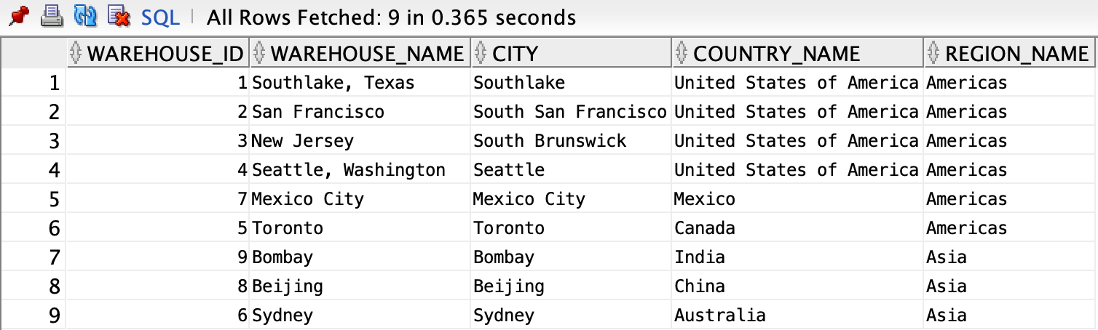

**2.** ¿Cuál es el nombre del producto que tiene más stock en Europa?

SELECT *

FROM

(SELECT

p.product_name,

SUM(i.quantity) as quantity

FROM products p

INNER JOIN inventories i ON i.product_id = p.product_id

INNER JOIN warehouses w ON w.warehouse_id = i.warehouse_id

INNER JOIN locations l ON l.location_id = w.location_id

INNER JOIN countries c ON c.country_id = l.country_id

INNER JOIN regions r ON r.region_id = c.region_id

WHERE r.region_name = 'Europe'

GROUP BY p.product_name

ORDER BY SUM(i.quantity) DESC)

WHERE ROWNUM = 1

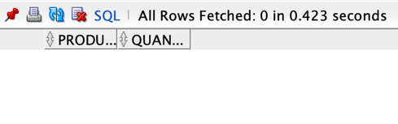

**3.** ¿Cuál es el producto que ha vendido más unidades durante 2016?

SELECT *

FROM

(SELECT p.product_name, SUM(oi.quantity) as sum

FROM orders o

INNER JOIN order_items oi ON oi.order_id = o.order_id

INNER JOIN products p ON p.product_id = oi.product_id

WHERE o.status = 'Shipped'

AND o.order_date BETWEEN '01/01/16' AND '01/01/17'

GROUP BY p.product_name

ORDER BY sum desc)

WHERE ROWNUM = 1

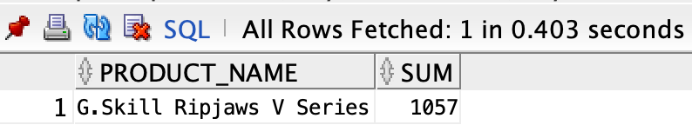

**4.** ¿Cuál es la categoría de productos que ha vendido más unidades durante 2017?

SELECT *

FROM

(SELECT

pc.category_name,

SUM(oi.quantity) as sum

FROM orders o

INNER JOIN order_items oi ON oi.order_id = o.order_id

INNER JOIN products p ON p.product_id = oi.product_id

INNER JOIN product_categories pc ON pc.category_id = p.category_id

WHERE o.status = 'Shipped'

AND o.order_date BETWEEN '01/01/17' AND '01/01/18'

GROUP BY pc.category_name

ORDER BY sum desc)

WHERE ROWNUM = 1

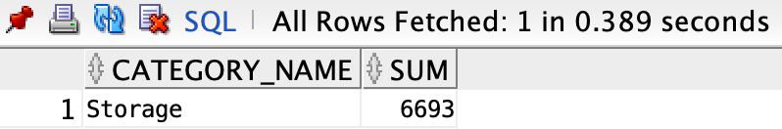

**5.** ¿Cuál es el nombre del cliente cuyo gasto ha sido más alto en 2015?

SELECT *

FROM

(SELECT

cu.name,

SUM(oi.quantity * oi.unit_price) as sum

FROM customers cu

INNER JOIN orders o ON o.customer_id = cu.customer_id

INNER JOIN order_items oi ON oi.order_id = o.order_id

INNER JOIN products p ON p.product_id = oi.product_id

WHERE o.status = 'Shipped'

AND o.order_date BETWEEN '01/01/15' AND '01/01/16'

GROUP BY cu.name

ORDER BY SUM(oi.quantity * oi.unit_price) DESC)

WHERE ROWNUM = 1

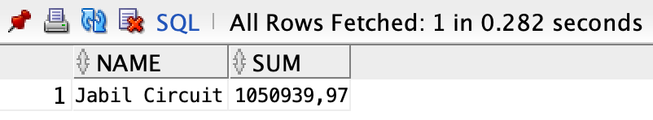

**6.** ¿Cuánto ha facturado la compañía en cada uno de los años de los que tiene datos?

SELECT

SUM(oi.quantity * oi.unit_price) as Facturacion,

EXTRACT(YEAR FROM o.order_date) AS year

FROM customers cu

INNER JOIN orders o ON o.customer_id = cu.customer_id

INNER JOIN order_items oi ON oi.order_id = o.order_id

INNER JOIN products p ON p.product_id = oi.product_id

WHERE o.status = 'Shipped'

GROUP BY EXTRACT(YEAR FROM o.order_date)

ORDER BY EXTRACT(YEAR FROM o.order_date) DESC

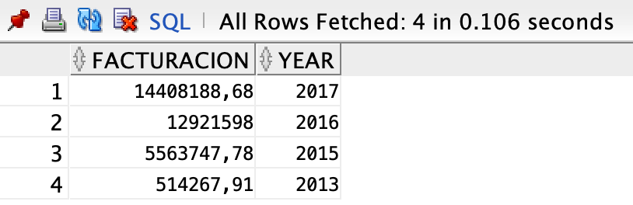

**7.** ¿Cuáles son los nombres de los productos cuyo precio es superior la media?

SELECT

DISTINCT(p.product_name),

p.list_price

FROM products p

WHERE list_price > (SELECT AVG(list_price) FROM products p)

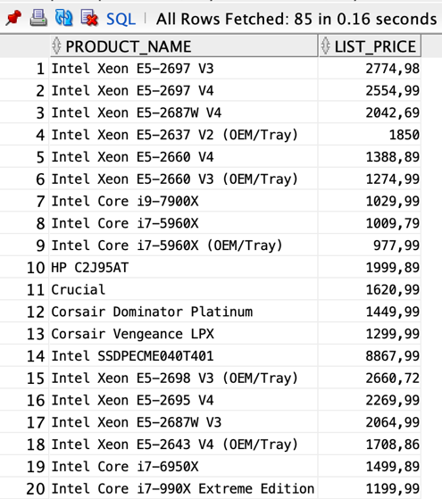

**8.** ¿Cuáles son los empleados (nombre y apellido) que han vendido más de 50K durante 2017?

SELECT

e.first_name ||' '|| e.last_name AS fullname,

SUM(oi.quantity * oi.unit_price) as Facturacion

FROM orders o

INNER JOIN employees e ON e.employee_id = o.salesman_id

INNER JOIN order_items oi ON oi.order_id = o.order_id

WHERE o.order_date BETWEEN '01/01/17' AND '01/01/18'

AND o.status = 'Shipped'

HAVING SUM(oi.quantity * oi.unit_price) > 50000

GROUP BY e.first_name ||' '|| e.last_name

ORDER BY SUM(oi.quantity * oi.unit_price) DESC

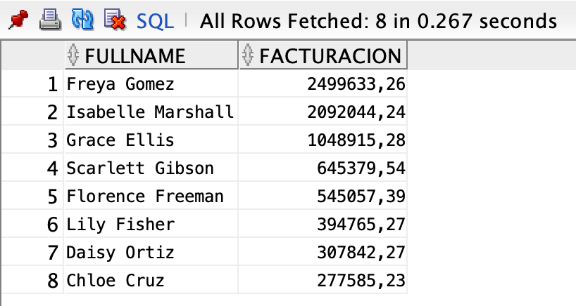

**9.** ¿Cuánto clientes no tienen persona de contacto?

SELECT cu.name, co.first_name ||' '|| co.last_name AS full_name

FROM customers cu

LEFT JOIN contacts co ON co.customer_id = cu.customer_id

WHERE co.first_name ||' '|| co.last_name = '' OR co.first_name ||' '|| co.last_name IS NULL

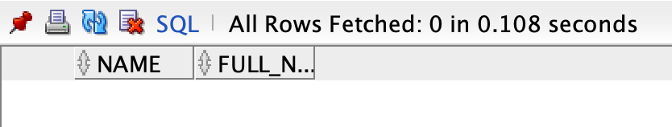

10. ¿Cuál es el Manager (nombre y apellido identificado por el campo manager_id) que menos ha vendido durante 2017?

SELECT *

FROM(

SELECT

m.first_name,

m.last_name,

t.facturacion

FROM employees m

INNER JOIN (

SELECT

e.manager_id,

SUM(oi.quantity * oi.unit_price) as facturacion

FROM employees e

INNER JOIN orders o ON o.salesman_id = e.employee_id

INNER JOIN order_items oi ON oi.order_id = o.order_id

WHERE o.order_date BETWEEN '01/01/2017' AND '01/01/2018'

AND o.status = 'Shipped'

GROUP BY e.manager_id

ORDER BY SUM(oi.quantity * oi.unit_price)) t ON t.manager_id = m.employee_id)

WHERE ROWNUM = 1

