Prepared by | Revision 00 | Date

Project Data
Transformer manufacturer |  | Country of installation
Transformer/project series number |  | Tap changer | --Choose an item--
End user/  Project caption |  | Motor drive for Type CZ tap changer | --Choose an item--

Transformer Data
Transformer application |  | --Select or enter text-- |  | Vector group of Transformer |  | .
Type |  | --Choose an item-- |  | No. of phases |  | --Choose an item--
Frequency |  | --Choose an item-- |  | Induction |  | --Choose an item--
Ambient temp. |  | -25℃~50℃ |  | -45℃~50℃ |  | -60℃~50℃
Height above sea level |  | ≤3000m |  | >3000m
Rated power |  | kVA，Constant |  | kVA，  Decreasing from Position
Regulated voltage |  | kV |  | No. of steps |  | Steps
Regulating range |  | % to % |  | % per steps |  | %
Nominal current |  | A |  | Max current |  | A
Step voltage in the phase |  | V，Constant |  | Max= V to Min= V, Variable
Regulation location
In neutral | In center |  | At line end |  | At line end |  | Special regulation (To be attached）
In center | 1+2 phases |  | At line end |  | In center

Insulation levels/Test voltages
In accordance with technical data | Provided as below | AC 1min.[kV] | LI 1.2/50[kV]
Tap changer to earth
Across fine tap winding[a]
Between adjacent taps[a1]
Between tapped winding of various phases[b]

Type CVT Tap Changer Data
Type | No. of phases | Max. rated through-current | Y/D | Um[kV] | Number of positions
CVT | III |  |  | 12
Designation of operating positions | Max. effect. number of turns at position |  | Mid-position(s) |  | Min. effect. number of turns at position
Contact terminal arrangement | 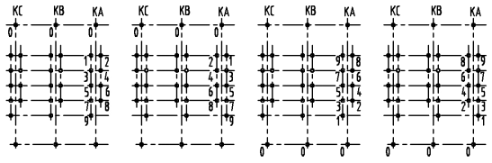  Standard design
AVR  HMJK-10Z controller | HMJK-10Z 220VAC  (Standard design) |  | Other power supply for AVR， V  Parallel control by AVR
Length of cable for HMJK-10Z controller | 30m cable  (Standard offer) |  | With m cable
Color of paint for cabinet | RAL 7032  (Standard design) |  | --Select or enter text--
Language of nameplate | 1st --Choose an item--
 | 2nd --Choose an item--
Language of documentation | 1st --Choose an item-- |  | Quantity 1
 | 2nd --Choose an item-- |  | Quantity
Remarks

Type CZ Tap Changer Data
Number of columns | Type | No. of phases | Max. rated through-current | Um[kV] |  | Number of positions
 | CZ | I
Designation of operating positions |  | Max. effect. number of turns at position |  | Mid-position(s) |  | Min. effect. number of turns at position
Contact terminal arrangement |  | 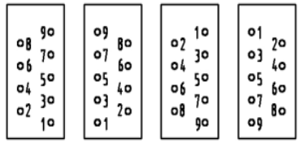  Standard design
Location of Motor drive |  | 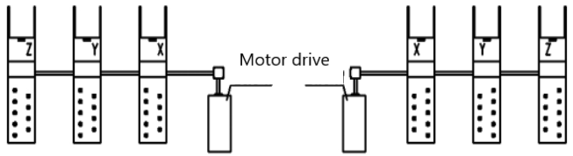
Dimensions |  | 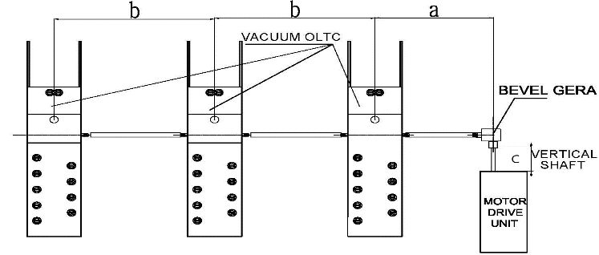 |  |  |  |  | a= mm  b= mm  c= mm  (Standard design for Vertical shaft c= 200mm)
Additional requirement |  | With HM supporting frame  (Standard color RAL 9005, Black) |  |  | Supporting frame with other color  --Select or enter text--
Color of paint for CZ |  | --Select or enter text--
Corrosive class |  | --Select or enter text--
Language of nameplate |  | 1st --Choose an item--
 |  | 2nd --Choose an item--
Language of documentation |  | 1st --Choose an item-- |  | Quantity 1
 |  | 2nd --Choose an item-- |  | Quantity
Remarks

