Prepared by | Revision 00 | Date

Project Data
Transformer manufacturer |  | Country of installation
Transformer/project series number |  | Tap changer | --Choose an item--
End user/  Project caption |  | Motor drive | --Choose an item--

Transformer Data
Transformer application |  | --Select or enter text-- |  | Vector group of transformer |  | .
Type |  | --Choose an item-- |  | No. of phases |  | --Choose an item--
Frequency |  | --Choose an item-- |  | Induction |  | --Choose an item--
Overload |  | IEC 60354 |  | >IEC 60354 .
Ambient temp. |  | -25℃~50℃ |  | -45℃~50℃ |  | -60℃~50℃
Rated power |  | kVA，Constant |  | kVA，  Decreasing from Position
Regulated voltage |  | High Voltage kV, OLTC on kV side |  | No. of steps |  | Steps
Regulating range |  | % to % |  | % per steps |  | %
Nominal current |  | A |  | Max current |  | A
Step voltage in the phase |  | V，Constant |  | Max= V to Min= V, Variable
Regulation location
In neutral | In center |  | At line end |  | At line end |  | Special regulation (To be attached）
In center | 1+2 phases |  | At line end |  | In center

Insulation levels/Test voltages
In accordance with technical data |  | Provided as below | AC 1min.[kV] | LI 1.2/50[kV]
Tap changer to earth
Across fine tap winding[a]
Between adjacent taps[a1]
Between tapped winding of various phases[b]
Across coarse and fine tap winding[c1]
Between coarse winding of various phases[c2]
Across coarse tap winding[d]
Winding arrangement
R1= mm  R2= mm  R3= mm  R4= mm  H1= mm  H2= mm  Cw= pF  Ca= pF  Recovery voltage= kV  Special winding arrangement  (To be attached) | 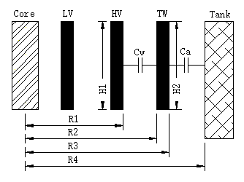
Remarks

Tap Changer Data
Number of columns | Type | No. of phases |  | Max. rated through-current |  | Y/D | Um[kV] |  | Tap selector size |  | Basic connection diagram
Tie-in resistor connection |  | --Choose an item--
Supporting flange for bell-type tank |  | Without |  |  |  | With |  |  |  | Special design
Designation of operating positions |  | Max. effect. number of turns at position |  |  |  | Mid-position(s) |  |  |  | Min. effect. number of turns at position
Type CV/SV/CV2/CM/CM2 Top gear variant of head cover |  | 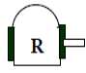 |  |  |  |  |  |  |  | 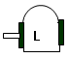
Type CM/CM2  head variant |  | 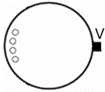 |  |  |  | 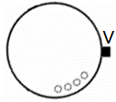 |  |  |  | 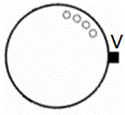
Type CMD/SHZV head variant |  | 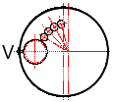  CMD≤600A |  |  |  | 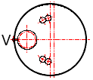  CMD≤600A |  |  |  |   CMD/SHZV>600A
Connection pipe  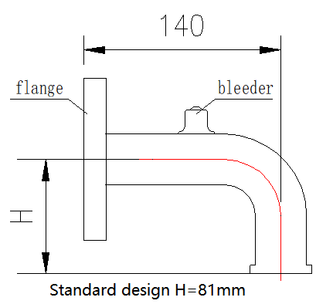  *Standard H=81mm |  | Q | --Choose an item-- |  |  |  |  |  |  | H= mm
 |  | S | --Choose an item-- |  |  |  |  |  |  | H= mm
 |  | R | --Choose an item-- |  |  |  |  |  |  | H= mm
 |  | E2 | --Choose an item-- |  |  |  |  |  |  | H= mm
Protective relay |  | --Choose an item-- |  |  |  |  |  | Other .
Pressure relief valve |  | Without (Standard design) |  |  |  |  |  | With --Select or enter text--
Temperature sensor |  | Without (Standard design) |  |  |  |  |  | With --Choose an item--
Horizontal drive shaft |  | H₁ = mm |  |  | H₂ = mm |  |  | H₃ = mm |  |  | H₄= mm
Vertical drive shaft |  | V₁ = mm |  |  | V₂ = mm |  |  | V₃ = mm |  |  | V₄ = mm
 |  | Standard design
Note：If a drive shaft exceeds 2000mm, an intermediate support box is required. Horizontal drive and vertical drive shaft protective cover are included in the scope of supply. Both drive shafts and protective cover could be cut as required
Sketch of drive shafts enclosed
Color of paint |  | --Select or enter text--
Corrosive class |  | --Select or enter text--
Language of nameplate |  | 1st --Choose an item--
 |  | 2nd --Choose an item--
Language of documentation |  | 1st --Choose an item-- |  |  |  | Quantity 1
 |  | 2nd --Choose an item-- |  |  |  | Quantity
Remarks

