Career Explorations  
Networking And Security   
Programming Lab 1

Your mission, should you choose to accept it, is to figure out a way to pass notes between two people (just like in the pre-lab activity) using the programming language called *Processing*.

We will provide you with some code to get you started and indicate the places where you will need to write your solutions. If something doesn’t look right, please raise your hand and one of us will come around to you.

**Step 1** : **Getting Started**

Download the starter code.  
Follow this link: [TODO Link]. A folder will be downloaded to your Desktop. Right-click on the folder and select “Extract”. You will see a folder entitled Main on your Desktop.

Download *Processing*.   
Follow this link: https://bit.ly/2GwpO4L. Again, a download will start automatically. Once it is downloaded, right click on the file and select “Extract”. This may take a few moments. You will see a folder entitled Processing on your Desktop.

Open Main with *Processing*  
Open *Processing*. You can do this by clicking on the start menu and typing *Processing* in the search bar. When the program opens, select File → Open, then click on “Desktop”. Select the file Main that you created previously, and click Open.   
A second window of Processing will appear. Close the original one. The new Processing window will have tabs called “Main”, “Lab_1”, “Lab_2”, “Lab_3”, etc.

**If you get stuck on any of the above, hit the brakes!   
Please flag an instructor over and we’ll give you a hand.**

**Step 2: Explore the Interface**

To run the starter code, press the Play button in the top left corner of the screen. A window with seven stick figures (labelled 0 through 6) should show up. You can click-and-drag to move people around.

Now, press the Run button on the lower right of the window. Nothing should happen, except that the Run button should turn yellow and say Pause instead. The reason nothing happened is that we didn’t request any activity. Let’s learn how to do that…

*Sending a Letter*.   
To send a letter from Person 4 to Person 1, click once on Person 4 and then once on Person 1. If your program is not paused, you should see a blue envelope move across the screen from Person 4 to Person 1. You can do this between any two Persons who are connected by a yellow line (e.g. Person 5 and Person 0, but not Person 2 and Person 3). Play around with sending messages between connected Persons. What happens when you try and send a letter from Person 5 to Person 3?

You can toggle the Run/Pause button to pause the animations (try hitting the spacebar, the ‘r’ key, or the ‘p’ key). Once you’ve paused the animation, try clicking the Step button (or similarly the ‘s’ or TAB keys).

At some point, send a letter between two people connected by a line (e.g. People 3 and 0) and pause the animation before the letter arrives. Then move your mouse over the letter and notice that the numbers of the sender and the receiver in the black box as **Snd** (for sender) and **Rcv** (for recipient).

If the window freezes, click on the *Processing* window and hit the Play button again.

**Step 3: Respond to a Letter**

Now it’s time to write some code! The people in our current simulation are rather rude, they receive letters but never respond to them... jerks!

You will implement the command itsForMe, which represents the code that should be executed by a Person whenever they receive a letter addressed to them. What do you do when you receive a letter that is addressed to you? You respond to it!

For instance, in the diagram below, Person 1 is about to receive a Letter from Person 4, which is addressed to them (because Rcv = 1). On the next step, when they do receive the letter, they will automatically execute the itsForMe command on the letter. The itsForMe command is basically blank. Technically we *are* doing something: nothing. You will make it do something more meaningful.

But what does it mean to “execute a command on the letter”? Examining the Lab_1 file, we can see where you will define the behavior of the itsForMe command.

void itsForMe(Letter l) {  
// TO DO : fill in code here (Beware! Code after // isn’t run!)   
} // (don’t worry about the void for now)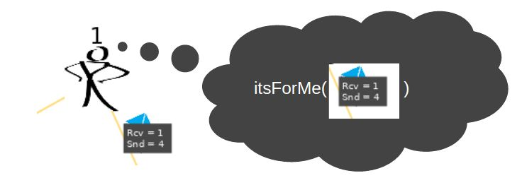

In this context, the Letter l is the letter that the Person needs to respond to. So, in the above example, the Letter l will be the letter in the picture. So what should you do? Send a response back to the Person who wrote the letter to you!

Your solution should send letters back and forth between two line-connected Persons. Here are a handful of commands that might be helpful in crafting your solution.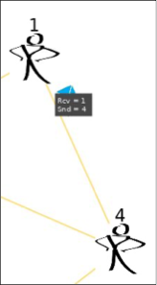

Person getSender (Letter l)  
Gets the sender of the letter l.  
To execute this command, you type getSender(l), which will behave like a function in math, where it has an input and an output. Here, the input is l and the output is the Person who sent l. In the example on the right, getSender(l) is the Person numbered 4.

Person getRecipient (Letter l)  
Gets the recipient of the letter l. For the letter in the figure to the right, it will return 1.

void sendALetterTo (Person p)   
Sends a letter to the person p. For example, in the image on the right, in order to send the letter from Person 4 to Person 1, Person 4 had to execute sendALetterTo(p) where p is the Person numbered 1.

void replyTo (Letter l)  
Using this function will look at the sender of the letter l and send a letter back. In the example on the upper right, if Person 1 executes replyTo(l) where l is the depicted letter, it will send a letter back to Person 4.

**Step 4: Send A Far-away Message**

You may have noticed that if you try to send a message to a person to whom you are not connected by a yellow line, nothing happens. This is because you currently “don’t know” how to get there. We will say that if two Persons are connected by a single yellow line, they are *neighbors*.

Think back to the group activity we just did. How did you pass a note to someone who wasn’t sitting next to you? You probably instructed a person who was sitting next to you to give it to your far-away correspondent.

Conversely, what happened when you received a note that was destined for a person whom you didn’t know how to reach? What about when you did know?

We’ve designed the commands to mirror this way of thinking. There is one command that will be executed when you doKnow where to forward the Letter to, and there is another command that will be executed when you dontKnow whom to give the letter to. We’ve gone ahead and filled in the code for the doKnow command. **You should only fill in the dontKnow** **command for now.**

Depending on your solution, you may see many white letters. This is okay! These letters simply represent the fact that the sender doesn’t know how to get to the recipient and is exploring its neighbors. In fact, if you successfully implement a far-away communication, you should see a checkmark at the recipient Person and may see many sad faces all over the place.

Your ultimate goal is to be able to (after a period of chaotic white-letter exploration) communicate with blue letters, which means learning information about the network. We’ll see how to do this in step 5. This will also fix the sad faces.

You may find the following commands (in addition to the previous ones) helpful in crafting your solution:

void forwardToAll (Letter l)  
Will forward a letter l to every neighbor. In the image to the right, executing this command on Person 5 will send a letter to each of its three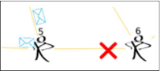 neighbors.

void forwardToAllExcept   
 (Person neighbor, Letter l)   
Will forward a letter l to every neighbor except the neighbor given as input. For example, if this command is called on Person 5 and neighbor is Person 6, then Person 5 will forward to only its other neighbors.

Person getRandomNeighbor()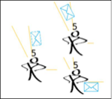  
Will return a random neighbor. On the right we show what happens when Person 5 executes forwardTo(getRandomNeighbor(),l) three different times for some Letter l.

Person getRandomNeighborExcept   
 (Person neighbor)  
Returns a random neighbor except the neighbor given as input.

void forwardTo (Person neighbor, Letter l)  
Accepts a *neighbor* and a letter, and passes along the letter to them. Note that the forwardTo function will preserve the color of letters.

boolean isMyNumber (int number)   
Each person has a number. This commandwill determine if the current person’s number is the input number. If so, it will return true, otherwise it will return false. For example on Person 5, isMyNumber(5) is true while isMyNumber(4) is false .

**Step 5: Learning How to Deliver Letters**

It seems silly to have to explore the network the way that we did in Step 4 every time we want to send a Letter across the room. What if we could use the information that people observe to help us save the effort of sending so many extra letters through the network? In this step, you will implement the command   
discover(Person neighbor, Letter l)   
which is called whenever a Person receives a Letter l from their neighbor .

Let’s think about this in our real-life example. What fact(s) can you learn if Gracie hands you a letter that is from Anshuman and addressed to Eric?

*You know that Gracie can return a letter to Anshuman.  
Maybe not directly, but she can do it.*

In the future, you receive a letter destined for Anshuman. Whom can you give it to?

*To Gracie!*

All you need to do is implement this reasoning in the discover command! You may find the following commands useful in crafting your solution, and you may get inspiration from the code in the doKnow method.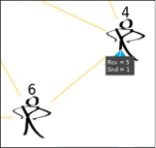

void memorizeHowToGetTo   
 (Person p, Person neighbor)   
Makes you “know” that to send a letter to Person p, you can just give it to neighbor. This is closely related to the rememberHowToGetTo method used in the doKnow command definition.

For example, in the image to the right, Person 4 was given a letter (by Person 6) addressed to Person 1 sent by Person 5. Person 4 can execute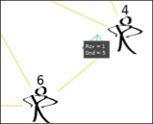  
 memorizeHowToGetTo(p, neighbor),   
where p is Person 5 and neighbor is Person 6. From this point on, Person 4 will hand future Letters that are addressed to Person 5 to Person 6 (as in the below right).

Person rememberHowToGetTo (Person p)   
Returns the neighbor who can deliver letters to Person p. In the figure to the right (described above), If Person 4 executes rememberHowToGetTo (Person p) where p is Person 5, it returns Person 6.

**Extra Credit Task 1: Experiment with different routing strategies**

If your solution to Step 4 was random, try forwarding to all of your neighbors, or only to certain ones. If you forwarded to all of your neighbors, try a random solution! Play around with these different commands and figure out which solution seems the “best”. Call one of us over and explain your reasoning.

**Extra Credit Task 2: Static Routing**

The solution so far is a *dynamic* routing scheme, in that it figures out how to forward letters based on what happens when the program runs. Try and implement a static routing scheme. Here there is no distinction between knowing and not knowing, because you always know where to hand the letter. To do this, you need to write special rules for each person. You will need if-statements and the isMyNumber function to figure out where to forward letters. Please call one of us over and we’d be happy to give you a quick tutorial about if-statements!

*Hint* : Each Person will forward all of the Letters it receives to the same neighbor. For instance, Person 3 may always forward to Person 4.