Author: Eric Thomas

Professor: Mary Walauskis

Course: Software Development II (CEN 4025C)

Date: 4/13/2023

**Source code:** <https://github.com/ericthomas98/Module-13>

Postman screenshots:

**API PUT:**

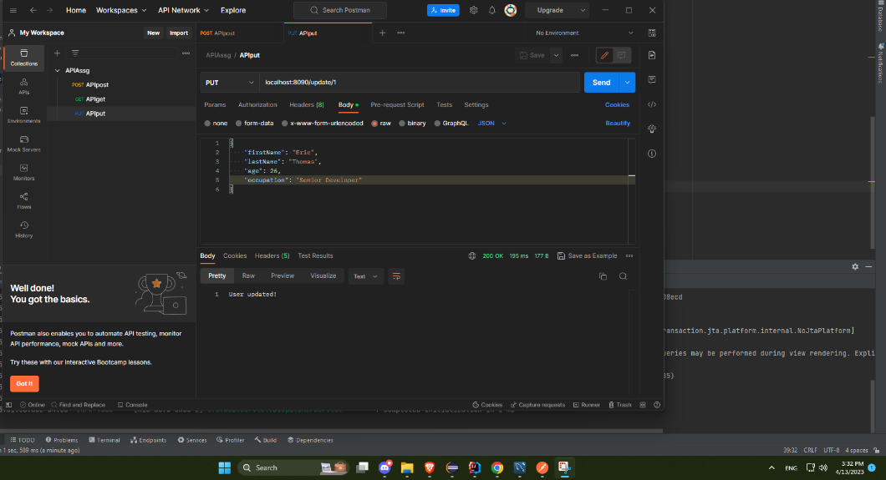

**API POST:**

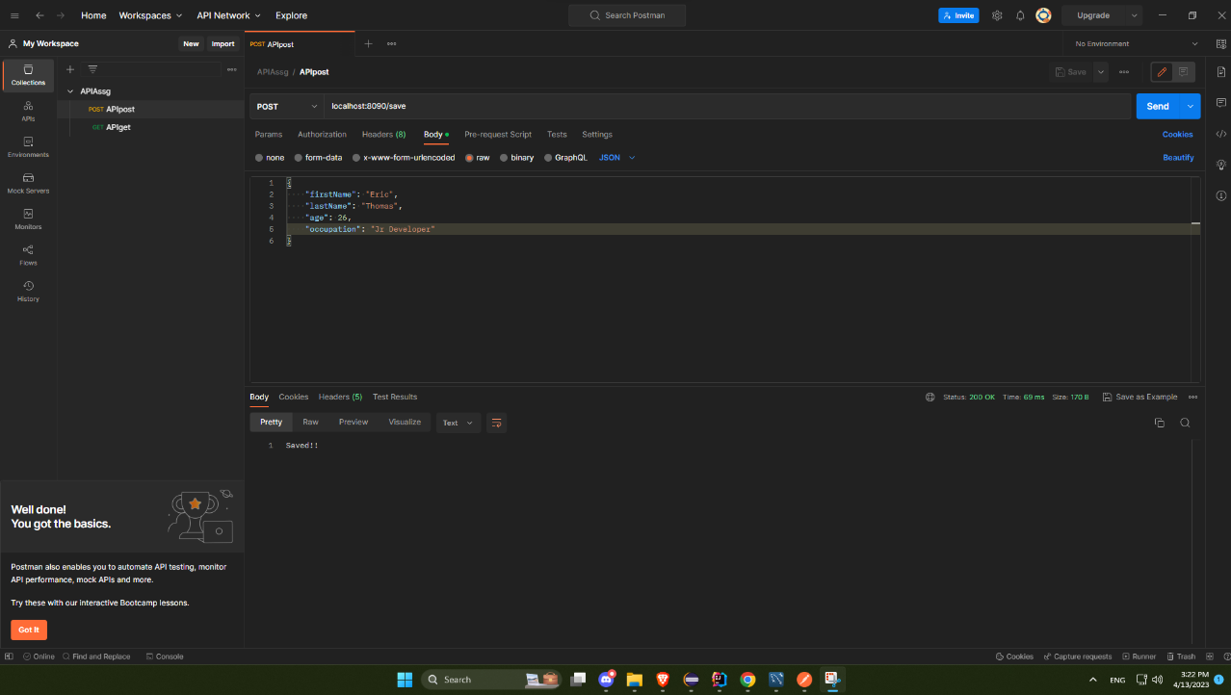

**API UPDATE:**

**API DELETE:**

**DATABASE:**

**DATABASE DELETED:**

