门禁系统，简易版本，没有用到密码，只是识别卡号，根据判断卡号是否正确，来判断开不开门。
实验步骤：
The card's number is :
93D3458C89
set the new card password, and can modify the data of the Sector: 1OK!
Read from the card ,the data is :
841011101033266111000000000
- 先把例程32.RFID 模块实验烧到板子里面。
下面是读到的串口数据：
The card's number is :
93D3458C89
set the new card password, and can modify the data of the Sector: 1OK!
Read from the card ,the data is :
841011101033266111000000000

把 93D3458C89 记下来；后边那它当钥匙。
unsigned char Key_Test[5]={0x93,0xd3,0x45,0x8c,0x89};//钥匙密码（也就是卡号）
只要按顺序修改，里面的值，就OK
例如我有一张卡卡号是：53 ,8 ,3F ,AA ,CE;
及把unsigned char Key_Test[5]={0x93,0xd3,0x45,0x8c,0x89};
改成unsigned char Key_Test[5]={0x53,0x08,0x3F,0xAA,0xCE};
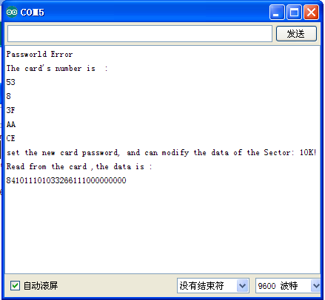
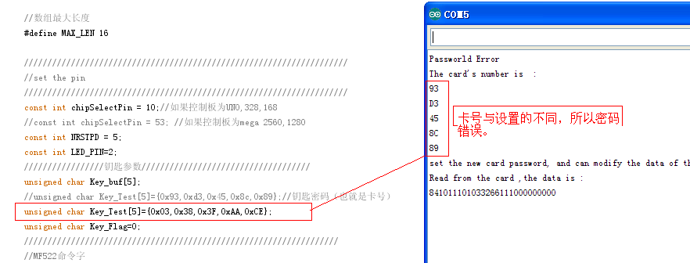

下面是密码正确的情况

