Where Are We?

# Introduction

If you were a PC gamer in the mid-80s, you will remember the grid-based first-person RPGs such as *The Bard's Tale, Wizardry,* and *Might and Magic*. You may have, at some point in recent history, thought about how much fun you had playing *Might and Magic 1*, noticed that it is for sale for nearly-free on GOG.com, and fired it up with nostalgic eyes. If you did, you probably decided against finding a pad of graph paper and pencil and instead found a set of the 55 maps in their 16x16 glory on the internet.

However, for a certain group of gamers, part of the real charm in playing a game of this vintage is not simply knowing what is around every corner. You may remember many an evening spent bashing your poor party's heads against walls to determine whether they were not as solid as they appeared, or making certain that you had actually visited all 256 of the squares in one of the old maps. Perhaps you even enjoyed wondering whether, after each step, you had encountered a spinning tile or teleporter that sent your merry group to an eerily-similar looking hallway twenty paces back. Never mind, nobody liked that last one. But if you can relate to the first few statements, this may be the program for you.

# Quick Start

When you first start "Where Are We?" you will be greeted with the *Setup Wizard*. If you have installed the GOG version of the *Might and Magic six-pack*, you should not have to do anything on the first page other than select which game you would like to play, then click "Next" and select a play style that suits you (you can change this at any time from the *Run setup* wizard), and finally click "Finish". For other games (such as the *Wizardry* and *Bard’s Tale* series), you will need to select the location of your DOSBox shortcuts for playing those games (unless you happen to have used the same paths as the author). If everything is set up correctly, the game you chose will be launched and you will soon see a *Map* displayed in the main window. After creating a party (don't forget to check out the *Character Creation Assistant*) and exiting the inn, your location will be shown by an icon (Icon-YouAreHere.png ). If you chose "Minimal" as your play style, you will only see a few visible squares on the map, with more revealed as your party travels.

As you explore the features of the program (the *Game* menu being likely the most interesting), the windows will all start centered on the main map. Place and size them however suits your display (or select *Auto-arrange windows* for a suggested layout), and when you exit the program they will be saved for the next session (unless part of the window would be off of the screen). The forms that will help you get the most out of the program are: *Party Information*, *Spell Reference*, *Quests*, and *Encounters*. However, there is much more to the program than just those. The rest of this document will describe all of the available features in detail. Enjoy the adventure and pass the program along to any other Might and Magic lovers!

Contents

[Introduction/Quick Start 1](#_Toc501736774)

[The Map 5](#_Toc501736776)

[Editing Modes 7](#_Toc501736777)

[Forms 8](#_Toc501736778)

[Colors 9](#_Toc501736779)

[Search for Note Text 9](#_Toc501736780)

[Map Information 10](#_Toc501736781)

[Note Templates 12](#_Toc501736782)

[Triggers 12](#_Toc501736783)

[Expand Sheet 13](#_Toc501736784)

[Organize Map Sheets 13](#_Toc501736785)

[Map Labels 14](#_Toc501736786)

[Party Information 15](#_Toc501736787)

[Spell Reference 22](#_Toc501736788)

[Monster List 22](#_Toc501736789)

[Game Information 23](#_Toc501736790)

[Item List 23](#_Toc501736791)

[Quests 23](#_Toc501736792)

[Roster Editor 25](#_Toc501736793)

[Shop Inventories 26](#_Toc501736794)

[Quick Reference 26](#_Toc501736795)

[Encounters 27](#_Toc501736796)

[Character Creation Assistant 28](#_Toc501736797)

[Training Assistant 30](#_Toc501736798)

[Edit Cartography Data 31](#_Toc501736799)

[Bag of Holding 31](#_Toc501736800)

[Scripts 32](#_Toc501736801)

[Setup Wizard 35](#_Toc501736802)

[Menu Items 35](#_Toc501736803)

[File 36](#_Toc501736804)

[Edit 36](#_Toc501736805)

[View 37](#_Toc501736806)

[Window 38](#_Toc501736807)

[Mode 38](#_Toc501736808)

[Sheet 38](#_Toc501736809)

[Maps 39](#_Toc501736810)

[Game 39](#_Toc501736811)

[Help 40](#_Toc501736812)

[Main Map Context Menu 40](#_Toc501736813)

[Options 42](#_Toc501736814)

[Maps 42](#_Toc501736815)

[Misc 45](#_Toc501736816)

[Keyboard 47](#_Toc501736817)

[Mouse 48](#_Toc501736818)

[Play 49](#_Toc501736819)

[Windows 52](#_Toc501736820)

[Spells 53](#_Toc501736821)

[Encounter 54](#_Toc501736822)

[Quests 56](#_Toc501736823)

[DOSBox 56](#_Toc501736824)

[Import /Export/Reset all settings 58](#_Toc501736825)

[Command-Line Options 58](#_Toc501736826)

[Keyboard Shortcuts 58](#_Toc501736827)

[Notifications 59](#_Toc501736828)

[Actions 59](#_Toc501736829)

[Appendices 62](#_Toc501736830)

[Editing Bytes 62](#_Toc501736831)

[Requirements 62](#_Toc501736832)

[Internal Settings 63](#_Toc501736833)

[Building the Project 63](#_Toc501736834)

[Map Icon Index 64](#_Toc501736835)

[Surface Maps 64](#_Toc501736836)

# The Map

At its core, "Where Are We?" is both an automapping retrofit for games that never had one (*Might and Magic 1,* the *Wizardry* series, and the first two *Bard’s Tale* games), and a general "virtual graph paper" that can be used for many mapping tasks. These are the main elements:

|  |  |  |
| --- | --- | --- |
| Block Color  Line Color  Icon  Label  Note  Unicode  Note Color  Note Symbol  Party  Cursor | The "Where Are We?" main interface | Mode  Map Title  Explored Area  Unexplored Area  You Are Here  Map Icons (exit)  Map Icons (stairs)  Note Text |

Complete descriptions of the elements are as follows:

### BlockStyle.pngBlock Color

This is used in the *Block*, *Hybrid*, and *Fill* modes to set the color and pattern for map squares. Right-click and drag to select from a set of 20 *Block Styles*, or left-click to select any color and pattern.

### LineStyle.pngLine Color

This is used in the *Line*, *Hybrid*, and *Fill* modes to set the color, thickness, and dash style for the lines on the edges of map squares. Right-click and drag to select from a set of 20 *Line Styles*, or left-click to select any color, thickness, and style.

### Icon

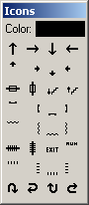Selecting an icon from this dropdown will allow placement of that icon on any square of the map. By default the mouse wheel will rotate the currently selected icon, and shift+wheel will cycle through the available icons. Select the Color section of the icon dropdown to change the color of the current icon.

### Label

Labels are bits of text that serve to identify an area of the map that should be quickly locatable. On the included game maps the Inn, Store, Temple, and a few other common town services are labeled by default. Additional labels may be added by right-clicking on the map and selecting *Add* *Label* from the menu. *Notes* mode is useful for detailed label editing and positioning.

### Note

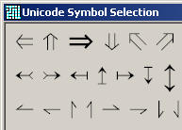Notes are one or two letters or symbols placed in a map square that indicate that more detailed information is available about this location. Moving the mouse over the Note, or moving the party into the square with the note, will show the full text in the Note Text area. If the *Note Symbol* is a single period (.), then it will not be displayed on the map at all. This is useful if you want to have a note in a location that is being represented by an icon (for example, a "stairs down" icon does not also need a note symbol, but you may want a note describing the map to which the stairs lead).

### Unicode

(not shown in *Play Mode*) Click this button to bring up a dialog of common Unicode symbols that are useful for map notes. Click the desired symbol to use it as the current note symbol.

### NoteColor.pngNote Color

(not shown in *Play Mode*) This sets the color for the current note symbol. Right-click and drag to select from one of 20 *Note Colors*, or left-click to select any color.

### Note Symbol

(not shown in *Play Mode*) Click here to change the symbols that are displayed on the map for this note.

### Party / Cursor

These show the current coordinates of the party/mouse cursor, as they are used by the in-game system. This may not be the same as the raw coordinates of the map square (see *Coordinate System*), which have the origin (0,0) as the upper-left corner of the map.

### ModeMenu.pngMode

This allows you to change the editing mode. For a detailed description of each mode see *Editing Modes*.

### Map Title

This is the title of the map as shown on the *Maps* menu and on the *Organize Map Sheets* form. Changes to the title will be reflected immediately.

### Explored / Seen / Unexplored Areas

"Where Are We?" keeps track of which squares the party has visited and saves those with the map. If the options are set so as to hide unvisited squares, they will be obscured and any icons, notes, or labels anchored to this square will not be shown. This obscuration is not shown when in *Edit* or *Fill* mode, or when the map has "Legend" as the title. Also, if *Use in-game cartography data if available* is checked, the game's internal tracking of visited squares will overwrite that kept information. When not using the in‑game cartography, speeding through the maps (e.g. holding down the movement key) may leave occasional squares shown as unvisited if the location polling does not catch them (see also *Reveal partial information for seen squares*).

### You Are Here

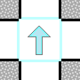This icon indicates the party's current location and facing. It will only be visible if the map shown is the map the party is actually using in-game (see *Automatically switch map sheets*).

### Map Icons

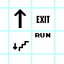A map square may contain any number of icons in various orientations. These icons have different meanings in different games (see *Map Icon Index*)

### Note Text

This is the full text of the note as represented by the symbol on a map square. Typically it shows the text that is displayed to the player when entering this square, as well as an explanation of the effects of various in-game choices made in this location.

# Editing Modes

### Play

Play Mode is designed to be used when actually playing one of the games, as opposed to creating and editing maps. It removes most of the editing options from the main map context menu, prevents the drawing of blocks and lines, and replaces the editing of notes with a view-only option.

### iconCursorHybridDouble.icoBlock

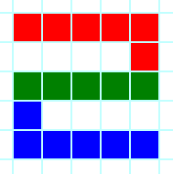Block Mode uses the currently-selected *Block Color* to fill map squares while dragging with the mouse on the main map. If Shift is held before clicking, only a straight line of blocks will be drawn. Drawing blocks is a toggle operation; if the block under the cursor is already filled with any color, blocks will be erased instead of drawn. If *Hide unvisited squares* is enabled, unvisited squares will not be altered.

### iconCursorHybridDouble.icoLine

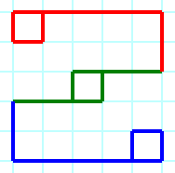Line Mode uses the currently-selected *Line Color* to draw or, if Control is held down, erase lines on the edges of the map squares. Internally, a map square may have a line on each edge, which means that the adjacent map square may or may not have a line on the opposing edge (which may be of a different color or style). However, lines drawn using this mode will always place or remove the same type of lines on the edges of both squares (with the exception of edge squares, which have no opposite square but are displayed as if they did). If *Hide unvisited squares* is enabled, unvisited squares will not be altered.

### iconCursorHybridDouble.icoHybrid

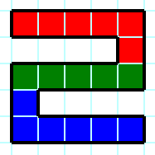Hybrid Mode operates mechanically in the same manner as *Block*, but in addition to drawing or erasing blocks, it places lines around the outer edge of contiguous map squares that have a block color. It does not distinguish between different colors, however; see the *Fill* for a way to surround blocks of a particular color. If *Hide unvisited squares* is enabled, unvisited squares will not be altered.

### iconCursorNoteDouble.icoNotes

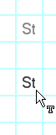Notes Mode is designed for creating or editing several individual notes or labels quickly. Clicking on a square will create or edit the note for that square without needing to select *Edit/View Note* from the context menu. A second click on a square that is already being edited will switch the focus from the note text to the symbol or back. Notes can be moved from square to square by simply dragging them around (hold Control to copy the note instead of moving it). A note may be deleted by dragging it off of the map. Holding Shift will constrain the movement to only horizontal or vertical directions.

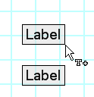Double-clicking on a label while in Notes Mode will open the *Map Labels* form. With this form open, labels may be dragged around and copied in the same manner as notes (with the form closed, the notes underneath the labels will be manipulated instead). Be aware that dragging a label off of the map does not actually delete the label, as negative positions are valid for their locations.

### Keyboard

iconCursorHybridDouble.ico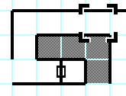Keyboard Mode is designed for the true graph-paper aficionados, and is intended to be used with the *Keyboard Hook* and keyboard shortcuts in order to move a cursor around the map and draw lines and squares while the game window is in focus. In this way you can start with a blank map and, for example, take an in-game step forward, move the cursor one square, and draw lines to represent the in-game walls for that area, all without leaving the game (note that you will need to choose *Shortcuts* that do not interfere with the game for best results). If the focus is on the map window, pressing "Enter" will edit the note under the cursor. Note that the cursor is separate for each *Map Sheet*.

### Fill

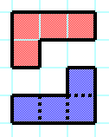Fill Mode will fill an area of contiguous map squares of the exact same color and pattern with the currently selected *Block Color*. Solid lines will stop the fill but dotted and dashed lines will not. If Control is held down, this mode will surround the fill area with the currently selected *Line Color* instead, which is similar to what *Hybrid Mode* creates but distinguishes between color/pattern differences. Note that selecting this mode will temporarily disable the *Hide unvisited squares* option.

### Edit

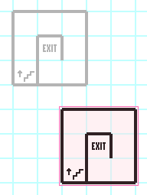Edit Mode allows the selection of a rectangular collection of squares that can then have various actions performed on them (see the *Edit* menu for details). Once an area is selected, the squares can be moved (or copied if Control is held down) by dragging the selection rectangle elsewhere. If Shift is held, the operation will be constrained to vertical or horizontal movement only. What types of data are affected can be chosen via *Edit mode affects*. Note that moving or copying a selection will merge the source data with the destination area, so depending on your intentions you may wish to delete the target squares first. Note that selecting this mode will temporarily disable the *Hide unvisited squares* option, and that unlike other modes, selecting Edit Mode again while already in it will switch back to the previous mode.

When a rectangle is selected, a “Select” label will be shown in the panel below the map giving the coordinates of the upper-left corner of the selected area, with the width and height in parentheses. For example, “Select: 3,2 (4,5)” indicates a 4 block wide by 5 block high rectangle located at x=3, y=2. These coordinates are relative to the grid (so 0,0 is always the upper left corner), whereas the “Party” and “Cursor” coordinates are modified by the *Coordinate System* currently used by the *Map Book*.

# Forms

The following is a list of the main "Where Are We?" program windows, the majority of which are accessed directly from the main menus.

## Colors

The colors form is used to set the quick-select colors and patterns used on the main form. These styles are saved independently of the map in the application's config file.

### LabelCopy.pngLabelCopy.pngBlocks

Blocks are composed of a color and a hatch style. Click on one of the colored blocks to set the quick style for that *Block* index.

### LabelCopy.pngLines

Lines are composed of a color, style, and width. Click on the colored box or use the controls to set the quick style for that *Line* index.

### LabelCopy.pngNotes

Notes have only a single color component. Click on one of the colored blocks to set the quick entry for that *Note* index.

### UI Elements

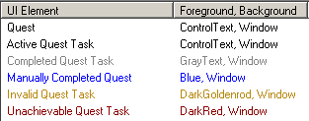The colors of a few of the text-based items in the UI may be configured from the “UI Elements” tab. Currently the majority of these items are on the *Quests* form, though more items will likely be added in future releases.

## Search for Note Text

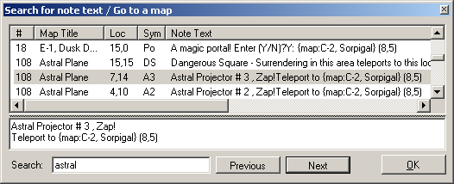This form allows you to find a note and its associated map by entering a search string. F3 and Shift+F3 will search for the next and previous match, respectively. Notes may be edited directly on this form, if desired. The context menu for the list of notes may be used to do the following actions:

### Go to this map

Switches the map to the one containing the selected note. If in *Keyboard Mode*, the cursor will be set to the exact location of the note.

### Set Lloyd's Beacon here

If *Cheating* is enabled, this menu item will set the target of the Lloyd's Beacon spell for the first character able to cast it. Note that in *Might and Magic 2*, there is only one Beacon for the entire party, regardless of how many individual Sorcerers or Archers you have.

### Refresh

The search window uses a cached copy of the notes that is made when it is opened. Selecting Refresh will reload the list of notes to include any updates that were made while the search window was open.

### Copy entire note / Copy location

Copies the selected note (or only the title and coordinates) to the clipboard in tab-delimited format.

### Copy all matching locations

This command will copy to the clipboard the map title, coordinates, and note text for all of the notes that match the string entered in the search field.

### Hide notes from unvisited squares

By default, the list will not show any notes from squares that are not marked as visited. This option will toggle that setting and allow you to see all of the notes in the entire map book.

## 

## Map Information

This form contains settings that pertain to the map book as a whole or to the currently visible sheet.

### Map Book

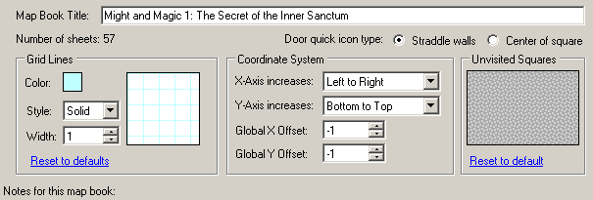The map book is a collection of one or more individual sheets. These settings apply to all of those sheets. The title is shown in the caption of the main program window.

##### Door quick icon type

For the keyboard shortcut "*Cycle through the door icons,*” this setting selects which type of door icon to use. Typically a game will employ either one or the other (for example, *Might and Magic 1* exclusively uses doors on a wall between squares, while *Dungeon Master*'s doors take up entire squares). This setting is only for convenience in editing; either or both types may be used in any map book.

##### Grid Lines

Here the color, style, and width of the grid lines that appear when no other line has been drawn can be changed. Be aware that the color and styles here are saved explicitly, so copying a selection (in *Edit*) from one map book and then pasting it into another map book that has different settings for the grid lines will copy the original grid line colors as well.

##### Coordinate System

Often the in-game system for representing a location will not coincide with the one used by "Where Are We?," and this setting allows for compensation of that difference. For example, *Might and Magic 1* uses the lower-left corner as the origin (0,0) for its map squares, but the grid used by the default map book has the origin at the upper-left corner. In addition, the default map book provided for *Might and Magic 1* has a one-square border around the entire map (mainly for informational purposes on the edges of the surface maps). This means that in order for the in-game location to be given correctly, the Y-Axis must be changed to increase from "Bottom to Top" and in addition the X and Y offsets must each be set to -1 (so that an on-grid X value of 1 translates to an in-game value of 0). If the coordinate system is set improperly, several functions (such as *Teleport to here*) will set the in-game value incorrectly.

##### Unvisited Squares

For a map sheet that is not using a custom image, this pattern will be used to obscure unvisited squares. Click on the pattern to change the hatch style, foreground, and background as desired (the opacity of this pattern is set in the *Miscellaneous Options*).

##### Notes for this map book

Here any notes that are to be saved with the map book may be entered. These notes are not used by the program and are only for the user's reference.

### Map Sheet

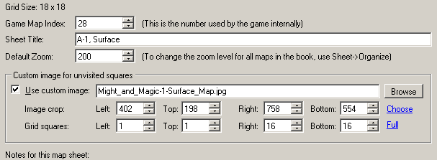Map sheets are individual two-dimensional grids of squares, each of which has a block style, four line styles, and a visited flag. Each square may also have a single note and any number of icons associated with it. The title (which appears on the *Maps* menu) and settings on this page of the Map Information form apply only to the specific sheet in the map book.

##### Game Map Index

Games generally use a single number to refer to a map, and that number should be entered here. If it is not correct, the *Automatically switch map sheets* function will not behave properly, as this is the value that is compared with the information read from the game's memory.

##### Default Zoom

This is the zoom level that will be used when this map is first displayed to the user. 100% zoom is a 16x16 pixel square, 200% is a 32x32 square, and so on. Any percentage may be used here, but the map icons are crafted to be the best looking at the exact 100%, 150%, 200%, and 300% levels. Also, once the map is displayed, the user may change the zoom level to whatever is convenient at the moment, and it will stay that way until the map book is reloaded. The default zoom level for all map sheets in the book may be changed at once using the *Organize Map Sheets* feature.

Custom image for unvisited squares

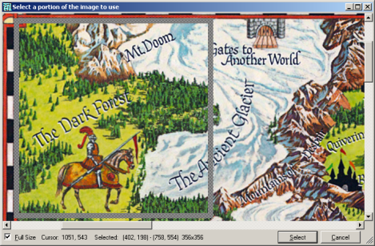Here an image, or part of an image, may be specified to be used instead of the general pattern for unvisited squares. In order to use an image in this way, browse to the file (for example, a hand-drawn map of the area) and select "Choose" to open the selection dialog. Draw a rectangle to select the cropped area of the image to use as the custom overlay, or hold Control to move an existing selection rectangle (hold Shift to move only in a horizontal or vertical line).

If you check the "Full Size" box, the image will be shown without any scaling for pixel-precision when selecting an area (use the scroll bars or drag with the right mouse button to move the view area). You may also use the keyboard to fine-tune your selection:

Arrow Keys Move the selection area one pixel

Control+Arrows Shrink the selection area by one pixel

Shift+Arrows Expand the selection area by one pixel

Control+Shift+Arrows Move the selection area by its width or height in pixels\*

\* Allows you to move the selection rapidly to another area of the same size horizontally or vertically.

To copy and paste values between map pages, right-click on the "Image crop" label for a context menu.

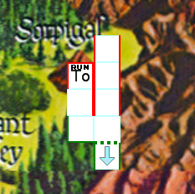The Grid Squares specify the (inclusive) rectangle over which the custom bitmap will be shown. Squares that fall outside of these limits will use the normal unvisited square pattern instead. For example, to specify that the image should be used for the 16x16 square in the center of an 18x18 grid, use left/top values of 1 and right/bottom values of 16. For more precise positioning of the image relative to map landmarks, see the *Move background image crop area* keyboard shortcut.

Notes for this map sheet: Here any notes that are to be saved with the map sheet may be entered. These notes are not used by the program and are only for the user's reference.

##### Map Sections

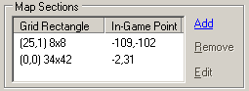 A map section is a collection of squares on the map grid whose in-game coordinates do not correspond with their neighboring squares. For example, in *Wizardry 5*, the first maze level includes an 8x8 section of the map with coordinates that (according to the *Dumapic* location spell) range from (-109,-102) to (-102,-109). This makes the virtual map of the level seem extremely large compared to the 32x32 grid that contains actual map information (other locations are “solid rock” that kill the party if they are there, making travel to the sectioned-off areas difficult if not impossible via teleportation spells. This section editor saves the information for these type of areas so that they can be shown as a single map in a condensed fashion while still indicating the proper coordinates for the “Party” and “Cursor” labels.

## Note Templates

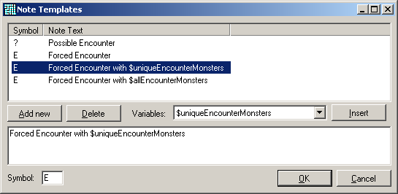Note templates are used via the *Add Note* context menu of the main map, and you may add new ones on this form. Variables (available via the dropdown) will be replaced with the in-game information when the note is added to the map sheet. Currently there are only two variables, namely $uniqueEncounterMonsters (replaced with a list of the monster types in the current combat) and $allEncounterMonsters (similar but also includes a count of each monster), which are useful to add a note telling the user which monsters will be found in this location by actually retrieving that information from the game instead of typing it in manually. Note templates are saved in the application config file, not the map file.

## Triggers

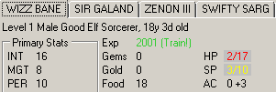If you would like a visual indicator of a problem with your party before disaster strikes, the Triggers feature will be of interest to you. From the main dialog, you may add, edit, and remove triggers, as well as enabling or disabling a specific triggers without deleting it. Triggers are checked whenever the *Party Information* or *Quick Reference* forms are updated (see *Party info polling rate*) and the appropriate items will be highlighted in the manner specified by the trigger if necessary.

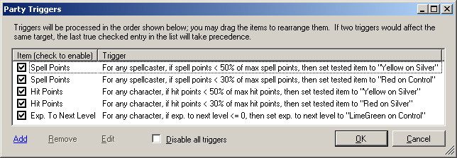If you right-click on a trigger in this list, in addition to the add, remove, and edit functions provided on the dialog, you may duplicate an existing trigger or add one of the pre-made examples. Example triggers may be more convenient to modify slightly rather than making a new one from scratch.

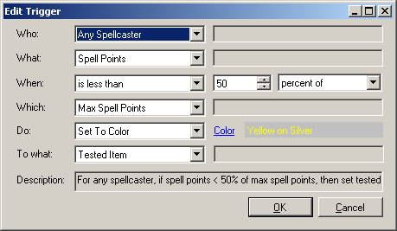Several aspects of a trigger may be customized to suit your needs. Hopefully the options are self-explanatory; the only special item is the “Tested Item” selection under “To what,” which means to apply the “Do” action to the label representing the value that was checked. For example, if “What” is “Spell Points,” then setting “To what” to “Tested Item” will change the color (or italicize, etc.) of the actual “Spell Points” label on the *Party Information* form. This is probably the “To what” selection of the most benefit most of the time, though there are other useful settings (for example, you could set a character’s “Name” to red if the Hit Points are low, instead of modifying the hit points label itself).

Some of the items are index-based (namely “Primary Stat Index” and “Resistance Index”); this simply means that the number provided (e.g. “0”) will be used instead of the name (e.g. “Might”). This may be of use when creating triggers that are useful for multiple games, as there is always a “Stat #0” but the “Might” stat may more appropriately be called “Strength” or similar in a different game.

Some items do not exist in some games, and others don’t make sense with the triggers as currently implemented. For example, in the *Wizardry* series, a spellcaster has a number of spell points per spell level, which is not directly targetable with the generic “Spell Points” option in the triggers, so it will not have any effect in those games.

## Expand Sheet

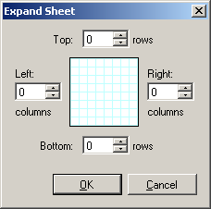If you have ever run across the edge of a piece of graph paper while exploring a dungeon that you thought was 16x16 but was really 16x32, you will appreciate this feature. It allows you to add new blank columns and/or rows of squares to the map sheet (though if you simply need to move the existing map into an unused area, *Edit Mode* may be easier). You may also expand a sheet by right-clicking outside the map area and selecting "Add Column" or "Add Row" as appropriate.

## Organize Map Sheets

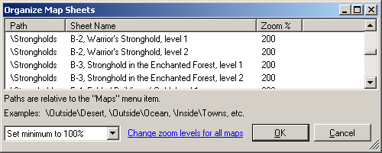This form allows you to specify the hierarchy of items under the *Maps* menu and change the *Default Zoom* level for the map sheets. To place a group of map sheets under the same parent menu item (for example, "Towns"), select all of the desired sheets, right-click and select "Edit Path" from the context menu, change the path to "\Towns" and click OK.

Choose "Change zoom levels for selected maps" to set all of the default zoom levels for the selected items either to a specific level or to a minimum level. Choosing a minimum level will adjust the lowest zoom level of those maps to be exactly the specified value, and the other levels to be relative to those (for example, if you have selected maps with zoom levels of 100, 200, and 300 and set the minimum for those three to 50, they will be set to 50, 100, and 150). Changing the minimum level may be useful if you have a particularly low- or high- resolution display and want the all of your maps either larger or smaller than the built-in defaults (don't forget to *Save* your map book after doing so).

The position of the maps on the menu may be adjusted by dragging the items around to the desired locations (dragging multiple items simultaneously is permitted). To display a map on the main window, right-click on it and select "Go to this map." Click on the column headers to sort the menu by either path or name. Sorting first by Sheet Name and then by Path will likely produce the most intuitive results on the *Maps* menu, although you may wish to fine-tune the positions afterward (for example, you may want towns shown in the order they appear on a Town Portal selection list rather than alphabetically).

## Map Labels

*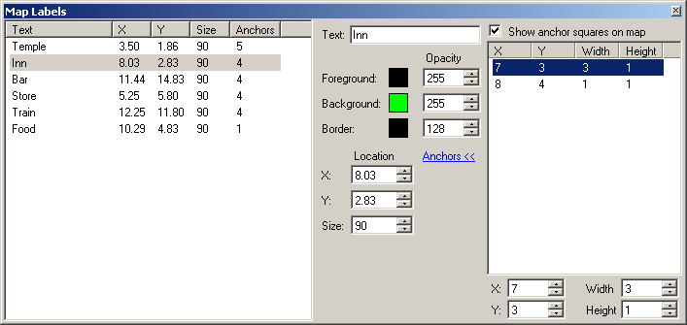Labels* are short strings of text that can be placed on a map sheet at arbitrary coordinates rather than being inside a map square like a *Note* is. This form allows fine control over the appearance, size, and location of these notes, although *Notes Mode* is also useful for dragging the labels around the map with the mouse. You may change the text, colors, opacity levels, size, location, or anchor point of any number of labels at once by selecting them in the list and changing the values in the control box to the right. An opacity level of 128 is 50% transparent, 255 is opaque. Size is given as a percentage of the size at which *Notes* are drawn on the map.

The anchor points are used to determine whether to show or hide the label. If all of the anchor points are unvisited, the label will not be shown, regardless of the squares the label actually covers. The anchor points are also used to determine whether to move/copy the label during *Edit* operations. A set of anchor points is defined by a set of rectangles, which may be edited by clicking on the "Anchors" link and changing the numbers at the bottom as desired. If you check "Show anchor squares on the map," you will see a darkened area corresponding to those rectangles (while the window is active).

The following operations are available via the context menu of the label list:

Undo Reverts the last set of changes made using the controls on the right panel

Add new label Creates a label and places it at position (0,0) or nearby if another exists there

Duplicate Creates a copy of each selected label in the list

Copy to clipboard Places the selected labels in the clipboard for pasting into the main map window

Delete Removes the selected labels entirely

Labels are stored by location and not intended to be on top of each other, so if an operation causes one or more labels to have the exact same coordinates as any existing labels, they will be offset by a small amount and a warning will appear to that effect. You may move multiple labels around with precision by holding Control and using the arrow keys to move the selected labels in the desired direction a single pixel at a time or, if holding Shift as well, by the size of single map squares.

## LabelCopy.pngParty Information

Along with the main map window, this form is one of the main areas of information displayed during gameplay. Note that not all elements are used (or shown) for all games. Values for some attributes are shown as "Base+Bonus" or occasionally "Base+Bonus+Equipment" instead of just the total, in order to distinguish between base statistics, temporary bonuses through spells and environmental effects, and bonuses due to equipment being used by the character.

Hovering the mouse over a value will show any additional information available for it (for example, a list of armor and their bonuses to AC, or the formula by which maximum hit points are calculated). The window caption will show the in-game date and time (if the game has it) and a note as to whether cheats are enabled. Click on the tabs to switch between characters or use the 1-8 keys on the keyboard. If *Automatically switch characters* is checked, the selected character will automatically change to the in-game active character if the game window is in the foreground.

If *Cheating* is enabled, almost all of the values on the form may be edited by right-clicking on the value and selecting one of the menu options (all of which are context-sensitive — the minimum and maximum are different for different values and the omnipresent "edit" option can bring up any of a number of dialogs peculiar to that piece of information).

### Basic Information

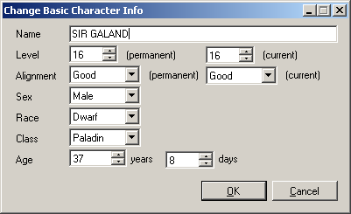Shows the character name, level, alignment, sex, race, class, and age. If *Cheating* is enabled, a special option is available on the context menu for this element entitled "Create Supercharacter." This will set all the character's statistics to their maximums (within reason), and give them a backpack filled with some of the best items in the game (tuned to that character's class and alignment, if applicable). The player should still equip the items via the in-game interface. Note that in *Might and Magic 2*, this will set the character's secondary skills to Mountaineer and Pathfinder (which may not be what you want for all characters in the party), and that changing a character's class to a caster class does not necessarily give the character access to spellcasting by itself (see *Spells*, *Spell Level*).

### Primary Stats

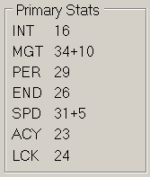The primary statistics for all *Might and Magic* games are Might, Intellect, Personality, Endurance, Speed, Accuracy, and Luck (though *Might and Magic 1* displays Intellect first). Hovering over any of the stats will reveal information, if any, regarding to what extent a secondary attribute is affected by the value (for example, how much of a bonus to melee combat your Might is providing, or the bonus to Armor Class that your Speed gives you). Stats are shown in Base+Bonus+Equipment format.

### Experience

All of the *Might and Magic* games have a numeric measurement of experience points, and this is shown here along with the amount required for the next level. If the character is eligible for training to the next level, "Train!" will be shown instead (or "Train 2," etc. if the character has sufficient experience to gain multiple levels in one training session). If *Cheating* is enabled, this context menu also contains the "Next Level" option, which adds the exact amount of experience required for the next character level.

### Gems/Gold/Food

These values are displayed here for the games that keep track of them separately for each character (i.e. *Might and Magic 1* and *2*). Other games store these values on a per-game basis and are viewable in the *Game Information* form.

### Spells

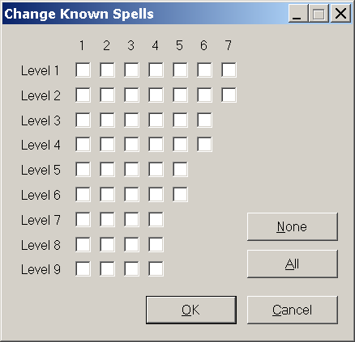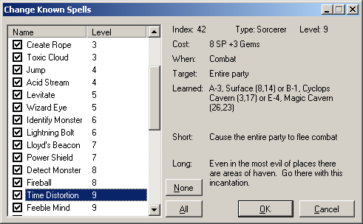Games in which spells are learned independently of your character's basic level show the number of spells known vs. the number of possible learnable spells for this character class. When *Cheating* is enabled, editing this value brings up a dialog in which the spells may be independently selected as learned or unlearned. For *Might and Magic 2* in particular, a checkbox grid similar to the in-game list of known spells allows editing in that way (hover over a checkbox to see what the name of that spell is), but for other games a standard list view is presented. Detailed information about each spell is also provided, which is the same as that available via the *Spell Reference* form.

### Thievery

If *Cheating* is enabled, thievery is editable only in games that have a stored value for the attribute (i.e. *Might and Magic 1* and *2*). In other games, this value is calculated solely based on factors such as the character level, class and race. Hovering over this value will reveal the formula used in those games.

### Melee/Ranged

The value shown here uses the format (Number of attacks) x (damage per attack) + (bonus damage per attack). Hovering over the value will show you which weapon is being used in the calculation. Damage per attack is shown using the (number of dice) d (faces per die) system (e.g. 4d6 for four six-sided dice).

### Ready

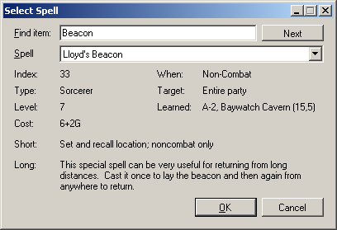This is the spell that will be selected by default when you choose the "Cast" command for this character. If you use *Cheating* to modify this value, be aware that *Might and Magic 3* allows any character to have any spell from any discipline set as the ready spell, while *Might and Magic 4/5* stores the spell in such a way that only the spells from the book for your class is valid. If not in cheating mode, only spells that the character knows will be selectable from the list. For an easy way to set the ready spell for multiple characters at once, see *Spell Hotkeys*.

### Main/Castle

These items, present for *Might and Magic 1* only, give you a brief description of your current progress in the main quest and in your current quest for one of the Lords of VARN. The values are not directly editable, but the bits for these quests may be set or reset on the *Quests* form.

### AC

The character's Armor Class is shown in Base+Bonus format, where Base is the sum of the armor class of all equipped items and the character's Speed modifier, and Bonus is any temporary boost from a spell such as "Bless" or a fountain's effects. Hover over the value to see a breakdown of how Base is calculated; the Bonus value is usually shown in the *Game Information* form (though once set by an effect, the game retains no memory of whether it was a spell, fountain, or other artifact).

### HP/SP

The current and maximum (and temporary maximum, if it differs) hit points for the character are shown here. If *Cheating* is enabled, these three values may be set independently of each other in *Might and Magic 1* and *2*, but as the maximum HP is calculated via an internal formula in *Might and Magic 3-5* only the current HP may be modified in this way (hover over the value to reveal the formula). Spell Points behave similarly to HP, but as there is no "Temporary Maximum" value in any of the supported games, only two values are editable.

### S. Lev

The Spell Level is only used in *Might and Magic 1* and *2*. If *Cheating* is used to modify a character's class from a non-caster to a caster, you will need to change this value as well if you want to cast any spells.

### Sign/Worthy

These values are peculiar to *Might and Magic 1*. The character's Sign is a value that is generated by the game upon visiting a gypsy woman and is never shown anywhere else. "Worthy" is a string of characters that reflect which of the seven permanent stat-increasers may be used by that character (or "Visit Clerics!" if they have all been used). This information is also available on the *Quests* form, but may be more convenient here when checking your party members for stat increase eligibility.

### Cure All

This link is only shown for characters that can cast clerical spells, and only if *Enable writing to game memory* is checked in the options. It does not require that full *Cheating* be enabled, as it has been crafted to only accomplish what the in-game character can do and reduces the character's spell points and gems by the same amount as in-game casting would. What it does is attempt to use spells the caster knows in order to remove several annoying conditions from all party members (in particular poisoned, diseased, asleep, weakness, and stone — Raise Dead and Resurrect are complex enough spells that they are left to the player to cast manually). When a trap poisons or diseases your entire party, this can save quite a few nuisance keystrokes.

If the *Restore HP with Cure-All* option is enabled, the most cost-efficient spell for healing damage will also be used to bring the characters to near-maximum HP. For example, in *Might and Magic 1* the most efficient spell is "First Aid," which costs 1 SP and restores 8 HP. If the character being healed has 20/37 HP, Cure-All will use 2 SP and restore 16 HP, leaving the character with 36/37 HP, as using a third spell point to heal the last single hit point would typically be somewhat of an undesired waste. Cure-All is also available as a context menu operation on the *Quick Reference* part of the party information form.

There are a few restrictions on the use of the Cure-All feature. It may not be used in combat, or if (in *Might and Magic 3-5*) there are monsters within the *Detect Monster* range of the party. The caster must be able to cast the required spells (i.e. know the spell, have the minimum spell level, and have sufficient spell points and gems). The party must not be in an anti-magic area. Finally, the caster must not have a condition that prevents spellcasting (e.g. silenced, paralyzed, dead, etc.).

In the *Wizardry* and *Bard’s Tale* games, the spells available for recovery and restoration of hit points are complicated to automate due to randomness and so this feature is generally unavailable. For *Wizardry* games, the Cure-All link is available in the Castle, as entering the Maze restores all of your party’s spell points (and so healing spells being random is not relevant). *Bard’s Tale* makes hit point restoration difficult intentionally, so this feature is unavailable in any location. (If *Cheating* is enabled, of course, you may set your characters’ conditions and hit points at any time by right-clicking on the labels.)

### Quests

This link opens (or closes) the *Quests* form and sets the selected character on it to the current one.

### Awards

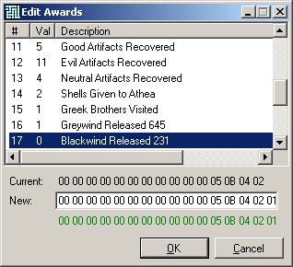Opens the Awards dialog for viewing (and editing, if *Cheating* is enabled) the per-character awards for *Might and Magic 3-5*. When editing the award values, any number from 0‑255 may be entered, but only a few items are understood by the game when other than 0 or 1 (for example, the "Number of Warzone Wins" in *Might and Magic 4/5*). The awards may be edited individually in the upper list (right-click for more options), or by editing the entire array of bytes that make up the awards in the lower panel (see also *Editing Bytes*).

### Condition

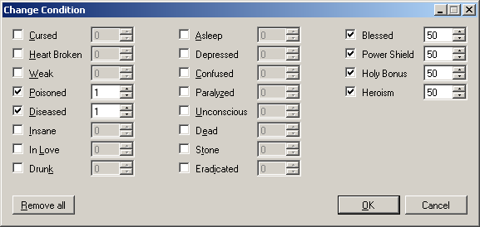When a character has one or more conditions (for example, "Poisoned" or "In Love"), they will be shown here. If you hover over the conditions, you will see more detailed information about the actual effects they are having on the character (such as which statistics are being modified). There are two conditions listed here for convenience that are not "real" ones shown by the game - namely "Broken Item" and "Cursed Item." These pseudo-conditions are not editable directly; you must modify the broken and/or cursed items themselves and uncheck those flags in order to remove them.

### Skills

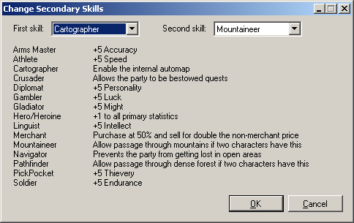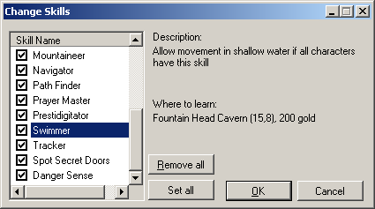The character's secondary skills are shown here (for games that have such traits), and if you hover over them you will be shown a short description of what effect those skills have. If *Cheating* is enabled, you will be able to edit the skills, otherwise the "Edit" command will be changed to "View" and you will only be able to see the information about the skills and the places where they are learned.

### Beacon

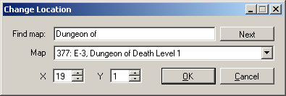For games that store a different Lloyd's Beacon destination for each character (*Might and Magic 3-5*), this will show that destination for the selected character. If *Cheating* is enabled, you may edit the map and coordinates directly, or use the "Add/Subtract 1" to change to quickly select the next or previous internal map index (useful if you want to visit each map).

### Equipped/Backpack

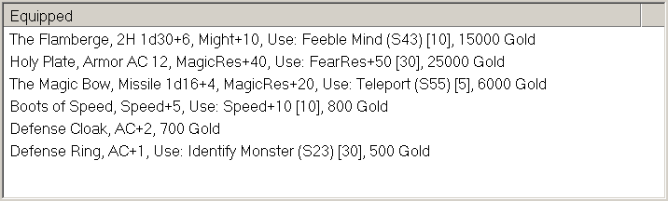This is where your character's inventory of items is shown. If an item is being used, it will be under the "Equipped" section. Editing equipped items is possible but not recommended as it may lead to some in-game inconsistencies. Hovering over an item will show a complete description of the item and its properties, and double-clicking (or pressing Enter) will bring up the *Compare Items* window. Right-clicking on a item or in the empty space in the list will bring up a context menu with these options:

##### Drop Trash

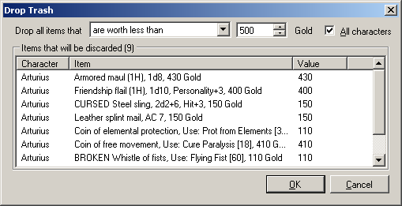This will bring up a dialog from which you can conveniently discard all items fitting a certain criteria (from either only this character, or from the entire party). Select the desired comparison and value from the controls at the top of the page, make sure that the list of items to be discarded is what you expected, and then click "OK" to permanently delete those items. This cannot be undone, so be careful.

The "have an attrib. bonus below" criteria includes the sum of both the elemental and attribute effects if both are present. For example, a *Might and Magic 3* "fuming ogre cloak" (+12 fire resistance, +8 might) would only be dropped if the attribute bonus criteria is over 20. It does not include any modifiers bestowed by the material (e.g. silver or obsidian). The other criteria should be self-explanatory.

##### Trade Backpacks

This allows you to swap all of the items in the "Backpack" list for this character with those in another character's backpack. Select the other character from the popup menu and the exchange will be made if there is enough space (*Might and Magic 3-5* store the equipped items in the same list as the backpack items, so it is common that one character will have more backpack space than another — in that case the trade will not take place).

##### Bag of Holding (see the *Bag of Holding* form)

##### Show item names / Show item information

These menu items allow you to select your desired level of information for each item: "Names" shows only the name of the item as seen directly in the game, "Info" shows the item type and various details about the item. Players of the "Minimal" mindset may prefer to turn off the extra information.

##### Fill with random items

(requires *Cheating*) Replaces the character's entire backpack with random items (including possibly "broken" and/or "cursed" for *Might and Magic 3-5*). This is mainly for debugging purposes, but it can be entertaining (did you need a "Noxious bronze leprechauns padded armor of disintegration"? Of course you did!). You will be asked for confirmation if the backpack is not already empty.

##### Edit/Add

(requires *Cheating*) Either creates a new item or changes the properties of an existing one. The form used to edit the item is somewhat different for each game (*Might and Magic 1* has only an item index and charges whereas the other games have other various attributes that can be associated with items) but should be self-explanatory. You can use the "Find item" and "Next" controls at the top to search for a basic item (e.g. "sword") instead of scrolling through the dropdown manually.

##### Duplicate

(requires *Cheating*) This will create another of the selected item, if there is enough space in the backpack (duplicating an equipped item will create an unequipped copy). This command ignores whether or not the game would permit the use of the "Duplicate" spell on the item.

##### Delete item/Clear all items

(requires *Cheating*) Removes a single item or all items from the character's backpack. Use with caution, as this can delete quest items (though you can always put them back with the Add function).

##### Stack charges

(requires *Cheating*) This will combine any items in the character’s backpack that are completely identical aside from the number of charges remaining. For example, in *Might and Magic 1*, you might have two “Antidote Brew” items, each with two charges. Since backpack space in this game is extremely limited, it is convenient to combine these two items into a single “Antidote Brew” item with four charges. The reason this requires *Cheating* to be enabled is that there is generally no actual in-game method to combine these items at all. Whether this amount of cheating is detrimental to the gaming experience or not is left up to the user of the software.

##### Item display format

This allows you to edit the formatting string that is used to display items in the inventory window. Any variables (e.g. "$[Name]") will be replaced with the item's actual values. You may select from some common formats via the dropdown menu or create a custom one to your liking. Selecting "Show Variables" will expand the window to show you every possible property that may be selected (some variables are not applicable to some games, for example "$[Material]" is not present in *Might and Magic 1* or *2*) and a short description of what the value means. The default formatting string displays nearly all available data about an item; if your window real estate is limited (or you want fewer spoilers about items' effects), you may want to remove some of the informational items that do not interest you.

### Compare Items

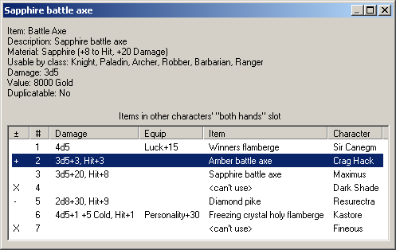From this window you may easily compare one item with all other items already equipped by other characters. For example, if you find a new piece of armor, this will allow you to determine which (if any) character can best make use of it. Double-clicking on an item in the *Backpack* will bring up this form, and you may move the item of interest to another party member by double-clicking on one of the items (or pressing the number key corresponding to that character). When you first open the Compare Items form, the first character who is both capable of using the item and is currently using something worse will be highlighted (this allows pressing Enter twice when a backpack item is selected to move that item to a character who can make better use of it).

The first column of the form is a "+" if the current item is better than the item equipped by the character on that row, a "-" if the reverse is true, or an "X" if the current item cannot be used by that character at all. The column is blank if the items cannot be directly compared (e.g. a ring of +10 Fire Resistance vs. a ring of +12 Cold Resistance). The second column is the character number (i.e. the key to press in order to move the current item to that character).

### Quick Reference

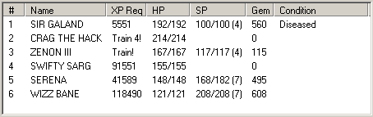This displays information about the characters' next-level requirements, hit points, spell points, and condition. The context menu contains *Cure All* (for clerical spellcasters) and "Show detailed quick reference" which will open a separate window with much more information (see *Quick Reference*).

### Resistances

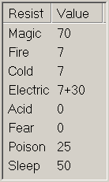Shows the resistances to various elements (e.g. Fire, Poison) in Base+Bonus+Equipment format. Bonuses are typically from effects such as fountains; spell effects such as "Protection from Elements" are generally shows in the *Game Information* form. Some other effects such as "Power Shield" and "Heroism" are shown in this area for *Might and Magic 3* only. Hovering over a value will show you additional information, if any, about it (for example, a +20 Magic Resistance bonus for gnomes, or a +12 Fire Resistance bonus from a fuming cloak).

## Spell Reference

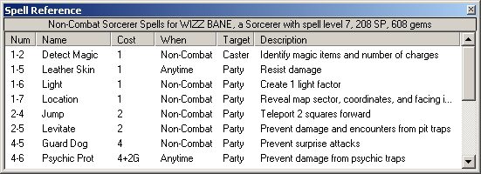If selected from the *Game* menu manually, this form will show every spell in the game, divided into the various spell categories (Sorcerer, Druid, Cleric, and others – drag the dividers to change the sizes of the sub-windows). Hovering over an entry will show you where the spell is learned (or at what level, if it is learned automatically) and the long description of the spell. Double-click on an entry to see all information about the spell or send the keys necessary to cast the spell (see *Send the appropriate keys when a spell is double-clicked*), or select the desired action from the right-click context menu for that spell. There will be an additional “Favorites” tab if *Show Favorites tab when a character is casting a spell* (q.v.) is checked.

If the *Show spell window when casting a spell* option is enabled, the spell reference form will be made visible when you instruct a character in-game to cast a spell. This is more useful in *Might and Magic 1* and *2*, since the spells are entered by level and number rather than from a list, but can also be convenient in other games. When this window is auto-shown in this manner, only the spells for that character's class and level will be shown, and spells not learned will be shown in a dimmed color.

## Monster List

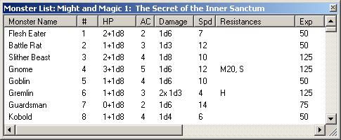This form shows a list of all of the monsters in the current game. The list may be sorted by any column desired, and you may search for text using Control+F (use F3 and Shift+F3 for the next and previous match). Hovering over, or double-clicking on, an entry in the list will provide full information about the monster.

## Game Information

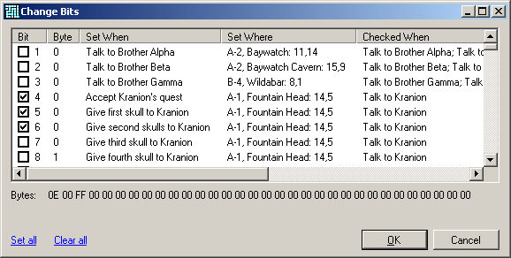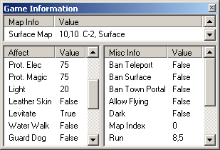This form displays miscellaneous information that is not specific to a character. For example, whether "Walk on Water" is active for the party or if the "Teleport" spell is permitted on this map. Most of the information is editable if *Cheating* is enabled by right-clicking and selecting "Toggle" or "Edit" depending on the type of information. However, some items are not editable even when cheating (such as the current map index) and there are a few items that bring up a special View/Edit Bits dialog that show a vast amount of information about the state of objects and places in the game. These items are the Party bits (*Might and Magic 3*) and the Clouds, Dark, World, Quest, and Character bits (*Might and Magic 4/5*). Right-click on any of these and select View/Edit to explore the inner workings of the game. The counterparts to these bits are the *Scripts*, which cause events to happen based on them (see also *Editing Bytes*)

## Item List

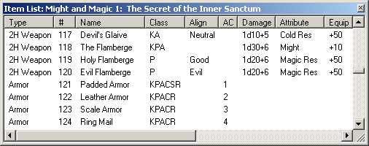Similar to the *Monster List*, this form will show all of the items in the game. In *Might and Magic 1* and *2*, the items are simply an index into this list. *Might and Magic 3-5* use a prefix and suffix system for the items that allows for a myriad of combinations and so the Item List will show only the base items and the individual prefix and suffix values that can be applied (for example, "platinum," "short sword," and "of megavoltage" will be three separate entries in the list). Control+F, F3, and Shift+F3 may be used for searching within the list.

Right-clicking on an entry in the list will allow you to filter out items not usable by a particular class, or (if you have searched for text with Control+F) that do not match your search terms. For example, if you search for the word “silver” and then open the context menu, ‘Show only matching “silver”’ will be listed, and if selected will show only items such as “silver sword,” “bag of silver,” and the like.

## Quests

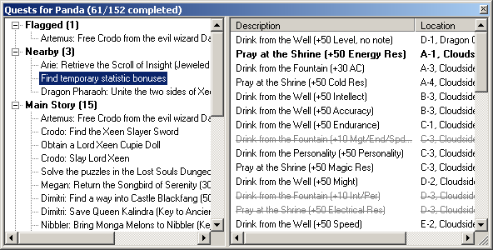This form shows the Accepted, Available, and Completed quests for a particular character (pressing the 1-8 keys on the keyboard will switch between the characters both on this form and on the *Party Information* form). In general the earlier games store all of the quest information on a per-character basis, and the later games have a mix of per-character and per-game quests (for example, in *Might and Magic 4/5*, the quest to sit on the Throne of Euphoria can be accomplished once by each character, but the quest to retrieve the Elixir of Restoration may only be completed once per game). However, for simplicity, the quests are shown as if all of them are per-character (a game-based quest will be marked as completed for all characters when any character completes it).

If you desire minimal information about the game, you may want to avoid the quest form unless you are having difficulty making progress, as it details exactly how to accomplish every task. Alternatively, if you would like to use the Quest Form as a simple list of your active quests without spoilers, you may hide the list of goals by right-clicking on the tree and selecting "Show quest goals" to un-check it.

The quest form can have a very large amount of information in it, so they are organized into major categories and some sub-categories that differ on a per-game basis. The major category names are followed by a count of the number of quests contained in that branch and are described below:

##### Flagged

If you want to keep track of a number of particular quests, right-click on each of them and select "Flag this quest." This will place a copy of the quest entry in the first branch of the tree entitled "Flagged" and keep them there until you right-click on them and select "Unflag this quest" or right-click on the Flagged branch itself and select "Unflag all quests." Flagged quests are stored with your .WAW file when you save the map, so be sure to *Save* it if you want to keep your flagged quests from session to session.

##### Nearby

This branch will automatically show any quests that have uncompleted goals with a target on the map in which 1the party is currently located. This does not always mean that the goal can be finished at the present time (for example, the party may be missing an item, or need to complete another quest first).

##### Main Story

The quests that are required to be completed in order to finish the game are listed here in more-or-less the manner in which they must be tackled (sometimes a number of the main quests can be completed in a different order).

##### Accepted/Available Side Quests

Different quests have different criteria for what constitutes being "accepted," but in general talking to the person who gives the quest, finding the first clue, or completing any of the goals will move a quest from Available to Accepted. Some quests with a single goal are Accepted by default (for example, the quests under the "Spells" sub-node).

##### Completed

A quest with every goal completed (or the final goal, if some are optional) is placed into this category.

##### Manual Quest/Task Completion

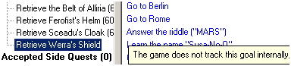Some quest tasks are impossible for “Where Are We?” to ascertain a status. For example, a task may require the party to learn a piece of information from a book, but if there are no in-game records of the party reading that book, it cannot be automatically marked as completed. Tasks like this are shown in blue and have a “Toggle Completed” item on the right-click context menu which will mark it with a strikethrough similar to non-manual tasks. Since the game does not keep track of this state internally, any manually-completed tasks will be stored when you *Save* your .WAW file.

Any quest may also manually be marked as completed regardless of the game’s internal state by selecting “Complete quest manually” from the context menu for it. This allows you to work around bugs in either the game or the Quest form that might leave a quest in an uncompleted state erroneously.

Double-clicking on a goal or right-clicking and selecting "Go to this map" will show the map related to that goal in the main window. The context menu will also show you how many squares away the goal is from the party's current location if the party is on the same map as the goal (or both are on the surface), for example, "Go to this map (North 12, East 33)". Also on this menu is "Hide invalid quest goals," which will, if unchecked, show goals that are invalid for this particular character in an italic font (for example, a quest goal that only applies to Robbers will be shown in this way for a Knight). If a goal cannot be completed for some other reason, it will be shown in a red italic font (typically this means that the game data files could not be loaded; hover over the goal to learn the reason). If *Show Nearby/Flagged goals in bold* is set, goals that refer to the party's current map will be shown in bold (with a cosmetic exception that if every single goal for this quest is on that one map, they will be shown in a normal font).

If you press Control+F while on the Quests Form, a text box will appear below the tree allowing you to search for a quest by entering some text. The first entry that contains the entered text will be selected as you type. Pressing F3 (or Enter) will find the next match, and Shift+F3 will find the previous one. Control+U will clear the line, and Escape will remove the search box.

If *Cheating* is enabled, you will be able to set Lloyd's Beacon to the target of a quest goal via the context menu in the list of goals on the right-hand side of the window. Also available is "Teleport to these coordinates," which will move the party to that x/y location (though if the party is not on the same map this will not be the quest goal location). *Might and Magic 1* and *2* have a special option to Set or Clear the quest bits on the context menu of some of the quests in the tree. These will alter the bits in the character record related to those quests to essentially "complete" or "un-complete" the quests as you desire. However, these options will not do things such as add or remove quest objects from the inventory and as such may put the game into an odd state. There is no direct equivalent for the other games, but you can set and clear game bits individually via the *Game Information* form if you wish.

For *Might and Magic 3-5*, a large part of the quest information is stored in files rather than in memory for maps other than the party's current location. The location of these files is determined automatically when "Where Are We?" first starts (see *Setup Wizard*), but if they are incorrect you may right-click on the tree and choose "Select game files" to locate them manually.

The tree view that serves as the left panel of the Quests form updates frequently and may have memory issues if left open for long periods of time while playing (more so for *Might and Magic 4-5* than for the other games, simply due to the large amount of polled information). Until this bug is resolved it may be wise to open the Quest form only when you wish to use it rather than leaving it up as a main window.

## Roster Editor

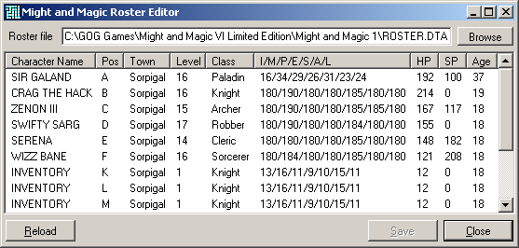 *Might and Magic 1* has no internal mechanism to rearrange the order of your characters in the roster that is presented when the game is started. It is convenient, once you have decided on a party, to have them occupy the A through F slots for ease in selecting them each time (especially if you tend to save the game at more than one inn, in which case the slot letters can become a nuisance). This is the purpose of the Roster Editor, though it is highly recommended that you open it while the game is *not* running, or your changes may be overwritten by the game when you sign in at an inn. To rearrange your characters, simply drag them around in the list view until you are happy with the order. When you click "Save," the roster will be saved and reloaded, which will update the positions.

*Might and Magic 2* saves your previously-selected party, which makes editing the roster less useful of a thing to do (but still accomplishes the same effect, if you desire). In *Might and Magic 3-5*, the roster editor will still function, but making changes to the order is not recommended except in situations where you are trying to fix something erroneous. The reason for this is that in these games the character portraits are tied to the position of the character in the roster. If you rearrange a human character, it may end up with a half-orc portrait; this has no effect on the actual race or sex as shown on the character sheet in the game, but it may be confusing (and serves no real purpose, as these games also save your most recent party selection for you). If you are making use of the *Bag of Holding*, you will see one or more characters here (as well as in the game itself) named "Inventory," which are the mechanism "Where Are We?" uses for storing the bag items.

## Shop Inventories

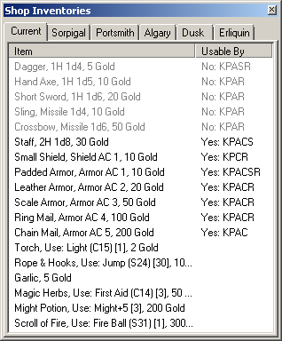This form may be summoned manually via the *Game* menu or shown automatically if *Show shop inventory window when in a store* is checked and the party enters one of the town stores. Its purpose is to show you information about the items available for purchase without having to buy them first. The same information is available in the *Item List*, but this form shows only the items that are actually for sale and dims any that are not usable by the currently selected character. Hover over an item to see a full description of it. The town tabs will show you what items are available at other stores (some shops change every in-game day, so you may want to make your way there via portals instead of walking). The keyboard keys 1-9 will select the corresponding tab. Note that if you manually close the Shop Inventory window while in a shop, the *Show shop inventory window when in a store* option will be unset (otherwise the form would re-show immediately after closing it).

## Quick Reference

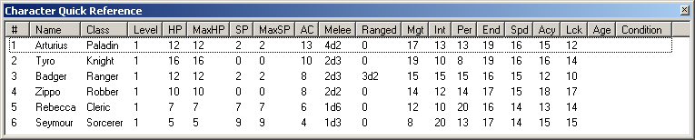The detailed Quick Reference form shows many of the stats and attributes of each character that are also available on the *Party Information* window. On the Quick Reference form, however, you may sort by any of the columns and tell at a glance whether someone is, for example, not equipped with a ranged weapon, or has been affected by magical aging. Sorting by the Melee or Ranged column uses the average damage of the entire formula as the sort criterion, including number of attacks (for example, 5x2d6+10 is an average damage of 85, which would be treated as higher than 4x2d12+8, which has an average damage of 84). Right-clicking on a character with healing capabilities will allow you to select the *Cure All* function, while right-clicking on the headers permits selectively showing only certain columns.

## Encounters

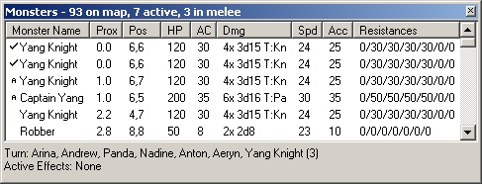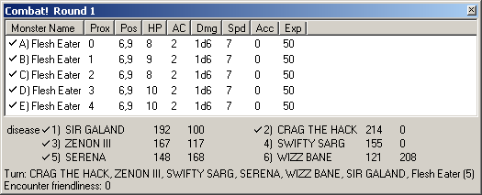If *Show encounter window when entering combat* is selected in the options, this form will appear when either you are in combat (*Might and Magic 1* and *2*), or there are monsters that fall into the categories selected on the *Encounter* page of the options dialog (*Might and Magic 3-5*). The Encounter form is similar to the *Monster List* except that it shows the current HP and position of the monster as well as the other statistics. The default sort order is by proximity, which can be changed by clicking on any of the columns. ("Proximity" means either the distance in squares between the party and the monster in *Might and Magic 3-5*, or the position in the list of monsters for other games). At the bottom of the window you will see the turn order (if in melee combat), which will show you in what order party members and monsters will act and may help you plan more specific tactics for a combat round. There is also a unique encounter attribute called "friendliness" in *Might and Magic 1* that is related to the difficulty that the party will have when attempting to run from or bribe the monsters.

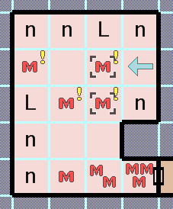For *Might and Magic 3­­-5*, hovering over a monster icon on the main map will show you basic information about that monster or monster group. Clicking on the icon (or multiple icons by holding down Control) will select those monsters in the encounter list (presuming you are not in an *Editing Mode* that will draw on the map instead). The left side of the "Monster Name" column will show a checkmark if the party is in melee combat with that monster. In games with mobile monsters, a small "A" will be shown by monsters that are actively tracking the party (i.e. will move to follow if the party moves), and an exclamation icon will be shown by the icon on the map if *Indicate Activated Monsters* is enabled. If you right-click on the column headers, you may select which pieces of information to show or hide; this setting will be saved in the application's config file ("Reset columns" will show them all again). Right-clicking on a monster in the list will bring up a context menu with the following options:

##### Remove all monsters

(requires *Cheating*) This will remove all of the monsters from the encounter array for the current map. Use caution, as this is not the same as killing the monsters and may have side-effects — especially in *Might and Magic 4-5*, which tends to use monsters being alive or dead in inaccessible places as a form of bit used in scripts (which may no longer function at all with the monster being missing rather than dead). If you instead want to kill all of the monsters in the same way the game does, select all of the monsters in the list, select "Edit" from the context menu, check the "killed" box, and press "OK."

##### Edit

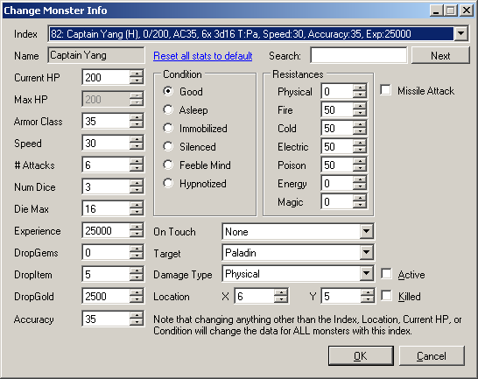(requires *Cheating*) This will bring up the Monster Editor, which allows you to change any or all of a monster's statistics. Some games, such as *Might and Magic* 1, store complete information for every individual monster, but for others (e.g. *Might and Magic 2-5*), a change to anything except the index, location, current HP, or condition will make that change to the global monster list, which means that *all* monsters of that index will now have that statistic. For example, if you change a Doom Bug's armor class to 50, every Doom Bug that exists or is summoned will have an AC of 50, and you will see that the entry for Doom Bug in the *Monster List* now shows that the Doom Bug has an AC of 50 (unless it was already open, in which case you must close and re-open the list to see the effect). The "Reset all stats to default" link will let you easily revert back to the original values for a monster. Also, changes to the game's internal monster list are temporary; if you exit the game and start it again, the monsters will be back to their original values.

##### Show dead (off-map) monsters

In *Might and Magic 3-5*, killing a monster does not literally remove it from the list of monsters, it simply changes its location to somewhere off of the map (e.g. 100,100 or 128,128). By default, monsters with off-map coordinates are not shown in the list, but you may see them if you wish by selecting this item.

##### Teleport party to monster / Move monster to party

(requires *Cheating*) This changes the party's location to be that of the monster, or vice-versa.

### NPC indicator

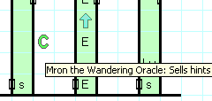Most games’ NPCs are in fixed locations (for example, a shopkeeper or quest-giver). In others (only *Wizardry 4* as of this writing), an NPC may wander the map much as monsters do. Instead of a red “M” these characters are given a green “C” to indicate a non-hostile potential encounter.

## Character Creation Assistant

### Might and Magic

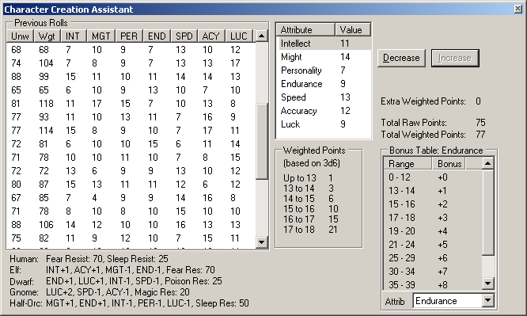Designed for the player who does not care much for the "random die roll" method of generating characters, this form will allow you to add a weighted point-buy system on top of the initial random numbers. It also will retain a history of your previous rolls and allow you to revert to any of those (avoiding the "itchy trigger finger" issues when re-rolling repeatedly). To use the assistant, go to the character creation screen in-game and open this form via the *Game* menu. As you roll and re-roll characters, the stats will appear in the "Previous Rolls" list. The "Unw" and "Wgt" columns represent the unweighted (sum of stats) and weighted (sum of weighted points as listed in the table to the right of the list) values for sorting convenience. The following options are available on the context menu of the Previous Rolls list:

##### Use these rolls

Selecting this menu item (or double-clicking on a roll in the list) will send these values back to the game for use in creating a character. If *Send keys to DOSBox for screen refreshes* is not enabled, you may need to manually press some in-game keys to see the effects (for example, in *Might and Magic 1*, selecting a class and then hitting Escape will show the new values).

##### Delete/Delete all except

This will remove (or leave only) the manually-selected items in the list.

##### Delete lower weighted/unweighted

Available if only a single row is selected, these menu items will remove any rolls in the list that are lower than the value of either the "Wgt" or the "Unw" value for the specified roll, respectively.

##### Remove unusable by

Selecting a class from the pop-up menu for this item will remove all rolls from the list that cannot be used to generate the desired class. For example, in *Might and Magic 1*, any rolls with Personality, Might, or Endurance scores below 12 will be removed by selecting "Remove unusable by Paladin."

##### Generate 100/1000 rolls

These options will roll virtual dice the specified number of times and add those entries to the list. The rolls generated with this method do not use the in-game engine and so may not have exactly the same probability distribution as "real" rolls generated by using the "re-roll" feature of the game itself.

When you select a roll from the list, the attribute values will be placed into the smaller list to the right. You may use the "Decrease" and "Increase" buttons (or right-click on the stat and select "Minimum" or "Maximum") to add to, or use weighted points from, your "Extra Weighted Points" pool as shown (some games require use of the "Update Game UI" button when you wish to see the effects in the game proper) . The Bonus Table is a reference as to what ranges of which statistic (selectable via the dropdown) have particular positive or negative effects for the *Currently playing game*.

The weighted points are based on the probability of obtaining that particular number given that the minimum weighted number is above average. For example, the 3d6 weighted range is 13-18 (arbitrarily chosen, but with the reasoning that 13 is the first number that gives any sort of positive bonus). In that range (i.e., the total set of 3d6 rolls that fall between 13-18, inclusive) the probability of an 18 is 1/56, and the probability of a 13 is 21/56. The weighted values are the reverse of that distribution, so raising a stat from 12 to 13 requires 1 point, but the jump from 17 to 18 requires 21 points (*Might and Magic 2* uses a 3d7 mechanism, but the algorithm is similar). The goal of this system is to make it possible to arrange your rolled values to create a similarly probable but more practically useful set for the character class that you would like, while making it impractical to drop one stat very low in order to raise another.

Use of the Character Creation Assistant does not specifically require that *Cheating* be enabled, though just how much the use of these features pushes the boundaries of outright cheating is up to the user.

The “Bard’s Tale” series of games uses stats of different names than the ones in Might and Magic (e.g. “Strength” instead of “Might”), and the algorithm for rolling the numbers is a bit different (leaning heavily toward higher numbers), but in general the Creation Assistant behaves very similarly and the differences are noted on the dialog itself.

### Wizardry

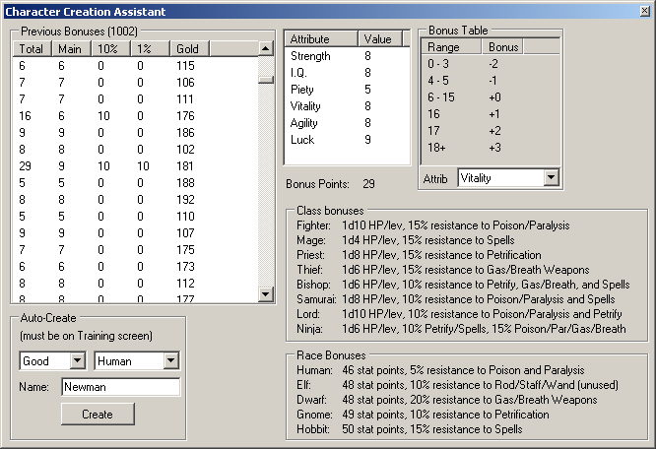Wizardry 1 allows character creation in a similar manner to the *Might and Magic* series, but with enough differences to warrant a bit of explanation. *Wizardry* does not roll numbers for each statistic, but instead just one “bonus points” pool. These points range evenly from 5-9, but with a 10% chance of an extra 10 points being added (making 15-19), and another 10% chance after that (i.e. a 1% chance overall) of yet another 10 points (making 25-29). Gold has a 25% chance of being a random value between 100 and 115, and a 75% chance of being a random value between 172 and 199.

If you would like to generate characters quickly in-game (as opposed to using the “Generate Rolls” context menu item), you may select an alignment, race, and name, then press the “Create” button. This will send a combination of keystrokes to the Wizardry game that creates the selected character.

## Training Assistant

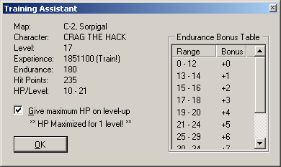This form is only useful in games that give random bonuses during level-up (which is all of them except *Might and Magic 2-5*). Generally games which use this system give you a random number of hit points (modified by Endurance, Vitality, or Constitution) when you level up. In *Might and Magic 1* and the *Bard’s Tale* series, this number of hit points is permanent and getting hit with bad luck for the first few levels can make the game more difficult in a way that isn't exactly fun. The later *Might and Magic* games made the number of hit points gained per level more consistent, and this Training Assistant attempts to bring that progress back to the first game. To use it, go to one of the training halls in-game, open the Training Assistant from the *Game* menu, and check the "Give maximum HP on level-up" box. With the form open, train your character and you will see the text "\*\* HP Maximized for X levels! \*\*" appear under the checkbox when the assistant has done its job. If you are training multiple levels, do not train too quickly (i.e. do not hold down the training key; instead press it once for each level you wish to train) or it is possible for the memory scanner to miss one. The other information on this form is for reference only. *Cheating* is not required to make use of the Training Assistant, though the distinction between cheating and repeatedly loading of a saved game in order to prevent low numbers is up to the user to determine.

The *Bard’s Tale* series applies this randomness to Spell Points as well as Hit Points, and so in those games the Training Assistant also includes a checkbox to maximize the SP gain if desired.

In the *Wizardry* series of games, characters have a chance to *lose* a stat point on level-up due to the whims of chance (but more likely if a character is over 65 years old). This can be prevented by checking the appropriate box in the Training Assistant, if desired.

## Edit Cartography Data

(requires *Cheating*) 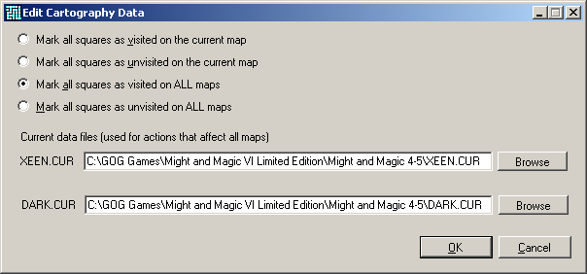For supported games with in-game automaps (*Might and Magic 2-5* and *Bard’s Tale 3*), you may select this form from the *Game* menu to set or reset the cartography data for the entire map (or even the entire game). *Might and Magic 2* holds the entire game world's mapping data in memory, but for the later games you will need to specify the locations of your save-game files in order to use the "all maps" capabilities. These files are auto-detected the first time that "Where are We?" is started (see *Setup Wizard*), but if they are incorrect you may adjust them here manually. To change the cartography data on a more granular level, see the *Toggle visited* context menu item.

## Bag of Holding

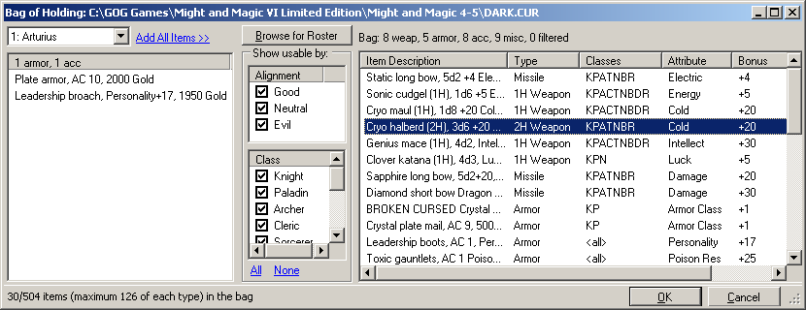The *Wizardry, Bard’s Tale,* and *Might and Magic* series of games, especially the earlier ones, have a limited backpack size and players sometimes create characters in the roster whose sole purpose is to hold interesting items that might be useful later. The Bag of Holding is a way to streamline this process with an interface that provides some basic organization to the collection of objects stored this way. To use it, right-click on a character's backpack in the *Party Information* form and select "Bag of holding" from the menu.

To place items into the bag, select the appropriate character from the drop-down on the left and then double-click on an item (or select any number of items and drag them to the list on the right). Reverse the procedure to retrieve an item or items from the bag. The central column of checkboxes can be used to filter the items in the bag to those usable only by the specified alignments or classes. The item descriptions can be changed with the "Show item names" and "Show item descriptions" context menu items (similarly to the ones on the *Party Information* form), and the items in the bag may be sorted by any of the columns by clicking on them. You may permanently destroy items in either the inventory or bag list by pressing the Delete key or right-clicking and selecting "Delete" from the menu (if you cancel out of the Bag of Holding form, these deletions will be undone as well as any other changes). The "Attribute" and "Bonus" columns show the single largest bonus on a particular item (for example, a shield that gives +4 AC, +8 Fire Resistance, and +5 Might will show only the +8 Fire Resistance). The item display string may be changed by right-clicking on the list and selecting "Item display format" (see *Item display format* on the *Party Information* form for more details).

When you click "OK," a number of characters named "Inventory" will be generated in the roster (if necessary) and the items will be placed in their backpacks. The number of items that the bag can hold depends on the number of empty slots in the roster (As *Might and Magic 4/5* keeps track of different item types in separate packs for each character, it is possible for the bag to be able to hold, for example, many more accessories but be out of room for more weapons). *Might and Magic 2* stores the entire roster in memory at all times, but for other games the roster files on disk are used to save the Inventory characters. These files are auto-detected the first time that "Where are We?" is started (see *Setup Wizard*), but if they are incorrect you may click "Browse for Roster" to adjust them here manually.

The Inventory characters are normal characters and may be placed into your party, but this is not recommended. If you try to use the Bag of Holding while adventuring with any of these characters, you will be given a warning and the bag will not function. If *Cheating* is enabled, the Bag of Holding will be accessible at any point while playing the game (even while in combat). Without cheats enabled, the locations are more restricted for the sake of retaining the intended utility of the bag as a convenience (i.e. simply to save you the trouble of swapping party members around to exchange the items manually) and not as a way to, say, avoid having to cast Town Portal to drop off excess equipment while in the middle of a dungeon — you must be in (or in front of) an Inn if playing *Might and Magic 1* or *2*, or in a town that has an Inn if playing *Might and Magic 3-5*. Being actually signed-in to the Inn is restricted in the latter games even if cheating is enabled, because exiting the inn would erase any items in the bag!

Manipulating the inventory in-game while using the Bag of Holding interface is not recommended. When "OK" is clicked on the Bag window, the data available when it was opened will be used to replace the inventories of the party characters as necessary to accommodate the changes. You will receive a warning if such an inventory modification is detected (which you may override if *Cheating* is enabled).

## Scripts

*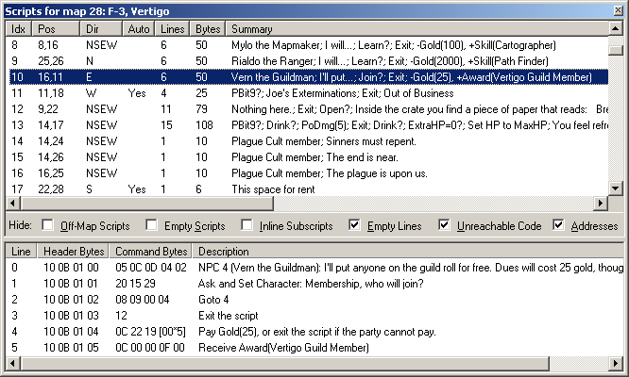Might and Magic 2-5* make extensive use of an internal scripting language that, although not necessarily useful for most players, can be a fascinating glimpse into the inner workings of the games (*Might and Magic 1* has code that does what the scripts in the other games do, but it is simply x86 assembly and not viewable via this form). Written originally to divine information in order to create the *Quests* form, the Script Viewer/Editor may be launched from the *Game* menu or by right-clicking on a particular map square and selecting *View scripts* from the context menu (this will jump to the script for that square, if there is one). The list on the top of the form shows all available scripts for the current map, and the bottom shows the lines of the currently selected script. The columns and checkboxes are explained below:

##### Lines/Bytes

This is the number of lines and bytes that the script occupies in memory.

##### Idx

This is the internal index of the script for this map. Sometimes the scripts are logically organized based on this index and sometimes not; clicking on the column header will re-sort the list of scripts back to its original internal order.

##### Pos/Dir/Auto

The position of this script on the current map (i.e. the square for which moving the party to it causes this to be the active script). The script will be run automatically if "Auto" is Yes, otherwise the user must press the spacebar or click the mouse to run the script (for example, a trap tile would be automatic, but taking an item from a wall alcove would not). Additionally, the party must be facing one of the directions in the "Dir" column for the script to execute ("NSEW" being "any direction").

##### Summary

This is a one-line (sometimes a very long line) summary of the main effects of the script. It is intended to provide a quick way to glance through the list of scripts in order to locate something of interest.

##### Line

Scripts have specific line numbers that may or may not be sequential. The number is used by other lines to accomplish such effects as "go to" or "make this line do nothing"

##### Header Bytes/Command Bytes/Description

Script bytes are divided into these two categories; the header bytes are typically just the position, direction, and line number. The command bytes make up the actual instructions for this line, such as "display this string" or "teleport to that map." The description is an English-style explanation of what these particular command bytes actually mean.

##### Hide Off-Map Scripts/Hide Inline Subscripts

If this is checked, scripts with a position that is not actually on the map will not be displayed in the upper list. For the most part, off-map scripts are called from other scripts that are in fact on the map (for example, a number of scripts might have a command that reads, "run the script at location 77,77" — this allows the script at position 77,77 to act as a sort of subscript that can be called from multiple places without needing many copies of those lines in all of the other scripts). If the "Hide Inline Subscripts" box is checked, these calls to the subscript will be shown as they are written. However, if the box is unchecked, you will see all of the lines from (in this example) position 77,77 as if they were part of the script directly (the line number will be appended with the line number from the subscript, for example, "0.1" and "0.2" for lines 1 and 2 of the subscript). Leaving the box unchecked usually leads to much more readable scripts as you do not need to refer manually to the subscript.

##### Hide Unreachable Code

If a script cannot reach a particular line of code (for example, if there is a line before it that is simply the command "Exit Script"), having this checkbox selected will hide those lines from the lower window. Usually this happens because the final action in a script is to modify itself to no longer do anything (or to display a message such as "The chest is empty" when the party has taken the treasure).

##### Hide Empty Scripts/Lines

If a script has no lines that do anything (typically any command bytes that begin with zero mean "do nothing"), or has lines containing zero bytes, checking these boxes will prevent those scripts or lines from being shown in the upper or lower list, respectively.

##### Hide Addresses

If unchecked, the header and command bytes will be prefixed with the script memory block offset.

Right-clicking on either of the lists will bring up a menu. The items in those menus are explained below:

##### Teleport to these coordinates

If *Cheating* is enabled this will move the party to this script's position (upper list) or to the target of a "Teleport" script command (lower list).

##### Set encounter text for this script's square

If this script contains an encounter with monsters, this will change the *Note* for the square at this script's position to a description of the encounter (this is mainly for *Might and Magic 2*).

##### Set Lloyd's Beacon here

If *Cheating* is enabled this will set the target of the Lloyd's Beacon spell (for the first party member that can cast it) to the target of this script line's "Teleport" command.

##### Go to this map

This will display the map referenced by this script line's "Teleport" command.

##### Copy

This will copy to the clipboard a tab-delimited string containing the contents of this script or line.

*Might and Magic 2* has some additional options on the context menu for the upper list:

##### Use Game Memory

This option will display the scripts that are particular to the currently loaded map (similar to *Might and Magic 3-5)*.

##### Use Internal Data / Use External File

Some of the per-map scripts in *Might and Magic 2* refer to a completely different list of scripts that are the same for every map. For example, in Middlegate, the script at (15,15) has only one line which reads "RunScript: Internal#14," and that internal script is nowhere to be found in the script list. "Use Internal Data" will show you the list of internal scripts (except for scripts 0-8, which are just x86 code for the Inn, Store, etc.). Using this internal list, you can see that script 14 is the one for Feldecarb Fountain. Note that editing bytes in the internal list will have no effect, as it is only a copy of the data. Alternatively, if you have a copy of this data in an external file, you may load that instead.

The actual scripting languages for each game are somewhat complicated and beyond the scope of this document. Most commands are largely self-explanatory but some are a bit bizarre. The Scripts form is not intended to be a complete scripting tool, but if *Cheating* is enabled you can double-click on a script line (or right-click and select "Edit") to change the raw bytes for that line. However, caution is advised as script errors can easily cause the game (and DOSBox) to crash (see also *Editing Bytes*).

## Setup Wizard

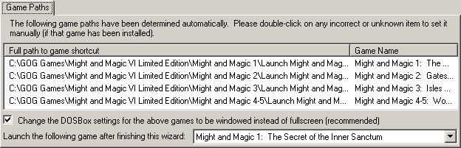This wizard will appear when the "Where Are We?" program is first run, or if chosen from the *Help* menu. The "Game Paths" tab, when selected, will scan the machine's registry for the location of the GOG-based versions of the *Might and Magic* games. If you are not using GOG's versions, or if for some other reason the paths are not found, you should edit the path for that game to point to the shortcut (.lnk file) that will launch that game. These paths will be used for several parts of the program (see *Quests*, *Roster Editor*, *Bag of Holding*, *Edit Cartography Data*, *Launch current game*), and if the paths are not set correctly then those parts will not function properly. You may right-click on a path in the list and select "Test Shortcut (launch game)" to attempt to launch the game, which will confirm that the path is correct.

If "Change the DOSBox settings ... to be windowed" is checked, the program will attempt to find the DOSBox .conf files for the games and change the line that reads "fullscreen=true" (the default when using the GOG installer) to read "fullscreen=false" instead ("Where Are We?" is designed to work best with DOSBox in windowed mode, although with multiple monitors you may prefer to leave it in fullscreen). Note that if you are not running as an Administrator, the files may not be writable and you will need to modify them manually if you wish to do so. When the Wizard is completed, the first game in the list will be launched unless you change the dropdown to something else.

By default, the GOG.com versions of *Might and Magic* run the windowed versions of DOSBox in one of the 2x modes. The party window is designed to be the most useful when its width is the size of DOSBox in one of the "3x" modes (hq3x, normal3x, etc.) and also retain the majority of its utility in the 2x-width modes (the basic *Quick Reference* part of the window is not completely visible at 2x, so you may want to open up the advanced *Quick Reference* form as well in that case and place it somewhere comfortable).

For games that do not have a Windows-based installer as of this writing (such as the *Bard’s Tale* and *Wizardry* series), you will need to double-click on the desired games and tell “Where Are We?” the location of the shortcuts that you use to launch the DOSBox process for those games.

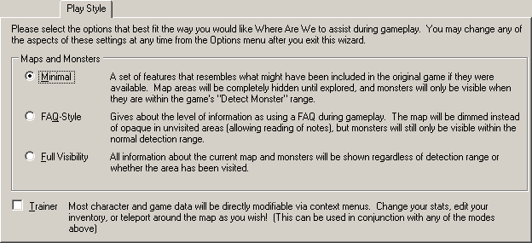The "Play Style" tab allows you to quickly choose between a collection of game options suited to a particular style of play. The descriptions of the styles on the Wizard form should be sufficient to make your choice between Minimal, FAQ-Style, and Full Visibility. You may also check the Trainer box to enable *Cheating*, if you like. If you launch the Wizard from the *Help* menu, you will be taken directly to the "Play Style" tab so that you can easily switch to another style without rummaging through the *Options* dialog for the various settings.

# Menu Items

Note that menu items not listed here generally are ones that simply open other *Forms* which are described in their own section.

## File

### New/Open/Save/Save As

Choose these commands to load and save the .WAW files that hold "Where Are We?" data. .WAW files are standard XML documents that may also be loaded in any XML editor if you want to use text-based functions such as search-and-replace. Note that although the notes and icons are in standard XML node-and-attributes format, the /MapBook/Sheet/Grid nodes are a base64-encoded GZip stream which contains the block and line information for the map and are not directly editable as XML (storing this data as full XML would make the .WAW files quite large, and the program does not recompress the stream when saving if none of the grid information has changed).

### Load internal map

The *Might and Magic 1-5* maps are stored directly as resources in the WhereAreWe.exe file itself, and you may access those via this menu. If you want to make changes (including keeping track of the visited squares), you will need to save to a new file.

### Export

"Current sheet as .PNG" will export the current map exactly as seen on the main window (including the zoom level) to a .PNG file. "Entire map book as .ZIP" will create a Zip archive of all of the maps in the book at the default zoom level for that map (including the currently displayed one, regardless of its current zoom level). Note that whatever settings you are using for hiding unvisited squares (for example, via the *Setup Wizard*) will also be used for all of these maps, so you may want to set the play style to "Full Visibility" first.

## Edit

### Undo/Redo

Most editing operations (drawing blocks and lines, editing and moving notes and labels, rotating and moving selections, etc.) can be un-done and re-done via these menu commands. The number of actions that can be un-done is controlled via *Levels of undo* in the options and is a separate list of actions for each *Map Sheet*.

There is a special type of undo that is not related to the normal undo/redo list; it will appear on the Edit menu as "Un-clear Note" if you are editing a note and hit "Escape" (or press the "Cancel" button to the right of the *Note Text*). Selecting this menu item will place your cursor back in the *Note Text* box with the text that was there prior to the cancellation and can be useful if you tend to hit Escape while typing text due to familiarity with other editors.

### Cut/Copy/Paste/Delete

These operations are only valid when in *Edit Mode* and you have selected a group of map squares. Paste can be used to move and copy blocks between sheets or even between map books (see also *Clone*)

### Find

This will bring up the *Search for Note Text* form (q.v.)

### Crop

When in a selection has been made in *Edit Mode*, this will remove all of the map squares surrounding it.

### Manipulate

These commands operate either on an *Edit Mode* selection or on the entire map in any mode:

##### Rotate/Flip

This command will perform a rotate or flip operation on whatever is checked in the *Edit mode affects* setting in the options.

##### Convert half-lines to full

This function will, for any squares containing a line, check the opposing square for the corresponding line. If one is not found, it will be added. One use for this function is to "thicken up" the single-square lines that are produced when a selection is moved away from the edge of a map (lines on the edge of a map are drawn as if they have an opposing line for cosmetic reasons, but when they are moved away from the edge the single-edged line is made obvious).

##### Fill with blocks

This will replace the background of every map square in the selected area with the current *Block Color*.

##### Outline

This will draw an line around the selected area using the currently selected *Line Color*.

### Live Squares

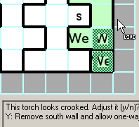This enters (and leaves) a mode in which clicking on a map square will toggle it between “static” and “live” modes. A live square is one that will be regularly monitored and updated if the actual square in the game changes. For example, if an in-game action removes a wall revealing a secret passage, the live square will show the wall or not, as appropriate (note that typically a live square is required on both sides of a wall in order to be properly updated).

Note that the live squares use the *Coordinate System* specified for the current *Map Book* when set. If the system is changed after live squares are enabled, the live squares will read current map data from the wrong locations in memory.

## View

### View Toolbar / View Notes panel

Toggles the visibility of the toolbar and/or lower panel (containing the *Note Symbol*, *Color*, and *Text*). Editing or viewing a note will automatically show the notes panel again.

### Z-Order

If you would always like forms to appear in a certain Z-Order (for example, if you would always like the *Spell Reference* to be on top of the *Party Information* regardless of which one opened first, you may organize those manually with this list (the default is to let the OS handle window placement).

## Window

### Fit Window

This will resize the main window to whatever size will completely contain the current map at its current zoom level (up to the size of the screen).

### Fit Width/Fit Height/Fit in Panel

This will set the zoom level to whatever size will fit either the width or the height (or both, for "Fit in Panel") of the map sheet as closely to the current size of the main window as possible, up to a maximum of 400% (64x64) or a minimum of 18% (3x3).

### Bring DOSBox to foreground

This will bring the DOSBox main window to the foreground, if it is running.

### Auto-arrange windows

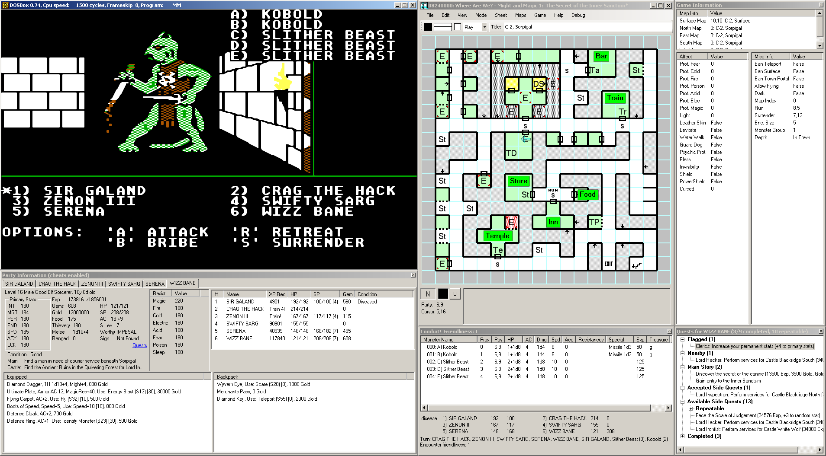This command will attempt to perform the following operations, in order: Move the DOSBox window to the upper-left corner of the screen, move the main "Where Are We?" window to the right of DOSBox, set the main window to a size that will fully contain a 200% zoom 18x18 map (the default for *Might and Magic 1*), and move the *Party Information*, *Game Information*, and *Encounters* forms below DOSBox, to the right of the main window, and below the main window, respectively. Other windows will not be moved by this command (though their positions will be saved when you exit the program).

### 100%/150%/200%/300%

Zoom100.png

Zoom100.png

Zoom100.png

Zoom100.png

These commands set the zoom level to correspond to square sizes of 16x16, 24x24, 32x32, and 48x48, respectively. The internal map icons are crafted to look best at those exact sizes (though they will be scaled to any size with some amount of blurring). *Notes* and *Labels* should appear properly at any zoom level (within reason; anything under 100% zoom will be rather tiny).

## Mode (see *Editing Modes*)

## Sheet

See also *Organize Map Sheets*, *Map Labels*.

### Add

This creates and adds to the *Map Book* a new map sheet with the *Default new map size* in the options.

### Clone

Cloning a sheet makes a new sheet with a blank title that contains an exact copy of all of the blocks, lines, notes, icons and labels on the current map sheet.

### Remove

This removes an entire sheet from the map book.

### Expand (see *Expand Sheet*)

### Previous/Next

Switches to the previous or next sheet in the map book, based on the position on the *Maps* menu. See *Organize Map Sheets* for information about rearranging that order.

### Go to

Selecting this menu item opens up a small form entitled "Search for a sheet by title." Entering text in this form jumps to the first sheet in the map book with a title that contains that text. F3 (or Enter) and Shift+F3 will find the next or previous sheet containing the text, respectively. Control+U will clear the text box, and Escape will close the small form.

### Clear visited squares

This will set each square on this map sheet to "unvisited." Be aware that if *Use in-game cartography data* is checked in the options, those same squares might be immediately reset to visited again when the in-game cartography changes (e.g. the party moves to an new square).

## Maps

This menu allows you to choose from any of the maps in the map book to display (see *Organize Map Sheets* if you wish to modify the menu layout) . If *Automatically switch map sheets* is set in the options, though, the map will switch back to the party's current location when you activate the DOSBox window. The exception is that if a map sheet is titled "Legend," selecting it will ignore that setting and remain displayed until you either select another map manually or select the Legend menu item again (in which case the last map selected will be re-displayed). The purpose of a "Legend" sheet is to explain the meanings of the various block and line colors, notes, and icons that are common in this map book.

## Game

See also *Party Information, Spells*, *Monster List*, *Item List*, *Game Info*, *Quests*, *Shop Inventories*, *Scripts*, *Quick Reference*, *Roster Editor*, *Character Creation* and *Training Assistants*, *Edit Cartography Data*

### Launch current game

This will attempt to run the shortcut for the selected game (see *Currently playing game* and *Edit shortcuts*) and attach the memory scanner to it (see *Re-acquire game process*).

### Show encounters when in combat

This toggles the same setting as *Show encounter window when entering combat* in the options dialog, but is included on this menu for convenience (since most other forms are on this menu as well).

### Re-acquire game process

This will dispose of and re-create the memory scanner that is used to collect information about the game from the process memory. The memory scanner is passive (i.e. it does not attach a debugger to the process; it only calls ReadProcessMemory and, if *Enable writing to game memory* is set, WriteProcessMemory).

### Remove all monsters from map

(requires *Cheating*) This is the same function that can be accessed via the context menu option on the *Encounters* form (see *Remove all monsters*). It is also on this menu because it has an effect for *Might and Magic 1* and *2* (to set all of the encounter squares to "inactive"), which would not be accessible outside of combat otherwise.

### Reset monsters on map

(requires *Cheating*) This will use internal data to reset all of the monsters on this map to their original locations and stats (for *Might and Magic 1* and *2*, this means re-activating encounter squares).

### Edit in-game cartography data

In games that support internal cartography, this will bring up a dialog that will allow you to easily set or clear all of that information for either a single map or the entire game (that is, revealing or hiding the entire in-game map).

## Help

### About

Displays version, copyright, and contact information for "Where Are We?"

### Run setup wizard

This activates the *Setup Wizard* with the focus set to the "Play Style" tab, for easy selection between the three main styles of play (Minimal, FAQ-Style, and Full Information).

## Main Map Context Menu

This is the menu that appears when you right-click on a map square in the main window.

### Edit/View Note

In *Play Mode* (or if *Read only maps*/*notes* is checked), this item is named "View Note," otherwise it is "Edit Note." Either option places the text of the note under the cursor into the edit box at the bottom of the main window (showing that panel first if necessary) and prevents mouse movement on the map from changing it until you are finished viewing/editing the note (either by selecting another note, pressing Escape, or clicking "Cancel" or "Finish"). It also provides a scroll bar for lengthy notes. While editing a *Note*, you may change the *Note Symbol* and/or *Note Color* by selecting the options to the left of the *Note Text*. Pressing Enter will finish editing a note; if you would like to insert a newline in the note text instead, use Control+Enter.

### Add Note

This allows you to add a note from the *Note Templates* to the map sheet at the location specified.

### Add Label

This creates a 50% transparent gray label with the black text "New Label" and no border, places it at the exact coordinates of the cursor, and opens the *Map Labels* form in order to make changes to the label. If you would like to drag the label around the map with the mouse, you must either select *Notes Mode* or use a mouse button that you have assigned to  *(Perform action) as if in Notes Mode* in the options.

### Copy location

This will copy the location of the square under the cursor to the clipboard in a format appropriate for pasting into a note, for example, "(C-2, Sorpigal: 8,5)"

### Copy Note/Paste Note

These options will copy and paste a note only (not blocks, lines, or icons) to another square. To copy or move other objects, use *Edit Mode*.

### Delete note/Remove icons

Removes the note or icons (only) from a square. To delete other objects, use *Edit Mode*.

### Set block color

This changes the *Block Color* to whatever style is being used by the square under the cursor.

### Go to linked sheet

If a note contains text in the form of "{map:Title}" then this menu item will be available. Selecting it will switch to the (first) map sheet that exactly matches the Title in the text. Only the first such string will be parsed in this way. The built-in maps use this format to specify what map the game will load when, for example, the party exits a town. Selecting "Go to linked sheet" from that town exit square will display the surface map on which the town is located (and selecting the same command for the square on the surface containing the town will re-show the town sheet).

### Toggle visited

This switches the square under the cursor to and from the "visited" state. Be aware that if *Use in-game cartography data* is checked in the options, that square's state might be reverted when the in-game cartography changes (e.g. the party moves to an new square). To prevent this, check the *Update the in‑game cartography when inaccessible squares are revealed* option.

### Teleport to here / Set Lloyd's Beacon here

(requires *Cheating*) These commands will set either the party's coordinates (on the current map), or the target of the Lloyd's Beacon spell (on any map) for the first character who can cast it, to the location of the square under the cursor.

### View scripts

This opens the *Scripts* form and selects the script for the square under the mouse, if any.

# Options

## Maps

### Default new map size / Default zoom level

This specifies the width and height (in map squares), that will be used for the *Add* command, as well as the zoom level that will be used when the sheet is first displayed.

### Show grid lines over

When the zoom level is small, the grid lines can become a nuisance. This setting controls at what level the grid lines will no longer be drawn. If you do not want grid lines on any map at all, set it to a value larger than the largest level of any of the maps in the book (e.g. 500%).

### Default mode / Switch to Play when a game is detected

This specifies the *Editing Mode* that will be selected when "Where Are We?" first starts. If the "Switch to Play" checkbox is set, the mode will be changed to *Play* if a known game is detected on startup, or if *Launch current game* succeeds.

### Autosave

If enabled, the current map book will be saved to the specified path every few minutes (as specified). If "Where Are We?" crashes and an autosave file is present, you will be asked if you want to load that file the next time you run the program (if you inadvertently say "no" you will still have those few minutes to shut down the program and copy the file manually before it is overwritten).

### Hide squares that have not been visited

This is the primary setting that the *Setup Wizard* "Full Visibility" selection adjusts. If this is unchecked, none of the visited statuses of any map squares will be checked when displaying the map. They will, however, still be modified when the party moves from square to square or the in-game cartography changes. This allows you to toggle the setting on and off at any time and still maintain the record of your journey (a more significant distinction in *Might and Magic 1*, as that has no internal cartography data on which to rely).

### Reset visited

This is similar in concept to *Clear visited squares* for a single sheet, except that pressing this button (and confirming it) will reset the visited state for every square in the entire map book. This may be useful if you have added your own annotations to a map, and wish to restart the game with a new party.

### Opacity/ Show notes, icons and labels in unvisited squares

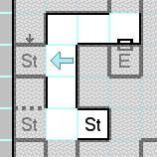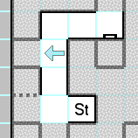These options controls how transparent the unvisited squares pattern (see *Map Book*) or image (see *Map Sheet*) is with respect to the lines on the sheet (and the notes, icons, and labels, if that option is enabled as well). These are the primary settings that are changed by the *Setup Wizard* "FAQ-Style" selection.

### Always reveal the edge squares

The built-in maps have a one-square border around all of their edges, in order to show information about adjacent sheets (typically for the surface maps, but occasionally for others). Since these border squares can't actually be visited, this setting allows them to be seen regardless of whether the squares are internally marked as visited. Disable the setting if you have created maps that do not make use of a set of border squares.

### Reveal inaccessible squares

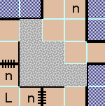This setting, if enabled, will perform a special test whenever a square is marked as visited. The test determines if an area marked as "inaccessible" (see *Show-always colors and patterns*) is now completely surrounded by visible squares. If it is, all of the squares in the contiguous inaccessible area will be marked as visited. This allows you to visually note that an area has been fully explored without requiring you to break your immersion by turning the *Hide squares that have not been visited* setting on and off.

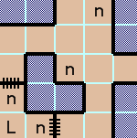This option is only particularly useful in *Might and Magic 3-5*, as those games prevent even the "etherealize" spell from allowing access to those areas. In *Might and Magic 1* and *2* there are some areas that are marked as "unimportant," but those are different than "inaccessible" in that the "teleport" and "etherealize" spells will still generally allow access to those square to verify that there is nothing of note in them (in fact, the "reveal inaccessible squares" logic is internally disabled for those two games to avoid some odd problems).

### Reveal teleporter squares

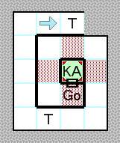One of the problems with using polling to determine the party's location is that if the location changes more than once between the checks (the internal interval used is 40 milliseconds) the change will not be noticed. When the party steps onto a square that automatically teleports them to another square, this tends to happen more often than not. There is no perfect solution to this problem, but if this option is set and the party is facing a square that contains a teleporter — which internally means that the note for the square begins with either "(Teleport" or "x% chance: (Teleport" — the square will be preemptively marked as visited. Also if the last key that was pressed (for example, the up arrow) but the next location read from memory is not the expected adjacent square on the map, the adjacent square will be marked as visited (though this fallback mechanism does not always work properly, particularly if the teleporter is random or sends the party back exactly one square, both of which are extremely common).

This option is probably sufficient if you are using the *Setup Wizard* "FAQ-Style" selection (and irrelevant if using "Full Visibility"), but in "Minimal" mode this option is disabled by default since knowing that the square in front of you is a teleporter is an extremely non-minimal amount of precognitive information for these types of games. There is no particularly good solution for the "Minimal" play style, though you can make your own workaround by turning *Cheating* on temporarily (see the *Toggle allowing cheats* keyboard shortcut to assign a hotkey for this purpose), right-clicking on the square that you now know is a teleporter (due to having been transported by it), and selecting "Toggle visited" to show the square. If the game has internal cartography you may also need to set *Update the in-game cartography when inaccessible squares are revealed*, to prevent the game from changing it back.

### Use in-game cartography data if available

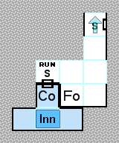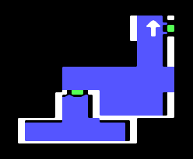For games that have their own method of keeping track of the party's movements (e.g. *Might and Magic 2-5*, *Bard’s Tale 3*), setting this option will use that internal cartographic information to automatically update the visited state of the squares on the current map sheet. This has some benefits over having "Where Are We?" manually keep track of the party's meanderings — for example, reloading a saved game will "un‑visit" any squares that had been marked as visited prior to that saved game, whereas in *Might and Magic 1*, once you have visited a square, even if your party dies and you reload at an Inn, the square is still seen as having been visited (although this is more in keeping with the "virtual graph paper" use of the software — your hand-drawn map isn't erased just because your party perishes, either). The using of the in-game cartography data only applies to the current in-game map; if you view other maps via the *Maps* menu, only the saved information will be seen.

### Hide items next to unvisited squares

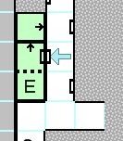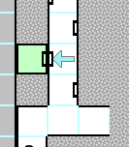This is another of the settings that *Setup Wizard* "Minimal" style enables. When set, this will hide any objects in a map square that reveal information about the adjacent square unless that adjacent square is marked as visited. For example, a small arrow pointing towards an edge typically indicates that travel in that direction is one-way. However, you would not normally know this until you step in that direction and find that you cannot go back, so that small arrow will not be shown until the party visits that other square (though they do not necessarily have to follow the arrow to do it; the level of sophistication of this feature is limited to what can be determined by a simple analysis of visited squares, not what path the party actually took to visit those squares). Bashable wall icons are also hidden for similar reasons.

An additional aspect of this option is to change dotted lines into solid lines until both squares that straddle the line are visited, as the dotted line tends to indicate a hidden passage. Note that if the *Opacity* is less than 100%, this will show solid lines instead of dotted lines throughout the partially-visible areas as well.

### Reveal partial information for seen squares

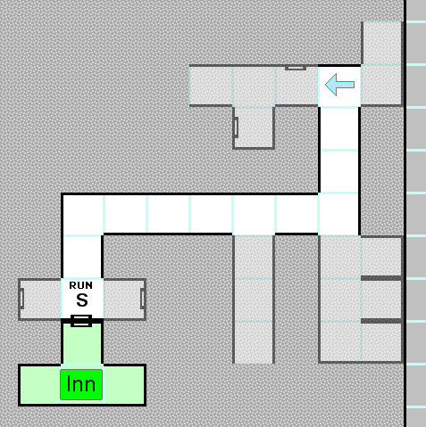In games for which no in-game mechanism exists for keeping track of which squares the party has “seen” (as opposed to actually visited), “Where Are We?” will, whenever the party moves, calculate a field of view three squares wide by four squares deep. Any squares that are visible from the party's location (i.e. not blocked by walls or other obstacles) after this calculation are marked as "seen" internally. When playing with *Hide unvisited squares* enabled, you may check this option if you would like these unvisited-but-seen squares partially revealed using the specified opacity. Notes are not revealed in these squares (unless *Show notes in unvisited squares* is set), and the only icons that are shown are those that would be visible in-game from a distance (e.g. doors or portcullises). Whether a square has been seen or not is not something that most games keep track of internally (though there are exceptions), and if playing one of those you will need to *Save* your map if you want to maintain that information between sessions.

Some games (particularly the *Wizardry* series) have different strengths of light available to the party (or traps that hinder sight partially). For these games, the sight distance (which is usually one of the items shown in the *Game Information* window) is taken into consideration when deciding which squares have been seen by the party. If there is no light whatsoever, only the square the party currently occupies will be considered “seen” (and visited).

Note that any type of *Lines* that would block line-of-sight to (at least part of) a square prevents it from being seen, regardless of any in-game transparency that might be provided. For example, in *Might and Magic 1*, a red line on a non-surface map indicates an invisible barrier, through which you might see a distant wall or doorway, but the squares past that barrier will not be revealed using this option. This is because the revealed squares would give away more information about other barriers, and the intention of this option is only to provide a little bit of extra utility to the *Minimal* play style while remaining as true as possible to the goal of minimizing unintended cheating via advance knowledge of the maps.

### Hide scroll bars in Play mode

If checked, the main window’s scroll bars will be removed when you are in *Play Mode*. They are always visible in other modes because drawing and moving items on a panel without them can cause some odd behaviors with regard to the starting point of the drawing action (which you may notice if you set one of your *Mouse Shortcuts* to "always draw as if in that mode" and use that function during *Play Mode*).

### Show labels on maps

Toggles whether *Labels* will be shown on maps or not. If this is not set, the *Map Labels* form will have "(not shown on map)" in the caption to remind you.

## Misc

### Read only maps/notes

Setting either of these prevents you from inadvertently making changes to the map or notes. Using *Play Mode* is typically more useful than setting these options.

### Edit mode affects

When using one of the commands that affects a selection in *Edit Mode*, (see *Cut/Copy/Paste/Delete* and *Manipulate*) these checkboxes allow you to choose which of the attributes of a map square are changed by that operation. Backgrounds are what are set using *Block Mode*, Outer Lines are the edges of map squares that surround the selection but are not part of it, Inner Lines are lines on map squares completely enclosed by the selection, and *Icons* and *Notes* should be self-explanatory. The "Select all" link will re‑check all of the boxes.

### Levels of undo (see *Undo/Redo*)

### Opacity of treasure window

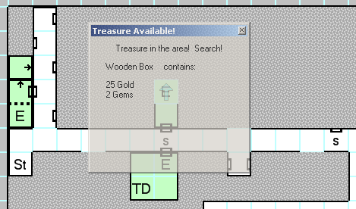Peculiar to *Might and Magic 1* and *2*, the Treasure Window will appear after combat is completed if there is anything to be found by using the in-game "Search" function. When this treasure window is up instead of the *Encounters*, it will be drawn with the opacity set here. The original purpose of this was to allow you to place the Encounters form over the main map form and have the map be slightly visible through the treasure window to remind you to search before leaving the square. If you are not going to place the Encounters form over the map window, leaving this setting at 100% is probably best.

### Opacity of You Are Here icon

TreasureOpacity.pngTreasureOpacity.pngTreasureOpacity.pngTreasureOpacity.pngDetermines the opacity in percent of the *You Are Here* arrow on the map, which indicates the position of the party. If you set it to 100% it may obscure the *Note Symbol* (or other information) in the square, as it is drawn above everything except *Monster Icons*. A sample of the icon at the specified opacity is shown to the right of the setting.

### Party info polling rate

This is the frequency at which the memory scanner reads party information is from the game memory; the default is 5 times per second (200 ms). If the program is becoming unresponsive when the *Party Information* form is open, try raising this value.

### Opacity of Monster icons

TreasureOpacity.pngTreasureOpacity.pngTreasureOpacity.pngTreasureOpacity.pngThis determines how transparent the "M" icons are on the map when monsters are located in the square (for *Might and Magic 3-5*). Monster icons are drawn above all other map objects (except the *Unexplored Area* pattern or image), so you may want them to be somewhat transparent in order to see the *Note* *Icon* and other information beneath them. To the right of this option are several examples of selected and unselected monster icons at the specified opacity.

### Show-always colors and patterns

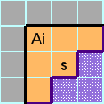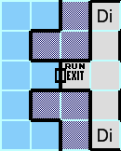The built-in maps for *Might and Magic 1-5* (mainly *3-5*) have areas to which the party can never normally move (even with spells such as "Etherealize" or "Teleport"), and to avoid having them never be revealed during a game with the *Hide unvisited squares* options set, they are always shown (with exceptions; see *Reveal inaccessible squares*). Those colors are shown here along with the type of terrain that they represent. Note that changing the styles here will not modify the maps, meaning that unless you create your own maps with your new styles, those types of squares will then be hidden. If you find yourself needing to set them back to the original values, the "Reset to defaults" link will do that.

### Unvisited squares bitmap cache size

When using a custom unvisited bitmap (see *Map Sheet*), the image must be divided into many small segments, which takes a nontrivial amount of time. In order to avoid having to repeat this process many hundreds of times when you switch maps, those smaller images are cached in memory up to the number of megapixels set here. The larger your background image, the larger this setting should be. Generally for good performance it should be at least twice as large as the size of one map's image (or image crop from the original). For example, if your main image is 4800x3200 pixels and it is divided into 24 (6x4) smaller images of 800x800 pixels each for the surface maps, the bitmap cache should be at least 2 \* 800 \* 800 = 1.28 megapixels (rounded up to 2).

Since memory in these amounts is typically not a serious concern, the default is 10 megapixels (40 megabytes), but you can lower it if you are running into resource problems). Very large values provide no particular benefit other than speeding up the process of switching rapidly through dozens of maps that have background images.

### Warn when loading a map book if it is missing any of its custom unvisited image files

By default, a warning will be displayed if a map book contains any sheets that reference an image file for the unvisited squares (see *Map Sheet*), but if you check "do not show this again" on the dialog, the message will be disabled. It can be re-enabled here. A map book is usable without the image files but will simply display the default pattern instead of the image.

## Keyboard

Almost any function is assignable to one or two different keyboard shortcuts via this tab of the options. See *Keyboard Shortcuts* for a comprehensive list of the different actions.

### Enable keyboard hook

A Windows keyboard hook allows a program to intercept keystrokes while another program is running. If this checkbox is set, "Where Are We?" will be able to understand keys that are pressed while DOSBox is running, without having to switch away from the game. This can be very useful for some functions (for example, showing the *Monster List*, *Cure All*, *Trade Backpacks*, setting your *Ready Spells*, etc.) that you would like to use without breaking your immersion in the game to select them from the menus.

In order to use a hotkey from inside the game you must enable the keyboard hook *and* check the box next to the action in the list (this is to prevent a key combination such as "Control+N" from inadvertently creating a new map while you are playing a game). Be aware that an active keyboard hook may appear suspicious to spyware-detection programs. "Where Are We?" does absolutely nothing with your keystrokes other than test them against the list of shortcuts, but it is certainly safe to leave the setting off if you would rather not worry (in fact, the default is not to use the hook at all).

### Shortcut keys

The full list of actions is shown here. Control+F will open up a search box to find a function by partial name (F3/Shift+F3 for next/previous). To assign a keyboard combination to a command, click in the "Input 1" or "Input 2" column and press the desired keys. To remove a shortcut, click on it and press the Delete key twice. The first items (prefixed with the menu name) are directly equivalent to the commands on the main menu, though only the "Input 1" keys will be shown on the menu itself (and even then only if they are valid for a Windows menu item; commands such as "Shift+1" will not be shown to the right of the menu item, though they will typically still work properly when pressed).

Some shortcuts will only work if the keyboard hook is enabled, due to the way Windows handles multiple simultaneous keys. In particular, a shortcut containing more than one non-modifier (Shift, Control, Alt) key is unlikely to work properly without the hook (for example, "Control+X+4") but will be handled properly if the hook is enabled.

### Reset to defaults

This will set all of the keyboard shortcuts back to the original set, which is fairly minimal.

### Import/Export

If you have a collection of keyboard shortcuts that you like, you may back them up and restore them independently of the rest of the program settings here. This function may also be useful if you would like to create a set of shortcuts on a per-game basis and import them as necessary (the *Command line option "-i"*  may be useful in that case as well).

### Enable Notifications

This checkbox will enable or disable all of the *Notifications* that have been configured.

## Mouse

Though not quite as extensive as the keyboard actions, there are a number of mouse-based commands that may be assigned to the mouse buttons and wheel here:

### Drag to scroll the map window in any mode

Whichever button is assigned to this function can be used to drag the map around if it is too large for the main window to display in its entirety. Note that if the *Keep the party location centered* option is set, it will override the manual scrolling when the party's location is updated from the game.

### Draw, move or select items, depending on the mode

This is the action that simply means "do whatever is appropriate for the currently-selected *Editing Mode* (for example, drawing blocks or lines, moving labels, or creating selections).

### Drag to scroll in Play Mode, draw/move/select items otherwise

This is similar to the previous action except that in *Play*, this button will drag the map around instead of selecting monsters, though you may still select them from the list (see *Encounters*).

### (Perform action) as if in (mode) except in Edit mode

This set of actions will perform the drawing action for the specified mode regardless of the actual *Editing Mode* that is selected (with the exception of *Edit*). For example, if you have a button assigned to "Always draw blocks as if in Blocks mode," that button will draw blocks on the map even if you are in *Play Mode*. The reason for the exception is to avoid complications that arise when attempting to draw while in the middle of moving or copying a selection.

### Zoom/Zoom to fixed percentage

When assigned to the mouse wheel (or modifier+wheel), "zoom" will change the zoom level of the map by around 10%, with preference for the 100%/150%/200%/300% levels if those are close to the desired zoom level (since the icons are crafted for those particular sizes). If "zoom to fixed percentage" is assigned instead, only those four exact levels will be allowed. If the mouse is over the map when you perform this action, a tooltip will inform you of the level and map square size that has been selected.

If the zoom level is too high for the sheet size, you will be warned and the zoom level will be set somewhat lower (the limit is fairly high; for example, the maximum zoom level for a 100x200 sheet is around 300%). The reason for this limit is that the bitmap image for the entire map at that zoom level is generated at once to make scrolling easier (since the typical usage is a 16x16 or at most 32x32 map). At lower zoom levels, the map may be much larger (a 500x500 map may be displayed at 50% zoom), but performance is not great at these sizes and it is recommended to keep the map size no larger than necessary. “Where Are We?” was designed with the intention of large numbers of map sheets in a map book, not large single maps.

### Select icons/Rotate icon

These actions will change to the next *Icon* or rotate the currently-selected *Icon* by 90°, respectively. Note that whereas selecting an icon from the toolbar will switch to *Block Mode* if necessary (icons can only be placed in the drawing modes), this mouse wheel action will only select an icon if you are already in one of the drawing modes.

### Change the block pattern

This will switch to *Block Mode* if necessary and cycle through the 25%, 50%, 75%, and 100% patterns for the selected *Block Color*.

### Change the line pattern

This will switch to *Line Mode* if necessary and cycle through the Solid, Dot, and Dash patterns for the selected *Line Color*.

### Change selected block/line style

This will switch to *Block*/*Line* mode if necessary and cycle through all of the custom *Block*/*Line* styles.

### Select the next or previous map sheet

Moves to the next or previous map sheet as with the *Previous/Next* menu items.

### Select the next or previous character

Cycles through the tabs on the *Party Information* form.

## Play

This collection of options are focused on launching and playing the game.

### Currently playing game

Selecting a game from this dropdown tells "Where Are We?" to actively search for that game every second or so in order to attach the memory scanner to it (see *Title regular expressions* for the captions used in this search). If you select "None" then the memory scanner will be disabled, which removes the (small but nonzero) overhead of scanning for a game if you are only using the program as a map editor rather than an automap for a particular game.

### Edit shortcuts

Brings up a dialog that allows you to change the shortcuts used when *Launch current game* is selected from the menu. This does not perform any kind of automatic search for the shortcuts; if you would like to use that feature, please run the *Setup Wizard*.

### Autoload file

This is the map that will be loaded when "Where Are We?" is started. There is a separate autoload file for each game in the *Currently playing game* dropdown. If you would like to use the built-in map for a particular game, select "(Internal Game Map)" instead of a filename. When you save a map while playing a game, that file becomes the autoload file for that particular game.

### Attempt to skip game introductions and start the default party

This option will attempt to detect the introduction and other miscellaneous pre-game screens on a per-game basis and send the proper keystrokes to move past them and into actual gameplay quickly. For example, in Might and Magic 1, it will wait for the screens and send keystrokes as shown below. The “Timing Tweak” setting allows some fine-tuning for a particular machine. At 200% tweak, the skip algorithm wait twice as long between events, and at 50%, half as long.

|  |  |  |
| --- | --- | --- |
| Send “Escape” | Send “Enter” | Send “1” |
| Send “Ctrl-A” to “Ctrl-F” | Send “X” | Ready for Adventure! |

### Launch game if it is not running

If set, this will instruct "Where Are We?" to attempt to launch the game selected in the *Currently playing game* dropdown when it starts up (unless it detects it already).

### Enable writing to game memory

This setting is required to be set if you want to use any of the *Cheating* features or some other functions that require it (such as updating the in-game cartography or the *Cure All* feature). If you do not want to use those, this setting may be disabled as an extra safety precaution against memory scanner accidents.

### Update the in-game cartography when inaccessible squares are revealed

When using the *Reveal inaccessible squares* feature, the map squares will be marked as visited. However, if the *Use in-game cartography data* setting is also being employed, it will typically overwrite those squares as being unvisited again. This option is a workaround that will mark the squares as visited in the game cartography itself as well as on the map.

### Restore HP with Cure-All

Restores hit points while curing conditions (see *Cure All* for details).

### Enable cheating

This is the same as the "Trainer" checkbox on the *Setup Wizard* and permits complete access to all of the right-click context menus that allow you to change aspects of the game to your liking. A message will be placed in the caption of the *Party Information* form when cheating is enabled as a quick way to determine whether an attribute in fact has no cheats or if this setting is simply disabled.

### Automatically switch map sheets when the in-game map changes

If set, the currently-displayed map sheet will change to whatever the current in-game map is (if the game window has focus). Note that the sheet's *Game Map Index* must be set properly in order for this feature to work. If the currently-display map is titled "Legend," this option will have no effect until a different map is selected (or "Legend" is clicked again).

### Automatically show notes for the party's location

If set, the *Note Text* will be updated whenever the party enters a square containing a *Note*. This is a convenience that you may not want if you are truly playing in a "Minimal" (see *Setup Wizard*) fashion, as the notes typically explain the results of choices made by the player. Another option for the minimalist style is to hide the *Notes Panel* entirely.

### Keep the party location centered

This will attempt to keep the party's location (i.e. the *You Are Here* icon) in the center of the map, if the map is too large for the main window. The centering is only applied when the party's location changes.

### Hide information about unidentified items

For games that require items to be identified (*Wizardry* and *Bard’s Tale*), having this option checked will show only a string similar to “(unidentified item),” “(unidentified shield)” or similar. The string will closely represent what is shown to the user in the game itself (for example, “?SHIELD” in *Wizardry*). If this option is not checked, an item’s full description will always be shown in the *Party* window regardless of the identification state.

### Place an indicator after a character's name when new inventory items are obtained

If checked, a Δ symbol will be shown after a character’s name in the *Party* window if a new item has been placed (created, traded, purchased, etc.) into that character’s backpack since the last time the symbol has been cleared. This can assist with quickly locating which character has found an item in games that give loot to a random character. To clear the symbol, simply double-click on the character name tab. This option may also be turned on and off by right-clicking on the character name tab and selecting it from the context menu.

## Windows

### Reset positions

This will set all of the saved window positions back to the defaults, which are (except for the *Party, Game*, and *Encounter* information forms) to show the form centered in front of the main map window.

### Save DOSBox window position

This will store the position of the DOSBox window when you close "Where Are We?" and restore it when you start it up or select *Launch current game*.

### DOSBox window position settings

If you find yourself accidentally moving DOSBox around the screen (or resizing it, in versions that have a resizable border), these options may help. When set, "Where Are We?" will monitor the position and/or size of the DOSBox window and adjust it according to the settings here. Clicking "Use current location" or "Use current size" will copy the currently-running DOSBox properties to their respective controls. Note that the standard build of DOSBox cannot be resized once started and so the "Keep DOSBox window at size" function will likely fail (this is why the location and size are selectable separately).

### Snap windows to edges

When this is enabled, most "Where Are We?" windows will move to be exactly aligned with other windows (including the DOSBox window) when they are dragged to within 20 pixels of the other window. If you have a lot of windows of varying sizes close to each other, however, this function may be more confusing than helpful. Hold down Alt to disable it temporarily while dragging a window.

### Show only one window in the taskbar

When enabled, the main "Where Are We?" map window will be the only one displayed in the Windows task bar (as well as the DOSBox window, as that is a separate process). Otherwise, windows such as the *Party Information*, *Game Information*, and *Quests* forms will be shown as well.

### Ensure that the DOSBox window is visible when any window is selected

When enabled, this will include the DOSBox window in the collection of windows brought to the foreground when any of the "Where Are We?" windows are activated. Otherwise, you will need to manually locate the DOSBox window if it becomes lost behind others. The most recently focused window will be brought to the foreground, but as the DOSBox window is its own process it may sometimes behave in slightly unexpected ways.

### Minimize and restore DOSBox with Where Are We and vice-versa

If this is checked, minimizing the main “Where Are We” window will also attempt to minimize any DOSBox window that is running, and restore it when the main window is restored. This is to help maintain the illusion that the game and the map (and other information) are part of one program.

### Show party/game information window automatically

If set, the *Party Information* and/or *Game Information* forms will be shown on startup (unless the *Currently playing game* is set to "None"). If you manually close either of the forms, the corresponding option will be deselected on shutdown.

### Automatically switch character tab when the in-game active character changes

If set, the character tab on the *Party Information* form will change whenever you select a different character in-game. Note that this only applies when the game window actually has focus.

### Show spell window when casting a spell

Brings up the *Spell Reference* whenever the memory scanner determines that one of the in-game characters is attempting to cast a spell.

### Show shop inventory window when in a store

Brings up the *Shop Inventories* whenever the memory scanner determines that the party is in a store that sells items.

### Equipped and backpack inventory window locations

This dropdown allows you to force the *Party Information* form to display the Equipped and Backpack windows either to the left and right ("Side-by-Side") or one below the other ("Top-and-Bottom"). The default ("Automatic") will select the former if the window is over a certain width.

### Notification window delay

This is the amount of time that a *Notification* will be displayed before disappearing (the fadeout is part of the total time).

## Spells

*Might and Magic 3-5* have the concept of a "Ready Spell" that a character can cast without opening the main list of spells to select one. This page allows you to select what the effects the *Spell Hotkey 1-10* keyboard actions will have (you will probably also want to enable the *Keyboard Hook* so that you can use the hotkeys while the game window is in the foreground) . You may set any spell to any key, but unless *Cheating* is enabled, the spell will only be set in-game if that character actually knows that spell. These hotkeys can make it much more convenient to use a party full of spellcasters; for example, in order to make it easy to fight monsters that are vulnerable to different elements, you could set one key to assign everyone's ready spell to "Fireball," another for "Fantastic Freeze," and a third to "Mega Volts." Another set of hotkeys might allow you to easily select between spells that target a single monster versus ones more suited to monster groups.

### Spell Hotkeys

This is the area where the spell hotkey actions are set. There are a different set of actions for each game that supports the concept of a "Ready Spell" (i.e. *Might and Magic 3-5*) and one for other games (namely, “Cast with Current Character”). The two main categories in the hotkey dropdown for ready spells are:

##### Set Character Ready Spell

This will set the selected spell as one particular character's ready spell. *Might and Magic 3* allows any character's ready spell to be set to any spell in the game, so if *Cheating* is enabled, a Paladin (for example) could have a ready spell of "Implosion" (which can normally only be cast by Sorcerers). *Might and Magic 4-5* is more restrictive; the ready spell may only be one that the class may ordinarily use.

##### Set all Arcane/Cleric/Druid Casters' Ready Spells

These function as the *Set Character Ready Spell* does, except that it will set that spell for all characters that can use it. For example, if you select "Set all Arcane Casters' Ready Spells" to "Fireball" then pressing the hotkey will set the ready spell to Fireball for all Sorcerers, Archers, Druids, and Rangers (if they actually know the spell, unless *Cheating* is enabled). Note that even if *Cheating* is enabled, this will not set the ready spell for characters that can't normally cast it (whereas the hotkey to set only a particular character's spell will, in fact, do exactly that).

For games that do not support a “ready spell,” the only hotkey option is to cast the selected spell with whatever character is currently active in the game.

Each game has its own list of spells that may be selected, but the first ten items in each list are always “Favorite Spell #1” through “Favorite Spell #10” because the Favorites tab in the *Spell Reference* is available for every game. Selecting this item will cast whatever that character has set as the numbered favorite spell. Each character has a distinct set of favorites, so you could assign a hotkey to “cast Favorite Spell #1” that would potentially cast a different spell for each character. For example, if you want a hotkey to “cast the character’s best damage spell,” this could be “Fireball” for your druid, “Flying Fist” for your priest, and “Incinerate” for your high-level hireling mage (but with the same hotkey pressed for each character’s combat turn).

### Send the appropriate keys when a spell is double-clicked

If this option is checked, double-clicking on a spell in the *Spell Reference* form (that can be cast by the active character) will send the proper keystrokes to the game to cast the selected spell. Otherwise, a spell information dialog will be shown. You can also always explicitly choose what happens by selecting the appropriate menu item from the spell’s right-click context menu.

### Show Favorites tab when a character is casting a spell

If enabled, a tab titled “Favorites” will appear on the *Spell Reference* form when a character is casting a spell in the game. This list is populated manually by selecting the “Add to Favorites” context menu item for a spell on one of the other pages. This page is a convenient location to place the spells you use most often so that you do not need to search the entire spell reference for them. The context menus for the Favorites page allow you to remove one or all (if none are selected) of the favorites from the list. The spells on the Favorites tab are saved with your map when you *Save* your .WAW file.

## Encounter

These settings apply to the *Encounters Form*.

### Show encounter window when entering combat

If set, the *Encounters Form* will be displayed when in combat mode (*Might and Magic 1* and *2*) or if there are visible monsters on the map (*Might and Magic 3-5*).This is the same setting as is set by the main menu item *Show encounters when in combat*.

### Show treasure window when searching is possible

Only relevant for *Might and Magic 1* and *2*, the *Encounters Form* will be replaced with a window describing the treasure that will be obtained if you use the in-game "search" function. This information is a bit of clairvoyance and you may wish to disable it if you are playing in an extremely minimalist way (See also *Opacity of treasure window*).

### Show dead monsters in the encounter list

In the games with monsters visible on the map (*Might and Magic 3-5*), killing a monster doesn't actually remove it from the internal monster list (see *Remove all monsters from map*), but instead changes the monster's coordinates to somewhere off of the map. If this option is enabled, you will see those "dead" monsters in the list as well (see also the *Show dead monsters* context menu item).

### Show monster icons on maps/Indicate activated monsters

In the games with mobile monsters (*Might and Magic 3-5*), having the first setting enabled will show icons (Monster_Icons.png ) on those squares (see also *Opacity of Monster icons*) and, if the monster has been alerted to the party's presence (loosely equating to "facing and within 3 squares of"), the second setting will show an exclamation icon (Monster_Icon_Activated.png ) on them as well. Note that a square containing more than three monsters will still only have three monster icons.

### Show monsters in unexplored areas in the encounter window

If *Hide squares that have not been visited* is enabled and a monster is in an *Unexplored Area*, this setting will determine whether that monster is shown on the *Encounter Form* or not.

### Show only monsters within the detect monster range

In *Might and Magic 3-5*, monsters are only visible and able to be activated when they are within three squares of the party, which is also the radius of the "Detect Monsters" in-game skill. If this setting is checked, *Monster* *Icons* will be shown only if they are within this radius of the party. Note that monster icons are never shown on squares that are not marked as "visited" (unless *Hide unvisited squares* is unchecked), regardless of this setting. However, monsters will be shown in areas that are *Seen*, and even though a partially-transparent unvisited square looks similar to a "seen" square, this is one of the differences between them.

### Hide monsters that are only serving as script bits

Peculiar to *Might and Magic 4/5* are (sometimes quite large) collections of monsters that are in inaccessible areas. The scripting language for that game makes it easy to test whether a particular monster is alive or dead, and to kill/resurrect them. Because of this, a fair number of the scripts (especially on *Darkside of Xeen*) use the state of these monsters to hold information (e.g. whether a button has been pressed or not). This setting will prevent those monsters from being displayed on the map or on the *Encounter Form*.

### Indicate squares with active scripts/Show encounters only

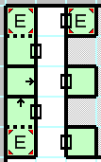This option only applies to *Might and Magic 1* and *2*, and for those games will indicate (via red triangles in the corner) any squares for which an active script is present. An active script is required for any interaction with the game other than normal movement and truly random encounters. Most active scripts are fixed encounters; if the “Show encounters only” box is checked, only those forced-encounter squares (and not, for example, inns, temples, traps, teleporters, etc.) will be shown. See also *Remove all monsters from map* and *Reset monsters on map*.

### Encounter info polling rate

The is the number of milliseconds between requests to the memory scanner to update the encounter information. If the program is becoming unresponsive only while the *Encounter Form* is open, you may need to raise this value.

## Quests

These settings apply to the *Quests Form*.

### Show current map Nearby/Flagged goals in bold

If this setting is enabled, quest goals that are on the current map will be shown in bold type in the list on the right if you are viewing the quest via the "Flagged" or "Nearby" tree nodes. If every single goal is on the current map, however, this setting will be ignored for that quest for cosmetic purposes.

### Prefix the quest with the giving entity's name

If enabled, this will prefix all quests in the tree with the name of whoever or whatever gave your party the quest (if applicable).

### Show the rewards for quests

If enabled, the rewards (if any) for completing a quest will be shown in parenthesis after the quest name in the tree.

### Hide invalid quest goals

If set, this will hide goals that are not valid for the currently-selected character (for example, a Knight viewing an optional task that can only be completed if you are a Robber). Otherwise, those goals will be shown in an dark yellow italic font.

### Quest info polling rate

The is the number of milliseconds between requests to the memory scanner to update the quest information. If the program is becoming unresponsive only while the *Quests* form is open, you may need to raise this value.

## DOSBox

These settings apply to the interaction between "Where Are We?" and the DOSBox process and window that hosts the game.

### Title regular expressions

These strings will be used to check for a match against the DOSBox caption in order to determine which game is running. The caption match is a quick process that is necessary before the memory scanner will attempt to locate certain key pieces of information in the process memory to ensure that the process is really for the selected game. Press F2 or double-click on an entry to change the value. How regular expressions operate is beyond the scope of this document, but for the default values be aware that the '$' character means "the end of the string" (so that "MM3$" matches the string "MM3" at, and only at, the end of the caption). Also note that there are spaces in the default strings. You may right-click on any entry in the list and select "Reset to default," or right-click where there is no item and select "Reset all values to default" if you so choose.

### DOSBox memory quick-scan only

Each of the memory scanners contains a string of bytes for which it searches through the memory of the DOSBox process. They also contain a small number of guesses as to exactly where those bytes might be (in particular, the offsets that differ between various builds of DOSBox). Searching those few guesses is called the "quick-scan" and takes an extremely small amount of time to succeed or fail. However, if a new version of DOSBox is created for which these guesses are incorrect, you may need to disable this setting and do a full scan of the entire memory of the process. This takes a nontrivial amount of time (a few seconds), so it is better if it is not needed (though the quick scan is always tried first regardless).

The memory guess locations are not directly editable in the options, but they are in the application's config file as an XML string.

### Warn if the game process is re-acquired repeatedly

After the initial memory scan, a *Watchdog timer* will check every few seconds to make sure that certain parts of the process memory are what it is expecting. If this memory is incorrect more than 10 times in a 30-second window, a warning will be shown. The warning may be disabled by unchecking this box, but the memory scanner will not work properly if this error is appearing for whatever reason.

### Offer to switch to the map for the running game

After *Launching a game*, if you are using one of the internal maps, and the memory scanner reports that the currently running game uses a different map (for example, you are viewing the *Might and Magic 1* map, and you launch *Might and Magic 3*), a message will appear asking if you want to switch maps. Disabling this option will prevent that question from being asked (and will not switch maps).

### Send keys to DOSBox for screen refreshes

After certain operations that update the game memory (such as *Cure All* and the *Character Creation Assistant*), the game screen will no longer match the internal numbers (for example, your character portrait or condition will still appear to be poisoned, or the stats will still be the original rolled values rather than any weighted exchanges you have made). In the case of the character portraits this is only a cosmetic issue, but if your stats show incorrectly it can keep you from choosing a class for the character (since the game is restricting the choice based on the original stats).

If this option is enabled, keystrokes will be sent to DOSBox to perform an innocuous action that has a side effect of forcing the game to re-read its own memory. For example, after a *Cure All* operation, a “dismiss a character, then cancel that dismissal” sequence will be sent (in *Might and Magic 3-5*). If you are using the standard release of DOSBox, the game window will be brought to the foreground (as it does not accept keys otherwise). Some of the SVN builds that include a menu bar do not have that restriction, and so it will be left in the background for those versions.

### Delay before starting the memory scanner

After *Launching a game*, a delay specified by this setting will take place before the memory scanner attempts to locate the memory markers to initialize itself. This delay helps prevent failures due to the program not being completely loaded. The minimum value that functions correctly depends on the speed of your machine.

### Watchdog timer

If the *Currently playing game* is set to anything other than “None,” the memory scanner will search for known games at intervals specified by this setting. If a game is found (see *Title regular expressions*), the memory scanner for that game will be started. If *Offer to switch maps* is enabled and you are using one of the built-in maps, you will be offered the chance to change to the map for the newly-detected game.

## Import /Export/Reset all settings

These links will allow you to save and restore the settings for the entire program. If the settings are corrupted in such a way that the “Where Are We?” will not start at all to allow access to these links, try specifying *--resetsettings* on the command line when starting it.

# Command-Line Options

"Where Are We?" is not particularly command-line driven, but there are a few. You may also add the path to a .WAW file at the end of the command line in order to load that file on startup.

### -g [game]

This will set the *Currently playing game* to the game represented by [game]. The possible arguments are mm1, mm2, mm3, mm45, bt1, bt2, bt3, wiz1, wiz2, wiz3, wiz4, and wiz5.

### -i [file]

This will import a previously-saved file of settings (see *Import/Export/Reset all settings*).

### --resetsettings

Changes all of the settings and options to their default values. This will reset all window positions, hotkeys, game paths, etc. and run the *Setup Wizard* again.

# Keyboard Shortcuts

From the Keyboard tab of the Options menu, these actions may be assigned to one or two separate key combinations and are described here.

## Notifications

If you right-click on any of the actions (or press the Insert key) you can launch the "Edit Notification" window. A notification is a text message and/or an audio alert that gives you feedback when an action has taken place. Most actions have no default notification, but you may create one for any that you wish (actions with default messages include *Cure All*, *Trade Backpacks*, and the *Spell Hotkeys*) so that you can be certain that the key you pressed did have the intended effect.

If you click "Show Variables" from the Edit Notification dialog, you will see the list of strings that will be replaced with a piece of in-game information when the notification is actually displayed. For example, the *Trade Backpack* with Characternotifications use the string "$curChar traded with $actionChar: $successState" which means that your actual notification will include both the currently-selected and the target character's actual in-game names, along with "succeeded" or "failed" depending on whether the trade was made. Similarly, the *Cure All* notification might say "failed" if your party is too close to active monsters on the map. If the variable name begins with an uppercase letter, the replacement string will be capitalized as well (for example, $successState becomes "succeeded" whereas $SuccessState becomes "Succeeded"). Notifications are intended for short strings, but you may use "\n" to place a newline in the text if you wish. Be aware that the notification dialog does not expand, so large amounts (or several lines) of text will cause parts of the string to fall outside of the boundaries and not be displayed.

If you would like audible confirmation of an action, check the "Audio File" box and enter (or Browse to) the location of a suitable short .wav file. If the WAV file cannot be located at the absolute path you provide, "Where Are We?" will also search in the directory in which the executable is located (in the same way as the custom unvisited bitmap on a *Map Sheet*). Pressing the "Play" button will test the file.

For more complex audio feedback, be aware that the variables are also replaced in the Audio File path, so you could create a path such as "CureAll-$successState.wav" that will attempt to play "CureAll-succeeded.wav" if the Cure-All succeeds, and "CureAll-failed.wav" if it does not. Although any variable may be used here, $successState and $enabledState will probably be the most useful. Pressing the Play button with one of those variables in the path will choose the succeeded/enabled state for the test playback.

## Actions

These are the actions available for assignment to keys and notifications.

### File/Edit/View/Mode/Sheet/Game/Help menu shortcuts

These first shortcuts are directly associated with the main menu items of the same name. The "Input 1" keys will be shown on the menu item itself, if they are valid.

### Zoom In/Out

Allows a key combination to work in the same manner as *Zoom/Zoom to fixed percentage*.

### Move Cursor

These move the cursor in *Keyboard Mode* in the direction indicated.

### Toggle Line / Toggle Double Line / Toggle Background

When in *Keyboard Mode*, these actions will place (or remove) a line of the current *Line Color* on the edge specified of the map square under the cursor. If it is a double line, a corresponding line will be placed on the opposite edge of the adjacent map square. "Toggle Background" will use the current *Block Color* to set (or clear) the background of the map square instead of the lines.

### Expand Sheet

Adds new map squares to the edge(s) of the current sheet in the specified direction (see *Expand Sheet*).

### Move background image crop area

This collection of shortcuts will move the custom unvisited bitmap (see *Map Sheet*) either one or ten pixels in the given direction. Mapping these actions to keys allows you to easily reposition the custom bitmap in relation to map features (for example, to ensure that the graphic for a town actually falls on top of the in-game square in which that town lies).

### Cycle through the door icons

This action will cycle through either the four on-wall door icons or the two in-square door icons, depending on this map book's setting (see *Map Book*). By default the mouse wheel will also cycle between the different rotations, but this action will also select the door icon if another icon is selected.

### Reset Memory Scanner

This will forcibly destroy and re-construct the object that scans the DOSBox process for information about the game. Typically the *Watchdog timer* will take care of any sporadic issues, but this action is available here as well if necessary.

### Cure All

These actions will invoke the *Cure All* feature for either the currently-selected character or a specific one (for example, your Cleric). Note that assigning a key to this action will perform the Cure-All without displaying a dialog for specific failure conditions (for example, you will not see a message if you have insufficient gems to cast all of the necessary spells) as opposed to clicking the link on the *Party Information* form. However, by default a *Notification* will be shown that will disappear automatically. The *Party Information* form must be visible in order to use the "selected character" feature.

### Load Recent Map

This will load one of the maps in the most-recently-used list on the *File Menu*.

### Show/Hide Map Legend

If there is a map sheet entitled, "Legend," this action will show that sheet. Pressing the shortcut key again will re-show the sheet that was visible originally.

### Encounter Window

This action will toggle the visibility of the *Encounter* form when in combat.

### Trade Backpack with Character

These will trade the backpack of the current character with that of the one specified in the action.

### Teleport to Cursor

This action will, if *Cheating* is enabled, teleport the party to the current *Keyboard Mode* cursor.

### Spell Hotkey 1-10

The keys assigned to these actions are used in a manner determined by the *Currently playing game* and the *Spell Hotkeys*.

### Set In-Game Cartography for Current Map to Visited/Unvisited

These actions will, if *Cheating* is enabled, change the in-game cartography (for games that use it) to be entirely visited or entirely unvisited (see *Edit Cartography Data*).

### Copy Current Location to Clipboard

This will copy the map and coordinates of the party’s current location to the clipboard as a string.

### Select Character in the Party Information window

These actions will set the focus to a particular party member on the *Party Information* form.

### Move the DOSBox window to the preset location and size

If *Save DOSBox window position* is enabled, the location of the DOSBox window will be saved whenever you exit the “Where Are We?” program. This action will manually move DOSBox to that saved position.

### Rotate the currently selected icon

If you are placing an *Icon* on the map, these actions will rotate it 90° in the specified direction.

### Redraw the map display

This will force the entire map image to be regenerated and may be useful if something in the display logic has failed to identify an area that needed to be redrawn.

### Select block/line color/pattern

These actions will select one of the first ten *Block* or *Line* styles.

### Use note template

These actions will insert the specified note template at the current *Keyboard Mode* cursor position.

### Change the current block/line style

These actions will open the selection dialog for the *Block* or *Line* styles in the same manner as clicking on the toolbar buttons.

### Select the next/previous common block/line style

For *Blocks*, this will cycle through the 25%, 50%, 75%, and 100% hatch patterns. For *Lines*, it will cycle through the solid, dotted, and dashed styles.

### Select the next/previous icon

If you are placing an *Icon* on the map, these actions will select the next or previous available icon.

### Select the next/previous character in the party window

Focuses on the next or previous character tab in the *Party Information* form.

### Open specific tab of the Options dialog

These actions will open the *Options* dialog with the focus set to the specified tab. For example, you could have a particular key open up the *Keyboard* tab quickly in order to test the effects of different actions without needing to select it each time you open the Options.

### Switch to one of the wizard play styles

Switches to one of the play styles available on the *Setup Wizard* (Minimal, FAQ-Style, or Full Visibility).

### Select the next/previous custom block/line style

Cycles through the entire list of *Block* or *Line* styles as specified on the *Colors* form.

### Switch between the most recent block/line styles

Swaps the current *Block* or *Line* style with whichever one was selected previously.

### Cycle opacity of a UI element by 10%

These actions will increase the opacity of various items by 10% (wrapping back to 30% if over 100%).

### Toggle allowing cheats

Changes the *Cheating* setting in the *Options*.

### Attack/Shoot/Defend the first monster with the current character

This will attempt a form of auto-combat using the active combat character. The algorithms used by each game are somewhat different but generally the priority is to use a melee attack against whatever monster is closest, or a ranged attack if melee is impossible. If neither can be performed, the character will block, parry, or otherwise adopt a defensive action. Spells will not be auto-cast (see *Spell Hotkeys* for ways to quickly cast spells).

### Toggle various settings in the Options

There are a number of actions that simply toggle the setting of the same name. They are not all listed here; please see their entry in the *Options* form for more information.

# Appendices

## Editing Bytes

Whenever a byte string is directly editable (for example, the *Awards* editor), you may prefix an integer with a period (e.g. “.85”) in order to automatically convert that decimal to hex when saving the string of bytes. For example, the string “0E 0F 1B .85 .255 .99999” will be converted to “0E 0F 1B 55 FF 9F 86 01” when saved (values greater than 255 are saved in little-endian order).

## Requirements

"Where Are We?" requires the .NET Framework version 4.5 or greater, which can be downloaded from Microsoft's website if it has not already been installed via a Windows Update. If you are not running as an Administrator, DOSBox must also not be run as an Administrator (or the memory scanner will not be permitted to access the process memory space). As of this writing, running the *Might and Magic* games as a non-administrator is not a good idea, as the game will not necessarily be able save to its own data files properly.

Ideally the program will work with any version of DOSBox and the *Might and Magic* games, but these are the versions that were used during testing:

DOSBox (non-SVN) 0.74 (provided with the GOG.com versions of *Might and Magic*)

DOSBox (SVN-Daum) 2014-01-27 and 2015-01-25 (32-bit and 64-bit\* versions)

Might and Magic 6-Pack GOG.com version 2.0.0.41

\*As of this writing, *Might and Magic 4-5* does not work properly on the 64-bit build of SVN-DAUM DOSBox

## Supported Games

These are the games supported by “Where Are We?” as of this writing

Might and Magic 1-5 Versions\* from the “Might and Magic 6-pack Limited Edition” (via GOG.com)

Bard’s Tale 1 BARD.EXE MD5 hash: 227d89c104fed7111d4163f3025535b2

Bard’s Tale 2 DK.EXE MD5 hash: 0bbe5684b53ceb9c1ecf2d7e13b70869

Bard’s Tale 3 THIEF.EXE MD5 hash: c2c7022228d3eceaf77b92421321de44

Wizardry 1 WIZ1.DSK MD5 hash: f316c0662d626ecda14dba51aca7f48f

Wizardry 2 WIZ2.DSK MD5 hash: 2800aaa829397fef26cf196352c800b6

Wizardry 3 WIZ3.DSK MD5 hash: 2de2052e7de0dd256d98b473444f35fa

Wizardry 4 WIZ4.DSK MD5 hash: 348685d2e17467d0f2ac00c368dca4cf

Wizardry 5 WIZ5.DSK MD5 hash: c6ce27c043172ecd534d0de19d09e060

\*Both the speech and non-speech versions of Might and Magic 4-5 are supported from this pack.

## Internal Settings

There are a number of settings that are in the config file for “Where Are We?” but not exposed via the options dialog. The location of this file varies from system to system but is typically named “user.config” in a directory named “C:\Users\<username>\AppData\Local\Microsoft” or similar. The following is not an exhaustive list, but may be useful. All of these settings are in the XML structure using the path “/configuration/userSettings/WhereAreWe.Properties.Settings” and node name “setting”

|  |  |
| --- | --- |
| Setting Name | Description |
| DosBoxProcessName | The name of the DOSBox executable that is running the desired game. If this setting is “dosbox” then “dosbox.exe,” “dosbox\_debug.exe” and “dosbox\_x64.exe” will be identified as processes of interest for memory reads and writes. |
| DosBoxProcessName2 | An optional alternate process name for the DOSBox executable. |
| DOSBoxClass | The DOSBox executable’s main window must match this class to be considered valid. |
| DOSBoxCaption | The DOSBox executable’s main window caption must match this to be considered valid. |

## Building the Project

The WhereAreWe.sln files should build in Visual Studio 2017 (earlier versions may work, but this is the one currently used by the author). There are a lot of files, but everything should be more-or-less self-contained. There is one pre-build step that calls GZipWAWFiles.bat from the Resources directory which will not work if Perl and gzip.exe are not installed (to run GZipIfNew.pl). If you do not want to bother installing Perl for that purpose, you can change the batch file to call GZipIfNew.ps1 to use PowerShell instead. I have found the Perl/gzip combination to be much faster (and I already have Perl installed for other projects), but either will serve the purpose of compressing the .WAW files in the Resource directories for inclusion in the executable.

## Map Icon Index

For many games the following icons are used for these general purposes:

|  |  |
| --- | --- |
| Icons1.png | A teleporter that moves the party a single square in the indicated direction |
| Icons1.png | Indicates that one-way travel is possible in the direction of the arrow |
| Icons1.png | A basic door |
|  | A locked door |
|  | A square that rotates (or otherwise alters the walls, as opposed to a spinner) |
| Icons1.png | A stairway (or other method of moving vertically between maps) |
| Icons1.png | A wall that can be bashed down (or simply passed through) to reveal a passageway |
| Icons1.png | A portcullis or other barrier |
| Icons1.png | The primary exit from this map, typically to an outdoor area |
| Icons1.png | The square to which the party will move when running from combat |
| Icons1.png | A spinner or other mechanism that will rotate the party on this square |

## 

## Surface Maps

The default maps for *Might and Magic 1-5* and *Bard’s Tale 1-*2 have custom image files specified for the unvisited bitmaps on the surface maps (see *Map Sheet*). These files must be located in the directory with WhereAreWe.exe in order to be used in the game or you may receive a *Warning*. If they are not also the size listed, the crops used for the surface maps will probably be incorrect.

Filename Dimensions (pixels)

Might\_and\_Magic-1-Surface\_Map.jpg 2577 x 1795

Might\_and\_Magic-2-Surface\_Map.jpg 2048 x 1553

Might\_and\_Magic-3-Surface\_Map.jpg 5089 x 3924

Might\_and\_Magic-4-Surface\_Map.jpg 1600 x 1262

Might\_and\_Magic-5-Surface\_Map.jpg 1600 x 1260

Bard's\_Tale\_1-Skara\_Brae.jpg 1230x1173

Bard's\_Tale\_2-Wilderness.jpg 868x1017

Of course, you may certainly alter the map sheet information to use whichever files you like, and select the correct crops from those images. These are the files that were available to the author at the time.