The following document is meant to instruct with the downloading of data and calibration standards from Maxim iButton Thermochron (1921G) and Hygrochron (1923) sensors.

Assumptions made in this manual:

* The user is accessing the iButton with the One Wire Viewer application provided by Maxim at the following address: <http://www.maximintegrated.com/en/app-notes/index.mvp/id/4373>
  + If you have not yet installed the application please do so before attempting to connect to an iButton sensor, as this prevents complications with the installation. If problems arise during the installation of the application please refer to the following link: <https://support.maximintegrated.com/tech_support/submit_question.mvp?pl_id=22>
* This manual was written using the 64bit version of the application

Maxim iButton Data and Calibration Standards Aquisition

There are a few extra steps to follow the first time an adapter is attached to a computer. After the adapter is set up these steps will no longer be necessary.

1. Open the One Wire Viewer application.
2. Place the iButton into the adapter and connect the adapter to the computer.
3. Go to the tab that corresponds to the type of adapter you are using, listed on the back of the adapter. ( i.e. DS9490B for usb adapter)
4. If port is not automatically selected, click the **Refresh Adapter List**.
5. Click **Next**

Data:

1. Select the iButton adapter from the device list by double clicking

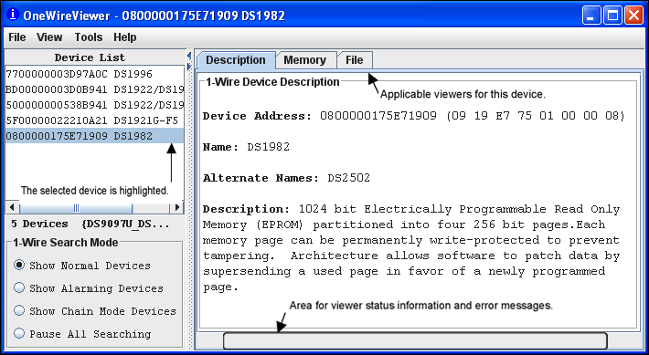

1. If needed click on the Thermochron/Hygrochron Viewer Tab.

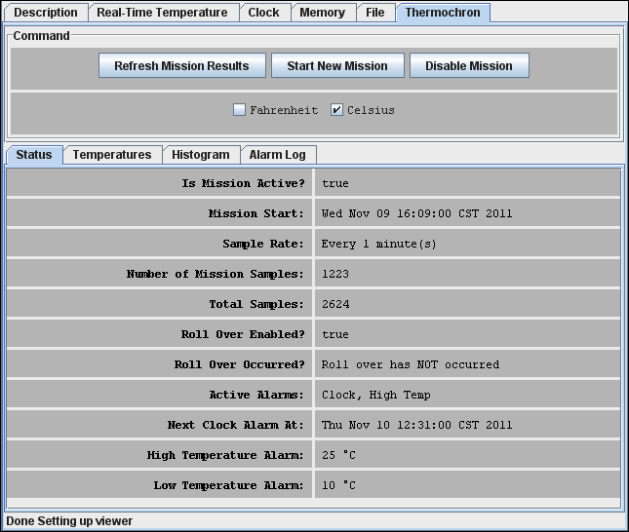

1. Click on **Temperature**, this will show you the temperature data that has been logged thus far.
2. Click on the **Save Data** button and select to save as a *.csv* file
   1. The file name should have the following structure: [site name]_[location #]_[sensor type/# if applicable]
      1. Ex. ‘Guv_101_temp’ or ‘Bari-2_101_temp2’
3. For the Hygrochron (DS1923) there is a **Humidity** Tab, it shows the humidity data that has been recorded.
4. Click on the **Save Data** button and select to save as a *.csv* file
   1. The file name should have the following structure: [site name]_[location #]_[sensor type/# (same as for temp)]
      1. Ex. ‘Guv_101_humidity’

Calibration Standards: ( For Hygrochron DS1923)

Two sets of calibration standards are needed for Hygrochron data, the temperature and humidity standards. Below are the instructions for how to extract both.

1. Select the iButton adapter from the device list by double clicking; if the console is not already open.
2. Each device has a unique Device Address. This can be viewed and copied from the **Description** tab.
   1. Make sure to copy down the Device Address in order to be able to tie in the device to its data from last year.
3. Go to the **Memory** tab

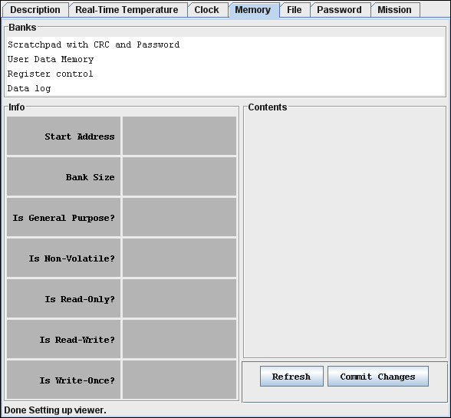

1. Select **Register control**, the data will be listed in rows of hexadecimal numbers.

(As shown with the scratchpad data below)

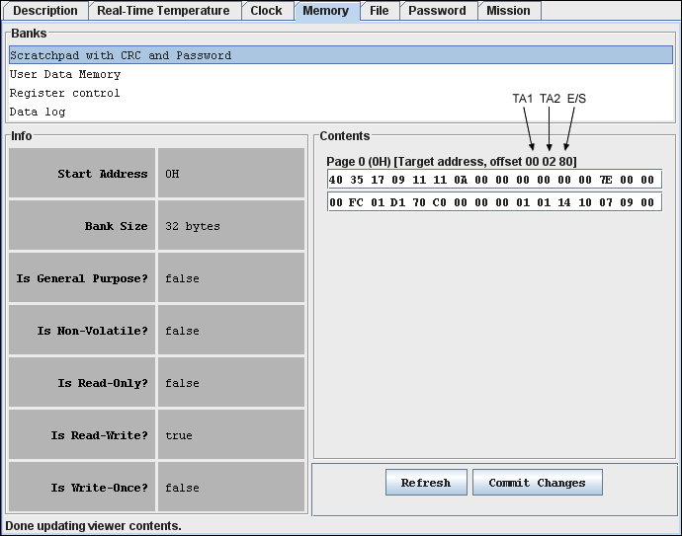

1. Go to the section titled 240h - 25Fh ( Section 260h - 27Fh is a duplicate of the same information)
2. Copy the two rows of hexadecimal numbers to a file.
   1. Make sure to copy the lines over in proper order, the first line contains the temperature standards and the second contains the humidity standards.
   2. Keep the standards grouped with the device’s address, so the standards are applied properly.