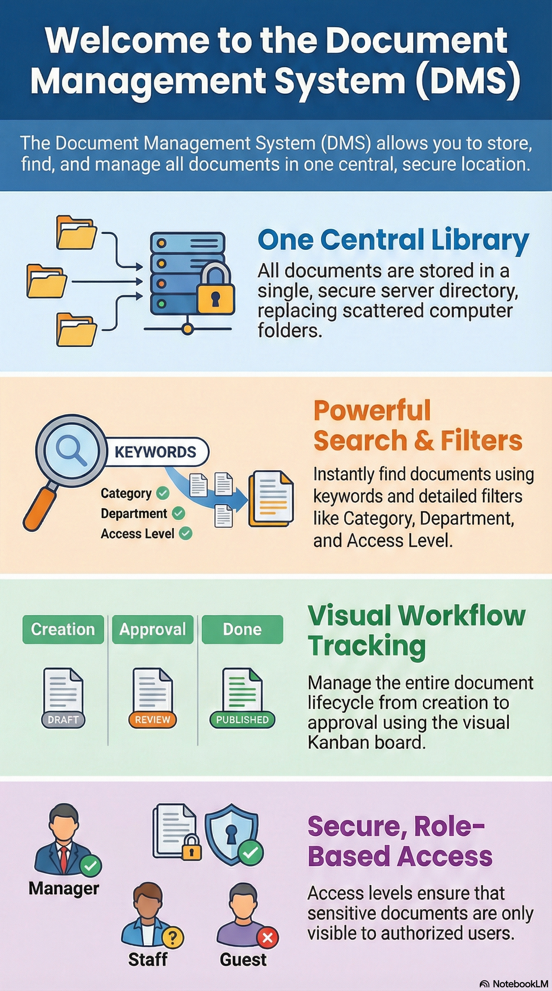

This comprehensive user manual details how to store, locate, and oversee digital files in a centralized repository. It outlines essential operational procedures, such as logging in through a secure portal and navigating a customizable dashboard tailored to specific user roles. This guide emphasizes security and organization, explaining how to utilize multi-layered filters, keyword searches, and access levels to protect sensitive information. Furthermore, it describes the integration of Agile project management through a Kanban board, which allows teams to track a document’s lifecycle from initial drafting to final approval. Users are also instructed on how to collaborate through comment sections and resolution tracking to ensure all revisions are properly addressed.

Prepared for SGAP Leaders

V 1.0

Document Management System (DMS)
User Guide

Table of Contents

1. Overview ..................................................................................................................................... 1
Centralized repository for storing, locating, and managing digital file
2. Document Library ..................................................................................................................... 1
Database records and secure server directory management
3. Getting Started ........................................................................................................................... 2
3.1. Logging In and Security Authentication
3.2. Navigating the Role-Based Customizable Dashboard
4. The Manage Page ....................................................................................................................... 3
4.1. Access Levels and Document Visibility
4.2. Utilizing Multi-Layered Filters (Organization, Category, Type)
4.3. Incremental Search and Reporting (Excel and Print Operations)
5. Document Operations ................................................................................................................ 5
5.1. Action Buttons: Info, Preview, and Download
5.2. Viewing Document Details (Information, Description, Tracker, and Notes Tabs)
5.3. Creating a New Document Record and File Uploading
5.4. Collaboration: Commenting and Resolution Tracking
5.5. Setting Security Levels and Archiving/Deactivating Records
6. The Kanban Board (Agile Project Management) ................................................................... 8
6.1. Board Configuration and Phase Visibility
6.2. Document Workflow Phases
6.3. Card Interactions: Lead/POC, Due Dates, and Status Movement Arrows
6.4. Information Indicators: Blocked, On-Hold, and Past Due
7. Appendices ................................................................................................................................ 12
Appendix A – Feature Map
Appendix B – Filter Definitions and Manage Operations

Overview

The Document Management System (DMS) allows users to store, find, and manage documents in one central location. Instead of searching through folders on a computer, users search for documents using filters and keywords. Each document has a record in the system that contains descriptive information and, when applicable, a link to the physical file.

Document Library

All documents are stored in a single secure directory on the server. Each document has a corresponding record in the database. Some records may not have a physical file attached and may instead contain text stored directly in the system, such as short procedures or instructions.

Logging In

The login page can be found at https://www.sgap.honcho.cloud .

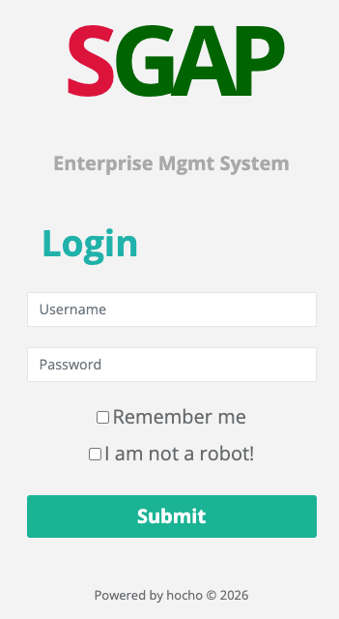

Enter your Username and Password provided.

Check the box if you want your session to last longer before being automatically logged out.
You must check to continue to prevent hacking & spam. You will be directed to your role’s dashboard.

The Dashboard

The options presented on the Dashboard are determined by the access rights of your assigned role. You may use either the side menu options or the large status buttons to access the functions.

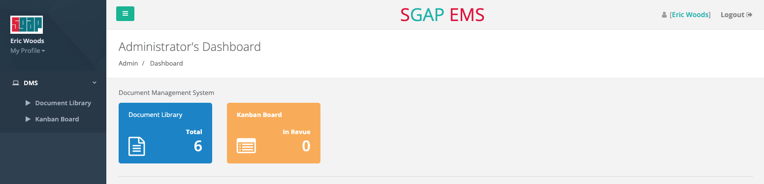

The Manage Page

The Manage Page is the main screen used to find and access documents. Each user is assigned an access level, and each document has a minimum access requirement. Users can only see documents that match or fall below their access level. This ensures sensitive documents are only available to authorized users.

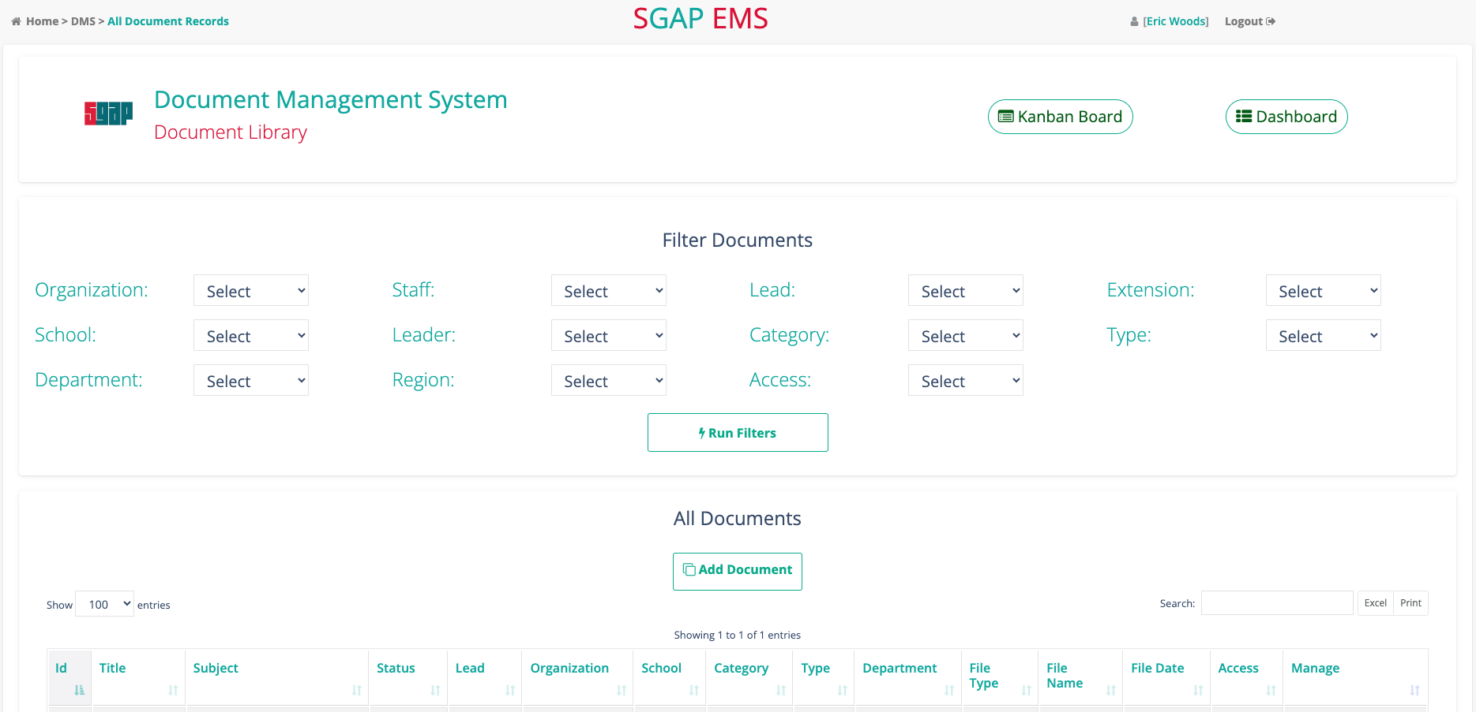

Filters appear at the top of the Manage Page and help narrow the list of documents. Available filters depend on the user’s role and may include Organization, School, Category, Type, Department, Lead, and Access Level.

Only filter options that are currently in use (meaning there is at least one document with that has been tagged with it) will appear, keeping the list easy to use. If you use more than one dropdown, there is an implied “and” between them in the filtering logic.

Each row in the document list represents one document. Common columns include Title, Status, Organization, Category, Type, File Name, File Date, and Access Level.

There is an incremental search box that will further filter the list using characters typed into it. It will search every column on the screen for that word or fragment and only include those document records that contain it.

In addition, you can print the whole or filtered list of documents in the table or download them as an MS Excel file.

The Dashboard button will return you to your dashboard and the Kanban button will take you to the document status board.

Depending on permissions, users may see the following action buttons:
• Info – View detailed information about the document
• Preview – Open the document in a preview window
• Comments – View comments made on the documents
• Download – Download a copy of the document
Administrative users may also have options to update or delete document records.

Viewing Document Details

When viewing a document, information is organized into four tabs:
• Information – Basic document details
• Full Description – Detailed description of the document
• Tracker – Progress and status tracking
• Notes – Additional notes or comments

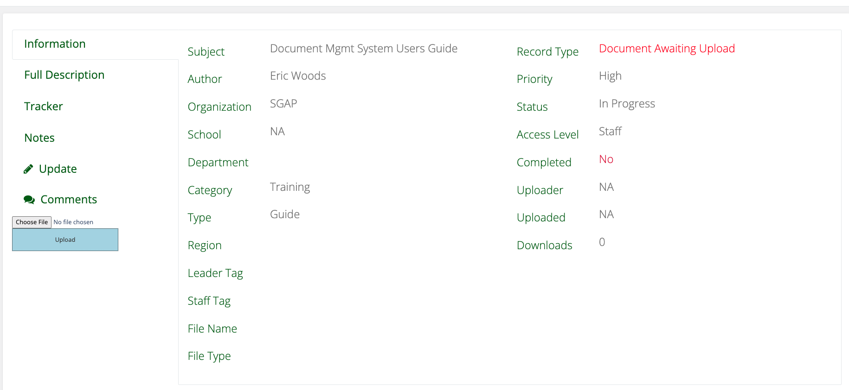

Select Choose File to choose a file from your filesystem to be uploaded. Then press Upload.

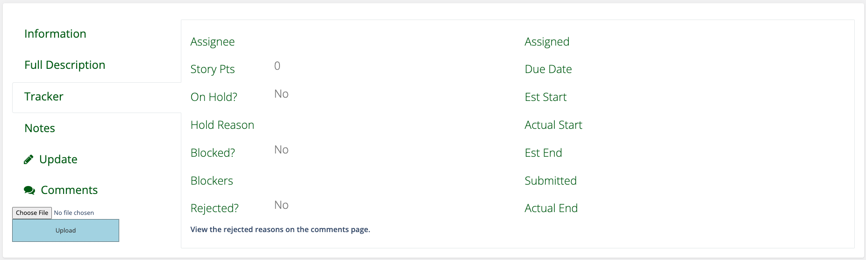

The Tracker tab shows the lead person who a document creation effort is assigned to, and the status with the reason for it. The Rejected reasons are stored on the Manage Comments page.

Select Manage to return to the manage documents page or Kanban to go to the document tracking page.

Commenting on a Document

Select the Comments button from the Manage or View Document pages to view all comments recorded about the document throughout the process.

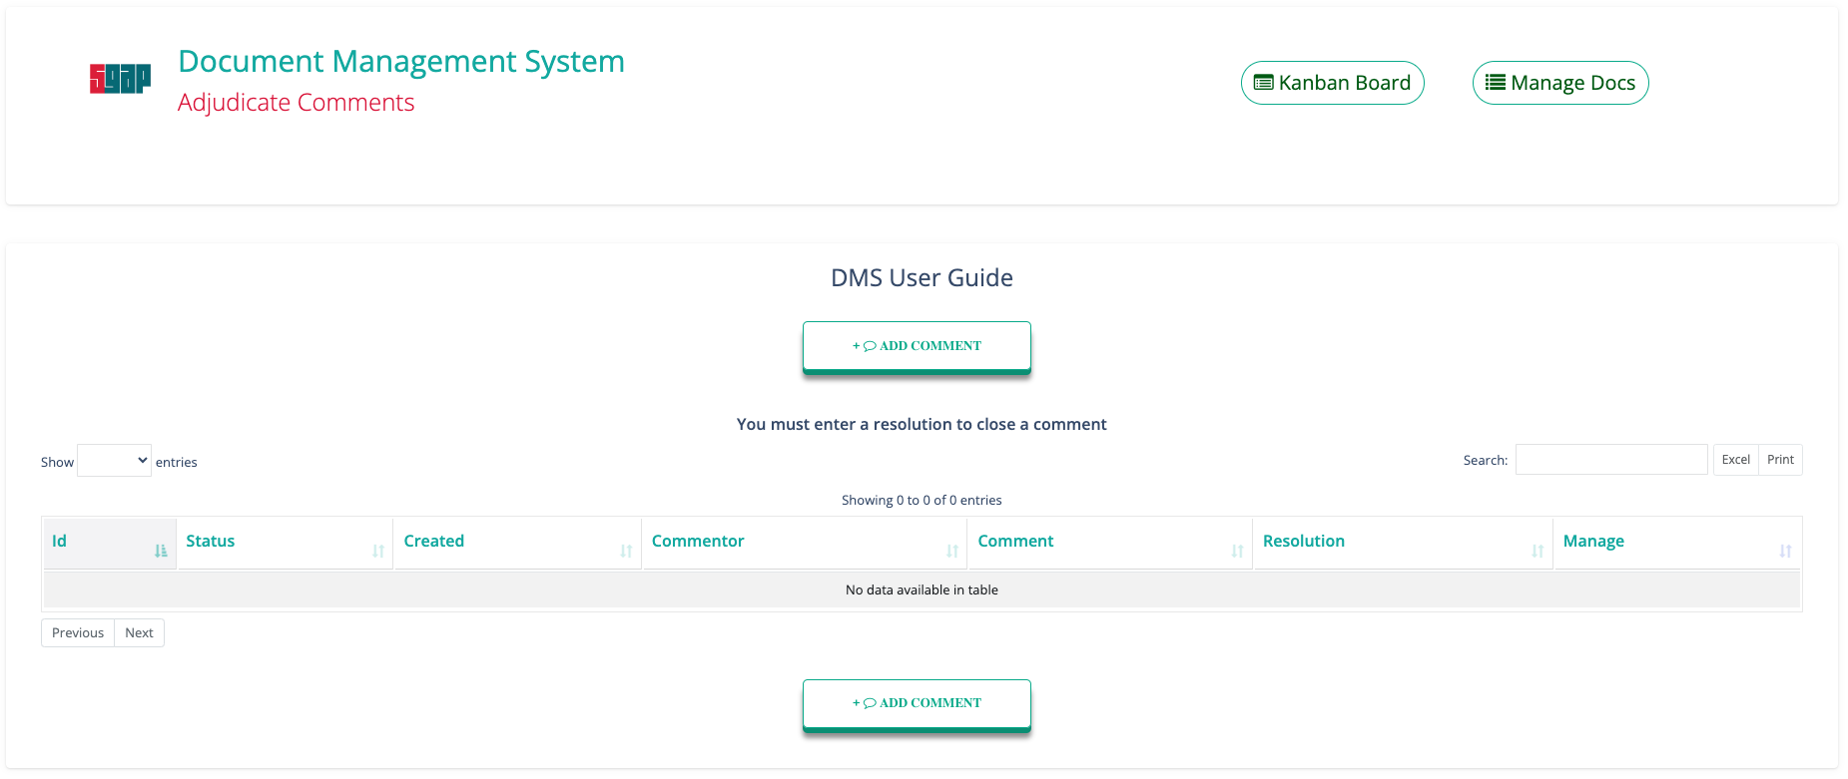

You may create a comment here or on the Kanban board. A popup modal form will appear on the screen with an automatic timestamp as the header.

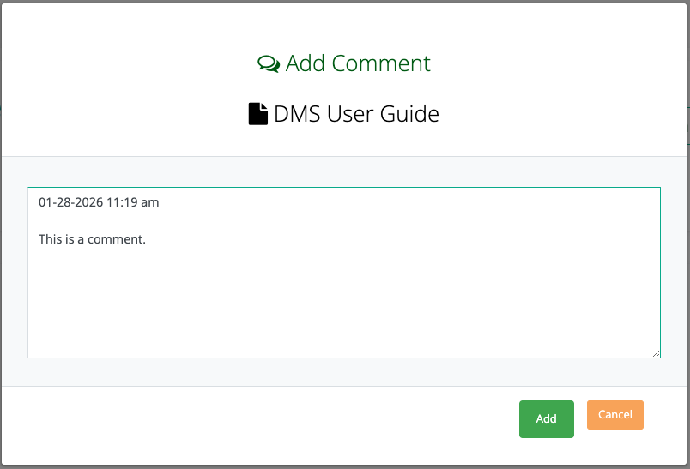

Once a comment is added, you can edit it from the Manage Comments page and add a resolution. You must enter a resolution to close a comment. This is helpful in assuring they are incorporated into document revisions. Only the user who created the comment can edit the Comment text, but any other authorized user can enter a resolution.
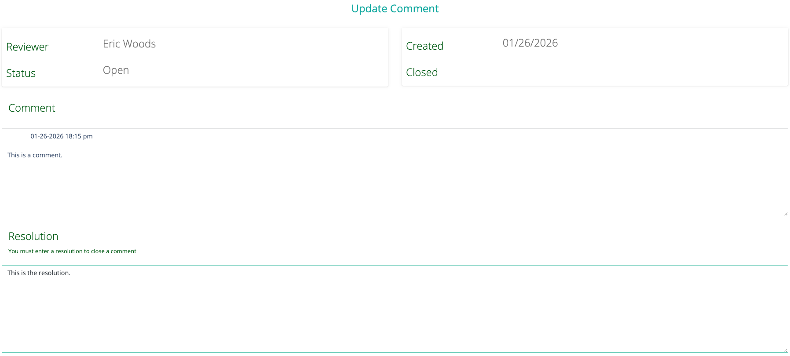

Creating a New Document Record

Authorized users can create new document records by selecting the Add Document option. The required information: title, access level, and if a file will eventually be attached file (not just a database entry) must be entered before saving. If the document is just a database entry, the text should be entered into the Full Text field for later viewing and printing.

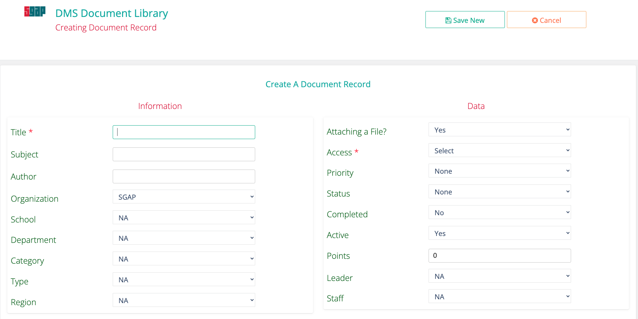
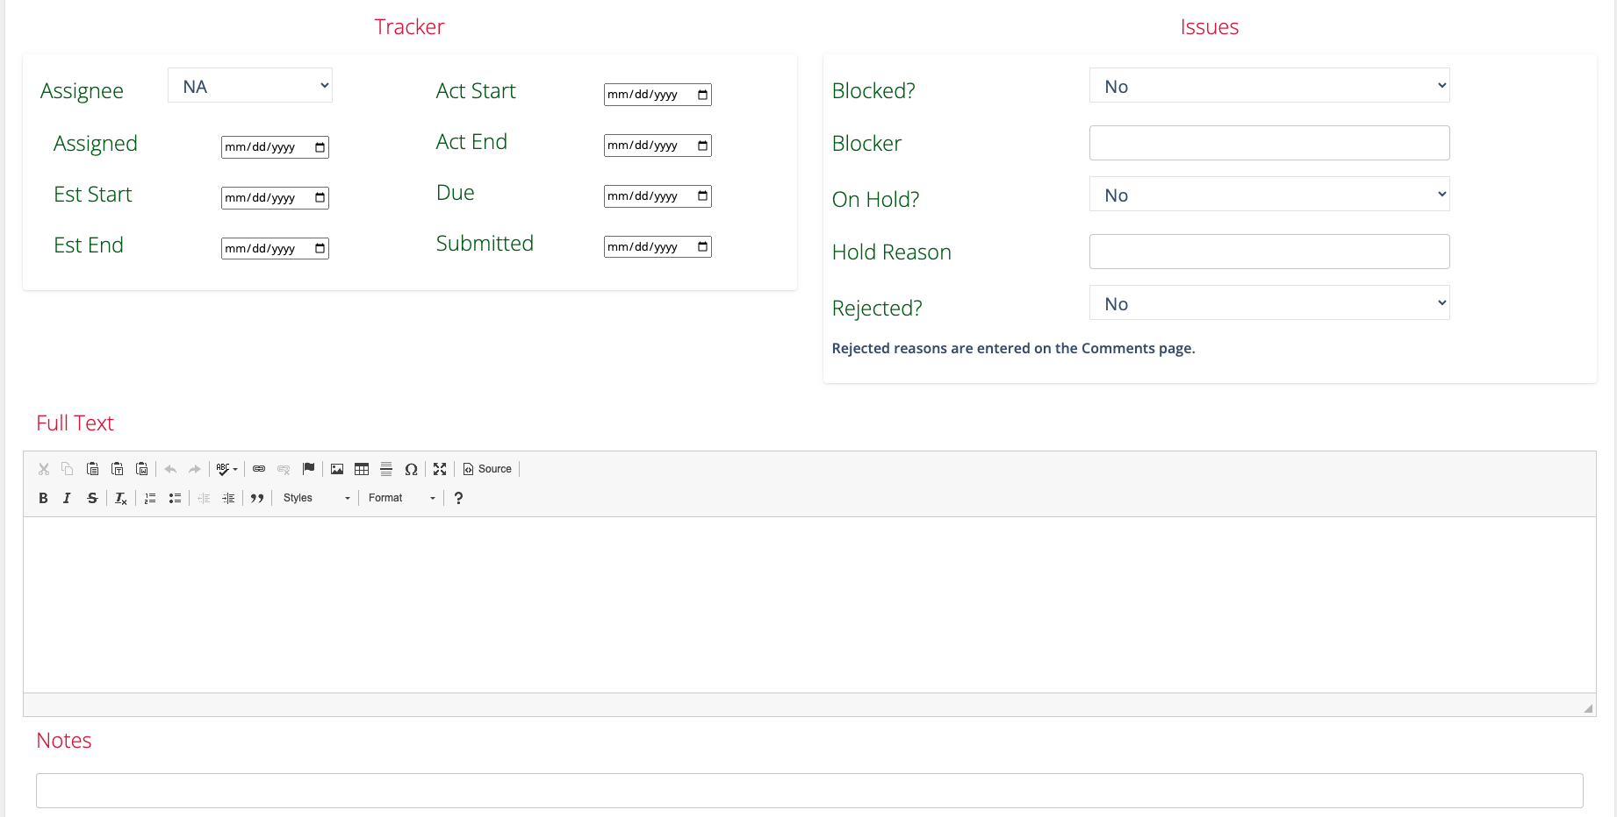

Setting Document Security

To set the document security level, click the Access dropdown menu. Select the level of access you desire your users to possess to access the document. Users below your selection will not have access. Users at your selection level or higher will have access and the document will appear in the listing on the Manage page.

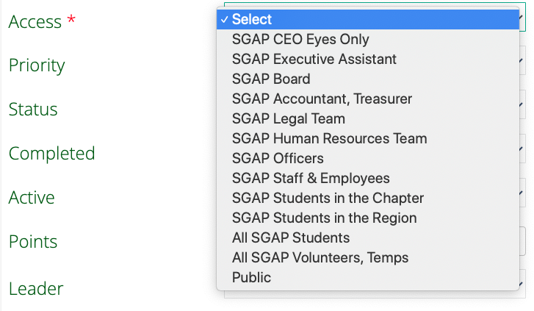

Archiving and Deleting

Documents can be deactivated or archived so they no longer appear in the document list. Deleted documents are typically soft deleted, meaning they are hidden but not permanently removed unless handled by an administrator.

The Kanban Board

The Kanban Board is an Agile project management tool used to track progress. It is configurable with four, five, or six columns, each representing a phase of your document creation workflow process. The default configuration is the following:

• Unrefined – These are planned documents that lack sufficient detail to assign to someone to begin work. Refinement meetings are held to ready these tasks for work and Backlog prioritization.
• Backlog – Documents that have enough to get started but no one to work them yet. Backlog Grooming meetings are held periodically to prioritize and verify readiness.
• In Progress – Documents being worked.
• In Review – Documents that are complete enough for review and comment.
• Pending Approval – Documents that have had all comments adjudicated and incorporated and ready for approval.
• Approved – These have been completed & approved but are remaining on the board for visibility. They are removed from the board when their status is changed to Closed.
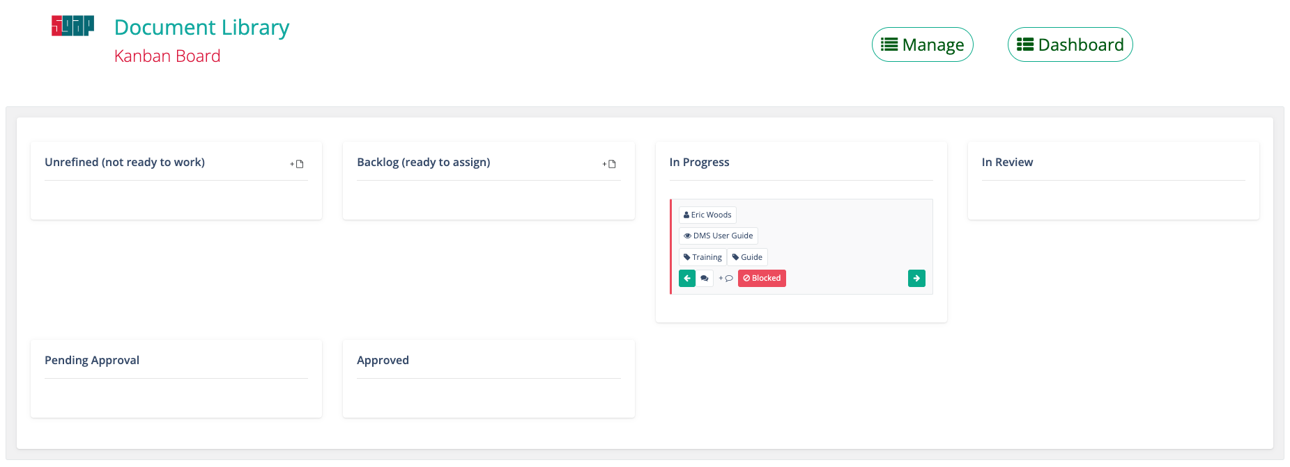
Note: This figure is meant to display what column wrapping would look like for all six columns. In this scenario, the actual number of columns would be reduced to four.

The first (Unrefined) and/or last (Approved) columns can be hidden by the System Administrator permanently, if desired, to reduce clutter. These two columns will automatically appear or disappear if there or aren’t are documents in that phase. Also, if there are Unrefined records but no Pending Approval records, then the blank Pending Approval column will not be shown to keep the maximum number columns to four all on one row.

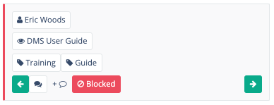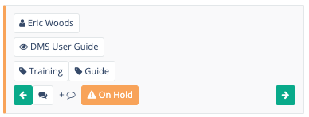

The first row contains a button with the person’s name assigned as the Lead/POC for this document effort and the Due Date if entered. The button invokes a contact information popup form for that person.

The second row contains a button with the document name. The button takes you to the view page for that document.

The third row displays tags for the Category and Type. They are not hot linked to anything.

The fourth row contains several buttons that appear depending on the situations:

• Green Arrows – Can move a document between phases without having to edit the record and change the status.
• Comments – The Comments icon will invoke the manage comments page.
• + Comments – The add comments icon will invoke the add comment popup form.
• Blocked – The red blocked button will invoke the reason the document cannot be completed.
• On Hold – The hold button will invoke the hold reason popup form.
• Past Due – A document where today’s date is passed the due date.

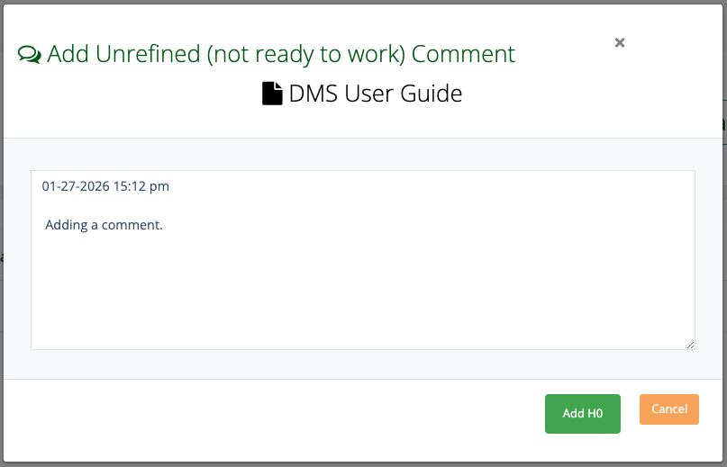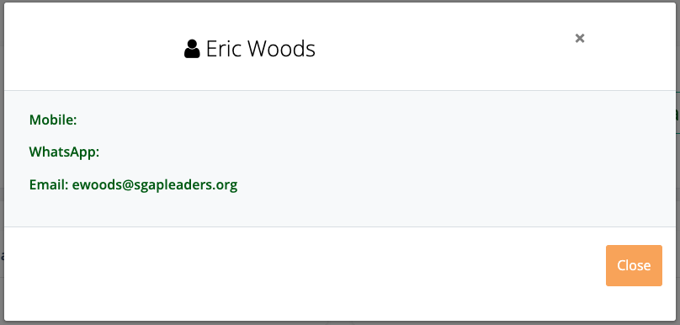
Contact Information popup box. Add Comment popup data-entry form.
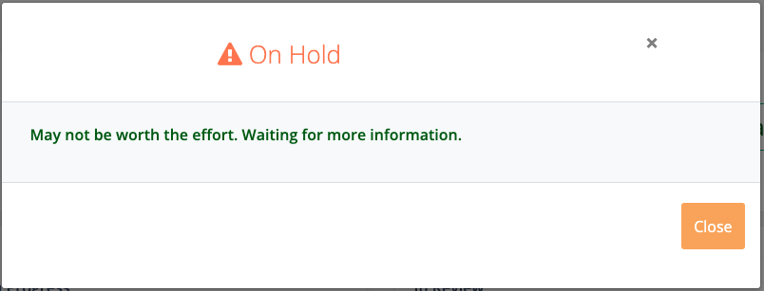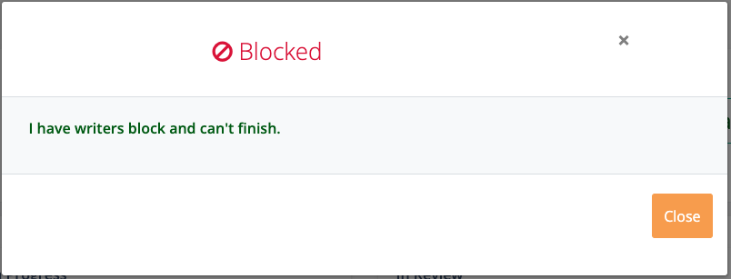
On Hold popup box. Blocked popup box.

Tagging a document as On Hold and Blocked, and entering the reasons, is done on the Update page. Being tagged “Blocked” does not prevent the document from moving between phases, it is only for information exchange.

When using the arrow buttons, there are settings that can be employed to force the user to edit the record to advance from Unrefined to Backlog and another from Backlog to In Progress to encourage users to add more information before promoting to the next phase.

Appendix A – Feature Map

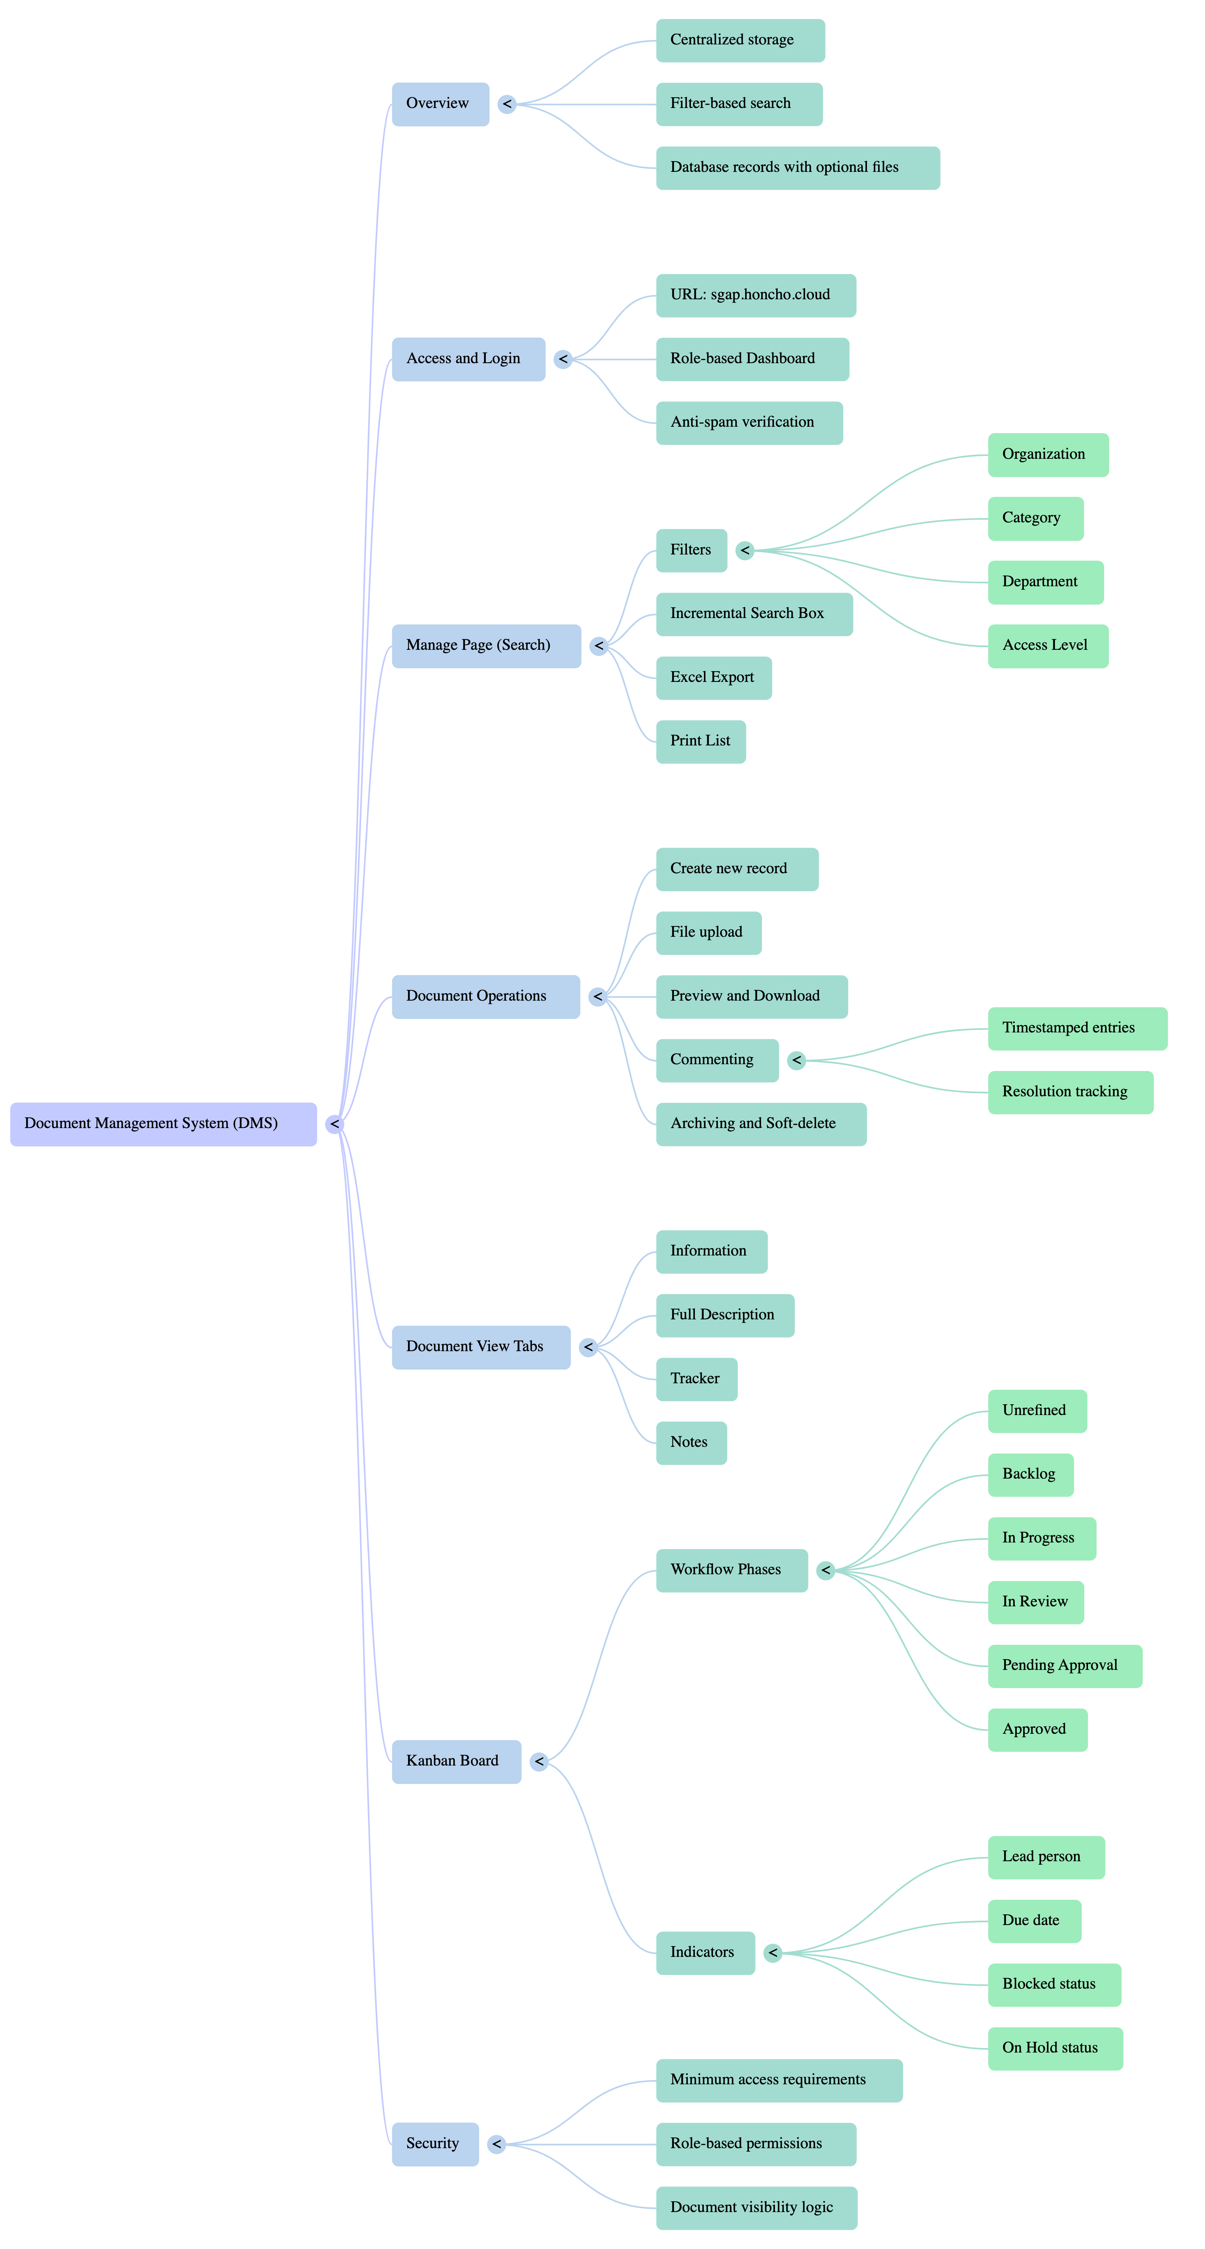

Appendix B – Filter Definitions

Filter | Definition | Note
Organization | Tags the document to a specific school system (organization/entity). | Label configurable as DMS_FL_TAG1 in Settings.
School | A tag used for schools associated with the organization. | Label configurable as DMS_SUBENTITY in Settings.
Department | A tag used for the department’s internal to your organization.
Staff | A tag used for employees, contractors, and volunteers internal to your organization. (i.e. not a customer, client, member or participant – CCMP).
Leader | This field allows the user to tag a document as being specific to a student (participant).
Region | A tag for geographical location.
Lead | A tag used for the staff person who is leading the document creation effort.
Category | A tag for grouping like documents. | Label configurable as DMS_FL_TAG2 in the configuration file.
Access | A tag used to filter on the access level required for a document.
Extension | The type of file extension on the physical file. (.txt, .pdf,.xls, .doc etc.)
Type | Another tag to further breakdown a grouping. | Label configurable as DMS_FL_TAG3 in the configuration file.
File Date | The timestamp on the computer file.
Manage Operations
Info | Launches the screen to view all the details about the document.
Update | Launches the update screen to edit the information about the document. | Not accessible by regular users
View Comments | View the document reviewer’s comments during the document creation process. | Not accessible by regular users.
Preview | Opens the document in a preview window.
Download | Downloads a copy of the document to your computer.
Delete | Marks a document record for deletion. | Not visible to regular users.

Note: The available filters are determined by the user’s role.

