# Front-end

## Angular, AngularJS and Angular 2

Angular is the name for the Angular of today and tomorrow. AngularJS is the name for all v1.x versions of Angular.

Angular 2: About a year ago, the Angular team made the decision to drastically change the tremendously popular AngularJS framework. Google and the Angular contributors sought to better the framework by reducing the learning curve and providing performance enhancements.

Main difference between Angular 1 and Angular 2:

1. Angular 2 works for more than just JavaScript

Angular 2 works with three languages: TypeScript, Dart, Vanilla JS (or ES2015/ES6 compiled with webpack to ES5).

2. Component-based UI, directives in Angular 1 become components in Angular 2, and controllers simply disappear.

3. Syntax changed.

4. Defining a module imports/dependencies and what it exports/provides is far more explicit and less confusing.

**5. Better performance**

Detailed difference please see <https://angular.io/docs/ts/latest/cookbook/ajs-quick-reference.html>.

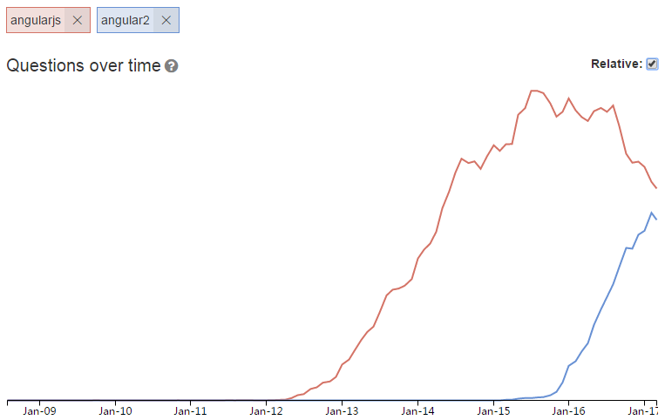

## Angular 2

Angular is an open source client-side framework developed initially by Google that supercharges HTML with additional tags to create powerful single page applications (SPA).

It is a framework for building client applications in HTML and either JavaScript or a language like TypeScript that compiles to JavaScript.

The framework consists of several libraries, some of them core and some optional.

Detailed information: <https://angular.io/docs/ts/latest/guide/architecture.html>

## TypeScript

TypeScript is a free and open-source programming language developed and maintained by Microsoft.

## Node.js

Node.js is an open-source, cross-platform JavaScript runtime environment for developing a diverse variety of server tools and applications. Although Node.js is not a JavaScript framework, many of its basic modules are written in JavaScript, and developers can write new modules in JavaScript. The runtime environment interprets JavaScript using Google's V8 JavaScript engine.

## Npm

Npm is automatically included when Node.js is installed. Npm consists of a command line client that interacts with a remote registry. It allows users to consume and distribute JavaScript modules that are available on the registry.

## Visual Studio Code

Visual Studio Code is a source code editor developed by Microsoft for Windows, Linux and macOS. It includes support for debugging, embedded Git control, syntax highlighting, intelligent code completion, snippets, and code refactoring. It is also customizable, so users can change the editor's theme, keyboard shortcuts, and preferences. It is free and open-source.

## UI Bootstrap & ng-bootstrap

Bootstrap components written in pure AngularJS by the AngularUI Team, it is used in AngularJS 1.x version.

For Angular 2 support, check out ng-bootstrap, created by the UI Bootstrap team.

This library is being built from scratch in Typescript using the Bootstrap 4 CSS framework.

## Webpack

Webpack is an open-source JavaScript module bundler.

## Dependencies

"bootstrap": "^4.0.0-alpha.6"

"@ng-bootstrap/ng-bootstrap": "^1.0.0-alpha.21

"angular-in-memory-web-api": "^0.3.1"

# Component

## Home Page

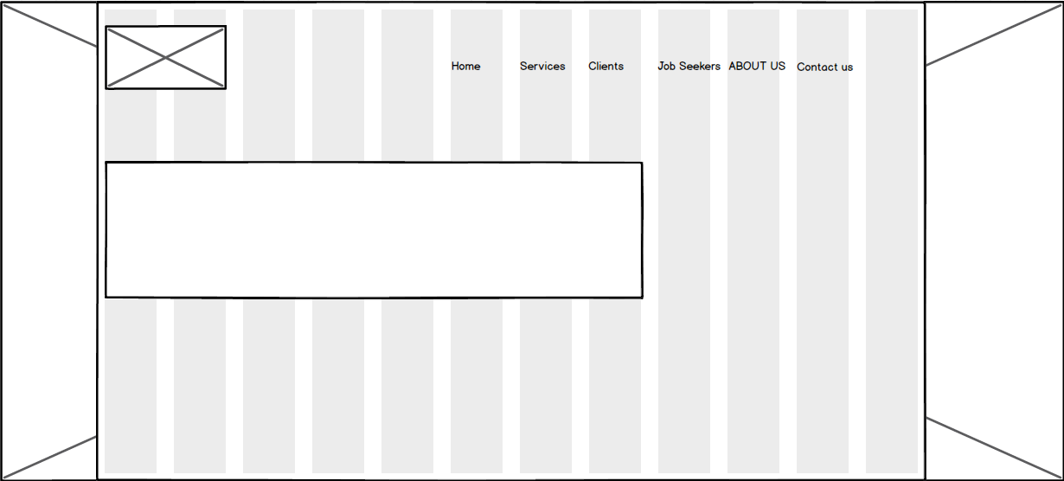



## Articles

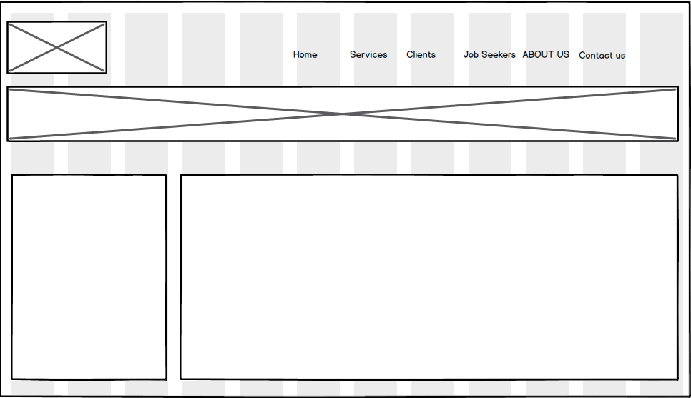

<https://www.globalattract.co.nz/>