

Faculty 09
Department of Landscape Ecology and Resources Management
Chair of Landscape, Water and Biogeochemical Cycles

Master‘s Thesis

Snow Accumulation Regimes During Nuclear Winter

Submitted by: Eric Wöstenberg,
Matriculation number: 6016099
Mail: eric.woestenberg@stud.uni-giessen.de

First Examiner: Prof. Dr. Lutz Breuer
Second Examiner: Dr. Florian Ulrich Jehn

35390 Gießen, October 21, 2026

35390 Gießen, 01.07.2026

List of Contents
1 Introduction 1
2 Data and Methods 2
2.1 Data Source 2
2.2 Spatial Analysis 2
2.3 Snow Model 3
2.4 Clustering 3
2.5 Basin-Scale Runoff Analysis 4
3 Results 5
3.1 Global Snow Storage Response 5
3.2 Cluster Analysis 6
3.3 Basin-Scale Runoff Analysis 9
4 Discussion 11
4.1 Mechanisms Driving Snow Storage Change 11
4.2 Hydrological Consequences 13
4.3 Beyond Water Availability - Societal Impacts of Extreme Snowpacks 15
5 Limitations 16
6 Conclusions 17
7 References 18
8 Annex 20
9 Acknowledgements 24

Abstract
Nuclear winter, caused by soot injection into the stratosphere following a nuclear conflict, would cause sustained disruptions to Earth's climate, including reductions in surface temperature and precipitation persisting for years to over a decade. Despite this overall decline in precipitation, the accompanying cooling would shift precipitation from rain to snow and suppress snowmelt, promoting snow accumulation and persistence. Yet the extent to which these changes would reorganize snow storage and reshape runoff generation across major river basins remains largely unexplored. Here, a temperature-index snow model was applied to climate simulations of three nuclear war scenarios (16, 47, and 150 Tg soot injection), with basin-scale analysis conducted for the 47 Tg case, to quantify changes in global snow storage and runoff generation across six major river basins. Global snow storage increases considerably and remains above control levels throughout the 15-year simulation period, despite a gradual decline from peak values. Three distinct regional response patterns emerge: new seasonal snowpacks in previously snow-free regions, prolongation of existing snow seasons, and continuous multi-year accumulation at high latitudes. Extended and intensified snow seasons generate higher spring runoff peaks, creating conditions conducive to elevated flood risk in the Rhine and Tigris-Euphrates basins, while winter runoff is suppressed across all basins. In contrast, persistent accumulation in high-latitude basins such as the Ob reduces snowmelt contributions to runoff. These results demonstrate that a large-scale nuclear exchange would fundamentally alter the timing and magnitude of runoff generation across the Northern Hemisphere, with significant implications for populations dependent on snowmelt-fed water resources.

Zusammenfassung
Ein nuklearer Winter, ausgelöst durch den Eintrag von Rußpartikeln in die Stratosphäre infolge eines nuklearen Konflikts, würde das Erdklima über Jahre bis Jahrzehnte hinweg erheblich verändern. Zu den wichtigsten Folgen zählen ein Rückgang der Oberflächentemperatur und des Niederschlags. Gleichzeitig würde die starke Abkühlung dazu führen, dass ein größerer Anteil des Niederschlags als Schnee fällt und dessen Schmelze unterdrückt wird. Dadurch könnten sich erhebliche Schneemengen ansammeln und über lange Zeiträume erhalten bleiben. Wie sich diese Veränderungen auf die globale Schneespeicherung und den Abfluss großer Flusseinzugsgebiete auswirken, wurde bislang jedoch nur wenig untersucht. In dieser Arbeit wurde ein temperaturindexbasiertes Schneemodell auf Klimasimulationen von drei nuklearen Kriegsszenarien mit 16, 47 und 150 Tg Rußeintrag angewendet. Für das Szenario mit 47 Tg wurde zusätzlich untersucht, wie sich die Veränderungen in sechs großen Flusseinzugsgebieten auf die Abflussbildung auswirken. Die Ergebnisse zeigen einen deutlichen Anstieg der globalen Schneespeicherung. Obwohl die Schneemengen nach Erreichen ihres Maximums allmählich zurückgehen, bleiben sie während des gesamten 15-jährigen Simulationszeitraums über dem Niveau der Kontrollsimulation. Dabei treten drei charakteristische Reaktionsmuster auf: die Bildung neuer saisonaler Schneedecken in bislang schneefreien Regionen, die Verlängerung bestehender Schneesaisons sowie eine über mehrere Jahre anhaltende Schneeakkumulation in hohen Breiten. Die verlängerten und verstärkten Schneesaisons führen zu einer Verringerung des Winterabflusses und zu höheren Abflussspitzen während der Schneeschmelze im Frühjahr. Dadurch steigt vor allem im Rhein- sowie im Tigris-Euphrat-Einzugsgebiet das Risiko für Hochwasserereignisse. In hohen Breiten wie im Ob-Einzugsgebiet hingegen verringert die anhaltende Schneeakkumulation den Anteil der Schneeschmelze am Abfluss. Die Ergebnisse verdeutlichen, dass ein großflächiger nuklearer Schlagabtausch Zeitpunkt und Stärke der Abflussbildung in weiten Teilen der Nordhemisphäre grundlegend verändern würde. Dies hätte erhebliche Folgen für Regionen und Bevölkerungen, deren Wasserverfügbarkeit maßgeblich von der Schneeschmelze abhängt.

Introduction
The risk of nuclear conflict has re-emerged as a pressing concern in contemporary international relations. The New START treaty between the United States and Russia expired on 5th February 2026 without a successor agreement (Liang, 2026), and all nine nuclear-armed states are actively modernizing their arsenals with some states also increasing warhead numbers (SIPRI, 2025; Fayet, 2026). Against this backdrop, a re-examination of the potential consequences of nuclear conflict is warranted.

These were first systematically explored during the 1980s, when early modeling studies showed that post-nuclear firestorms could inject black carbon into the atmosphere, triggering sustained surface cooling, a phenomenon termed nuclear winter (Crutzen & Birks, 1982; Aleksandrov & Stenchikov, 1983; Turco et al., 1983). With the end of the Cold War, research expanded to include more limited regional exchange scenarios, and modern coupled climate models have since confirmed and in some cases strengthened early projections, demonstrating that even a regional nuclear exchange could produce surface cooling of a magnitude not seen since the last Ice Age (Robock et al., 2007b; Mills et al., 2014; Coupe et al., 2019; Toon et al., 2019). Surface cooling would substantially reduce evapotranspiration and, consequently, precipitation, weakening the hydrological cycle as a whole (Robock et al., 2007a). Nuclear winter conditions would alter not only how much freshwater is available, but also when it becomes available, a distinction that is critical for human water security. Among the processes governing the timing of freshwater availability, seasonal snow storage plays a particularly important role. Acting as a natural reservoir, it captures winter precipitation in solid form and releases it as meltwater during warmer months, when irrigation demand and evapotranspirative losses are higher (Hayhoe et al., 2004; Barnett et al., 2005, 2008). This buffering function supports freshwater supplies for approximately 1.9 billion people worldwide and is critical for irrigation systems across High Mountain Asia, Central Asia, the western United States, and the southern Andes, where agricultural production depends heavily on snowmelt-fed runoff (Immerzeel et al., 2020; Qin et al., 2020). While volcanic eruptions offer a partial analogue and have been shown to alter river discharge patterns (Iles & Hegerl, 2015; Kim et al., 2025), the specific implications of nuclear winter for snow accumulation, melt timing, and the resulting seasonality of runoff remain poorly constrained.

This study therefore investigates how a large-scale nuclear exchange would alter global snow storage dynamics, how these changes vary regionally, and to what extent they modify the timing and magnitude of runoff generation in six major river basins, thereby providing new insights into the hydrological consequences of nuclear winter.

Data and Methods

Data Source
The snow dynamics analysis is forced by monthly surface air temperature and precipitation provided by Harrison et al. (2026), who processed climate simulation output from Toon et al. (2019) and Coupe et al. (2019) by reducing the vertical dimension to the surface layer. The data covers a control run and three nuclear war scenarios with soot injections of 16, 47, and 150 Tg, at a spatial resolution of 1.9° in latitude and 2.5° in longitude. All scenarios cover a 15-year period starting in January 2005, with soot injection initiated on May 15th, 2005.

While all three soot injection scenarios are included in the global snow storage analysis for completeness, the detailed cluster and hydrological analyses focus on the 47 Tg scenario, as it represents a plausible large-scale nuclear conflict and produces spatially differentiated snow responses that allow meaningful cluster separation. In the 16 Tg scenario, regions with fundamentally different snow regimes were frequently grouped together, even when the number of clusters was increased.

Spatial Analysis
Grid cell areas were computed using the spherical approximation, accounting for the latitudinal variation in cell size by integrating over the latitudinal extent of each cell as in Equation (1).
$$A_{i}= R^{2}· Δλ· \left|\sin\left(ϕ_{\left\{upper\right\}}\right)-\sin\left(ϕ_{\left\{lower\right\}}\right)\right|$$ | (1)

where $A_{i}$ is the area of each grid cell in km², $R$ is the Earth's radius (6371 km), Δλ is the longitudinal extent of the grid cell in radians, and ϕ_{upper} ​and ϕ_{lower} are the upper and lower latitudinal boundaries of the grid cell in radians.
Each grid cell was treated as a polygon, and the fractional overlap with the land polygons (Natural Earth, 2009) or each catchment boundary (Lehner & Grill, 2013) was computed through spatial intersection. These fractional weights multiplied by corresponding grid cell areas were used for all subsequent area-weighted calculations, including global means, quantiles, and catchment-integrated volumes.

Snow Model
To calculate snow storage and snowmelt, a simple temperature-index model following Massmann (2019) was applied. A four-year spin-up period before the 15-year analysis was used to initialize the snowpack for all scenarios. Snowmelt ($M$ [mm]) is modelled as proportional to the positive difference between mean surface air temperature ($T_{mean}$ [°C]) and a melt threshold ($T_{melt}$[°C]) of 0°C (Equation (2)), as specified by the U.S. Department of Agriculture (2004). Since the degree-day-factor (DDF) represents a daily melt rate, this difference is additionally multiplied by the number of days ($d$) in the respective month. The DDF was set to 4 mm °C⁻¹ day⁻¹, a value close to the center of the range commonly reported in the literature for seasonal snowmelt (Hock, 2003; Massmann, 2019), and adopted as a representative global estimate.
$$M=\left\{\begin{aligned}\text{DDF}×d\left(T_{mean}-T_{melt}\right)& \text{when} T_{mean}>T_{melt} \\ 0 & \text{when} T_{mean}≤T_{melt}\end{aligned}\right\}$$ | (2)

The temperature threshold below which precipitation is assumed to fall as snow was set to 1.7°C (Massmann, 2019). The model yields three output variables: snow storage, snowmelt, and rain.
Snow storage and melt are tracked as snow water equivalent (SWE). Actual snow depths would be considerably greater due to the lower density of fresh snow.

Clustering
To identify spatial patterns in global snow storage, a k-means clustering approach was applied to the snow storage time series extracted from each grid cell for the 47 Tg soot case. Dynamic time warping (DTW) was chosen as the distance measure due to its ability to capture similarities between time series that may be shifted in time or differ in the speed at which patterns unfold (Müller, 2007). The clustering was performed using the tslearn library (Tavenard et al., 2020). Before clustering, all time series were normalized via minimum-maximum scaling, which rescales each time series to the range [0, 1] (Equation (3)), to ensure that differences in absolute snow storage magnitude did not dominate the distance calculation.
$$x_{t}^{'}=\frac{x_{t}-\min\left(x\right)}{\max\left(x\right)-\min\left(x\right)}$$ | (3)

where $x_{t}^{'}$ is the normalized value, $x_{t}$​ denotes the original value of the time series at time $t$, and $min(x)$ and $max(x$) denote the minimum and maximum values of that same time series, respectively.

Although the elbow method suggested three to four clusters, five clusters were selected to better capture the regional differentiation of snow storage responses (Figure A1). The four-cluster solution merged regions with sustained multi-year accumulation into the same cluster as regions where seasonal winter snow emerged only transiently during peak cooling and disappeared again as temperatures recovered.

To avoid distortion of the global snow storage metrics by grid cells with permanent snow accumulation, such as those in Antarctica and Greenland, a k-means clustering was additionally applied to the control run and the elbow method suggested three clusters (Figure A2). Grid cells assigned to the permanently accumulating cluster in the control run were excluded from the computation of global mean snow storage, snow storage anomaly, and snow cover extent anomaly.

Basin-Scale Runoff Analysis
To assess how runoff regimes are affected under the 47 Tg scenario, six major river basins distributed across different regions of the world were selected. The basins were chosen to provide broad geographic coverage of regions where snow processes constitute a relevant component of the hydrological cycle, with preference given to large, densely populated catchments where changes in snowmelt may affect the greatest number of people. Based on these criteria, the following six basins were selected:

Table 1. Selected river basins and corresponding region.
Region | River Basin
North America | Mississippi
Europe | Rhine
Siberia | Ob
Middle East | Tigris-Euphrates
South Asia | Ganges-Brahmaputra-Meghna
East Asia | Yellow River
.
Catchment boundaries were derived from the HydroBASINS database (Lehner & Grill, 2013) and mapped onto the model grid following the spatial intersection approach described in Section 2.2. Monthly snowmelt and rainfall volumes were integrated over each catchment and converted to runoff-equivalent mean monthly discharge [m³ s⁻¹], without representation of evapotranspiration, infiltration, soil moisture dynamics, or river routing. The resulting values therefore represent an upper bound of potential water input rather than routed streamflow. For brevity, these runoff-equivalent values are hereafter referred to simply as discharge. As the soot injection is initiated in May, the first simulation year encompasses both pre- and post-injection months. Results for this year should therefore be interpreted with caution.

Results

Global Snow Storage Response
The global mean snow storage response scales with the soot injection magnitude. The 150 Tg scenario produces a peak snow storage anomaly of approximately +168 mm in Year 4, compared to +85 mm for the 47 Tg scenario in Year 6 and +30 mm for the 16 Tg scenario in Year 4. Across all scenarios, recovery is slow, with anomalies declining considerably from their peak values but remaining slightly elevated above control levels throughout the entire 15-year simulation period (Figure 1b). Notably, the seasonal timing of maximum snow storage anomaly differs from that of absolute snow storage. While absolute storage peaks consistently occur in March, anomalies peak in May or June across all scenarios (Figure 1a and Figure 1b).

The snow cover extent anomaly follows a different temporal pattern, peaking earlier than the snow storage anomaly, with maximum values of approximately +37 %-points in Year 2 for the 150 Tg scenario, +20 %-points in Year 1 for the 47 Tg scenario, and +11 %-points in Year 1 for the 16 Tg scenario (Figure 1c). At the same time the recovery of the extent is considerably faster than that of mean snow storage, with the anomaly approaching the ±1σ band of the control towards the end of the simulation period, at least for the 16 Tg and 47 Tg scenarios.

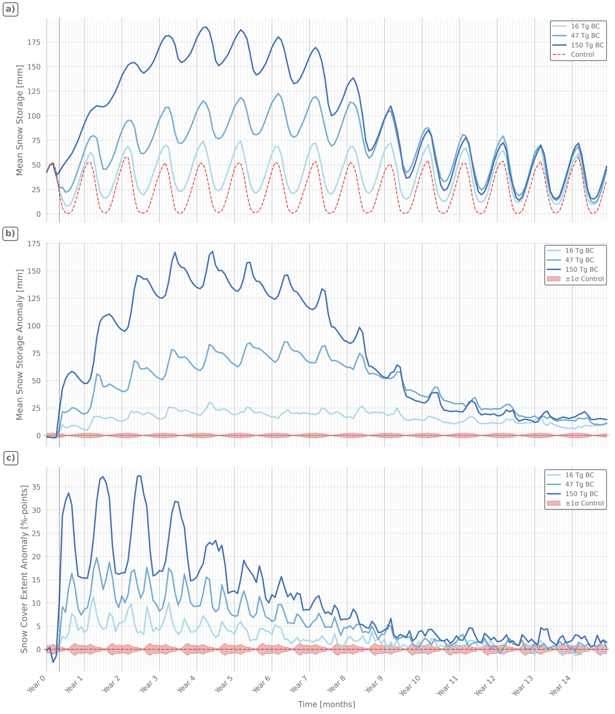
Figure 1. Global snow storage response to soot injection scenarios. (a) Monthly global mean snow storage for the 16, 47, and 150 Tg soot injection scenarios alongside the control run. (b) Monthly global mean snow storage anomaly relative to the climatological monthly mean of the control run. (c) Monthly snow cover extent anomaly relative to the climatological monthly mean of the control run, expressed in percentage points of global land area. The shaded red band indicates ±1 standard deviation from the model climatological mean of the control run. The vertical dashed black line marks the month of soot injection (May 2005). Grid cells identified as permanently accumulating in the control run were excluded from all calculations (see Section 2.4).

Cluster Analysis
Five distinct geographical clusters have been identified, each representing a characteristic snow storage pattern in response to the 47 Tg soot injection scenario (Figure 2a).
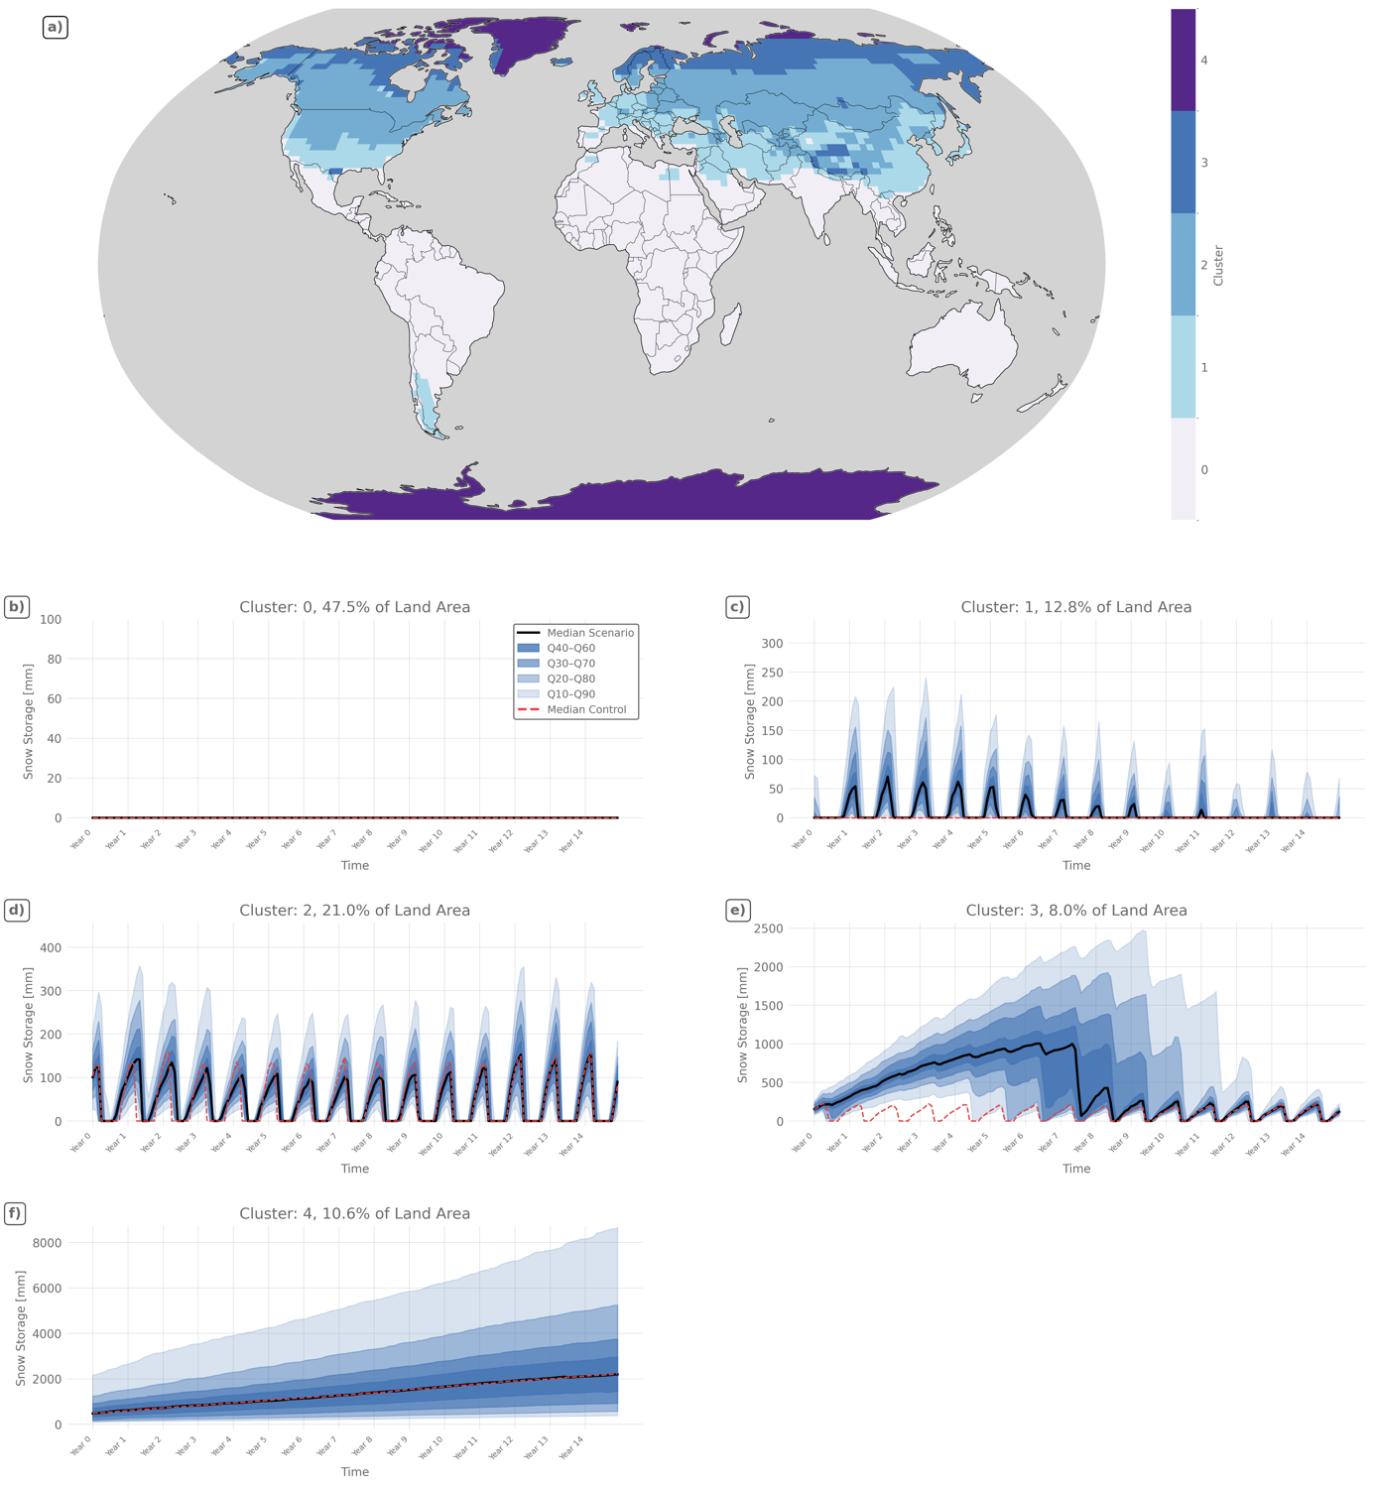
Figure 2. Spatial distribution and time series of snow storage clusters for the 47 Tg soot injection scenario. (a) Global distribution of the five clusters. (b-f) Monthly snow storage time series for each cluster. Major tick marks on the x-axis indicate January of each simulation year. The black line indicates the weighted median of the scenario, the dashed red line shows the weighted median of the control run for the same set of grid cells, included for reference as the clustering was performed on the scenario time series only. Blue shaded areas indicate the distribution of grid cell time series within each cluster. The darkest shade contains the 20% of time series closest to the median (Q40-Q60), with progressively lighter shades extending to Q30-Q70, Q20-Q80, and Q10-Q90. All calculations are weighted by grid cell area.

Cluster 0 (Figure 2b) comprises permanently snow-free regions, covering tropical and subtropical landmasses, where temperatures remain too high to sustain seasonal snow cover under both control and scenario conditions. However, parts of the subtropics, including the Middle East, experience snowfall under nuclear winter conditions and are therefore captured in Cluster 1.

Cluster 1 (Figure 2c) is characterized by the emergence of a pronounced seasonal snow regime that is absent in the control. A continuous winter snowpack develops from November through March, with the median snow storage across Cluster 1 grid cells peaking above 50 mm in Years 1 through 5, while the same grid cells show no snow storage under control conditions. Both the amplitude and duration of this seasonal signal gradually decline after Year 5, with the median showing no seasonal signal after approximately Year 11, though the upper quantiles indicate that some cells retain a weak seasonal signal beyond this point.

Cluster 2 (Figure 2d) exhibits a pronounced seasonality throughout the simulation period. In contrast to Cluster 1, the peaks of the median snow storage are considerably higher, ranging between approximately 100 and 150 mm, and the seasonal signal does not weaken over time. In the first years following the soot injection, the snow season is notably prolonged compared to the control, extending from approximately September through April rather than the typical November through March period, and the seasonal peak is shifted towards the summer months. Both effects gradually diminish towards the end of the simulation period as the climate recovers. Most notably, the median peak snow storage remains persistently below that of the control after the first year, reaching its minimum around Years 5-9 before beginning to recover around Year 12.

Cluster 3 (Figure 2e), encompassing the high-latitude regions of Russia, Scandinavia, and Canada, is characterized by the development of massive, multi-year snowpacks that persist well beyond a single snow season, with the median reaching peak values of approximately 1000 mm. The median maintains a continuous snow cover until rapid melting occurs in summer of Year 7, after which a seasonal signal gradually resumes, approaching control levels only towards the end of the simulation period in Years 13-14. The cluster also exhibits high internal variability, as reflected by the wide spread between quantiles, both in terms of the timing of the first major melt event and the magnitude of the accumulated snowpack, ranging from cells that begin to melt as early as Year 4 with snowpacks of around 350 mm to cells that accumulate up to 2500 mm until rapid melting occurs in summer of Year 11.

Cluster 4 (Figure 2f) is primarily located in Arctic regions and Greenland and is characterized by continuous snow accumulation without a pronounced seasonal cycle throughout the simulation period, albeit at slightly reduced levels compared to the control run. This reduction is not strongly visible in the median trajectory, as the anomaly is spatially heterogeneous within the cluster. It is nonetheless present and can be traced in both the spatial anomaly and Hovmoeller diagrams shown in the appendix (Figure A3 and Figure A4).

Basin-Scale Runoff Analysis
Discharge from both snowmelt and rainfall is strongly reduced during the winter months due to the colder temperatures, with the number of consecutive months exhibiting negligible discharge increasing substantially relative to the control, particularly in the Yellow River, Ob and Mississippi basins (Figure 3c, e and f). Concurrently, snowmelt-driven discharge is delayed across all basins. For the remaining months, rainfall discharge is also substantially reduced, especially in the Ganges-Brahmaputra-Meghna, Yellow River and Ob basins (Figure 3b, c and e).

At the annual scale, total discharge is reduced by 30-79 % across all basins except the Tigris-Euphrates, with the strongest reductions occurring in the first years following the soot injection. None of the affected basins return to the interannual variability of the control before at least Year 9 (Figure A5).

Except for the Ob and Yellow River, all basins exhibit predominantly positive snowmelt anomalies following the soot injection (Figure A6). This is most pronounced in the Tigris-Euphrates, where annual snowmelt anomalies reach up to +580 % in the first years. Strong spring snowmelt peaks emerge that are virtually absent under control conditions (Figure 3d). Snowmelt alone reaches approximately 28,000 m³ s⁻¹ in a single month, approaching the magnitude of the two largest discharge peaks in the control. Combined with rainfall, discharge of comparable magnitude occurs nine times over the simulation period, with a maximum of approximately 39,200 m³ s⁻¹, around 24 % above the control maximum of 31,700 m³ s⁻¹. A similar but less pronounced pattern is evident in the Rhine, where discharge from snowmelt alone reaches approximately 16,900 m³ s⁻¹in a single month, slightly exceeding the control peak discharge of 16,700 m³ s⁻¹, which includes both snowmelt and rainfall contributions (Figure 3a). High-flow months above 15,000 m³ s⁻¹ occur four times in the scenario compared to twice under control conditions. In contrast, in the Ob and Yellow River basins, snowmelt discharge is reduced by up to 55 % and 60 % respectively in the first years (Figure A6).

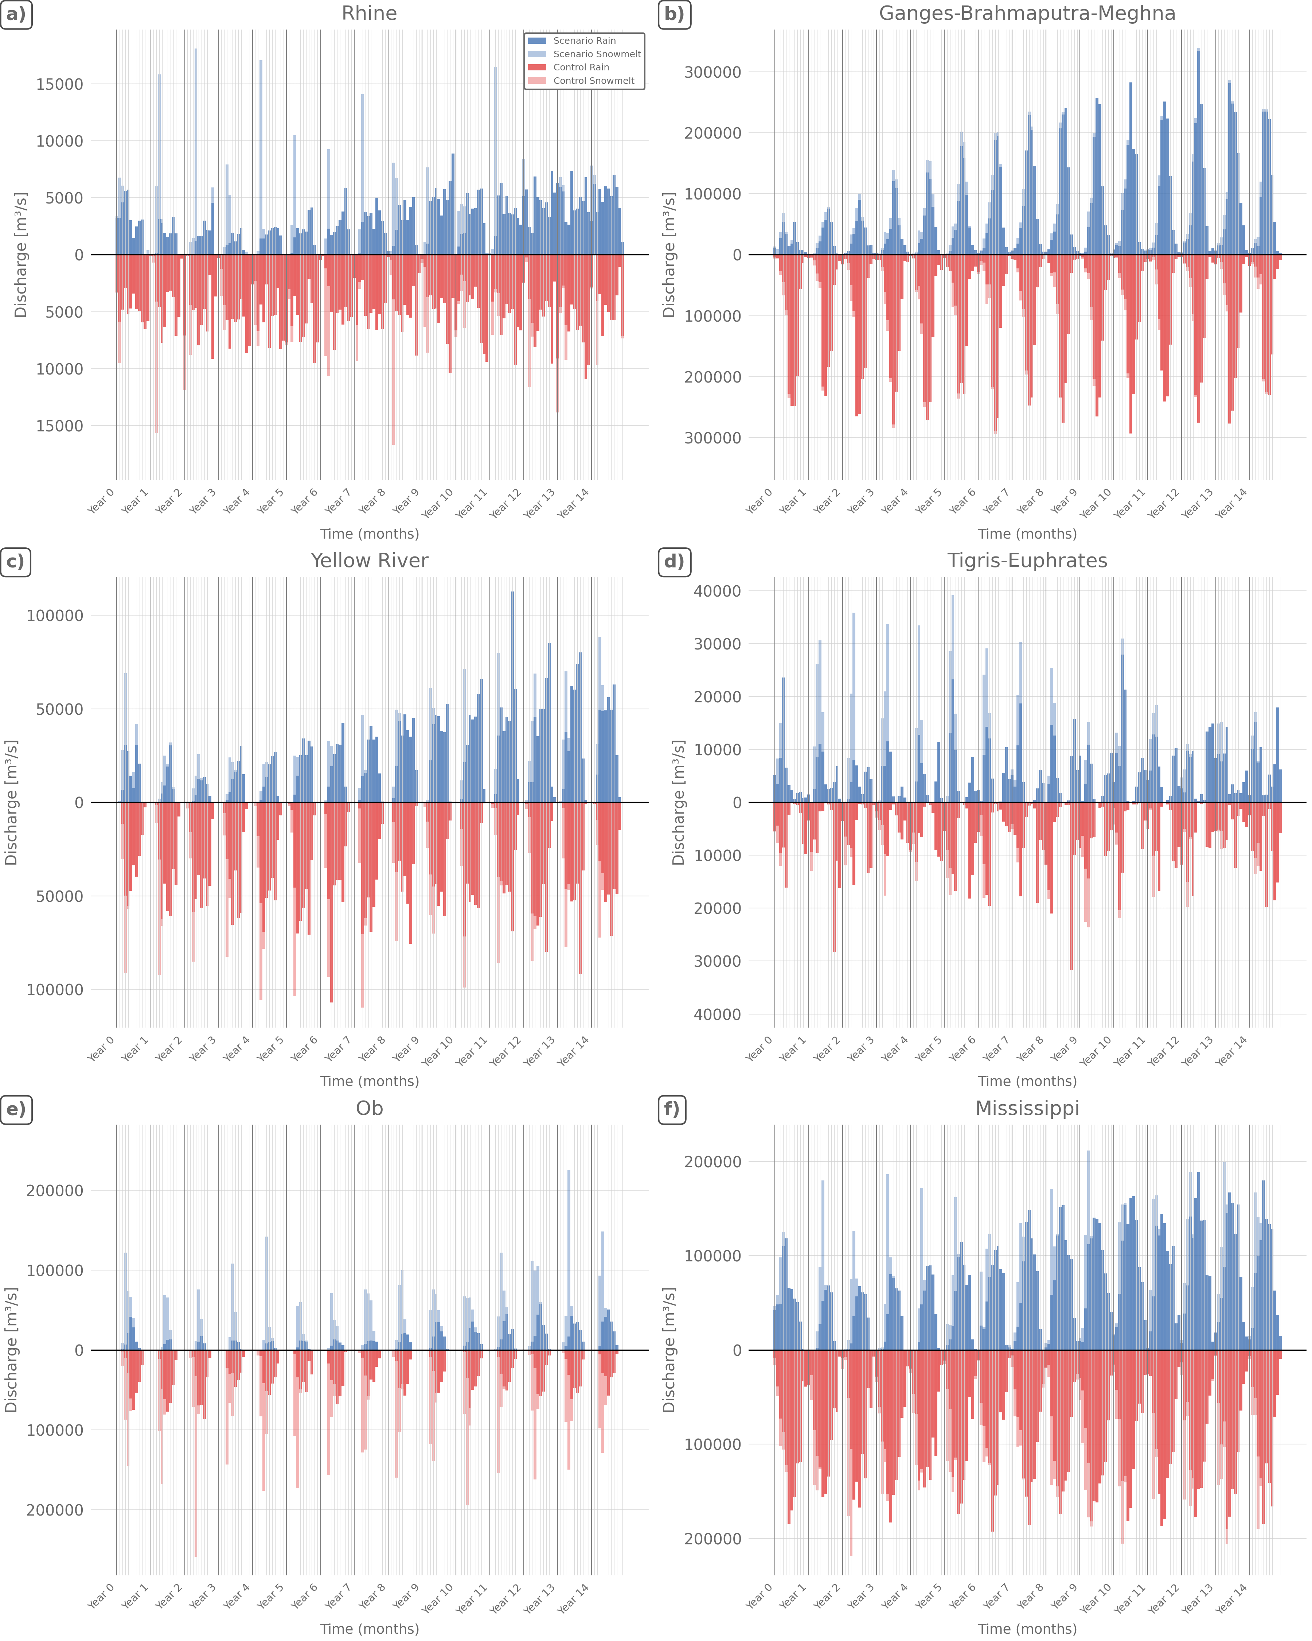
Figure 3. Monthly mean discharge from snowmelt and rain for six major river basins under the 47 Tg soot injection scenario. Blue bars show scenario discharge (dark blue: rain, light blue: snowmelt), plotted above the zero line. Red bars show control discharge (dark red: rain, light red: snowmelt), plotted below the zero line for visual comparison. Major tick marks on the x-axis indicate January of each simulation year. Discharge values represent catchment-integrated volumes converted to mean monthly discharge in m³ s⁻¹.

Discussion

Mechanisms Driving Snow Storage Change
The global temperature reduction following the soot injection affects snow dynamics through three distinct mechanisms: the emergence of new seasonality in previously snow-free regions, the prolongation of existing snow seasons, and the continuous multi-year accumulation in high-latitude regions.
The first mechanism is most directly visible in the rapid expansion of snow cover extent in Year 1 and 2. As winter temperatures are pushed below the freezing threshold in regions that rarely experience sub-zero conditions, precipitation shifts from rain to snow, generating entirely new seasonal snow signals as seen in Cluster 1. The spatial footprint of this response reflects the southward displacement of the winter freezing isotherm under nuclear winter conditions, a pattern that scales with the magnitude of soot injection (Coupe et al., 2019). Observational evidence from volcanic eruptions supports the plausibility of this mechanism. Snowfall has been documented in the Middle East in the winter of 1172/73 following a major medieval eruption in 1170/71, and in the winter of 1991/92 following the Pinatubo eruption, though a causal link for the medieval case remains inconclusive (Guillet et al., 2025). Because this new seasonality is directly tied to the temperature threshold being crossed, both the recovery of Cluster 1 and the global snow cover extent anomaly track the temperature recovery more closely than mean snow storage.
The second mechanism, prolongation of existing snow seasons, is reflected in the timing of the global mean storage anomaly and snow cover extent anomaly, which peak in May or June rather than in winter. This indicates that snow persists into months that would normally see rapid melting, driven by the stronger negative temperature anomalies over land during summer relative to winter (Coupe et al., 2019). Cluster 2 illustrates this mechanism particularly clearly, as the period with seasonal snow cover extends substantially relative to the control. However, the concurrent reduction in total precipitation causes annual snow storage maxima to temporarily fall below control levels.
The third mechanism, continuous multi-year accumulation, is reflected by Cluster 3 in high-latitude regions, where temperature reductions are large enough to suppress the melt season almost completely, allowing snowpacks to build up continuously in the first years after the soot injection. Even as global temperatures begin to recover, they remain below the melt threshold in these regions, which explains why the maximum of the global snow storage anomaly is delayed relative to the maximum of the temperature reduction. Subsequent recovery is comparably slow, as it requires substantial latent heat input to melt these accumulated snowpacks.
The spatial pattern of these three regimes broadly corresponds to the reduction in growing season length projected by Coupe et al. (2019) and the increase in maximum frost depth described by Lamilla Cuellar et al. (2026), with Cluster 3 regions facing near-complete elimination of the growing season in the first years following the soot injection and the largest frost depth increases, while Cluster 2 regions experience growing season reductions of 50-150 days. This correspondence across independent analyses underlines that the snow regimes identified here are part of a coherent pattern of regional climate disruption. It should be noted, however, that while the land-surface model underlying these frost depth estimates (Oleson et al., 2010) accounts for the insulating effect of snow on soil heat loss (Zhang, 2005), the reliability of frost depth estimates under such extreme multi-year snowpacks remains questionable.
A further notable feature is that snow storage anomalies do not return to control levels within the 15-year simulation period across all scenarios, including the 16 Tg case. This persistent anomaly reflects the equally persistent temperature depression reported by Coupe et al. (2019) and Toon et al. (2019), which itself does not return to pre-war levels within the simulation period. As Harrison et al. (2022) demonstrate, even relatively moderate soot injections trigger a hysteresis response in the ocean that persists well beyond the atmospheric forcing, with sea ice expansion and enhanced vertical mixing maintaining a cooled ocean state for decades, providing a physical basis for the incomplete recovery observed here. The persistence of large snowpacks in high-latitude regions such as those represented by Cluster 3 and 4 would further amplify this signal through the snow-albedo feedback. Additional snow cover reflects a greater fraction of incoming solar radiation, suppressing surface warming and delaying the recovery of surface temperatures. Robock (1984) demonstrated this mechanism using an energy balance model, showing that snow and ice feedbacks can substantially amplify and prolong the climatic response to nuclear winter forcing beyond what atmospheric processes alone would predict.
Not all snow storage anomalies in this study are driven by the same mechanism, nor are they uniformly positive. While the increases observed in Clusters 1 and 3 are primarily driven by cooling-induced changes in snowfall and melt, this temperature-driven mechanism is progressively counteracted by the concurrent decline in precipitation in Cluster 2, eventually driving its annual maxima below control levels. In Cluster 4, where temperatures already remain below the snowfall threshold under both control and scenario conditions, this temperature-driven mechanism is absent altogether, leaving the decline in precipitation as the dominant influence. This manifests as pronounced and sustained negative snow storage anomalies in parts of the cluster, particularly Greenland, although the cluster-level signal remains comparatively weak because of strong spatial heterogeneity. This divergence illustrates that the response to nuclear winter forcing is not governed by a single mechanism, even within terrestrial snow storage.

A similar divergence is evident beyond terrestrial snow. While this study identifies a robust increase in terrestrial snow storage across the Northern Hemisphere, cryospheric responses to nuclear winter forcing are not uniformly positive globally either. Coupe et al. (2023) demonstrate that Antarctic sea ice undergoes a substantial decline in the largest nuclear war scenario despite global cooling, driven by wind-stress-induced ocean circulation changes. Together, these findings suggest that nuclear winter reorganizes the cryosphere in spatially complex ways rather than producing a uniform expansion of snow and ice. While cooling promotes snow accumulation across large parts of the Northern Hemisphere, precipitation-driven reductions in snow storage remain possible in permanently frozen regions, and Antarctic sea ice may even decline despite lower global temperatures.

Hydrological Consequences
The shift of precipitation from rain to snow under nuclear winter conditions fundamentally reshapes the seasonal distribution of runoff across most basins.

First, the extended period of sub-zero temperatures prolongs the phase during which little to no runoff is generated from either rainfall or snowmelt. As precipitation falls predominantly as snow and temperatures remain too low to trigger melting, this water is effectively stored in the snowpack rather than contributing to discharge. River discharge during this phase would be sustained primarily by groundwater baseflow, which may itself be reduced under freezing conditions. Wang (2019) demonstrates that low temperatures can decrease aquifer hydraulic conductivity, thereby constraining groundwater contributions to streamflow even where groundwater storage remains available. In addition, groundwater recharge may be both reduced and increasingly confined to warmer periods. Prolonged soil freezing and the delayed onset of snowmelt could postpone infiltration. At the same time, the general reduction in total precipitation limits the overall volume available for recharge. This potentially increases the risk of long-term groundwater depletion, although quantifying this would require dedicated groundwater modelling beyond the scope of this study. These hydrological changes have direct implications for freshwater availability. Under nuclear winter conditions, underground water supply infrastructure is simultaneously at risk of frost damage (Lamilla Cuellar et al., 2026), thereby increasing dependence on surface water resources precisely during periods of minimum runoff availability.

Second, the extended snow season allows for prolonged accumulation, resulting largely in greater snowpack volumes. As melt remains confined to a broadly similar seasonal time window, these larger volumes generate substantially higher discharge peaks, with potential implications for flood risk, as evident especially in the Rhine and Tigris-Euphrates basins. This effect is further amplified by the higher runoff coefficient of snowmelt relative to rainfall. Meltwater release occurs during periods of naturally low evapotranspiration, allowing a larger fraction to be converted directly into discharge (Berghuijs et al., 2014; Jenicek & Ledvinka, 2020), an effect likely reinforced by the broad suppression of evapotranspiration under nuclear winter conditions (Robock et al., 2007b). In some regions, delayed melt may additionally increase the potential for overlap with summer rainfall events, although this effect appears limited given the strongly weakened monsoon systems across Asia, North America, and Africa under nuclear winter conditions (Robock et al., 2007b; Coupe et al., 2019).

Third, not all basins follow this pattern. In the Ob and Yellow River basins, annual snowmelt anomalies are negative, primarily reflecting the general reduction in precipitation and thus in snowfall accumulation. In the Ob, however, the accumulation mechanism of cluster 3 operates. Temperatures remain too low for complete seasonal melting, causing a growing fraction of the snowpack to persist year-round, preventing it from contributing to discharge as snowmelt. This has particularly severe consequences because the Ob's hydrology is fundamentally structured around its spring flood pulse, which accounts for 70-80 % of total annual runoff and derives approximately half of its volume from snowmelt (Papina et al., 2023). Under scenario conditions, snowmelt contributions to river discharge are reduced by up to 55 %, directly undermining this flood pulse, with potential implications for water availability and freshwater ecosystems across this high-latitude region.

Taken together, these hydrological responses are broadly consistent with previous evidence on streamflow responses to stratospheric aerosol forcing from volcanic eruptions. Kim et al. (2025) combined global climate model simulations with a statistical streamflow model applied to 7,886 gauging stations worldwide to investigate changes in seasonal peak discharges with a 2-year return interval. For the Pinatubo eruption, whose symmetric aerosol distribution most closely resembles nuclear winter forcing, they find a widespread reduction in the frequency of winter (DJF) peak discharge events across the Northern Hemisphere, broadly consistent with the general suppression of discharge identified here. Conversely, both the frequency and magnitude of peak discharges increase during spring and early summer (MAM and JJA) in arid and temperate regions, consistent with the elevated discharge peaks identified for the Tigris-Euphrates and Rhine basins. The agreement across both the seasonal timing and regional patterns of discharge responses suggests that the hydrological changes under nuclear winter conditions represent an intensified extension of processes already observed following major volcanic forcing. The broader implication is that nuclear winter would not simply reduce freshwater availability, but fundamentally alter its seasonal distribution, increasing the potential for both hydrological droughts and flood events across snow-influenced river basins.

Beyond Water Availability - Societal Impacts of Extreme Snowpacks
The snowpack anomalies identified in this study would have consequences extending well beyond their hydrological significance, most acutely in Cluster 3 regions, primarily the high-latitude regions of Russia, Scandinavia, and Canada, where multi-year snowpacks develop that reach exceptional depths. To translate SWE into snow depth, a representative bulk density of 0.3-0.4 g cm⁻³ can be assumed for settled to wind-compacted snowpacks. This range is consistent with physically based density evolution from seasonal snow to firn (Cuffey & Paterson, 2010) and with observed snowpack properties in tundra and taiga environments (Sturm et al., 2010). The median snow storage reaches approximately 1000 mm SWE after 5-6 years, corresponding to snow depths on the order of 2.5-3.3 m under these assumptions. Upper quantiles of the simulated SWE distribution yield substantially greater depths, reaching approximately 6-8 m in the most snow-accumulating locations. Such depths would challenge infrastructure systems designed to cope with seasonal snow accumulation but not with persistent multi-year snowpacks. Transport would be severely disrupted, with roads and railways buried under snow and airport operations greatly constrained. Maintaining transport infrastructure would require substantial effort and could impair the supply of food, fuel, and medical resources to affected populations. Heavy snow loads could increase the risk of failures in electricity infrastructure, for example through direct structural loading on transmission towers or damage to overhead power lines from falling snow-laden trees. Any resulting power outages would further exacerbate energy insecurity at a time when heating demands are substantially elevated. The accumulating snowpacks would furthermore place exceptional structural loads on buildings, increasing the risk of roof damage or collapse.

Overall, these compounding pressures suggest that extreme multi-year snowpacks would represent not only a hydrological anomaly, but also a broader challenge to societal resilience in affected regions.

Limitations
Temperature-index approaches implicitly assume a relatively stable relationship between air temperature and available melt energy. Even under present day conditions, DDFs vary considerably reflecting differences in solar radiation, albedo, snow density, and topographic factors such as slope, aspect, and elevation (Hock, 2003). In high-latitude regions where temperatures remain below the melt threshold year-round, the approach is not applicable at all, as it attributes mass loss solely to above-freezing temperatures. Such regions were therefore excluded from the calculation of global mean snow storage anomalies. Under nuclear winter conditions, the core assumption is further challenged by a temporal decoupling of radiation and temperature. Reductions in incoming solar radiation precede the surface temperature minimum, while temperature recovery is delayed by ocean thermal inertia (Coupe et al., 2019; Harrison et al., 2022). As a result, the DDF is likely overestimated during the early years of the simulation, when radiation is already strongly reduced but temperatures have not yet reached their minimum, and potentially underestimated during the recovery phase, when radiation recovers faster than surface temperature. While the DDF applied here falls within the range reported in the literature (Massmann, 2019), this systematic temporal bias should be considered when interpreting melt-driven discharges.

Additionally, the discharge estimates represent the total liquid water input to each catchment from snowmelt and rainfall, without accounting for catchment-scale partitioning into infiltration, soil moisture storage, groundwater recharge, or evapotranspiration. They therefore represent an upper bound of potential surface water availability rather than actual river discharge. As evapotranspiration losses are smaller under nuclear winter conditions (Robock et al., 2007b), the true reduction in water availability relative to control may be smaller than the raw discharge values suggest, since a larger share of the estimated liquid input would actually reach the river as streamflow.

The monthly temporal resolution of the forcing data limits the representation of sub-monthly snowmelt dynamics and precludes the explicit simulation of rain-on-snow events. Consequently, short-term discharge peaks and flood-generating processes cannot be assessed. Daily forcing data would provide a more realistic representation of melt onset and intensity, rain-on-snow occurrence, and extreme discharge events. However, the monthly resolution is sufficient to analyze the large-scale seasonal changes in snow storage and runoff timing that are the focus of this study.

Conclusions
This study provides a first-order assessment of how nuclear winter conditions reorganize global snow storage and terrestrial water availability across major river basins. Three dominant, threshold-driven snow response regimes emerge: the development of seasonal snow in previously snow-free regions, a prolongation of existing snow seasons, and the formation of persistent multi-year snowpacks at high latitudes. Global snow storage does not recover within the 15-year simulation period, consistent with the equally persistent temperature depression reported by Coupe et al. (2019) and Toon et al. (2019). These regimes fundamentally alter the seasonal timing of runoff. The widespread shift from rain to snow suppresses direct winter runoff, allowing larger seasonal snowpacks to build up. Where these larger snowpacks melt within the same seasonal window, the greater meltwater volume amplifies spring and summer discharge peaks and increases flood risk. Where they do not fully melt, water is sequestered in long-term snow storage, effectively preventing it from contributing to discharge and exacerbating water scarcity beyond what precipitation changes alone would imply. Taken together, these findings highlight snowpack dynamics as a critical but previously underexplored pathway through which nuclear winter translates into freshwater disruption, extending the documented impacts of nuclear conflict beyond temperature and agricultural systems. Future work should therefore incorporate water balance processes, including evapotranspiration, infiltration, and groundwater recharge, through process-based global hydrological models to better constrain the implications for seasonal water availability and flood risk.

References
Aleksandrov, V., & Stenchikov, G. L. (1983). On the modelling of the climatic consequences of the nuclear war (The Proceedings on Applied Mathematics) (p. 21). Moscow: Computing Centre, USSR Academy of Sciences.
Barnett, T. P., Adam, J. C., & Lettenmaier, D. P. (2005). Potential impacts of a warming climate on water availability in snow-dominated regions. Nature, 438(7066), 303–309. https://doi.org/10.1038/nature04141
Barnett, T. P., Pierce, D. W., Hidalgo, H. G., Bonfils, C., Santer, B. D., Das, T., et al. (2008). Human-Induced Changes in the Hydrology of the Western United States. Science, 319(5866), 1080–1083. https://doi.org/10.1126/science.1152538
Berghuijs, W. R., Woods, R. A., & Hrachowitz, M. (2014). A precipitation shift from snow towards rain leads to a decrease in streamflow. Nature Climate Change, 4(7), 583–586. https://doi.org/10.1038/nclimate2246
Coupe, J., Bardeen, C. G., Robock, A., & Toon, O. B. (2019). Nuclear Winter Responses to Nuclear War Between the United States and Russia in the Whole Atmosphere Community Climate Model Version 4 and the Goddard Institute for Space Studies ModelE. Journal of Geophysical Research: Atmospheres, 124(15), 8522–8543. https://doi.org/10.1029/2019JD030509
Coupe, J., Harrison, C., Robock, A., DuVivier, A., Maroon, E., Lovenduski, N. S., et al. (2023). Sudden Reduction of Antarctic Sea Ice Despite Cooling After Nuclear War. Journal of Geophysical Research: Oceans, 128(1), e2022JC018774. https://doi.org/10.1029/2022JC018774
Crutzen, P. J., & Birks, J. W. (1982). The atmosphere after a nuclear war: Twilight at noon. Ambio, 11(2–3), 114–125.
Cuffey, K. M., & Paterson, W. S. B. (2010). The physics of glaciers (4th ed.). Academic Press.
Fayet, H. (2026, March 5). France has a new nuclear doctrine of ‘forward deterrence’ for Europe. What does it mean? Retrieved May 28, 2026, from https://thebulletin.org/2026/03/france-has-a-new-nuclear-doctrine-of-forward-deterrence-for-europe-what-does-it-mean/#post-heading
Guillet, S., Corona, C., Yang, Z., Oppenheimer, C., Lavigne, F., Ludlow, F., & Stoffel, M. (2025). Challenges in detecting volcanic forcing in climate and societal proxies: insights from the 1170/1171 CE eruption. Climatic Change, 178(3), 58. https://doi.org/10.1007/s10584-025-03867-x
Harrison, C., Rohr, T., Maroon, E. A., Bachman, S., Bardeen, C. G., Coupe, J., et al. (2022). A New Ocean State After Nuclear War. AGU Advances, 3(4), e2021AV000610. https://doi.org/10.1029/2021AV000610
Harrison, C., Faulkner, W., Coupe, J., Asante, E. K., Bardeen, C., Garza, V., et al. (2026). Accessible Climate and Impact Model Output for Studying the Human and Environmental Impacts of Nuclear Conflict. Geoscience Data Journal, 13(3), e70076. https://doi.org/10.1002/gdj3.70076
Hayhoe, K., Cayan, D., Field, C. B., Frumhoff, P. C., Maurer, E. P., Miller, N. L., et al. (2004). Emissions pathways, climate change, and impacts on California. Proceedings of the National Academy of Sciences, 101(34), 12422–12427. https://doi.org/10.1073/pnas.0404500101
Hock, R. (2003). Temperature index melt modelling in mountain areas. Mountain Hydrology and Water Resources, 282(1), 104–115. https://doi.org/10.1016/S0022-1694(03)00257-9
Iles, C. E., & Hegerl, G. C. (2015). Systematic change in global patterns of streamflow following volcanic eruptions. Nature Geoscience, 8(11), 838–842. https://doi.org/10.1038/ngeo2545
Immerzeel, W. W., Lutz, A. F., Andrade, M., Bahl, A., Biemans, H., Bolch, T., et al. (2020). Importance and vulnerability of the world’s water towers. Nature, 577(7790), 364–369. https://doi.org/10.1038/s41586-019-1822-y
Jenicek, M., & Ledvinka, O. (2020). Importance of snowmelt contribution to seasonal runoff and summer low flows in Czechia. Hydrology and Earth System Sciences, 24(7), 3475–3491. https://doi.org/10.5194/hess-24-3475-2020
Kim, H., Villarini, G., Yang, W., & Vecchi, G. (2025). Global response of floods to tropical explosive volcanic eruptions. Nature Geoscience, 18(10), 983–988. https://doi.org/10.1038/s41561-025-01782-5
Lamilla Cuellar, J. E., Palm, R., Denkenberger, D. C., & Jehn, F. U. (2026). Frost depth increase under a nuclear winter scenario projected to sever piped-water access in the Northern Hemisphere. Water Security, 27, 100193. https://doi.org/10.1016/j.wasec.2025.100193
Lehner, B., & Grill, G. (2013). Global river hydrography and network routing: baseline data and new approaches to study the world’s large river systems. Hydrological Processes, 27(15), 2171–2186. https://doi.org/10.1002/hyp.9740
Liang, X. (2026, April). New START at a Glance. Retrieved June 9, 2026, from https://www.armscontrol.org/factsheets/new-start-glance
Massmann, C. (2019). Modelling Snowmelt in Ungauged Catchments. Water, 11(2), 301. https://doi.org/10.3390/w11020301
Mills, M. J., Toon, O. B., Lee-Taylor, J., & Robock, A. (2014). Multidecadal global cooling and unprecedented ozone loss following a regional nuclear conflict. Earth’s Future, 2(4), 161–176. https://doi.org/10.1002/2013EF000205
Müller, M. (Ed.). (2007). Dynamic Time Warping. In Information Retrieval for Music and Motion (pp. 69–84). Berlin, Heidelberg: Springer Berlin Heidelberg. https://doi.org/10.1007/978-3-540-74048-3_4
Natural Earth. (2009). Natural Earth Data Land Polygons (Version 4.0.0) [Data set]. Retrieved from https://www.naturalearthdata.com/downloads/110m-physical-vectors/110m-land/
Oleson, K. W., Lawrence, D. M., Bonan, G. B., Flanner, M. G., Kluzek, E., Lawrence, P. J., et al. (2010). Technical Description of Version 4.0 of the Community Land Model (CLM) (NCAR Technical Note No. NCAR/TN-478+STR). Boulder, CO: National Center for Atmospheric Research. https://doi.org/10.5065/D6FB50WZ
Papina, T., Eirikh, A., Kotovshchikov, A., & Noskova, T. (2023). Impact of Snowmelt Conditions on the Isotopic Composition of the Surface Waters of the Upper Ob River during the Flood Period. Water, 15(11), 2096. https://doi.org/10.3390/w15112096
Qin, Y., Abatzoglou, J. T., Siebert, S., Huning, L. S., AghaKouchak, A., Mankin, J. S., et al. (2020). Agricultural risks from changing snowmelt. Nature Climate Change, 10(5), 459–465. https://doi.org/10.1038/s41558-020-0746-8
Robock, A. (1984). Snow and ice feedbacks prolong effects of nuclear winter. Nature, 310(5979), 667–670. https://doi.org/10.1038/310667a0
Robock, A., Oman, L., Stenchikov, G. L., Toon, O. B., Bardeen, C., & Turco, R. P. (2007a). Climatic consequences of regional nuclear conflicts. Atmospheric Chemistry and Physics, 7(8), 2003–2012. https://doi.org/10.5194/acp-7-2003-2007
Robock, A., Oman, L., & Stenchikov, G. L. (2007b). Nuclear winter revisited with a modern climate model and current nuclear arsenals: Still catastrophic consequences. Journal of Geophysical Research: Atmospheres, 112(D13), 2006JD008235. https://doi.org/10.1029/2006JD008235
SIPRI. (2025). SIPRI Yearbook 2025: Armaments, Disarmament and International Security. Oxford University Press. https://doi.org/10.1093/sipri/9780198979791.001.0001
Sturm, M., Taras, B., Liston, G. E., Derksen, C., Jonas, T., & Lea, J. (2010). Estimating Snow Water Equivalent Using Snow Depth Data and Climate Classes. Journal of Hydrometeorology, 11(6), 1380–1394. https://doi.org/10.1175/2010JHM1202.1
Tavenard, R., Faouzi, J., Vandewiele, G., Divo, F., Androz, G., Holtz, C., et al. (2020). Tslearn, A Machine Learning Toolkit for Time Series Data. Journal of Machine Learning Research, 21(118), 1–6.
Toon, O. B., Bardeen, C. G., Robock, A., Xia, L., Kristensen, H., McKinzie, M., et al. (2019). Rapidly expanding nuclear arsenals in Pakistan and India portend regional and global catastrophe. Science Advances, 5(10), eaay5478. https://doi.org/10.1126/sciadv.aay5478
Turco, R. P., Toon, O. B., Ackerman, T. P., Pollack, J. B., & Sagan, C. (1983). Nuclear Winter: Global Consequences of Multiple Nuclear Explosions. Science, 222(4630), 1283–1292. https://doi.org/10.1126/science.222.4630.1283
U.S. Department of Agriculture (USDA). (2004). National Engineering Handbook. Part 630 Hydrology, Chapter 11 Snowmelt. (2004th ed.). Retrieved from https://directives.nrcs.usda.gov/sites/default/files2/1712930610/7301.pdf
Wang, S. (2019). Freezing Temperature Controls Winter Water Discharge for Cold Region Watershed. Water Resources Research, 55(12), 10479–10493. https://doi.org/10.1029/2019WR026030
Zhang, T. (2005). Influence of the seasonal snow cover on the ground thermal regime: An overview. Reviews of Geophysics, 43(4). https://doi.org/10.1029/2004RG000157

Annex
Figure A1. Elbow-Plot for the clustering of the 47 Tg soot injection case 21
Figure A2. Elbow-Plot for the clustering of the control simulation 21
Figure A3. Spatial anomaly of snow storage for the 47 Tg soot injection case. 22
Figure A4. Hovmoeller diagrams of the zonal mean snow storage anomaly 22
Figure A5. Annual total discharge anomaly for six major river basins 23
Figure A6. Annual snowmelt anomaly for six major river basins 23

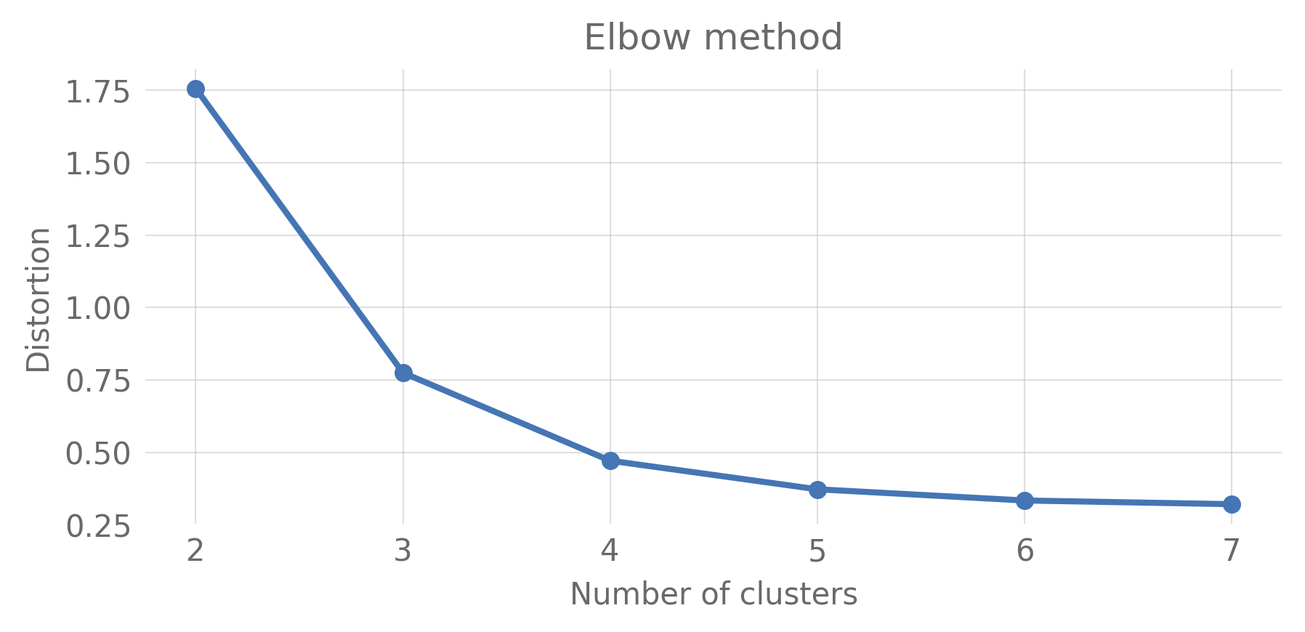
Figure A1. Elbow-Plot for the clustering of the 47 Tg soot injection case, based on a randomly selected subset comprising 30% of the total data points.

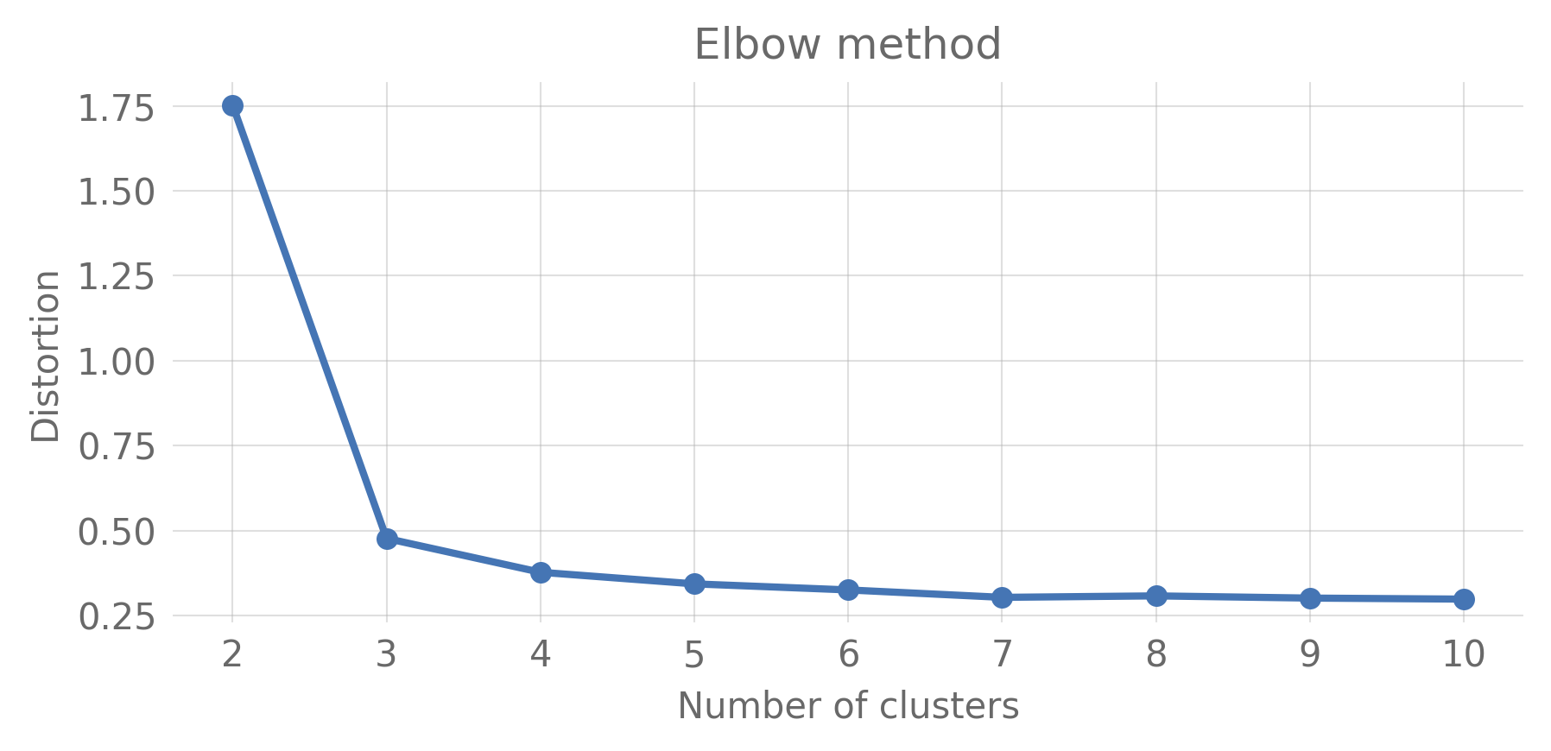
Figure A2. Elbow-Plot for the clustering of the control simulation, based on a randomly selected subset comprising 30% of the total data points.
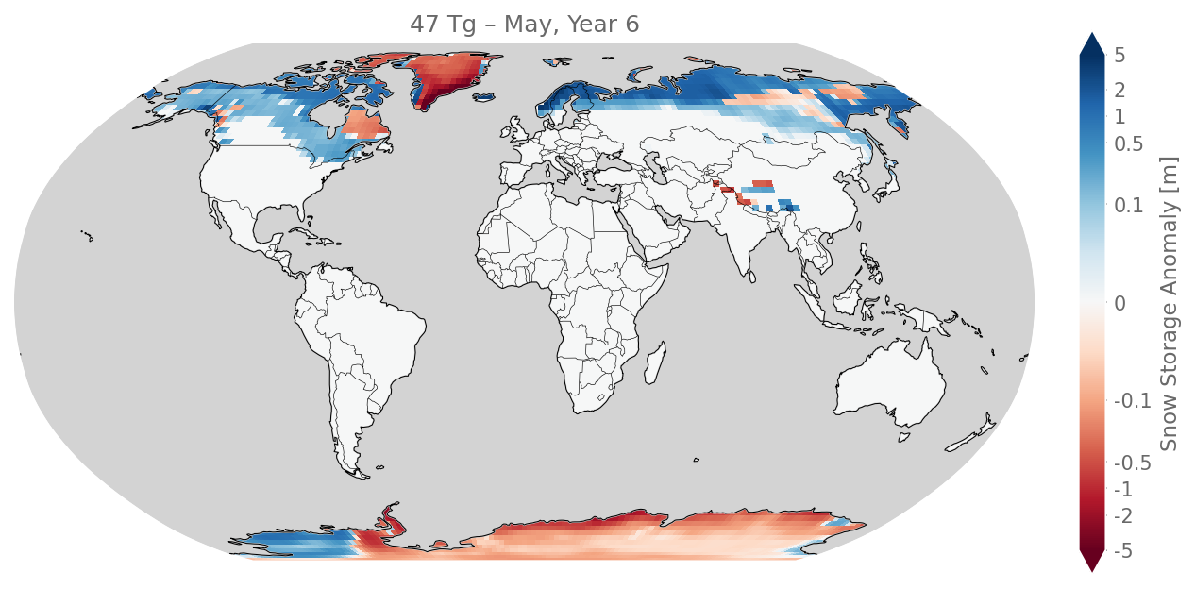
Figure A3. Spatial anomaly of snow storage for the 47 Tg soot injection scenario relative to the control simulation, shown for May, Year 6 — the time of maximum global snow storage anomaly. A symmetric logarithmic color scale resolves both small and large deviations. Values beyond ±5 m are clipped (colorbar arrows). Blue indicates increased, red indicates decreased snow storage relative to control.

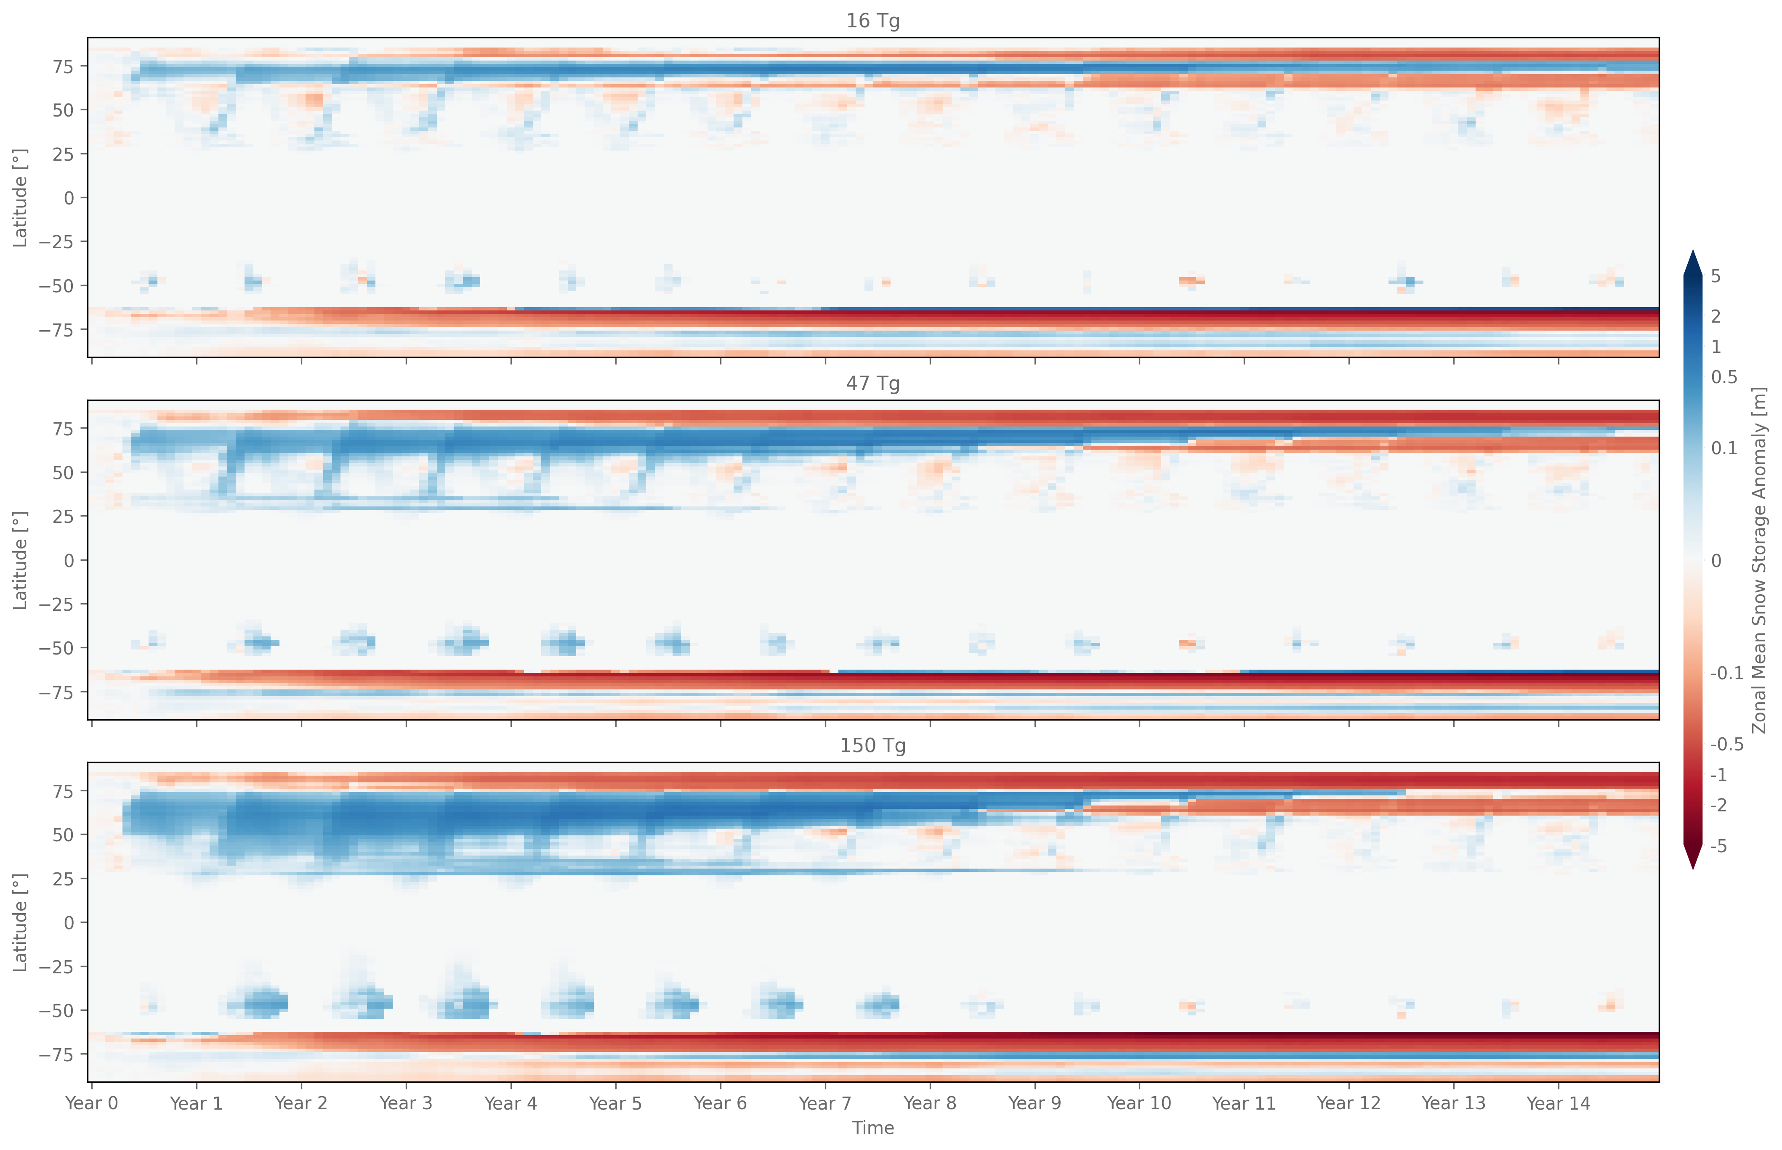
Figure A4. Hovmoeller diagrams of the zonal mean snow storage anomaly for the 16 Tg, 47 Tg, and 150 Tg soot injection scenarios relative to the control simulation. Anomalies are calculated from area-weighted zonal averages of land snow storage and shown using a symmetric logarithmic color scale to resolve both small and large deviations. Values beyond ±5 m are clipped (colorbar arrows). Blue indicates increased, red indicates decreased snow storage relative to control. The persistent positive anomaly band near 60-80°N and the persistent negative anomaly near 60-80°S reflect the long-term accumulation behavior of Cluster 4 regions (Arctic and Antarctic/Greenland), discussed separately in Section 3.2.
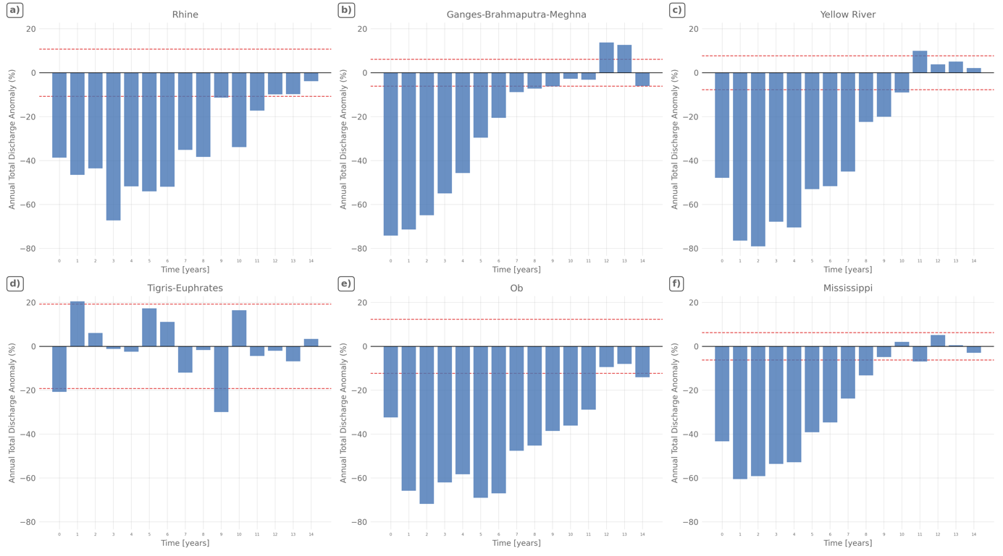
Figure A5. Annual total discharge anomaly for six major river basins under the 47 Tg scenario, expressed as percentage deviation from the climatological mean of the control run. Dashed red lines indicate ±1 standard deviation of the control run. Year 0 encompasses both pre- and post-injection months and should be interpreted with caution.

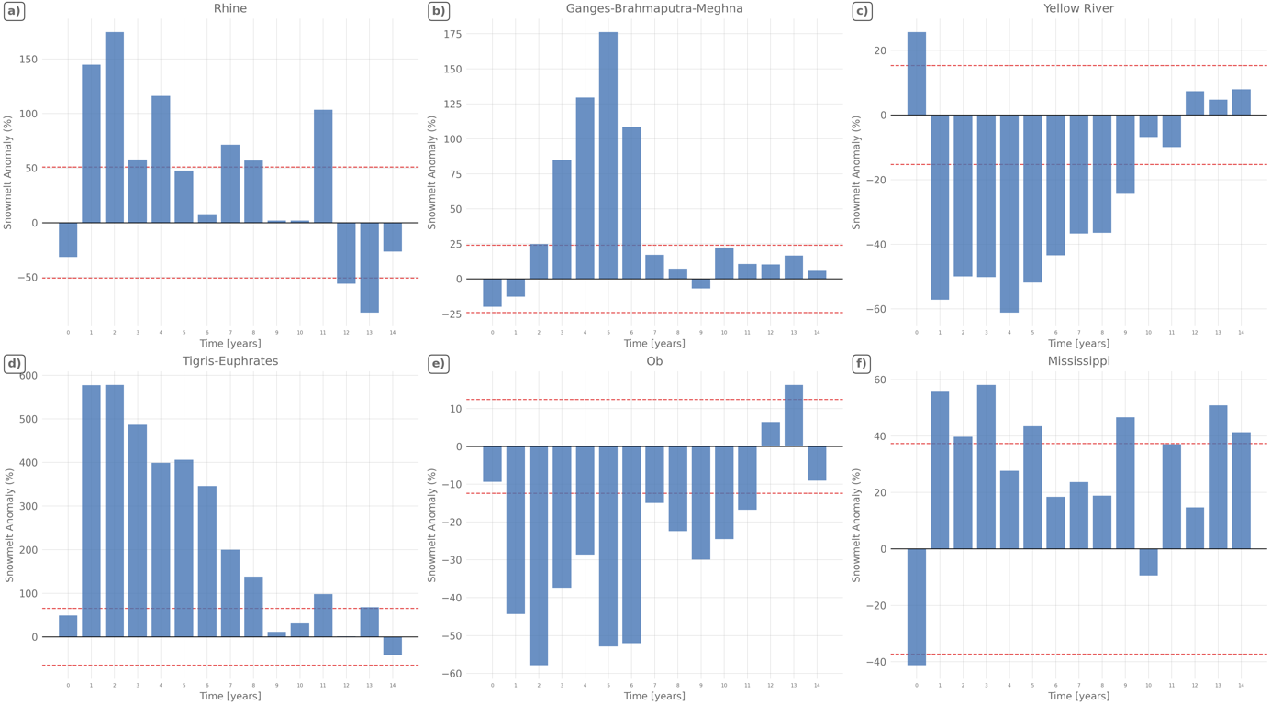
Figure A6. Annual snowmelt anomaly for six major river basins under the 47 Tg scenario, expressed as percentage deviation from the climatological mean of the control run. Dashed red lines indicate ±1 standard deviation of the control run. Year 0 encompasses both pre- and post-injection months and should be interpreted with caution.

Acknowledgements
I thank Prof. Dr. Lutz Breuer and Dr. Florian Ulrich Jehn for their valuable supervision and guidance throughout this work.

All code for data processing, clustering, and analysis is publicly available at: https://github.com/ericwoe/snow_storage_and_snowmelt_in_nuclear_winter

A large language model (Claude Sonnet 4.6, Anthropic) was used to support text formulation, revision, and the structuring of sections. Additionally, it was used to assist with code development for the data analysis and visualization presented in this thesis.

