In this challenge, you’ll use your knowledge of Python and unsupervised learning to predict if cryptocurrencies are affected by 24-hour or 7-day price changes.

**Before You Begin**

1. Create a new repository for this project called CryptoClustering. **Do not add this homework to an existing repository**.
2. Clone the new repository to your computer.
3. Push your changes to GitHub.

**Files**

Download the following files to help you get started:

[Module 19 Challenge filesLinks to an external site.](https://static.bc-edx.com/data/dl-1-2/m19/lms/starter/Starter_Code.zip)

**Instructions**

1. Rename the Crypto_Clustering_starter_code.ipynb file as Crypto_Clustering.ipynb.
2. Load the crypto_market_data.csv into a DataFrame.
3. Get the summary statistics and plot the data to see what the data looks like before proceeding.

**Prepare the Data**

* Use the StandardScaler() module from scikit-learn to normalize the data from the CSV file.
* Create a DataFrame with the scaled data and set the "coin_id" index from the original DataFrame as the index for the new DataFrame.
  + The first five rows of the scaled DataFrame should appear as follows:

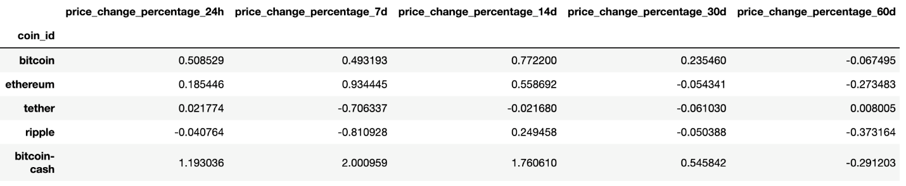

**Find the Best Value for k Using the Original Scaled DataFrame**

Use the elbow method to find the best value for k using the following steps:

* Create a list with the number of k values from 1 to 11.
* Create an empty list to store the inertia values.
* Create a for loop to compute the inertia with each possible value of k.
* Create a dictionary with the data to plot the elbow curve.
* Plot a line chart with all the inertia values computed with the different values of k to visually identify the optimal value for k.
* Answer the following question in your notebook: What is the best value for k?

**Cluster Cryptocurrencies with K-means Using the Original Scaled Data**

Use the following steps to cluster the cryptocurrencies for the best value for k on the original scaled data:

* Initialize the K-means model with the best value for k.
* Fit the K-means model using the original scaled DataFrame.
* Predict the clusters to group the cryptocurrencies using the original scaled DataFrame.
* Create a copy of the original data and add a new column with the predicted clusters.
* Create a scatter plot using hvPlot as follows:
  + Set the x-axis as "price_change_percentage_24h" and the y-axis as "price_change_percentage_7d".
  + Color the graph points with the labels found using K-means.
  + Add the "coin_id" column in the hover_cols parameter to identify the cryptocurrency represented by each data point.

**Optimize Clusters with Principal Component Analysis**

* Using the original scaled DataFrame, perform a PCA and reduce the features to three principal components.
* Retrieve the explained variance to determine how much information can be attributed to each principal component and then answer the following question in your notebook:
  + What is the total explained variance of the three principal components?
* Create a new DataFrame with the PCA data and set the "coin_id" index from the original DataFrame as the index for the new DataFrame.
  + The first five rows of the PCA DataFrame should appear as follows:

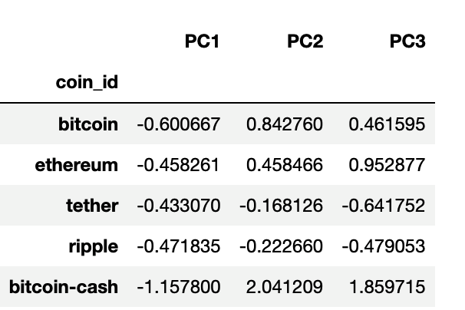

**Find the Best Value for k Using the PCA Data**

Use the elbow method on the PCA data to find the best value for k using the following steps:

* Create a list with the number of k-values from 1 to 11.
* Create an empty list to store the inertia values.
* Create a for loop to compute the inertia with each possible value of k.
* Create a dictionary with the data to plot the Elbow curve.
* Plot a line chart with all the inertia values computed with the different values of k to visually identify the optimal value for k.
* Answer the following question in your notebook:
  + What is the best value for k when using the PCA data?
  + Does it differ from the best k value found using the original data?

**Cluster Cryptocurrencies with K-means Using the PCA Data**

Use the following steps to cluster the cryptocurrencies for the best value for k on the PCA data:

* Initialize the K-means model with the best value for k.
* Fit the K-means model using the PCA data.
* Predict the clusters to group the cryptocurrencies using the PCA data.
* Create a copy of the DataFrame with the PCA data and add a new column to store the predicted clusters.
* Create a scatter plot using hvPlot as follows:
  + Set the x-axis as "price_change_percentage_24h" and the y-axis as "price_change_percentage_7d".
  + Color the graph points with the labels found using K-means.
  + Add the "coin_id" column in the hover_cols parameter to identify the cryptocurrency represented by each data point.
* Answer the following question:
  + What is the impact of using fewer features to cluster the data using K-Means?

**REWIND**

Recall that you learned how to create composite plots in a previous module. If you need a refresher on how to create these plots, review that module. You can also check [Composing PlotsLinks to an external site.](https://holoviz.org/tutorial/Composing_Plots.html) in the hvPlot documentation.

**Requirements**

**Find the Best Value for k by Using the Original Data (15 points)**

To receive all points, you must:

* Code the elbow method algorithm to find the best value for k. Use a range from 1 to 11. (5 points)
* To visually identify the optimal value for k, plot a line chart of all the inertia values computed with the different values of k. (5 points)
* Answer the following question: What’s the best value for k? (5 points)

**Cluster the Cryptocurrencies with K-Means by Using the Original Data (10 points)**

To receive all points, you must:

* Initialize the K-means model with four clusters by using the best value for k. (1 point)
* Fit the K-means model by using the original data. (1 point)
* Predict the clusters for grouping the cryptocurrencies by using the original data. Review the resulting array of cluster values. (3 points)
* Create a copy of the original data, and then add a new column of the predicted clusters. (1 point)
* Using hvPlot, create a scatter plot by setting x="price_change_percentage_24h" and y="price_change_percentage_7d". Color the graph points with the labels that you found by using K-means. Then add the crypto name to the hover_cols parameter to identify the cryptocurrency that each data point represents. (4 points)

**Optimize the Clusters with Principal Component Analysis (10 points)**

To receive all points, you must:

* Create a PCA model instance, and set n_components=3. (1 point)
* Use the PCA model to reduce the features to three principal components. Then review the first five rows of the DataFrame. (2 points)
* Get the explained variance to determine how much information can be attributed to each principal component. (2 points)
* Answer the following question: What’s the total explained variance of the three principal components? (3 points)
* Create a new DataFrame with the PCA data. Be sure to set the coin_id index from the original DataFrame as the index for the new DataFrame. Review the resulting DataFrame. (2 points)

**Find the Best Value for k by Using the PCA Data (10 points)**

To receive all points, you must:

* Code the elbow method algorithm, and use the PCA data to find the best value for k. Use a range from 1 to 11. (2 points)
* To visually identify the optimal value for k, plot a line chart of all the inertia values computed with the different values of k. (5 points)
* Answer the following questions: What’s the best value for k when using the PCA data? Does it differ from the best value for k that you found by using the original data? (3 points)

**Cluster the Cryptocurrencies with K-means by Using the PCA Data (10 points)**

To receive all points, you must:

* Initialize the K-means model with four clusters by using the best value for k. (1 point)
* Fit the K-means model by using the PCA data. (1 point)
* Predict the clusters for grouping the cryptocurrencies by using the PCA data. Review the resulting array of cluster values. (3 points)
* Create a copy of the DataFrame with the PCA data, and then add a new column to store the predicted clusters. (1 point)
* Using hvPlot, create a scatter plot by setting x="PC1" and y="PC2". Color the graph points with the labels that you found by using K-means. Then add the crypto name to the hover_cols parameter to identify the cryptocurrency that each data point represents. (4 points)

**Visualize and Compare the Results (15 points)**

To receive all points, you must:

* Create a composite plot by using hvPlot and the plus sign (+) operator to compare the elbow curve that you created from the original data with the one that you created from the PCA data. (5 points)
* Create a composite plot by using hvPlot and the plus (+) operator to compare the cryptocurrency clusters that resulted from using the original data with those that resulted from the PCA data. (5 points)
* Answer the following question: Based on visually analyzing the cluster analysis results, what’s the impact of using fewer features to cluster the data by using K-means? (5 points)

**Coding Conventions and Formatting (10 points)**

To receive all points, you must:

* Place imports at the top of the file, just after any module comments and docstrings, and before module globals and constants. (3 points)
* Name functions and variables with lowercase characters, with words separated by underscores. (2 points)
* Follow DRY (Don't Repeat Yourself) principles, creating maintainable and reusable code. (3 points)
* Use concise logic and creative engineering where possible. (2 points)

**Deployment and Submission (10 points)**

To receive all points, you must:

* Submit a link to a GitHub repository that’s cloned to your local machine and that contains your files. (4 points)
* Use the command line to add your files to the repository. (3 points)
* Include appropriate commit messages in your files. (3 points)

**Code Comments (10 points)**

To receive all points, your code must:

* Be well commented with concise, relevant notes that other developers can understand. (10 points)