Eric Yang

304263623

Homework 2

1.

Problem 1

$A∪B∪C$

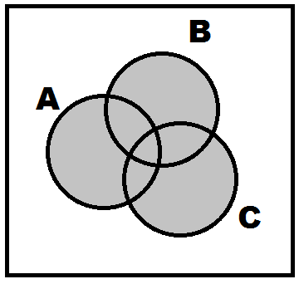

$(\left(A∩B\right)∪\left(B∩C\right)∪\left(A∩C\right))'$

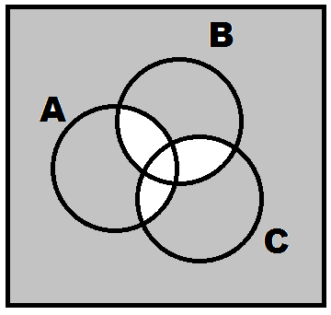

$A'∩B'∩C'$

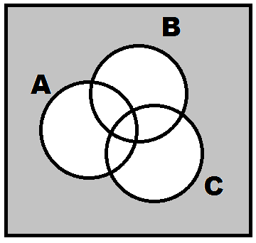

$A∩B∩C$

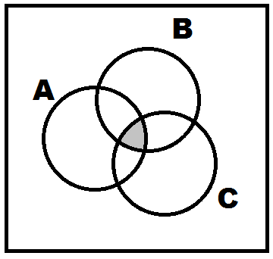

$(\left(A∩B\right)∪\left(B∩C\right)∪\left(A∩C\right))'∪(A∪B∪C)$

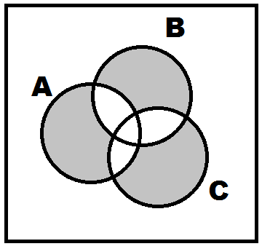

$A∩B∩C'$

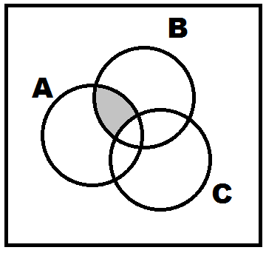

$A∪(A^{'}∩B^{'})$

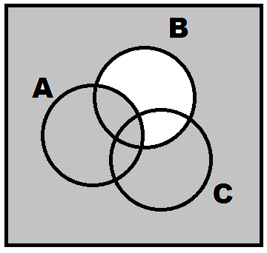

Problem 2

1. 1/8
2. 1/8
3. 3/8
4. 1/2

Problem 3

P(B) = (4-1/6)/4 = 23/24 = 95.83%

P(C) = 0

P(A) = 5/6\*5/6 = 25/36

P(D) = (4-2/3)/4 = 5/6

P($A∩D$) =

Problem 4

$\frac{π}{100π}=1\%$

$\frac{9π-π}{100π}=8\%$

2.

Problem 1

1. 1/2 = 50%
2. 1/3 = 33.33%

Problem 2

1/(9/4) = 44.44%

Problem 3

1. P(GPU request|1 Granted) = 0.4/1.1-0.28 = 48.78%
2. P(GPU granted|Granted) = 0.4/1.1= 36.36%

Problem 4

1. 0.4\*.25 = 0.1

0.6\*0.15 = 0.09

Search in A

Problem 5

3.

Problem 1

4C4\*48C4 / 52C8

Problem 2

Problem 3

1. e^-3
2. 1-e^-6-6e^-6