Eric Yang

304263623

Homework 6

Problem 1

$π0=0.7π0+0.2π1+0.1π2$

$π1=0.2π0+0.6π1+0.4π2$

$π2=0.1π0+0.2π1+0.5π2$

$π0+π1+π2=1$

$π0=$ 0.35

$π1=$ 0.41

$π2=$ 0.24

Problem 2

$\begin{matrix}0.5 & 0.4 & 0.1 \\ 0.3 & 0.4 & 0.3 \\ 0.2 & 0.3 & 0.5\end{matrix}$

$πH=0.5πH+0.3πR+0.2πAP$

$$πR=0.4πH+0.4πR+0.3πAP$$

$$πAP=0.1πH+0.3πR+0.5πAP$$

$$πH+πR+πAP=1$$

$πH=$ 21/62

$πR=$ 23/62

$πAP=$ 18/62

Problem 3

1. States: SS, SF, FS, FF (first is last task, second is one before)

$\begin{matrix}0.7 & 0 & 0.3 & 0 \\ 0.5 & 0 & 0.5 & 0 \\ 0 & 0.4 & 0 & 0.6 \\ 0 & 0.2 & 0 & 0.8\end{matrix}$

Problem 4

$\left[\begin{matrix}0.7 & 0.3 \\ 0.6 & 0.4\end{matrix}\right]$

P^4 = $\left[\begin{matrix}0.67 & 0.33 \\ 0.66 & 0.34\end{matrix}\right]\left[\begin{matrix}0.67 & 0.33 \\ 0.66 & 0.34\end{matrix}\right]=\left[\begin{matrix}0.6667 & 0.3333 \\ 0.6666 & 0.3334\end{matrix}\right]$

P[choose A on 4th] = $\frac{1}{2}*0.6667+\frac{1}{2}*0.6666=66.665\%$

Problem 5

$\left[\begin{matrix}0.25 & 0.75 \\ 0.20 & 0.80\end{matrix}\right]$

$πLaptop=0.25πLaptop+0.20πCellphone$

$πCellphone=0.75πLaptop+0.80πCellphone$

$$πLaptop+πCellphone=1$$

$πLaptop=\frac{4}{19}$

$$πCellphone=\frac{15}{19}$$

Laptops are 4/19 of devices

Problem 6

1. 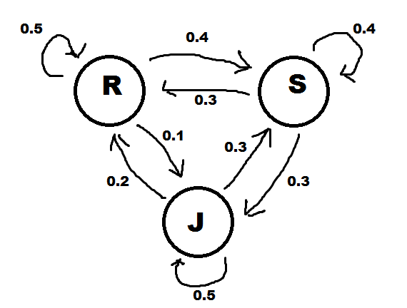

$\left[\begin{matrix}0.5 & 0.4 & 0.1 \\ 0.3 & 0.4 & 0.3 \\ 0.2 & 0.3 & 0.5\end{matrix}\right]$

$πR=0.5πR+0.3πS+0.2πJ$

$$πS=0.4πR+0.4πS+0.3πJ$$

$$πJ=0.1πR+0.3πS+0.5πJ$$

$$πR+πS+πJ=1$$

$πR=$

$πS=$

$πJ=$

Problem 7

1. YY: collisions occurred both times

YN: collision last time but not before

NY: no collision last time but collision before that

NN: no collision both times

$\left[\begin{matrix}0.7 & 0 & 0.3 & 0 \\ 0.5 & 0 & 0.5 & 0 \\ 0 & 0.4 & 0 & 0.6 \\ 0 & 0.2 & 0 & 0.8\end{matrix}\right]$

$π1=0.7π1+0.5π2$

$$π2=0.4π3+0.2π4$$

$$π3=0.3π1+0.5π2$$

$$π4=0.6π3+0.8π4$$

$$πR+πS+πJ=1$$

$π1=$

$π2=$

$π3=$

$π4=$