Eric Yang

304263623

CS 118

Dis 1A

Homework 7

32. The problem shouldn’t occur if we decrease the cost of a link because a loop won’t form. The problem should also not occur if we connect two nodes that don’t have a link because that is the same as decreasing the cost of a link.

35. Suppose there is a route for a peer. If this peer sees that it’s AS number is in the AS path, then there is a loop.

37. a. eBGP

b. iBGP

c. eBGP

d. iBGP

40. X’s view: there is no route to w or y that contains the link between A and C

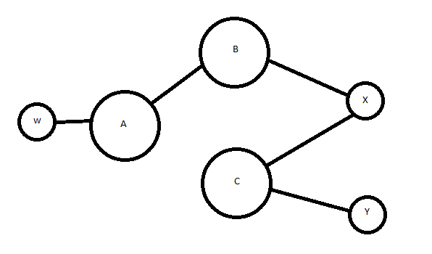

W’s view: there is no route to x or y that contains the link between B and C

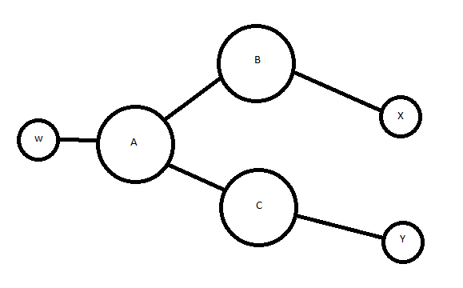

46.

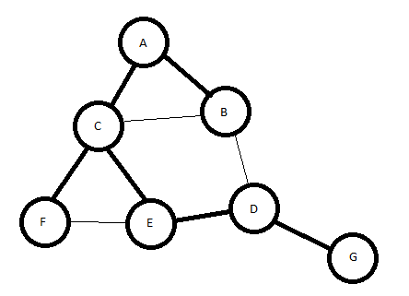

7. A. It can detect single bit error in D because flipping a bit in D would mean that the value no longer yields zero when divided by G.

B. Since an odd number of 1s can’t be divided by 11 but G can be divided by 11, then G cannot detect an odd number of bit errors.