Eric Yang

304263623

Homework 2

1a.

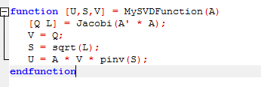

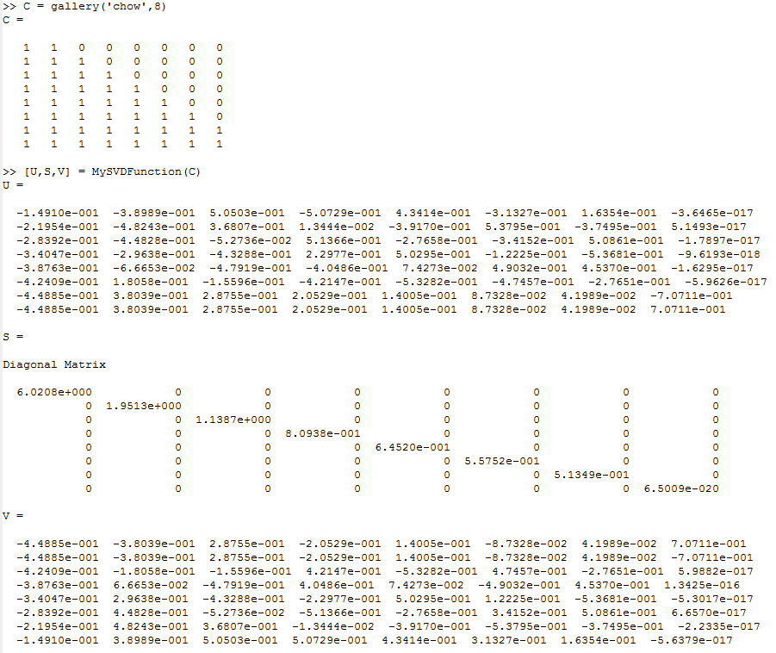

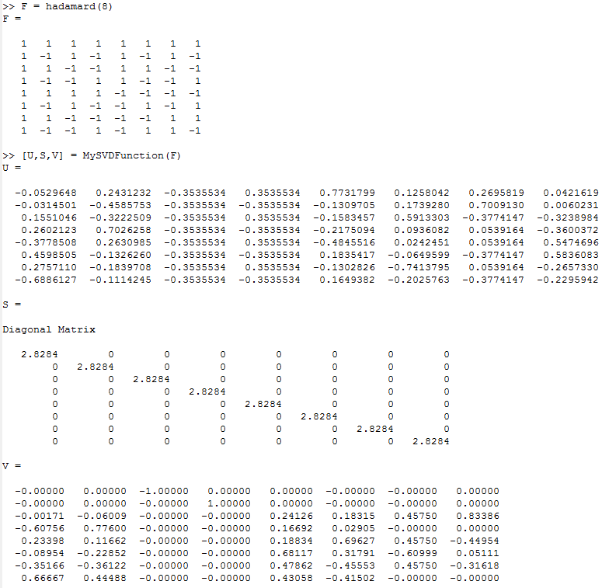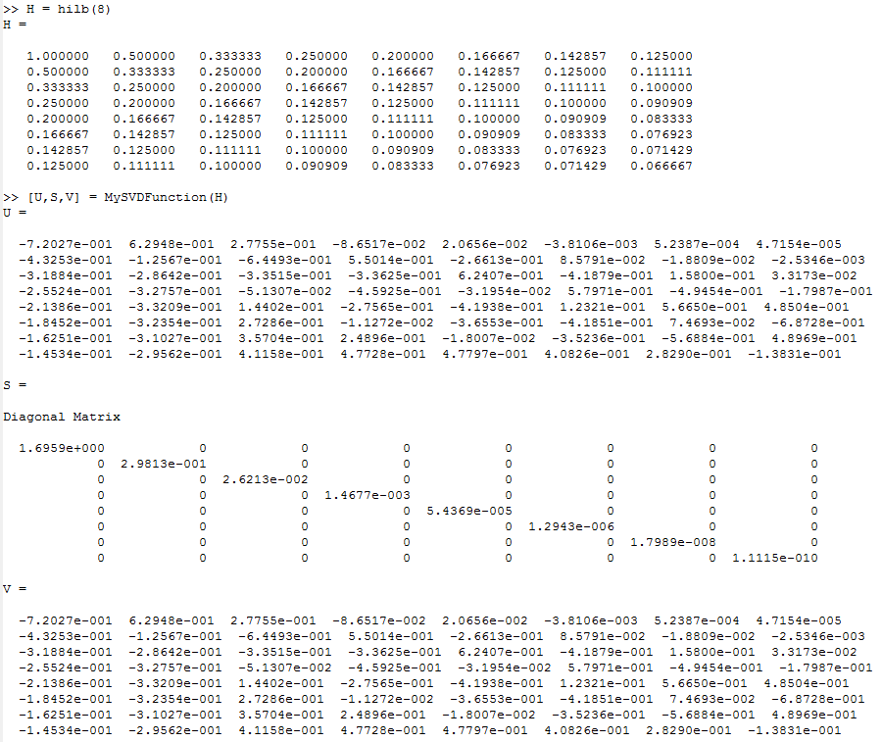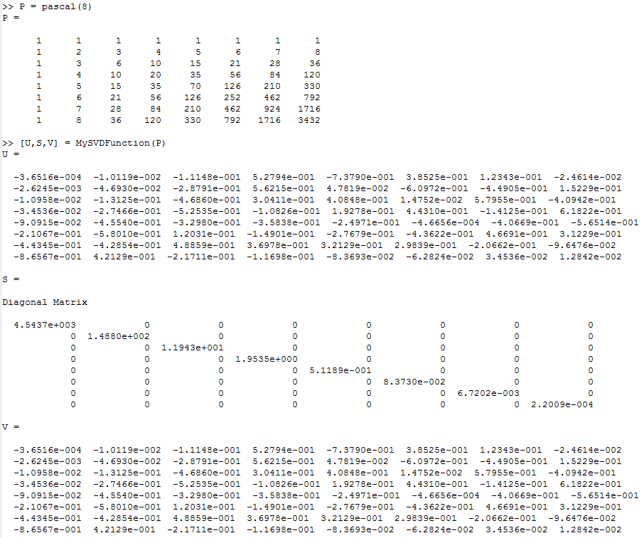

1b.

Chow = 9.2615 x 10^19

Hadamard = 1

Hilbert = 1.5258 x 10^10

Pascal = 2.0645 x 10^7

1c.

K = 5

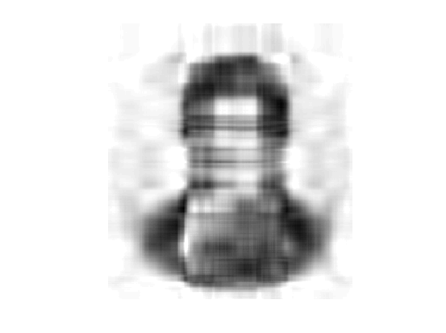

K=10



K = 20



K = 50

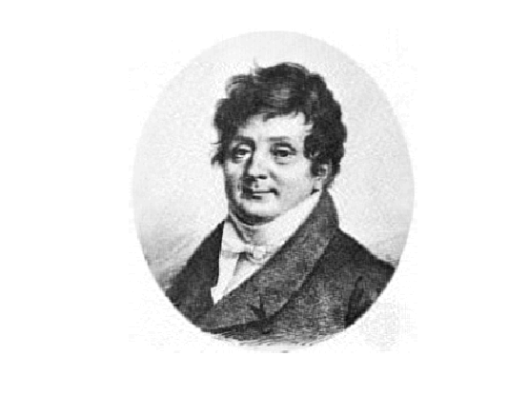

2a.

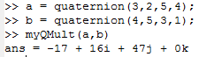

2b.

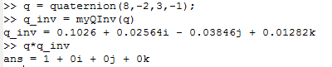

2c.

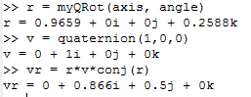

2d.

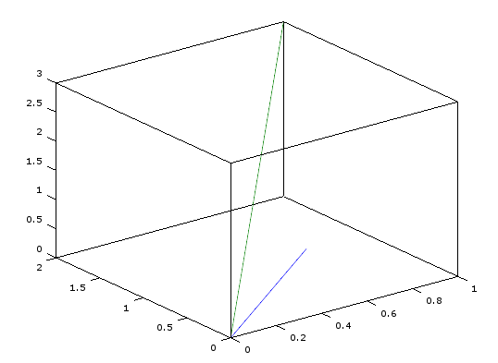

2e.

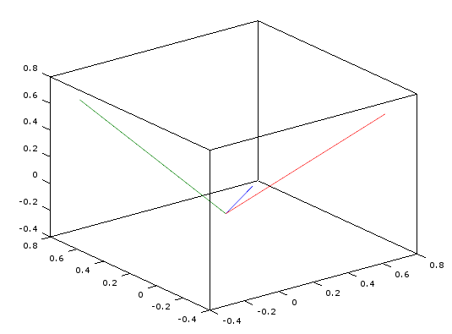

Plots are the same for negated p

3a.

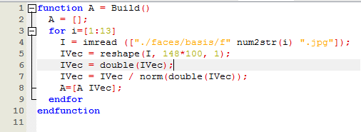

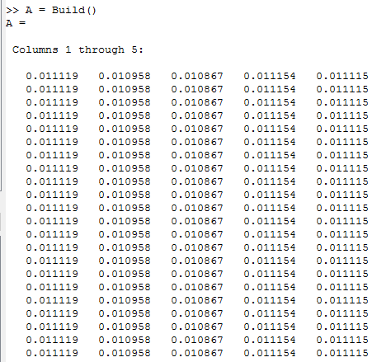

3b.

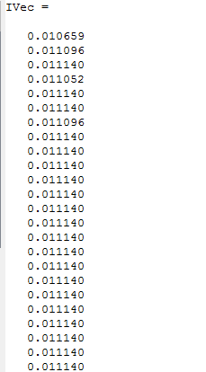

3c.

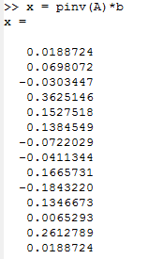

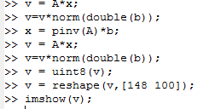

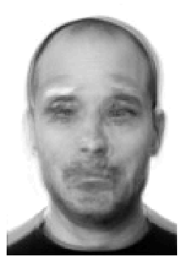



3d.



Basis images f1, f2, f3

3e.

Correlation between f1 and f3 is highest at 0.78896

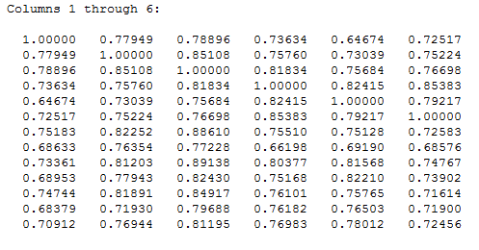

3f.

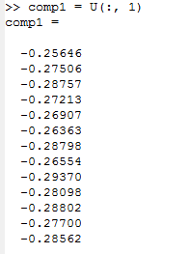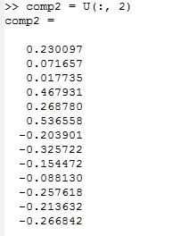

3g.

Images 7 and 11 have (x,y) positions closest

4a.

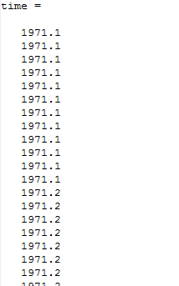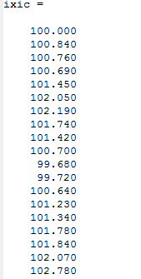

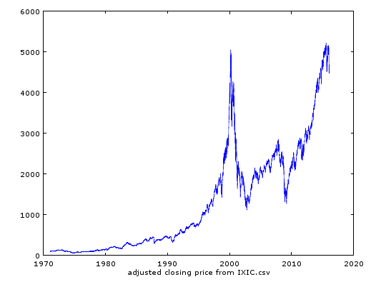

4b.

Coefficients of polyfit for 1971-02-05 – 2000-03-09:

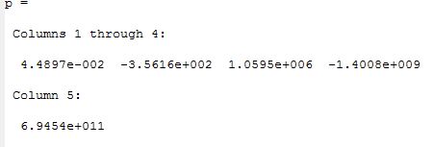

Coefficients of polyfit for 2009-03-10 – 2015-11-04:

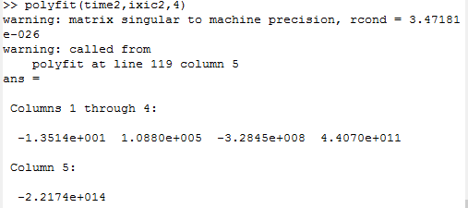

Coefficients of exp fit for 1971-02-05 – 2000-03-09:

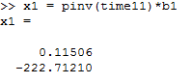

Coefficients of exp fit for 2009-03-10 – 2015-11-04:

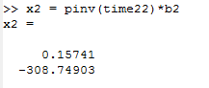

Graph of data set 1971-02-05 – 2000-03-09 with expfit and polyfit:

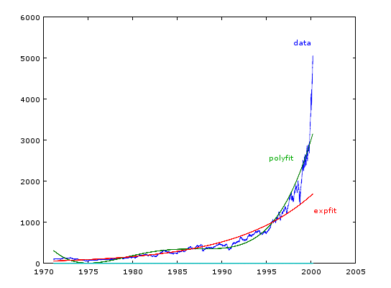

Graph of data set 2009-03-10 – 2015-11-04 with expfit and polyfit:

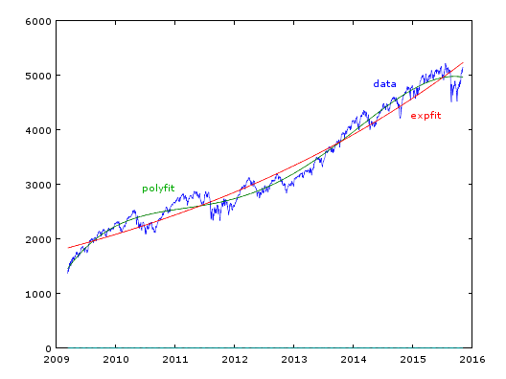

Squared error of polyfit for 1971-02-05 – 2000-03-09: 1.6906e+008

Squared error of expfit for 1971-02-05 – 2000-03-09: 6.0131e+009

Squared error of polyfit for 2009-03-10 – 2015-11-04: 2.9578e+007

Squared error of expfit for 2009-03-10 – 2015-11-04: 1.9377e+010

Polyfit generally has less squared error

5.

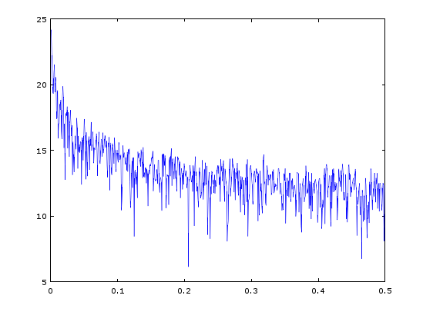

The frequency is about 0.018283 per day or 0.219396 per month