Eric Yang

304263623

Homework 3 + 4

1.

a.

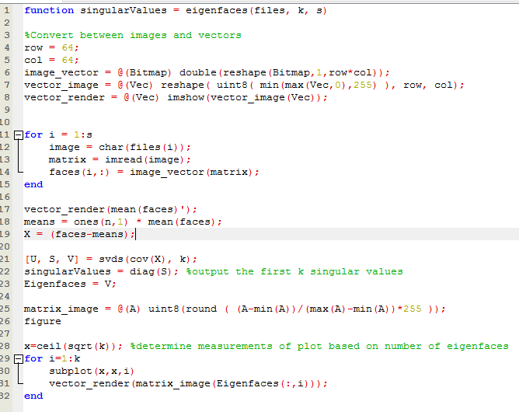

b.

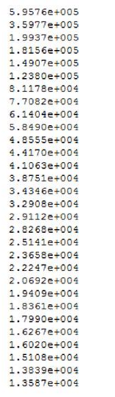

c.

Average face for good:

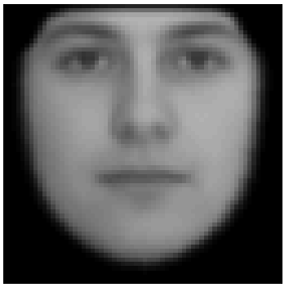

Average face for evil:

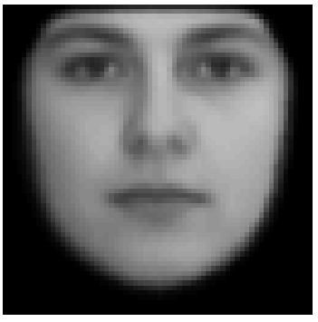

d. good – evil:

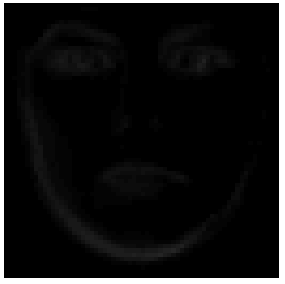

e. 102 and 103 are a pair



f.

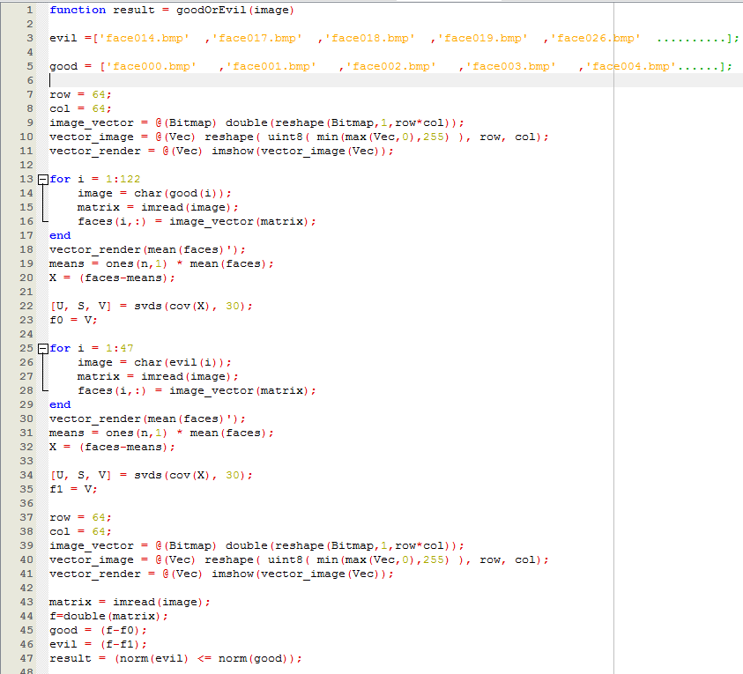

The function returns 01111011111101110111110110111011111011110111101. The function doesn’t seem to work too well probably because a lot of the faces look similar. The evil and good average face are not that far apart.

2.

a. Fs is 44100hz sampling frequency which is the usual CD-quality sample rate.

b. y is 1411200 entries long.

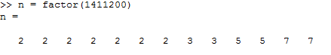

c. fft(y) takes 0.0419381 seconds when tested with tic; and toc; and it takes 0.040 seconds tested with profile

d.

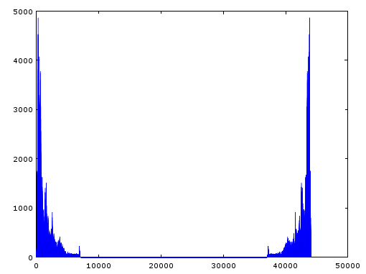

e. Nyquist frequency = 22050

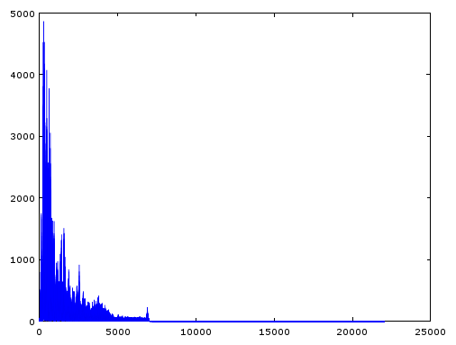

f.

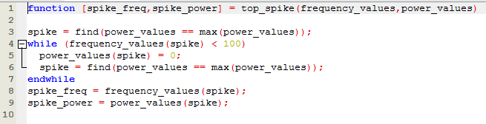

Using the function top_spike, I found the top 4 spikes in the interval from 0 to 22050 (excluding frequencies below 100) to be at 265.39hz, 312.99hz, 234.21hz, 265.77hz.

g. The key is C# at frequency 265.39hz and there is no harmony as the next spike is at 312.99hz but 265.39(5/4) = 331.74hz.

h. The top spike for untune is at 104.09hz and there is no harmony as the next spike is around 184.35hz and that is not a multiple of 5/4(104.09hz).

3.

a.

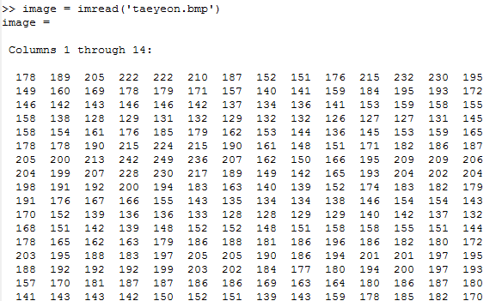

b.

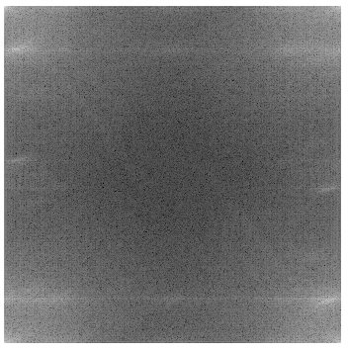

c.

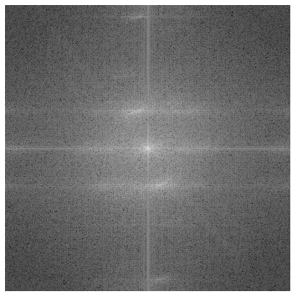

d.

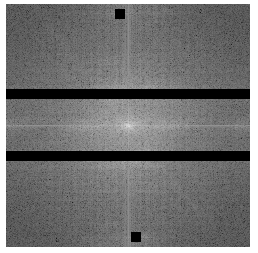

e. There seems to be some improvement when put together with the image before noise removal:

 

4.

a.

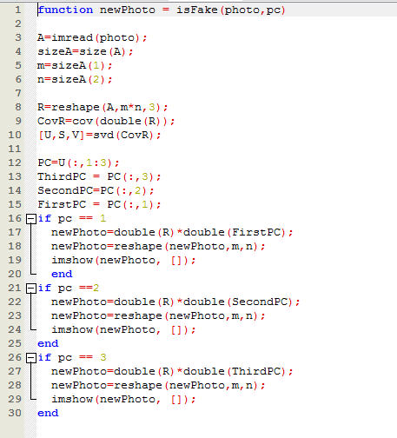

Ran my function isFake() on the photo and it seems to be fake due to many bright and dark spots in first photo:

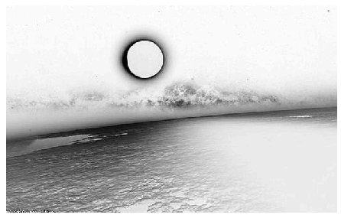

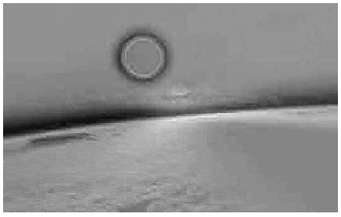

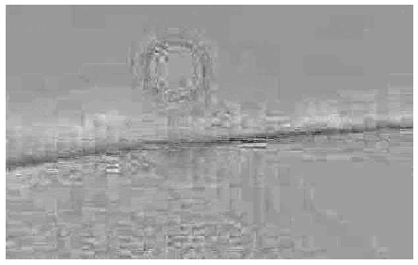

b. this shark attack photo also seems to be fake from the bright spots in the first photo:



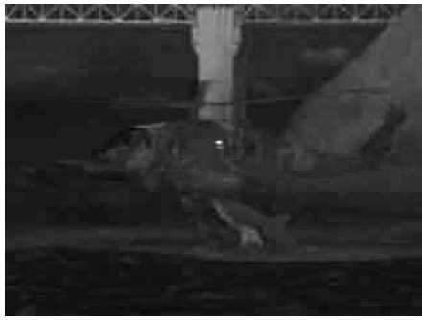

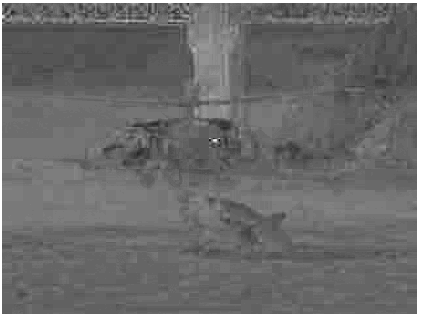

c. In these photos, it seems the 1st and 3rd PC are better indicators of fake photos. The raccoon one doesn’t show much in the 2nd PC but the 3rd PC shades the cat in black and the 1st shows inconsistent coloring of the cat in contrast to the raccoon so this photo is fake. The flooding one seems to be real. The 2nd and 3rd PC don’t indicate anything is strange and the 1st shows a lot of bright white and black that seems to be just the color contrast between water and grass/trees.

