Survey
This is a survey about your commuting patterns. All responses will remain anonymous. Thank you for responding honestly! :)

1. How do you commute to school / work? (Circle one)
- Walking
- Bicycle
- Car (sole driver)
- Car (carpool)
- Public transit
- Other (Specify: ___________________________)
2. How do you commute from school / work? (Circle one)
- Walking
- Bicycle
- Car (sole driver)
- Car (carpool)
- Public transit
- Other (Specify: ___________________________)
3. Approximately far do you live from school / work? ____________________ km
4. Please specify the postal code or main intersection of your school / workplace:
- _ _ _ _ _ _ (postal code)
or
- ___________________________ and _________________________ (intersection)
5. Please specific the postal code or main intersection of your home:
- _ _ _ _ _ _ (postal code)
or
- ___________________________ and _________________________ (intersection)
6. If you circled ‘Car’ in your response for question 1, please list the streets (including highways) used in your commute to school / work:
_______________________________________________________
_______________________________________________________
_______________________________________________________
_______________________________________________________
_______________________________________________________
_______________________________________________________
7. If you circled ‘Car’ in your response to question 2, please list the main streets (including highways) used in your commute from school / work:
_______________________________________________________
_______________________________________________________
_______________________________________________________
_______________________________________________________
_______________________________________________________
_______________________________________________________
8. If you circled ‘Public Transit’ in question 1, please list the routes (including buses, streetcars and subways, and non-TTC transit) used in your commute to work / school:
_______________________________________________________
_______________________________________________________
_______________________________________________________
_______________________________________________________
_______________________________________________________
_______________________________________________________
9. If you circled ‘Public Transit’ in question 2, please list the routes (including buses, streetcars and subways, and non-TTC transit) used in your commute from work / school:
_______________________________________________________
_______________________________________________________
_______________________________________________________
_______________________________________________________
_______________________________________________________
_______________________________________________________
10. In minutes, how long on average does your commute to work / school take? ___________ minutes
11. In minutes, how long on average does your commute from work / school take? ___________ minutes
12. Which days of the week do you commute to work / school? Circle all that apply:
- Sunday
- Monday
- Tuesday
- Wednesday
- Thursday
- Friday
- Saturday

Thank you for taking your time to honestly fill out this survey! You get awesome points forever.

Sampling Method
The proposed sampling method would be a stratified random sampling method. Toronto would be broken up according to wards, which are the strata, and each ward would have 1000 working or student-aged individuals randomly selected to be surveyed. The results of each strata would be weighted according to their population so as to avoid household bias. This would be a cross-sectional survey. If possible, this survey would be made involuntary. However, even if the survey is only voluntary, it is not expected that non-response or response bias cause a systematic bias in the data.

Primary Data
Primary survey data was not collected for this investigation since it was not deemed crucial, would unduly take resources and existing data is already sufficiently wide-spanning and accurate enough for analyses.

However, primary data was collected in the form of TTC vehicle locations. Every two minutes, a query was sent to the TTC’s Next Vehicle Arrival System, which would report the location of all active (on-duty) buses with information such as GPS coordinates, last updated time, and heading direction. This was required since the NVAS does not store historical data, so it had to be queried and stored manually in order to be analyzed.
Some difficulties encountered during this process included understanding and learning to query the NVAS. This was overcome by experimenting and examining the results received until it worked. Another challenge was finding a way to programmatically run and store the results of the queries every 2 minutes. This problem was solved by running it on an external server on a schedule. In total, over 4,100,000 rows of data were collected.
A snippet of the data is included:

Vehicle ID | Route | Direction | Latitude | Longitude | Heading | Timestamp
1560 | 41 | 41_1_41B | 43.668083 | -79.465553 | 343 | 1399296144819
8062 | 44 | 44_1_44 | 43.59425 | -79.51667 | 253 | 1399296139588
1024 | 127 | 127_0_127 | 43.6673509 | 79.403687 | 74 | 1399296124156

Since there are over four million rows of similar data, and frequency tables and exhaustive listings would be meaningless, they are omitted.
A summary of the data, in the form of a time-distribution plot, is included:
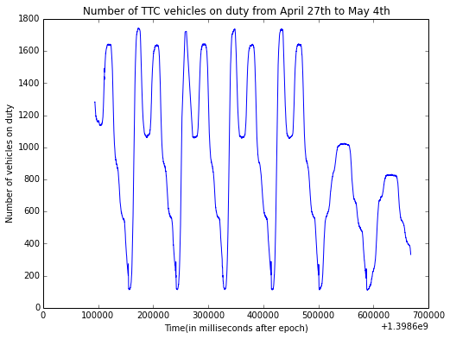

Secondary Data
Secondary data was collected from these sources. A snippet of the data drawn from each (where applicable) is included:
City of Toronto Open Data (March 2014). TTC Routes and Schedules. Retrieved from http://www1.toronto.ca/wps/portal/contentonly?vgnextoid=96f236899e02b210VgnVCM1000003dd60f89RCRD

Trip ID | Arrival Time | Departure Time | Stop ID
22801520 | 6:15:00 | 6:15:00 | 14146
22801522 | 17:32:23 | 17:32:23 | 2670
22801597 | 8:02:00 | 8:02:00 | 4095

City of Toronto Open Data (April 2014). Next Vehicle Arrival System. Retrieved from https://www1.toronto.ca/wps/portal/contentonly?vgnextoid=4427790e6f21d210VgnVCM1000003dd60f89RCRD
(See above, under primary data).
Toronto Transit Commission (n.d.). TTC Transit Planning. Retrieved from http://www.ttc.ca/About_the_TTC/Transit_Planning/index.jsp
Toronto Transit Commission (2012). Surface Ridership. Retrieved from http://www.ttc.ca/About_the_TTC/Transit_Planning/Surface_Ridership_2012.jsp

Route | Mode/  note | Customers per day, Mon-Fri | Vehicles in morning peak period | Vehicles in afternoon peak period | Hours per day, Mon-Fri | Kilometres per day, Mon-Fri | Cost per day, Mon-Fri
192 Airport Rocket |  | 4,000 | 4 | 6 | 95 | 3,300 | $16,100
117 Alness |  | 2,800 | 4 | 4 | 45 | 750 | $6,500
99 Arrrow Rd |  | 130 | 0 | 0 | 13 | 310 | $1,800

Toronto Transit Commission (2013). TTC Subway Ridership 2012-2013. Retrieved from http://www.ttc.ca/PDF/Transit_Planning/Subway_ridership_2012-2013.pdf
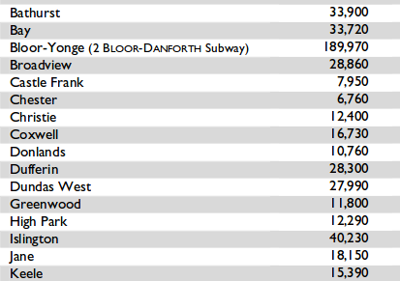
Statistics Canada (2011). Commuting to Work. Retrieved from http://www12.statcan.gc.ca/nhs-enm/2011/as-sa/99-012-x/99-012-x2011003_1-eng.cfm

Census metropolitan area | Car, truck or van (total) | Car, truck or van (driver) | Car, truck or van (passenger) | Public transit | Walking | Bicycle
Toronto (Ontario) | 69.9 | 64.5 | 5.4 | 23.3 | 4.6 | 1.2

