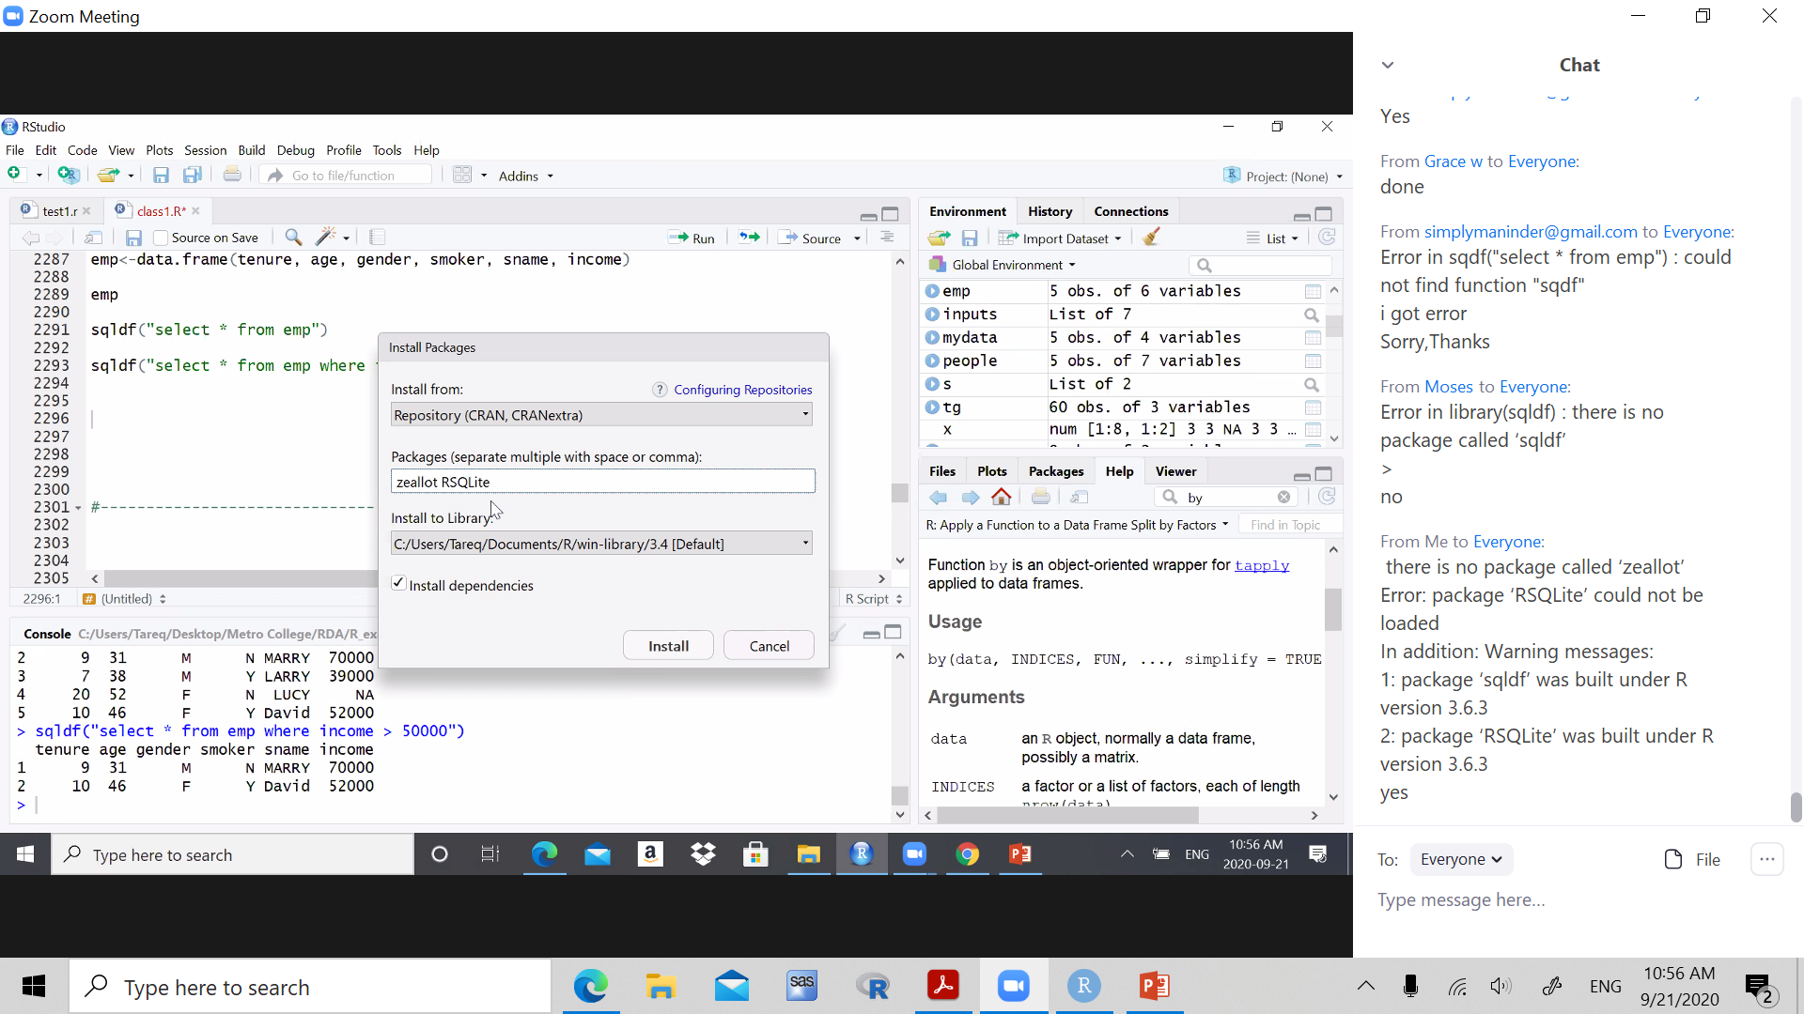

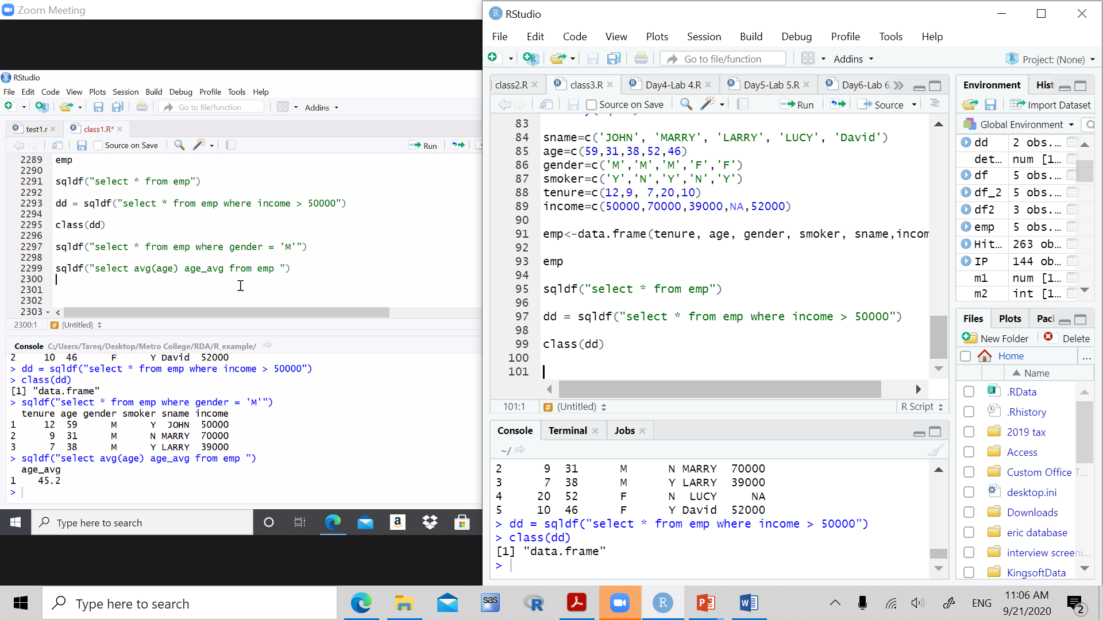

10 graphs, 4 columns, etc

10 different

Pie charts, bar chart, histogram, scatter plot, box plots, etc, different types of graphs

Quick analysis, quick summaries,

No calculations needed when is it due?

Code, presentation files, and report.

Powerpoint 12 slides, 10 images and analysis, intro of data and conclusion

Report show images, what does this images show, most important info

Presentation, report, code, dataset