|  |  |  |  |  |
| --- | --- | --- | --- | --- |
| Test # | Method | Tool | Expected Result | Pass/Fail |
| 1 | Press the connect button when it is not toggled | Program | Message saying that the server has started or the client has joined with the username specified | Pass |
| 2 | Press the connect button when toggled | Program | The client/server stops sending/receiving messages and the list of users online is cleared, nothing inside | Pass |
| 3 | Press the disconnect button | Program | The client/server stops sending/receiving messages and the list of users online is cleared, nothing inside | Pass |
| 4 | Press the settings button after changing settings | Program | The settings windows pop out in a new window, and all previously accepted settings are there | Pass |
| 5 | 2 clients send messages on chat | Program | Messages sent by both clients will be visible to anyone that was connected when message was sent | Pass |
| 6 | Open “test.txt” on where the program is | Program | Keeps all history so far of previous chat conversations up to this point | Pass |
| 7 | Client changes its username in settings | Program | When connected it will prompt the updated username as well as future messages by the same user | Pass |
| 8 | Changing the setting and pressing cancel | Program | The settings remain unchanged because of the cancel being pressed | Pass |

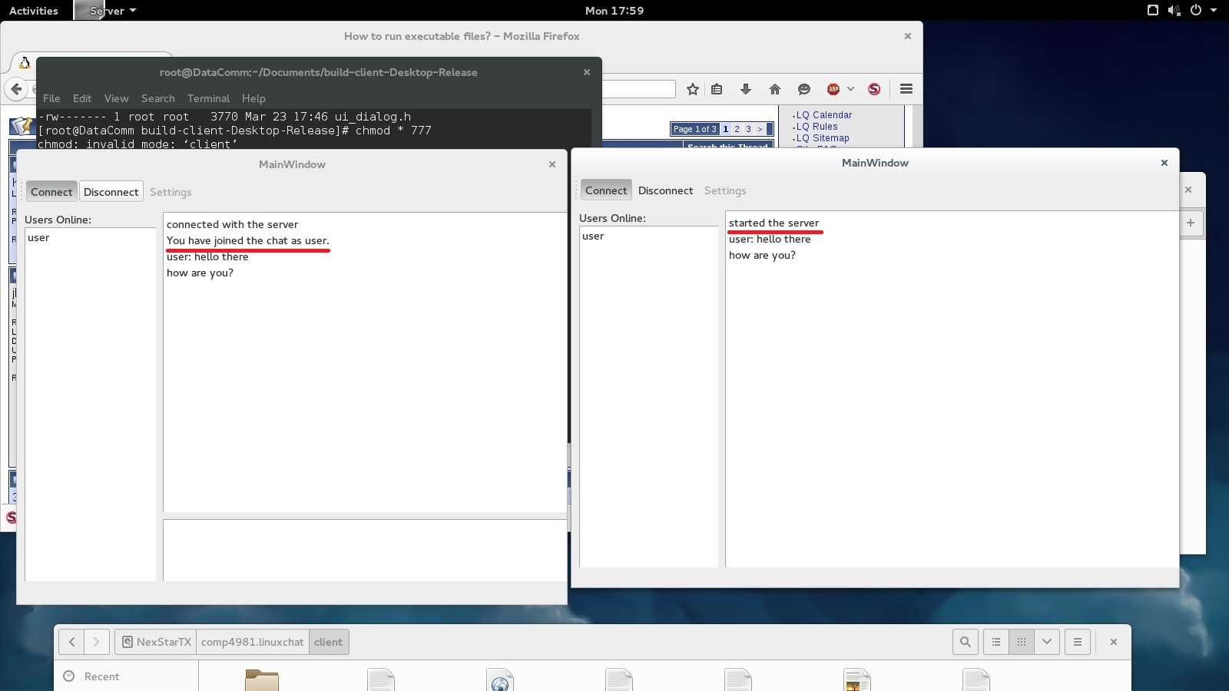

Test 1: The messages are shown according to whether they are client or server

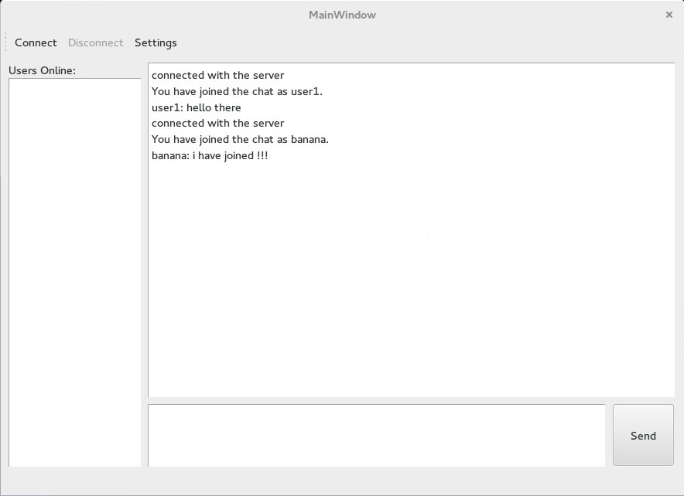

Test 2, 3: when it is not connected, the list of users online goes to empty and all messages sent are displayed but not sent to the server.

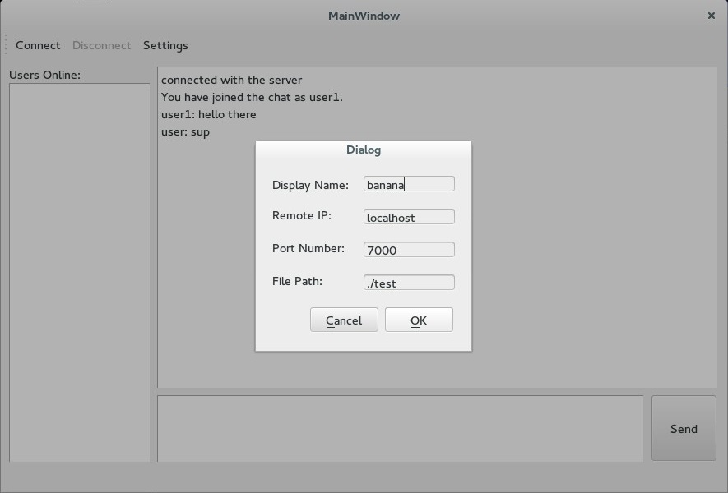

Test 4 client: The window for the client’s settings, default settings are initially there and if there and changes, it will remain when accepted.

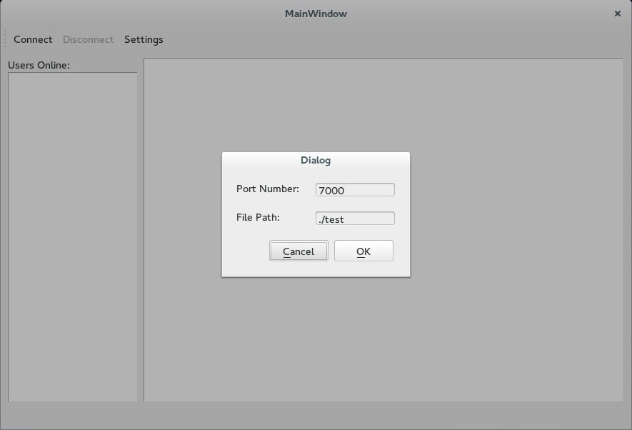

Test 4 server: The window for the server’s settings, default settings are initially there and if there and changes, it will remain when accepted.

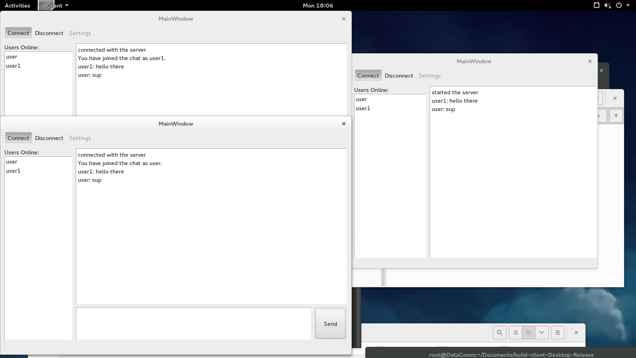

Test 5.1: Messages were successfully sent and received by the server which in turns sends the message to the rest of the clients.

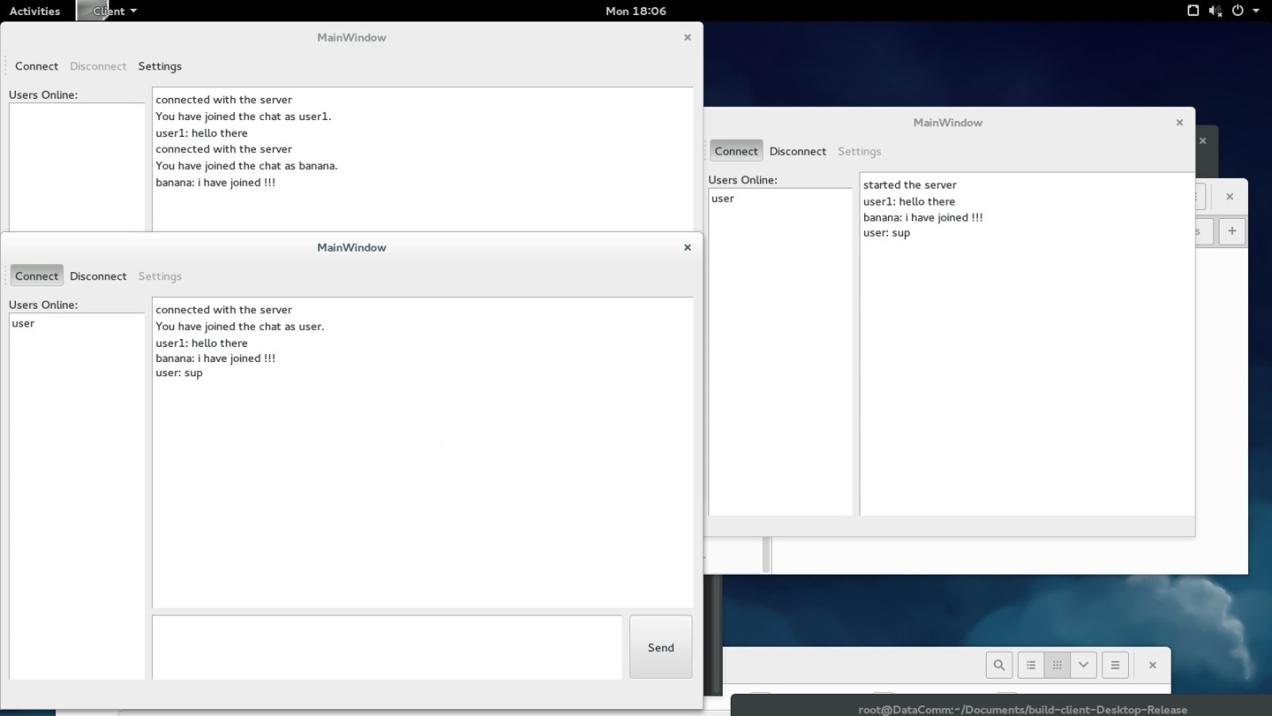

Test 5.2: For the users that are not connected, the message won’t be sent to.

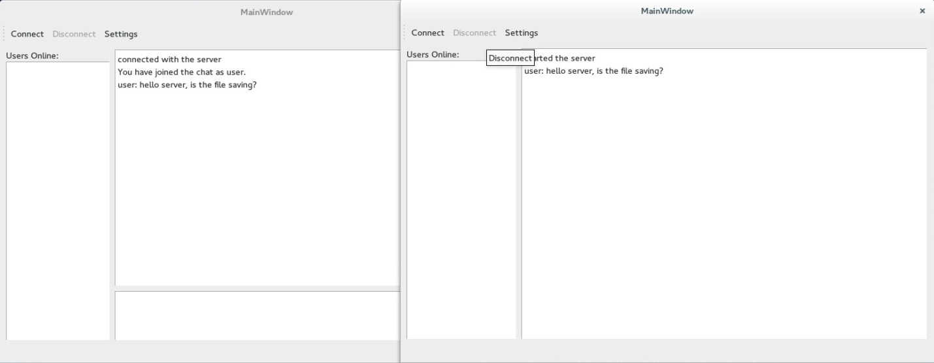

Test 6.1: These are some sample chat content to have to save into the test.txt file

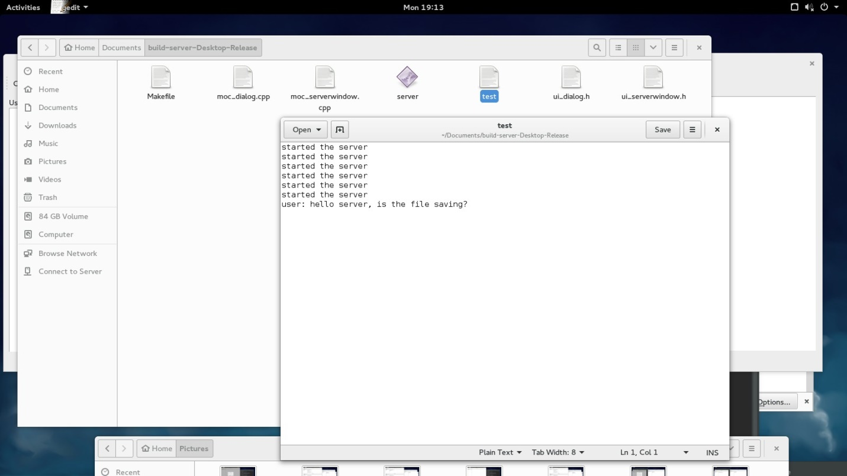

Test 6.2: The test.txt document with the content of the chat, the connect button has been pressed a couple of times as seen in the document.



Test 7: The user had to disconnect to access settings, reconnect with the new username and posted a message just before disconnecting