|  |
| --- |
|  |
| User Guide for Simple Chat Program |
| Linux Chat program using QT |

|  |
| --- |
| Eric Tsang, A00841554, 4O  *Jonathan Chu A00881533, 4O* |

Table of Contents

The server 2

Main Window 2

Settings windows 3

The Client 4

Main Window 4

Settings windows 5

How to Connect/Disconnect 7

Connect 7

Disconnect 7

How to Chat 8

# The server

## Main Window

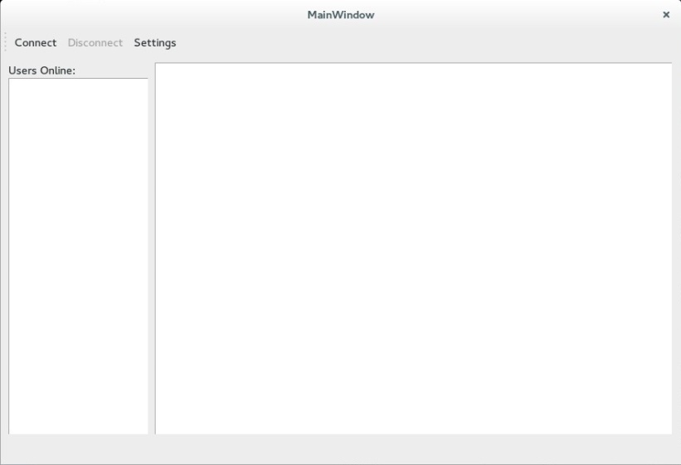

Elements:

*Connect* - Toggle Button that can be used to start or stop the server.

*Disconnect* - Button that stops the server, enabled only when the server is connected.

*Settings* – Button that brings out the settings window, enabled only when not connected.

*Users Online List* – Displays the users that are currently online.

*Display Area* – Displays all the messages that are received when the server is online

When the server has been opened, there are a couple of actions that can be performed. Ideally configuring the settings would be good if there are specific settings you would like to change, as of now the default settings are set so that it can be tested on a machine. For further information about the settings, please check the next section.

Once settings are configured, the server can be started by pressing the connect button, once done, the server will be ready and running. To close the server, the only action needed to do is to either un-toggle the connect button or just press the disconnect button.

**Note**: The settings button will be disabled during connect mode so make sure the settings are the desired one, since it cannot be changed once the server has started.

## Settings windows

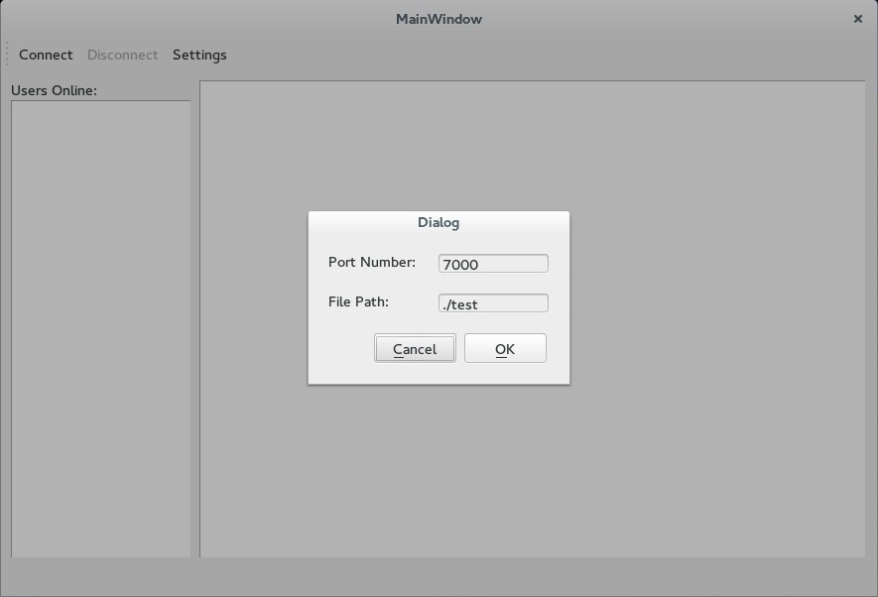

Elements:

*Port Number* – The port number that is going to be used by the server for the client to connect

*File Path* – This is where the document will save the chat history, in this case the file being called ‘test’

Initially when the server is started, the settings will be set to the default settings which are 7000 for the port and “test” for the file name of the chat history which will be saved where the executable is located. The way to enable saving into a file is to open settings and confirm that the file path as well as the document name is the one desired. In order to disable the saving of the chat history, leave this space blank.

Finally, pressing ok will save the settings while when pressing cancel, the settings will be reverted and any changes done will not be saved.

# The Client

## Main Window

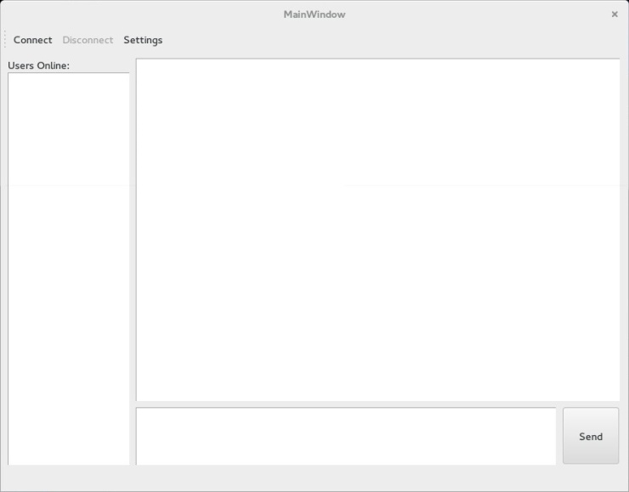

Elements:

*Connect* - Toggle Button that can be used to start or stop the server.

*Disconnect* - Button that stops the server, enabled only when the server is connected.

*Settings* – Button that brings out the settings window, enabled only when not connected.

*Users Online List* – Displays the users that are currently online.

*Display Area* – Displays all the messages that are received when the server is online.

*Message Area* – Message that wishes to be sent will be written here.

*Send Button* – Pressing this button will send the message contained in the message area.

When the client has been opened, there are a couple of actions that can be performed. Ideally configuring the settings would be a good option as it needs to match the client that needs to be connected to, as of now the default settings are set so that it can be tested on a machine. For further information about the settings, please check the next section.

Once settings are configured, the client will try and connect to a server using the specified settings. A message will notify the client as to whether the connection was successful or not. Once the connection has been successful, the client will be ready and running. To close the client, the only action needed to do is to either un-toggle the connect button or just press the disconnect button.

**Note**: The settings button will be disabled during connect mode so make sure the settings are the desired one, since it cannot be changed once the server has started.

## Settings windows

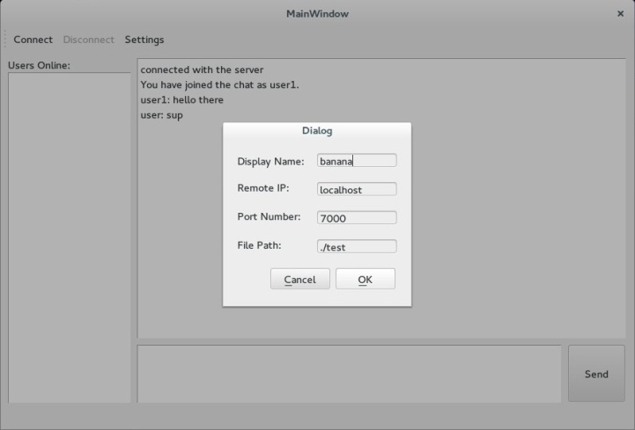

Elements:

*Display Name* – The name that the user wants to be seen as.

*Remote IP* – The IP of the server that the client wants to connect to.

*Port Number* – The port number that is going to be used by the server for the client to connect

*File Path* – This is where the document will save the chat history, in this case the file being called ‘test’

Initially when the client is started, the settings will be set to the default settings which are user for the username, localhost for the IP, 7000 for the port and “test” for the file name of the chat history which will be saved where the executable is located. The way to enable saving into a file is to open settings and confirm that the file path as well as the document name is the one desired. In order to disable the saving of the chat history, leave this space blank.

Finally, pressing ok will save the settings while when pressing cancel, the settings will be reverted and any changes done will not be saved.

**Note:** If the user specified by the client already exists, a new username will be assigned to that client, which is the original username and it keeps appending ‘1’ until the username becomes unique.

# How to Connect/Disconnect

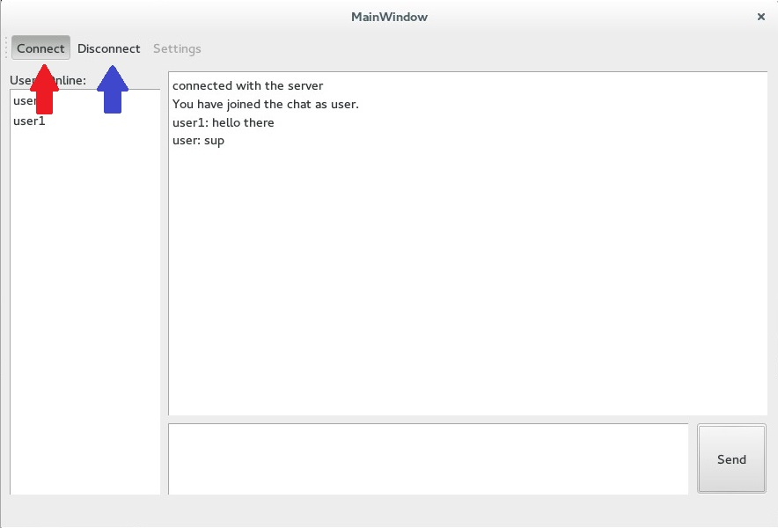

## Connect

For both client and server, in order to connect there is just a need to press the button connect. As seen, the red arrow points to a connect button that has already been clicked and that indicates that is currently connected.

## Disconnect

To disconnect on both server and client, there are two methods. The first method is by clicking on the disconnect button indicated by the blue arrow. The second method is by clicking on the toggled connect button, as indicated by the red arrow, to un-toggle it, which in turn will disconnect.

**Warning:** For servers note that by disconnecting the service, all connections that were established by the server by the clients connecting to it will be severed. This means that all the clients will be unable to do anything.

# How to Chat

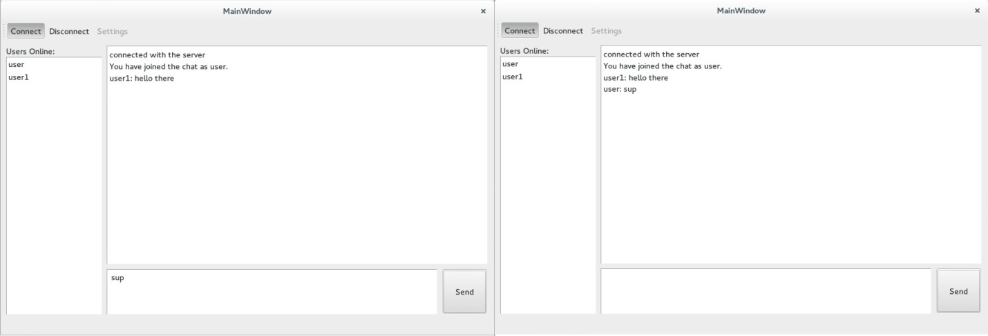

Sending messages is as easy as entering the message that the client wants to send to the other clients and then pressing the send button. When typing a message on the message area, pressing the enter button will make a new line instead of sending the message, the only way to send message as of right now is by pressing the send button.