# Tests

| **Test #** | **Test procedure / description** | **Expected Outcome** | **Actual Outcome & Remarks** | **Pass / Fail** |
| --- | --- | --- | --- | --- |
| 1 | Compiles a program used to test the FindFactorsTask class.   1. make clean 2. make FindFactorsTaskTest 3. valgrind ./FindFactorsTaskTest.out | The FindFactorsTaskTest is run and prints out all the numbers that 1000 is divisibe by, and shows that there are no memory leaks | As expected | Pass |
| 2 | Compiles a program used to test the Number class.   1. make clean 2. make NumberTest 3. valgrind ./NumberTest.out | The program is run and valgrind shows that there are no memory leaks | As expected | Pass |
| 3 | Compiles the process version of the application and runs it.   1. make clean 2. make Processes-Main 3. valgrind ./Processes-Main.out 100000 ./file | * The program is run and valgrind shows that there are no memory leaks. * It also creates a file in the current directory named “file” that contains what was printed to the screen within. * Output on stdout shows all the factors of 100000 starting at 1, ending at 100000. | As expected | Pass |
| 4 | Compiles the threaded version of the application and runs it.   1. make clean 2. make Threads-Main 3. valgrind ./Threads-Main.out 100000 ./file | Same as test 3 | As expected | Pass |

## Screenshots

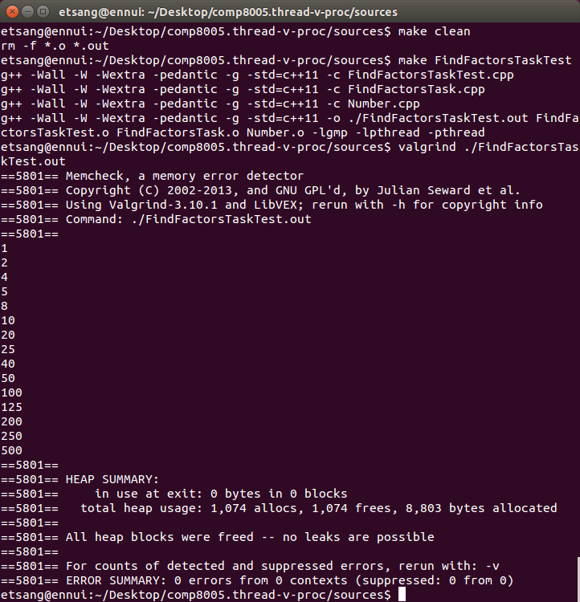Illustration 1: screenshot of test 1

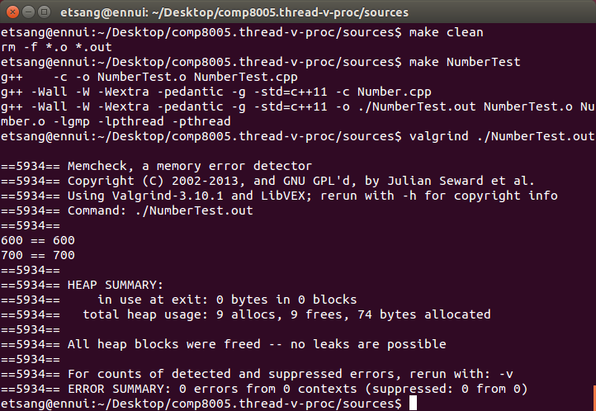Illustration 2: screenshot of test 2

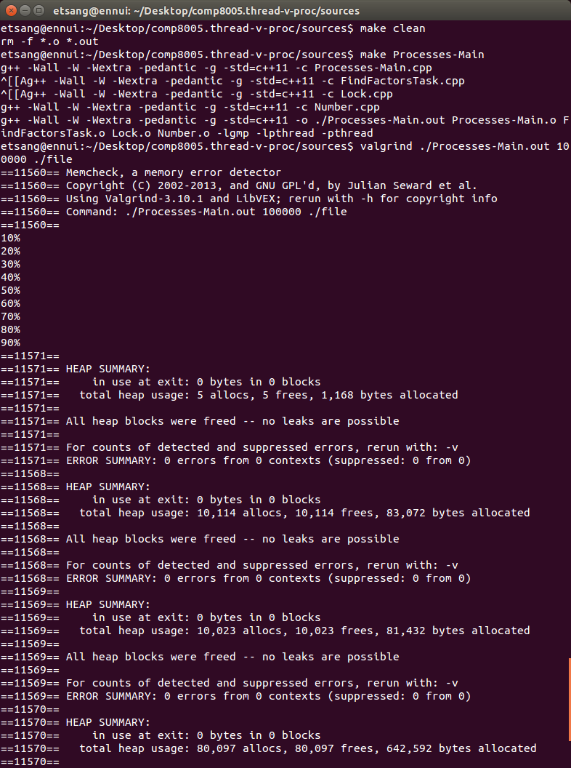Illustration 3: screenshot of test 3 showing clean compile

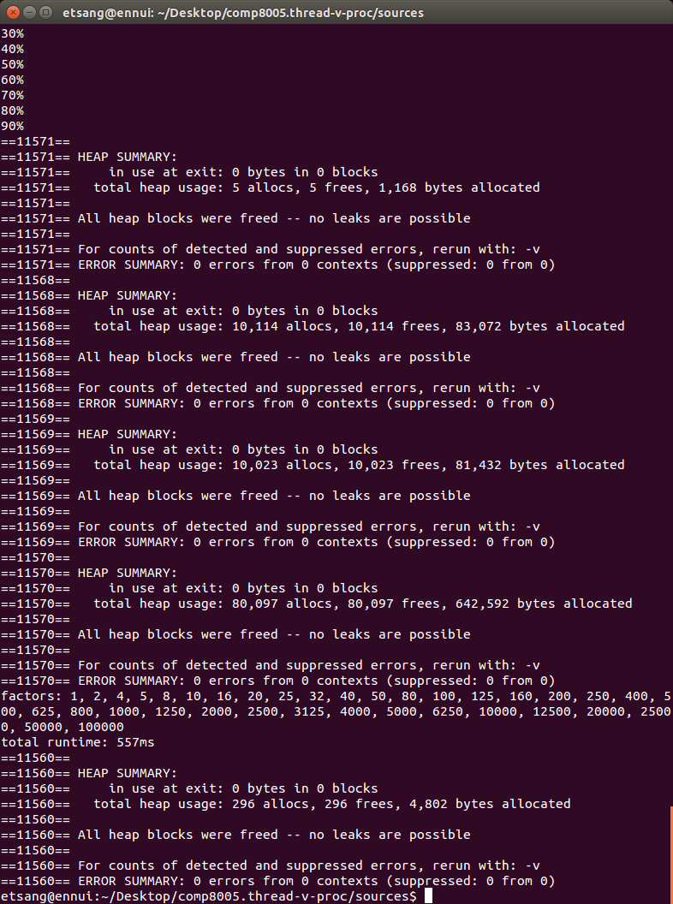Illustration 4: screenshot of test 3, showing zero memory leaks

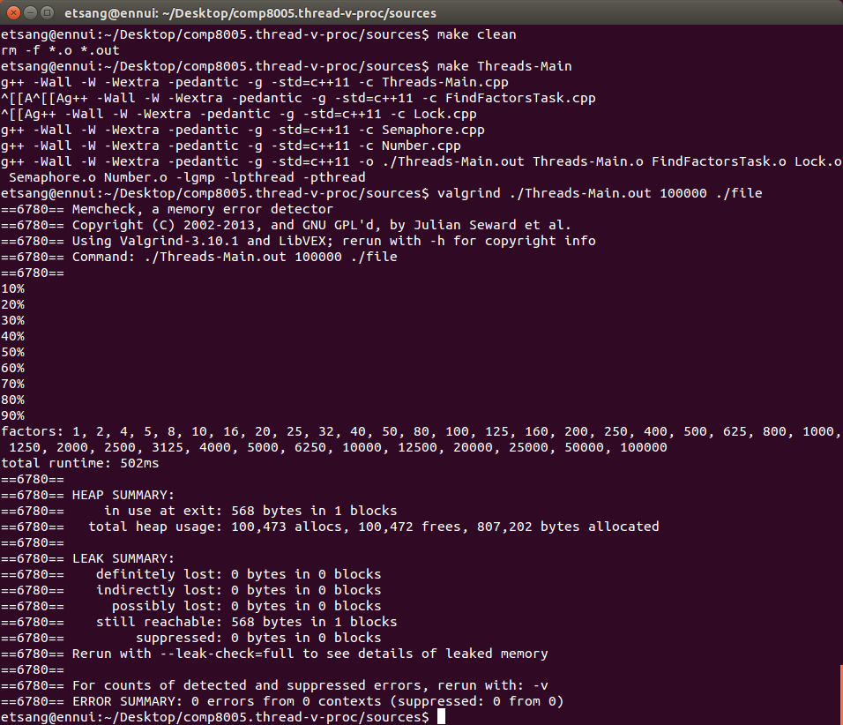Illustration 5: screenshot of test 4 showing clean compile and zero memory leaks

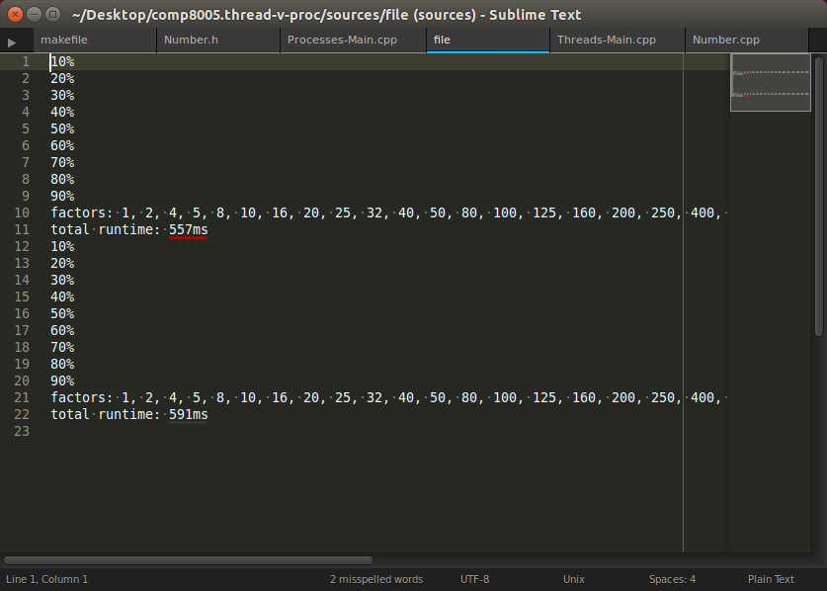Illustration 6: output to file "file" from tests 3 and 4