# Tests

| **Test #** | **Test procedure / description** | **Expected Outcome** | **Actual Outcome & Remarks** | **Pass / Fail** |
| --- | --- | --- | --- | --- |
| 1 | Smoke test the firewall:   1. apply the firewall:    * sudo ./firewall.sh 2. run the test script:    * sudo ./test.sh [peer ip address] 3. run the test script from the peer computer:    * sudo ./test.sh [firewall ip address] 4. list firewall rules:    * sudo iptables -L -v -n | * During step 1, nothing is printed. * During step 2, all tests except for those under the "### testing firewall rules of $address ###" heading should pass. * During step 3, all tests under the "### testing firewall rules of $address ###" heading should pass * During step 4, all firewall rules are listed. most rules have a non-zero packet count. all user chains have a non-zero packet count. | As expected | Pass |
| 2 | Test DNS, HTTP and HTTPS:   1. apply the firewall:    * sudo ./ firewall.sh 2. open a web browser and go to a website that uses the HTTP protocol, then go to another site that uses a HTTPS protocol. 3. list firewall rules: | When listing firewall rules:   * all DNS rules associated with UDP protocols should have non-zero packet counts. * WWW_CLIENT rules associated with the WAN interface should have non-zero packet counts. * the WWW_CLNT and DNS chains should have non-zero packet counts. | As expected | Pass |
| 3 | Test SSH to peer from firewall:   1. apply the firewall:    * sudo ./ firewall.sh 2. set up an SSH server on a peer. 3. SSH to the peer from the firewall. 4. list firewall rules. | When SSH-ing to the peer from the firewall:   * A connection should be established; the program should not hang.   When listing firewall rules:   * SSH_CLNT rules associated with the WAN interface should have non-zero packet counts. * SSH_CLNT chain should have a non-zero packet count. | As expected | Pass |
| 4 | Test HTTP into the firewall from peer:   1. apply the firewall:    * sudo ./ firewall.sh 2. set up a web server on the firewall. 3. connect to the web server from peer. 4. list firewall rules. | When connecting to the firewall from a peer with a web browser:   * A connection should be established; the web browser should not hang. it should display a web page.   When listing firewall rules:   * WWW_SVR rules associated with the WAN interface should have non-zero packet counts. * WWW_ SVR chain should have a non-zero packet count. | As expected | Pass |
| 5 | Test SSH into the firewall from peer:   1. apply the firewall:    * sudo ./ firewall.sh 2. set up an SSH server on the firewall. 3. connect to the SSH server from peer. 4. list firewall rules. | When SSH-ing to the firewall from the peer:   * A connection should be established; the program should not hang.   When listing firewall rules:   * SSH_SVR rules associated with the WAN interface should have non-zero packet counts. * SSH_ SVR chain should have a non-zero packet count. | As expected | Pass |
| 6 | Test HTTP into firewall from firewall:   1. apply the firewall:    * sudo ./ firewall.sh 2. set up a web server on the firewall. 3. connect to the web server from the firewall. 4. list firewall rules. | When connecting to the firewall from a peer with a web browser:   * A connection should be established; the web browser should not hang. it should display a web page.   When listing firewall rules:   * WWW_CLNT and WWW_SVR rules associated with the loopback interface should have non-zero packet counts. * WWW_CLNT and WWW_ SVR chains should have a non-zero packet count. | As expected | Pass |
| 7 | Test SSH into firewall from firewall: |  | As expected | Pass |

## Screenshots

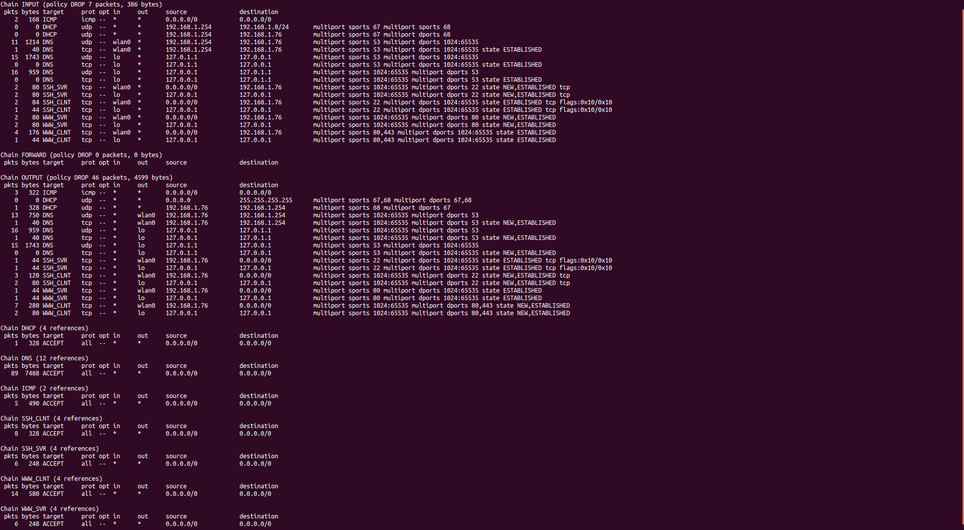

Figure test 1, all user chains have non-zero values, and most firewall rules also have non-zero values

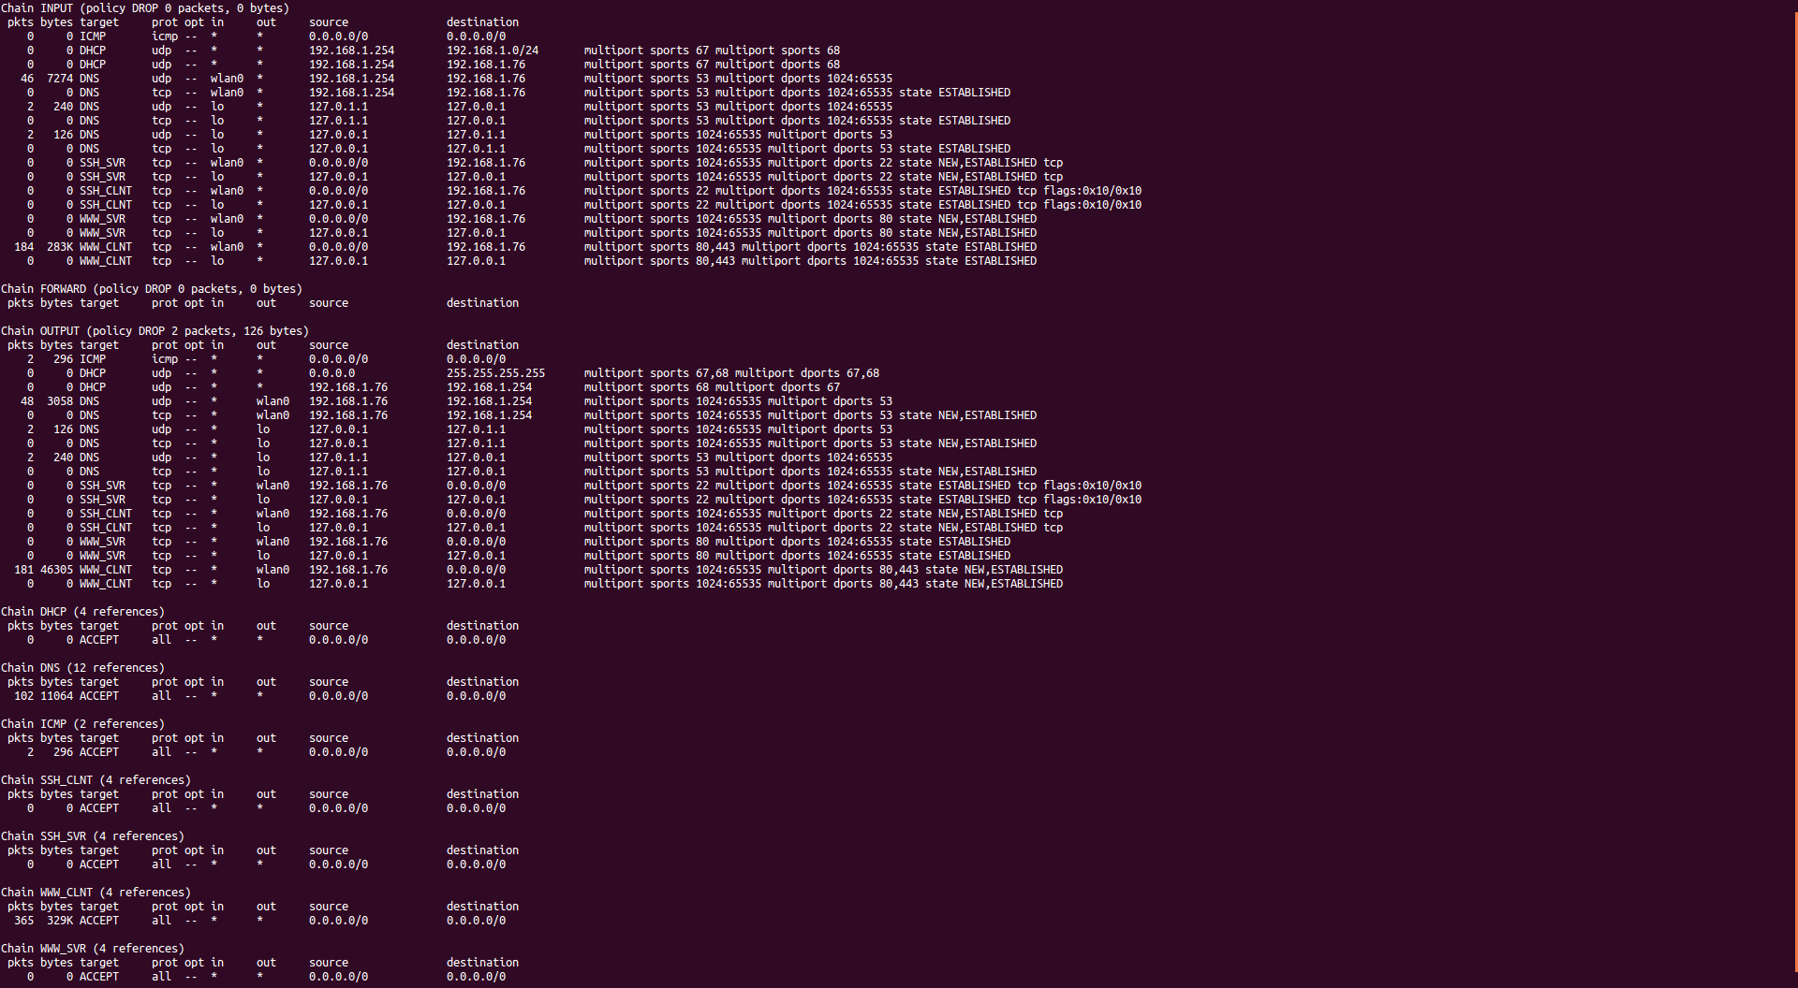

Figure test 2, all DNS rules have non-zero packet count, and www_clnt rules associated with wlan0 interface has a non-zero packet count

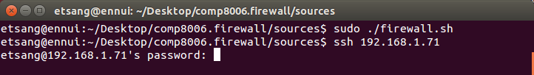

Figure test 3, ssh connection established successfully

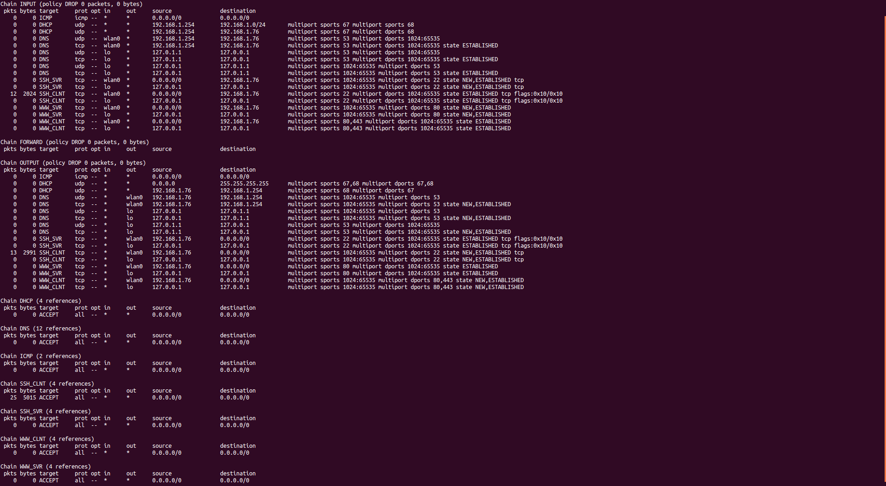

Figure test 3, all SSH_CLNT rules associated with wlan0 interface as well as the SSH_CLNT chain have non-zero packet counts

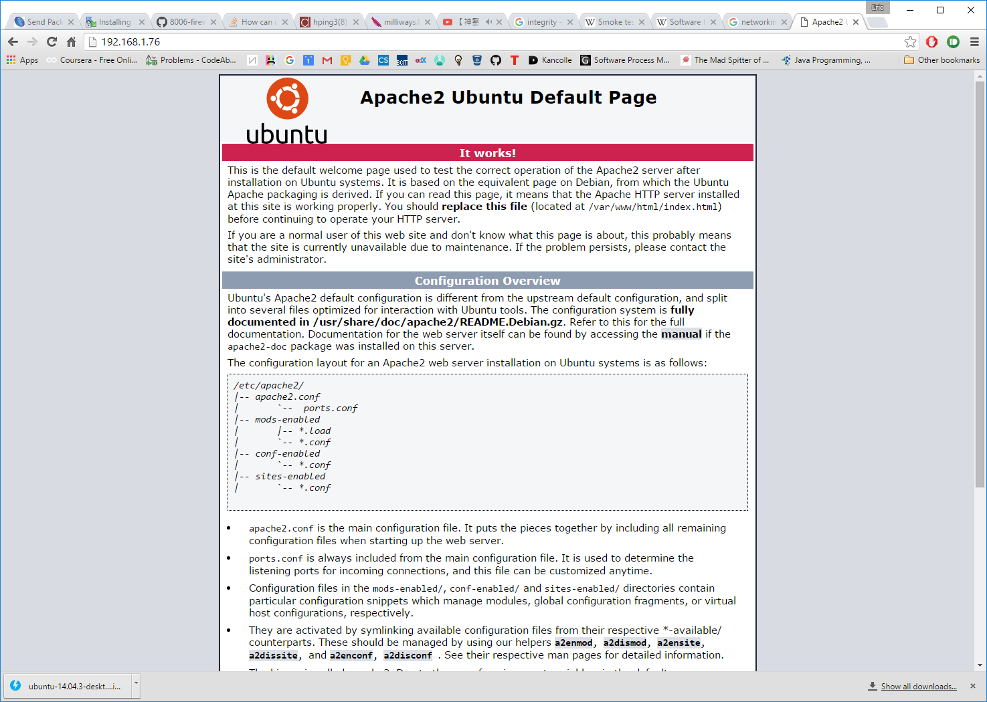

Figure test 4, browser can connect to the firewall, and it is displaying a web page delivered by the web server on the firewall

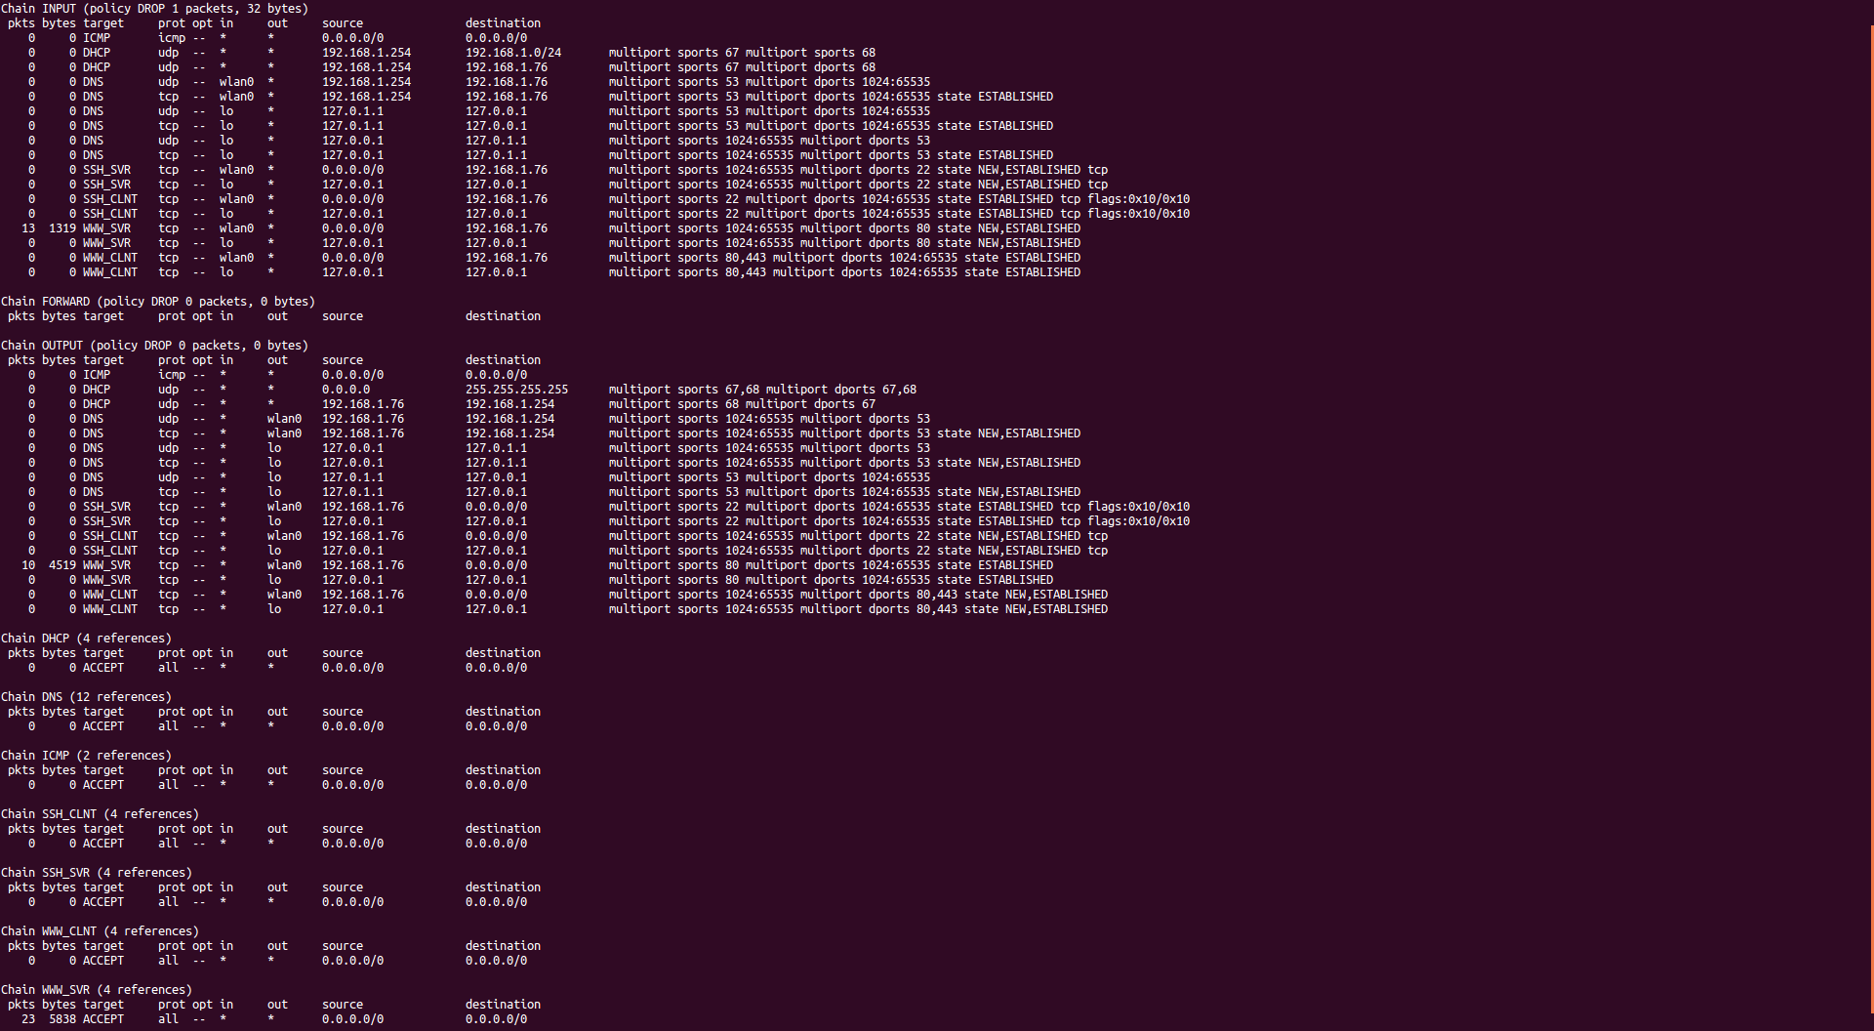

Figure test 4, WWW_SVR rules associated with wlan0 as well as the WWW_SVR chain display non-zero packet counts

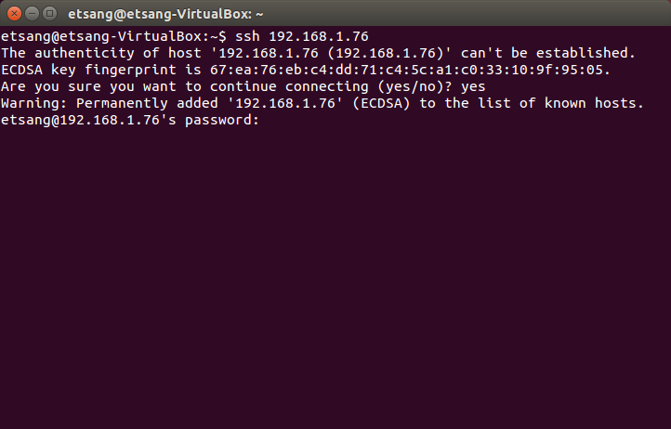

Figure test 5, SSH into the firewall from a peer on the same network. The SSH client has established a connection with the firewall.

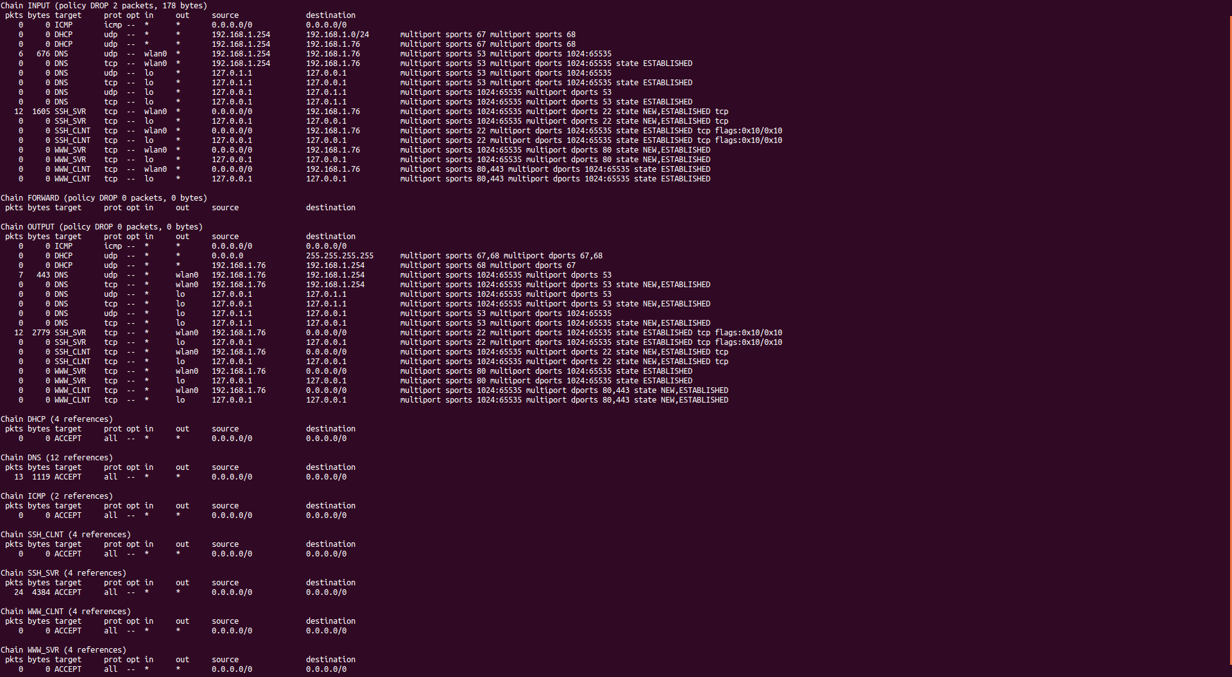

Figure test 5, SSH_SVR rules associated with wlan0 and SSH_SVR chain have non-zero packet counts