# Project 3

**Relational Model**

1. Mother(healthcard id, phonum, name, d_birth, email, address, profession, blood)
2. Father(Father ID, healthcard id, phonum, name, d_birth, email, address, profession, blood)
3. Couple(Couple ID, expected birth time, pregnancy counts)
4. InfoSession(practitioner id, iDate, iTime, language, couples)

Practitioner_id referenced Midwife

1. InfoSessionAttendence(practitioner id, iDate, iTime, Couple ID)

practitioner_id reference Midwife

data, time referenced InfoSession

Couple ID referenced Couple

1. Midwife(practitioner id, email, phonum, name, Institution_email)

Institution_email referenced Institution

1. Institution(email, name, phonum, website)
2. BirthingCenter(email, name, phonum, website)

email referenced Institution

1. CommunityClinic(email, name, phonum, website)

email referenced Institution

1. PregnantCouple(Couple ID, momID, dadID, exp_birthtime)

Couple ID referenced Couple

1. Baby(Couple ID, name, blood type, gender, d_birth)

Couple ID referenced PregnantCouple

1. Appointment(Appoint ID, aDate, aTime, Couple ID, practitioner_id)

Practitioner id referenced Midwife

Couple ID referenced PregnantCouple

1. InitialApointment(Appoint ID, aDate, aTime, Couple ID, practitioner_id)

Practitioner id referenced Midwife

Couple ID referenced PregnantCouple

1. Note(Appoint ID, nDate, nTime, info)

Appoint ID referenced Appointment

1. Medical_Test(Appoint ID, type, test date, sample date, lab date, result, techID)

AppointmentID referenced Appointment

techID referenced Technician

1. Technician(techID, phonum, name)
2. MidwifeAssignment(Couple ID, practitioner id)

Couple ID referenced PregnantCouple

Practitioner id referenced Midwife

1. Backup-MidwifeAssignment(Couple ID, practitioner id)

Couple ID referenced PregnantCouple

Practitioner id referenced Midwife

**Application interaction**

(a)

i.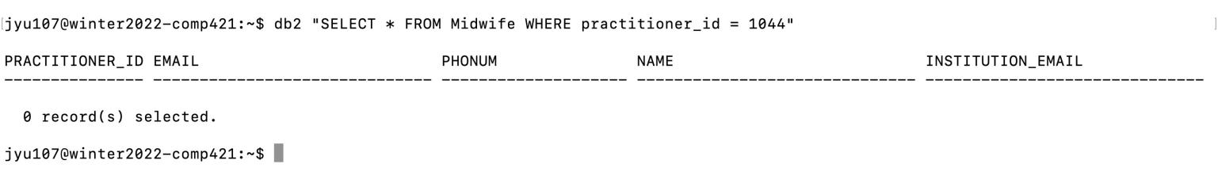ii.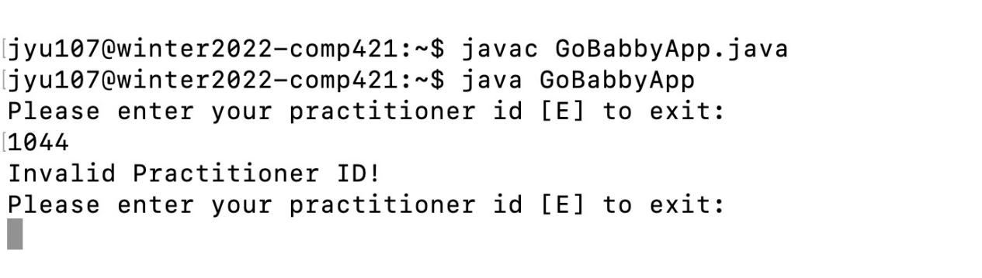(b)

i.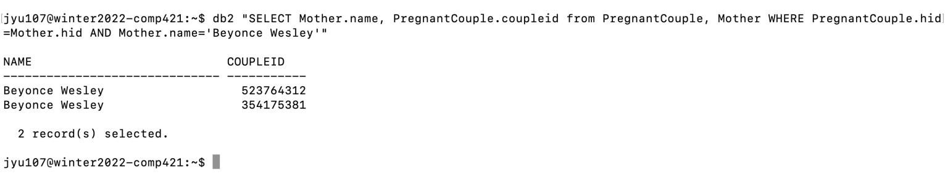ii.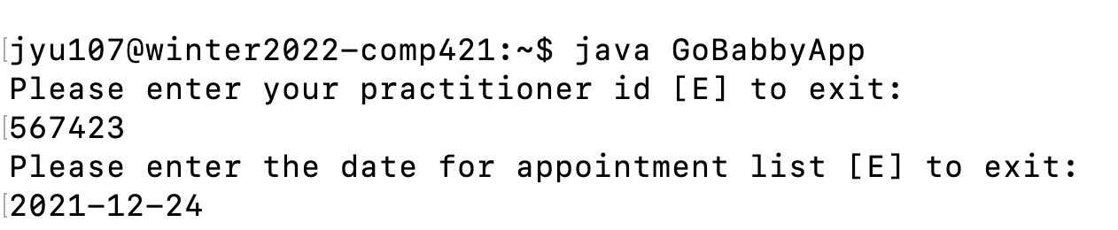

iii.

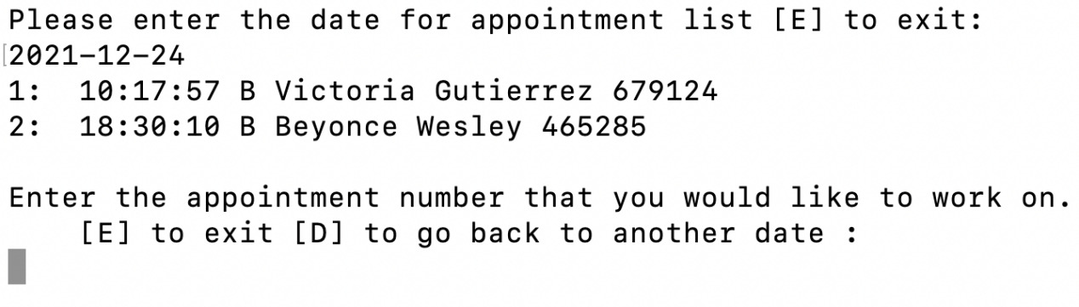

iv.

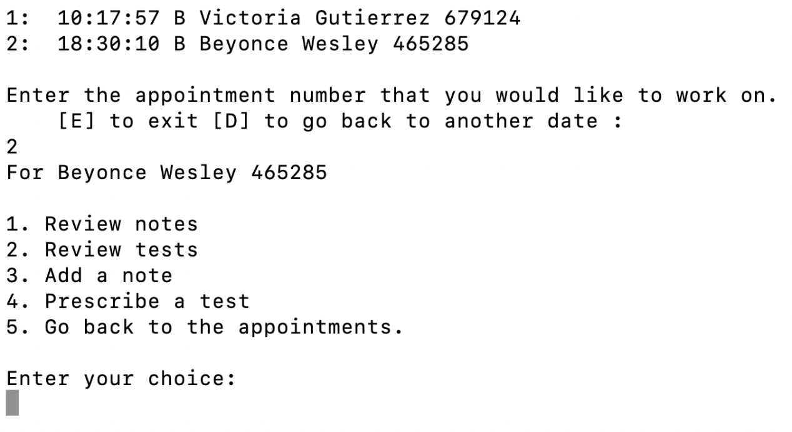

v. 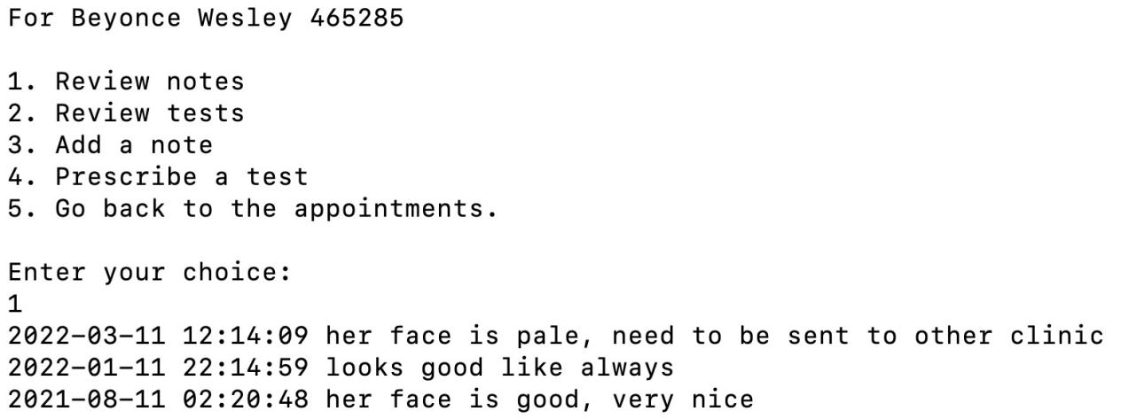vi.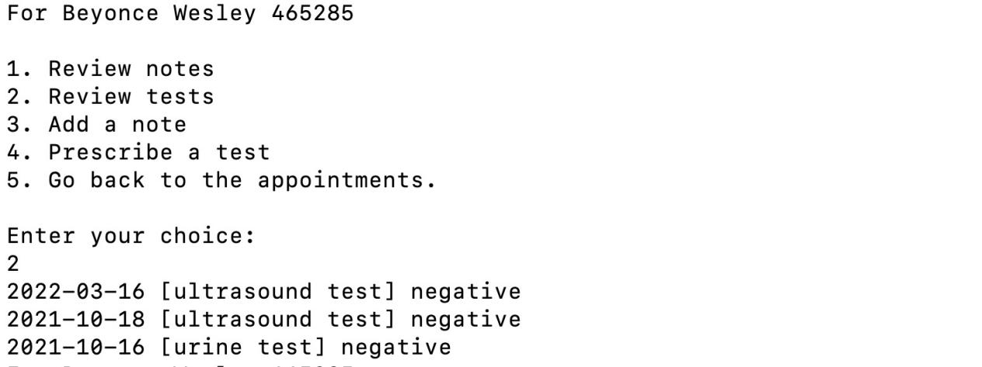vii.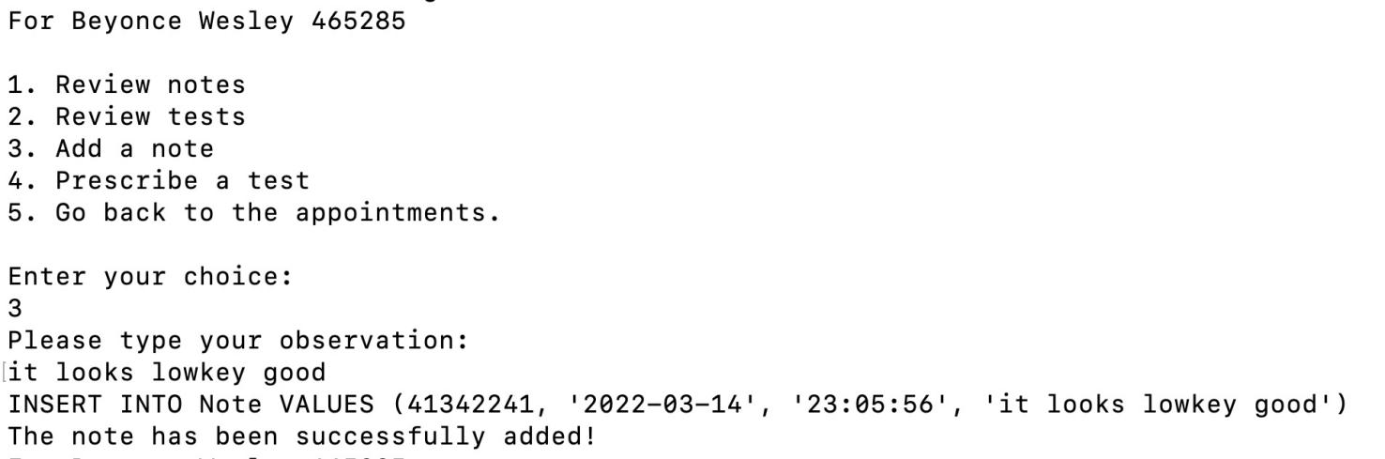

viii.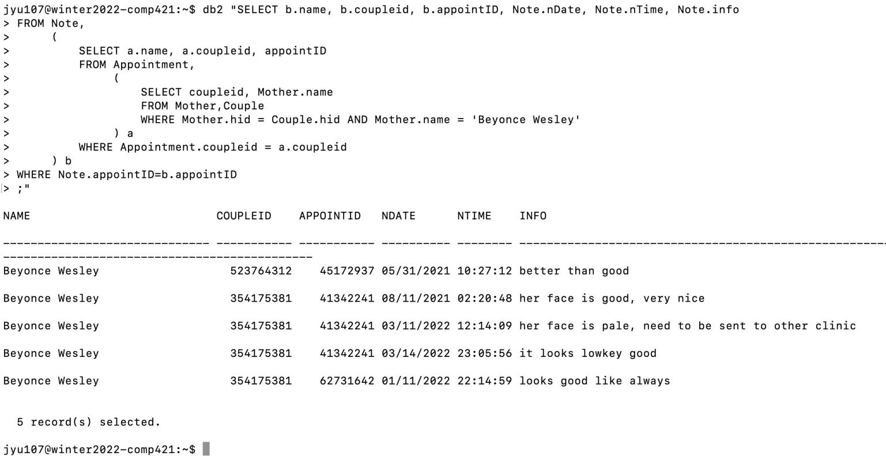

ix.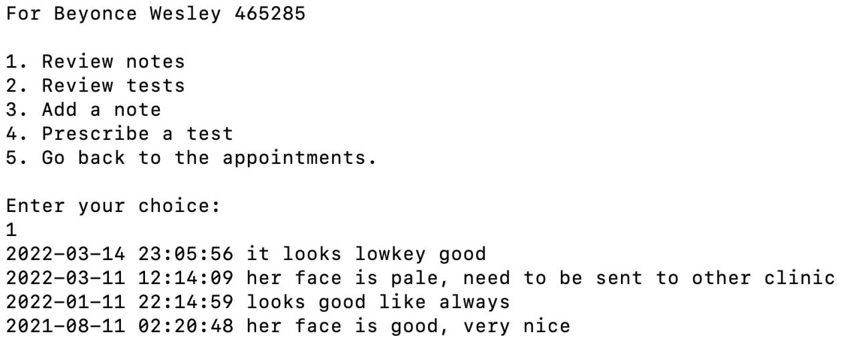x.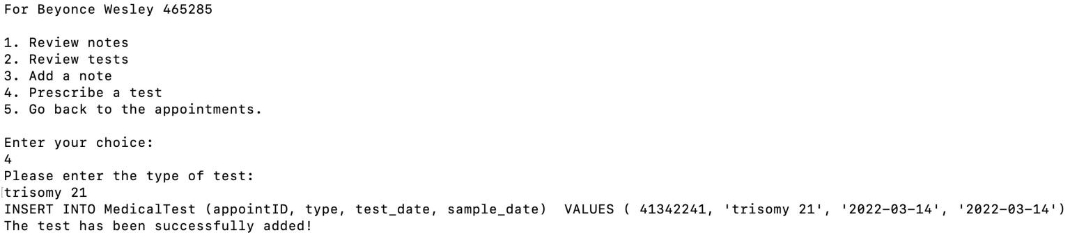xi.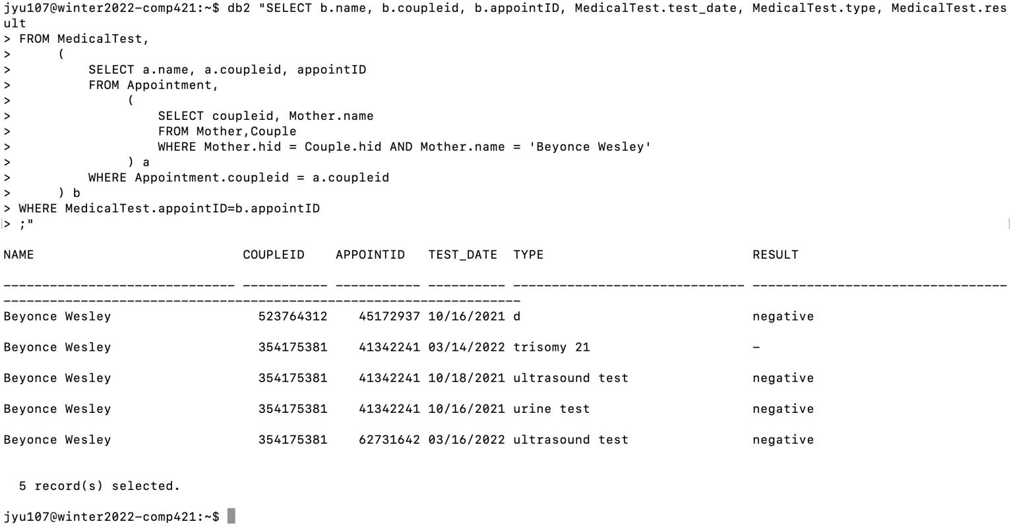xii.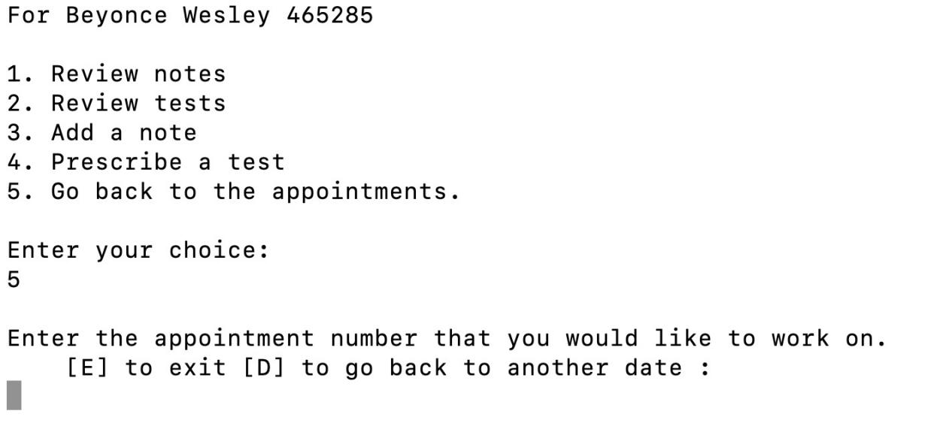

(c)

i.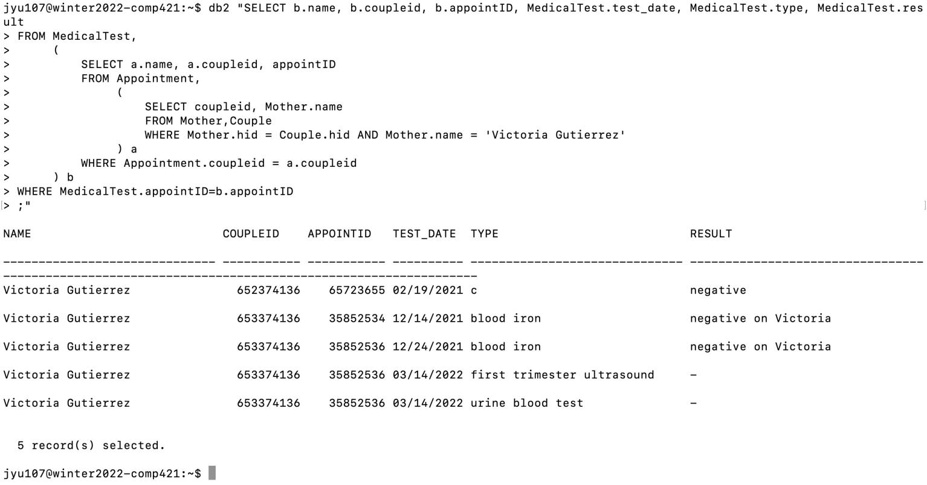ii.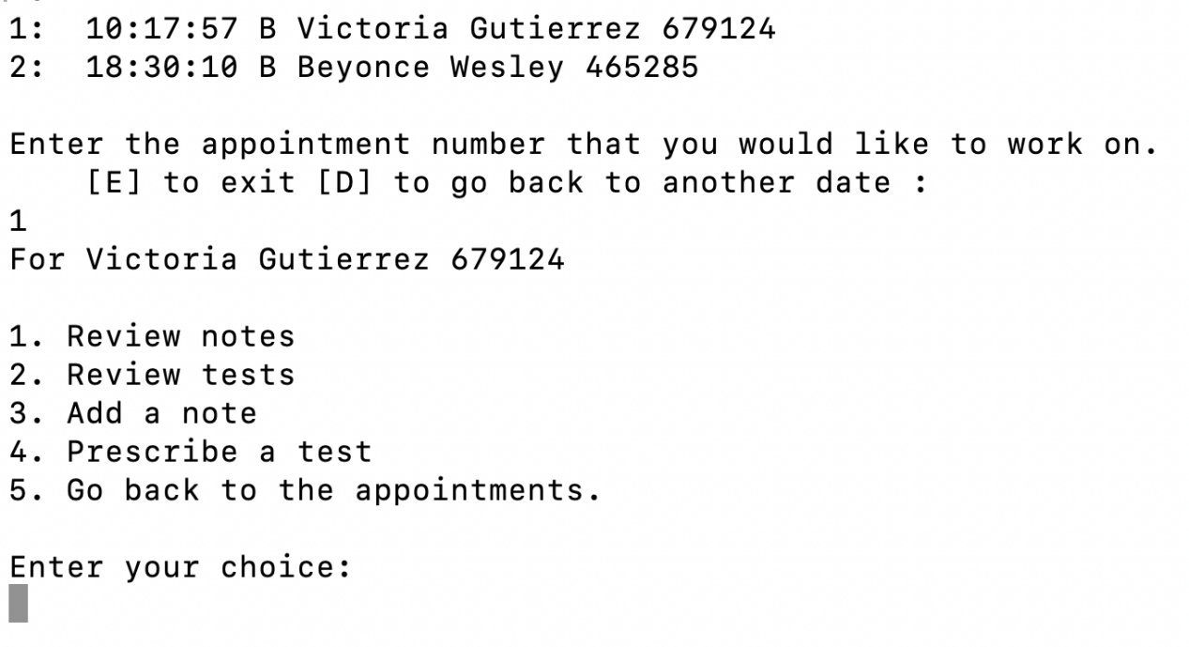

iii.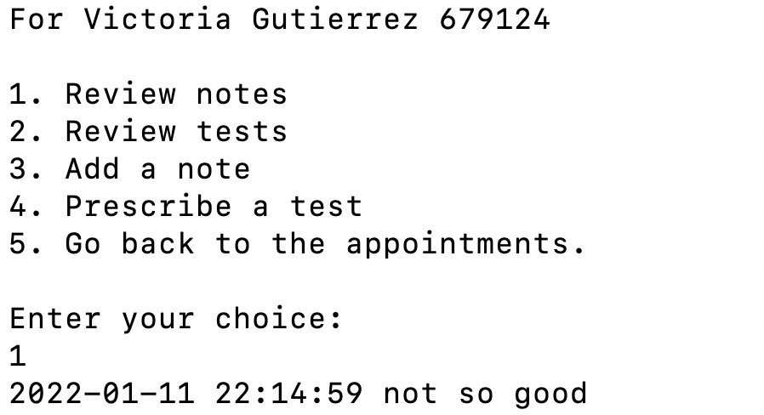iv.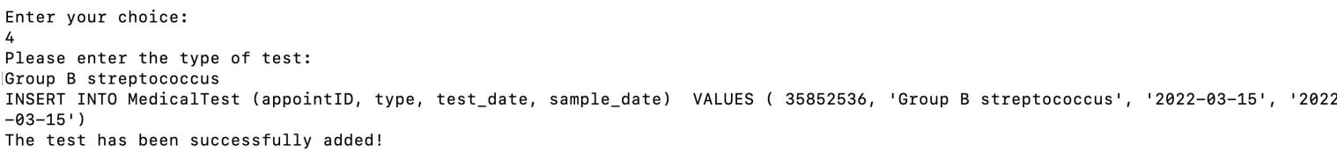v. 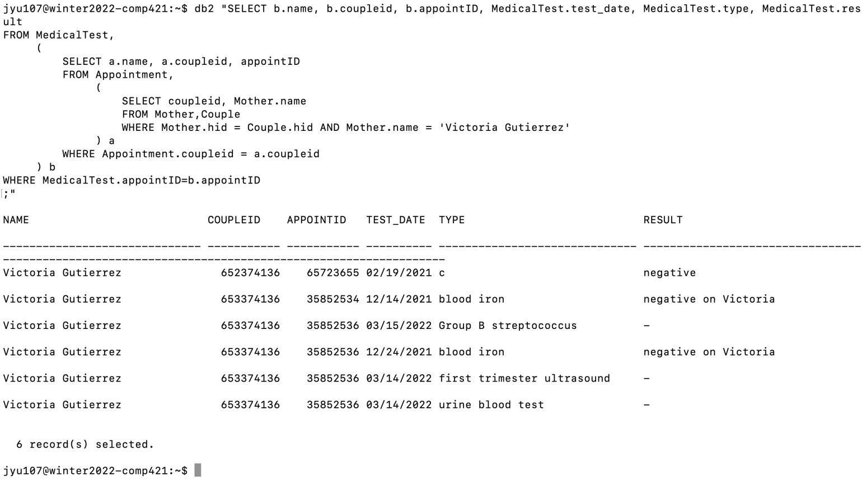(d)

i.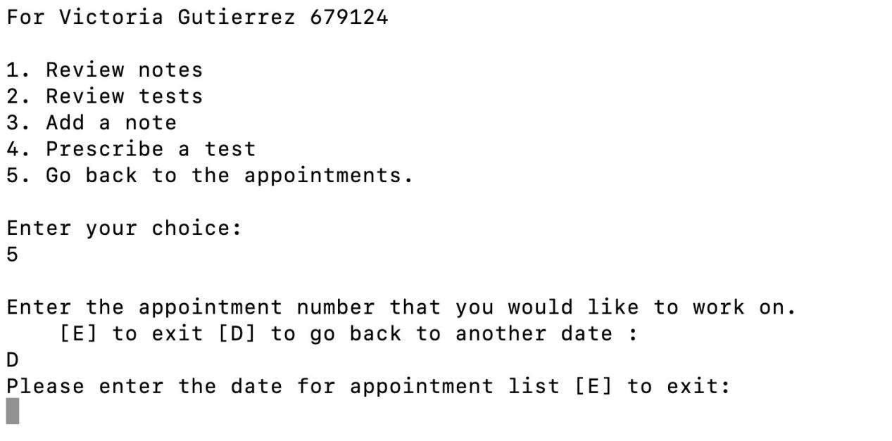(ii) and (iii)

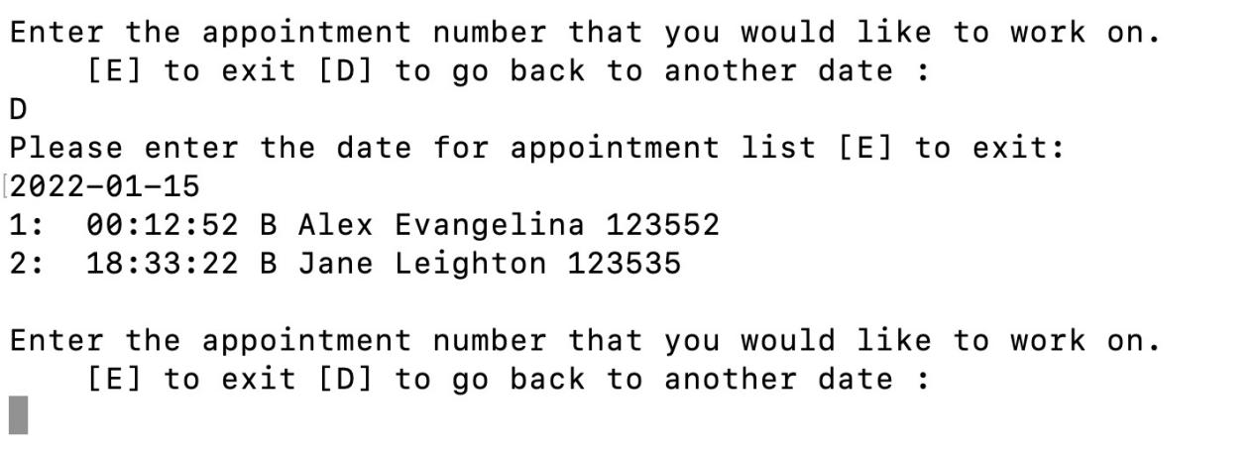

**Indexing**

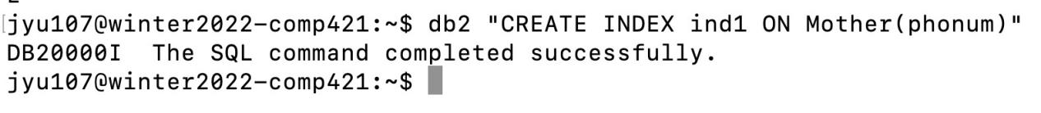

**Data Analytics**

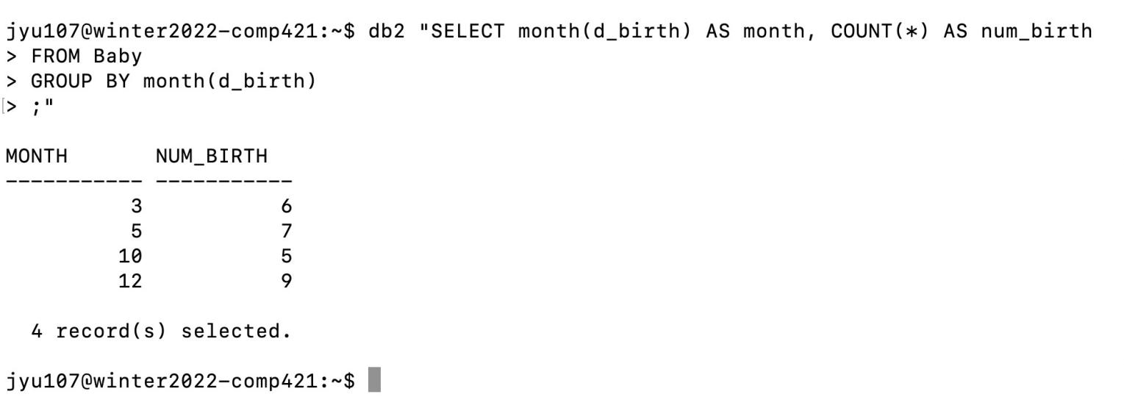

The excel workbook is attached with the name of “worksheet.xlsx”