**50.005 Computer System Engineering**

**Yap Wei Lok 1002394**

Question 1

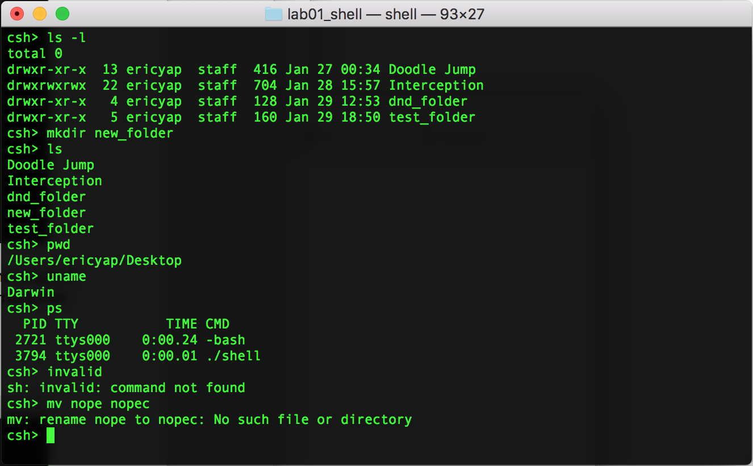

In the above screenshot, the shell executes several commands like *ls*, *mkdir*, *pwd* etc. The result of the execution is also printed in the shell. When the shell tries to execute an invalid command like “invalid” or with invalid arguments, an error status is printed out on the shell.

Question 2

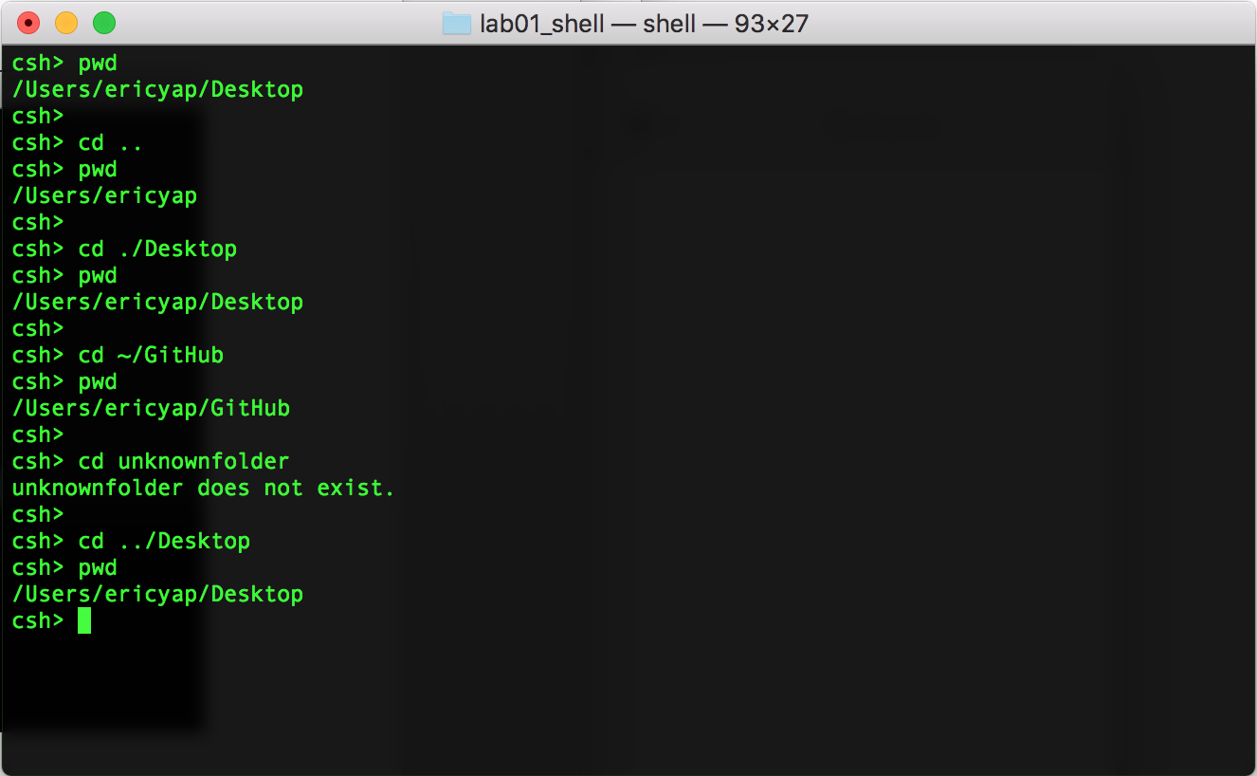

In the above screenshot, the shell executes the *cd* command. Shorthands like“..”, “~” and “.” are supported by the shell as shown above. Whenever the user tries to change directory to one that does not exist, the shell notifies the user.

Question 3

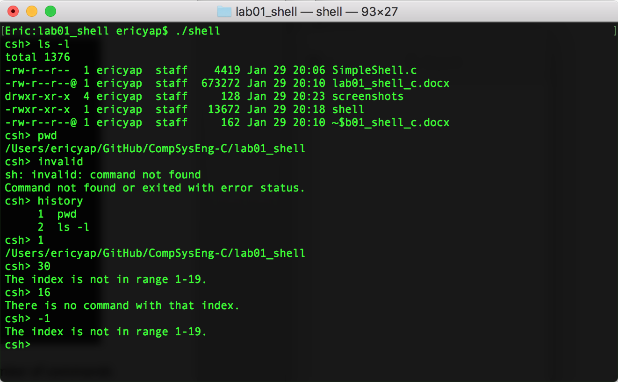

In the above screenshot, the *history* command is executed. The maximum number of commands that can be stored in the history list is 20. The history only stores commands that are valid. If the user enters *!!* the shell executes the previously executed command. If the user enters an integer index, the command that is associated with that index is executed but not saved in history. An error message will be printed if the index is not associated with a command or if the index is not within the range of 1-20.