**Notes on testing BLAS Fortran F77 package**

**Level 1** is mostly focusing on vectors, and all have been tested, including givens rotation.

For modified givens rotation, the principals are not yet understood, but it was tested.

**Level 2** relates to matrix, and it becomes a little complicated, due to the different matrix storage format. Here is a table of all possible matrix format and examples demonstrating their storage.

GE GB

SY SB SP

HE HB HP

TR TB TP

Note the difference between BLAS-general-band storage and general-band storage:

**General-band (only for square matrix)**

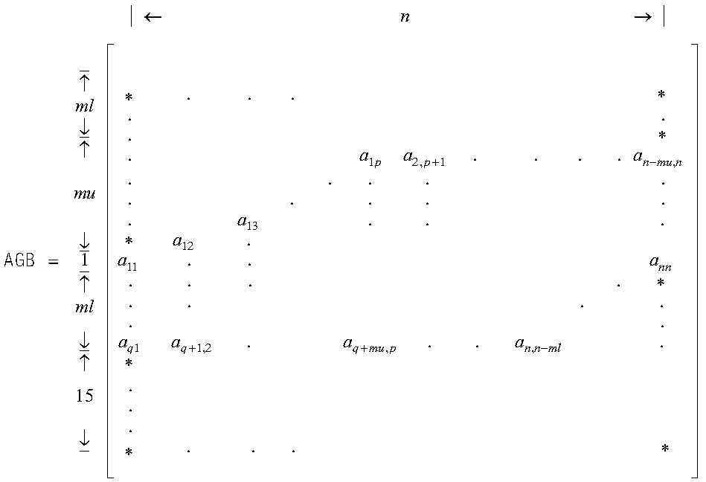

**BLAS-general-band (used for both square and rectangular matrices)**

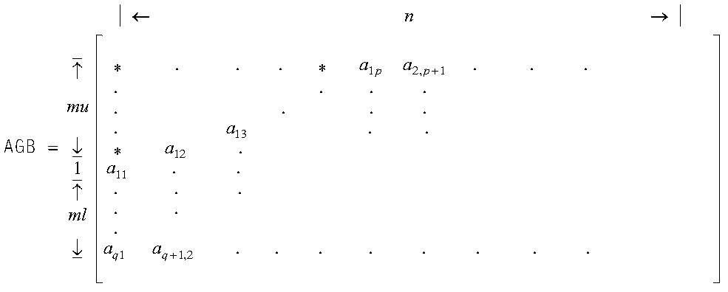

**GE**

A real general matrix **A** of size 4 by 3. Because lda is 10 and n is 3, array A must be declared to start from position 1. Note if in C/C++, the matrix should be saving in column-major format.

TRANSA M N ALPHA A LDA X INCX BETA Y INCY

| | | | | | | | | | |

SGEMV_( 'N' , 4 , 3 , 1.0 , &A(1) , 5 , X , 1 , 1.0 , Y , 1 )

| . . . |

| 1.0 2.0 3.0 |

A = | 2.0 2.0 4.0 |

| 3.0 2.0 2.0 |

| 4.0 2.0 1.0 |

**GB**

A real general band matrix **A** 5 by 4 in its initial form.

| 1.0 1.0 1.0 0.0 |

| 2.0 2.0 2.0 2.0 |

| 3.0 3.0 3.0 3.0 |

| 4.0 4.0 4.0 4.0 |

| 0.0 5.0 5.0 5.0 |

Saved in BLAS-general-band storage mode:

TRANSA M N KL KU ALPHA A LDA X INCX BETA Y INCY

| | | | | | | | | | | | |

CALL SGBMV( 'N' , 5 , 4 , 3 , 2 , 2.0 , A , 8 , X , 1 , 10.0 , Y , 2 )

| . . 1.0 2.0 |

| . 1.0 2.0 3.0 |

| 1.0 2.0 3.0 4.0 |

A = | 2.0 3.0 4.0 5.0 |

| 3.0 4.0 5.0 . |

| 4.0 5.0 . . |

| . . . . |

| . . . . |

KL/ML – number of sub-diagonal

KU/MU - number of super-diagonal.

**REF:** <https://www.ibm.com/support/knowledgecenter/SSFHY8_6.2/reference/am5gr_upbsm.html>

**SY**

UPLO N ALPHA A LDA X INCX BETA Y INCY

| | | | | | | | | |

CALL SSYMV( 'L' , 3 , 1.0 , A , 3 , X , 1 , 1.0 , Y , 2 )

| 8.0 . . |

A = | 4.0 6.0 . |

| 2.0 7.0 3.0 |

UPLO N ALPHA A LDA X INCX BETA Y INCY

| | | | | | | | | |

CALL SSYMV( 'U' , 3 , 1.0 , A , 4 , X , -2 , 2.0 , Y , 1 )

| 8.0 4.0 2.0 |

A = | . 6.0 7.0 |

| . . 3.0 |

| . . . |

**SP**

A real symmetric matrix ***A*** of order 3, stored in upper/lower-packed storage mode:

| 8.0 4.0 2.0 |

| 4.0 6.0 7.0 |

| 2.0 7.0 3.0 |

UPLO N ALPHA AP X INCX BETA Y INCY

| | | | | | | | |

CALL SSPMV( 'L' , 3 , 1.0 , AP , X , 1 , 1.0 , Y , 2 )

AP = (8.0, 4.0, 2.0, 6.0, 7.0, 3.0)

UPLO N ALPHA AP X INCX BETA Y INCY

| | | | | | | | |

CALL SSPMV( 'U' , 3 , 1.0 , AP , X , -2 , 2.0 , Y , 1 )

AP = (8.0, 4.0, 6.0, 2.0, 7.0, 3.0)

**SB**

A real matrix of size 5 by 5 in its initial form.

| 1.0 1.0 1.0 1.0 1.0 |

| 1.0 2.0 2.0 2.0 2.0 |

| 1.0 2.0 3.0 3.0 3.0 |

| 1.0 2.0 3.0 4.0 4.0 |

| 1.0 2.0 3.0 4.0 5.0 |

upper-band-packed storage mode

UPLO N K ALPHA A LDA X INCX BETA Y INCY

| | | | | | | | | | |

CALL SSBMV( 'U' , 5 , 5 , 2.0 , A , 7 , X , 1 , 10.0 , Y , 2 )

| . . . . . |

| . . . . 1.0 |

| . . . 1.0 2.0 |

A = | . . 1.0 2.0 3.0 |

| . 1.0 2.0 3.0 4.0 |

| 1.0 2.0 3.0 4.0 5.0 |

| . . . . . |

**Note on band-packed storage:**

Lower-Band-Packed Storage Mode

| 11 21 31 0 0 0 |

| 21 22 32 42 0 0 |

| 31 32 33 43 53 0 |

| 0 42 43 44 54 64 |

| 0 0 53 54 55 65 |

| 0 0 0 64 65 66 |

| 11 22 33 44 55 66 |

ASB = | 21 32 43 54 65 * |

| 31 42 53 64 * * |

Upper-Band-Packed Storage Mode

| 11 12 13 14 0 0 |

| 12 22 23 24 25 0 |

| 13 23 33 34 35 36 |

| 14 24 34 44 45 46 |

| 0 25 35 45 55 56 |

| 0 0 36 46 56 66 |

| * * * 14 25 36 |

ASB = | * * 13 24 35 46 |

| * 12 23 34 45 56 |

| 11 22 33 44 55 66 |

**TR**

Matrix **A** is a real 4 by 4 lower triangular matrix that is unit triangular stored in lower-triangular storage mode:

| 1.0 . . . |

| 1.0 1.0 . . |

| 2.0 3.0 1.0 . |

| 3.0 4.0 3.0 1.0 |

UPLO TRANSA DIAG N A LDA X INCX

| | | | | | | |

CALL STRMV( 'L' , 'N' , 'U' , 4 , A , 4 , X , 1 )

| . . . . |

A = | 1.0 . . . |

| 2.0 3.0 . . |

| 3.0 4.0 3.0 . |

| 1.0 2.0 3.0 2.0 |

| . 1.0 2.0 5.0 |

| . . 1.0 3.0 |

| . . . 1.0 |

UPLO TRANSA DIAG N A LDA X INCX

| | | | | | | |

CALL STRMV( 'U' , 'T' , 'U' , 4 , A , 4 , X , 1 )

| . 2.0 3.0 2.0 |

A = | . . 2.0 5.0 |

| . . . 3.0 |

| . . . . |

**TP**

Matrix **A** is a real 4 by 4 upper triangular matrix that is not unit triangular, stored in upper-triangular-packed storage mode

| 1.0 . . . |

| 1.0 1.0 . . |

| 2.0 3.0 1.0 . |

| 3.0 4.0 3.0 1.0 |

UPLO TRANSA DIAG N AP X INCX

| | | | | | |

CALL STPMV( 'L' , 'N' , 'U' , 4 , AP , X , 1 )

AP = ( . , 1.0, 2.0, 3.0, . , 3.0, 4.0, . , 3.0, . )

| 1.0 2.0 3.0 2.0 |

| . 2.0 2.0 5.0 |

| . . 3.0 3.0 |

| . . . 1.0 |

UPLO TRANSA DIAG N AP X INCX

| | | | | | |

CALL STPMV( 'U' , 'T' , 'N' , 4 , AP , X , 1 )

AP = (1.0, 2.0, 2.0, 3.0, 2.0, 3.0, 2.0, 5.0, 3.0, 1.0)

X = (5.0, 4.0, 3.0, 2.0)

**TB**

Matrix **A** is a real 7 by 7 upper triangular band matrix with a half band width of 3 that is not unit triangular, stored in upper-triangular-band-packed storage mode

| 1.0 1.0 1.0 1.0 0.0 0.0 0.0 |

| 0.0 2.0 2.0 2.0 2.0 0.0 0.0 |

| 0.0 0.0 3.0 3.0 3.0 3.0 0.0 |

| 0.0 0.0 0.0 4.0 4.0 4.0 4.0 |

| 0.0 0.0 0.0 0.0 5.0 5.0 5.0 |

| 0.0 0.0 0.0 0.0 0.0 6.0 6.0 |

| 0.0 0.0 0.0 0.0 0.0 0.0 7.0 |

UPLO TRANSA DIAG N K A LDA X INCX

| | | | | | | | |

CALL STBMV( 'U' , 'N' , 'N' , 7 , 3 , A , 5 , X , 1 )

| . . . 1.0 2.0 3.0 4.0 |

| . . 1.0 2.0 3.0 4.0 5.0 |

A = | . 1.0 2.0 3.0 4.0 5.0 6.0 |

| 1.0 2.0 3.0 4.0 5.0 6.0 7.0 |

| . . . . . . . |

Matrix **A** is a real 7 by 7 lower triangular band matrix with a half band width of 3 that is not unit triangular, stored in lower-triangular-band-packed storage mode

| 1.0 0.0 0.0 0.0 0.0 0.0 0.0 |

| 1.0 2.0 0.0 0.0 0.0 0.0 0.0 |

| 1.0 2.0 3.0 0.0 0.0 0.0 0.0 |

| 1.0 2.0 3.0 4.0 0.0 0.0 0.0 |

| 0.0 2.0 3.0 4.0 5.0 0.0 0.0 |

| 0.0 0.0 3.0 4.0 5.0 6.0 0.0 |

| 0.0 0.0 0.0 4.0 5.0 6.0 7.0 |

UPLO TRANSA DIAG N K A LDA X INCX

| | | | | | | | |

CALL STBMV( 'L' , 'T' , 'N' , 7 , 3 , A , 5 , X , 1 )

| 1.0 2.0 3.0 4.0 5.0 6.0 7.0 |

| 1.0 2.0 3.0 4.0 5.0 6.0 . |

A = | 1.0 2.0 3.0 4.0 5.0 . . |

| 1.0 2.0 3.0 4.0 . . . |

| . . . . . . . |