Supplementary Information

Supplementary Figure S1. Violin plots of sex-specific marker gene expression across major brain cell types in four samples with mismatched metadata and sex-linked gene expression.
Each column shows the expression of the sex-linked genes XIST (top row) and UTY (bottom row) for one subject across seven major cell types: astrocytes (Ast), excitatory neurons (Exc), inhibitory neurons (Inh), oligodendrocytes (Oli), oligodendrocyte precursor cells (OPC), microglia (Mic), and endothelial cells (End). The column headers indicate the subject ID (projid) along with the sex information from metadata annotations.

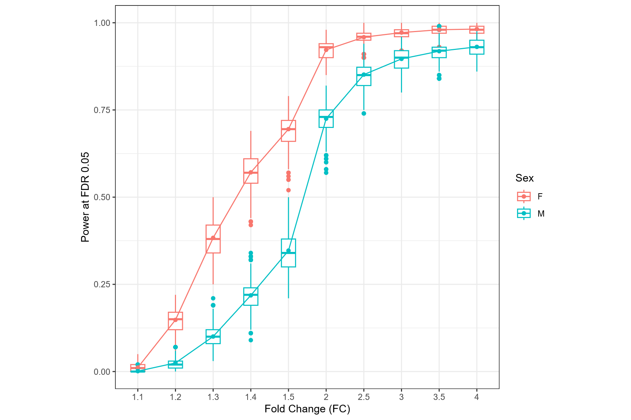
Supplementary Figure S2. Power analysis for sex-stratified differential expression in the APOE e2 carrier group. Statistical power estimated from scDesign3-based simulations is shown as a function of effect size (fold change, FC) separately for females and males. Boxplots depict the distributions of power estimates from 100 repeated simulations at each fold change, while overlaid line plots indicate the mean power across simulations.

