Revised Mouse Validation Strategy for a Human PFC Alzheimer's Study
A public-data plan for APOE, sex, disease, and cell-type validation
Prepared for a human prefrontal cortex Alzheimer's disease validation project
Updated August 22, 2026
Scope note
This document turns the revised recommendation into a practical study design. It does not report new biological results. The central constraint is that no one public mouse dataset simultaneously supplies exact PFC tissue, APOE3 versus APOE4, female versus male, AD versus non-AD, broad cell types, and strong independent-mouse replication.

Executive summary
New core recommendation
Use GSE241553, GSE185063, and GSE163857 as three complementary anchors. GSE241553 supplies cortical APOE-by-sex evidence under amyloid pathology; GSE185063 supplies broad cortical cell-type localization; and GSE163857 supplies the direct APOE-by-sex-by-disease test in sorted microglia. Analyze each study separately, then compare effect directions and pathway scores.

Because the human discovery tissue is prefrontal cortex (PFC), cortical mouse datasets should now receive more weight than hippocampal or whole-brain datasets. This changes the priority order, but it does not eliminate non-cortical datasets. A non-cortical study can still provide cell-type or pathway support if it is labeled correctly.
- Primary regional anchor: GSE241553.
- Primary broad cortical cell-type anchor: GSE185063.
- Primary full-factorial microglial anchor: GSE163857.
- Optional disease-direction references: GSE140399 and GSE140510.
- Secondary astrocyte and cross-region support: GSE143758.
- Optional APOE2 and immune-aging support: GSE225503.
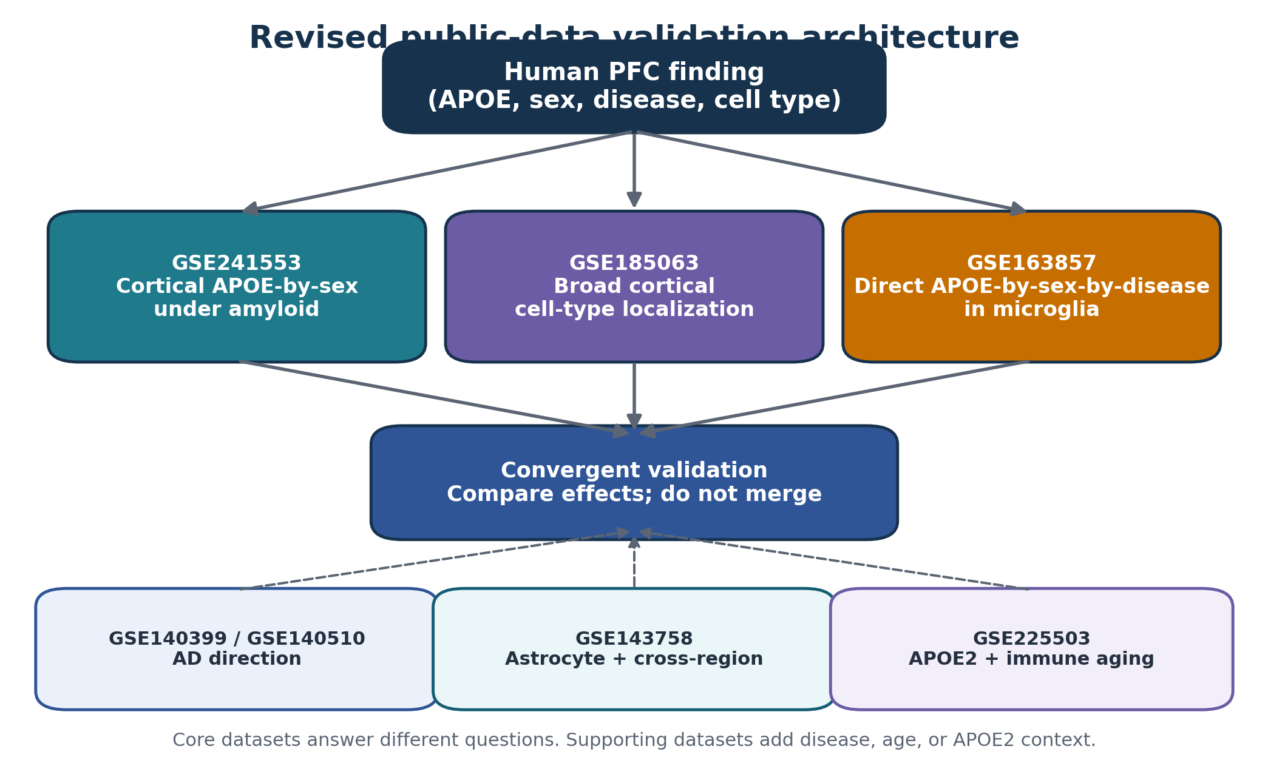
Figure 1. The revised setup uses three core datasets and several specialized supporting datasets.

1. Why the PFC detail changes the recommendation
The prefrontal cortex is a cortical brain region involved in planning, decision making, working memory, and other higher functions. Brain regions share broad cell classes, but they do not contain identical neuronal subtypes, cell proportions, or disease responses. A mouse hippocampal result therefore cannot be presented as an exact replication of a human PFC result.
Region matching is especially important for neurons because cortical excitatory and inhibitory neurons are organized by layers and projection patterns. Glial cells such as microglia and astrocytes are distributed more broadly, so cross-region pathway validation can still be useful, although it is weaker than cortical validation.
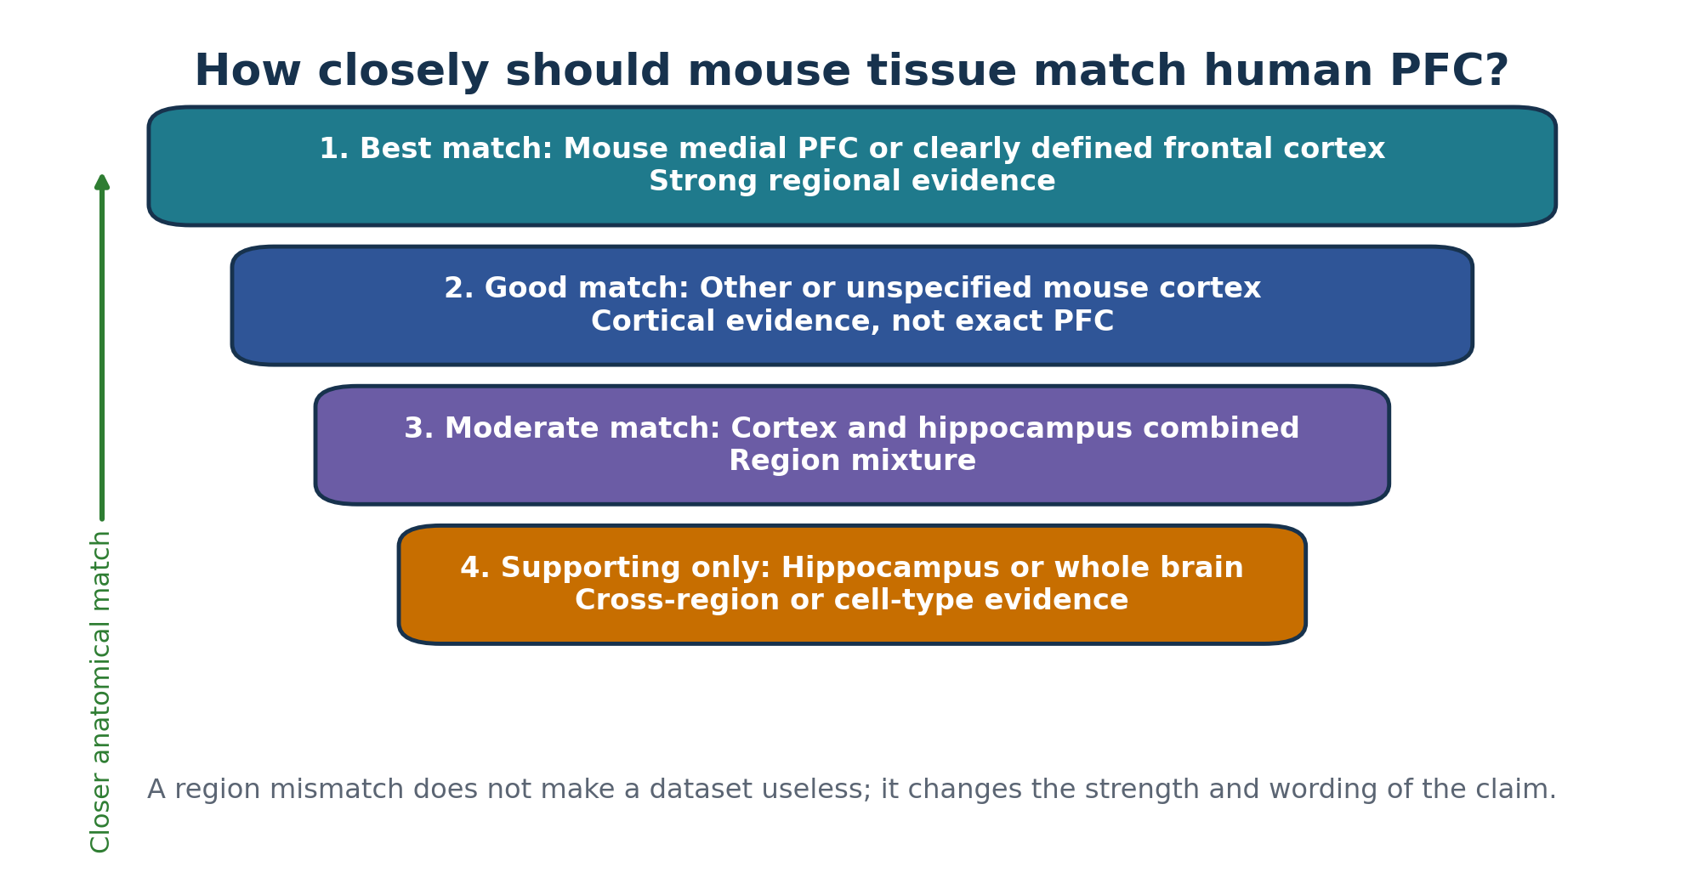
Figure 2. Anatomical matching changes the strength of a cross-species claim.
Claim-language rule
Use "cortical cross-species validation" when human PFC and mouse cortex agree. Use "cross-region pathway support" when the mouse evidence comes from hippocampus or whole brain. Do not write "mouse PFC replication" unless the mouse tissue is explicitly frontal or prefrontal cortex.

2. Recommended dataset portfolio
Role | Dataset | Tissue and modality | What it can test | Main limitation
Core 1 | GSE241553 | Cortex; scRNA-seq | APOE3 versus APOE4, female versus male, within an amyloid-model setting | No matched non-AD group; APOE is conditionally expressed mainly in microglia/CAMs; not explicitly PFC
Core 2 | GSE185063 | Cortical mantle; snRNA-seq | APOE3 versus APOE4 across neurons, glia, and vascular cells; age effects | No AD background; public sample-to-sex mapping requires verification
Core 3 | GSE163857 | Sorted brain microglia; bulk RNA-seq | Complete APOE x sex x disease design | Not cortex-specific; bulk rather than single-cell; small control groups
Optional | GSE140399 | Cortex and hippocampus; snRNA-seq | AD-versus-control direction and TREM2 dependence | Three mice per genotype were pooled into one sequencing sample
Optional alternative | GSE140510 | Mouse brain; snRNA-seq | AD-versus-control direction with three independent mice per genotype | Not cortex-specific and no APOE3/4 factor
Secondary | GSE143758 | Main atlas: hippocampus; small cortex astrocyte subset | 5xFAD disease, age, astrocyte states, and cross-region support | No human APOE factor; cortical subset is too small for strong inference
Specialized | GSE225503 | Cortical and hippocampal CD45+ cells; scRNA/multiome | APOE2/3/4 and immune-cell aging on 5xFAD background | No non-AD group; region and mouse-level metadata must be audited

3. The three core datasets

GSE241553 - cortical APOE-by-sex anchor
GEO describes 24 cortical single-cell samples from an amyloid-model mouse cohort. There are four groups with six mice per group, balanced as three females and three males. The groups compare control versus tamoxifen-induced APOE3 or APOE4 expression in microglia and CNS-associated macrophages.
Group | APOE line | Induction | Female mice | Male mice | Total
E3 control | APOE3 | No | 3 | 3 | 6
E3 induced | APOE3 | Yes | 3 | 3 | 6
E4 control | APOE4 | No | 3 | 3 | 6
E4 induced | APOE4 | Yes | 3 | 3 | 6

Primary analysis: restrict the first confirmatory test to the induced APOE3 and induced APOE4 groups. Build one pseudobulk profile per mouse and cell type, then fit an APOE-by-sex model.
expression_or_module_score ~ APOE * sex
Interpretation: this dataset can show whether a human PFC signature has a similar APOE-by-sex pattern in mouse cortical cells under amyloid pathology. It cannot estimate an AD-versus-non-AD effect because every group is on an amyloid-model background.

GSE185063 - broad cortical cell-type anchor
This study profiled 16 cortical snRNA-seq samples from APOE3 and APOE4 knock-in mice. The published methods describe four mice per genotype at 2-3 months and four mice per genotype at 9-12 months. Nuclei were isolated from the right cortical mantle after removal of the hippocampus and visible white matter.
The study contains excitatory neurons, inhibitory neurons, oligodendrocytes and OPCs, astrocytes, microglia, endothelial cells, pericytes, and other vascular cells. It is therefore the best current dataset for locating a human PFC APOE-related module across broad cortical cell types.
expression_or_module_score ~ APOE * age
Both male and female mice were used, but the public sample-to-sex map must be verified before fitting a sex interaction. Do not infer sex only from expression or filename patterns unless the assignment is independently confirmed.

GSE163857 - direct factorial microglial anchor
This is bulk RNA-seq from sorted mouse microglia carrying human APOE3 or APOE4 on either targeted-replacement control or 5xFAD backgrounds. Female and male mice are represented, creating all eight combinations of APOE, sex, and disease background.
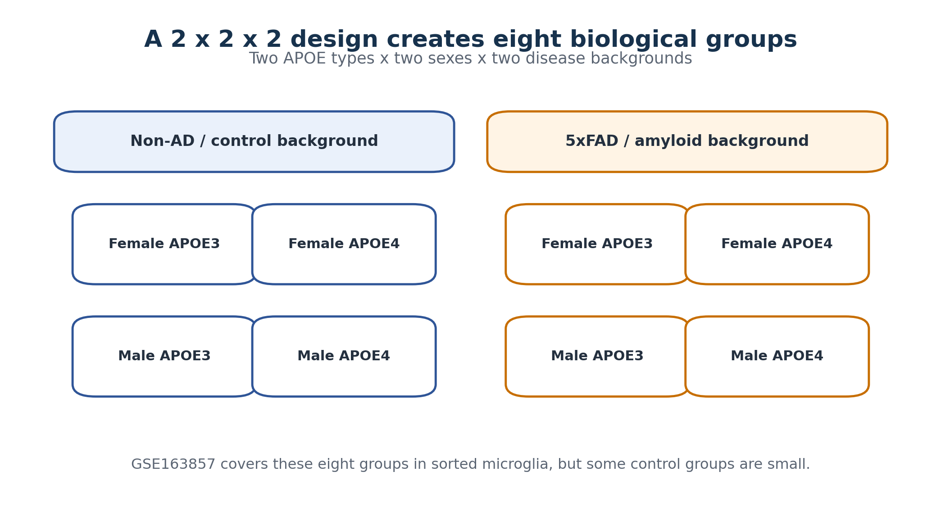
Figure 3. The complete 2 x 2 x 2 design contained in GSE163857.
expression_or_module_score ~ sex * APOE * disease
The most important coefficient is the three-way interaction: whether the disease-related APOE4 effect differs between females and males. However, the GEO sample list shows small and imbalanced control strata, so report effect sizes and confidence intervals and examine preplanned simpler contrasts rather than relying only on one p-value.
- Female 5xFAD: APOE4 versus APOE3.
- Male 5xFAD: APOE4 versus APOE3.
- Female APOE4: 5xFAD versus control.
- Male APOE4: 5xFAD versus control.

4. Optional and supporting datasets

GSE140399 - descriptive cortical disease direction
This 15-month dataset includes separate cortex and hippocampus samples from WT, TREM2-knockout, 5xFAD, and combined TREM2-knockout/5xFAD mice. Its cortical component is anatomically useful, but GEO states that cells from three mice per genotype were pooled for sequencing. It can support pathway direction and cell-state localization, but ordinary mouse-level inference is not available from the pooled library.

GSE140510 - replicated non-regional disease alternative
This 7-month companion dataset contains three biologically independent mice per genotype processed and sequenced separately. It provides stronger biological replication than GSE140399, but it is not a clearly defined cortical or PFC dissection. Use it when independent replication matters more than regional matching.

GSE143758 - astrocyte, age, and cross-region support
The main all-cell matrix is a hippocampal 5xFAD-versus-WT snRNA-seq atlas, and the broader study is especially informative for disease-associated astrocytes and age progression. GEO also lists four cortical records, but the processed cortical matrix is astrocyte-focused and includes only one record per age-by-genotype combination at 7 and 10 months. This is too small for a strong cortical disease test.
Recommended use: secondary evidence that a PFC-derived astrocyte or mitochondrial pathway also appears in 5xFAD disease or across vulnerable brain regions. Do not call it direct mouse PFC replication.

GSE225503 - APOE2 and immune-aging support
This study profiles CD45-positive immune cells from hippocampal and cortical regions of 5xFAD mice carrying human APOE2, APOE3, or APOE4 across several ages. It is most useful when APOE2, microglial aging, or late-stage immune states are part of the human finding. Because all animals are on the 5xFAD background, it does not provide a disease-versus-control comparison.

5. Analysis plan
- Freeze the human PFC findings before examining the mouse datasets. Create separate gene lists or module scores for each human cell type and contrast.
- Convert human genes to one-to-one mouse orthologs and keep one fixed mapping table for all datasets.
- Audit each dataset for mouse ID, sex, APOE genotype, disease background, age, region, cell type, pooling, library, and batch.
- For scRNA-seq or snRNA-seq, sum counts by mouse and cell type to create one pseudobulk profile per mouse.
- Analyze GSE241553 first for cortical APOE-by-sex evidence under amyloid.
- Analyze GSE185063 second to locate the APOE-related module across cortical cell types and ages.
- Analyze GSE163857 third for the complete APOE-by-sex-by-disease microglial design.
- Use optional studies only to answer unresolved questions about cortical disease direction, astrocytes, age, APOE2, or cross-region consistency.
- Compare study-specific effect sizes and directions. Do not merge raw count matrices across studies.
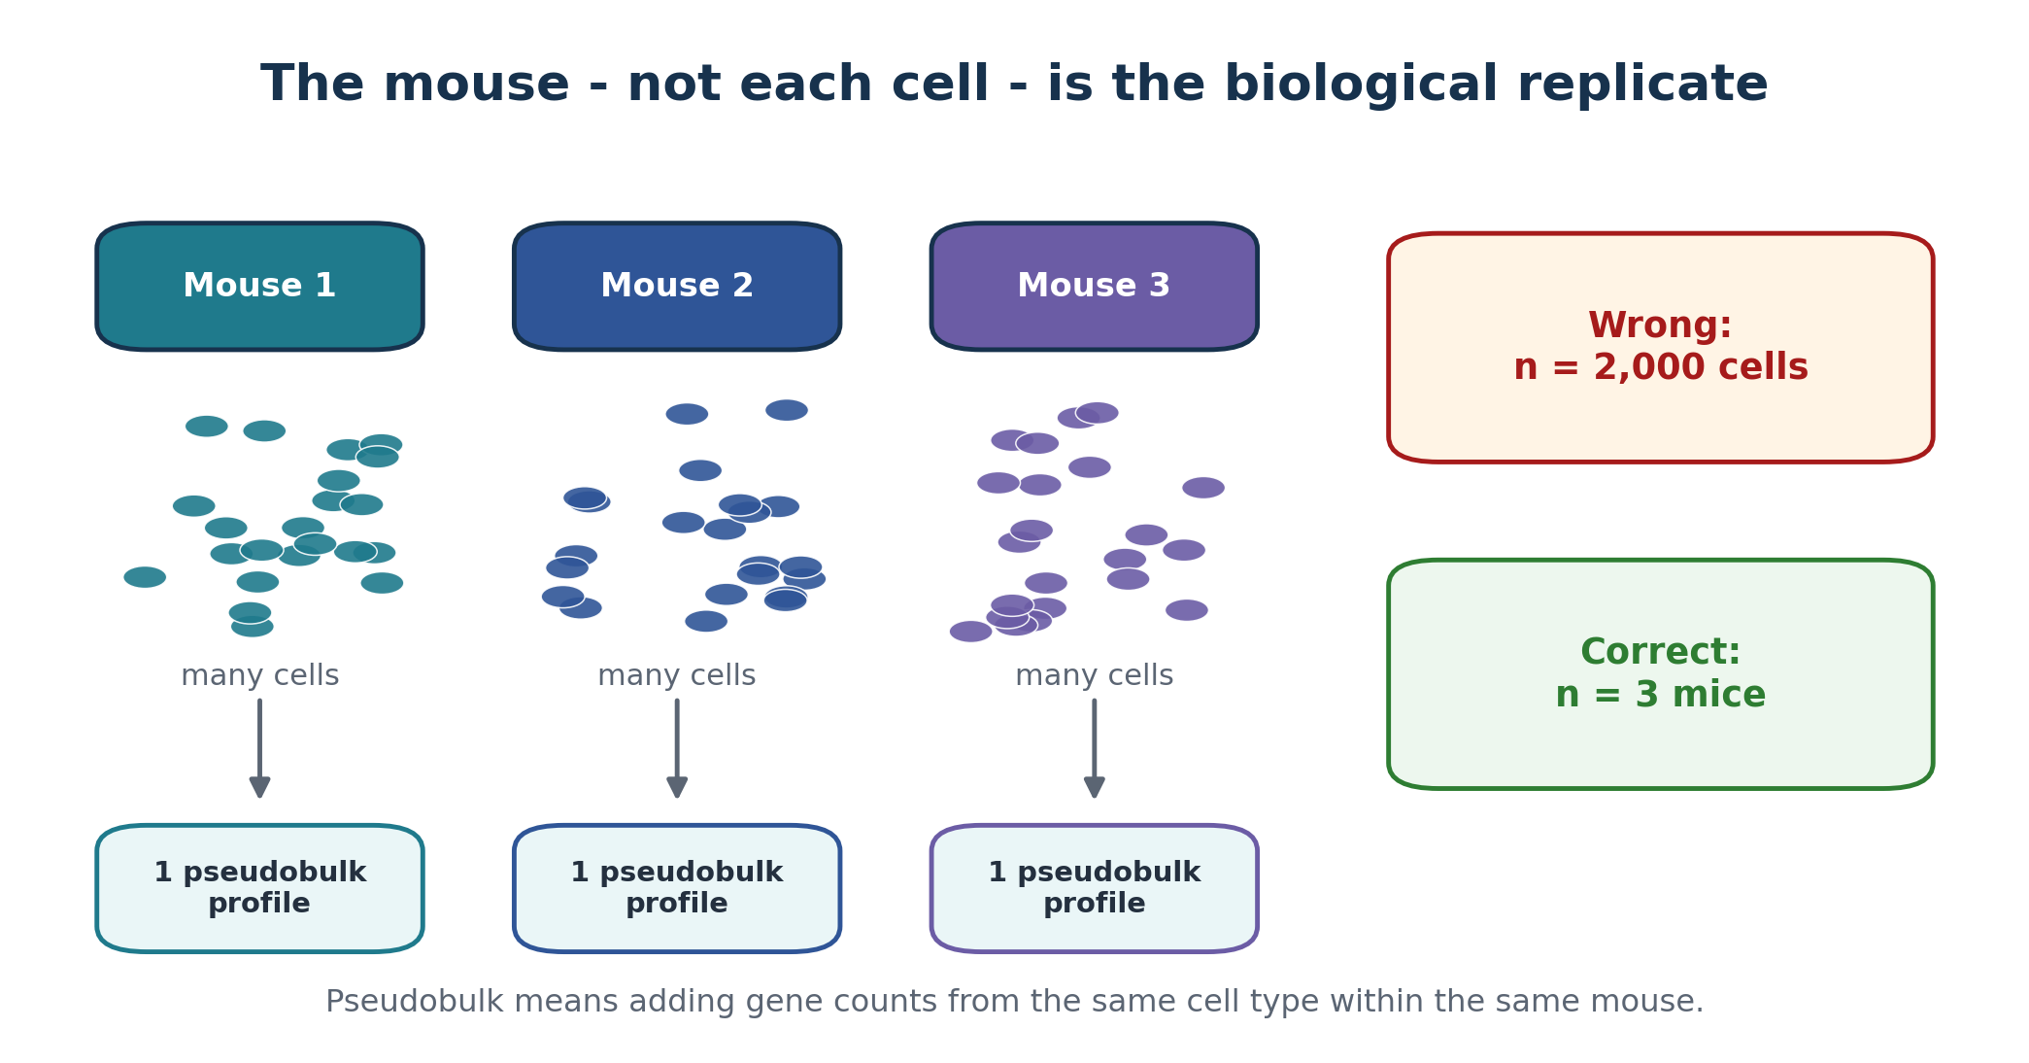
Figure 4. Pseudobulk analysis preserves the mouse as the independent experimental unit.

6. Cell-type-specific use
Human PFC cell type | Primary mouse evidence | Secondary evidence | Strongest defensible claim
Microglia | GSE241553 + GSE163857 | GSE185063; GSE225503 | Cortical APOE-by-sex support plus independent factorial microglial support
Astrocytes | GSE185063 | GSE140399; GSE143758 | Cortical APOE localization plus descriptive/cross-region AD support
Excitatory neurons | GSE185063 | GSE140399 or GSE140510 | Cortical APOE localization; AD direction remains separate
Inhibitory neurons | GSE185063 | GSE140399 or GSE140510 | Cortical APOE localization; avoid hippocampal neuron equivalence
Oligodendrocytes / OPCs | GSE185063 | GSE140399 or GSE140510 | Cortical APOE evidence with optional disease-direction support
Endothelial / pericyte | GSE185063 | New data may be needed | Cortical APOE vascular evidence; no full public factorial AD test

7. Minimum, preferred, and definitive setups
Setup | Datasets / design | What it supports
Minimum defensible public-data package | GSE241553 + GSE185063 + GSE163857 | Best balance of cortical relevance, broad cell-type localization, and direct factorial microglial testing
Preferred public-data package | Core three + GSE140399 or GSE140510 + GSE143758; add GSE225503 only when relevant | Adds disease direction, astrocyte/age evidence, and optional APOE2 or immune-aging context
Definitive new experiment | APOE3/4 x female/male x AD/control; frontal or medial PFC snRNA-seq; independent mice in all eight groups | Direct region-matched, cell-type-specific interaction testing

Planning target for a new experiment
A reasonable starting design is 6-8 independent mice per group across eight groups, followed by formal power analysis. Use one library per mouse, randomize groups across processing batches, and retain adjacent tissue for pathology or protein validation.

8. Evidence labels and reporting language
Observed evidence | Recommended wording
Human PFC and mouse cortical data agree | Cortical cross-species validation
Same cell type agrees in non-cortical mouse tissue | Cell-type-specific cross-species support
Human PFC and mouse hippocampus agree | Cross-region pathway support
Pooled mouse sample agrees | Descriptive concordance
GSE163857 three-way pattern agrees | Factorial microglial support
Several complementary studies agree | Convergent or triangulated validation

Recommended final summary sentence:
Suggested language
We used GSE241553, GSE185063, and GSE163857 as complementary mouse validation datasets. Together they provided cortical APOE-by-sex evidence, broad cortical cell-type localization, and independent factorial testing in microglia. Supporting datasets were used only for disease direction, age, astrocyte state, APOE2, or cross-region concordance. Results were compared at the effect-size and pathway level without merging studies.

9. Main limitations
- None of the public datasets is an exact mouse PFC APOE3/4 x sex x AD/control single-nucleus experiment.
- Mouse cortex is not always labeled as frontal or prefrontal cortex.
- GSE241553 has no non-AD comparison.
- GSE185063 has no AD background and requires careful sex-metadata verification.
- GSE163857 is bulk sorted microglia, not broad cortical single-cell data, and its control groups are small.
- Pooled or one-library-per-group datasets should be used descriptively rather than for ordinary replicate-aware inference.
- Human-to-mouse validation should emphasize conserved pathways and pre-specified gene modules, not only exact one-gene matches.

Sources and verification links
1. GEO: GSE241553: https://www.ncbi.nlm.nih.gov/geo/query/acc.cgi?acc=GSE241553
2. GEO: GSE185063: https://www.ncbi.nlm.nih.gov/geo/query/acc.cgi?acc=GSE185063
3. Barisano et al., Journal of Experimental Medicine, 2022: https://doi.org/10.1084/jem.20221137
4. GEO: GSE163857: https://www.ncbi.nlm.nih.gov/geo/query/acc.cgi?acc=GSE163857
5. GEO: GSE140399: https://www.ncbi.nlm.nih.gov/geo/query/acc.cgi?acc=GSE140399
6. GEO: GSE140510: https://www.ncbi.nlm.nih.gov/geo/query/acc.cgi?acc=GSE140510
7. GEO: GSE143758: https://www.ncbi.nlm.nih.gov/geo/query/acc.cgi?acc=GSE143758
8. GEO: GSE225503: https://www.ncbi.nlm.nih.gov/geo/query/acc.cgi?acc=GSE225503
9. Zhou et al., Nature Medicine, 2020: https://pubmed.ncbi.nlm.nih.gov/31932797/
Scientific planning note: dataset metadata should be re-audited immediately before analysis. The document distinguishes directly verified GEO or paper facts from analysis recommendations and inferential choices.

