Beginner's Tutorial: Validating Human PFC Alzheimer's Findings with Mouse Data
How to use complementary APOE, sex, disease, and single-cell datasets
Prepared for a human prefrontal cortex Alzheimer's disease validation project
Updated August 22, 2026
Scope note
This tutorial assumes no advanced biology background. It explains the vocabulary first, then walks through the revised three-dataset strategy. Examples and numerical plots are educational illustrations, not biological results.

How to use this tutorial
Read Chapters 1-5 first if you are new to Alzheimer's biology or RNA sequencing. Chapters 6-10 describe the actual project workflow. Chapters 11-14 show how to interpret results, avoid common mistakes, and prepare figures for a paper.
The one-sentence plan
Use GSE241553 to test APOE-by-sex patterns in mouse cortex under amyloid, GSE185063 to learn which cortical cell types carry the signal, and GSE163857 to test the complete APOE-by-sex-by-disease pattern in microglia. Treat the other datasets as specialized supporting evidence.

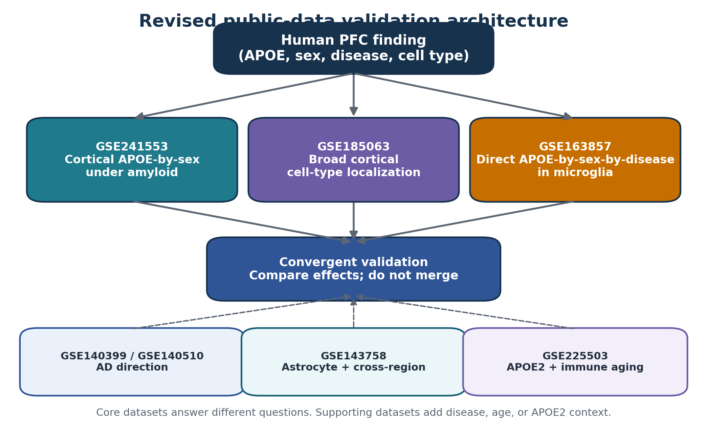
Figure 1. The three core datasets answer different pieces of the same question.

1. The biological question in plain language
Your human study starts with tissue from the prefrontal cortex, usually shortened to PFC. You are asking whether Alzheimer's disease changes gene activity differently depending on a person's APOE type and sex, and whether those changes occur in specific brain cell types.
Mouse data are used as external validation. External validation means checking whether a result appears again in a different experiment. A mouse study cannot perfectly reproduce a human brain, but it can test whether the same cell type, gene group, or biological pathway changes in a similar direction.
Important idea
Validation is not all-or-nothing. A result can receive regional support, cell-type support, pathway support, or full-factorial support. The wording of the conclusion should match the type of evidence.

2. Essential biology vocabulary
Term | Beginner definition | Why it matters here
Alzheimer's disease (AD) | A brain disease involving memory and thinking problems, abnormal proteins, inflammation, and loss of brain function. | The mouse models imitate selected parts of AD, especially amyloid pathology.
Prefrontal cortex (PFC) | A front part of the cerebral cortex involved in planning, judgment, attention, and working memory. | Your human discovery tissue comes from this region, so cortical mouse tissue is preferred.
APOE | A gene that helps move fats and cholesterol and influences brain cells and immune responses. | APOE4 increases AD risk; APOE3 is more common; APOE2 is often considered relatively protective.
Isoform / allele | A different version of the same gene. | APOE2, APOE3, and APOE4 are different APOE versions.
Sex as a biological variable | Female and male organisms can show different biology because of chromosomes, hormones, development, and other factors. | The APOE4 effect may not be the same in females and males.
Amyloid | A protein fragment that can accumulate into plaques in AD. | 5xFAD mice develop strong amyloid pathology.
5xFAD mouse | A genetically engineered mouse that develops amyloid plaques quickly. | It models amyloid-related parts of AD but not every feature of human disease.
Knock-in / targeted replacement | A mouse is engineered to carry a chosen gene version, such as human APOE3 or APOE4. | This allows direct comparison of human APOE types in mice.
Cell type | A category of cell with a particular job. | Different cell types may react differently to APOE, sex, and disease.

3. The major brain cell types
Cell type | Simple analogy | Main job | Why it may matter in AD
Excitatory neuron | The brain's "send" wires | Sends signals that activate other neurons | May lose connections or change energy use
Inhibitory neuron | The brain's brakes | Prevents circuits from becoming overactive | May change network balance
Microglia | Resident immune and cleanup cells | Survey tissue, remove debris, respond to damage | Strongly affected by APOE and amyloid
Astrocyte | Support and maintenance crew | Feeds neurons, manages chemicals, supports blood vessels | Can enter reactive disease states
Oligodendrocyte | Cable-insulation maker | Produces myelin around axons | May show stress or altered metabolism
OPC | Oligodendrocyte precursor | Can develop into oligodendrocytes | May respond to injury and aging
Endothelial cell | Blood-vessel lining | Forms the blood-brain barrier | APOE4 can affect vascular function
Pericyte | Blood-vessel support cell | Stabilizes small vessels and barrier function | Can be involved in blood-brain barrier breakdown

A strong validation result should compare roughly corresponding cell types. For example, human PFC microglia should be compared with mouse microglia, and human PFC excitatory neurons should be compared with mouse cortical excitatory neurons rather than with all mouse neurons mixed together.

4. What RNA sequencing measures
DNA is the long-term instruction book in a cell. RNA is a working copy of selected instructions. When a gene is active, the cell often produces more RNA from that gene. RNA sequencing measures these RNA molecules and gives an estimate of gene expression.
Method | What is measured | Main advantage | Main limitation
Bulk RNA-seq | RNA mixed from many cells | Stable, simple, often good for small samples | Cannot tell which individual cell type caused the change
scRNA-seq | RNA from individual whole cells | Shows cell types and cell states | Fresh-cell isolation may change cells; some cell types are hard to recover
snRNA-seq | RNA from individual nuclei | Works well with frozen brain tissue and captures broad brain cell types | Nuclear RNA is incomplete and differs from whole-cell RNA

GSE241553 is single-cell RNA-seq, GSE185063 is single-nucleus RNA-seq, and GSE163857 is bulk RNA-seq from sorted microglia. These methods are different, so you should compare their biological conclusions rather than combine their raw numbers into one matrix.

5. Why brain region matching matters
The cortex and hippocampus share broad cell categories, but their neurons and local environments are not identical. Therefore, a result in mouse cortex is a better regional match to human PFC than a result in mouse hippocampus.
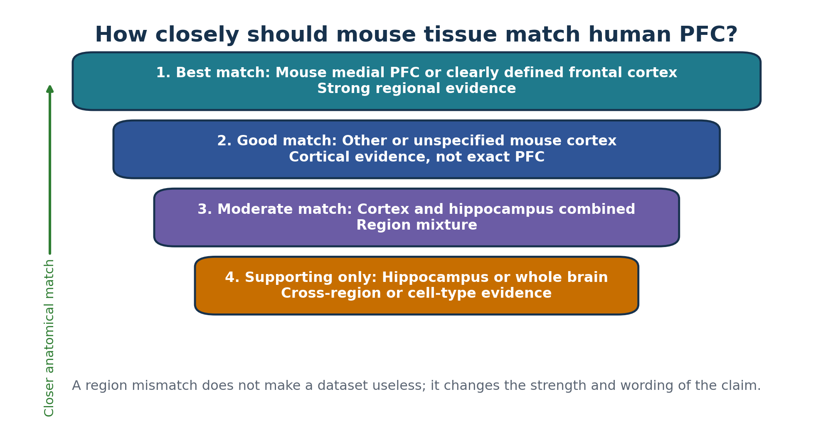
Figure 2. A practical hierarchy for matching mouse tissue to human PFC.
- For neuronal results, region matching is especially important.
- For microglial and astrocyte pathways, cross-region evidence may still be useful.
- A negative hippocampal result does not automatically disprove a human PFC result.
- An unspecified cortex dataset supports a cortical claim but not an exact PFC claim.

6. Why one dataset is not enough
Imagine trying to solve a puzzle with three missing pieces: one piece tells you whether the tissue region matches, one tells you which cell type carries the signal, and one tells you whether APOE, sex, and disease interact. No current public dataset supplies every piece at once.
Dataset | Question it answers best | Question it cannot answer alone
GSE241553 | Does APOE3 versus APOE4 behave differently in female and male cortical cells under amyloid? | What is the AD-versus-non-AD effect?
GSE185063 | Which cortical cell types show APOE3/APOE4 differences, and do they change with age? | Is the effect specific to an AD background?
GSE163857 | Does the APOE effect during disease differ by sex in microglia? | Is the effect specific to PFC or another cortical region?

Triangulation
Triangulation means using different studies to test different parts of the same claim. Agreement across studies is convincing because the same conclusion survives different mouse models, laboratories, and measurement methods.

7. The most important statistics concept: the mouse is the replicate
A biological replicate is an independently studied organism. If one mouse contributes 3,000 microglial cells, those cells share the same genetics, sex, age, environment, and disease status. They are repeated measurements of one mouse, not 3,000 independent mice.
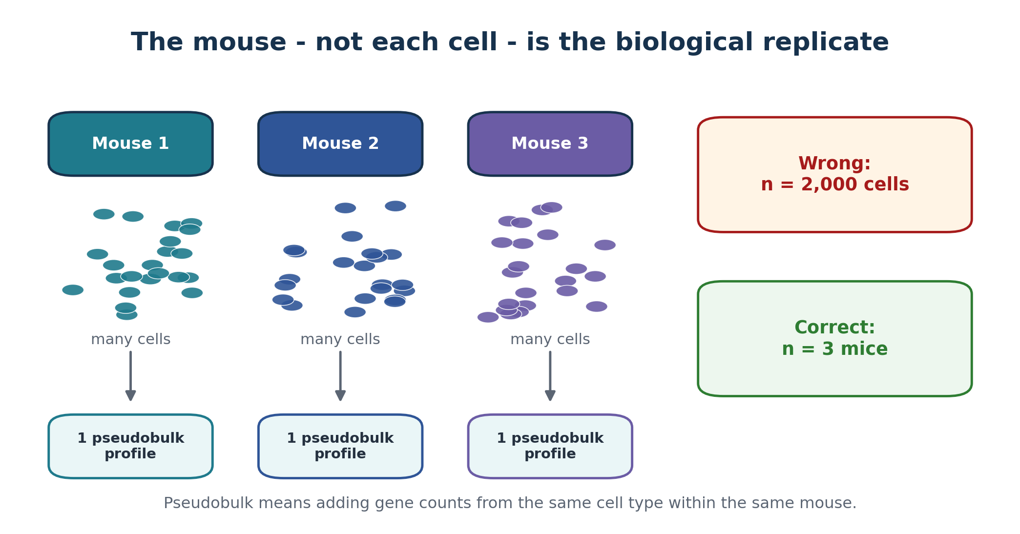
Figure 3. Many cells from one mouse become one mouse-level pseudobulk profile.
Pseudobulk analysis adds the gene counts from all cells of one cell type within one mouse. For example, all microglia from Mouse 1 become one microglial count profile; all microglia from Mouse 2 become a second profile; and so on.
Pseudoreplication warning
Pseudoreplication means pretending repeated measurements from the same subject are independent subjects. Treating 20,000 nuclei as n = 20,000 would make uncertainty look far smaller than it really is.

8. What is an interaction?
An interaction means the effect of one factor depends on another factor. Suppose APOE4 lowers a mitochondrial gene score by 1.0 unit in females but only 0.2 unit in males. The APOE effect is different by sex, so there is an APOE-by-sex interaction.
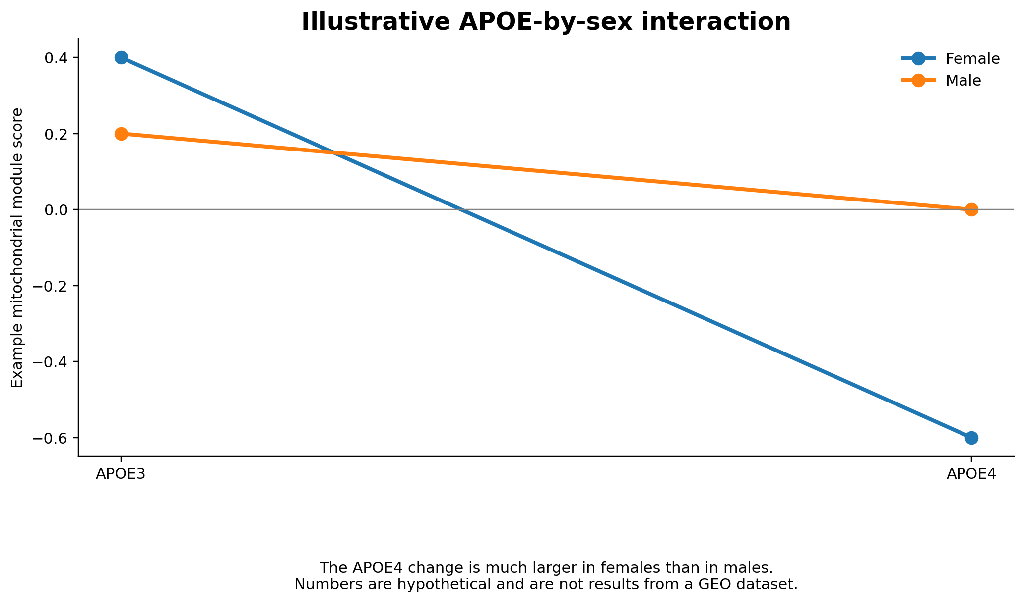
Figure 4. Hypothetical example of an APOE-by-sex interaction.
Term | Question
APOE main effect | On average, is APOE4 different from APOE3?
Sex main effect | On average, are female and male mice different?
Disease main effect | On average, is the AD model different from control?
APOE x sex | Is the APOE4 effect different in females and males?
APOE x disease | Is the APOE4 effect different in AD and control backgrounds?
Sex x disease | Is the disease effect different in females and males?
APOE x sex x disease | Does the disease-related APOE4 effect differ between females and males?

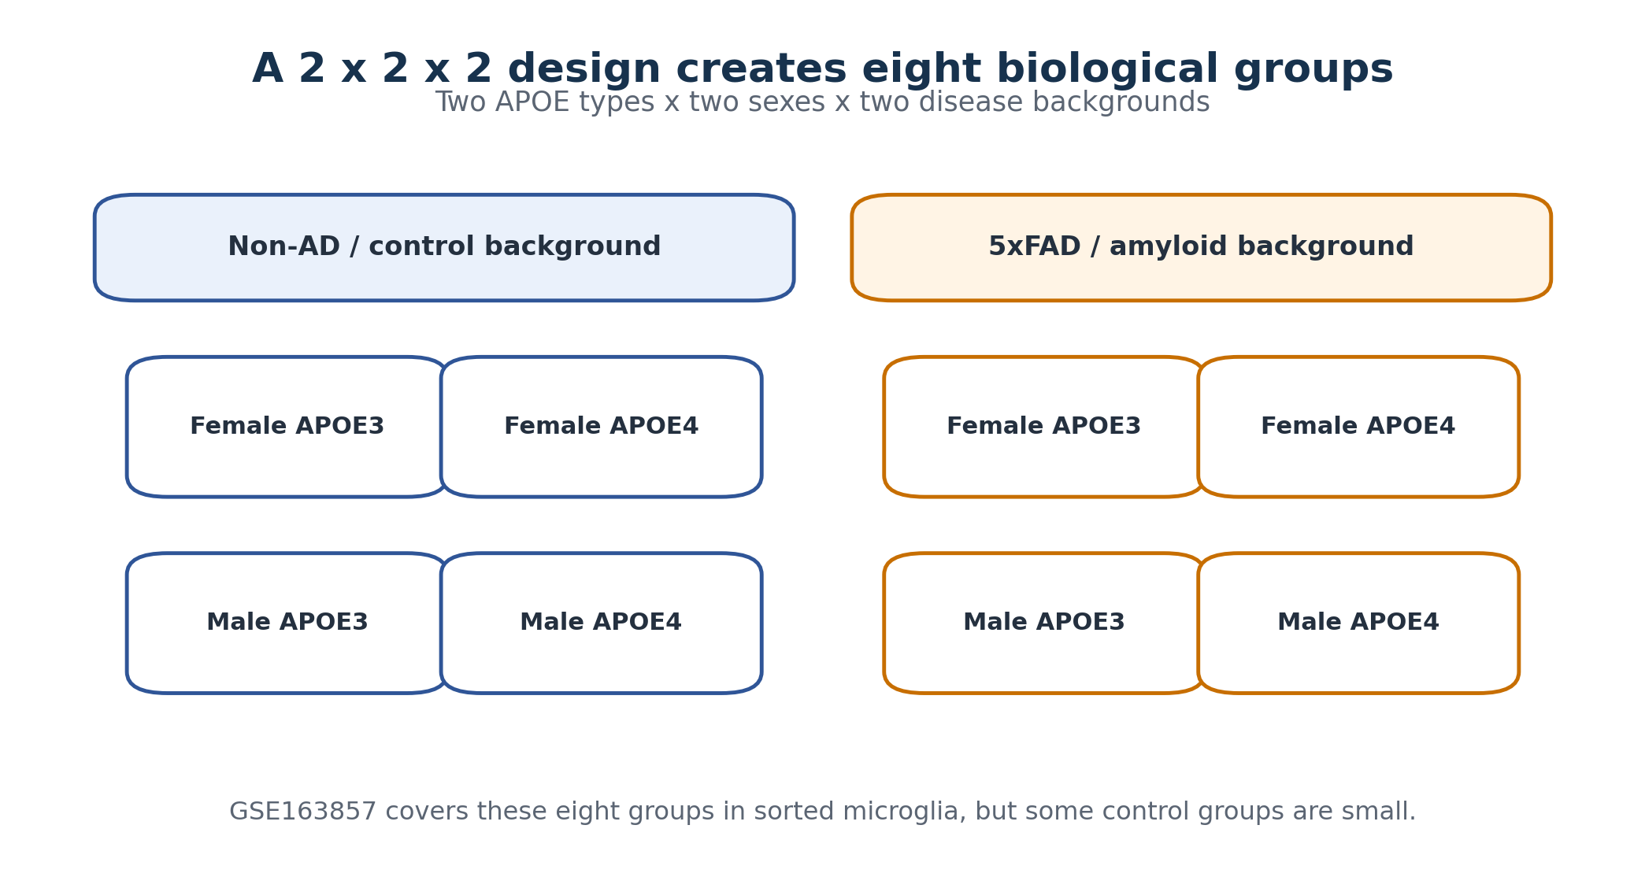
Figure 5. A complete APOE3/4 x sex x disease experiment contains eight groups.

9. Before touching the mouse data

9.1 Freeze the human result
Write down the human PFC result before checking the mouse studies. This prevents cherry-picking, which means changing the question after seeing which mouse result looks favorable.
Human result item | Example
Cell type | Microglia
Human contrast | Female APOE4 AD versus female APOE3 AD
Gene module | Oxidative phosphorylation genes
Expected direction | Lower in APOE4
Primary outcome | Mouse ortholog module score
Secondary outcomes | Individual genes and pathway enrichment

9.2 Convert human genes to mouse orthologs
An ortholog is the corresponding version of a gene in another species. Human gene names are usually uppercase, such as APOE, while mouse gene names often use only the first letter uppercase, such as Apoe. Some genes have one clear match; others have multiple or no simple matches.
- Start with the fixed human gene list.
- Use a trusted ortholog database such as Ensembl BioMart.
- Prefer one-to-one human-mouse matches for the primary analysis.
- Save a table with the human gene, mouse gene, mapping type, and reason for any exclusion.
- Use exactly the same mapping in every mouse dataset.

9.3 Build a metadata audit table
Metadata are facts describing each sample. You should not begin statistical testing until every row has been checked.
sample_id | mouse_id | sex | APOE | disease | age | region | cell type | pooled? | batch
MiE-01 | M01 | F | E3 | amyloid | study age | cortex | microglia | No | B1
MiE-02 | M02 | M | E4 | amyloid | study age | cortex | microglia | No | B1

Go/no-go checkpoint
If you cannot identify mouse ID or cannot determine whether animals were pooled, stop and resolve the metadata before treating samples as independent replicates.

10. Core dataset tutorial 1: GSE241553
Best role: primary cortical APOE-by-sex analysis under amyloid pathology.
Feature | What GSE241553 provides
Tissue | Mouse cortex
Method | Single-cell RNA-seq
Mice | 24 total; 6 per group; 3 female and 3 male per group
APOE design | Control versus induced APOE3 or APOE4 expression in microglia/CAMs
Disease context | All groups are in an amyloid-model setting
Best cell types | Microglia and CNS-associated macrophages; other cortical cells can be examined as downstream responders

10.1 Recommended first comparison
Use only the induced APOE3 and induced APOE4 groups for the first confirmatory analysis. This makes the biological contrast easy to explain.
For each mouse and cell type:
sum cell counts -> one pseudobulk profile
Fit:
expression_or_module_score ~ APOE * sex

10.2 Hypothetical example
Group | Mean module score | Interpretation
Female APOE3 | 0.40 | Reference female group
Female APOE4 | -0.60 | Large APOE4-associated decrease
Male APOE3 | 0.20 | Reference male group
Male APOE4 | 0.00 | Small APOE4-associated decrease

In this imaginary example, the APOE4 change is -1.00 in females but -0.20 in males. That difference between differences is the interaction. Real conclusions must use actual mouse-level data and uncertainty estimates.

10.3 What you may conclude
Safe wording
The human PFC module showed a concordant APOE-by-sex pattern in mouse cortical cells under amyloid pathology.

Unsafe wording
The full APOE-by-sex-by-AD interaction was replicated in mouse PFC. This is unsupported because there is no non-AD group and the tissue is cortex, not explicitly PFC.

11. Core dataset tutorial 2: GSE185063
Best role: determine which cortical cell types carry an APOE-related human PFC signal.
Feature | What GSE185063 provides
Tissue | Right cortical mantle after removal of hippocampus and visible white matter
Method | Single-nucleus RNA-seq
Samples | 16 cortical samples
Groups | APOE3 and APOE4; 2-3 months and 9-12 months; four mice per genotype-age group
Cell types | Excitatory and inhibitory neurons, oligodendrocytes/OPCs, astrocytes, microglia, endothelial cells, pericytes and other vascular cells
Main gap | No AD-model background; individual sex assignments require careful verification

11.1 Recommended analysis
For each cell type:
expression_or_module_score ~ APOE * age
Run the same frozen mouse-ortholog module in each major cell type. A heatmap can show whether the module is altered in microglia only, in several glial types, in neurons, or in vascular cells.
Human PFC cell type | Mouse comparison
Excitatory neuron | Mouse cortical excitatory neurons, ideally matched at a broad subclass level
Inhibitory neuron | Mouse cortical inhibitory neurons
Microglia | Mouse cortical microglia
Astrocyte | Mouse cortical astrocytes
Oligodendrocyte / OPC | The corresponding mouse cortical population
Endothelial / pericyte | The corresponding cortical vascular population

Only add sex to the model after the sample-level sex key is confirmed. A study can state that both sexes were used while still lacking a public map that tells you which accession came from which sex.

12. Core dataset tutorial 3: GSE163857
Best role: direct testing of APOE-by-sex-by-disease interactions in microglia.
Feature | What GSE163857 provides
Tissue / cells | Sorted brain microglia
Method | Bulk RNA-seq
APOE | Human APOE3 or APOE4 targeted replacement
Sex | Female and male
Disease background | Control or 5xFAD
Main gap | Not cortex-specific; no broad cell-type information; control groups are small and imbalanced

expression_or_module_score ~ sex * APOE * disease
The three-way interaction asks whether the disease-related APOE4 effect differs by sex. Because several control cells contain only about one to three mice, a large estimated effect may still have a wide confidence interval.

12.1 Use both the full model and simpler contrasts
- Female 5xFAD: APOE4 versus APOE3.
- Male 5xFAD: APOE4 versus APOE3.
- Female APOE4: 5xFAD versus control.
- Male APOE4: 5xFAD versus control.
- Optionally repeat these contrasts for the full gene module and for a few pre-specified genes.
Effect size
An effect size tells you how large a difference is. A confidence interval shows the plausible uncertainty around that estimate. These are especially important when sample sizes are small.

13. When to use the optional datasets
Dataset | Use it when... | Treat it as...
GSE140399 | You need cortical AD-versus-control direction or TREM2-related glial states | Descriptive support because three mice were pooled per genotype
GSE140510 | You want independent 7-month mouse replicates for AD-versus-control direction | Replicated disease support, but not cortex-specific
GSE143758 | You study astrocytes, aging, disease-associated astrocytes, or cross-region consistency | Secondary hippocampal/cross-region support; tiny cortical astrocyte subset is descriptive
GSE225503 | Your hypothesis includes APOE2, very old mice, microglial exhaustion, or immune aging | Specialized 5xFAD immune-cell evidence; not an AD-versus-control study

A useful rule is to add an optional dataset only when it answers a clearly written question that the core three cannot answer. More datasets do not automatically make a project better; they can also add inconsistent models, ages, regions, and technical differences.

14. Combining evidence without combining raw matrices
Each GEO study was generated in a different laboratory, with different mouse ages, tissue preparation, sequencing method, and disease model. If you merge all raw counts and apply batch correction, study identity may become inseparable from biological factors. Instead, analyze each study independently.
1. Calculate the same pre-specified module score or gene effect in each study.
2. Keep the relevant cell type separate.
3. Record the effect direction: up, down, opposite, or not testable.
4. Record the effect size and uncertainty when replicate-aware statistics are possible.
5. Summarize the evidence in a concordance table, heatmap, or forest plot.
Human prediction | GSE241553 | GSE185063 | GSE163857 | Overall
Female APOE4 microglial mitochondrial module is lower | Same direction | Same direction in cortical microglia | Same direction in female 5xFAD microglia | Strong convergent support
APOE4 astrocyte stress module is higher | Not the primary test | Same direction in cortical astrocytes | Astrocytes not measured | Moderate cortical support
AD lowers excitatory-neuron respiration | No AD control | No AD background | Microglia only | Not resolved by core package

The table above is an illustration of how to organize results. It is not a report of actual findings.
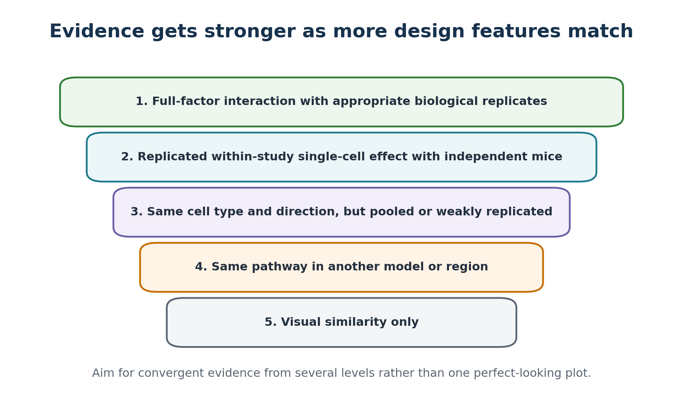
Figure 6. A simple evidence hierarchy for interpreting cross-study agreement.

15. Recommended figures for the final project
Figure | What it shows | Beginner interpretation
Dataset coverage matrix | Which dataset contains cortex, APOE, sex, disease, cell types, and independent mice | Why multiple studies are needed
Forest plot | Effect size and confidence interval from each study or contrast | Whether studies agree in direction and how uncertain they are
Cell-type heatmap | Module effect across cell types in GSE185063 | Where in the cortex the signal is located
Interaction plot | APOE3 and APOE4 scores separated by sex | Whether APOE behaves differently in females and males
Concordance table | Same/opposite/not-testable results across datasets | Overall strength and limitations of validation

16. Common mistakes and how to avoid them
Mistake | Why it is a problem | Better practice
Counting cells as independent mice | Greatly exaggerates sample size | Use mouse-level pseudobulk or an appropriate mixed model
Calling hippocampus a PFC replication | The regions are biologically different | Call it cross-region pathway support
Merging all GEO matrices | Study and biology can be confounded | Analyze separately and compare effects
Guessing missing sex labels | Can reverse or invent an interaction | Request or verify the sample key
Changing the gene list after seeing results | Creates cherry-picking bias | Freeze the human module first
Using only p-values | Small studies may be underpowered; huge cell counts can mislead | Report effect sizes, confidence intervals, and replicate counts
Treating every mouse AD model as equivalent | Amyloid, tau, aging, and immune models capture different biology | Describe the model and limit the claim

17. A practical project checklist
[ ] Write the exact human PFC claim and cell type.
[ ] Freeze the human gene module and expected direction.
[ ] Create a human-to-mouse ortholog table.
[ ] Download and audit metadata for the three core datasets.
[ ] Verify mouse ID, sex, APOE, disease, age, region, pooling, and batch.
[ ] Perform QC without removing a biological group disproportionately.
[ ] Create mouse-by-cell-type pseudobulk profiles for GSE241553 and GSE185063.
[ ] Fit the APOE-by-sex model in GSE241553.
[ ] Fit the APOE-by-age model in GSE185063; add sex only after verification.
[ ] Fit the APOE-by-sex-by-disease model and planned contrasts in GSE163857.
[ ] Add optional datasets only for a pre-defined unresolved question.
[ ] Prepare an effect-direction concordance table.
[ ] Use wording that matches tissue region and evidence strength.
[ ] Save scripts, metadata tables, software environment, and final figures.

18. What would a definitive new mouse experiment look like?
Public data cannot provide a complete region-matched test. A definitive study would collect frontal or medial PFC from mice in all eight APOE, sex, and disease combinations.
Design element | Recommended starting point
APOE | Humanized APOE3 and APOE4
Sex | Female and male
Disease | AD model and matched non-AD control
Groups | 2 x 2 x 2 = 8 groups
Region | Clearly defined frontal or medial PFC
Replicates | About 6-8 independent mice per group as a planning target, followed by formal power analysis
Assay | snRNA-seq with one independent library per mouse
Batch control | Randomize all groups across dissection, nuclei isolation, library preparation, and sequencing
Additional validation | Retain adjacent tissue for plaques, protein, histology, or other pathology measures

Six to eight mice across eight groups means roughly 48-64 mice before allowing for sample loss or quality-control failure. This number is a planning range, not a substitute for a power calculation.

19. Glossary
Word | Meaning
Batch | A group of samples processed together. Batch differences can look like biology if groups are not randomized.
Cell state | A temporary or disease-related condition within a cell type, such as a reactive astrocyte.
Confidence interval | A range showing uncertainty around an estimated effect.
Contrast | A specific comparison, such as female APOE4 5xFAD versus female APOE3 5xFAD.
Differential expression | Testing whether a gene has different expression between groups.
Effect direction | Whether a gene or module is higher or lower in one group.
Effect size | How large a biological difference is.
Factor | An experimental variable such as APOE, sex, disease, age, or brain region.
Gene module | A pre-defined group of genes analyzed together because they represent a process or pattern.
GEO | NCBI Gene Expression Omnibus, a public repository for gene-expression studies.
Interaction | A situation where the effect of one factor depends on another factor.
Metadata | Information describing samples, such as mouse ID, sex, age, genotype, and tissue.
Ortholog | A corresponding gene in another species.
Pathway | A collection of genes and proteins that work together in a biological process.
Pseudobulk | Counts from cells of the same type and mouse added together into one mouse-level profile.
Pseudoreplication | Incorrectly treating repeated measurements from one subject as independent subjects.
Replicate | An independently studied biological subject, usually one mouse in this project.
UMAP | A two-dimensional map often used to visualize groups of single cells; nearby cells have similar expression profiles.

Sources and verification links
1. GEO: GSE241553: https://www.ncbi.nlm.nih.gov/geo/query/acc.cgi?acc=GSE241553
2. GEO: GSE185063: https://www.ncbi.nlm.nih.gov/geo/query/acc.cgi?acc=GSE185063
3. Barisano et al., JEM 2022 methods and cortical snRNA-seq: https://doi.org/10.1084/jem.20221137
4. GEO: GSE163857: https://www.ncbi.nlm.nih.gov/geo/query/acc.cgi?acc=GSE163857
5. GEO: GSE140399: https://www.ncbi.nlm.nih.gov/geo/query/acc.cgi?acc=GSE140399
6. GEO: GSE140510: https://www.ncbi.nlm.nih.gov/geo/query/acc.cgi?acc=GSE140510
7. GEO: GSE143758: https://www.ncbi.nlm.nih.gov/geo/query/acc.cgi?acc=GSE143758
8. GEO: GSE225503: https://www.ncbi.nlm.nih.gov/geo/query/acc.cgi?acc=GSE225503
9. Zhou et al., Nature Medicine 2020: https://pubmed.ncbi.nlm.nih.gov/31932797/
Teaching note: all numerical examples labeled hypothetical or illustrative were created only to explain analysis concepts. They must not be cited as results.

