EdgeMix-ATAC
A tutorial for boundary-aware deconvolution of spatial ATAC-seq
How to borrow information from neighboring spots without blurring real tissue borders

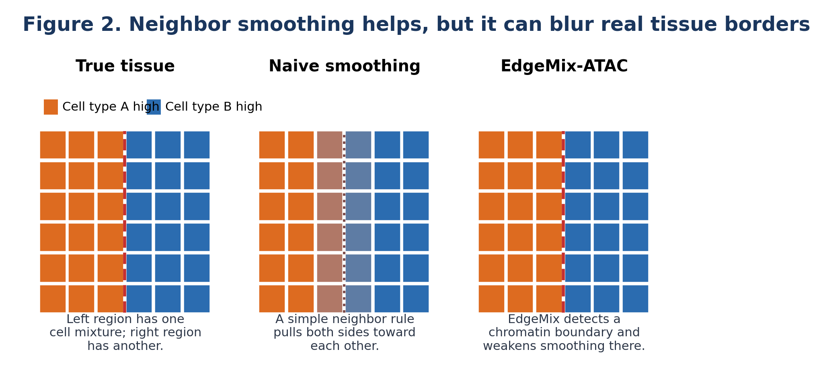
Audience: high-school biology background + curiosity about computational biology
Status: research proposal, not yet a validated software package

1. The big idea in plain English
One-sentence version
EdgeMix-ATAC estimates which cell types are inside each spatial ATAC spot, while using chromatin-defined boundaries to decide when neighboring spots should or should not be allowed to influence one another.
Imagine a tissue section as a map made of many tiny squares. Each square is a spatial spot. In spatial ATAC-seq, each spot reports DNA accessibility fragments from whatever nuclei happen to be inside that spot. If the spot contains several cells, the measured signal is a mixture. Deconvolution is the computational task of unmixing that signal.
Many methods estimate each spot mostly from its own counts, or they smooth across nearby spots because nearby tissue locations are often similar. The problem is that real tissues also have borders: cortex layers, tumor-normal margins, lymphoid follicles, developing organs, and injury zones. Smoothing across those borders can create false mixtures.
EdgeMix-ATAC is built around one rule:
Rule of EdgeMix
Borrow information from nearby spots when chromatin says they are similar. Stop borrowing when chromatin says there is a boundary.
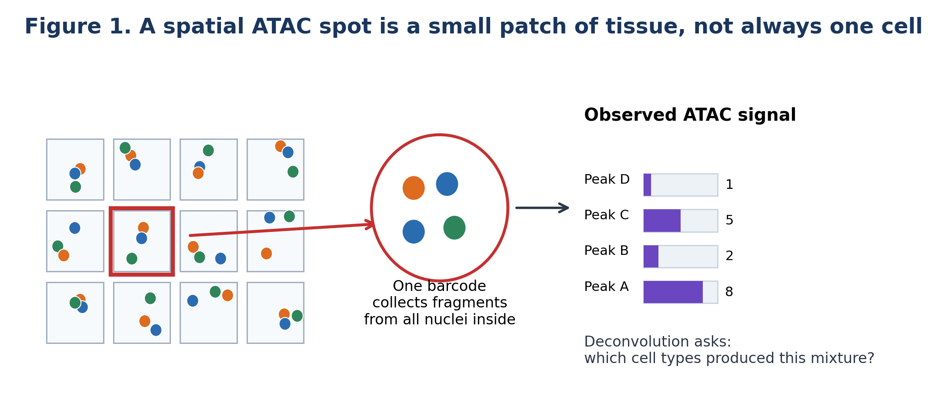
Figure 1. A spot can contain several cells, so its ATAC peak counts are a mixture. EdgeMix-ATAC tries to explain that mixture using cell-type-specific accessibility signatures from a reference dataset.

2. Background: what problem are we solving?

2.1 What is ATAC-seq?
ATAC-seq is a method for measuring open chromatin. Chromatin is DNA wrapped around proteins. Some regions are tightly packed and hard for proteins to reach. Other regions are open and accessible. Open regions often include promoters, enhancers, and transcription-factor binding sites. ATAC-seq uses an enzyme called Tn5 to cut and tag open regions, producing DNA fragments that can be sequenced.
Spatial ATAC-seq keeps track of where those fragments came from in the tissue. The spatial-ATAC-seq workflow from Deng et al. used in situ Tn5 transposition and spatial barcoding to create a tissue mosaic of spatially indexed chromatin accessibility measurements. Their paper also notes that spatial-ATAC-seq pixels can contain more than one nucleus depending on pixel size and tissue type. This is exactly why deconvolution is needed.
Important ATAC-native clue
ATAC data are not just gene-expression data with different feature names. ATAC has peaks, fragment-length patterns, TSS enrichment, motif accessibility, enhancer accessibility, and strong sparsity.

2.2 What is deconvolution?
Suppose a spot contains 40% B cells, 40% T cells, and 20% macrophages. The ATAC signal is a mixture of accessibility patterns from those cell types. A deconvolution method tries to recover the hidden recipe: how much of each cell type is present.
Question | Everyday analogy | Spatial ATAC meaning
What was mixed? | Several paint colors in one cup. | Fragments from several cell types in one spot.
What do we know? | The color of the final mixture and examples of pure colors. | Spot peak counts and reference scATAC profiles.
What do we estimate? | The amount of each paint color. | The proportion or abundance of each cell type.
What can go wrong? | Two nearby cups are from different paintings. | Two adjacent spots may be separated by a tissue boundary.

2.3 Why spatial ATAC is hard
- One spot may contain several nuclei, so the measurement is mixed.
- ATAC features are chromatin peaks, and there can be more than 100,000 of them.
- Most peak counts are zero or low, so the data are sparse.
- Nearby spots are often similar, but not always.
- The most dangerous mistakes happen near tissue borders, where two regions touch.

2.4 Why this is a good time for a new method
The deconvATAC benchmark showed that spatial transcriptomics deconvolution methods such as Cell2location and RCTD can be applied to spatial chromatin accessibility data, but it also emphasized that the field still lacks mature, dedicated spatial ATAC deconvolution methods. The benchmark also found that feature choice matters strongly for ATAC, with highly variable peaks outperforming highly accessible peaks. EdgeMix-ATAC is meant to be an ATAC-native answer to a specific gap: spatial smoothing that respects chromatin boundaries.

3. The core problem: helpful neighbors versus dangerous neighbors
In tissue, cells are organized. If one spot is in a B-cell follicle, nearby spots are likely to also contain many B cells. If one spot is in a cortex layer, nearby spots often share the same layer identity. That means neighboring spots can help reduce noise.
But the same idea can fail at a boundary. A spot just inside a tumor and a spot just outside the tumor may be physically close, but biologically different. If a model blindly smooths them together, tumor signal can leak into normal tissue, or normal signal can leak into tumor tissue.

Figure 2. Naive smoothing reduces noise but can blur a real border. EdgeMix-ATAC tries to keep the good part of smoothing while avoiding cross-boundary leakage.
The key challenge
We want to use spatial information, but we do not want to erase biology. The model should smooth within tissue regions and stop at boundaries.

4. What the name EdgeMix-ATAC means
Part of name | Meaning
Edge | The model builds a graph connecting neighboring spots. Each connection is an edge. It also learns tissue edges, meaning borders between regions.
Mix | Each spot is a mixture of cell types. The model estimates that mixture.
ATAC | The model uses chromatin accessibility features: peaks, motifs, topics, gene-activity scores, and ATAC count behavior.
A graph is just a network. In EdgeMix-ATAC, each spot is a node, and neighboring spots are connected by edges. A strong edge means: these two spots are similar, so they can help each other. A weak edge means: be careful; this may be a boundary.
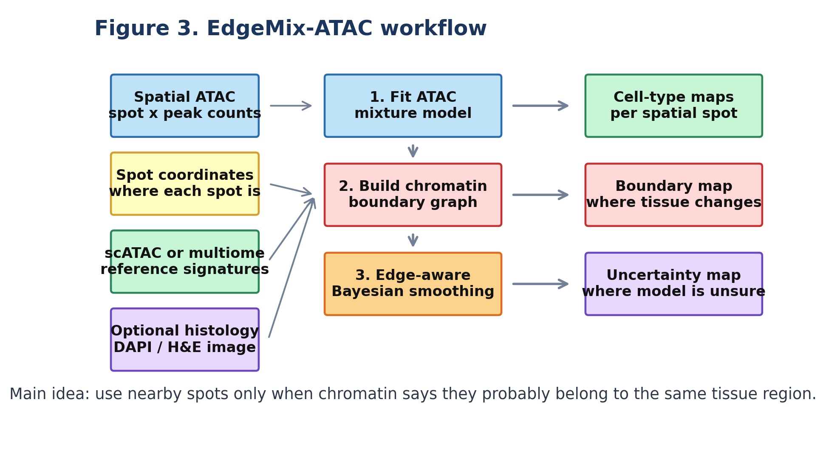
Figure 3. EdgeMix-ATAC combines a count model, a chromatin boundary graph, and an edge-aware spatial prior to produce cell-type maps and boundary maps.

5. Inputs and outputs

5.1 Inputs
1. Spatial ATAC count matrix Y: rows are spatial spots, columns are peaks or regulatory features.
2. Coordinates for each spot: x-y positions on the tissue section.
3. Reference profiles from scATAC or multiome: expected accessibility for each cell type.
4. Optional image information: DAPI, H&E, or tissue masks that may help identify boundaries.
5. Optional regulatory feature matrix: motif activities, topic scores, gene activity, or peak-to-gene modules.

5.2 Outputs
1. Cell-type abundance or proportion for every spot.
2. Boundary map showing where chromatin changes sharply.
3. Uncertainty map showing where the model is confident or unsure.
4. Quality-control diagnostics such as boundary leakage and posterior predictive checks.
5. Optional cell-type-specific reconstructed accessibility profiles in each spot.

6. Model Part A: the ATAC count mixture
The first part of EdgeMix-ATAC is a standard mixture idea. For each spot and each peak, the model predicts the expected number of fragments from the cell types in the spot.
Plain English model
Observed peak count = sequencing depth x peak detectability x mixture of cell-type accessibility profiles + noise
A simple version is:
y[s,p] ~ NegativeBinomial(mean = depth[s] * bias[p] * sum_c a[s,c] * theta[c,p], dispersion[p])
where:
- y[s,p] is the observed fragment count in spot s at peak p.
- a[s,c] is the amount of cell type c in spot s. This is what we want to estimate.
- theta[c,p] is the expected accessibility of peak p in cell type c, learned from the reference.
- depth[s] corrects for the fact that some spots have more total fragments than others.
- bias[p] corrects for peak-specific detectability, such as peak width, GC content, mappability, or Tn5 bias.
- NegativeBinomial is a flexible count distribution. A simpler first prototype could use Poisson.

6.1 Toy numerical example
Suppose we only study one peak. In the reference, this peak is very open in B cells and mostly closed in T cells:
Cell type | Reference accessibility at peak P | Meaning
B cell | 0.9 | Peak P is usually open
T cell | 0.1 | Peak P is usually closed
Now a spatial spot has a high count at peak P. The model will think: this spot probably has more B-cell signal than T-cell signal. With thousands of peaks, the model combines all pieces of evidence.

6.2 Why peak weights help
Some peaks are useful for cell-type deconvolution. Others are open in almost every cell type and mostly tell us sequencing depth, not identity. EdgeMix can include a peak usefulness weight v[p], so cell-type-informative peaks matter more than generic peaks.
weighted log-likelihood = sum over spots and peaks of v[p] * log Pr(y[s,p] | model)
A practical first version can use highly variable peaks, marker peaks, or motif-linked peaks. A more advanced version can learn v[p] during model fitting.

7. Model Part B: the chromatin boundary graph
This is the part that makes EdgeMix special. We first connect nearby spots into a graph. Then we decide how strong each connection should be. A strong connection means the spots are probably in the same tissue region. A weak connection means they are probably separated by a boundary.
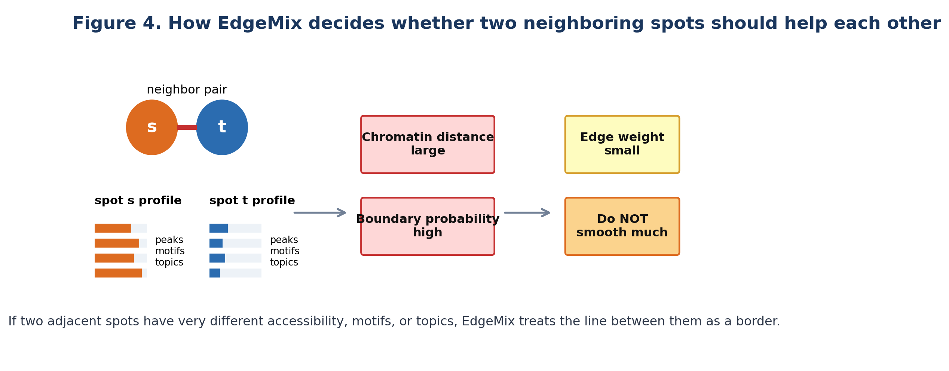
Figure 4. EdgeMix uses ATAC-derived similarity to decide whether neighboring spots should share information.

7.1 What information can define an ATAC boundary?
- Peak-count similarity: do the two spots have similar accessibility at important peaks?
- Motif similarity: do they show similar transcription-factor motif activity?
- Topic similarity: do they share the same co-accessible regulatory programs?
- Gene activity similarity: do nearby gene-linked accessibility profiles agree?
- Histology or DAPI boundary evidence, if available.
- Spatial distance: very far spots should not smooth each other even if they look similar.

7.2 A simple edge-weight formula
Let Z[s] be a compact ATAC feature vector for spot s. Z can contain LSI components, motif activities, topic scores, or selected peak scores. For neighboring spots s and t:
chromatin_distance[s,t] = distance between Z[s] and Z[t]
base_weight[s,t] = exp(-physical_distance[s,t] / d0)
edge_weight[s,t] = base_weight[s,t] * exp(-chromatin_distance[s,t] / tau)
If two spots are physically close and chromatin-similar, edge_weight is high. If two spots are physically close but chromatin-different, edge_weight is low.
High-school math intuition
The formula uses two dials. d0 controls how far spatial influence reaches. tau controls how sensitive the model is to chromatin differences. Small tau means even moderate ATAC differences can cut the edge.

8. Model Part C: the edge-aware Bayesian prior
A Bayesian model combines observed evidence with prior beliefs. In EdgeMix-ATAC, the observed evidence is the ATAC count matrix. The prior belief is: neighboring spots should have similar cell-type mixtures, but only when the edge between them is strong.
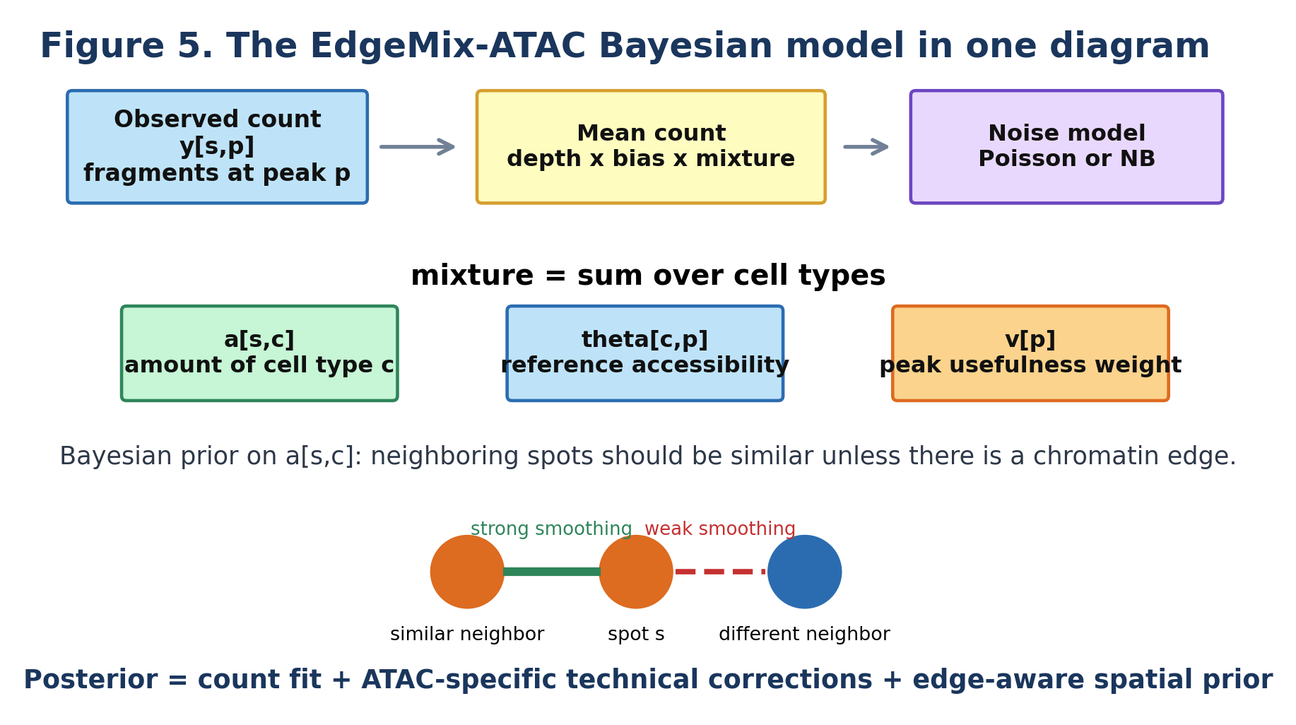
Figure 5. EdgeMix-ATAC can be explained as a count model plus an edge-aware spatial prior.

8.1 The posterior in words
Posterior = data fit + prior
EdgeMix chooses cell-type proportions that explain the ATAC counts and also look spatially reasonable according to the chromatin boundary graph.
A MAP version, which is easier to implement than full Bayesian inference, can optimize this objective:
Objective = ATAC count fit
- lambda * sum over neighbor pairs (s,t) of w[s,t] * difference(a[s], a[t])
The key term is w[s,t]. If w[s,t] is large, EdgeMix strongly encourages neighboring proportions to be similar. If w[s,t] is small, the model allows a sharp change.

8.2 Two possible choices for the spatial prior
Prior type | Plain meaning | When useful
Gaussian graph prior | Neighboring spots should have similar log-proportions. | Smooth tissues with gradual changes.
Total-variation prior | Neighboring spots should be similar, but sharp jumps are allowed. | Layered tissues, tumor margins, follicles, and hard boundaries.
Hybrid prior | Smooth within regions but allow jumps at high-boundary edges. | Recommended default for EdgeMix-ATAC.

8.3 Full generative story
A generative story is a step-by-step story of how the data could have been created. EdgeMix uses this story in reverse to infer the hidden cell-type mixture.
1. For each cell type, learn an accessibility signature from scATAC or multiome reference data.
2. For each spatial spot, choose hidden cell-type abundances.
3. For each pair of neighboring spots, assign an edge weight based on spatial distance and chromatin similarity.
4. For each peak in each spot, generate a fragment count from the mixture of reference signatures, corrected for depth and peak bias.
5. During inference, reverse the story: use observed counts and edge weights to estimate hidden cell-type abundances.

9. Toy example: two tissue regions touching
Imagine a tissue with two regions: region A on the left and region B on the right. Cell type A is common on the left. Cell type B is common on the right. The raw independent estimates are noisy because ATAC counts are sparse.
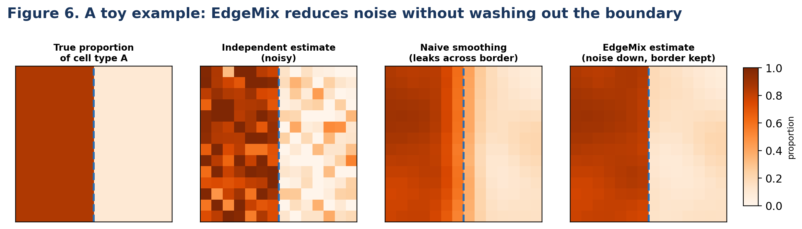
Figure 6. EdgeMix smooths within each region, but weakens smoothing across the boundary.

9.1 What the toy example teaches
- Independent estimation is noisy because each spot has limited fragments.
- Naive smoothing reduces noise but creates fake gradual transitions at hard boundaries.
- EdgeMix can reduce noise while preserving a sharp border.
- This is useful for cortex layers, germinal centers, tumor-normal margins, and developmental zones.

10. Biological examples where EdgeMix should help

10.1 Mouse cortex or hippocampus layers
Brain tissue often has layered structure. Adjacent layers can contain related but distinct neuronal subtypes. A naive spatial prior might blur Layer 2/3 excitatory neurons into Layer 4 or Layer 5. EdgeMix should use chromatin accessibility and motif/topic changes to weaken smoothing across layer boundaries.

10.2 Tonsil: lymphoid follicle versus extrafollicular zone
The spatial-ATAC-seq paper reported spatially distinct immune organization in human tonsil, including lymphoid follicles and extrafollicular zones. This is a natural use case: within a follicle, smoothing is helpful; across the follicle boundary, smoothing could produce false mixed immune compositions.

10.3 Tumor-normal margin
A tumor-normal margin can have abrupt changes in cell type and chromatin state. Naive smoothing can make tumor cells appear outside the tumor, or hide immune cells at the margin. EdgeMix can use chromatin boundary evidence to protect the margin while still denoising within each side.
Best first biological demo
A tissue with known sharp regions is ideal for testing EdgeMix. Good candidates are mouse brain layers, human tonsil follicles, or tumor-normal margins with histology.

11. Step-by-step algorithm
Here is a practical version that could be implemented first.
1. Preprocess spatial ATAC: align fragments, call peaks, make a spot-by-peak count matrix, and compute QC metrics.
2. Select ATAC features: start with highly variable peaks, marker peaks, motif scores, or topic scores.
3. Build reference signatures: aggregate scATAC or multiome cells by cell type to obtain theta[c,p].
4. Initialize cell-type proportions independently for each spot using NNLS, Poisson regression, RCTD-like fitting, or Cell2location-like fitting.
5. Compute compact spot features Z: LSI coordinates, topic scores, motif scores, or selected peak profiles.
6. Build the neighbor graph: connect spots within a small radius or using k-nearest neighbors.
7. Compute edge weights: make weights high for physically close and chromatin-similar spots; make weights low across suspected boundaries.
8. Fit the edge-aware mixture model: optimize cell-type abundances using the count likelihood plus the edge-aware spatial prior.
9. Estimate uncertainty: use posterior samples, variational inference, bootstrap, or local curvature around the MAP solution.
10. Run diagnostics: check boundary leakage, rare-cell false positives, and posterior predictive reconstruction of ATAC counts.

11.1 Pseudocode
Input: Y = spot x peak ATAC counts
X = spot coordinates
R = reference cells with cell-type labels
1. Learn reference signatures theta[c,p] from R
2. Select informative peaks or regulatory features
3. Compute spot feature vectors Z[s]
4. Build neighbor graph G from coordinates X
5. For each edge (s,t) in G:
distance = physical distance between s and t
chromatin_gap = distance between Z[s] and Z[t]
w[s,t] = exp(-distance/d0) * exp(-chromatin_gap/tau)
6. Fit mixture model:
y[s,p] ~ CountDistribution(depth[s] * bias[p] * sum_c a[s,c] * theta[c,p])
spatial prior encourages a[s] similar to a[t] when w[s,t] is large
7. Return cell-type map A, boundary map B, uncertainty map U

12. Three model versions: from simple to advanced
Version | What it includes | Why start here? | Main limitation
V1: EdgeMix-MAP | Poisson or NB count model, fixed peak weights, fixed edge weights, MAP optimization. | Easy to implement and explain. | Uncertainty is approximate.
V2: EdgeMix-Bayes | Full Bayesian priors on proportions, peak weights, edge weights, and uncertainty. | More principled and better uncertainty. | Harder to code and slower.
V3: EdgeMix-State | Adds cell-state or regulatory-program layer: motifs/topics vary by spot and cell type. | More biologically informative. | Needs more data and careful validation.
Recommended prototype
Start with V1. Make it fast, interpretable, and benchmarked against Cell2location and RCTD. Add V2 or V3 only after V1 clearly works.

13. How EdgeMix differs from existing methods
EdgeMix-ATAC should be positioned carefully. It is inspired by spatial deconvolution ideas from RNA methods such as SONAR, Cell2location, RCTD, and SpatialDWLS. The novelty is not simply using neighbors. The novelty is using ATAC-derived chromatin boundaries to control spatial borrowing in a spatial ATAC deconvolution model.
Method family | What it does well | What EdgeMix adds for spatial ATAC
Cell2location / RCTD transfer to ATAC | Strong count-model baselines for deconvolution. | ATAC-native boundary graph and boundary leakage diagnostics.
SONAR for spatial RNA | Spatially weighted modeling and elastic neighbor filtering. | Uses chromatin features, motifs, topics, and peak counts to define boundaries in ATAC.
SpatialDWLS | Simple and fast signature-based deconvolution. | Probabilistic count likelihood plus spatial edge prior.
Generic graph smoothing | Uses coordinates to denoise. | Weakens graph edges specifically where chromatin says the tissue changes.
Domain clustering / spatial ATAC clustering | Finds tissue regions. | Uses region-boundary information inside cell-type deconvolution, not only after clustering.

Careful novelty claim
A defensible claim is: EdgeMix-ATAC is a boundary-aware spatial ATAC deconvolution framework that uses chromatin-derived edge weights to smooth within tissue regions while preserving sharp boundaries. I would avoid claiming that no one has ever used spatial information for deconvolution, because SONAR and CARD already do this in spatial transcriptomics.

14. How to evaluate EdgeMix-ATAC
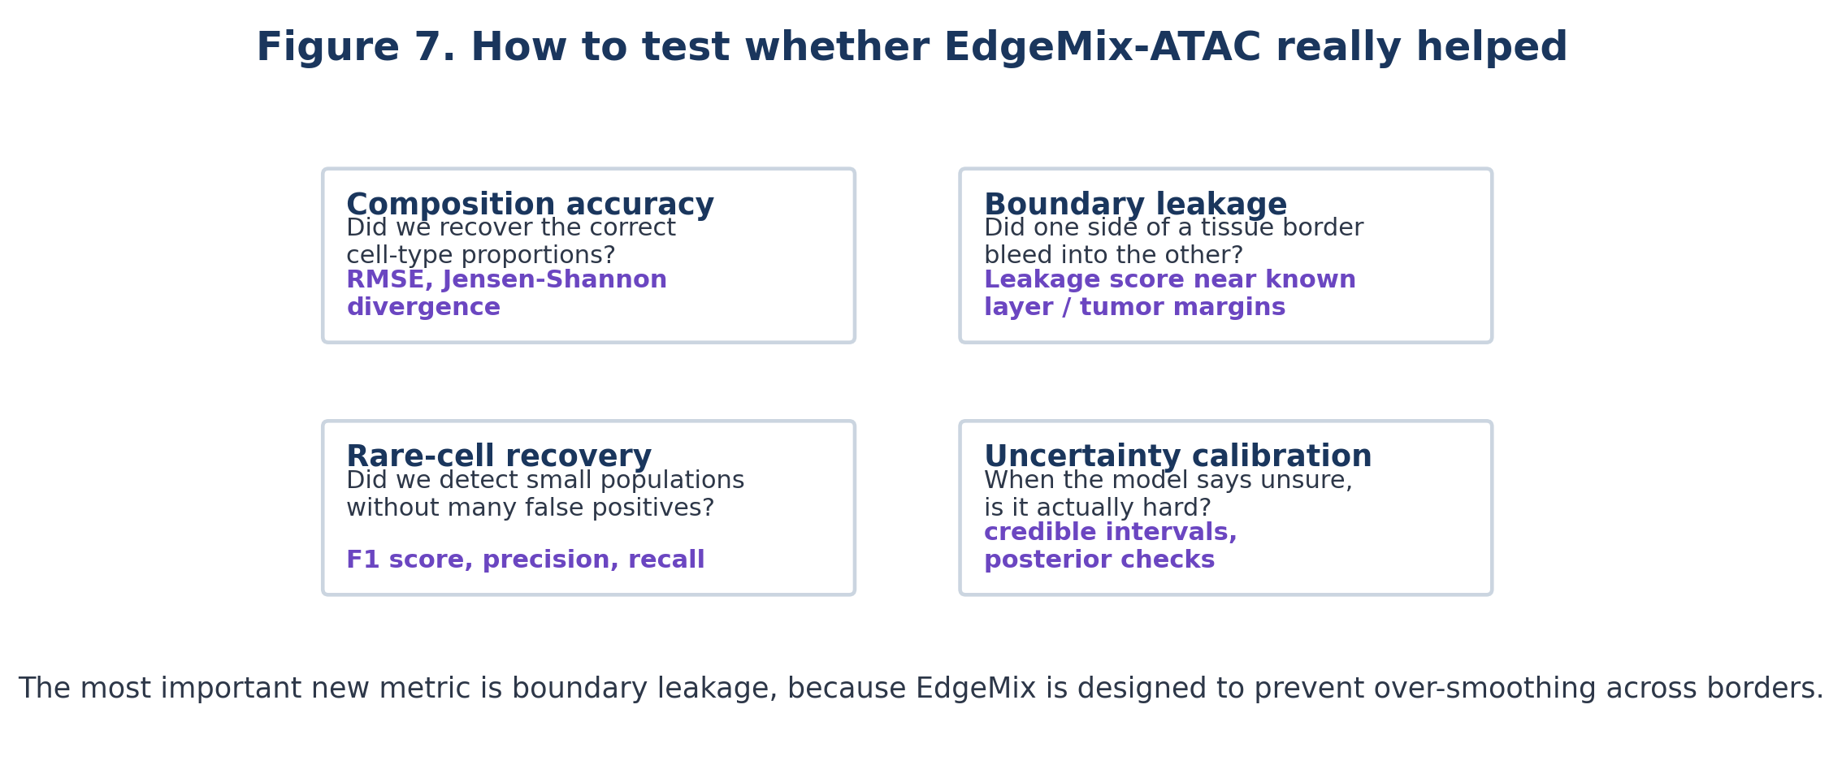
Figure 7. EdgeMix should be evaluated not only by proportion accuracy, but also by whether it avoids boundary leakage.

14.1 Baselines
- Cell2location adapted to spatial ATAC peak counts.
- RCTD adapted to spatial ATAC peak counts.
- SpatialDWLS with TF-IDF/LSI preprocessing.
- Tangram cluster mode if reference and spatial data are well matched.
- A simple independent Poisson or NNLS mixture model without spatial smoothing.
- A naive smoothing version of EdgeMix that ignores chromatin boundaries.

14.2 Datasets
- Simulated spatial ATAC spots from multiome references, using deconvATAC-style simulations.
- Pseudo-spots made by aggregating single-cell or near-single-cell spatial ATAC data.
- Real spatial ATAC tissues with strong known anatomy, such as mouse embryo, mouse brain, human hippocampus, tonsil, or tumor sections.
- Multi-modal spatial datasets where RNA, histology, or proteins provide external validation.

14.3 Metrics
- RMSE or Jensen-Shannon divergence for cell-type proportion accuracy.
- F1 score for rare-cell detection.
- Boundary leakage score for whether cell types are incorrectly smoothed across known borders.
- Spatial autocorrelation within known regions, but without cross-region spillover.
- Posterior predictive checks: can the inferred mixtures reconstruct held-out ATAC peaks?
- Runtime and memory usage.

14.4 Boundary leakage score
Because EdgeMix is designed to protect tissue boundaries, it needs a metric that directly measures boundary mistakes. A simple leakage score can be defined when two regions are known, such as cortex layer A and layer B:
Leakage = average predicted B-type abundance inside region A near the border
+ average predicted A-type abundance inside region B near the border
A lower leakage score is better, as long as true mixed spots are not wrongly suppressed. This metric should be reported alongside standard proportion accuracy.

15. Practical implementation choices

15.1 Feature space for edge detection
Feature space | Good for | Risk | Recommendation
Raw peaks | Maximum detail. | Very sparse and noisy. | Use only selected peaks.
LSI components | Fast compact representation. | May capture technical variation. | Good V1 default.
Motif scores | TF/regulatory interpretation. | Motif databases imperfect. | Great for ATAC-native edges.
Topic scores | Co-accessible programs. | Topic number must be chosen. | Good for robustness.
Gene activity | Easier cross-modal validation. | Less directly ATAC-native. | Useful as secondary evidence.
Histology/DAPI | Physical tissue morphology. | Image artifacts. | Use as optional support, not sole evidence.

15.2 Count distribution
Start simple. Fit Poisson and Negative Binomial versions and compare posterior predictive performance. Poisson is easier and may work surprisingly well for some peak-count settings. Negative Binomial is more flexible when counts are overdispersed.

15.3 Hyperparameters
- lambda controls how strongly neighboring spots are encouraged to agree.
- d0 controls how far spatial smoothing can reach.
- tau controls how quickly smoothing stops as chromatin profiles diverge.
- number of selected peaks affects noise, speed, and rare-cell detection.
- minimum edge weight can prevent total disconnection in very noisy tissues.

16. Common mistakes and how to avoid them
Mistake | How to avoid it
Smoothing across real boundaries. | Use chromatin-derived edge weights and boundary leakage diagnostics.
Using too many peaks. | Start with highly variable or marker peaks; use motif/topic features for edges.
Confusing technical batch effects with tissue boundaries. | Use replicate-aware preprocessing and compare against histology and QC metrics.
Overtrusting the reference. | Include uncertainty and consider an unknown/residual component in later versions.
Calling every gradient a boundary. | Distinguish hard boundaries from gradual developmental trajectories.
Only reporting pretty maps. | Report quantitative benchmarks, held-out peak reconstruction, and uncertainty.

17. Optional extension: EdgeMix with regulatory states
The simplest EdgeMix estimates only cell-type composition. A more advanced version can also estimate cell-type-specific regulatory states. This matters because the same cell type can have different chromatin programs in different tissue niches.
accessibility of cell type c in spot s = baseline cell-type profile + local regulatory programs
Example: a macrophage near a tumor border may have inflammatory enhancer accessibility, while a macrophage farther away may have a different regulatory state. A future EdgeMix-State model could return both:
- cell type proportions: how many macrophages, T cells, tumor cells, etc.
- regulatory programs: which TF motifs or enhancer modules are active in those cells.
- boundary-specific states: which programs change at the tissue edge.

18. Mini exercises to check your understanding
1. A spot is next to another spot, but their motif activity profiles are very different. Should EdgeMix give their edge a high or low weight?
2. Why might naive smoothing make tumor cells appear in normal tissue?
3. Why are highly accessible peaks not always good for deconvolution?
4. What output would tell you the model is unsure near a boundary?
5. Why is spatial ATAC deconvolution different from spatial RNA deconvolution?
Suggested answers
1: Low weight. 2: It averages neighboring compositions across the border. 3: Peaks open in many cell types are not specific. 4: A high-uncertainty map or wide credible interval. 5: ATAC uses sparse chromatin peaks, motifs, enhancer programs, and fragment behavior rather than gene-expression counts.

19. Cheat sheet
Concept | One-line explanation
Deconvolution | Unmixing a spot into cell-type proportions.
Spatial prior | Neighboring spots should often be similar.
Boundary problem | Neighboring spots can be different if they lie across a tissue border.
Edge weight | How much two neighboring spots are allowed to influence each other.
Chromatin edge | A boundary detected from ATAC features such as peaks, motifs, topics, or gene activity.
EdgeMix-ATAC | A spatial ATAC deconvolution model that smooths within regions but protects boundaries.
Best first prototype | Poisson/NB mixture model + fixed ATAC edge weights + MAP optimization.
Most important diagnostic | Boundary leakage score.

20. Source notes and references used for this tutorial
This tutorial is a proposal document. The exact EdgeMix-ATAC method described here has not yet been validated experimentally. The ideas are grounded in the attached literature and should be tested against strong baselines.
- Deng et al., Nature 2022: Spatial profiling of chromatin accessibility in mouse and human tissues. Introduced spatial-ATAC-seq, described the Tn5 spatial barcoding workflow, showed that pixels may contain multiple nuclei, and reported ATAC-specific data quality patterns such as fragment size and TSS enrichment.
- Ouologuem et al., Bioinformatics 2025: Spatial transcriptomics deconvolution methods generalize well to spatial chromatin accessibility data. Benchmarked Cell2location, RCTD, Tangram, SpatialDWLS, and DestVI on spatial ATAC-like data; reported that transferred methods work but ATAC still has gaps, especially for rare cell types and feature selection.
- Liu et al., Nature Communications 2023: SONAR. A spatial transcriptomics method using spatially weighted Poisson-Gamma modeling and elastic weighting to avoid edge effects. EdgeMix borrows the boundary-aware idea but makes the boundary evidence ATAC-native.
- Guo et al., Nature Methods 2025: Spatial-Mux-seq. Demonstrated spatial co-profiling of chromatin accessibility, histone marks, RNA, and proteins, highlighting that chromatin and RNA can reveal complementary spatial information.
- Cell2location, RCTD, SpatialDWLS, Tangram, DestVI papers: Important baseline methods for deconvolution or spatial mapping. EdgeMix should be benchmarked against them rather than replacing them by assumption.

21. Final takeaway
EdgeMix-ATAC in one paragraph
Spatial ATAC spots are noisy mixtures of cell types. Neighboring spots can help, but only when they belong to the same biological region. EdgeMix-ATAC builds an ATAC-derived boundary graph from peaks, motifs, topics, and optional histology, then uses that graph inside a count-based deconvolution model. The result should be cleaner cell-type maps with less false smoothing across tissue borders.
The simplest publishable version is not a giant deep-learning model. It is a clear, explainable probabilistic model: ATAC count mixture + chromatin-derived edge weights + boundary-preserving spatial prior + boundary leakage evaluation.

