HARP-ATAC
A tutorial for a hierarchical Bayesian deconvolution method for spatial ATAC
HARP = Hierarchical Alarm-Regulon Priors

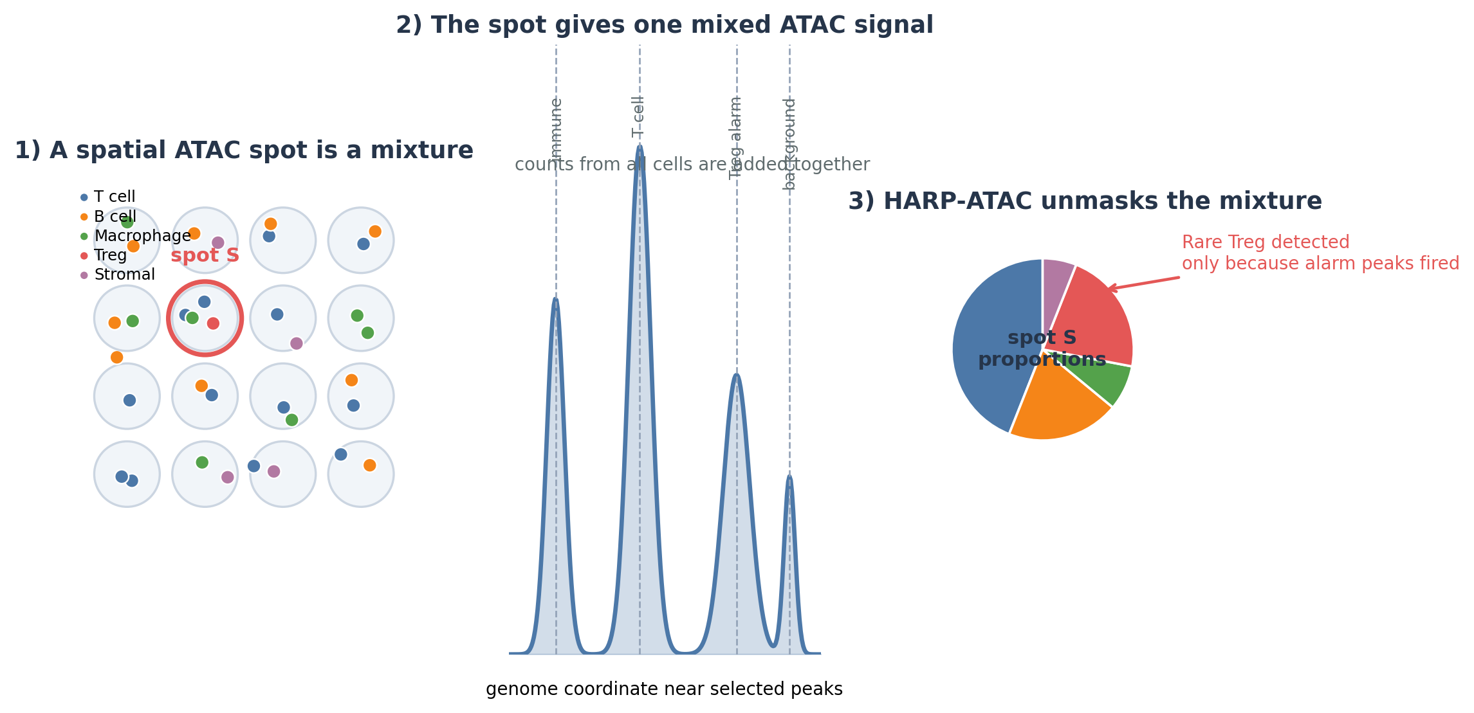
Figure 1. HARP-ATAC turns one mixed spatial ATAC signal into cell-type proportions and rare-cell confidence.
One-sentence idea
HARP-ATAC first asks broad questions, such as “is this spot immune?”, then asks narrower questions, such as “is it T cell?”, and only then tests rare subtypes using special ATAC alarm peaks and motifs.

Audience: written for a motivated high-school student with some biology background.

Road map
1. Why spatial ATAC deconvolution is hard
2. The HARP-ATAC idea in plain English
3. Part 1: the cell-type hierarchy
4. Part 2: chromatin alarms and regulons
5. Part 3: the Bayesian rare-cell gate
6. Part 4: the count model
7. Part 5: spatial support and boundary awareness
8. A full toy example
9. Implementation plan, outputs, validation, and novelty
10. Glossary and sources
How to read this tutorial
Read the story first and do not worry about the equations. The equations are included so the idea can later become a real algorithm. You can understand the main method from the figures and examples.

1. Why spatial ATAC deconvolution is hard
Spatial ATAC-seq measures open chromatin in tissue. Open chromatin means parts of DNA that are physically accessible. These accessible regions often include promoters, enhancers, and other regulatory DNA. In ATAC-seq, an enzyme called Tn5 cuts and tags accessible DNA. Sequencing then tells us where those cuts came from.
The problem is that many spatial ATAC technologies measure a small square or pixel of tissue rather than one single cell. One pixel can contain several nuclei. The measured ATAC fragments are therefore a mixture of signals from multiple cell types.
Smoothie analogy
Imagine blending strawberries, blueberries, and spinach into one smoothie. You can taste the final smoothie, but you do not directly see how much of each ingredient was added. Deconvolution is the computational version of separating the smoothie back into ingredients.

For spatial ATAC, the “ingredients” are cell types, and the “taste” is a vector of chromatin peak counts. A peak is a DNA region with many ATAC fragments. A spot may have thousands of peak counts, but most entries are zero because ATAC data are sparse.

Why ATAC is different from RNA
Question | Spatial RNA | Spatial ATAC
Feature measured | Genes | Chromatin peaks, motifs, and regulatory regions
Biological meaning | How much RNA is present | Whether DNA is open and potentially regulatory
Number of features | Usually thousands of genes | Often tens of thousands to 100,000+ peaks
Sparsity | Sparse | Usually even more sparse
Best opportunity | Cell-type expression signatures | Cell-type chromatin programs, motifs, and enhancer alarms

The main challenge
A normal flat deconvolution method tries to estimate all cell types at once. That can work for abundant cell types. But rare or closely related cell types are harder. A rare Treg cell, for example, may contribute only a small part of the spot signal. If the model is not careful, it may either miss the rare cell or sprinkle tiny false-positive amounts of many rare cell types everywhere.
Key problem HARP-ATAC targets
Rare cell types are hard because their signal is small. Fine subtypes are hard because they may share most of their peaks with related cell types. HARP-ATAC solves this by asking smaller questions and requiring “alarm” evidence before rare subtypes are allowed.

2. The HARP-ATAC idea in plain English
HARP-ATAC stands for Hierarchical Alarm-Regulon Priors. Each word matters:
- Hierarchical: The method uses a cell-type tree. It first separates broad lineages, then finer subtypes.
- Alarm: Rare subtypes need special chromatin evidence before the model says they are present.
- Regulon: Instead of only individual peaks, the method can use motif and regulatory-program features linked to transcription factors.
- Priors: The model uses prior knowledge: rare cells are usually rare, related cell types share chromatin, and neighboring spots often look similar.
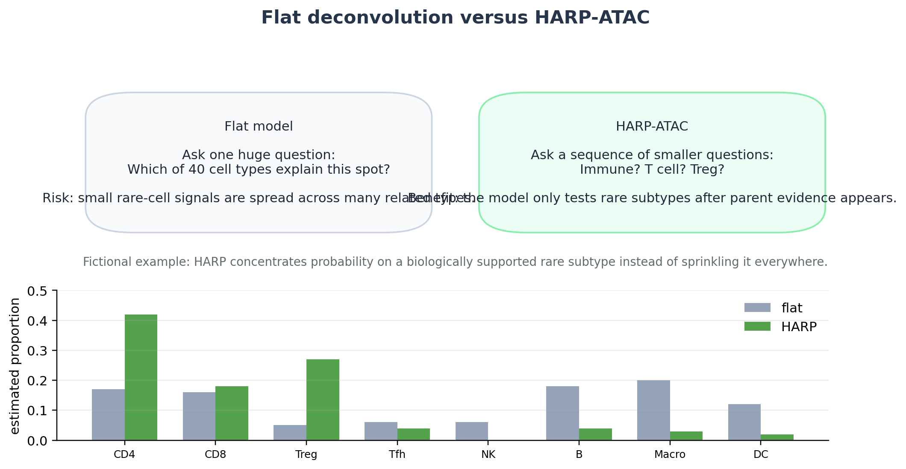
Figure 2. A flat model asks one giant question; HARP-ATAC asks a sequence of smaller, biologically easier questions.
A useful way to think about HARP-ATAC is as a careful detective. It does not immediately accuse every rare cell type. It first asks whether the broader family is present. Only after the family is likely does it inspect specialized clues for the rare subtype.

3. Part 1: the cell-type hierarchy
A hierarchy is a tree. The top of the tree contains all possible nuclei. The next level contains broad lineages, such as immune, epithelial, stromal, and neural. The next level contains smaller groups, such as T cells, B cells, and macrophages. The bottom contains fine subtypes, such as CD4 T, CD8 T, Treg, or T follicular helper cells.
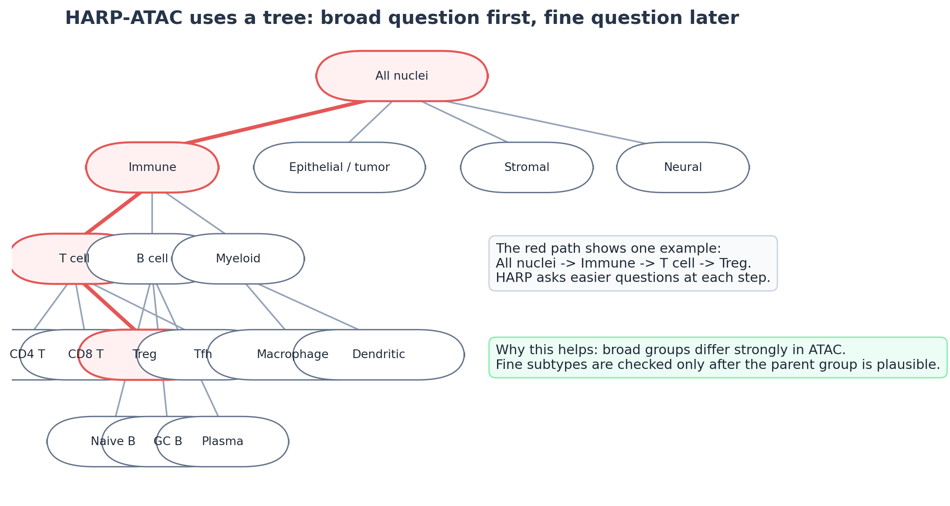
Figure 3. The cell-type hierarchy lets HARP-ATAC decompose a hard problem into easier branch-level questions.
The key advantage is that each branch has its own feature set. To decide “immune versus non-immune,” HARP uses broad immune peaks. To decide “T cell versus B cell,” it uses T/B-specific peaks and motifs. To decide “Treg versus other T cells,” it uses Treg-specific alarm features.
Why the tree helps rare cells
Rare cell detection becomes easier if the method first proves that the parent lineage exists. A Treg alarm is only meaningful if there is also evidence for T cells. This reduces false positives from random sparse peak counts.

How to build the tree
There are three practical choices for building the tree:
- Manual tree: use biological knowledge, such as immune -> T cell -> Treg. This is easiest to explain and safest for a first version.
- Reference-based tree: cluster a scATAC or multiome reference and group similar clusters by chromatin similarity.
- Hybrid tree: start with a manual tree, then let the data suggest sub-branches inside each family.
For a first research project, I recommend a manual or hybrid tree. It is easier to debug because every branch has an understandable biological meaning.

4. Part 2: chromatin alarms and regulons
A chromatin alarm is a peak, motif, or regulatory program that strongly suggests a specific child cell type inside a branch. The word “alarm” is intentional: the feature should be special enough that, when it appears, the model pays attention.
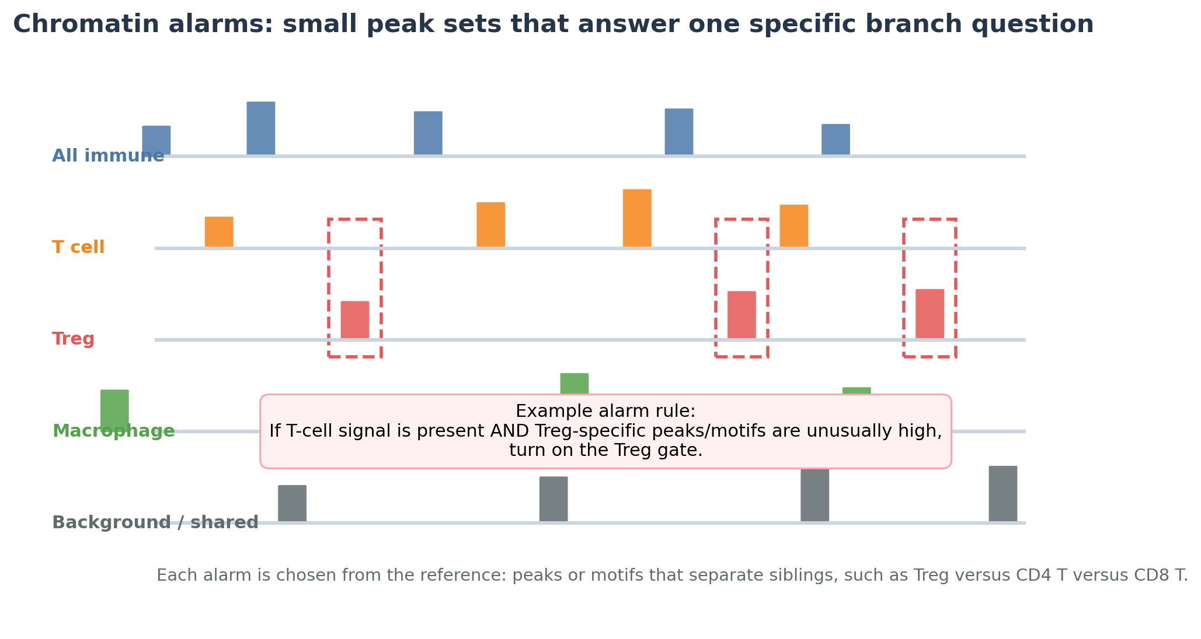
Figure 4. Alarm features are chosen separately for each branch of the tree, not once globally for all cell types.
There are three levels of alarms:
Alarm type | Example | Why useful | Risk
Peak alarm | A Treg-specific enhancer peak | Very direct ATAC evidence | Sparse, may be missing by chance
Motif alarm | FOXP3-like, RUNX, PU.1, ETS motif activity depending on branch | Aggregates many peaks, less sparse | Motifs are shared and not perfectly specific
Regulon alarm | A group of peaks linked to one TF or gene program | Biologically interpretable and robust | Needs careful construction

How to choose alarms from a reference
1. For each parent node, compare its child cell types only against each other. For example, compare Treg versus CD4 T versus CD8 T, not Treg versus all cells in the tissue.
2. Select peaks that are open in one child and closed or much weaker in siblings.
3. Prefer peaks that are reproducible across donors or batches.
4. Add motif scores for transcription factors known to distinguish the branch.
5. Optionally combine several peaks into a regulon score to reduce sparsity.
Important detail
HARP does not need every alarm to fire. It asks whether enough independent evidence supports the rare subtype. This protects against a single noisy peak causing a false rare-cell call.

5. Part 3: the Bayesian rare-cell gate
Bayesian reasoning means updating a belief after seeing evidence. Before looking at the data, the model has a prior belief. For example, Tregs are often rare, so the prior probability of Treg in a random spot may be low. After seeing T-cell peaks and Treg alarm peaks, the model updates this belief to a posterior probability.
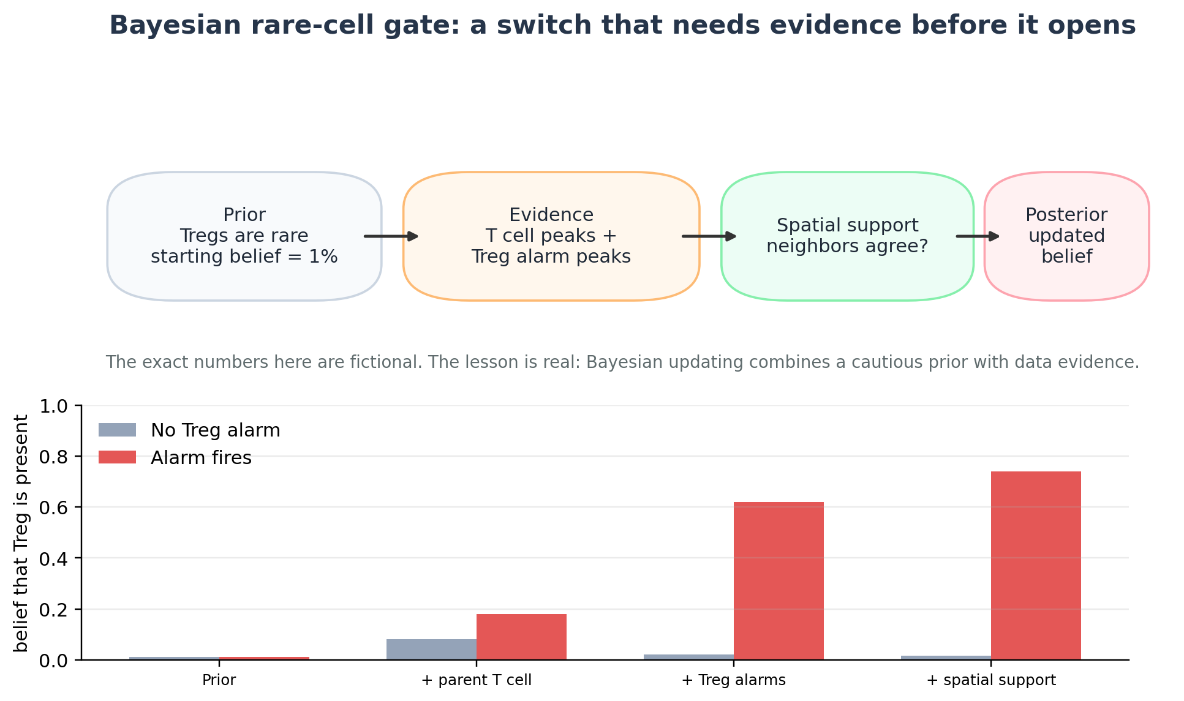
Figure 5. The rare-cell gate updates a cautious prior using ATAC alarm evidence and spatial support.
The gate is a switch. If the switch is off, the cell type abundance is exactly zero. If the switch is on, the model estimates how much of that cell type is present. In statistics, this is often called a spike-and-slab idea: the spike is zero, and the slab is a range of possible nonzero values.
Plain-language rule
A rare subtype should not appear just because the model can fit a tiny amount of it. It should appear because the parent lineage is present and the subtype-specific alarms are convincing.

A simple gate formula
Light math
For spot s and child cell type c:

Gate probability = sigmoid(base rarity + alarm evidence + spatial support + parent evidence)

If the gate is off: abundance = 0
If the gate is on: abundance is estimated from peak counts

The sigmoid function just turns any score into a probability between 0 and 1.

Here is the meaning of each term:
- base rarity: rare cell types start with a lower probability
- alarm evidence: the subtype-specific peaks, motifs, and regulons observed in the spot
- spatial support: whether nearby similar spots also support the subtype
- parent evidence: whether the parent lineage is present, such as T cells before Tregs

6. Part 4: the ATAC count model
The count model explains the observed ATAC fragments in a spot as a mixture of reference chromatin profiles. For a given branch of the tree, HARP only compares the children of that branch.
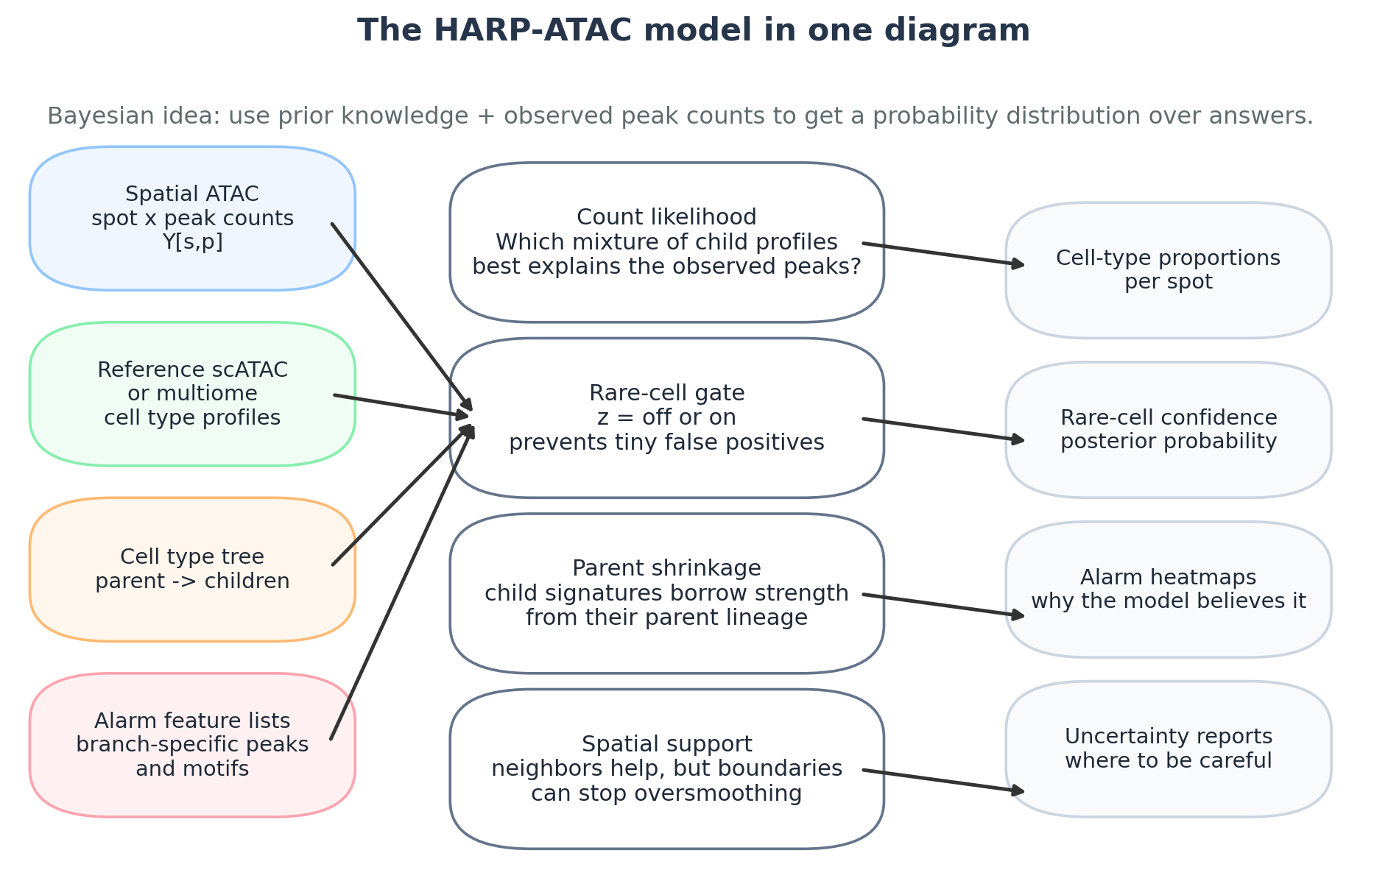
Figure 6. HARP-ATAC combines a count likelihood, rare-cell gate, parent shrinkage, and spatial support.
Main equation in words
Observed count at a peak = spot depth x peak detectability x mixture of child cell-type accessibility profiles + noise.

A more formal version is:
Light math
Y[s,p] ~ NegativeBinomial(mu[s,p], dispersion[p])

mu[s,p] = depth[s] x peak_bias[p] x sum over child c { abundance[s,c] x signature[c,p] }

Y[s,p] is the observed fragment count in spot s and peak p. The model chooses abundances that make the observed counts likely.

A Poisson likelihood is simpler and may be a good first prototype. A negative-binomial likelihood is more flexible because it handles overdispersion: the data vary more than a simple Poisson model expects. A practical project should benchmark both.

Symbol table
Symbol | Meaning | Simple translation
Y[s,p] | Observed ATAC count in spot s, peak p | What the experiment measured
signature[c,p] | Expected accessibility of peak p in cell type c | Reference fingerprint
abundance[s,c] | Amount of cell type c in spot s | How much of each ingredient
depth[s] | Total sequencing depth of spot s | How much data the spot has
peak_bias[p] | Peak-specific detectability | Some peaks are easier to detect than others
z[s,c] | Rare-cell gate | Off/on switch for a cell type

Parent shrinkage
Fine subtypes can have noisy reference signatures, especially if the reference contains few cells. HARP can stabilize them by shrinking each child signature toward its parent. For example, a Treg signature is allowed to be Treg-specific, but it still borrows information from the general T-cell signature.
Why this is intuitive
A Treg is a kind of T cell. So a Treg chromatin profile should look mostly like a T-cell profile, plus a smaller number of Treg-specific differences. Parent shrinkage encodes that idea mathematically.

7. Part 5: spatial support without oversmoothing
Cells in tissue are not randomly scattered. Neighboring spots often have related cell compositions. HARP can use this by borrowing weak evidence from nearby spots. But it must be careful at tissue boundaries, where two neighboring spots may belong to different zones.
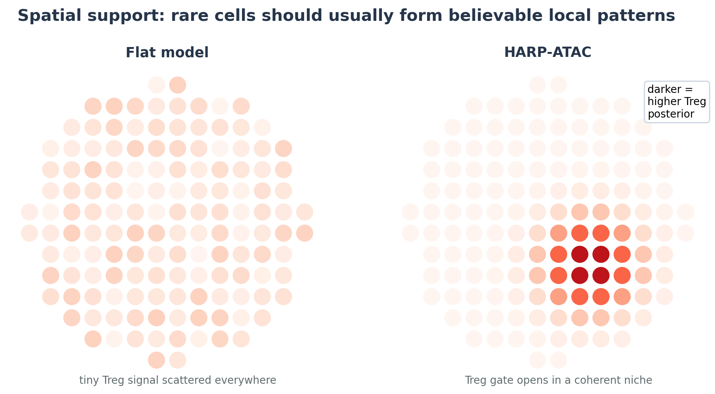
Figure 7. Spatial support helps rare cells form coherent patterns instead of random scattered false positives.
The simplest spatial rule is: neighboring spots should have similar abundances. A better rule is: neighboring spots should be similar only when their ATAC profiles also look similar. This prevents the model from smoothing across sharp boundaries, such as a tumor-normal edge or a lymphoid follicle boundary.
Spatial support rule
Borrow strength from neighbors that are close in physical space and similar in chromatin. Do not borrow strongly from neighbors that are close but biologically different.

8. Full toy example: finding rare Tregs
Imagine a tissue region with B cells, ordinary T cells, macrophages, and rare Tregs. The reference tells us that Tregs share many peaks with T cells, but have a few special alarm peaks and motif programs. We observe three spots.
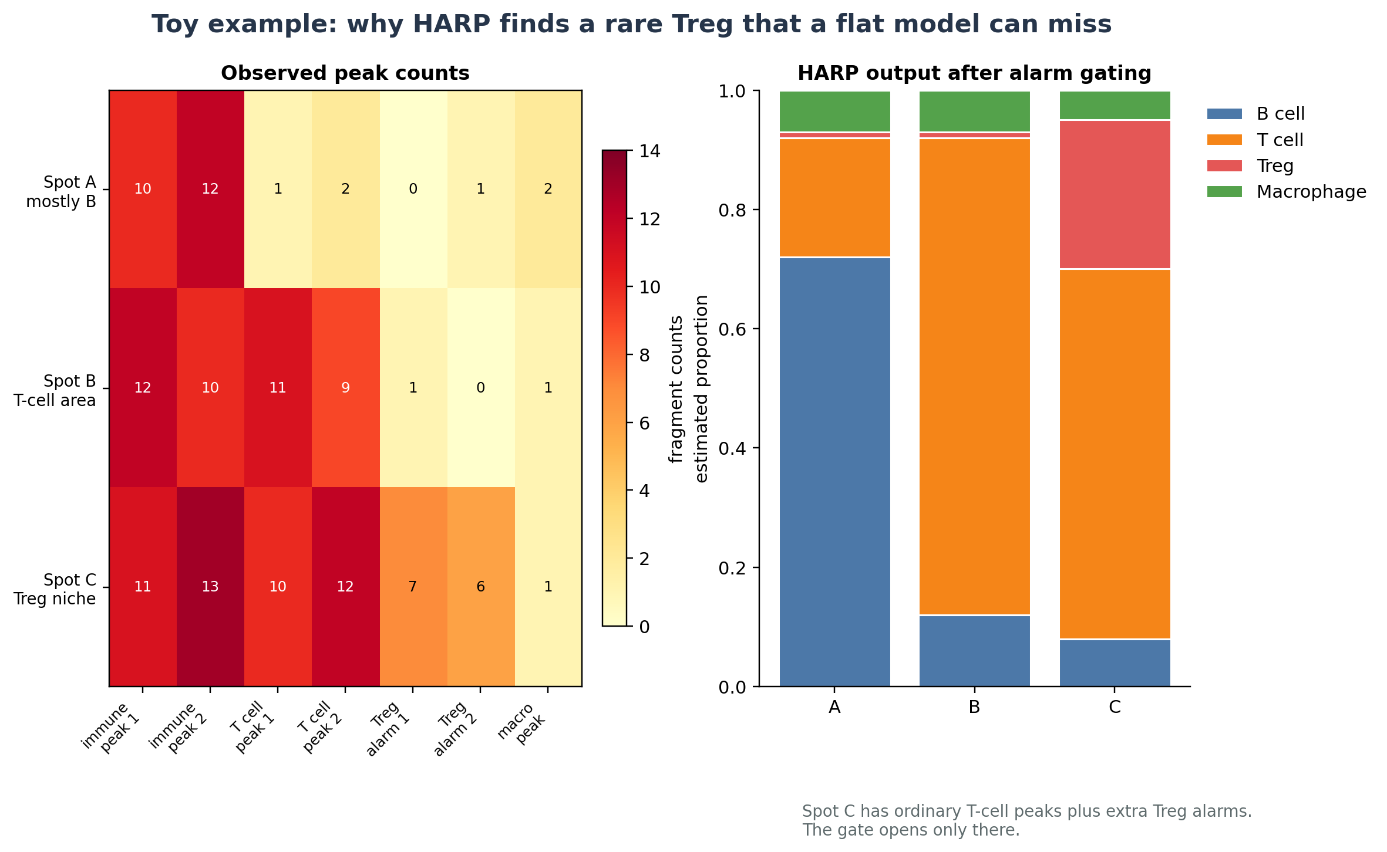
Figure 8. Toy data: Spot C has general immune peaks, T-cell peaks, and extra Treg alarm peaks, so HARP opens the Treg gate.
HARP would reason as follows:
1. At the root level, all three spots have immune evidence.
2. Inside the immune branch, Spot A looks mostly B-cell-like; Spots B and C look T-cell-like.
3. Inside the T-cell branch, Spot B lacks Treg alarms, so the Treg gate stays off.
4. Spot C has T-cell evidence plus Treg alarm peaks, so the Treg gate opens.
5. The final output reports a Treg proportion for Spot C and a posterior confidence score.
Why this example matters
A flat model might assign tiny Treg fractions to many spots because Tregs are similar to T cells. HARP instead asks whether the specific Treg alarms appear in the right T-cell context.

9. The algorithm step by step
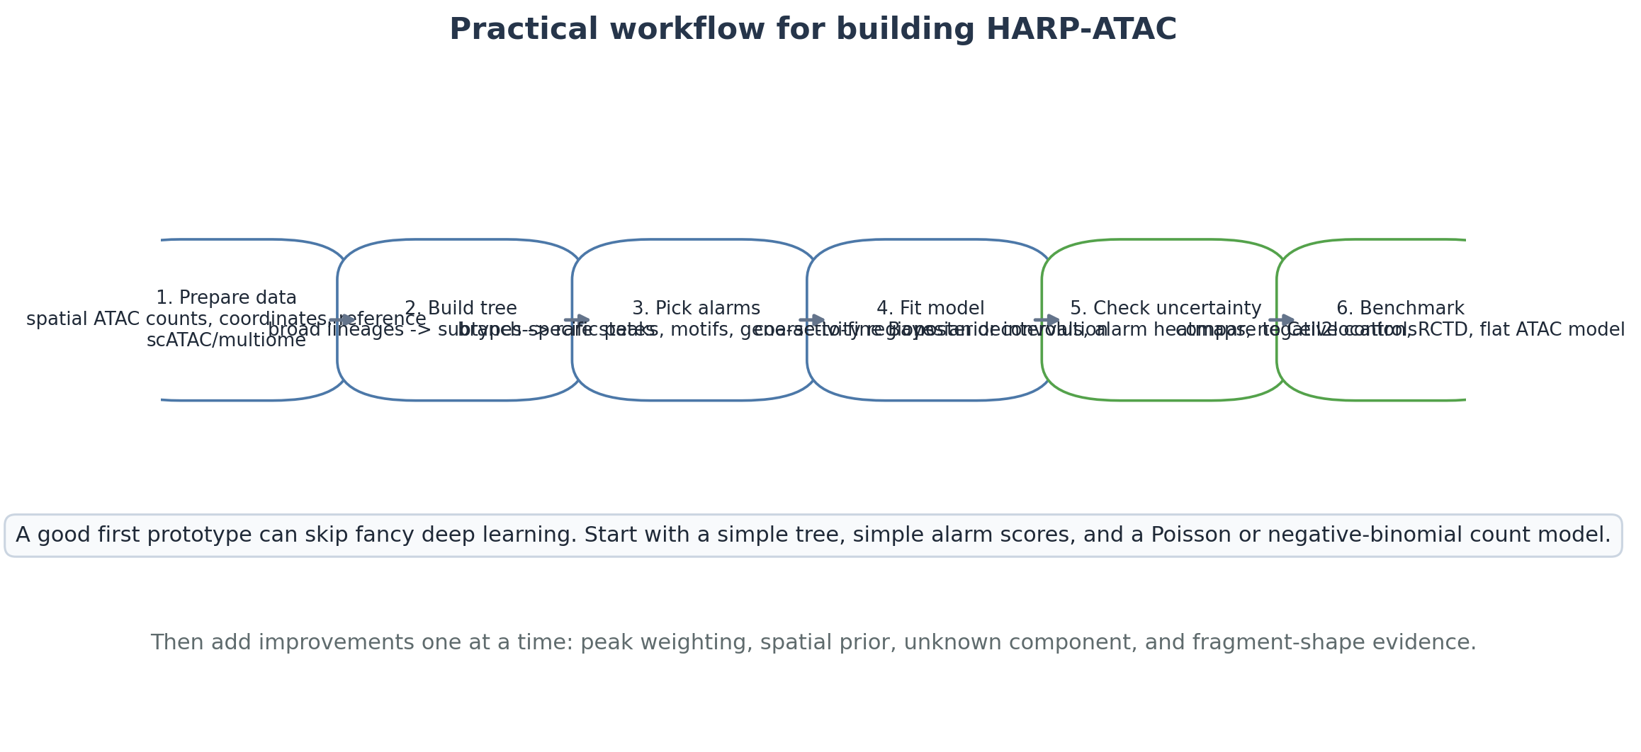
Figure 9. A practical workflow for developing and testing HARP-ATAC.
Here is the algorithm in tutorial-style pseudocode:
Pseudocode
Input: spatial ATAC counts, spatial coordinates, scATAC/multiome reference, cell-type tree

1. Learn a reference signature for every cell type.
2. For every parent node, select branch-specific alarm peaks and motifs.
3. Start at the root of the tree.
4. Estimate broad lineage abundance in every spot.
5. For each lineage that is present, move to its children.
6. For each rare child, compute an alarm score and gate probability.
7. Fit the count model using only enabled children and branch features.
8. Add spatial support from nearby similar spots.
9. Continue until leaf cell types are reached.
10. Output proportions, confidence, alarm explanations, and uncertainty.

The important design choice is that feature selection is local to each branch. A peak does not need to distinguish every cell type in the body. It only needs to help answer the current branch question.

10. What HARP-ATAC should output
- Cell-type abundance map: A map for each cell type showing where it appears and how much is present.
- Rare-cell posterior probability: For rare subtypes, a probability that the cell type is truly present in each spot.
- Alarm explanation map: A map showing which alarm peaks or motifs drove the rare-cell call.
- Uncertainty interval: A range of plausible abundances, not just one number.
- Branch-level summary: Broad lineage maps and fine subtype maps, so users can inspect the tree from top to bottom.
- Quality flags: Warnings for low-depth spots, missing-reference signals, or weak alarms.
Explainability is part of the method
HARP should not just say “Treg = 25%.” It should also say “Treg gate opened because parent T-cell evidence was strong, two Treg enhancer alarms were high, and nearby similar spots agreed.”

11. Minimal first implementation
A first version should be simple enough to debug. Do not start with a huge neural network. Start with a transparent probabilistic model.
- Data input: Peak-count matrix for spatial ATAC, coordinates, and a scATAC/multiome reference with cell-type labels.
- Feature space: Use 10,000 to 30,000 highly variable or branch-informative peaks, plus 50 to 200 motif/regulon scores.
- Tree: Manual hierarchy for the tissue: for example immune -> T/B/myeloid -> T subtypes.
- Likelihood: Start with Poisson; then test negative binomial.
- Gates: Use logistic gate probabilities for rare subtypes.
- Spatial prior: Start with a simple neighbor smoothing penalty; later add boundary-aware weights.
- Inference: Use variational inference or expectation-maximization for speed. A MAP version is enough for a prototype.

A prototype model
Prototype equation
For each branch and spot:

1. Compute parent abundance.
2. Compute child alarm scores.
3. Turn child gates on or off.
4. Fit peak counts using enabled children only.

This can be implemented before adding complex features such as unknown states or fragment-shape evidence.

12. How to test whether HARP-ATAC works
A good method needs careful validation. HARP should be compared against strong baselines, not weak ones.
1. Compare against Cell2location and RCTD adapted to spatial ATAC peak counts.
2. Compare against a flat ATAC-native Poisson or negative-binomial model without hierarchy or gates.
3. Use simulations where the true cell-type proportions are known.
4. Use pseudo-spots created by aggregating single-cell or near-single-cell spatial ATAC data.
5. Evaluate rare-cell F1 score, not only overall RMSE.
6. Check calibration: when HARP says 80% confidence, is it correct about 80% of the time.
7. Ablate one component at a time: no hierarchy, no alarms, no gate, no spatial prior.

Suggested metrics
Metric | What it measures | Why important for HARP
RMSE / MAE | Distance from true proportions | Basic accuracy
Jensen-Shannon divergence | Difference between true and predicted composition distributions | Good for mixture proportions
Rare-cell F1 | Whether rare cells are found without too many false positives | Main target of HARP
Calibration curve | Whether posterior probabilities mean what they claim | Important for Bayesian confidence
Boundary leakage score | Whether the method smooths across real tissue boundaries | Tests spatial prior
Alarm faithfulness | Whether rare calls depend on the expected alarm features | Tests explainability

Most important benchmark
The main claim should not be “HARP improves every cell type.” The strongest claim is narrower and more realistic: HARP improves rare and fine-subtype detection while keeping false positives low.

13. What makes HARP-ATAC novel
The novelty is not simply “use a Bayesian model.” Bayesian deconvolution already exists in spatial transcriptomics. The novelty is the combination of ATAC-native ideas:
- A cell-type hierarchy designed for coarse-to-fine ATAC deconvolution.
- Branch-specific chromatin alarms: peaks, motifs, and regulons chosen for each parent-child decision.
- Rare-cell gates that require alarm evidence before a rare subtype can receive nonzero abundance.
- Parent shrinkage, so fine subtype signatures borrow from related broad lineage signatures.
- Explainable outputs that show which chromatin alarms supported each rare-cell call.
Careful novelty claim
A defensible paper claim would be: “To our knowledge, HARP-ATAC is the first spatial ATAC deconvolution framework that combines hierarchical lineage decomposition, branch-specific chromatin alarm features, and Bayesian rare-cell gating.” This should be verified again before publication.

14. Risks and how to reduce them
Risk | What could go wrong | Possible fix
Alarm too strict | Rare cells are missed | Let multiple weak alarms combine; tune thresholds by validation
Alarm too loose | False rare-cell positives | Require parent evidence and spatial support
Bad reference | The tree/signatures do not match the tissue | Use tissue-matched multiome references and add an unknown component
Shared motifs | A motif is not unique to one cell type | Combine motif with peak and parent-lineage evidence
Oversmoothing | Rare niches blurred across boundaries | Use ATAC-similarity weighted neighbors
Too many peaks | Model slow and noisy | Use branch-specific feature selection

15. Extensions after the first version
After the basic HARP model works, several extensions could make it stronger:
- Unknown-state component: allow the model to say “this signal is not in the reference.”
- Fragment-shape features: combine HARP with ShapeMix-ATAC by adding footprint or fragment-length alarms.
- Cell-count constraints: use DAPI or histology to limit the total number of cells per spot.
- Regulatory state deconvolution: separate cell abundance from activation state, such as resting versus inflammatory macrophage chromatin.
- Multiome supervision: use RNA labels in a paired multiome reference to build better ATAC alarms.

16. Glossary
Term | Meaning
ATAC-seq | A method that detects open chromatin using Tn5 transposase.
Chromatin | DNA plus proteins. It can be packed tightly or open.
Peak | A genomic region with many ATAC fragments, suggesting open chromatin.
Motif | A short DNA sequence pattern recognized by a transcription factor.
Regulon | A set of regulatory elements controlled by a shared regulator or program.
Spatial spot / pixel | A small tissue location measured by the experiment. It may contain multiple nuclei.
Deconvolution | Computationally unmixing a spot into cell-type proportions.
Bayesian prior | The model’s starting belief before seeing the data.
Posterior | The updated belief after seeing the data.
Spike-and-slab | A statistical off/on idea: exactly zero or a nonzero amount.
Rare-cell F1 | A score for finding rare cells while avoiding false positives.

17. One-page summary
HARP-ATAC in five lines
1. Spatial ATAC spots are mixtures of multiple nuclei.
2. Flat deconvolution struggles with rare and closely related subtypes.
3. HARP uses a cell-type tree to ask broad-to-fine questions.
4. Rare subtypes need branch-specific chromatin alarms before their gate opens.
5. The output is not only proportions, but also confidence and explanations.

The best first project is to build a simple HARP prototype for one tissue, probably immune tissue or brain, where a clear hierarchy exists and rare/fine cell types are biologically important. Start with a manual tree, simple peak alarms, and a Poisson or negative-binomial likelihood. Then evaluate whether hierarchy plus alarms improves rare-cell detection over Cell2location, RCTD, and a flat ATAC model.

18. Sources and literature context
This tutorial proposes a new method. It is not a claim that HARP-ATAC has already been experimentally validated. The following papers and uploaded reports motivated the design:
- Deng et al. “Spatial profiling of chromatin accessibility in mouse and human tissues.” Nature, 2022. Motivates spatial ATAC, mixed pixels, fragment-size distributions, TSS enrichment, and spatial chromatin mapping.
- Ouologuem et al. “Spatial transcriptomics deconvolution methods generalize well to spatial chromatin accessibility data.” Bioinformatics, 2025. Motivates the need for spatial ATAC deconvolution benchmarks and reports that transferred RNA methods work but leave room for ATAC-specialized methods, especially for rare cells.
- Kleshchevnikov et al. “Cell2location maps fine-grained cell types in spatial transcriptomics.” Nature Biotechnology, 2022. Motivates Bayesian deconvolution, statistical strength sharing, and fine cell-type mapping.
- Cable et al. “Robust decomposition of cell type mixtures in spatial transcriptomics.” bioRxiv / RCTD. Motivates probabilistic mixture deconvolution and platform-effect awareness.
- Liu et al. “SONAR enables cell type deconvolution with spatially weighted Poisson-Gamma model for spatial transcriptomics.” Nature Communications, 2023. Motivates spatial weighting and boundary-aware smoothing.
- The uploaded spatial ATAC survey and deconvolution notes. These summarize the gap: current spatial ATAC deconvolution is mostly transfer/adaptation rather than ATAC-native method design.
Final research statement
HARP-ATAC is designed to be easy to explain, biologically intuitive, and methodologically distinct: it treats rare spatial ATAC cell-type detection as a cautious, hierarchical, evidence-gated Bayesian problem rather than a flat all-cell-types-at-once regression.

