ShapeMix-ATAC
A tutorial on the Bayesian model behind fragment-shape-aware deconvolution of spatial ATAC-seq
Written for a biology learner who wants the math explained step by step
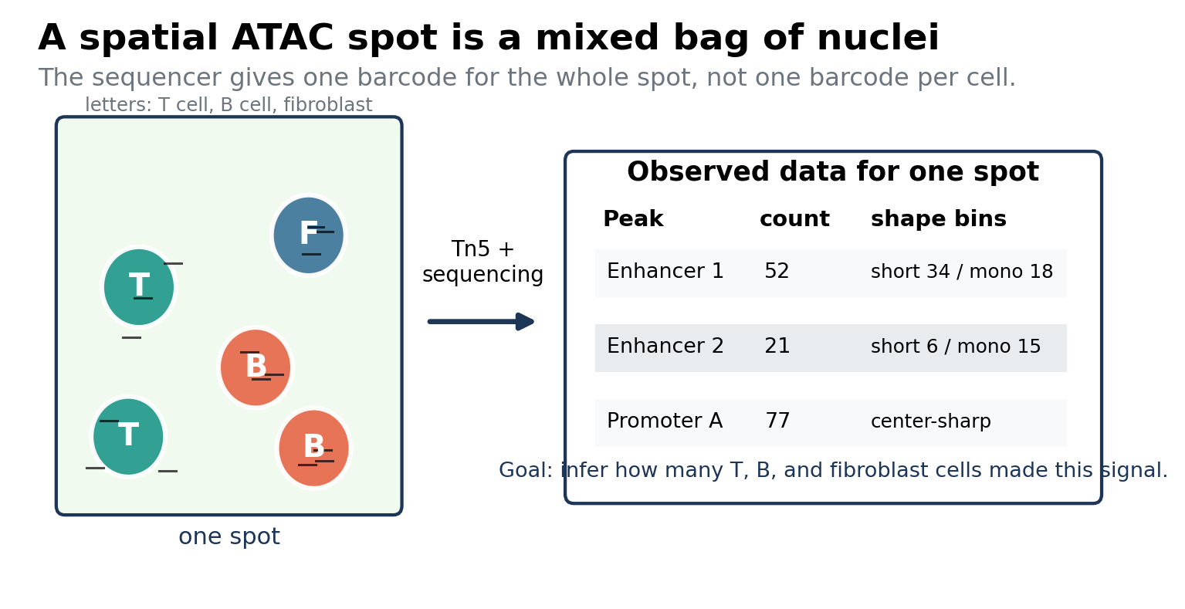
Figure 1. A spatial ATAC spot can contain a mixture of nuclei. ShapeMix-ATAC tries to infer the hidden mixture from observed chromatin fragments.
The idea in one sentence
A spatial ATAC spot is treated as a mixture of cell-type chromatin fingerprints, where each fingerprint includes both which peaks are accessible and what shape the ATAC fragments have inside those peaks.

Version: tutorial draft for method development

Contents
1. What problem are we solving?
2. Why ordinary deconvolution is not enough for ATAC
3. Bayesian modeling without fear
4. The simple peak-count model
5. The ShapeMix-ATAC model
6. Priors: biological guardrails
7. Toy examples
8. How to fit the model
9. What the method outputs
10. What makes this new and testable
Appendix: equations, implementation notes, and references

1. What problem are we solving?
Spatial ATAC-seq measures open chromatin across a tissue section. The technology uses Tn5 to insert sequencing adapters into accessible DNA, then assigns fragments to spatial barcodes. A single spatial barcode usually represents a small physical region of tissue, not necessarily one cell.
The goal of deconvolution is to answer a hidden-mixture question: given the ATAC fragments measured in a spot, how much of that spot came from each cell type?
Plain-language analogy
Imagine a jar containing red, blue, and green candies. You cannot look inside the jar directly. Instead, someone gives you a messy list of candy wrappers found nearby. Deconvolution is the problem of guessing the mixture of candies from the wrappers. ShapeMix-ATAC uses not only wrapper color, but also wrapper shape.

This is important because many spatial ATAC protocols operate at spot resolution. The original spatial-ATAC-seq paper notes that pixels may contain more than one nucleus, with examples such as about 1-2 cells per 10 micrometer pixel and about 25 cells per 50 micrometer pixel in an embryonic mouse experiment. It also reports ATAC quality signals such as TSS overlap and fragment-size distributions. These details motivate an ATAC-native model rather than a direct copy of an RNA model.
- Input: a spatial ATAC fragment matrix for tissue spots.
- Reference: single-cell ATAC or multiome data with known cell-type labels.
- Output: estimated cell-type composition for each spot, ideally with uncertainty.
- ShapeMix extension: also use fragment length, cut-position, and footprint information.

2. Why ordinary deconvolution is not enough for ATAC
Most spatial deconvolution methods were created for spatial transcriptomics. In RNA data, the features are genes. In ATAC data, the features are accessible DNA regions, often called peaks. A peak-count model asks: how many fragments landed in each peak? That is already useful, but it throws away a special part of ATAC data: the fragment pattern inside the peak.
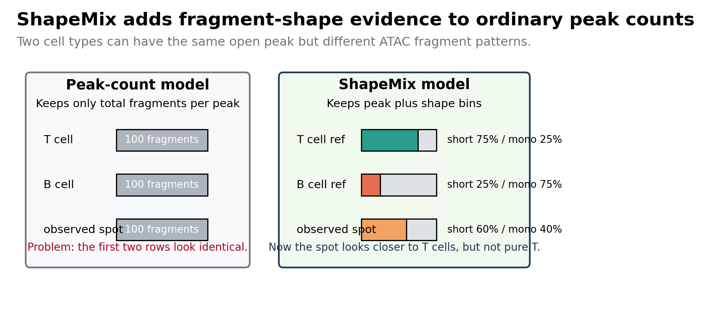
Figure 2. A peak-count model can miss information. ShapeMix keeps the shape bins that ordinary peak-count deconvolution ignores.
RNA deconvolution idea | ATAC peak-count idea | ShapeMix-ATAC idea
A spot is a mixture of gene-expression profiles. | A spot is a mixture of accessibility profiles. | A spot is a mixture of accessibility-plus-fragment-shape profiles.
Feature = gene. | Feature = peak. | Feature = peak plus shape bin.
A count says how much RNA was captured. | A count says how many ATAC fragments landed in a peak. | A count says how many fragments landed in a peak with a particular shape.
Cannot observe fragment lengths or footprints. | Uses ATAC but discards fragment-level detail. | Uses information unique to ATAC.

Why this is biologically intuitive
ATAC-seq is not just a peak counter. It is produced by a physical enzyme cutting accessible DNA. The lengths and positions of fragments carry information about nucleosomes, open regions, and possible transcription-factor binding. ShapeMix tries to make this extra evidence useful for deconvolution.

The three shape signals to start with
For a first method, do not try to use every possible ATAC detail. Start with simple bins that are easy to explain and easy to compute.
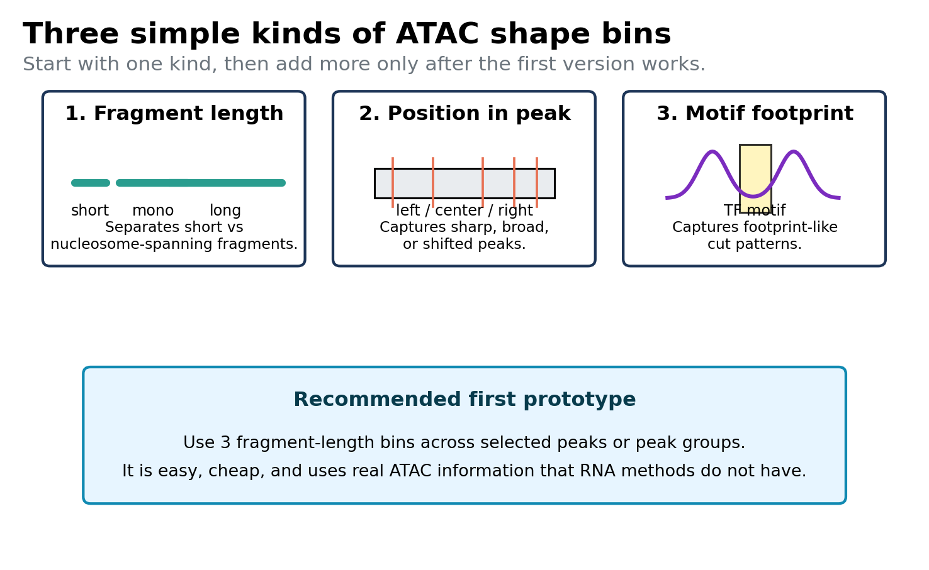
Figure 3. Three possible shape-bin choices. The first prototype should probably start with fragment-length bins.

3. Bayesian modeling without fear
A Bayesian model is a way to combine three things: what we observe, what we believe before seeing the data, and what we infer after seeing the data.
Bayesian word | Meaning in ShapeMix-ATAC | Everyday meaning
Data | Observed ATAC fragment counts in each spot, peak, and shape bin. | The clues.
Latent variable | Hidden cell counts or proportions in a spot. | The thing we want to guess.
Likelihood | Probability of seeing the observed fragments if a proposed mixture were true. | How well the guess explains the clues.
Prior | Biological expectations, such as neighboring spots being similar or reference signatures being reliable but not perfect. | Background knowledge.
Posterior | Updated belief about the cell mixture after combining data and priors. | The final answer with uncertainty.

The most important Bayesian formula is not as scary as it looks:
Bayes rule in words
posterior proportional to likelihood x prior
p(hidden mixture | observed fragments) proportional to
p(observed fragments | hidden mixture) x p(hidden mixture)

In ShapeMix, the hidden mixture is usually the unknown cell-type abundance in each spot. The observed fragments are the counts inside a three-dimensional table: spot by peak by shape bin.

4. Start simple: the peak-count model
Before adding shape, it helps to understand the ordinary peak-count model. Suppose Y[s,p] is the number of fragments observed in spot s and peak p. A peak-count model says this number is produced by adding contributions from all cell types in the spot.
Peak-count deconvolution model
Y[s,p] ~ NegativeBinomial(mean = lambda[s,p], dispersion = kappa[p])
lambda[s,p] = depth[s] * detect[p] * sum_c cells[s,c] * yield[c] * access[c,p] + background[s,p]

Read the equation as a sentence: the expected number of fragments at a peak equals spot sequencing depth, times peak detectability, times the sum of the contributions from each cell type.
Symbol | Meaning | How to think about it
Y[s,p] | Observed fragments in spot s and peak p. | What the sequencer reports.
cells[s,c] | Unknown abundance of cell type c in spot s. | The main thing we want.
access[c,p] | Accessibility of peak p in cell type c. | A reference fingerprint from scATAC.
depth[s] | Sequencing depth for spot s. | Some spots get more reads than others.
detect[p] | Peak-specific detectability. | Some peaks are easier to capture than others.
kappa[p] | Overdispersion/noise parameter. | Counts are noisier than ideal coin flips.

Why use a Negative Binomial?
A Poisson model is the simplest count model: it assumes the variance is about equal to the mean. Real sequencing counts are often noisier than that. A Negative Binomial model is like a Poisson model with extra randomness. For a first prototype, a Poisson model is easier; for a serious model, Negative Binomial is safer.

Relationship to existing models
Cell2location is a Bayesian count model for spatial transcriptomics that decomposes spatial count matrices into reference cell-type signatures using a negative-binomial framework and priors that share information across locations. RCTD is a likelihood-based method that models spatial counts using a Poisson mixture with platform-effect correction. These are strong baselines. ShapeMix keeps the count-mixture idea, but changes the measurement from a spot-by-peak table to a spot-by-peak-by-shape tensor.

5. The ShapeMix-ATAC model
Now we add the key new ingredient. Instead of counting only how many fragments land in a peak, ShapeMix counts how many fragments land in each peak-shape bin.
Core data structure
Y[s,p,b] = number of fragments in spatial spot s, peak p, and shape bin b. For example, b might be short, mononucleosomal, or long fragments.

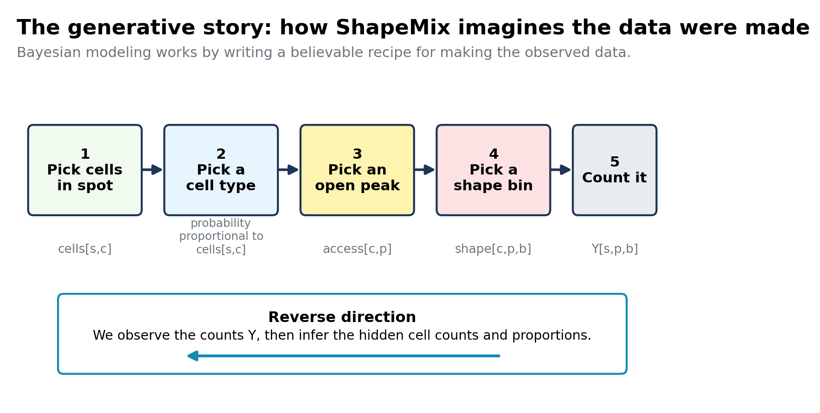
Figure 4. The generative story behind the model. ShapeMix writes down how cell mixtures could generate the observed ATAC shape counts.

5.1 The core likelihood
The likelihood is the part of the model that says how the hidden cell mixture creates the observed counts.
ShapeMix likelihood
Y[s,p,b] ~ NegativeBinomial(mean = lambda[s,p,b], dispersion = kappa[p])

lambda[s,p,b] = depth[s] * detect[p] *
sum_c cells[s,c] * yield[c] * access[c,p] * shape[c,p,b]
+ background[s,p,b]

This is the central equation of ShapeMix. It has one extra factor compared with the peak-count model: shape[c,p,b].
Term | Meaning
cells[s,c] | How many cells of type c are in spot s. This is hidden and inferred.
access[c,p] | How open peak p is in cell type c. Learned from a reference.
shape[c,p,b] | If cell type c contributes to peak p, how likely its fragments are to fall in bin b. Learned from reference fragments.
depth[s] | Spot-level sequencing depth.
detect[p] | Peak-level capture bias, such as width, GC, mappability, or Tn5 preference.
yield[c] | Optional per-cell ATAC yield. Some cell types may contribute more fragments per cell.
background[s,p,b] | Background signal or unexplained fragments.

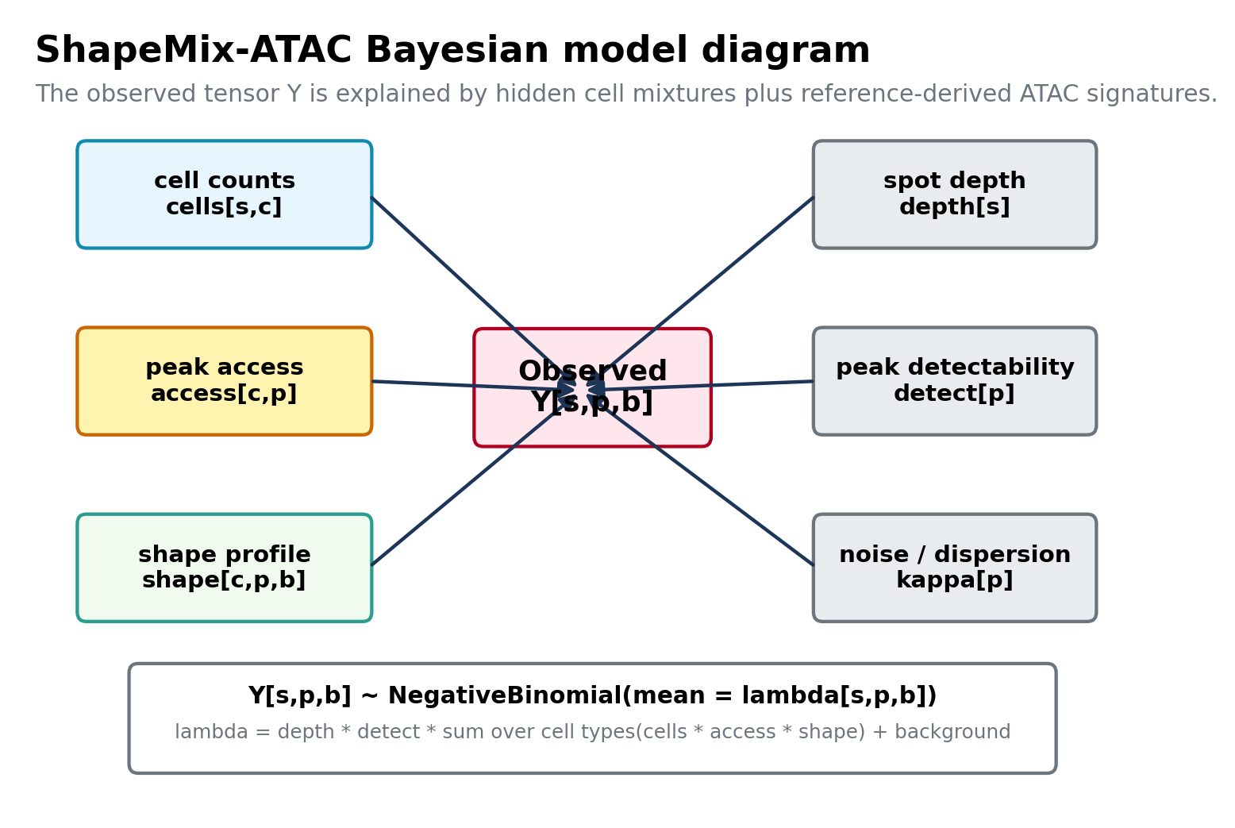
Figure 5. Diagram of the ShapeMix Bayesian model. The hidden cell mixture and ATAC reference signatures jointly explain the observed tensor Y.

5.2 What is shape[c,p,b]?
shape[c,p,b] is a probability distribution over bins. For each cell type c and peak p, the shape values across all bins add up to 1.
Shape probabilities
sum_b shape[c,p,b] = 1
shape[c,p,b] >= 0

Example with three length bins:
Cell type | Peak | short fragments | mononucleosomal | long fragments
T cell | Enhancer X | 0.70 | 0.25 | 0.05
Fibroblast | Enhancer X | 0.25 | 0.60 | 0.15
B cell | Enhancer X | 0.45 | 0.45 | 0.10

If a spot has many short fragments at Enhancer X, that is evidence for T cells. If it has many mononucleosomal fragments, that is evidence for fibroblasts. The peak count alone may not distinguish them.

5.3 How to learn reference signatures
ShapeMix needs a reference built from scATAC-seq or single-cell multiome data. The reference tells the model what each cell type tends to look like.
Reference estimates
access_ref[c,p] = normalized fragments at peak p in reference cells of type c
shape_ref[c,p,b] = fragments from type c at peak p and bin b / fragments from type c at peak p

Because ATAC is sparse, the per-peak shape reference may be noisy. A practical first version should smooth or group shape information. For example, instead of shape[c,p,b] for every individual peak, use shape[c,g,b], where g is a peak group such as promoters, enhancers with a motif, or peaks of similar width.
Reference option | More detailed? | More stable? | Recommended use
Per-cell-type global fragment-length profile | Low | High | Debugging and first toy experiments.
Per-cell-type, per-peak-group shape | Medium | Medium/high | Best first serious prototype.
Per-cell-type, per-peak shape | High | Low unless deep data | Later extension for high-depth data.
Motif-centered footprints | High for TF biology | Medium if motifs are pooled | Second-stage module after length bins.

6. Priors: biological guardrails
Priors are a formal way to say what solutions are biologically reasonable before looking at the spot counts. They help stabilize the model, especially because spatial ATAC is sparse.

6.1 Prior on cell counts in a spot
If we know nothing, cell counts can have a broad positive prior. If we have a DAPI or histology image, we can use the estimated number of nuclei in each spot as a soft constraint.
Cell-count prior
cells[s,c] >= 0
sum_c cells[s,c] approximately equals nuclei_count[s] (if image-derived nuclei counts exist)
log(cells[s,c] + small_number) is similar to nearby spots, unless there is a boundary

6.2 Prior on accessibility signatures
The reference is useful but not perfect. A disease tissue, donor, or spatial protocol may shift accessibility. ShapeMix should trust the reference, but allow small corrections.
Reference-shrinkage prior for accessibility
log access[c,p] ~ Normal(log access_ref[c,p], sigma_access^2)

6.3 Prior on shape signatures
Shape profiles are probabilities, so a Dirichlet prior is natural. It says the learned shape should stay near the reference shape unless the spatial data strongly disagree.
Shape prior
shape[c,p,1:B] ~ Dirichlet(tau_shape * shape_ref[c,p,1:B])
large tau_shape = trust reference shape more
small tau_shape = allow shape to move more

6.4 Prior on peak detectability
Not all peaks are equally easy to detect. Longer peaks, GC content, mappability, and Tn5 bias can change counts. detect[p] catches peak-specific technical effects so they are not mistaken for cell-type biology.
Peak detectability prior
log detect[p] ~ Normal(beta0 + beta_width * log(width[p]) + beta_gc * GC[p], sigma_detect^2)

Important modeling principle
Do not let every parameter move freely at the beginning. A simple first implementation can fix access and shape to reference estimates, then infer only cells, depth, and dispersion. After that works, add Bayesian uncertainty around the reference.

7. Toy examples

7.1 A two-cell-type example
Suppose one peak has 100 total fragments in the spot. Both T cells and B cells are equally open at this peak, so the peak count alone cannot tell them apart. But their fragment shapes differ.
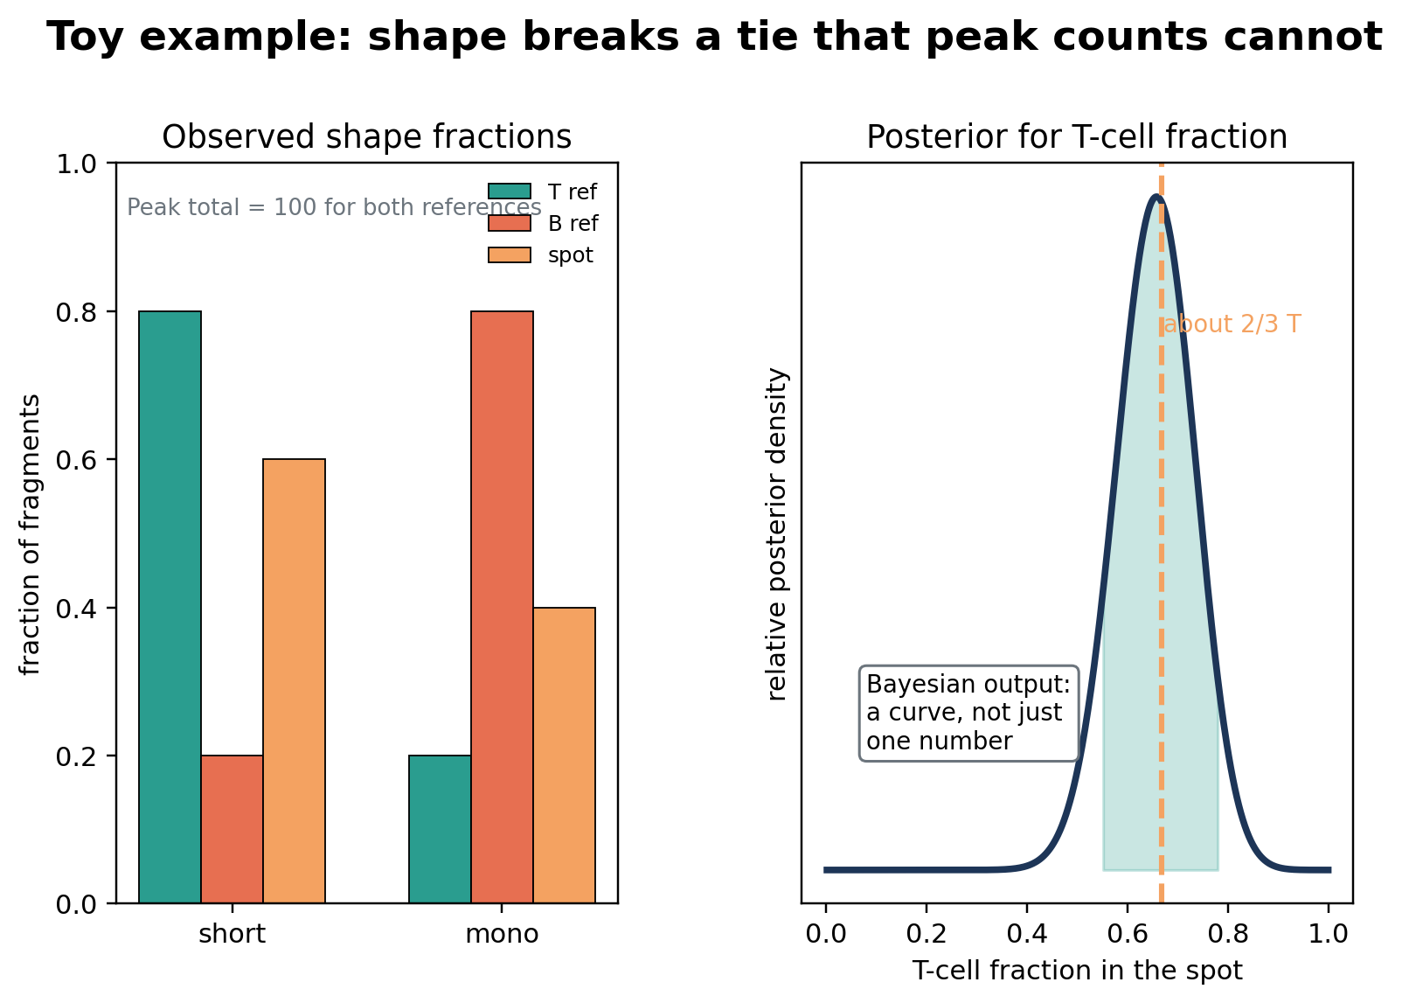
Figure 6. A toy example. Shape bins can estimate a mixture even when the peak count is uninformative.
In this toy case:
Solving the toy mixture
T-cell short-fragment probability = 0.80
B-cell short-fragment probability = 0.20
observed short-fragment fraction = 0.60

0.60 = 0.80 * T_fraction + 0.20 * (1 - T_fraction)
T_fraction = (0.60 - 0.20) / (0.80 - 0.20) = 0.67

The Bayesian model does not only output 0.67. It outputs a posterior distribution. That means it can say something like: the most likely T-cell fraction is about 0.67, but values from about 0.55 to 0.78 are still plausible given the limited number of fragments.

7.2 A spatial example
Neighboring spots in real tissue are often related. If one spot is predicted to have 90% T cells but every neighbor has 5% T cells, we should be suspicious unless the peak and shape evidence is very strong. A spatial prior helps with this.
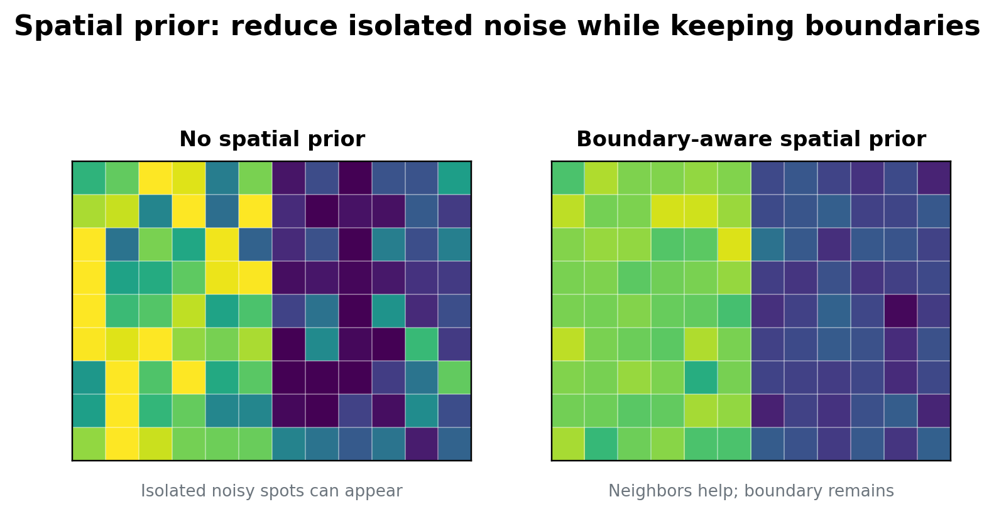
Figure 7. A spatial prior can reduce noisy isolated predictions while preserving tissue boundaries.
Boundary warning
Never smooth blindly. Brain layers, tumor margins, follicles, and developmental zones can have real sharp boundaries. ShapeMix should use boundary-aware smoothing: neighbors help only when their chromatin patterns are compatible.

8. How to fit the model
Fitting means finding the posterior distribution of the hidden variables. In practice, we usually use an approximation because the full posterior is too complicated to compute exactly.
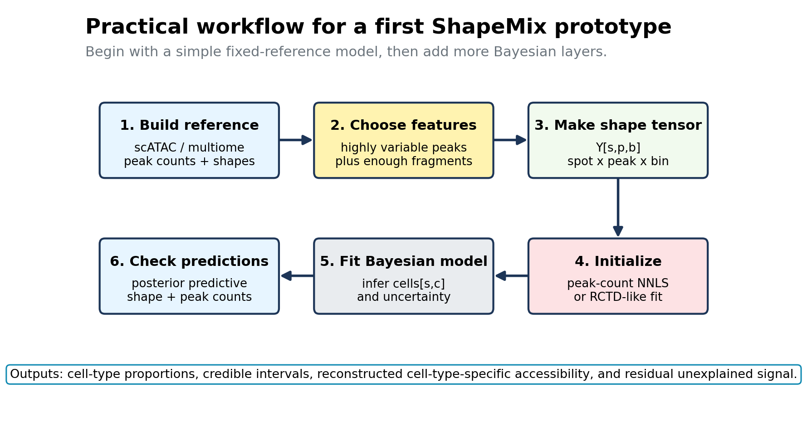
Figure 8. A practical first workflow for implementing ShapeMix-ATAC.

8.1 Minimal prototype
- Select 5,000-20,000 informative peaks. Start with highly variable peaks plus peaks that distinguish reference cell types.
- Make a spot-by-peak count matrix Y_peak[s,p].
- Make a spot-by-peak-by-shape tensor Y_shape[s,p,b] using three fragment-length bins.
- Build reference access[c,p] from scATAC or multiome cells.
- Build reference shape[c,g,b] for peak groups g rather than every peak p.
- Initialize cell proportions using NNLS, RCTD, or Cell2location on peak counts only.
- Fit the ShapeMix likelihood with fixed reference access and shape.
- Add priors and uncertainty after the fixed-reference model works.

8.2 Inference options
Inference option | What it gives | Pros | Cons
MAP optimization | One best parameter setting. | Fast, easier to debug. | Less uncertainty.
Variational inference | Approximate posterior distributions. | Scales better than MCMC; good for Bayesian output. | Needs careful checking.
MCMC | More exact posterior samples. | Good for small toy models and validation. | Too slow for full spatial ATAC.
EM-like updates | Alternating updates for cells and nuisance parameters. | Easy to derive for simple Poisson versions. | Can get stuck; uncertainty is limited.

8.3 Pseudocode
ShapeMix pseudocode
Input: spatial fragments, spot coordinates, scATAC/multiome reference
1. Call or choose peaks and define shape bins.
2. Count Y[s,p,b] from fragments.
3. Estimate access_ref[c,p] and shape_ref[c,g,b] from the reference.
4. Initialize cells[s,c] using a peak-count model.
5. Repeat until convergence:
update cells[s,c] to improve the shape-aware likelihood
update depth/detect/dispersion nuisance parameters
apply priors: nonnegative cells, spatial smoothness, reference shrinkage
6. Output posterior mean, credible intervals, and reconstructed cell-type-specific ATAC.

9. What the method outputs
A good ShapeMix implementation should return more than a heatmap of proportions. The Bayesian model should return uncertainty and diagnostics.
Output | Meaning | Why it matters
cell_prop[s,c] | Estimated proportion of cell type c in spot s. | Main deconvolution result.
cell_count[s,c] | Estimated number of cells if nuclei counts are available. | More interpretable than proportions when tissue density varies.
credible_interval[s,c] | Uncertainty interval for each cell type in each spot. | Tells you which predictions are trustworthy.
recon_peak[s,p] | Predicted peak counts reconstructed from the mixture. | Checks whether the model explains peak counts.
recon_shape[s,p,b] | Predicted shape-bin counts. | Checks whether the shape module is actually useful.
residual[s,p,b] | Observed minus predicted signal. | Can reveal missing reference cell states or technical artifacts.

Posterior predictive checks
A posterior predictive check asks: if the fitted model were true, would simulated data from the model look like the real data? This is one of the most important safeguards.
- Check whether predicted total fragments per spot match observed total fragments.
- Check whether predicted peak counts match observed peak counts.
- Check whether predicted fragment-length distributions match observed fragment-length distributions.
- Check whether predictions are stable across random initializations.
- Check whether high-uncertainty spots correspond to low-depth or ambiguous tissue regions.

10. What makes ShapeMix new and testable
The deconvATAC benchmark shows that transferred spatial transcriptomics methods such as Cell2location and RCTD can work on spatial chromatin accessibility data, but that ATAC-based deconvolution still leaves room for specialized methods, especially for rare cell types. The same benchmark emphasizes that ATAC has many more features than RNA and that feature selection matters.
The proposed novelty of ShapeMix is not simply using a Bayesian count model. Count models already exist. The novelty is to make the likelihood fragment-shape-aware: the observation is Y[s,p,b], not just Y[s,p].
Careful novelty claim
A defensible claim would be: ShapeMix-ATAC is a spatial ATAC deconvolution model that uses ATAC fragment-shape distributions as direct likelihood evidence for cell-type mixtures. I did not find this exact idea in the attached papers, but a final manuscript should still include a focused literature and software search before claiming first-in-field novelty.

Ablation tests that make the claim testable
Ablation | Question answered
Peak counts only | How well does a standard ATAC peak-count model do?
Peak counts + fragment-length bins | Does length shape improve deconvolution?
Peak counts + peak-position bins | Does within-peak shape help?
Peak counts + motif-footprint bins | Does TF footprint evidence help subtypes?
No spatial prior | Does spatial smoothing improve stability?
No reference shrinkage | Does Bayesian uncertainty around the reference help?
No unknown component | Does the residual module prevent false positives?

Evaluation metrics
- RMSE or mean absolute error for simulated cell proportions.
- Jensen-Shannon divergence for mixture distributions.
- F1 score for rare-cell detection.
- Calibration of credible intervals: do 90% intervals contain truth about 90% of the time in simulations?
- Reconstruction accuracy for peak counts and shape-bin counts.
- Boundary leakage score: does the model blur across known tissue boundaries?

Appendix A. Full model in one place
ShapeMix-ATAC mathematical summary
Observed:
Y[s,p,b] = fragment count in spot s, peak p, shape bin b

Likelihood:
Y[s,p,b] ~ NegativeBinomial(mean = lambda[s,p,b], dispersion = kappa[p])

Mean model:
lambda[s,p,b] = depth[s] * detect[p] * sum_c cells[s,c] * yield[c] * access[c,p] * shape[c,p,b]
+ background[s,p,b]

Reference priors:
log access[c,p] ~ Normal(log access_ref[c,p], sigma_access^2)
shape[c,p,1:B] ~ Dirichlet(tau_shape * shape_ref[c,p,1:B])

Cell-count priors:
cells[s,c] >= 0
sum_c cells[s,c] approximately equals nuclei_count[s] if available
nearby spots have similar log cells[s,c], unless boundary evidence is strong

Posterior:
p(cells, access, shape, detect, kappa | Y, reference) proportional to
likelihood x priors

Appendix B. Identifiability: what can go wrong?
Identifiability means whether the data contain enough information to recover the hidden variables. ShapeMix adds information, but it still has risks.
Risk | Why it happens | Practical fix
access and cells trade off | Twice as many cells with half the accessibility can look similar. | Fix or strongly regularize reference access first.
shape signatures are noisy | Some peaks have too few fragments in the reference. | Use peak groups and Dirichlet smoothing.
protocol changes shape | Fragment length can differ across experiments. | Add batch-specific shape calibration and control peaks.
missing reference cell type | The model forces unknown signal into known types. | Add background/residual or unknown component.
too many peaks | ATAC can have 100,000+ peaks. | Feature selection, mini-batching, and sparse tensors.

Appendix C. Recommended first implementation
Minimum viable ShapeMix
Use fixed reference access and fixed reference shape. Infer only cell abundances, spot depth, peak detectability, and dispersion. Use three fragment-length bins and grouped peaks. Compare against peak-count-only and against Cell2location/RCTD on the same peak set.

- Use deconvATAC-style simulations to create ground truth spot mixtures.
- Run a peak-count-only Bayesian or NNLS baseline.
- Run ShapeMix with fragment-length bins.
- Show whether ShapeMix improves rare-cell detection and fine subtype separation.
- Add motif-footprint bins only after length bins show stable behavior.

Appendix D. Short glossary
Term | Meaning
ATAC-seq | Assay that measures open chromatin by cutting accessible DNA with Tn5.
Peak | A genomic region with many ATAC fragments, suggesting open chromatin.
Fragment | A sequenced DNA piece produced by Tn5 cutting.
Shape bin | A category describing a fragment, such as short vs mononucleosomal.
Deconvolution | Estimating the mixture of cell types in a bulk or spatial spot measurement.
Likelihood | A probability model for observed data given hidden parameters.
Prior | A model of what parameter values are plausible before seeing the data.
Posterior | Updated belief about parameters after seeing the data.
Credible interval | A Bayesian uncertainty interval.

Appendix E. Sources used to motivate the tutorial
- Deng et al. Spatial profiling of chromatin accessibility in mouse and human tissues. Nature, 2022. Used for spatial-ATAC-seq workflow, mixed-pixel motivation, TSS enrichment, and fragment-size/nucleosomal pattern motivation.
- Ouologuem et al. Spatial transcriptomics deconvolution methods generalize well to spatial chromatin accessibility data. Bioinformatics, 2025. Used for the current benchmark landscape, lack of dedicated spatial chromatin accessibility deconvolution methods in that benchmark, and the performance of Cell2location/RCTD.
- Kleshchevnikov et al. Cell2location maps fine-grained cell types in spatial transcriptomics. Nature Biotechnology, 2022. Used as a reference for Bayesian negative-binomial deconvolution with reference signatures and spatial sharing.
- Cable et al. Robust decomposition of cell type mixtures in spatial transcriptomics. Preprint / Nat Biotechnol version. Used as a reference for Poisson mixture deconvolution, platform effects, and pixel mixture modeling.
- Guo et al. Multiplexed spatial mapping of chromatin features, transcriptome, and proteins in tissues. Nature Methods, 2025. Used as broader motivation that chromatin accessibility can be spatially co-profiled with other modalities and reveal regulatory states.

