ShapeMix-ATAC
A beginner-friendly tutorial for a fragment-shape-aware deconvolution method for spatial ATAC
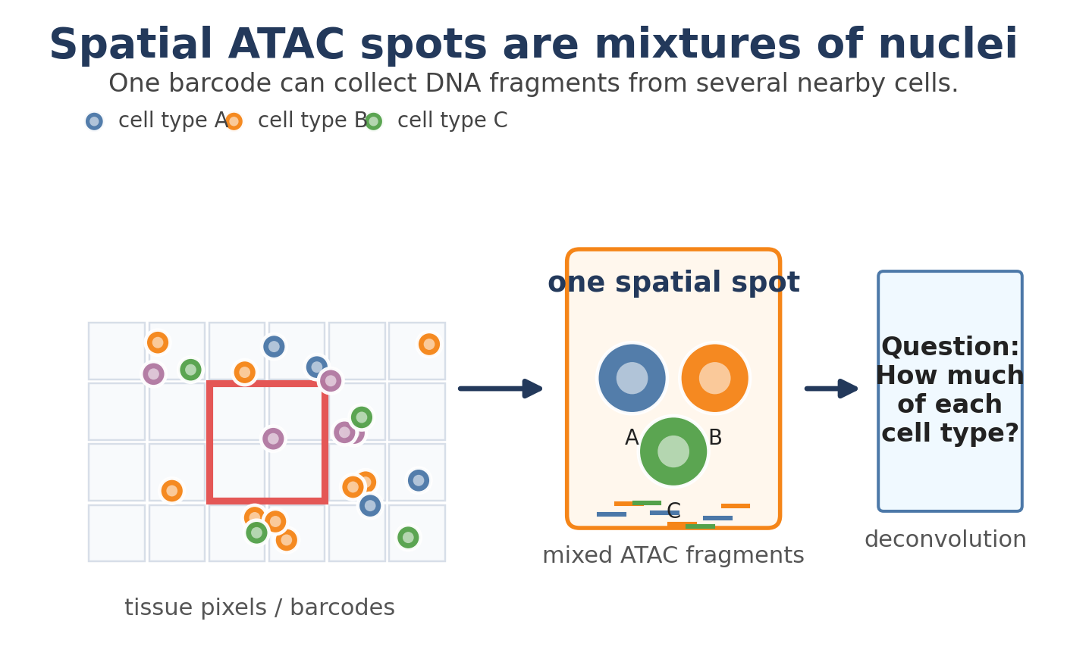
Figure 1. The basic problem: one spatial ATAC spot can contain several cells, so the observed DNA fragments are a mixture.
One-sentence explanation
ShapeMix-ATAC estimates which cell types are inside each spatial ATAC spot by comparing both where ATAC fragments land in the genome and what shapes those fragments have.

Prepared as a tutorial-style research proposal. The method is a proposal, not an already validated algorithm.

Road map
This tutorial is written for a reader who knows basic biology but is still learning computational genomics. It starts from the biological intuition and then gradually builds the algorithm.
1. The biological problem: why spatial ATAC needs deconvolution.
2. The key intuition: ATAC contains fragment-shape information that RNA does not have.
3. The ShapeMix-ATAC algorithm: inputs, fingerprints, model, and outputs.
4. Toy examples: how the model can distinguish cell types that look identical by peak counts.
5. Novelty, implementation plan, evaluation, and limitations.
How to read this document
Read Sections 1-5 first. They are the conceptual core. The math in Section 7 is optional; it is included so the idea can later become a formal method paper.

1. The biological problem

1.1 What is ATAC-seq?
Inside a cell, DNA is not floating around naked. It is wrapped and packed with proteins. Some regions are tightly packed, and other regions are open. Open regions are often important because they can contain promoters, enhancers, and transcription-factor binding sites that help control genes.
ATAC-seq is a method that uses an enzyme called Tn5 to cut and tag DNA that is open. After sequencing, we see many short DNA fragments from open chromatin regions. In simple language:
- Open DNA -> more ATAC fragments.
- Closed DNA -> few or no ATAC fragments.
- A peak -> a genomic region where many ATAC fragments pile up.
Analogy
Imagine DNA as a book. Closed chromatin is like pages glued shut. Open chromatin is like pages that can be read. ATAC-seq drops bookmarks into the open pages.

1.2 What makes spatial ATAC different?
Single-cell ATAC tells us the chromatin accessibility of individual cells, but it loses where those cells were located in the tissue. Spatial ATAC keeps location, but a single measured spot may contain several nuclei. The original spatial-ATAC-seq work describes in situ Tn5 transposition plus spatial barcoding, and notes that pixel size affects how many cells are captured per pixel. For example, a 50 micrometer pixel in mouse embryo data can contain many more cells than a 10 or 20 micrometer pixel. This is why deconvolution matters.
Deconvolution means unmixing. We want to turn a mixed spot into an estimate like:
Example output
Spot 127 = 55% neuron + 25% glia + 15% immune cell + 5% endothelial cell

Spatial RNA | Spatial ATAC
Counts are usually gene expression counts. | Counts are DNA fragments in open chromatin peaks.
Features are genes, often thousands. | Features are peaks, often tens of thousands to more than 100,000.
RNA mostly says what genes are being used now. | ATAC says which regulatory DNA regions are accessible and possibly ready to be used.
The molecule is RNA. | The molecule is DNA fragments made by Tn5 cutting.

1.3 Why current methods are not enough
A 2025 deconvATAC benchmark tested spatial transcriptomics deconvolution methods on spatial chromatin accessibility data. The important lesson is encouraging but incomplete: RNA-based methods such as Cell2location and RCTD can be adapted to ATAC peak counts, but ATAC deconvolution still leaves room for specialized methods, especially for rare cell types and feature selection. The same benchmark emphasizes that spatial ATAC has many more features than RNA and that peak selection matters a lot.
Most adapted methods treat ATAC like this:
Count-only view
For each spot and each peak, count how many fragments were observed. Then fit the spot as a mixture of reference cell-type peak-count profiles.

ShapeMix-ATAC keeps that useful count information, but adds something ATAC-specific: the shapes of the fragments.

2. The key idea: ATAC has fragment shapes
RNA deconvolution mostly has gene counts. ATAC has more physical information. Each fragment has a start position, an end position, a length, and a location relative to peaks, motifs, or transcription start sites. These details are usually summarized as quality-control plots, but ShapeMix-ATAC treats them as biological evidence.
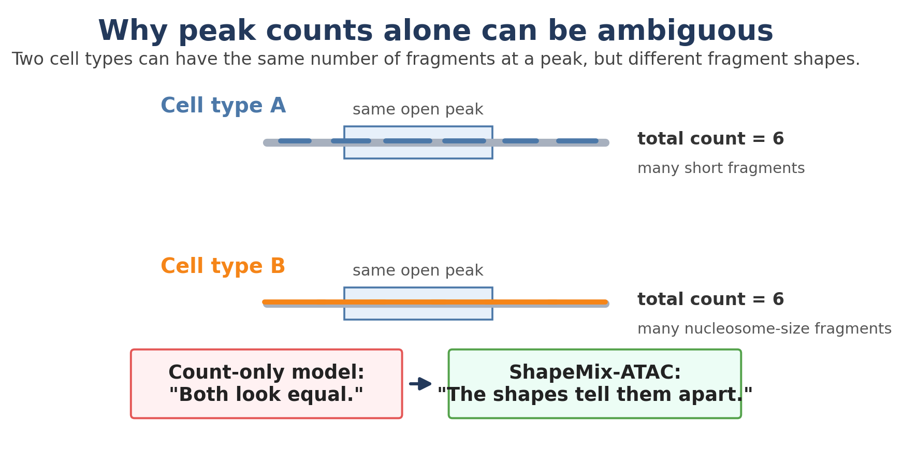
Figure 2. A count-only model cannot separate these two cell types because both have six fragments at the peak. A shape-aware model can notice that the fragment patterns differ.

2.1 Four kinds of shape signals
ShapeMix-ATAC can start with simple shape features. The first version does not need to use every possible feature. It can begin with fragment length because that is easy to explain and easy to compute.
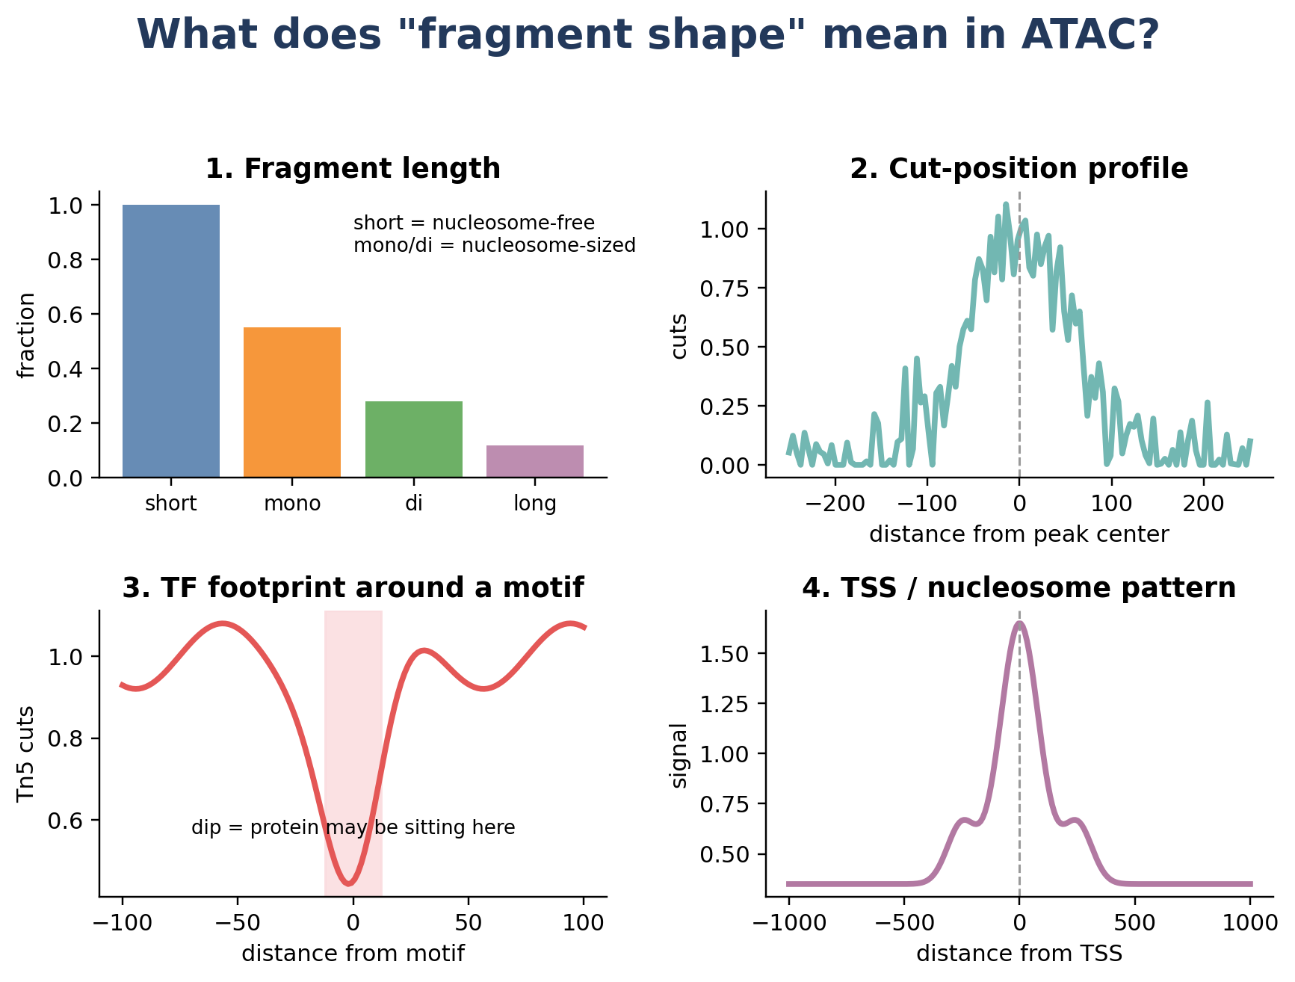
Figure 3. Examples of fragment-shape features: length, cut-position profile, transcription-factor footprint, and TSS or nucleosome pattern.
Shape feature | What it means biologically | Why it helps deconvolution
Fragment length | Short fragments often come from nucleosome-free DNA; longer fragments can span nucleosomes. | Two cell types may have the same open peak but different nucleosome organization.
Cut-position profile | Where Tn5 cuts inside a peak. | A sharp center versus broad shoulders can distinguish regulatory states.
Motif footprint | A dip or pattern around a TF motif can suggest a protein is bound nearby. | Cell types often use different TFs, even when the same enhancer is open.
TSS profile | Signal around transcription start sites. | Promoter organization can differ across cell types and states.

Important simplification
ShapeMix-ATAC does not need to perfectly identify every transcription factor. It only needs shape patterns that are repeatable enough to help tell cell types apart.

2.2 The central hypothesis
The method is based on this hypothesis:
Hypothesis
A cell type has a chromatin fingerprint. That fingerprint includes both which peaks are open and how ATAC fragments are shaped inside those peaks.

If this hypothesis is true, then a mixed spatial spot can be unmixed more accurately by using both peak counts and fragment shapes.

3. ShapeMix-ATAC in plain language

3.1 Inputs and outputs
ShapeMix-ATAC needs two data sources:
- Reference data: single-cell ATAC or single-cell multiome data where cells have known labels such as neuron, T cell, macrophage, endothelial cell.
- Spatial data: spatial ATAC fragments with spot barcodes and x-y coordinates.
It returns:
- A table of estimated cell-type proportions for every spatial spot.
- Uncertainty estimates, so we know when the model is unsure.
- Optional feature explanations: which peaks or shapes supported each cell-type call.
- Optional reconstructed cell-type-specific accessibility in space.
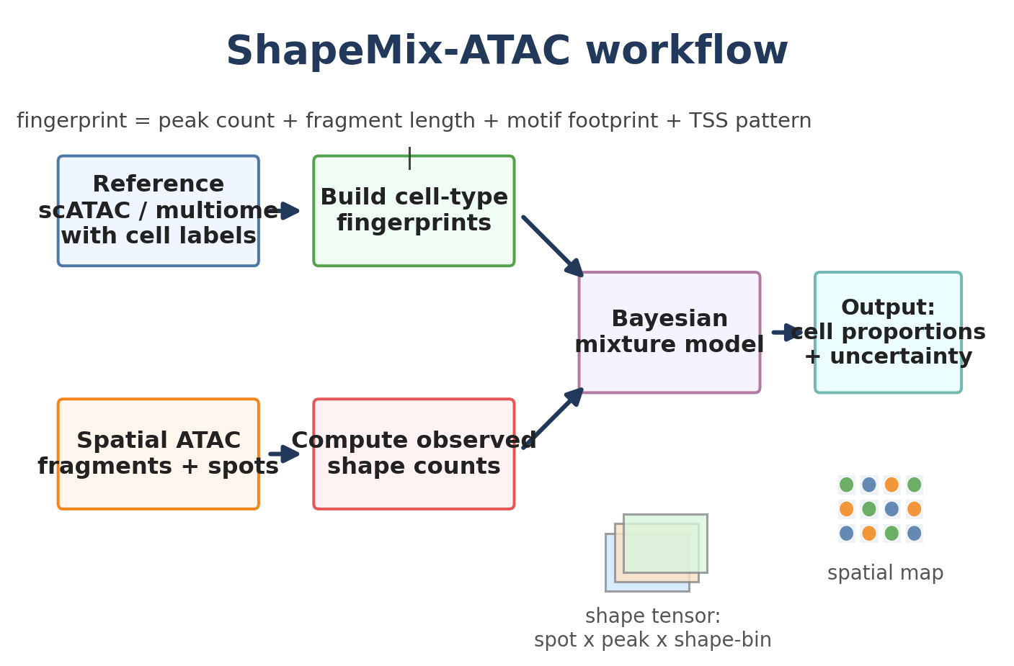
Figure 4. ShapeMix-ATAC workflow. Reference cells build fingerprints; spatial fragments build observed shape counts; a Bayesian mixture model estimates the cell types in each spot.

3.2 What is a cell-type fingerprint?
A fingerprint is a summary of what a cell type usually looks like in ATAC. For a count-only model, the fingerprint might say: peak 1 is high, peak 2 is low, peak 3 is medium. For ShapeMix-ATAC, the fingerprint is richer:
ShapeMix fingerprint
For each cell type and each useful peak: how many fragments are expected in each shape bin?

A shape bin can be simple. For example, fragment length can be binned into short, mononucleosome-like, dinucleosome-like, and long. A motif footprint can be binned into positions around a motif. A TSS profile can be binned by distance from the TSS.

3.3 A tiny toy example
Suppose a peak is open in both T cells and macrophages. A count-only model sees the same total count and gets confused. But T cells might have mostly short fragments at that peak, while macrophages might have mostly mononucleosome-size fragments. If a spatial spot has a half-and-half shape profile, ShapeMix-ATAC estimates that the spot is about half T cell and half macrophage.
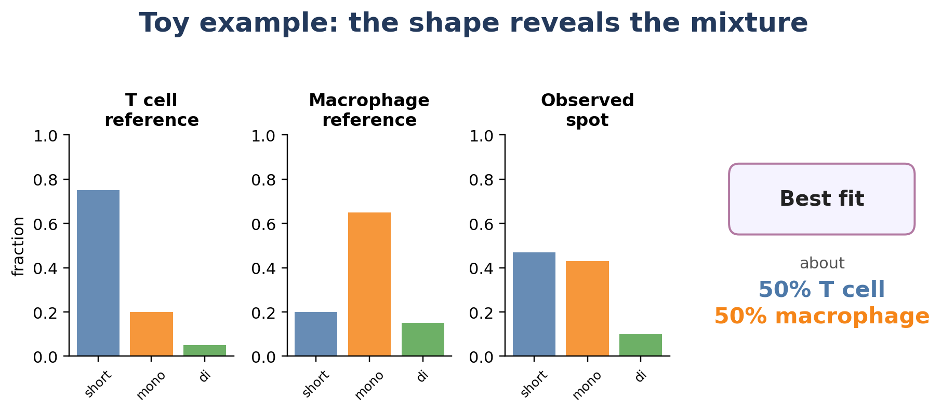
Figure 5. A toy example using three fragment-length bins. The observed spot shape is best explained by a mixture of the two reference shapes.

4. Step-by-step algorithm
Here is the algorithm as a recipe. This is the version I would implement first because it is simple, testable, and easy to explain.

Step 1: Choose shared peaks
Create a common list of peaks that exist in both the reference scATAC data and the spatial ATAC data. Do not use every peak at first. Start with peaks that are variable across cell types, marker-like, reproducible, and high enough depth to estimate shapes.

Step 2: Create shape bins
For the first prototype, use fragment-length bins. For example:
- short fragments: often nucleosome-free
- mononucleosome-like fragments
- dinucleosome-like fragments
- longer fragments
Later versions can add motif footprints, cut-position profiles, and TSS patterns.

Step 3: Build reference fingerprints
For each cell type, count how often fragments fall into each peak and shape bin. Then normalize so the fingerprint does not simply reflect that one reference cell type had more sequencing depth.

Step 4: Build the spatial shape-count tensor
For each spatial spot, count fragments in each selected peak and shape bin. The result is like a 3D spreadsheet:
Shape tensor
spot x peak x shape-bin

Step 5: Fit each spot as a mixture
The model asks: What combination of reference fingerprints best recreates the observed shape-count tensor for this spot?
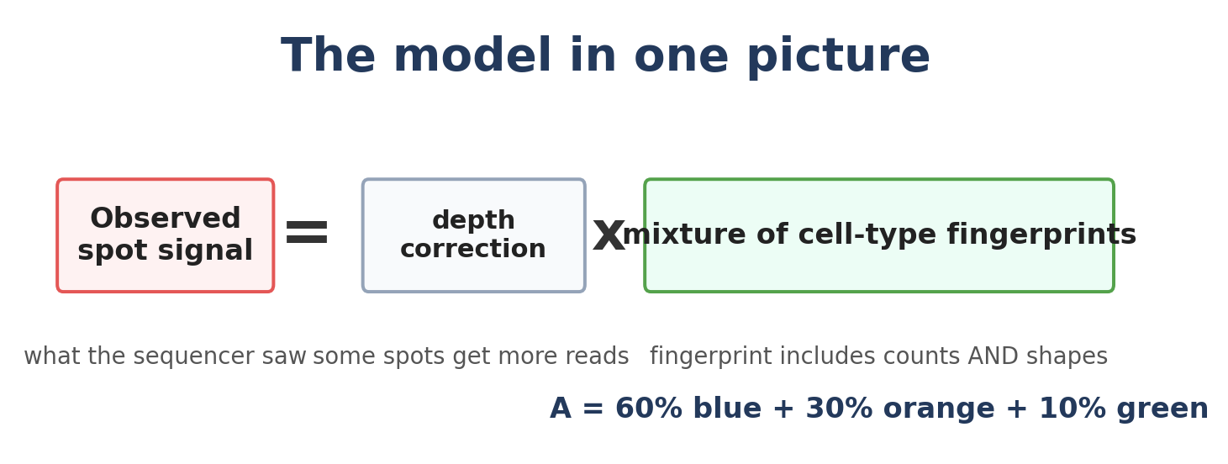
Figure 6. The intuitive model equation. Observed signal is explained by sequencing depth times a mixture of cell-type fingerprints.

Step 6: Add uncertainty
Because ATAC is sparse and noisy, ShapeMix-ATAC should be Bayesian. Bayesian does not mean mysterious; it means the model returns a range of plausible answers, not only one number. For example, it might say a spot is 60% T cell, but the uncertainty interval is 50-70%.

Step 7: Make maps
Finally, turn the estimated proportions into spatial maps. These maps can show where each cell type is located, where predictions are uncertain, and which shape features helped.
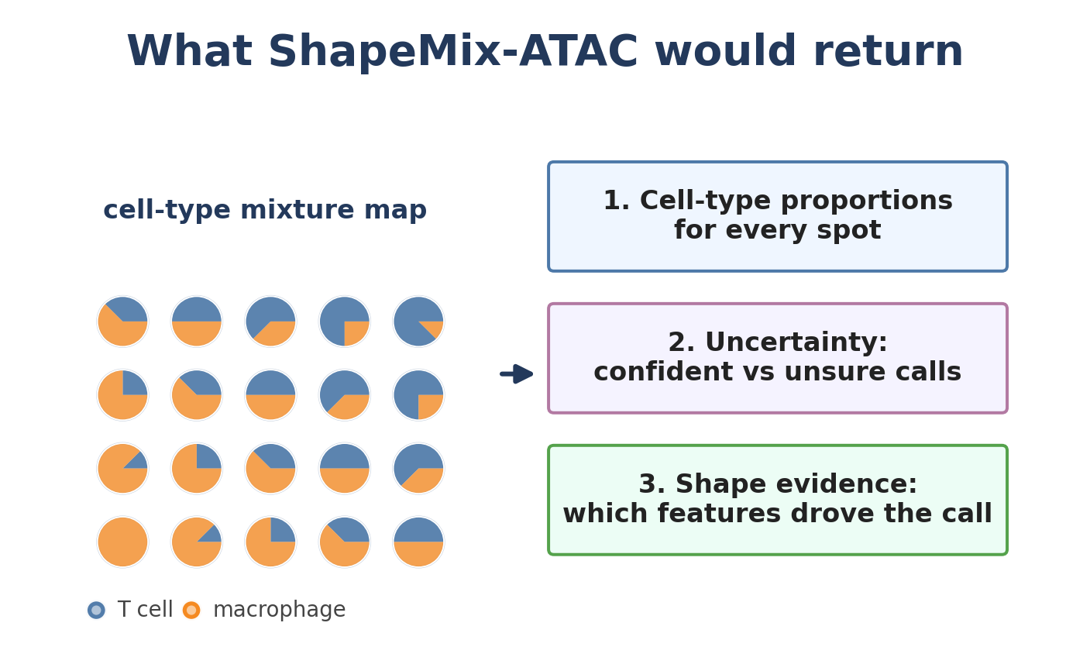
Figure 7. ShapeMix-ATAC outputs cell-type proportions, uncertainty, and evidence summaries across tissue space.

5. The model with optional math
This section gives a formal version for later implementation. You can skip it and still understand the idea.

5.1 Names of the objects
Symbol | Meaning
s | a spatial spot
p | a peak or regulatory region
b | a shape bin, such as short-fragment bin or motif-position bin
c | a cell type
Y(s,p,b) | observed number of fragments in spot s, peak p, shape bin b
theta(c,p,b) | reference fingerprint: expected signal of cell type c at peak p and shape bin b
a(s,c) | unknown abundance of cell type c in spot s; this is what we want to estimate

5.2 Simple likelihood
A simple count model is:
Mathematical version
Y(s,p,b) is drawn from a Poisson or negative-binomial distribution whose mean is proportional to: spot depth x sum over cell types [a(s,c) x theta(c,p,b)].

In words: the expected number of fragments in a spot is the sum of the fragments contributed by each cell type. Each contribution depends on how much of that cell type is present and what its reference fingerprint looks like.

5.3 Useful priors
Priors are reasonable assumptions that help the model when data are noisy.
- Nonnegative abundance prior: cell-type amounts cannot be negative.
- Sparsity prior: most spots probably contain only a few major cell types, not every cell type.
- Neighbor prior: nearby spots often have similar composition, unless a boundary is detected.
- Shape reliability prior: some peaks have reliable shape patterns; others are too noisy and should get lower weight.

5.4 Why not make it too complex at first?
The first version should be simple enough to debug. The safest prototype is: peak counts plus fragment-length bins, Poisson or negative-binomial likelihood, learned peak weights, and optional spatial smoothing. Motif footprints can be added after the basic version works.

6. Why this should work intuitively
ShapeMix-ATAC should help most when cell types share open peaks but differ in how those peaks are organized. This can happen often, because two cell types can use the same broad regulatory region while using different transcription factors or nucleosome arrangements.
Situation | Count-only model | ShapeMix-ATAC
Two cell types have the same open enhancer. | May confuse them because total counts look similar. | Can use fragment length, footprint, or cut-position pattern to separate them.
Rare cell type is present in a few spots. | May miss it if peak counts are sparse. | Can combine weak evidence across many shape-aware features.
Reference and spatial data differ in sequencing depth. | May overfit depth differences. | Can explicitly model depth and peak/shape reliability.
A spot is near a tissue boundary. | May be unstable or overly smoothed. | Can use shape evidence plus optional boundary-aware smoothing.

The intuitive advantage
Peak counts tell us which doors are open. Fragment shapes tell us how people are standing in the doorway.

7. What is new about ShapeMix-ATAC?
The novelty is not simply using ATAC peak counts in a Bayesian model. That direction is close to existing RNA-style count deconvolution and to your unfinished improvedATAC direction. ShapeMix-ATAC should be framed around a different core contribution:
Proposed novelty claim
To our knowledge, ShapeMix-ATAC is the first spot-level spatial ATAC deconvolution model that jointly uses peak accessibility and cell-type-specific fragment-shape fingerprints.

This claim is plausible because the direct spatial ATAC deconvolution literature is currently dominated by transferred spatial RNA methods that use peak-count matrices. Related ATAC work uses fragment information for quality control, footprinting, or single-cell ATAC analysis, but I did not find a method whose deconvolution likelihood directly models a spot x peak x shape-bin tensor.

7.1 What it is not
- It is not just Cell2location with peaks instead of genes.
- It is not just RCTD with an ATAC matrix.
- It is not only motif enrichment or chromVAR scores.
- It is not only denoising or clustering spatial ATAC domains.

7.2 What it is
- A mixture model for spot-level spatial ATAC.
- A cell-type proportion estimator.
- A fragment-shape-aware model, not only a peak-count model.
- A biologically interpretable method: each prediction can be linked to peaks, motifs, or shape patterns.

8. Implementation plan

8.1 Minimal prototype
The first version should be deliberately small:
1. Use a shared peak set from reference and spatial ATAC.
2. Select 5,000-20,000 informative peaks, prioritizing highly variable and cell-type-specific peaks.
3. For each peak, compute four fragment-length bins.
4. Build reference fingerprints from labeled scATAC or multiome cells.
5. Fit each spatial spot using a Poisson or negative-binomial mixture model.
6. Compare against count-only ShapeMix, Cell2location, RCTD, Tangram, SpatialDWLS, DestVI, and simple NNLS.

8.2 Second version
- Add motif-footprint bins for selected motifs.
- Add TSS profiles for promoter-like peaks.
- Add uncertainty calibration.
- Add a spatial prior that smooths nearby spots but preserves boundaries.
- Add an unknown/residual component for cell states missing from the reference.

8.3 Pseudocode
Pseudocode
Input: reference fragments with cell labels, spatial fragments with spot labels, shared peak set.
1. For each cell type c, peak p, and shape bin b, estimate theta(c,p,b).
2. For each spot s, peak p, and shape bin b, count Y(s,p,b).
3. For each spot s, find cell abundances a(s,c) that make sum_c a(s,c) theta(c,p,b) match Y(s,p,b).
4. Return a spot-by-cell-type table, uncertainty, and evidence summaries.

9. Evaluation plan
A new method should be judged by whether it improves real scientific tasks, not only whether the model sounds clever. The best first benchmark is deconvATAC-style simulation, because true cell proportions are known in simulated spots.
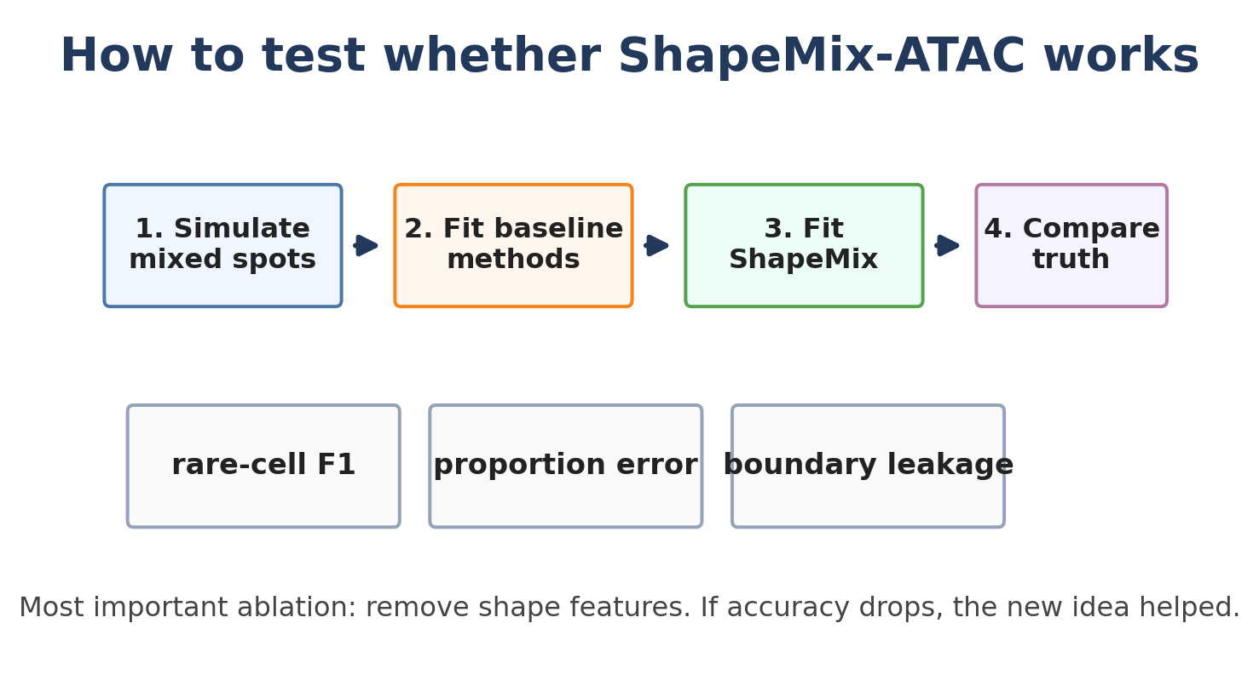
Figure 8. Validation plan. The key test is whether shape-aware features improve accuracy compared with the same model after removing shape information.
Test | Question answered
Proportion RMSE or Jensen-Shannon divergence | Are the estimated cell proportions close to the truth?
Rare-cell F1 score | Does the method find rare cell types without many false positives?
Ablation: remove shape bins | Did fragment shape actually help?
Ablation: fragment length only vs footprint only | Which shape feature is most useful?
Boundary leakage score | Does smoothing blur across tissue borders?
Calibration | When the model says it is 80% confident, is it really correct about 80% of the time?

Most important experiment
Run the exact same model twice: once with shape bins, once after collapsing all shape bins into total peak counts. If the shape-aware version improves rare-cell and fine-subtype recovery, the core idea is supported.

10. Risks and fixes
Risk | Why it matters | Possible fix
Shape data are sparse. | Per-peak fragment shapes may be too noisy. | Aggregate peaks by motif, promoter, or topic; use shrinkage.
Reference data do not match spatial data. | Different protocols can change fragment patterns. | Learn reference-to-spatial bias terms; use multiome data when possible.
Motif footprints are hard at low depth. | Footprint signals need many fragments. | Start with fragment length; add footprints only for abundant motif groups.
Too many peaks make the model slow. | ATAC has far more features than RNA. | Use feature selection and mini-batch optimization.
Shape differences may reflect technical artifacts. | Tn5 bias, GC bias, or peak width could mimic biology. | Include peak width, GC, mappability, and Tn5-bias corrections.

11. How to explain ShapeMix-ATAC in one minute
Here is a short explanation you could use in a presentation:
One-minute pitch
Spatial ATAC spots often contain mixtures of cells, so we need deconvolution. Existing methods mostly adapt spatial RNA deconvolution by replacing genes with ATAC peaks. ShapeMix-ATAC adds an ATAC-native idea: every ATAC fragment has a shape, including its length and position inside a peak. Different cell types can have similar peak counts but different fragment shapes because their nucleosomes and transcription factors are arranged differently. ShapeMix-ATAC learns cell-type-specific peak-and-shape fingerprints from single-cell ATAC references and fits each spatial spot as a mixture of those fingerprints. The output is a spatial map of cell-type proportions plus uncertainty and evidence.

12. Glossary
Term | Simple meaning
Chromatin | DNA plus proteins that package and regulate DNA.
Accessible chromatin | DNA that is open enough for proteins, and Tn5, to reach.
ATAC-seq | A sequencing method that tags open DNA regions using Tn5.
Fragment | A piece of DNA cut and sequenced by ATAC-seq.
Peak | A genomic region with many ATAC fragments.
Spatial spot / pixel | A small physical area on the tissue slide with a barcode.
Deconvolution | Unmixing a mixed signal to estimate which cell types contributed.
Reference | Single-cell data with known cell-type labels used to learn signatures.
Motif | A short DNA sequence pattern recognized by a transcription factor.
Footprint | A cut pattern near a motif that may suggest protein binding.
Bayesian model | A model that estimates plausible answers and uncertainty.

13. Sources and positioning
These sources shaped the proposal. They are included so the novelty and biological assumptions can be checked carefully.
- Deng Y. et al. Spatial profiling of chromatin accessibility in mouse and human tissues. Nature, 2022. Key relevance: spatial-ATAC-seq workflow, spot resolution, fragment-size distribution, TSS enrichment, and spatial chromatin maps.
- Guo P. et al. Multiplexed spatial mapping of chromatin features, transcriptome, and proteins in tissues. Nature Methods, 2025. Key relevance: spatial multi-omics and regulatory layers including chromatin accessibility, histone marks, RNA, and protein.
- Ouologuem S. et al. Spatial transcriptomics deconvolution methods generalize well to spatial chromatin accessibility data. Bioinformatics, 2025. Key relevance: deconvATAC benchmark, transferred RNA deconvolution methods, rare-cell limitation, and feature-selection importance.
- Lareau C. et al. Modeling fragment counts improves single-cell ATAC-seq analysis. Nature Methods, 2023. Key relevance: fragment counts preserve quantitative information in ATAC.
- Biancalani T. et al. Deep learning and alignment of spatially resolved single-cell transcriptomes with Tangram. Nature Methods, 2021. Key relevance: multimodal projection of chromatin accessibility, but not measured mixed-spot spatial ATAC fragment-shape deconvolution.
- Kleshchevnikov V. et al. Cell2location maps fine-grained cell types in spatial transcriptomics. Nature Biotechnology, 2022. Key relevance: Bayesian spatial transcriptomics deconvolution baseline.
- Cable D. et al. Robust decomposition of cell type mixtures in spatial transcriptomics. bioRxiv/Nature Biotechnology lineage of RCTD/spacexr. Key relevance: probabilistic count-mixture baseline.
Careful novelty wording
For a paper, use “to our knowledge” and cite the literature search. Avoid claiming absolute firstness until a final systematic search is complete.

Appendix: concrete first experiment
A first publishable experiment could be extremely direct:
1. Use a paired multiome reference with annotated cell types.
2. Create simulated spatial ATAC spots by mixing known cells, so the true proportions are known.
3. Fit a count-only model using peak counts.
4. Fit ShapeMix-ATAC using peak counts plus fragment-length bins.
5. Compare rare-cell F1, overall proportion error, and calibration.
6. Repeat in several tissues and under different spot cell densities.
The most convincing result would be a simple ablation plot showing that the shape-aware model beats the count-only version, especially when cell types have similar accessibility peaks but different regulatory structure.
End of tutorial

