Table of Contents
what is spatial atac seq? difference from atac seq 1
What is standard ATAC-seq? 1
What is Spatial ATAC-seq? 1
The Core Differences 1
Why does this difference matter? 1
what are the research problems and challenges in the area of spatial ATAC 1
How do we evaluate the tools for spatial ATAC, it seems if some data is missing, it is hard to know, right? 1
why is it important to develop and improve spatial ATAC techniques? 1
what is spatial ATAC deconvolution 1
The Context: What is Spatial ATAC-seq? 1
The Problem: The "Mixed Spot" Issue 1
The Solution: Deconvolution 1
Common Tools and Frameworks 1
Why Does This Matter? 1
history of spatial atac technology 1
1. The Foundation: Standard ATAC-seq (2013) 1
2. The Bridge: Single-Cell ATAC (2015) 1
3. The Breakthrough: Spatial Integration (2020–2021) 1
A. Microfluidic Indexing (DBiT-seq) 1
B. Spatial ATAC-seq via Tn5 (2021) 1
4. The Multi-Omics Era (2022–Present) 1
Summary of Evolution 1
What are the challenges and unsolved research problems in this area? 1
1. The "Sparsity" Problem (The Data is Mostly Zeros) 1
2. The FFPE Bottleneck (Clinical Translation) 1
3. The Resolution vs. Field of View (FOV) Trade-off 1
4. Computational Benchmarking and the "Wild West" of Software 1
5. The Leap to True 3D Epigenomics 1
I am think about working on "spatial ATAC deconvolution with uncertainty or rare-cell focus" as a high school science project, what do you think? 1
My honest rating 1
Best project version 1
What you would actually do 1
The most realistic uncertainty idea 1
Metrics that would make the project look rigorous 1
Why this is a good science project 1
What I would avoid 1
A strong final project structure 1
My recommendation 1
Please find a list of university professors working on spatial ATAC seq, please focus on those in the USA. 1
Please find more relevant people in this research area, they can be researchers or professors 1
Strong additional U.S.-based names 1
U.S. researchers in very close adjacent methods 1
Global names worth knowing 1
Best additions to prioritize 1

what is spatial atac seq? difference from atac seq
This is a great question about one of the most exciting, rapidly evolving areas in genomics right now. To understand Spatial ATAC-seq, it helps to briefly ground it in what standard ATAC-seq does.

What is standard ATAC-seq?
ATAC-seq (Assay for Transposase-Accessible Chromatin using sequencing) is a technique used to figure out which parts of the genome are "active" or "open."
Think of your DNA like a massive, coiled-up instruction manual. Most of the manual is tightly packed away (closed chromatin) because the cell doesn't need those instructions right now. However, the specific pages the cell is actively using are unspooled and accessible (open chromatin). ATAC-seq uses an enzyme called Tn5 transposase, which acts like a molecular tagger that slips into these open sections and attaches sequencing tags to them.
The limitation: To do standard ATAC-seq (whether on bulk tissue or single cells), you have to break the tissue apart and dissolve it into a liquid suspension. You learn exactly what parts of the genome are open, but you completely lose the information about where those cells were physically located in the tissue.

What is Spatial ATAC-seq?
Spatial ATAC-seq takes the core chemistry of ATAC-seq and maps it directly onto an intact slice of tissue. It tells you not just what DNA regions are accessible, but exactly where in the tissue those accessible regions are located.
Instead of blending the tissue into a "smoothie," scientists place a razor-thin slice of tissue onto a specialized slide. This slide (or a microfluidic device placed over the tissue) contains microscopic grids of spatial barcodes. When the Tn5 enzyme tags the open DNA, the spatial barcodes attach to those tags.
After sequencing the DNA, computers use those barcodes like GPS coordinates ( and coordinates) to map the open chromatin back to its exact original location on a picture of the tissue.

The Core Differences
Here is a straightforward breakdown of how they compare:
Feature | Standard ATAC-seq (Bulk/Single-Cell) | Spatial ATAC-seq
Tissue State | Dissociated (blended/broken apart into a liquid). | Intact (a thin slice preserved on a slide).
What it tells you | Which genes are active/open across a cell population. | Which genes are active/open, mapped to exact tissue locations.
Spatial Context | Lost. You don't know if a cell was next to a blood vessel or deep inside a tumor. | Preserved. You can see how chromatin changes based on neighboring cells.
Primary Use Case | Finding regulatory regions, mapping developmental pathways in isolated cells. | Studying tissue architecture, like how a tumor interacts with the healthy tissue surrounding it.

Why does this difference matter?
Biology is highly dependent on location. For example, a cancer cell on the outer edge of a tumor acts very differently than a cancer cell suffocating in the oxygen-deprived center of the tumor. Standard ATAC-seq mixes all those cells together, blurring the lines. Spatial ATAC-seq allows scientists to actually look at the tissue's "geography" and see how a cell's physical neighborhood changes its fundamental genetic programming.

what are the research problems and challenges in the area of spatial ATAC
I’m pulling together recent spatial-ATAC papers and reviews to separate method-specific limitations from broader experimental, computational, biological, and standards-related open problems, then I’ll condense them into a current research-focused summary with citations.
The main bottlenecks are converging on a tradeoff among resolution, signal quality, and real-tissue compatibility, plus ATAC-only data often under-resolving cell identity. Computationally, transcriptomics-adapted spatial-feature methods still struggle on ATAC peaks.
Thought for 22m 49s
By spatial ATAC, I mean methods that measure chromatin accessibility while preserving tissue coordinates, such as in situ barcoded spatial-ATAC-seq, solid-phase slide capture approaches, and joint spatial-ATAC–RNA assays. Compared with spatial transcriptomics, this part of spatial epigenomics is still younger and less mature, so many of the biggest questions are still methodological.
The main research problems and challenges are:
- True single-cell resolution is still not routine. Even when papers report cellular or near-single-cell scales, many pixels or spots still mix multiple cells. In juvenile mouse brain, most 20 μm pixels contained 1–3 cells; in adult human hippocampus, 50 μm pixels contained 1–9 cells; and solid-phase spatial ATAC used 55 μm spots. That makes deconvolution, cell segmentation, and image-aware inference major open problems.
- The data are extremely sparse and noisy. Recent spatial epigenomics work explicitly describes low signal detection, substantial noise, extremely sparse peak matrices, and missing data from low capture rates. This hurts nearly every downstream step: clustering, motif analysis, gene activity scoring, and peak calling. Because spatial ATAC inherits much of the ATAC/scATAC workflow, consensus peak definitions can also miss rare, cell-type-specific regulatory elements.
- The statistics for spatially variable peaks are still immature. Identifying peaks with real spatial structure is one of the core tasks in spatial ATAC, but this area is still catching up to spatial RNA. Descart was introduced partly because there had been a lack of methods tailored to spatial ATAC, and a 2025 benchmark found that most methods were poorly calibrated and that more specialized algorithms are still needed for spatially variable peaks.
- Cell-type annotation and cross-sample integration are hard. Accessibility alone has fewer clean cell-type markers than RNA, so interpretation often depends on gene activity scores, scRNA-seq references, or joint ATAC–RNA measurements. Recent spATAC integration work also points to urgent needs for spATAC-specific methods that can correct batch effects, preserve biology, and annotate domains across multiple samples.
- Regulatory inference is much harder than clustering. The deeper biological question is not just “where are the open peaks?” but “which peaks regulate which genes, in which spatial neighborhoods, and in which cell states?” Newer methods such as MultiGATE were built because spatial multi-omics needs explicit modeling of cross-modality regulation like peak–gene links. The fact that these methods validate predictions against external eQTL and ChIP data suggests, in my view, that strong native ground truth for in situ regulatory links is still limited.
- Histology and morphology are still underused. The original spatial-ATAC-seq paper explicitly suggested deconvolution and integration with high-resolution immunofluorescence to resolve mixed pixels. MultiGATE also notes that current spatial ATAC–RNA analysis does not yet incorporate histology images into pixel embeddings. So a big open area is joint modeling of images, spatial coordinates, and accessibility.
- Clinical translation is only starting. Until 2025, spatial ATAC was largely limited to fresh-frozen tissue. Spatial FFPE-ATAC-seq was developed specifically to overcome formalin-induced crosslinking that blocks Tn5 access and complicates chromatin recovery. Because FFPE blocks dominate pathology archives, robust FFPE-compatible spatial ATAC is one of the most important translational problems in the field.
- Scalability, cost, and standardization remain bottlenecks. Some methods still depend on bespoke slides and capture chemistries, and others, such as sciMAP-ATAC, reported manual punching and post hoc registration as limits on precision and throughput. So there is still a lot of room for work on platform portability, automation, and reproducible end-to-end workflows.
- The ecosystem needs better benchmarks, software, and study design. Reviews emphasize the need for better data sharing, documentation, visualization, and benchmarking, while dedicated platforms such as AtlasXplore exist because raw spatial epigenome data are still hard to explore without substantial custom processing. On the experimental side, spatial power-analysis work shows that field-of-view size, number, placement, and resolution can materially change which spatial features you can detect.
A compact way to state the field’s central problem is:
How do we recover cell-resolved, reproducible, biologically interpretable regulatory maps from sparse, partially mixed, platform-specific chromatin accessibility measurements in intact tissue?
The most fertile directions right now are denoising, image-aware deconvolution, spATAC-specific integration/annotation, and better validation of peak–gene links, especially on FFPE disease cohorts.
If it helps, I can turn this into a research proposal-style list of open questions for a PhD, postdoc, or grant.

How do we evaluate the tools for spatial ATAC, it seems if some data is missing, it is hard to know, right?
I’m framing this as an evaluation problem under partial ground truth, focusing on how spatial ATAC tools are actually benchmarked, which checks are trustworthy, and what remains fundamentally unidentifiable when missingness is substantial.
In practice, that means not trusting visually plausible maps alone: strong benchmarks combine semi-synthetic truth, matched modalities, reproducibility, and null-calibration tests, always against simple baselines too.
Thought for 58m 31s
Yes. At the level of one spot–peak entry, you usually cannot know from the observed matrix alone whether a zero means real closed chromatin or missed capture. In ATAC-type data, missing observations appear as zero counts rather than NAs, and spatial ATAC adds spot mixing because many barcoded spots contain multiple cells. That is why spatial ATAC benchmarking cannot rely on a single gold-standard matrix.
I’d evaluate tools in layers:
- Separate assay quality from algorithm quality.
Before comparing methods, put them on the same filtered set of spots or cells and report core ATAC QC: TSS enrichment, FRIP or related signal-in-peak measures, unique fragments, duplication, and fragment periodicity. In scATAC benchmarks these QC metrics track downstream annotation and differential-accessibility quality, and spatial ATAC papers similarly use TSS enrichment or TSS overlap, nucleosome periodicity, unique fragments per spot, and concordance with reference snATAC/ENCODE as core checks.
- For denoising or imputation, build controlled pseudo-ground-truth.
Because real missingness is ambiguous, the cleanest test is to start from higher-quality data, create pseudo-spots or downsample spatial ATAC, and then ask how well the method recovers held-out or known signal. Simple random masking is only part of the story, because capture probability is cell-specific in ATAC data. Recent spatial epigenomics papers benchmark denoisers on both simulated and real tissue datasets, and they also check whether the denoised output actually helps downstream tasks such as differential accessibility, spatial-domain identification, and gene-activity inference.
- Use task-specific metrics, not one global score.
For spatially variable peak callers, a recent benchmark evaluates ranking accuracy, classification accuracy, statistical calibration of p-values, scalability, and impact on downstream spatial clustering. It found that most methods are poorly calibrated and that current RNA-derived approaches are weak on spatially variable peaks because spatial ATAC matrices are sparse, near-binary, and high-dimensional. For integration tools, evaluate biological conservation, batch correction, and annotation separately. INSTINCT, for example, uses ARI/AMI/NMI/FMI/completeness/homogeneity, representation metrics like mAP and ASW, batch metrics like kBET and batch PCR, and slice-wise annotation accuracy/F1.
- On real tissue, lean on orthogonal validation.
Since full ground truth is missing, the strongest evidence is agreement with something measured independently: matched RNA on the same section, scATAC/snATAC references, known anatomy or histology, and biological replicates. Spatial-ATAC-RNA-seq reported very high replicate correlations and used both gene-activity/expression concordance and label transfer from scRNA/scATAC for validation. Spatial ATAC also showed concordance with ENCODE reference accessibility and corresponding Visium spatial patterns.
- Stress-test missingness itself.
A good method should remain stable when you downsample reads, change spot filters, or leave out a slice, and it should not “win” by over-smoothing away rare states. The scATAC protocol benchmark showed that annotation accuracy and DAR strength depend strongly on sequencing depth and fragment counts, so depth sensitivity should be part of every benchmark. INSTINCT also explicitly tested whether a rare spot-type was preserved after integration, which is exactly the kind of check that guards against over-mixing.
So your intuition is correct: for a single missing value, it is often fundamentally hard to know. In spatial ATAC, evaluation is mostly probabilistic and comparative: does the method stay calibrated under null data, recover known structure in controlled simulations, preserve rare biology, reproduce across replicates, and improve concordance with orthogonal data? That is much more informative than a single “accuracy” number.

why is it important to develop and improve spatial ATAC techniques?
I’m focusing on why spatial ATAC matters specifically beyond spatial RNA, pulling together the strongest reasons from the spatial epigenomics literature rather than giving a generic answer.
I’ve got the main case now: spatial ATAC captures where regulation happens in tissue, adding the upstream layer behind RNA patterns, and improved protocols are what make developmental, disease, and archived clinical samples truly usable.
Thought for 23m 8s
The main reason is that tissues are spatially organized regulatory systems, not just maps of gene expression. Spatial RNA tells you where transcripts are, but spatial ATAC tells you where chromatin is accessible and which regulatory programs are available in each location. In joint spatial ATAC–RNA measurements, the epigenome and transcriptome were partly concordant but also showed distinct spatial patterns, revealing epigenetic priming, differentiation, and gene-regulatory effects that RNA alone would miss.
It is also important because standard scATAC loses the tissue map. The original spatial-ATAC-seq paper notes that dissociation removes spatial context and can bias cell recovery or perturb cell states. Spatial ATAC keeps chromatin accessibility tied to position in the tissue, so regulatory states can be interpreted in their native anatomical setting instead of after the tissue has been broken apart.
That matters biologically. In embryos and brain, spatial ATAC identified region-specific epigenetic landscapes and regulators involved in CNS development, and slide-based spatial ATAC linked progenitor-versus-neuron regulatory elements and transcription factor motifs to cortical layer differentiation. Joint spatial ATAC–RNA then mapped how epigenetic mechanisms relate to transcriptional phenotype and cell dynamics in embryonic, juvenile, and adult brain tissue.
It matters for disease too. Spatial ATAC has already been used to resolve immune organization in tonsil tissue, identify HER2-positive regions and tumor–myeloid interfaces in breast cancer, and profile chromatin accessibility across tumor and non-tumor regions in archived human melanoma. Those are exactly the kinds of settings where spatially localized regulatory states, not just averaged expression, shape pathology.
Improving the technology is important because the field is promising but still technically immature. Even a leading joint platform described itself as near-single-cell resolution, not universally true single-cell, and earlier work noted that spatial chromatin profiling was still limited in scale and often depended on specialized setups such as custom microfluidics or microbiopsies. A 2025 spatial FFPE-ATAC method was notable precisely because archived pathology samples are a large resource and formalin crosslinking had made spatial chromatin profiling difficult. Better sensitivity, resolution, robustness, and compatibility with routine clinical specimens are what will turn spatial ATAC from a powerful niche method into a standard way to study gene regulation in intact tissues.
At bottom, it matters because many of the hardest questions in development, neuroscience, immunology, and cancer are really questions about where regulatory states arise, interact, and change inside tissue. Spatial ATAC is one of the few tools that can address that directly

Since spatial ATAC-seq is hard than spatial RNA, what is the additional value does spatial ATAC bring that spatial RNA does not provide?
I’ll compare spatial ATAC against spatial RNA by focusing on the extra biological information ATAC adds: regulatory potential, noncoding elements, upstream drivers, and poised states.
Thought for 3m 21s
Spatial ATAC’s added value is that it gives you the spatial map of regulatory potential, while spatial RNA gives you the spatial map of expressed output. In other words: spatial RNA tells you what genes are being expressed where; spatial ATAC helps explain why those genes can be expressed there, which regulatory elements are active or poised, and which transcription factors may be driving the state.
A useful way to think about it:
Question | Spatial RNA | Spatial ATAC
Where is gene X expressed? | Excellent | Indirect
Which cell types/states are present? | Excellent | Good, often complementary
Which enhancers/promoters are accessible? | No | Yes
Which TFs may regulate a spatial region? | Indirect | Stronger, via motif/accessibility
Which noncoding regulatory variants matter in a niche? | Usually no | Yes
Which cells are epigenetically primed before RNA changes? | Often weak | Stronger
Why do two nearby regions express different programs? | Descriptive | More mechanistic

1. It identifies the regulatory DNA behind spatial gene expression
Most gene regulation is not encoded only at promoters or in the mRNA abundance of transcription factors. It often depends on enhancers, silencers, promoters, insulators, and other noncoding regulatory elements. Spatial RNA does not directly measure whether these DNA elements are open. Spatial ATAC does.
This is one of the core motivations for spatial ATAC: spatial transcriptomics can map gene expression, but spatial ATAC adds genome-wide chromatin-accessibility information in tissue context. The original spatial-ATAC-seq paper describes the method as a way to map chromatin accessibility in tissue and identify tissue-region-specific epigenetic landscapes and gene regulators.
So, instead of only saying:
“Gene A is high in this tumor border region.”
spatial ATAC can help say:
“Gene A is high in this tumor border region, and a set of nearby enhancers is accessible there, enriched for AP-1/TEAD/NF-κB/etc. motifs, suggesting a candidate regulatory mechanism.”
That is a different biological layer.

2. It helps infer transcription-factor activity more directly
Spatial RNA can tell you whether a TF mRNA is present, but TF mRNA abundance is often a poor proxy for TF activity. A transcription factor can be present but inactive, post-translationally regulated, excluded from the nucleus, or lacking accessible binding sites.
Spatial ATAC lets you ask whether the binding sites for that TF are accessible in that spatial niche. ATAC-seq is broadly used to detect chromatin landscapes associated with cell type, perturbation, or disease, and it does not require knowing in advance which TFs or epigenetic marks are involved.
This is a major added value in disease and development. For example, in a tumor, spatial RNA may show an inflammatory gene-expression program near immune infiltrates. Spatial ATAC can help identify whether that program is associated with accessible NF-κB, STAT, IRF, AP-1, or interferon-response regulatory elements.

3. It can reveal “primed” or latent states before RNA changes
RNA is often a snapshot of what a cell is expressing right now. Chromatin accessibility can reveal what a cell is competent or poised to express. During differentiation, activation, injury response, or tumor evolution, regulatory elements may become accessible before the corresponding genes are strongly expressed.
This is why joint spatial epigenome–transcriptome papers emphasize “epigenetic priming.” In one spatial ATAC–RNA study, the authors reported that spatial epigenome and spatial transcriptome features were often concordant but also showed distinct patterns, allowing investigation of spatial epigenetic priming, differentiation, and gene regulation within tissue architecture.
That matters when you want to distinguish:
Situation | Spatial RNA alone may show | Spatial ATAC can add
Early differentiation | Weak or ambiguous marker RNA | Open lineage enhancers
Immune activation | Some cytokine genes not yet expressed | Accessible inflammatory response elements
Drug resistance | Similar baseline expression | Pre-existing accessible survival/regulatory programs
Developmental patterning | Gradual gene-expression gradients | Region-specific enhancer activation
This is one of the strongest arguments for spatial ATAC: it can detect regulatory state before phenotype is obvious at the RNA level.

4. It distinguishes similar RNA states that have different regulatory mechanisms
Two tissue regions can have similar RNA profiles but different underlying regulatory architecture. For example, two populations may both express a marker gene, but one may use one enhancer module and the other a different enhancer module. Spatial RNA would see similar expression; spatial ATAC can reveal different accessible regulatory elements.
The spatial epigenome–transcriptome co-profiling study explicitly found that spatial epigenome and transcriptome profiles can identify concordant tissue features but also distinct patterns, implying that the two layers define cell states differently.
This is especially useful in:
- development, where cells transition through regulatory states;
- cancer, where tumor cells can converge on similar expression phenotypes through different regulatory programs;
- immune biology, where activation, exhaustion, memory, and tissue-resident states may have overlapping RNA markers but different chromatin programs.

5. It links spatial biology to noncoding disease variants
A lot of disease-associated genetic variation lies outside protein-coding genes, often in enhancers or other regulatory elements. Spatial RNA generally cannot tell you whether a disease-associated noncoding locus is active in a particular tissue niche. Spatial ATAC can ask:
Is this disease-associated enhancer accessible in this cell type, in this anatomical region, under this disease condition?
That is valuable for GWAS interpretation, cancer somatic noncoding mutations, eQTL/caQTL interpretation, and enhancer prioritization. Spatial RNA can tell you the downstream gene-expression consequence, but spatial ATAC can identify the regulatory DNA element where the variant may act.
A practical example would be inflammatory bowel disease, Alzheimer’s disease, breast cancer, or autoimmune tissue: many candidate variants are noncoding. Spatial ATAC helps map those variants onto the specific spatial cell states where the relevant regulatory elements are accessible.

6. It gives a more mechanistic view of tissue niches
Spatial RNA can define a niche by expressed genes: ligands, receptors, cytokines, matrix genes, metabolic genes, and markers. Spatial ATAC can define the niche by regulatory logic: enhancer accessibility, motif enrichment, TF regulons, and chromatin state.
For example:
Tissue niche | Spatial RNA tells you | Spatial ATAC adds
Tumor invasive edge | EMT, hypoxia, immune genes are expressed | Which enhancers/TFs drive invasion or immune evasion
Germinal center | B-cell activation markers | Regulatory elements distinguishing follicular zones
Developing brain | Regional marker genes | Enhancer programs controlling arealization and fate
Injury border | Stress/inflammation genes | Primed repair or fibrosis regulatory programs
Spatial ATAC has already been used to delineate region-specific epigenetic landscapes in mouse embryos, brain regions, and human tonsil immune organization. Solid-phase spatial ATAC was also presented as a way to discover regulatory programs underlying spatial gene expression during organogenesis, lineage differentiation, and human pathology.

7. It can improve cell-state annotation when RNA is limited or misleading
Spatial RNA has its own biases: dropout, transcript diffusion depending on platform, high abundance of housekeeping genes, stress-induced dissociation signatures in references, and difficulty separating closely related states. Spatial ATAC has different biases, but it can identify cell identity through accessible promoters and enhancers, sometimes even when marker RNAs are low.
For example, a cell may no longer express a developmental marker transcript, but its chromatin may still retain lineage-specific enhancer accessibility. Conversely, a transient RNA burst may occur without a stable chromatin-state change. Having ATAC can help separate transient expression from deeper regulatory identity.

8. It enables better enhancer–gene linking when combined with spatial RNA
The most powerful use is not necessarily spatial ATAC instead of spatial RNA, but spatial ATAC with spatial RNA. Spatial RNA gives gene expression; spatial ATAC gives candidate regulatory elements. When measured in the same or aligned tissue context, you can ask:
Which accessible enhancers spatially co-vary with which genes?
That allows construction of spatial peak-to-gene links, spatial regulons, and regulatory circuits. The spatial epigenome–transcriptome work specifically emphasizes linking epigenome and transcriptome pixel by pixel to study gene regulation within tissue architecture.
This is where spatial ATAC has very high value: it converts spatial transcriptomics from a descriptive map into a candidate mechanistic map.

The simplest distinction
Spatial RNA answers:
What is this tissue region doing?
Spatial ATAC answers:
What regulatory program makes this tissue region capable of doing that?
Or more concretely:
RNA is the current output. ATAC is the accessible regulatory code that helps produce, constrain, or prime that output.

When spatial ATAC is worth the extra difficulty
Spatial ATAC is especially worth it when your biological question involves:
- Enhancers or promoters, not just genes.
- Transcription-factor regulation, not just marker expression.
- Developmental transitions or priming.
- Disease-associated noncoding variants.
- Tumor microenvironments or immune niches.
- Mechanistic interpretation of spatial RNA patterns.
- Regulatory differences between similar-looking cell states.
It is probably not worth the added complexity when the main goal is simply to build a spatial cell-type map or identify where known marker genes are expressed. For that, spatial RNA is usually easier, richer, and more mature. The strongest case for spatial ATAC is when you need to move from where genes are expressed to which regulatory elements and TF programs explain that spatial expression pattern.

what is spatial ATAC deconvolution
Spatial ATAC deconvolution is a computational technique used in bioinformatics to estimate the specific proportions of different cell types present within a single "spot" or pixel of a spatial ATAC-seq dataset.
To understand why this is necessary and how it works, it helps to break down the technology and the biological problem it solves.

The Context: What is Spatial ATAC-seq?
ATAC-seq (Assay for Transposase-Accessible Chromatin using sequencing) is a method used to find areas of open, active chromatin in the genome. While standard ATAC-seq requires mashing up tissue and losing physical context, spatial ATAC-seq maps these epigenetic signals directly onto a tissue slide. It allows researchers to see exactly where in a tissue the genome is actively being regulated.
+1

The Problem: The "Mixed Spot" Issue
The catch with many spatial sequencing technologies (like 10x Genomics Visium or DBiT-seq) is that they rarely offer true, single-cell resolution. Instead, the tissue is mapped onto a microscopic grid of spots (typically 10 to 50 micrometers wide).
Depending on how densely packed the tissue is, a single spot might capture the chromatin accessibility data of anywhere from 2 to 20+ cells. Because of this, the signal retrieved from one spot is essentially a "bulk" mixture of several different cell types jumbled together.

The Solution: Deconvolution
Deconvolution is the mathematical process of un-mixing that blended signal. If a spatial spot is a smoothie, deconvolution is the algorithm that tells you exactly which fruits went into it and in what percentages.
How the process generally works:
- The Reference: Researchers input a high-resolution, single-cell reference dataset—usually scATAC-seq or single-cell RNA-seq (scRNA-seq) from the same tissue type. This provides a pure, isolated "signature" (peak accessibility or gene activity) for every individual cell type.
- The Spatial Data: The algorithm looks at the mixed, spatially resolved ATAC-seq spots.
- The Mapping: Computational models compare the mixed spatial signal to the pure single-cell reference signatures. By finding the best statistical fit, the algorithm might determine that a specific spot on a brain slice is exactly 60% neuron, 30% astrocyte, and 10% microglia.

Common Tools and Frameworks
Because spatial ATAC-seq is a newer modality than spatial RNA sequencing, the bioinformatics community often adapts highly successful spatial transcriptomics deconvolution tools to handle chromatin data. Recent benchmarks show that these tools generalize very well to spatial ATAC data:
- Cell2location: A Bayesian probabilistic model that is highly accurate at mapping fine-grained cell types across spatial spots.
- RCTD (Robust Cell Type Decomposition): A statistical method using maximum-likelihood estimation to predict cell-type proportions, working well with curated single-cell references.
- Tangram: A deep learning-based tool that aligns single-cell data to spatial data, excelling at mapping profiles into spatial coordinates.
- Seurat & Signac: A very popular R-based ecosystem. Signac is used to calculate "gene activity scores" from the ATAC open chromatin peaks. This effectively translates the ATAC data into a format that looks like RNA expression, creating a bridge that allows standard RNA deconvolution methods to work seamlessly.
+1

Why Does This Matter?
Spatial ATAC deconvolution allows scientists to achieve near-single-cell resolution on spatial epigenetic data. This is critical for mapping out complex tissues (like the human heart or cerebral cortex), identifying where rare cell types are hiding, and understanding the physical interactions within tumor microenvironments—ultimately showing how gene regulation drives disease in its native anatomical context.
Bottom of Form

history of spatial atac technology
The evolution of spatial ATAC-seq (Assay for Transposase-Accessible Chromatin) represents a massive leap in genomics, moving us from "smoothie" style data (where all cell signatures are mixed) to a "high-resolution map" where we can see exactly where regulatory DNA activity is happening within a tissue.
Here is the timeline of how we got here.

1. The Foundation: Standard ATAC-seq (2013)
Before it was "spatial," it was just ATAC-seq. Developed by William Greenleaf and Howard Chang at Stanford, this method used a hyperactive Tn5 transposase to "cut" into open areas of chromatin and insert sequencing adapters.
- The Problem: While fast and sensitive, it required breaking tissues apart into a single-cell suspension, losing all information about where those cells originally sat in the organ.

2. The Bridge: Single-Cell ATAC (2015)
Techniques like scATAC-seq allowed researchers to see chromatin accessibility at a single-cell level. However, even with single-cell resolution, the "spatial context" was still missing. Researchers had to use computational "best guesses" to map these cells back to their original locations.

3. The Breakthrough: Spatial Integration (2020–2021)
The real history of Spatial ATAC-seq began in earnest around 2020, driven by two primary technological approaches:

A. Microfluidic Indexing (DBiT-seq)
Developed by Rong Fan’s lab at Yale, DBiT-seq (Deterministic Barcoding in Tissue) was a game-changer.
- How it works: It uses a microfluidic chip to deliver barcodes directly onto a tissue slide in a grid pattern (X and Y coordinates).
- Significance: This was the first time researchers could map chromatin accessibility directly onto a tissue image with high resolution (10–25 ).

B. Spatial ATAC-seq via Tn5 (2021)
A landmark paper published in Nature (Deng et al., 2021) formalized the method known specifically as Spatial-ATAC-seq. By combining the Tn5 transposase reaction with the microfluidic barcoding mentioned above, they successfully mapped the "epigenetic landscape" of developing mouse embryos.

4. The Multi-Omics Era (2022–Present)
The most recent history involves Spatial Multi-omics. Researchers realized that seeing just the DNA accessibility (ATAC) wasn't enough; they wanted to see the resulting RNA expression (Transcriptomics) at the same time.
- Spatial RNA-plus-ATAC: New platforms now allow for the simultaneous capture of both ATAC and RNA from the same tissue section. This allows scientists to see the "instruction manual" (ATAC) and the "finished product" (RNA) side-by-side in space.
- Commercialization: Companies like 10x Genomics (with Visium) and others have begun integrating these high-resolution spatial epigenetic tools into standardized kits, moving the tech out of specialized bio-engineering labs and into general oncology and neuroscience research.

Summary of Evolution
Era | Focus | Key Technology
2013 | Discovery | Bulk ATAC-seq (Tn5 Transposition)
2015-2018 | Granularity | Single-cell ATAC-seq
2020-2021 | Geography | DBiT-seq / Spatial ATAC-seq
2022-2026 | Complexity | Spatial Multi-omics (ATAC + RNA + Protein)
The field is currently moving toward sub-cellular resolution, where we won't just see which cell has open chromatin, but where within that cell's nucleus the activity is localized.
How specific is your interest in this—are you looking at a particular tissue type, or are you investigating the microfluidic hardware behind the barcoding?

What are the challenges and unsolved research problems in this area?
While spatial ATAC-seq has opened up entirely new ways to view tissue biology, it is still a nascent technology. The leap from "can we do this?" to "can we do this perfectly and cheaply?" is fraught with significant biological, chemical, and computational hurdles.
Here are the biggest challenges and unsolved research problems currently defining the field:

1. The "Sparsity" Problem (The Data is Mostly Zeros)
Unlike RNA-seq, where a highly active gene might produce thousands of mRNA copies in a single cell for the sequencer to catch, there are only two copies of a DNA locus per diploid cell.
- The Challenge: If the Tn5 transposase enzyme misses an open region of DNA during the chemical reaction, you get zero signal for that region in that spatial "pixel."
- The Unsolved Problem: Because of this, spatial ATAC-seq data is notoriously "sparse." Computational biologists are still struggling to build algorithms that can reliably differentiate between biological reality ("the chromatin was tightly packed and closed here") and a technical drop-out ("the chromatin was open, but the enzyme just missed it").

2. The FFPE Bottleneck (Clinical Translation)
For a technology to truly revolutionize medicine, it needs to work on patient biopsy samples. The vast majority of clinical tissue samples sitting in hospital biobanks worldwide are FFPE (Formalin-Fixed Paraffin-Embedded).
- The Challenge: Most spatial ATAC-seq protocols require pristine, fresh-frozen tissue. The harsh chemicals, heavy cross-linking, and baking processes used to create standard FFPE blocks degrade DNA and make it incredibly difficult for the transposase enzyme to enter the chromatin.
- The Unsolved Problem: Unlocking reliable, high-quality spatial chromatin accessibility data from FFPE samples remains a massive hurdle. Until this is solved, spatial ATAC-seq will largely remain a basic research tool rather than a standard diagnostic test for patients.

3. The Resolution vs. Field of View (FOV) Trade-off
- The Challenge: Right now, researchers often have to choose between zooming in to see tiny details (sub-cellular resolution) on a microscopic piece of tissue, or zooming out to see an entire organ slice at a "blurry," multi-cell resolution.
- The Unsolved Problem: Scaling up to map massive tissues (like a whole human brain slice) at true single-cell resolution is both a hardware and financial nightmare. It generates unmanageable petabytes of data and requires cost-prohibitive amounts of sequencing depth.

4. Computational Benchmarking and the "Wild West" of Software
Because the multi-omics field is moving so fast, new analysis algorithms are being published almost weekly.
- The Challenge: Many researchers try to analyze spatial ATAC-seq data using software tools originally built for spatial transcriptomics (RNA).
- The Unsolved Problem: Recent benchmarking studies (moving into 2025/2026) have shown that many of these borrowed algorithms fail when applied to epigenetics. They often produce statistically inflated p-values or struggle to identify "Spatially Variable Peaks" (SVPs) accurately. The field desperately needs standardized, mathematically calibrated computational pipelines built specifically for the unique quirks of spatial chromatin data.

5. The Leap to True 3D Epigenomics
- The Challenge: Biology happens in 3D, but current spatial ATAC platforms rely on ultra-thin 2D tissue slices mounted on glass slides.
- The Unsolved Problem: To understand how a tumor or a developing organ is regulated, scientists want a 3D map. This requires taking hundreds of consecutive 2D slices, running the ATAC-seq assay on all of them, and then computationally "stacking" them back together. Aligning this fragile, sparse data across multiple layers without losing exact cellular coordinates is an incredibly complex math and physics problem that is far from being solved at scale.

I am think about working on "spatial ATAC deconvolution with uncertainty or rare-cell focus" as a high school science project, what do you think?
This is promising but advanced, so I’ll assess feasibility, novelty, available tools/datasets, and then narrow it into a realistic computational high-school project with concrete risks.
I think it’s a very strong idea, but only if you narrow it. As a full problem, “spatial ATAC deconvolution with uncertainty” is PhD-level. As a high-school science project, the winning version is:
Can uncertainty estimates help detect rare cell types more reliably in spatial ATAC-seq deconvolution?
That is specific, testable, and connected to a real research gap.
Spatial ATAC-seq measures chromatin accessibility while preserving tissue location, rather than losing spatial context through dissociation. The original spatial-ATAC-seq work used spatially resolved chromatin accessibility to map mouse embryo, brain, tonsil, and human brain tissues. More recently, a benchmark specifically found that standard spatial transcriptomics deconvolution tools can be applied to spatial chromatin-accessibility data, but that rare cell types are harder to resolve in ATAC than RNA, leaving room for specialized methods. That sentence alone makes your idea scientifically justified.

My honest rating
Ambition: 9/10
Feasibility for high school: 5–7/10, depending on scope
Science-fair originality: very high
Risk: tool installation, data complexity, and explaining the biology clearly
I would not try to invent a brand-new deep learning model. I would do a benchmark + uncertainty analysis using public data and simulations. That is still impressive, but much more realistic.

Best project version
A good title would be:
“Uncertainty-aware detection of rare cell types in spatial ATAC-seq deconvolution.”
Your hypothesis could be:
In spatial ATAC-seq deconvolution, rare cell-type predictions with high uncertainty are more likely to be false positives; filtering or calibrating predictions by uncertainty improves rare-cell precision.
This is a nice hypothesis because even a negative result is publishable-looking: maybe uncertainty helps, maybe it does not, but either outcome teaches something.

What you would actually do
Use processed public data rather than raw sequencing files. There are public spatial ATAC / spatial RNA+ATAC datasets, including mouse brain spatial RNA+ATAC data with processed files available through tutorials and repositories. One COSMOS tutorial, for example, uses a P22 mouse brain coronal section with jointly profiled spatial chromatin accessibility and RNA, with raw data hosted at the UCSC Cell Browser and processed data on Zenodo.
Then create synthetic spatial spots where you know the true mixture of cell types. For example, mix single-cell ATAC profiles into artificial spots containing:
Scenario | Rare cell proportion
absent | 0%
extremely rare | 1%
low | 2–5%
moderate | 10%
easier case | 20%
Then run deconvolution and ask: when the rare cell is truly present, does the model detect it? When it is absent, does the model hallucinate it?
You could compare:
Method level | Example
Simple baseline | non-negative least squares or logistic/Poisson regression
Established deconvolution | RCTD or Cell2location-style analysis
Uncertainty method | bootstrap confidence intervals, posterior intervals, or prediction stability
RCTD is a statistical method for estimating cell-type proportions in spatial pixels or spots using a single-cell reference. Its current Bioconductor tutorial also clearly defines the task as estimating cell-type proportions in pixels that may contain mixtures of multiple cells. Cell2location is especially relevant because it is Bayesian and designed to estimate fine-grained cell-type abundance maps; the original paper reported mapping rare and fine cell populations in spatial transcriptomics data. Its documentation also exports posterior summaries such as means, standard deviations, and 5%/95% quantiles, which are directly useful for an uncertainty-focused project.

The most realistic uncertainty idea
For a high-school project, I would use bootstrap uncertainty, not a custom Bayesian model.
For each artificial spatial spot:
- Randomly resample peaks or genes.
- Randomly resample reference cells.
- Run deconvolution many times.
- Measure how variable the rare-cell prediction is.
Then define:
High-confidence rare-cell call = predicted rare-cell proportion is above a threshold in most bootstrap runs.
That gives you an uncertainty score without needing to derive complicated math.
You can then test whether high-confidence calls have better precision than raw calls.

Metrics that would make the project look rigorous
Use at least three metrics:
Question | Metric
Are overall mixtures estimated well? | RMSE or mean absolute error
Are rare cells detected? | AUROC or AUPRC
Are confidence scores meaningful? | calibration curve or “uncertainty vs. error” plot
Do you reduce false positives? | precision at fixed recall
Do spatial maps look right? | true-vs-predicted heatmaps
For rare-cell work, AUPRC is often more informative than accuracy, because most spots will not contain the rare cell. A model can look “accurate” by always predicting “rare cell absent,” so you need metrics that focus on rare positive cases.

Why this is a good science project
It has a clear scientific reason: current spatial ATAC deconvolution is underdeveloped compared with spatial RNA deconvolution. A 2025 benchmark found that Cell2location and RCTD perform robustly on spatial chromatin accessibility data, but also noted that RNA-based deconvolution still performed better, especially for rare cell types.
It also has a clear technical reason: spatial deconvolution usually estimates cell-type mixtures in spots or pixels, often using a single-cell reference. Your project would ask not just “what cell type is where?” but “how sure are we?” That is a more mature scientific framing.

What I would avoid
Do not frame it as:
“I will solve spatial ATAC deconvolution.”
That is too broad.
Do not start from raw FASTQ/BAM files unless you have a mentor and a powerful compute setup. Alignment, peak calling, QC, gene activity scoring, and batch correction could consume the entire project.
Do not compare ten methods. Two or three methods plus a strong uncertainty analysis is better than a messy giant benchmark.

A strong final project structure
Your final poster or paper could have this flow:
- Problem: Spatial ATAC-seq can map regulatory activity in tissue, but cell-type mixtures and rare populations are hard to resolve.
- Question: Can uncertainty estimates improve rare-cell detection?
- Data: Public spatial ATAC or spatial RNA+ATAC mouse brain data.
- Simulation: Create artificial spatial spots with known rare-cell proportions.
- Methods: Compare baseline deconvolution, RCTD/Cell2location-style deconvolution, and bootstrap uncertainty filtering.
- Results: Show rare-cell detection curves and uncertainty maps.
- Conclusion: Uncertainty either improves rare-cell precision or reveals when rare-cell predictions are unreliable.

My recommendation
Yes, pursue it, but rename and narrow it to:
“Benchmarking uncertainty-aware rare-cell detection in spatial ATAC-seq deconvolution.”
That version is advanced, current, and realistic. It gives you a clear hypothesis, public data, measurable outcomes, and a strong story for judges: rare-cell discoveries are exciting, but without uncertainty, they may be false positives.

Please find a list of university professors working on spatial ATAC seq, please focus on those in the USA.
I’ll treat “spatial ATAC-seq” broadly as spatially resolved chromatin-accessibility or epigenomics work, prioritizing U.S. university PIs with direct publication evidence.
I’ll make the output a sourced shortlist, distinguishing direct method developers from adjacent spatial epigenomics researchers and excluding labs focused only on conventional single-cell ATAC-seq.
Thought for 12m 7s

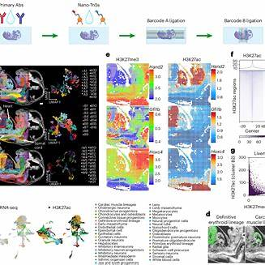
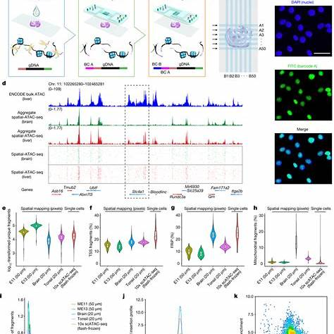
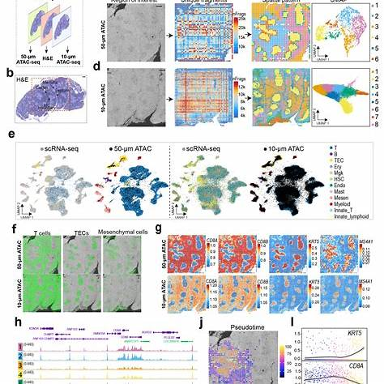
Below is a curated U.S.-focused shortlist. I interpreted “spatial ATAC-seq” broadly as spatially resolved chromatin accessibility profiling, including the exact DBiT-style spatial-ATAC-seq method, spatial ATAC–RNA-seq, spatial FFPE-ATAC-seq, sciMAP-ATAC, SPACE-seq, and other closely related spatial epigenomics methods.
Priority | Professor | Institution | Why they are relevant
1 | Rong Fan | Yale University, Biomedical Engineering / Pathology | Probably the most direct U.S. match. His Yale profile explicitly says his work led to spatial epigenomics technologies including spatial-ATAC-seq, spatial-CUT&Tag, and spatial epigenome-transcriptome co-profiling. The 2022 Nature spatial-ATAC-seq paper describes spatially resolved chromatin-accessibility profiling using in situ Tn5 transposition plus microfluidic deterministic barcoding, and Fan is a corresponding author.
2 | Yanxiang Deng | University of Pennsylvania, Pathology and Laboratory Medicine | Very strong match. Deng is an Assistant Professor at Penn with research expertise listed as spatial omics, single-cell analysis, and microfluidics; Penn lists the 2022 Nature spatial chromatin-accessibility paper among his selected publications. His lab also highlights spatial FFPE-ATAC-seq and spatial-Mux-seq, which co-captures chromatin accessibility with other modalities.
3 | Yang Xiao | University of Michigan, Pathology / Biomedical Engineering / Computational Medicine & Bioinformatics | Strong match for biological applications, especially brain and pathology. Her Michigan lab page says it uses in-house spatial mRNA and ATAC-seq platforms and has a specific section for Spatial ATAC-Seq; her BME profile describes integration of spatial transcriptomic, epigenomic, and proteomic data to map the brain.
4 | Yang Liu | Yale School of Medicine, Pathology | Strong match in DBiT/spatial multi-omics. His lab page explicitly lists “DBiT-seq, Spatial-CITE-seq and Spatial ATAC-seq” as techniques, and his Yale profile says his lab focuses on spatial omics methods across transcriptome, proteome, epigenome, and applications to disease.
5 | Sai Ma | Icahn School of Medicine at Mount Sinai, Genetics and Genomic Sciences | Strong match for single-cell/spatial epigenomics. Ma is an Assistant Professor at Mount Sinai; his lab says it is developing experimental sequencing tools including Spatial-ATAC-seq, and his publications include both the 2022 spatial chromatin-accessibility paper and the 2023 spatial epigenome-transcriptome co-profiling paper.
6 | Andrew C. Adey | Oregon Health & Science University, Molecular & Medical Genetics | Strong adjacent match. Adey’s group works on high-throughput epigenomics and chromatin accessibility, including spatial information. His group developed sciMAP-ATAC, described as a scalable, spatially resolved single-cell chromatin-accessibility method retaining positional information for each cell.
7 | Jason D. Buenrostro | Harvard University / Broad Institute, Stem Cell and Regenerative Biology | Strong adjacent match and central ATAC-seq figure. Harvard says Buenrostro developed ATAC-seq and single-cell ATAC-seq, and his lab is building spatial genomics methods. He is also an author on SPACE-seq and on photoselective sequencing, both relevant to spatial chromatin accessibility.
8 | Fei Chen | Harvard University / Broad Institute, Stem Cell and Regenerative Biology | Strong adjacent match for spatial genomics technology. Harvard lists Chen as an Assistant Professor whose lab develops spatial and temporal genomics tools; Chen is a senior author on photoselective sequencing, which validates spatially guided chromatin-accessibility measurements in mouse brain.
9 | Howard Y. Chang | Stanford University, Dermatology / Genetics / Pathology | Strong adjacent match through spatial epigenomics and SPACE-seq. Stanford lists Chang as a professor of cancer research/genetics, and Stanford’s technology page identifies SPACE-seq as a spatial epigenomics/transcriptomics platform that adapts ATAC-seq for spatial multiomics. Note: his Stanford profile currently lists him as on leave through Dec. 15, 2026.
10 | Kam W. Leong | Columbia University, Biomedical Engineering / Systems Biology | Relevant collaborator rather than a primary spatial-ATAC specialist. Leong is a Columbia professor, and the original Nature spatial-ATAC-seq paper lists Yang Xiao and Kam W. Leong under Columbia Biomedical Engineering / Systems Biology affiliations. I would treat him as a collaborator/mentor connection rather than the first-choice PI for spatial ATAC-seq work.
The strongest “exact-match” cluster is Rong Fan, Yanxiang Deng, Yang Xiao, Yang Liu, and Sai Ma. The next tier—Andrew Adey, Jason Buenrostro, Fei Chen, and Howard Chang—is highly relevant if you are also considering broader spatial chromatin accessibility / spatial epigenomics rather than only the original DBiT-style spatial-ATAC-seq assay.

Please find more relevant people in this research area, they can be researchers or professors
I’ll expand beyond the first shortlist to include both method developers and application-focused researchers, prioritizing U.S.-based labs while noting especially central non-U.S. figures if needed.

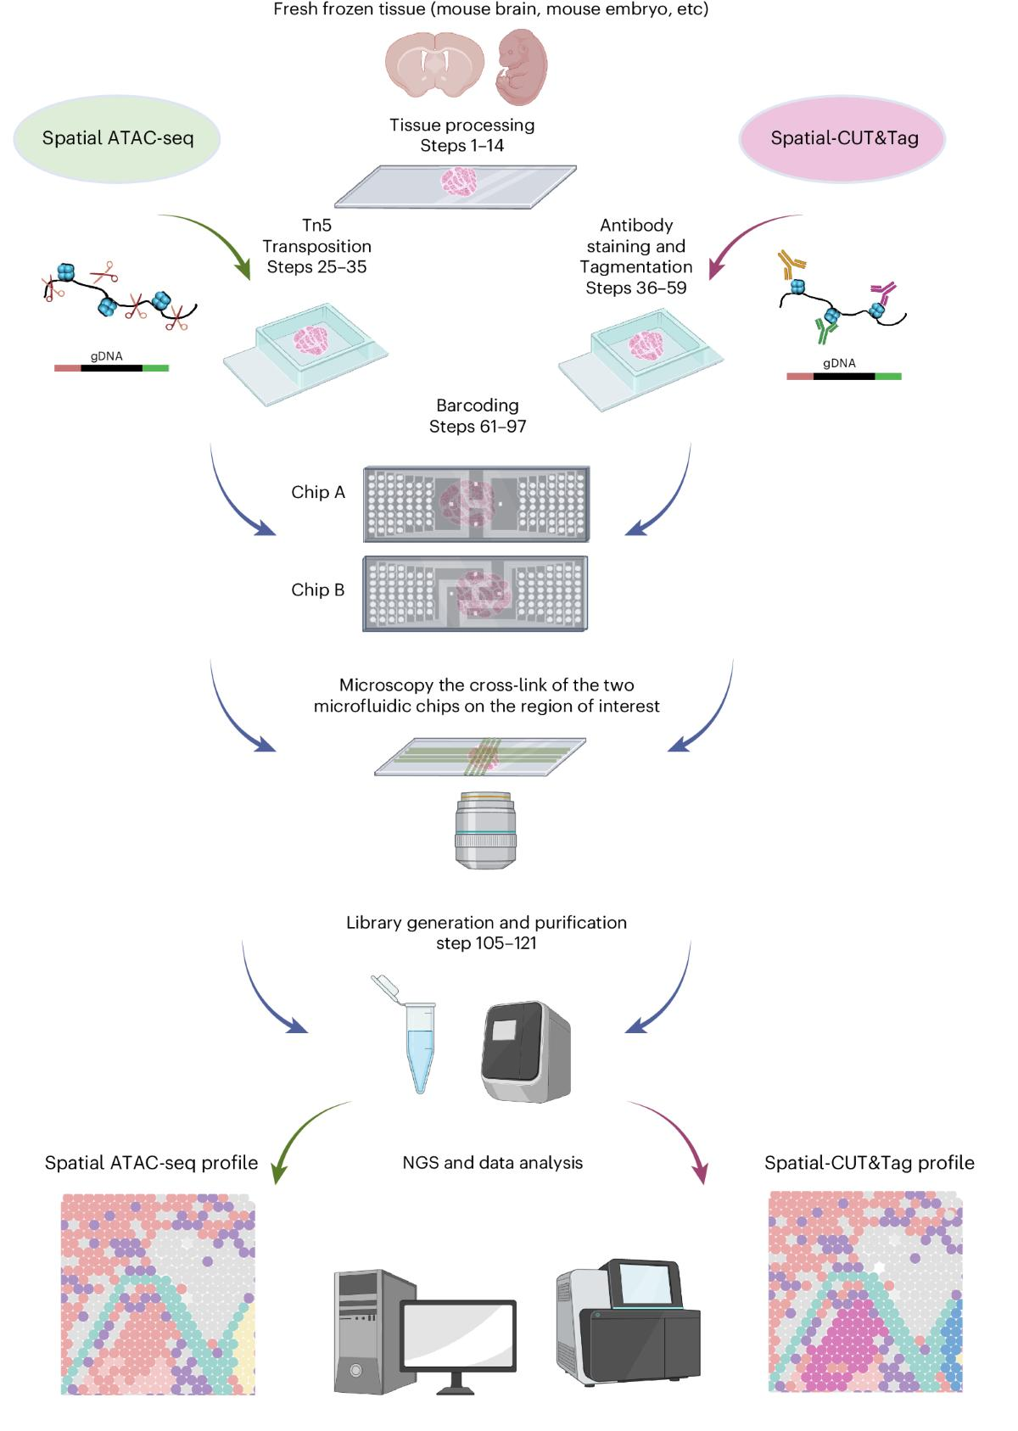
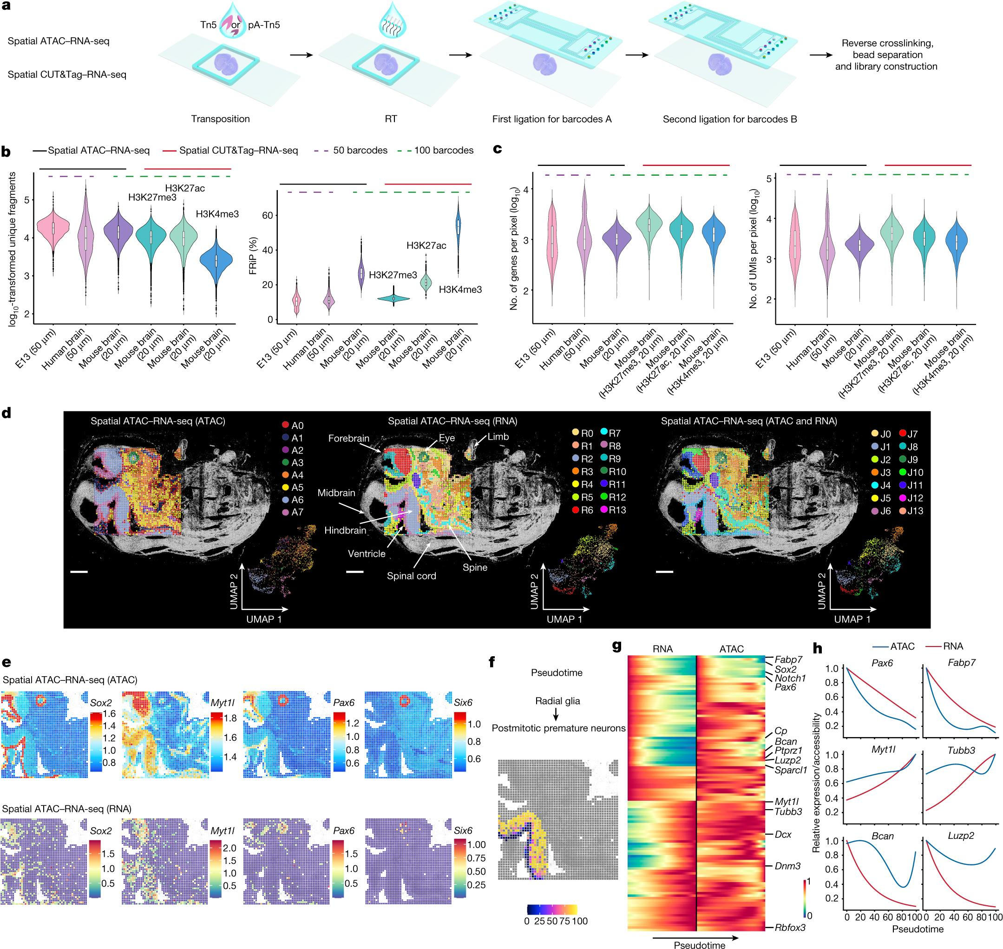
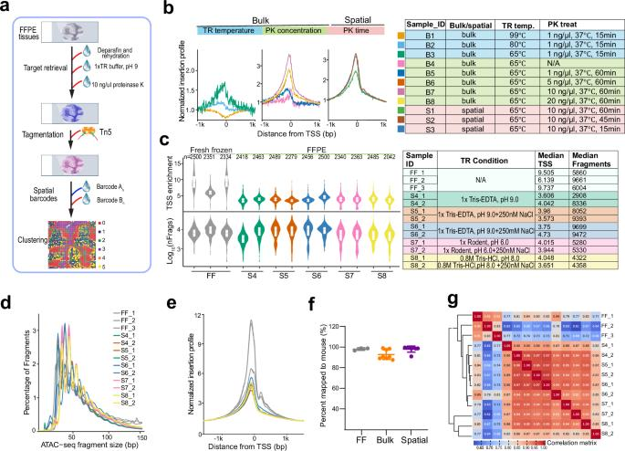
Here are additional people to add beyond the first list. I’m keeping the emphasis on the USA, but I also added a short “global names to know” section because several important spatial-ATAC/spatial-epigenomics methods originated outside the U.S. I marked people as direct when they have worked on spatial ATAC-seq/spatial chromatin accessibility itself, and adjacent when they work on methods that spatialize ATAC/scATAC or analyze spatial epigenomic data.

Strong additional U.S.-based names
Person | Current / likely affiliation | Relevance
Pengfei Guo | University of Pennsylvania / Deng Lab | Direct. Key first/co-first author on spatial-Mux-seq and spatial FFPE-ATAC-seq, both very relevant to spatial chromatin accessibility. Deng Lab notes that “Guo and Chen” developed spatial FFPE-ATAC-seq and “Guo and Mao” introduced spatial-Mux-seq; Pengfei Guo’s profile lists spatial omics, biochemistry, and epigenetics.
Liran Mao | University of Pennsylvania | Direct/computational. Works on computational biology/bioinformatics for spatial omics; coauthor on spatial-Mux-seq and spatial FFPE-ATAC-seq, with a personal page listing these papers.
Yufan Chen | University of Pennsylvania / Deng Lab publication cluster | Direct. Co-first author with Pengfei Guo on the 2025 spatial FFPE-ATAC-seq work, which maps chromatin accessibility in archived FFPE tissue while preserving tissue architecture.
Negin Farzad | Yale University / Fan Lab | Direct. First author on the Nature Protocols spatial epigenomics protocol with Rong Fan, Yanxiang Deng, Archibald Enninful, Shuozhen Bao, and Di Zhang; her ORCID also lists Yale and spatial-ATAC/RNA-related protocols.
Archibald “Archie” Enninful | Yale University / Fan Lab | Direct. Fan Lab PhD student working on spatial omics in lymphoid/tumor contexts; coauthor on spatial epigenomics protocols and spatial multi-omics work.
Shuozhen Bao | Yale University / Fan Lab | Direct. Coauthor on Fan Lab spatial ATAC/spatial CUT&Tag and spatial ATAC–RNA protocol work; good person to track for hands-on DBiT-style spatial epigenomics.
Di Zhang | Yale University | Direct. First author on the spatial epigenome–transcriptome co-profiling Nature paper; Google Scholar lists Yale and research areas including spatial systems bioengineering and spatial gene regulation.
Graham Su | Yale / Fan Lab publication cluster | Direct/early platform contributor. Coauthor on the original DBiT-seq spatial multi-omics work and on spatial-ATAC/spatial ATAC–RNA papers; relevant for the microfluidic deterministic barcoding lineage behind spatial ATAC-seq.
Xiaoyu Qin | Yale / Fan Lab publication cluster | Direct. Coauthor on the original spatial-ATAC-seq paper and related Fan Lab spatial epigenomics work.
Benjamin J. Raphael | Princeton University | Computational/adjacent-direct. Coauthor on the spatial ATAC–RNA-seq / spatial CUT&Tag–RNA-seq Nature paper; relevant for computational interpretation of spatial epigenome–transcriptome data.
Yuval Kluger | Yale University | Computational/adjacent-direct. Coauthor on spatial epigenome–transcriptome co-profiling; relevant for analysis/integration of spatial multi-omic epigenomic data.
Maximilian Haeussler | UC Santa Cruz | Data/computational adjacent. Coauthor on the spatial epigenome–transcriptome paper; UCSC Cell Browser infrastructure is also used for browsing spatial multi-omics datasets.
Theodore J. Price | University of Texas at Dallas | Direct application area. Senior/corresponding investigator on human dorsal-root-ganglion work using bulk and spatial ATAC-seq to study chromatin accessibility in pain biology; UTD lists him as an Ashbel Smith Professor and neuroscience/pain researcher.
Úrzula Franco-Enzástiga | University of Texas at Dallas | Direct application area. First author on the human dorsal-root-ganglion spatial/bulk ATAC-seq study; her profile lists neurobiology of pain and epigenomics.
Nikhil N. Inturi | UT Dallas / Price Lab publication cluster | Direct application/computational. Coauthor on the human DRG spatial ATAC-seq study and involved in computational analysis per the author-contribution statement.
Xusheng Wang | University of Tennessee Health Science Center | Direct application area. Corresponding author on a 2025 preprint applying spatial ATAC-seq to 5xFAD Alzheimer’s disease mouse brain to map glial chromatin-accessibility changes.
Kai Yang | Indiana University School of Medicine | Direct application area. Corresponding author on the same Alzheimer’s spatial ATAC-seq study; useful if the interest is neurodegeneration and spatial epigenomics.
Dehui Kong | UTHSC / Wang Lab publication cluster | Direct application area. First author on the Alzheimer’s spatial ATAC-seq mouse-brain preprint.
Hongjie He | UTHSC / collaborator cluster | Direct application area. Co-first author on the Alzheimer’s spatial ATAC-seq study.

U.S. researchers in very close adjacent methods
Person | Affiliation | Relevance
Yung-Hsin Huang | Stanford/Chang-Buenrostro publication cluster | SPACE-seq. Co-first author on SPACE-seq, a 2025 PNAS method for spatial epigenome, transcriptome, and cell-lineage profiling that adapts ATAC-seq to polyA-based spatial transcriptomics workflows.
Julia A. Belk | Harvard/Broad/Buenrostro publication cluster | SPACE-seq. Co-first author on the same SPACE-seq paper and maintainer of the public SPACE-seq analysis repository.
Ruochi Zhang | Harvard/Broad publication cluster | SPACE-seq / chromatin-accessibility methods. Coauthor on SPACE-seq; also appears in Buenrostro Lab chromatin-accessibility method work.
Natasha E. Weiser | Stanford/SPACE-seq publication cluster | SPACE-seq. Coauthor on the PNAS SPACE-seq method.
Zachary Chiang | Stanford/SPACE-seq publication cluster | SPACE-seq. Coauthor on the PNAS SPACE-seq paper; relevant for spatial epigenome-transcriptome work.
Paul S. Mischel | Stanford University | Cancer application of SPACE-seq. Coauthor on SPACE-seq, which was applied to human glioblastoma to study tumor microenvironment, extrachromosomal DNA copy number, and mtDNA variants.
Sarah M. Mangiameli | Broad Institute / Harvard | Photoselective sequencing. First author on photoselective sequencing, a microscopy-guided genomic/epigenomic method validated by measuring chromatin accessibility in spatially selected mouse-brain cell types.
Haiqi Chen | Broad/Harvard publication cluster | Photoselective sequencing. Coauthor on photoselective sequencing; relevant for light-guided spatial chromatin-accessibility measurements.
Andrew S. Earl | Harvard University | Photoselective sequencing / chromatin biology. Coauthor on photoselective sequencing; profile lists gene regulation, chromatin biology, and single-cell genomics.
Casey A. Thornton | OHSU/Adey publication cluster | sciMAP-ATAC. First author on sciMAP-ATAC, a spatially mapped single-cell chromatin-accessibility method that retains positional information for each cell.
Ryan M. Mulqueen | OHSU/Adey publication cluster | sciMAP-ATAC. Coauthor on sciMAP-ATAC and involved in experiments/analysis according to the contribution statement.
Andrew Russell | Broad Institute / Macosko-Chen publication cluster | Slide-tags. First author / Tools-of-the-Trade author for Slide-tags, which spatially barcodes nuclei and can feed into snRNA-seq, snATAC-seq, and TCR-seq workflows.
Jackson A. Weir | Harvard/Broad publication cluster | Slide-tags. Co-first author on Slide-tags; relevant because Slide-tags can add spatial information to single-nucleus ATAC-seq.
Naeem M. Nadaf | Broad/Macosko publication cluster | Slide-tags. Co-first author on Slide-tags; useful to track for spatial single-nucleus multi-omics.
Evan Z. Macosko | Broad Institute / Harvard | Slide-tags senior author. Slide-tags is not “spatial ATAC-seq” in the DBiT sense, but it can spatialize snATAC-seq, making Macosko highly relevant to spatial chromatin accessibility.

Global names worth knowing
Person | Country / institution | Relevance
Marek Bartosovic | Stockholm University / Sweden | Direct. Coauthor on the original spatial-ATAC-seq paper and spatial epigenome–transcriptome co-profiling work.
Gonçalo Castelo-Branco | Karolinska Institutet / Sweden | Direct. Corresponding author on spatial ATAC–RNA-seq / spatial CUT&Tag–RNA-seq and coauthor on the original spatial-ATAC-seq work.
Patrik L. Ståhl | KTH / SciLifeLab, Sweden | Direct/parallel method. Senior author on solid-phase spatial ATAC, which integrates ATAC-seq with barcoded solid-phase capture for spatial epigenomics.
Enric Llorens-Bobadilla | Karolinska Institutet / Sweden | Direct/parallel method. First author on solid-phase spatial ATAC.
Margherita Zamboni | Ståhl Lab / Sweden | Direct/parallel method. Co-first author on solid-phase spatial ATAC and listed as a Ståhl Lab postdoc.
Maja Marklund | Sweden / spatial ATAC publication cluster | Direct/parallel method. Co-first author on solid-phase spatial ATAC.
Nayanika Bhalla | KTH / Ståhl Lab | Direct/parallel method. Coauthor on solid-phase spatial ATAC and listed on the Ståhl Lab team.
Caterina Carraro | Germany / LCM-ATAC-seq publication cluster | Spatial chromatin-accessibility adjacent. First/corresponding author on LCM-ATAC-seq, which uses laser-capture microdissection coupled to ATAC-seq for spatially targeted chromatin accessibility.
Joachim L. Schultze | Germany | Spatial chromatin-accessibility adjacent. Senior author on LCM-ATAC-seq; relevant for region/cell-population-targeted spatial chromatin accessibility.

Best additions to prioritize
For hands-on spatial ATAC-seq / DBiT-style work, I would add Pengfei Guo, Liran Mao, Yufan Chen, Negin Farzad, Archie Enninful, Shuozhen Bao, Di Zhang, Graham Su, and Xiaoyu Qin.
For disease applications, especially nervous system or pathology, I would add Theodore Price, Úrzula Franco-Enzástiga, Xusheng Wang, Kai Yang, Dehui Kong, and Hongjie He.
For adjacent platform development, I would track Yung-Hsin Huang, Julia Belk, Sarah Mangiameli, Casey Thornton, Andrew Russell, Evan Macosko, and Paul Mischel.

explain the sentence to me "Mapping human lymph node cell types to 10X Visium with Cell2location"
This sentence describes a cutting-edge scientific process used in computational biology and immunology. In plain English, it means: Researchers are using a specific computer algorithm to figure out exactly where different types of immune cells are physically located within a slice of human lymph node tissue.
To really understand what this means, let's break down the sentence piece by piece:

1. "Human lymph node cell types"
Lymph nodes are small, bean-shaped structures that act as filters for your immune system. They are packed with various "cell types" (like B cells, T cells, and macrophages) that each have specific jobs in fighting off infections. In this context, researchers usually already have a "dictionary" or reference list of these specific cell types, typically gathered from another technology called single-cell sequencing.

2. "10X Visium"
10X Visium is a specific commercial technology (made by a company called 10x Genomics) used for Spatial Transcriptomics.
- How it works: Scientists take a microscopic slice of tissue (in this case, a lymph node) and place it on a special glass slide. This slide is covered in thousands of tiny, microscopic "spots."
- The catch: The technology reads the genetic activity (RNA) happening right on top of each spot. However, these spots are just a little bit too big to capture a single cell. Instead, each spot usually captures a "mishmash" of about 1 to 10 different cells.

3. "Cell2location"
Because 10X Visium spots contain a mixture of cells, scientists have a problem: they know the total genetic activity of a spot, but they don't know which specific cells are making it.
Cell2location is a sophisticated mathematical algorithm (a computational tool) designed to solve this exact problem. It acts like a highly advanced detective. It looks at the genetic mishmash on a Visium spot, compares it to the "dictionary" of known lymph node cell types, and calculates the exact recipe of cells in that spot.

4. "Mapping"
This is the final result. By running the Cell2location algorithm on the 10X Visium data, the researchers are "mapping" or plotting the data. They can now generate a colorful map of the lymph node slice that says, "Spot A contains exactly 3 B-cells and 1 T-cell, while Spot B contains 4 macrophages."

The "Satellite Map" Analogy
If you are still having trouble picturing it, think of it like this:
- 10X Visium is like a satellite map of a city divided into equal-sized grids (spots). You can see the total amount of electricity being used in each grid, but the camera isn't zoomed in enough to see the individual buildings.
- Cell types are like a city census. You know the city contains houses, factories, and office buildings, and you know how much power each usually uses.
- Cell2location is the computer program that looks at the electricity usage of a grid on the satellite map, checks the census data, and maps it out by concluding: "Grid 1 must contain exactly 3 houses and 1 factory."
Why does this matter? By understanding exactly how immune cells are physically organized next to each other in a healthy or diseased lymph node, scientists can better understand how the immune system communicates, how it fights diseases like cancer, and how to develop better vaccines or treatments.

